WORK INTEGRATED LEARNING: DATA ANALYTICS
Customer Segmentation of a Telecommunications Customer Base
Stage 2 Clustering Results Report
K-Means segmentation and churn profiling
Team 8
Prepared by: Jyoti Saini, Data Analyst (Clustering)
Project Manager: Raman Shrestha
Jira epic: T8-27 Stage 2 Clustering results (stories T8-46 to T8-52)
Handover date: 1 November 2026
Purpose: Segment the client's customers with K-Means, profile each segment and hand the results to the predictive modelling and business analysis stages.

Executive Summary
The client, a telecommunications provider, loses about one customer in four (26.5 per cent of the 7,043 customers in the supplied dataset). It treats its customer base as a single group, yet a new customer on a high monthly plan and a long-standing customer on a low-cost plan are unlikely to leave for the same reasons. This report sets out the clustering stage of the project, which divides the customer base into segments so that the churn model and the retention recommendations can be aimed at the groups most at risk.
The work started from the processed dataset delivered by the Data Engineer in Part 1 of the shared notebook. Nine customer attributes were used; churn was held back so that segments formed on customer characteristics alone, and gender was excluded because it showed no difference in churn. The elbow method and the silhouette score were used to choose the number of clusters, and a K-Means model with four clusters was trained, checked for stability and visualised with principal component analysis.
Four segments emerged, driven mainly by tenure and monthly charges. The most important finding is that one segment, At-Risk New Premium Customers, holds 31.6 per cent of customers but 58.3 per cent of all churners, loses 49.0 per cent of its members and accounts for about two thirds of the monthly revenue lost to churn. Loyal Budget Customers, at the other end, churn at only 4.8 per cent. Contract type and internet service were spread evenly across all four segments and therefore did not separate customers in this dataset. The cluster labels and segment profiles have been handed to the Data Analyst (Predictive) and the Business Analyst, and the method is documented on Confluence.

Table of Contents
Executive Summary
Introduction
Part A Data readiness and preparation
Readiness of the processed dataset
Feature selection and scaling
Part B Choosing the number of clusters
Elbow method and silhouette score
Final model and stability check
Part C The four customer segments
Visualising the segments
Segment profiles
Churn and revenue at risk by segment
Part D Key findings and implications
Part E Handover, limitations and conclusion
Handover to the next stages
Limitations
Conclusion
References

Introduction
This report records the results of the clustering stage of Team 8's customer churn project. It covers charter steps C1 to C7, tracked in Jira under epic T8-27, from confirming the processed data was ready through to handing over the results. K-Means clustering was used because it is simple, fast and easy to explain to business stakeholders, which makes it one of the most widely used segmentation methods (Jain, 2010). All analysis was carried out in Python with Pandas and Scikit-learn (Pedregosa et al., 2011) in Part 2 of the team's shared notebook, Churn.ipynb, directly after the Data Engineer's preparation in Part 1, so that the whole analysis can be run from top to bottom. The report follows the order of the work: data readiness, choice of the number of clusters, the segments themselves, the findings, and the handover.

Part A Data readiness and preparation

Readiness of the processed dataset
The clustering took the processed dataset directly from Part 1 rather than loading a separate file, so that every member works from one source. The original client file, Dataset_ATS_v2.csv, was used only to describe the segments in real units such as months and dollars. Table 1 summarises the readiness checks.
Table 1
Readiness Checks on the Processed Dataset
Check | Result and decision
Size | 7,043 customer records; 11 columns in the processed file, 10 attributes in the original file
Missing values | None in either file
Category labels | Consistent; no stray spellings or spaces
Duplicate rows | 302 identical rows. The file has no customer ID, so two customers with the same ten attributes look identical. They were kept, which also keeps the data aligned with the ANN dataset
Fields assumed in the charter | TotalCharges and PaymentMethod are not in the dataset; the plan was adjusted to the ten attributes available
Work from Part 1 | tenure and MonthlyCharges standardised; phone, lines, internet and contract columns one-hot encoded as booleans
Note. Source: Part 2, section 2.1 of the shared notebook.

Feature selection and scaling
K-Means groups customers by distance, so every input must be numeric and on a comparable scale. On a working copy, leaving the Part 1 data unchanged, gender and Dependents were converted to 0/1, SeniorCitizen was used in its original 0/1 form so that it reads as a yes/no flag in the profiles, and the boolean dummy columns were converted to 1/0. Tenure and monthly charges were confirmed at a mean of 0 and a standard deviation of 1. The remaining features are 0/1 flags on a small common range, so no single variable dominates the distance calculation.
Nine features were used, as shown in Table 2. Two were deliberately left out. Churn was held back because clustering on it would simply split customers into those who left and those who stayed, which adds nothing for the business; leaving it out allows churn to be compared across segments that formed on customer characteristics. Gender was excluded because churn was almost identical for women (26.9 per cent) and men (26.2 per cent), so it would add noise without separating customers.
Table 2
Clustering Features
Group | Features | Form
Account | tenure, MonthlyCharges | Standardised
Customer | SeniorCitizen, Dependents | 0/1 flags
Services | PhoneService_Yes, MultipleLines_Yes, InternetService_Fiber optic | 0/1 flags
Contract | Contract_One year, Contract_Two year (month-to-month as baseline) | 0/1 flags
Held back | Churn (outcome), gender (no separating power) | Not used

Part B Choosing the number of clusters

Elbow method and silhouette score
K-Means was run for k from 1 to 10. The elbow method plots inertia, the within-cluster sum of squares, and looks for the point where adding another cluster stops giving much improvement (Thorndike, 1953). The silhouette score was used as a check; it measures how well each customer fits its own cluster compared with the nearest other cluster, on a scale from -1 to 1 (Rousseeuw, 1987). Figure 1 and Table 3 show the results.
Figure 1
Elbow Method and Silhouette Score for k = 1 to 10
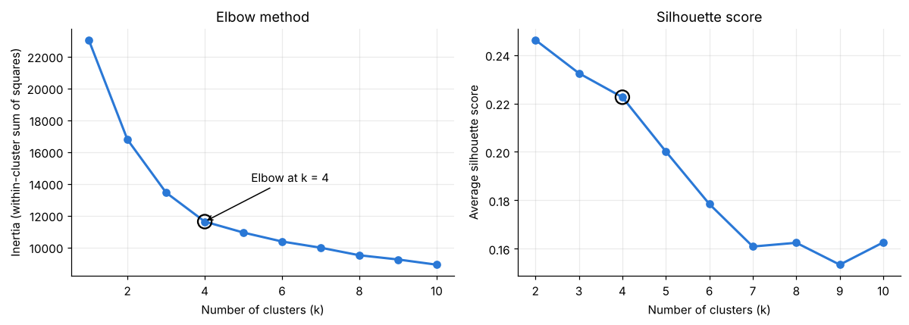
Note. Source: Part 2, section 2.4 of the shared notebook.
Table 3
Inertia and Silhouette Score by Number of Clusters
k | Inertia | Drop from previous k | Silhouette score
2 | 16,777 | 6,264 | 0.246
3 | 13,442 | 3,334 | 0.232
4 | 11,620 | 1,823 | 0.223
5 | 10,930 | 689 | 0.200
6 | 10,368 | 563 | 0.178

The curve falls steeply up to four clusters and then flattens: moving from three to four clusters removes 1,823 units of inertia, but moving from four to five removes only 689. The silhouette score is highest at two clusters, but two groups would only separate new customers from long-standing ones, which is too broad for targeted retention. At four clusters the score is still positive and reasonable. Low to moderate silhouette values are normal for customer data, where people do not fall into perfectly separate groups. Four clusters were therefore chosen as the best balance between statistical fit and business use.

Final model and stability check
The final model used four clusters with k-means++ initialisation, which spreads the starting centres to give more reliable results (Arthur & Vassilvitskii, 2007), ten runs and a fixed random state so that the results can be reproduced. It reached an inertia of 11,619.6 and an average silhouette score of 0.225 on the full dataset. To test stability, the model was retrained with five different random seeds and the groupings were compared using the adjusted Rand index, where 1.0 means identical groupings (Hubert & Arabie, 1985). Every comparison scored between 0.999 and 1.0, so the segments do not depend on the starting point. The clusters were then numbered in a fixed order, by average tenure and then monthly charges, so the numbering is the same every time the notebook is run.

Part C The four customer segments

Visualising the segments
Principal component analysis reduces the nine features to two dimensions for plotting while keeping as much of the variation as possible (Jolliffe & Cadima, 2016). The first two components explain 62 per cent of the variance, and Figure 2 shows four clearly separated groups. Figure 3 plots the same customers in their original units and explains why: the segments are formed mainly by how long customers have stayed and how much they pay each month, giving four combinations of short or long tenure and low or high charges.
Figure 2
Customer Clusters on the First Two Principal Components
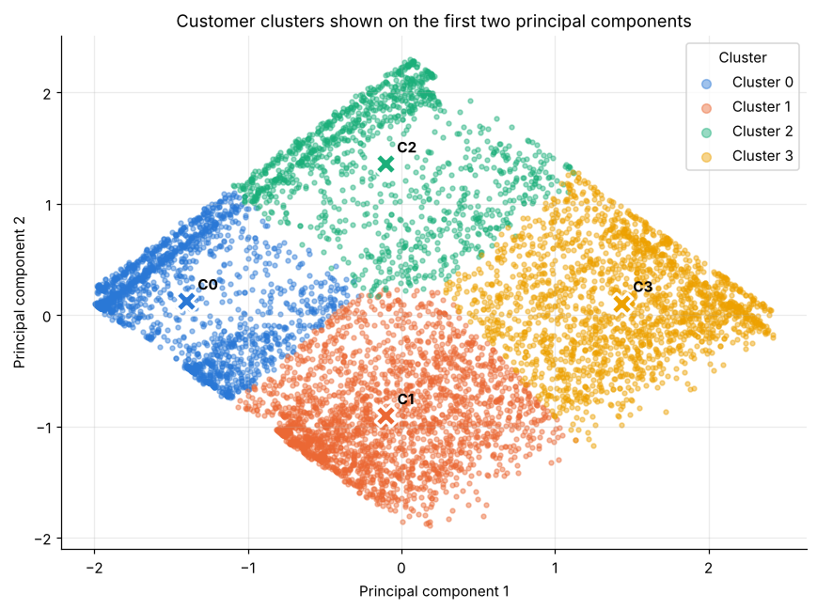
Figure 3
Clusters by Tenure and Monthly Charges in Original Units
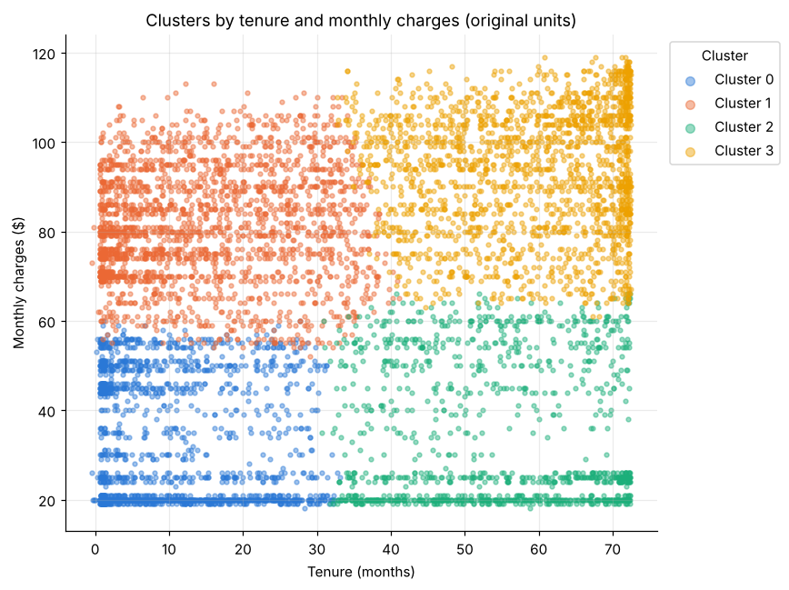
Note. Source: Part 2, section 2.6 of the shared notebook. Crosses in Figure 2 mark the cluster centres.

Segment profiles
Each cluster was profiled on the original attributes and given a business name that describes it in plain terms. Table 4 sets out the profiles, and Figure 4 compares tenure, charges and segment size.
Table 4
Profile of the Four Customer Segments
Cluster | Segment | Customers | Average tenure | Average monthly charge | Churn rate
C0 | New Budget Customers | 1,721 (24.4%) | 10 months | $32 | 24.6%
C1 | At-Risk New Premium Customers | 2,223 (31.6%) | 15 months | $81 | 49.0%
C2 | Loyal Budget Customers | 1,176 (16.7%) | 54 months | $35 | 4.8%
C3 | Loyal Premium Customers | 1,923 (27.3%) | 59 months | $93 | 15.5%
Note. Overall churn rate across all customers is 26.5 per cent. Source: Cluster_Profiles.csv.
Figure 4
Average Tenure, Average Monthly Charges and Share of Customers by Segment
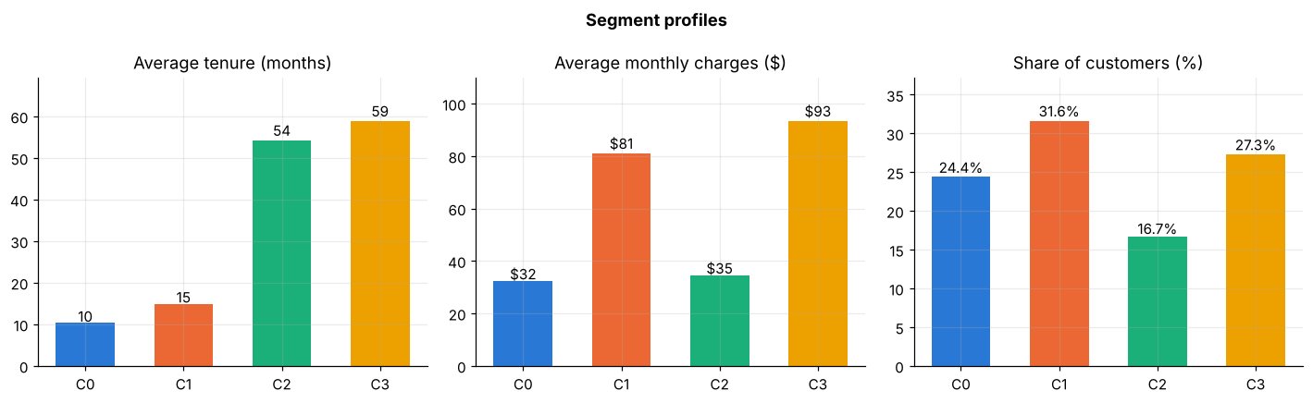
Table 5 shows the service and household mix. Seniors make up about a fifth to a quarter of the two premium segments but under 8 per cent of the budget segments, and Loyal Budget Customers are the most likely to have dependents. Almost every premium customer has phone service. By contrast, the share of month-to-month contracts (54 to 56 per cent) and fibre internet (42 to 46 per cent) is almost the same in every segment.
Table 5
Service and Household Mix by Segment (per cent of segment)
Segment | Month-to-month | Two-year | Fibre | Phone | Senior | Dependents
C0 New Budget | 54.6 | 23.0 | 44.3 | 79.3 | 6.6 | 31.0
C1 At-Risk New Premium | 55.6 | 25.1 | 42.3 | 99.8 | 23.8 | 17.9
C2 Loyal Budget | 54.2 | 24.0 | 44.0 | 73.6 | 7.4 | 45.4
C3 Loyal Premium | 55.3 | 24.0 | 45.5 | 99.5 | 21.5 | 33.4

Churn and revenue at risk by segment
Churn was compared across the finished segments. Figure 5 shows the churn rate for each segment against the overall rate, and Table 6 shows how the 1,869 churners and their combined monthly charges of about $139,100 are distributed.
Figure 5
Churn Rate by Customer Segment
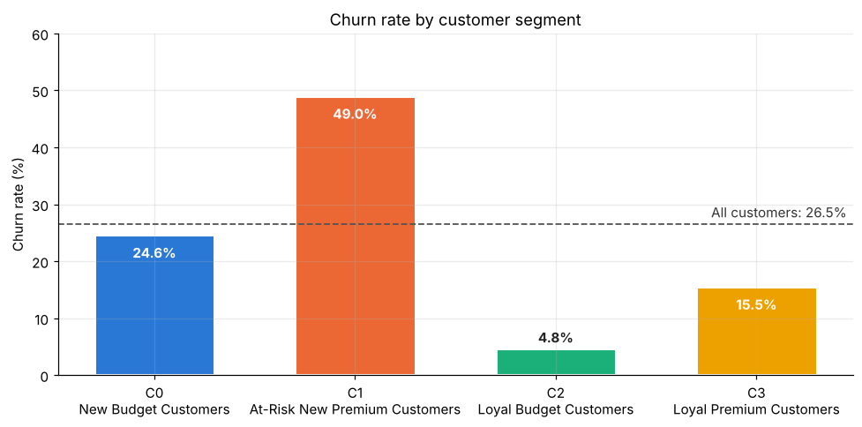
Table 6
Distribution of Churners and Monthly Revenue Lost by Segment
Segment | Churners | Share of churners | Monthly charges lost | Share of revenue lost
C0 New Budget | 424 | 22.7% | $15,986 | 11.5%
C1 At-Risk New Premium | 1,090 | 58.3% | $91,338 | 65.7%
C2 Loyal Budget | 56 | 3.0% | $2,539 | 1.8%
C3 Loyal Premium | 299 | 16.0% | $29,244 | 21.0%
Total | 1,869 | 100% | $139,107 | 100%
Note. Monthly charges lost is the sum of MonthlyCharges for customers whose churn value is Yes. Source: Clustered_Customers.csv.

Part D Key findings and implications
Four findings come out of the segmentation. First, tenure is the strongest dividing line. The two newer segments, C0 and C1, together account for 81 per cent of churners, so a customer's early months are where retention effort will have the most effect. Second, new customers on high charges are the riskiest combination. C1 loses almost half of its members, close to double the overall rate, and because these customers pay about $81 a month, it accounts for about two thirds of the monthly revenue lost to churn. This makes C1 the first priority for the retention strategies.
Third, loyalty is real but not uniform. Loyal Budget Customers churn at only 4.8 per cent, while Loyal Premium Customers churn at 15.5 per cent; C3 has the highest charges of any segment, so its losses, about a fifth of revenue lost, are still significant. Fourth, contract type and internet service are spread evenly across the segments, so in this dataset they do not explain who leaves. This is worth noting for the predictive model, because features that look important in other churn studies may add little here.
These findings are descriptive and come from one snapshot. They show which groups churn, not why, and the Business Analyst's work will test what drives the difference between segments.

Part E Handover, limitations and conclusion

Handover to the next stages
The results were handed over on 1 November 2026, completing story C7. Table 7 lists what each member received.
Table 7
Clustering Outputs Handed Over
Recipient | File | Use
Bao Ngoc Nguyen, Data Analyst (Predictive) | Updated_Dataset_with_Clusters.csv | The Part 1 dataset with a Cluster column, to be one-hot encoded and tested as an extra ANN input, and to check model results by segment
Fahad Parsha Mohammed, Business Analyst | Clustered_Customers.csv; Cluster_Profiles.csv | Every customer with segment and name; the segment summary table for retention strategy design
Raman Shrestha, Project Manager | This report; figures 1 to 5 | Stage 2 deliverables on 15 November 2026 and the Confluence clustering page
Whole team | Churn.ipynb, Part 2 | Full, reproducible clustering method, run from top to bottom after Part 1

One point was passed on for the ANN stage: gender and Dependents are still text in the Part 1 output, so they will need converting to 0/1 before they are used as model inputs.

Limitations
The analysis is limited to a single snapshot of ten attributes, with no usage, billing history or payment method data, so it cannot show how customer behaviour changes over time. K-Means works best when clusters are roughly round and similar in size and is sensitive to scaling (Jain, 2010), so the segments are best read as broad customer groups rather than exact boundaries. The 302 duplicate rows were kept on the reasonable assumption that they are separate customers; if the client confirms they are errors, the segments should be refreshed, although with fewer than 5 per cent of rows affected the profiles are unlikely to change materially.

Conclusion
The clustering stage achieved its purpose. Four stable, clearly separated segments were found, each with a plain business profile, and churn differs sharply between them, from 4.8 to 49.0 per cent. The At-Risk New Premium segment stands out as the group where retention effort will protect the most revenue. With the labels and profiles now with the predictive and business analysis stages, the team can move from describing who leaves to predicting churn and recommending how to prevent it.

References
Arthur, D., & Vassilvitskii, S. (2007). k-means++: The advantages of careful seeding. In Proceedings of the eighteenth annual ACM-SIAM symposium on discrete algorithms (pp. 1027–1035). Society for Industrial and Applied Mathematics.
Hubert, L., & Arabie, P. (1985). Comparing partitions. Journal of Classification, 2(1), 193–218. https://doi.org/10.1007/BF01908075
Jain, A. K. (2010). Data clustering: 50 years beyond K-means. Pattern Recognition Letters, 31(8), 651–666. https://doi.org/10.1016/j.patrec.2009.09.011
Jolliffe, I. T., & Cadima, J. (2016). Principal component analysis: A review and recent developments. Philosophical Transactions of the Royal Society A, 374(2065), Article 20150202. https://doi.org/10.1098/rsta.2015.0202
Pedregosa, F., Varoquaux, G., Gramfort, A., Michel, V., Thirion, B., Grisel, O., Blondel, M., Prettenhofer, P., Weiss, R., Dubourg, V., Vanderplas, J., Passos, A., Cournapeau, D., Brucher, M., Perrot, M., & Duchesnay, E. (2011). Scikit-learn: Machine learning in Python. Journal of Machine Learning Research, 12, 2825–2830.
Rousseeuw, P. J. (1987). Silhouettes: A graphical aid to the interpretation and validation of cluster analysis. Journal of Computational and Applied Mathematics, 20, 53–65. https://doi.org/10.1016/0377-0427(87)90125-7
Thorndike, R. L. (1953). Who belongs in the family? Psychometrika, 18(4), 267–276. https://doi.org/10.1007/BF02289263

