

**<< DNA Testing Service Management System** **>>**

**Software Requirement Document**

**Report 1 - Introduction**

– HoChiMinh, May 2025 –

Contents

Record of Changes 2

I. Introduction 3

1. Product Background 3

2. Existing Systems 3

2.1 GENTIS (https://gentis.com.vn/) 3

2.2 ADNVIETNAM (https://adnvietnam.com/) 3

2.3 CGAT (http://cgat.vn/) 4

3. Business Opportunity 4

4. Software Product Vision 4

5. Major Features 5

6. Limitations and Exclusions 5

II. Overall Description 6

1. Product Overview 6

2. Business Process: 7

III. User Requirements 12

1. Actors 12

2. Use Cases 13

2.1 Diagram 13

2.2 Descriptions 14

3. Business Rules 70

IV. Functional Requirements 70

1. System Functional Overview 70

1.1 Screen Flow 70

1.2 Screen Descriptions: 73

1.3 Screen Authorization 77

1.4 Non-Screen Functions 79

2. Data Requirements 80

2.1 Logical Data Model 80

2.2 Data Dictionary 80

2.3 Dashboards 85

2.4 State transition diagram 90

3. User account management 92

4. Personal information management 96

5. Test requirments management 99

6. User account management 102

7. Feedback management 113

8. User account management 116

V. Non-Functional Requirements 122

1. External Interface Requirements 122

1.1 User Interfaces 122

1.2 Software Interfaces 122

1.3 Hardware Interfaces 123

1.4 Communications Interfaces 124

2. Quality Attributes 124

2.1 Usability 124

2.2 Performance 125

2.3 Security 126

2.4 Safety 126

2.5 Availability 126

2.6 Reliability 127

2.7 Design Contrainsts 127

# Record of Changes

|  |  |  |  |
| --- | --- | --- | --- |
| Date | A* M, D | In charge | Change Description |
|  |  |  |  |
|  |  |  |  |
|  |  |  |  |
|  |  |  |  |
|  |  |  |  |
|  |  |  |  |
|  |  |  |  |
|  |  |  |  |
|  |  |  |  |
|  |  |  |  |
|  |  |  |  |
|  |  |  |  |
|  |  |  |  |

*A - Added M - Modified D - Deleted

# I. Introduction

## 1. Product Background

DNA testing services in Vietnam are rapidly growing due to demand in paternity verification, legal procedures, and genetic screening. However, many centers still operate manually, leading to lack of transparency, delays, and frequent errors.

Surveys from centers like GENTIS, ADNVIETNAM, and CGAT reveal that customers do not have personal accounts to manage tests, cannot track sample progress, receive results manually, and have no system to provide feedback. This causes inconvenience and management difficulties.

The **DNA Testing Service Management System** is designed to digitize the entire process from registration, sample collection, testing, to result delivery and service feedback. This solution enhances user experience, improves management efficiency, ensures accuracy and safety, and allows scalability across national testing centers.

## 2. Existing Systems

### ****GENTIS (****<https://gentis.com.vn/>****)****

**Advantages:**

* A leading testing provider offering diverse services (paternity, kinship, genetics…).
* Owns ISO-certified laboratories.

**Limitations:**

* Website only allows single form submissions, lacks login or history tracking.
* Customers cannot view sample status or order progress.
* No modules for feedback, evaluation, or performance dashboards.

### ****2.2 ADNVIETNAM (****<https://adnvietnam.com/>****)****

**Advantages:**

* Offers a full range of civil and legal DNA testing services.
* Clear basic information available on the website.

**Limitations:**

* Website is purely informational – no customer profile management.
* No personal account creation or online result storage.
* No sample tracking or post-service feedback options.

### ****2.3 CGAT (****<http://cgat.vn/>****)****

**Advantages:**

* A long-established provider in kinship DNA testing in Vietnam.

**Limitations:**

* Website focuses on service information – lacks digital platform for post-registration interaction.
* No tracking for test status or sample progress.

## 3. Business Opportunity

Despite years in the market, most DNA testing centers in Vietnam have not implemented modern management systems to automate their services. Users cannot proactively track testing progress, do not have a secure portal for personal data, and lack tools for feedback or quality evaluation.

The **DNA Testing Service Management System** is designed to fully resolve these issues. Unlike existing platforms that are mainly informational or contact-based, our system will deliver a comprehensive, intelligent, and optimized experience:

* Enables users to register for testing online, monitor each stage of the sample process, and securely receive encrypted results.
* Provides personal dashboards for customers and executive dashboards for managers, optimizing workforce allocation, quality control, and performance tracking.
* Integrates a service evaluation system to gather real data for continuous improvement.

## 4. Software Product Vision

The **DNA Testing Service Management System** is a comprehensive web-based platform supporting both customers and testing centers. Customers can easily register, monitor progress, access results, and submit feedback directly.

For centers, the system enables efficient test process management, shift-based staff assignment, sample tracking, data control, and automated reporting (daily/monthly/quarterly). With an open and configurable architecture, the system can be deployed across different centers with varying scales and needs.

In the long term, the software aims to become the standard DNA service management system in Vietnam, facilitating data sharing across units and contributing to a transparent, efficient digital healthcare ecosystem.

## 5. Major Features

* **FE-01:** Login and register
* **FE-02:** View testing services and knowledge blog
* **FE-03:** Online DNA test registration (civil or legal)
* **FE-04:** Sample reception and processing (at home or facility)
* **FE-05:** Sample progress management (from registration → sample collection → testing → result available)
* **FE-06:** Online delivery of test results
* **FE-07:** Enables customer feedback and service evaluation
* **FE-08:** Statistical dashboard for performance, data, and test history
* **FE-09:** System administration: accounts, notifications, service types, result templates
* **FE-10:** Blog content management (knowledge & guidance)
* **FE-11:** Appointment scheduling for facility collection
* **FE-12:** Profile and history management for customers
* **FE-13:** Notification system for test status and results
* **FE-14:** Role-based access and permissions

## 6. Limitations and Exclusions

* **LE-01:** The system does not support forensic DNA testing or advanced medical genetic analysis.
* **LE-02:** There is currently no integration with multiple online payment gateways..
* **LE-03:** The system is designed for a single medical facility and does not support multi-branch or multi-national deployments.
* **LE-04:** Mobile applications are not included; the system is web-based only.
* **LE-05:** Internal laboratory inventory and supply chain management are out of scope.
* **LE-06:** Multi-language interface is not supported in the current version.
* **LE-07:** Content publishing workflow (e.g., blog article approvals) is not detailed or automated in the current system.

# II. Overall Description

## 1. Product Overview

The Bloodline DNA Testing Service Management System is a software platform that comprehensively supports activities from service introduction, consultation registration, receiving test requests, sample management, returning results to collecting feedback from customers. The system serves many user groups such as guests, customers, employees, managers and administrators, helping to optimize the testing operation process in the hospital or testing center environment.

(Context Diagram)

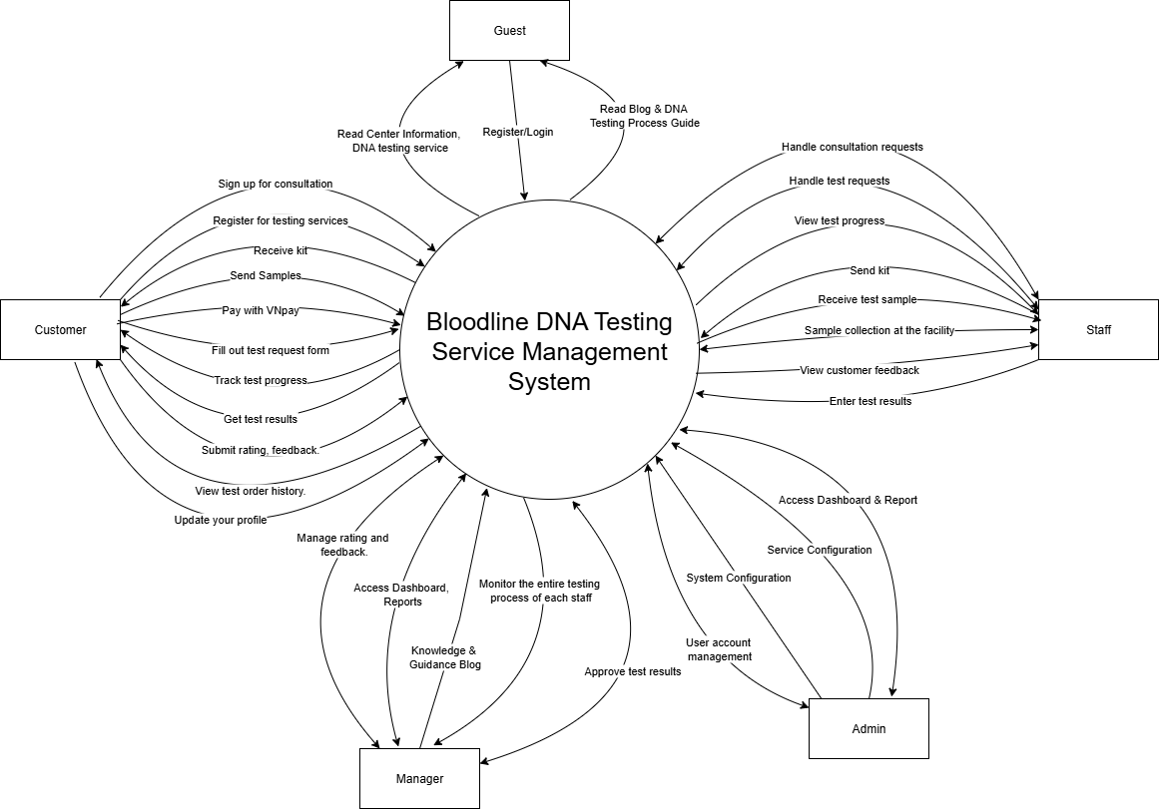

## Business Process:

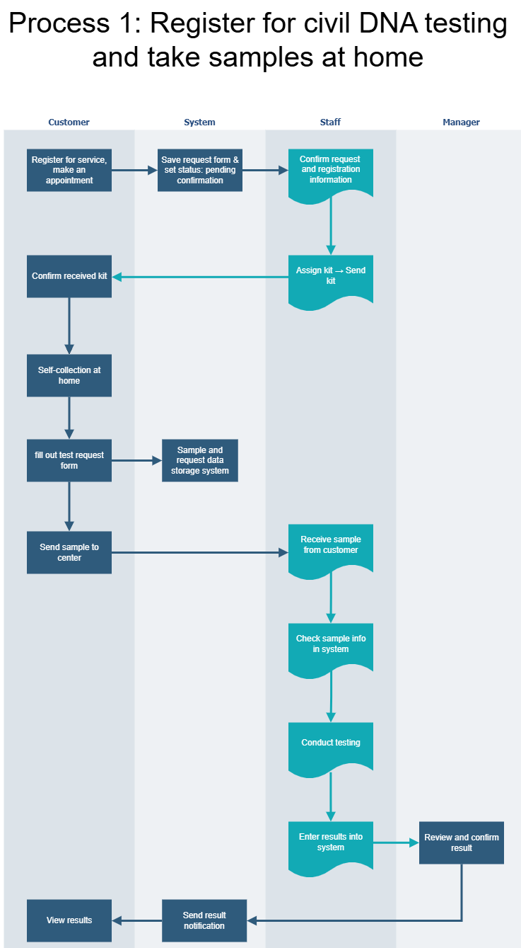

|  |  |  |
| --- | --- | --- |
| **#** | **Process Step** | **Description** |
| 1 | Register for service, make an appointment | Customer registers and schedules an appointment for DNA testing at home. |
| 2 | Save request form & set status: pending confirmation | The system saves the request and sets status as pending for staff confirmation. |
| 3 | Confirm request and registration information | Staff reviews and confirms the customer's request and registration details. |
| 4 | Assign kit → Send kit | Staff assigns a kit and ships it to the customer. |
| 5 | Confirm received kit | Customer confirms receipt of the kit. |
| 6 | Self-collection at home | Customer collects DNA sample using the kit at home. |
| 7 | Fill out test request form | Customer fills in the test request form attached to the sample. |
| 8 | Send sample to center | Customer sends collected sample to the facility. |
| 9 | Sample and request data storage system | System logs sample and form data for processing. |
| 10 | Receive sample from customer | Staff receives the sample. |
| 11 | Check sample info in system | Staff verifies the sample information. |
| 12 | Conduct testing | Staff conducts the DNA test on the received sample. |
| 13 | Enter results into system | Test results are entered into the system. |
| 14 | Review and confirm result | Manager reviews and approves test results. |
| 15 | Send result notification | System sends notification to customer. |
| 16 | View results | Customer views results through their account. |

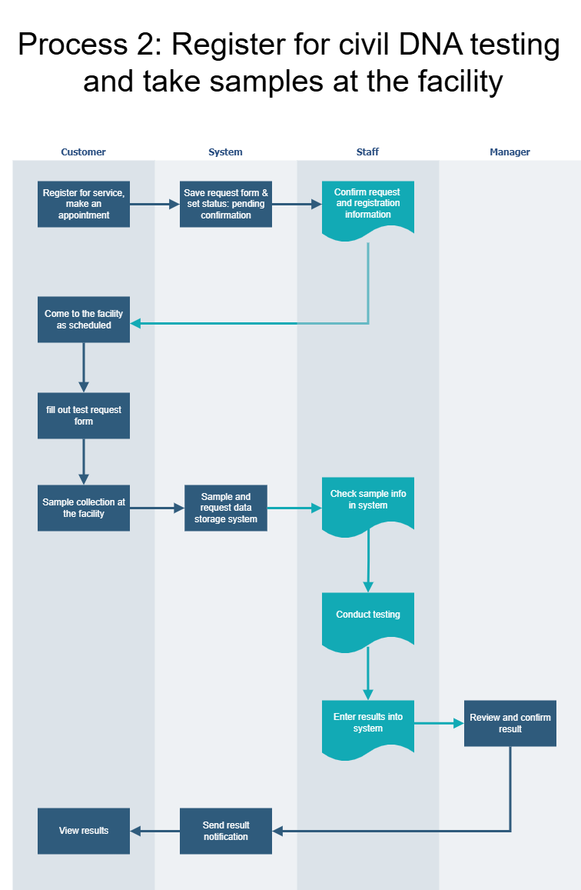

|  |  |  |
| --- | --- | --- |
| **#** | **Process Step** | **Description** |
| 1 | Register for service, make an appointment | Customer registers and schedules an appointment at the facility. |
| 2 | Save request form & set status: pending confirmation | System saves request and waits for staff to confirm. |
| 3 | Confirm request and registration information | Staff confirms customer's details and test information. |
| 4 | Come to the facility as scheduled | Customer arrives at facility as scheduled. |
| 5 | Fill out test request form | Customer completes form before providing sample. |
| 6 | Sample collection at the facility | Staff collects the DNA sample on-site. |
| 7 | Sample and request data storage system | System logs sample and form data. |
| 8 | Check sample info in system | Staff verifies sample and updates the system. |
| 9 | Conduct testing | Staff performs testing procedures. |
| 10 | Enter results into system | Test results entered for review. |
| 11 | Review and confirm result | Manager reviews and confirms results. |
| 12 | Send result notification | Customer receives result notification. |
| 13 | View results | Customer logs in and views test results. |

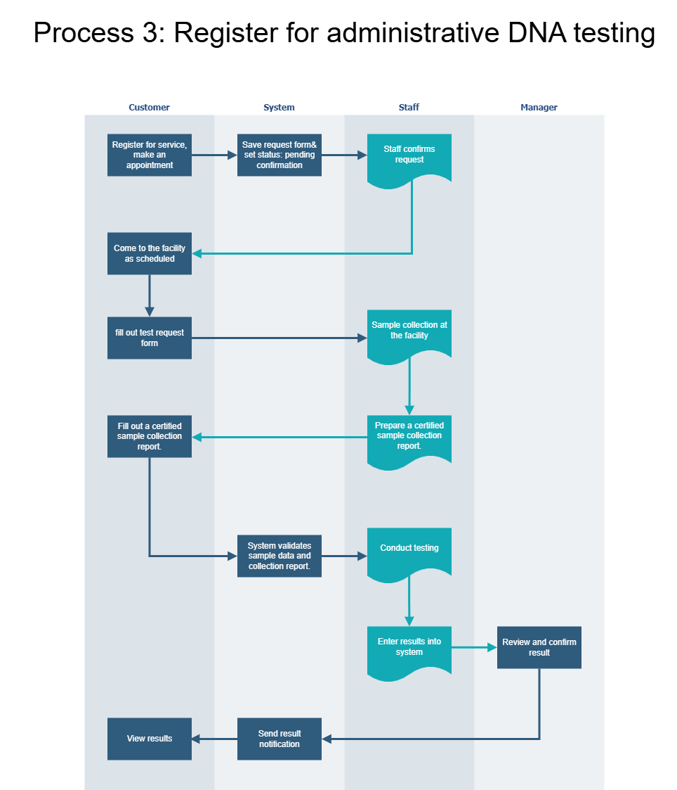

|  |  |  |
| --- | --- | --- |
| **#** | **Process Step** | **Description** |
| 1 | Register for service, make an appointment | Customer registers for a legal/administrative DNA test and books a time. |
| 2 | Save request form & set status: pending confirmation | System logs the registration, pending staff review. |
| 3 | Staff confirms request | Staff confirms and prepares for sample collection. |
| 4 | Come to the facility as scheduled | Customer appears at the testing facility. |
| 5 | Fill out test request form | Customer completes the legal test request form. |
| 6 | Sample collection at the facility | Staff collects sample in a formal/legal setting. |
| 7 | Prepare a certified sample collection report | Staff prepares certified documentation for legal compliance. |
| 8 | Fill out a certified sample collection report | Customer signs the official sample report for record. |
| 9 | System validates sample data and collection report | System ensures the sample and documents are complete and valid. |
| 10 | Conduct testing | Staff analyzes the DNA sample. |
| 11 | Enter results into system | Results are recorded into the platform. |
| 12 | Review and confirm result | Manager or legal validator confirms the result. |
| 13 | Send result notification | Notification is sent to the customer. |
| 14 | View results | Customer checks their legal DNA result. |

# III. User Requirements

## Actors

|  |  |  |
| --- | --- | --- |
| **#** | **Actor** | **Description** |
| 1 | Guest | Guest is a user who has not logged in to the system. Guest can access the home page to view an overview of the testing center, a list of available services (civil and administrative testing), and articles with instructions on sample collection and testing procedures, as well as sharing knowledge about DNA. Guest cannot register for testing or view results until they register for an account. |
| 2 | Customer | As a registered user, Customer can register for testing services, choose the type of sample collection (at home or at the facility), make an appointment, and track the sample processing progress in real time via the dashboard. After receiving the results, Customer can view the test results, download PDF files, rate satisfaction, and send feedback. Customer can also view transaction history and previous orders. |
| 3 | Staff | A technical staff member at a testing center. Staff are responsible for receiving and processing test applications, checking specimens (sent back or collected at the facility), updating sample information (sample type, condition, etc.), performing DNA analysis, and entering results into the system. Staff are also authorized to assign kits to civil applications at home, and monitor the sample collection process. Some staff may have access to customer feedback related to the cases they process. |
| 4 | Manager | As the testing center manager, the Manager has the right to monitor the entire process: from receiving documents, testing progress, inventory of kits to handling sample errors and customer feedback. Manager, confirms test results before sending to customers, views statistics (defective sample rate, average processing time, satisfaction level), and exports periodic reports. |
| 5 | Admin | As an IT system administrator. Admin is responsible for initial system configuration (service types, price list, result delivery time...), creating and assigning user rights (staff, manager), updating service interface and content. Admin can also monitor the entire system's activities, monitor feedback and perform technical interventions when necessary. |

## Use Cases

### 2.1 Diagram

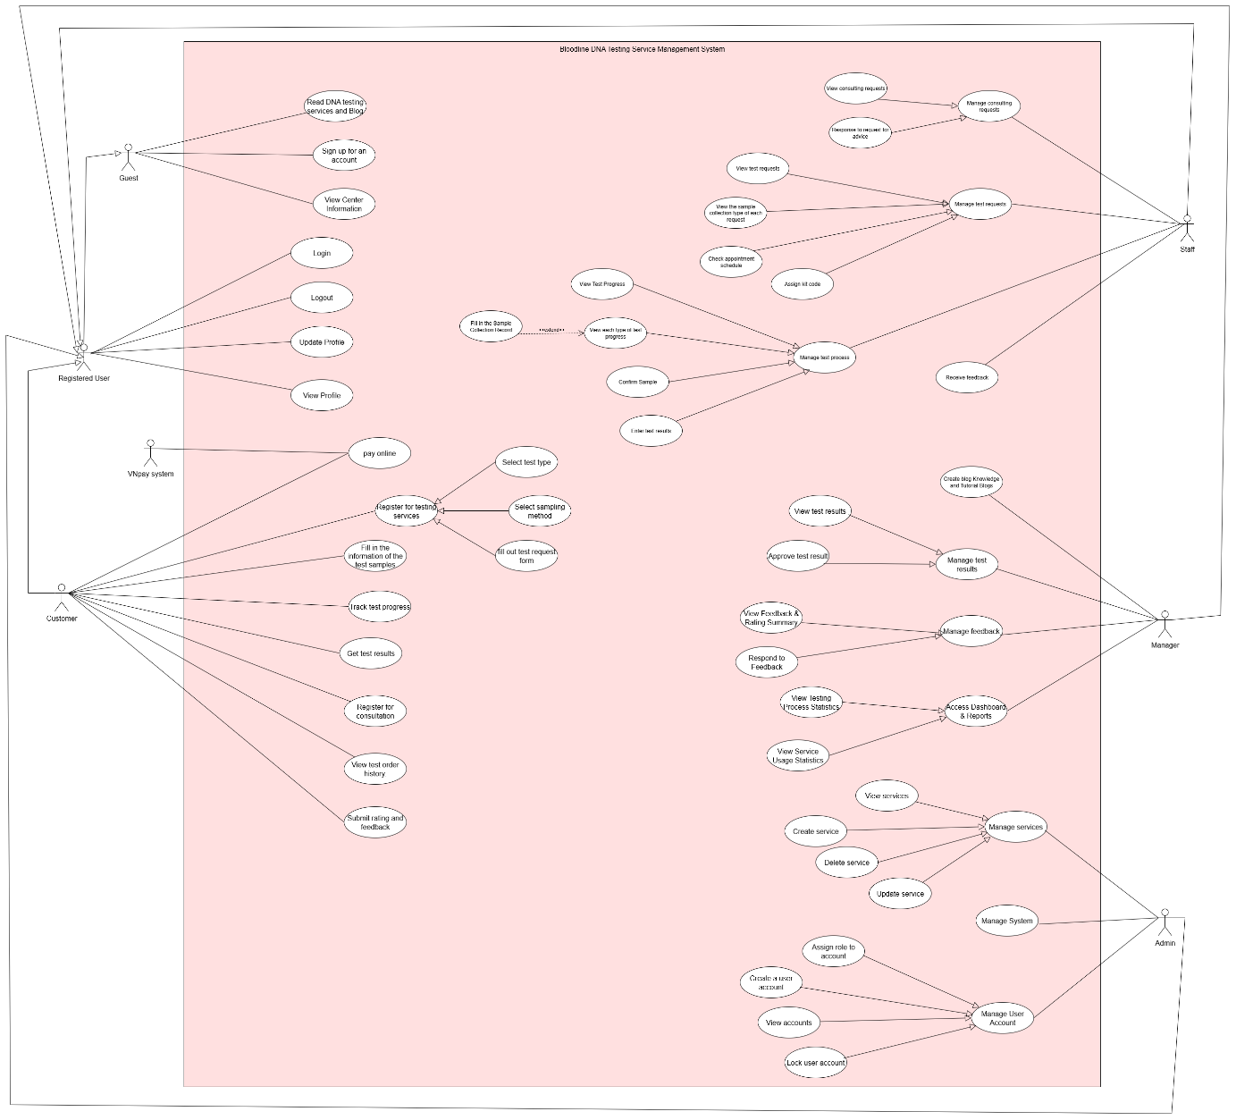

### 2.2 Descriptions

|  |  |  |  |  |  |  |  |
| --- | --- | --- | --- | --- | --- | --- | --- |
| **ID** | | **Use Case** | | **Actors** | **Use Case Description** | | |
| UC-01 | | Read DNA testing services and Blog | | Guest | Unregistered users can view the introduction, blog, and all DNA test services offered. | | |
| UC-02 | | Sign up for an account | | Guest | Register to become a user. | | |
| UC-03 | | View Center Information | | Guest | Check public information of the DNA center. | | |
| UC-04 | | Login | | Registered User | Users log in using valid credentials. | | |
| UC-05 | | Logout | | Registered User | Users log out to secure their session. | | |
| UC-06 | | Update Profile | | Registered User | Edit personal information in the user profile. | | |
| UC-07 | | View Profile | | Registered User | View personal profile information. | | |
| UC-08 | | Create User Account | | Admin | Create new user accounts for Manager and Staff. | | |
| UC-09 | | View Accounts | | Admin | View list and details of user accounts. | | |
| UC-10 | | Assign Roles to Accounts | | Admin | Assign roles (Admin, Staff, Customer) to users. | | |
| UC-11 | | Lock a User Account | | Admin | Allows an admin to lock a user account. A locked user cannot log in or access the system, but their data remains stored in the database. | | |
| UC-12 | | View services | | Admin | View all DNA test services offered. | | |
| UC-13 | | Create service | | Admin | Add new DNA test service to the system. | | |
| UC-14 | | Lock a service | | Admin | Allows an admin to lock a service by changing its status. Locked services are hidden from the user interface but are still stored in the database. | | |
| UC-15 | | Update service | | Admin | Edit service details. | | |
| UC-16 | | Manage System | | Admin | Allows Admin to set up system configuration (operating hours, default permissions), send notifications, managehomepage/dashboard content. | | |
| UC-17 | | Create blog Knowledge and Tutorial Blogs | | Staff | Post knowledge or guides related to DNA testing. | | |
| UC-18 | | View test requests | | Staff | View all incoming test requests. | | |
| UC-19 | | View the sample collection type of each request | | Staff | Check the requested sampling method. | | |
| UC-20 | | Check appointment schedule | | Staff | Review appointment schedule for sampling. | | |
| UC-21 | | Assign kit code | | Staff | Assign sample kit codes for home collection. | | |
| UC-22 | | Confirm Request | | Staff | Accept a test request into the processing workflow. | | |
| UC-23 | | View consulting requests | | Staff | View submitted consultation requests. | | |
| UC-24 | | Response to request for advice | | Staff | Provide guidance to users via request form. | | |
| UC-25 | | View Test Progress | | Staff | Monitor the test progress for each case. | | |
| UC-26 | | View each type of test progress | | Staff | View details of administrative or voluntary test types | | |
| UC-27 | | Fill in the Sample Collection Record | | Staff | Fill out the sample collection form for administrative testing | | |
| UC-28 | | Confirm Sample | | Staff | Confirm receipt of sample from customer. | | |
| UC-29 | | Enter test results | | Staff | Enter the final result into the system. | | |
| UC-30 | | Receive feedback | | Staff | Allows Staff to receive and view feedback and reviews from customers. | | |
| UC-31 | | Register for testing services | | Customer | Customer sends request for test registration | | |
| UC-32 | | Select test type | | Customer | Customers request the deletion of their personal account. | | |
| UC-33 | | Select sampling method | | Customer | Choose how the sample is collected (at home/on-site). | | |
| UC-34 | | Fill out test request form | | Customer | Fill in the detailed registration information on the test request form. | | |
| UC-35 | | Pay online | | Customer | Full payment for DNA testing is due upon registration. | | |
| UC-36 | | Fill in the information of the test samples | | Customer | Allows Customer to declare detailed information of the test sample (name of sample provider, relationship, sample type, test code if available, etc.). | | |
| UC-37 | | Track test progress | | Customer | View the current progress of your registered test request. | | |
| UC-38 | | Get test results | | Customer | Receive and view test results on the web after completion. | | |
| UC-39 | | Register for consultation | | Customer | Customer for consultation on services or issues related to DNA testing. | | |
| UC-40 | | View test order history. | | Customer | Allows Customers to view the history of all test requests made: date ordered, service type, result status.. | | |
| UC-41 | | Submit rating and feedback | | Customer | Allow Customers to send reviews and feedback about testing services: enter rating score, feedback content and send to the system. | | |
| UC-42 | | View test results | | Manager | Allows Manager to view list and details of test results that have been entered or are pending approval. | | |
| UC-43 | | Approve test result | | Manager | Confirm or reject the test results after checking the contents. | | |
| UC-44 | | View Feedback & Rating Summary | | Manager | Allows Manager to view user rating and feedback statistics. | | |
| UC-45 | | Respond to Feedback | | Manager | Allows Manager to respond to feedback or complaints from customers. | | |
| UC-46 | | Access Dashboard & Reports | | Manager | Allows Manager to access the overview interface to monitor system status: number of tests, users, reviews, service performance. | | |
| UC-47 | | View Testing Process Statistics | | Manager | Allows Manager to view testing progress statistics: number of samples processed, on-time rate, status chart, performance by staff. | | |
| UC-48 | | View Service Usage Statistics | | Manager | Allows Manager to view statistics on the usage of testing services: number of registrations, popular services, average usage time, by period. | | |
| ID and Name: | | **UC-01 Read DNA testing services and Blog** | | | | | |
| Created By: | | Phạm Bảo Phi | | | Date Created: | 19/6/25 | |
| Primary Actor: | | Guest | | | Secondary Actors: | None | |
| Description: | | An unregistered user (Guest) can view the introduction, blog, and all DNA test services offered by the testing center on the system's homepage, including service descriptions, pricing, processing times, and knowledge articles related to DNA testing. | | | | | |
| Trigger: | | A Guest accesses the system's homepage to explore available DNA testing services or read educational content. | | | | | |
| Preconditions: | | PRE-1: The system homepage is accessible and functional.  PRE-2: Blog content and service information are up-to-date and published. | | | | | |
| Postconditions: | | POST-1: System logs the read dna testing services and blog. POST-2: The Guest successfully views the list of DNA testing services and blog content. | | | | | |
| Normal Flow: | | **1.0 Read DNA testing services and Blog.**  1. Guest accesses the system's homepage.  2. System displays the list of DNA testing services and blog content.  3. Guest navigates through service descriptions, pricing, processing times, and knowledge articles.  4. System logs the Guest's activity.  5. Guest completes viewing or exits the page | | | | | |
| Alternative Flows: | | **1.1 View Filtered Content**  1. Guest applies filters (e.g., by service type or date) to view specific content.  2. System updates the display with filtered results.  3. Return to step 3 of Normal Flow.  **1.2 Exit Mid-Process**  1. Guest closes the browser or navigates away before completing viewing.  2. System discards unsaved session data and logs the partial activity. | | | | | |
| Exceptions: | | **1.0.E1 System Unavailable**  1. If the homepage is inaccessible, System displays an error message ("Service temporarily unavailable. Please try again later").  2. Guest is redirected to a maintenance page.  **1.0.E2 Content Not Loaded**  1. If blog or service data fails to load, System displays an error ("Content failed to load. Please refresh the page").  2. Guest can retry or contact support. | | | | | |
| Priority: | | Medium | | | | | |
| Frequency of Use: | | Approximately 500 users per day, with peak usage during business hours (8:00 A.M. to 5:00 P.M.). | | | | | |
| Business Rules: | | **BR-01** | | | | | |
| Other Information: | | 1. The Guest can navigate through the service list and blog without restrictions. 2. The system should display ratings and feedback from other users for transparency. | | | | | |
| Assumptions: | | Assume that 60% of Guests will proceed to sign up after viewing the services and blog content. | | | | | |

|  |  |  |  |
| --- | --- | --- | --- |
| ID and Name: | **UC-02 Sign up for an account** | | |
| Created By: | Phạm Bảo Phi | Date Created: | 19/6/25 |
| Primary Actor: | Guest | Secondary Actors: | System |
| Description: | Register to become a customer. | | |
| Trigger: | Click on Sign Up. | | |
| Preconditions: | PRE-1: Guest is authenticated and authorized. PRE-2: Relevant test or data context is available. | | |
| Postconditions: | POST-1: System logs the sign up for an account. POST-2: Related status or data updated. | | |
| Normal Flow: | **2.0 Sign up for an account**  1. Guest clicks "Sign Up" on the homepage.  2. System displays the registration form.  3. Guest enters full name, email, password, and phone number.  4. System validates the input.  5. System creates the account with the default role "Customer" and redirects to the login page. | | |
| Alternative Flows: | **1.1 Cancel Registration** 1. Guest cancels the process before submission. 2. System discards input and returns to the homepage. **1.2 Pre-filled Data** 1. Guest re-enters with pre-filled data from a previous attempt. 2. Return to step 3 of Normal Flow. | | |
| Exceptions: | **1.0.E1 Email Already Exists** 1. If email is already in use, System displays "Email already in use" error. 2. Guest can retry with a different email. **1.0.E2 Validation Failure** 1. If input fails validation (e.g., invalid email), System shows "Invalid data" error. 2. Guest corrects and resubmits. | | |
| Priority: | High | | |
| Frequency of Use: | Approximately 300 users per day, with peak usage between 9:00 AM and 6:00 PM (local time), reflecting ~60% conversion from UC-01 views. | | |
| Business Rules: | **BR-02** | | |
| Other Information: | Email must be unique per customer account. | | |
| Assumptions: | User provides valid and unique information. | | |

|  |  |  |  |
| --- | --- | --- | --- |
| ID and Name: | **UC-03 View Center Information** | | |
| Created By: | Phạm Bảo Phi | Date Created: | 19/6/25 |
| Primary Actor: | Guest | Secondary Actors: | None |
| Description: | Check public information of the DNA center. | | |
| Trigger: | Guest navigates to the "About Us" or "Contact" section on the homepage. | | |
| Preconditions: | PRE-1: Homepage is accessible. PRE-2: Center information is published. | | |
| Postconditions: | POST-1: System logs the view action. POST-2: Guest successfully views center information. | | |
| Normal Flow: | **3.0 View Center Information** 1. Guest clicks "About Us" link. 2. System displays center information (e.g., address, contact, services). 3. Guest reviews the content. 4. System logs the interaction. | | |
| Alternative Flows: | **1.1 View Specific Details** 1. Guest clicks on a specific subsection (e.g., contact). 2. System expands the details. 3. Return to step 3 of Normal Flow. **1.2 Language Switch** 1. Guest switches language if available. 2. Return to step 2 of Normal Flow. | | |
| Exceptions: | **1.0.E1 Information Unavailable** 1. If data is missing, System displays "Information not available" message. 2. Guest can retry later. **1.0.E2 System Error** 1. If system fails, System shows "Error loading data" message. 2. Guest is redirected to homepage. | | |
| Priority: | Medium | | |
| Frequency of Use: | Approximately 200 users per day. | | |
| Business Rules: | **BR-01** | | |
| Other Information: | Information is publicly accessible without login. | | |
| Assumptions: | Assume 30% of Guests will explore center info before signing up. | | |

|  |  |  |  |
| --- | --- | --- | --- |
| ID and Name: | **UC-04 Login** | | |
| Created By: | Phạm Bảo Phi | Date Created: | 19/6/25 |
| Primary Actor: | Registered User | Secondary Actors: | System |
| Description: | Users log in using valid credentials. | | |
| Trigger: | User clicks "Login" on homepage. | | |
| Preconditions: | PRE-1: User has a registered account. PRE-2: System is online. | | |
| Postconditions: | POST-1: User is authenticated. POST-2: User is redirected to role-specific dashboard. | | |
| Normal Flow: | **4.0 Login** 1. User clicks "Login". 2. System displays login form. 3. User enters email and password. 4. System validates credentials. 5. User is redirected to their dashboard (Customer/Staff/Manager/Admin). | | |
| Alternative Flows: | **4.1 Forgot Password (Future)** 1. User selects "Forgot Password". 2. System sends reset link to email. 3. Return to step 1 after reset. **4.2 Auto-Login** 1. User stays logged in via token. 2. Skip to step 5. | | |
| Exceptions: | **4.0.E1 Invalid Credentials** 1. If email/password is wrong, System shows "Incorrect email or password". 2. User can retry or reset password. **4.0.E2 System Down** 1. If system fails, System displays "Service unavailable". 2. User retries later. | | |
| Priority: | High | | |
| Frequency of Use: | Approximately 400 logins per day. | | |
| Business Rules: | **BR-02** | | |
| Other Information: | Supports role-based redirection. | | |
| Assumptions: | Assume 90% of users have valid credentials. | | |

|  |  |  |  |
| --- | --- | --- | --- |
| ID and Name: | **UC-05 Logout** | | |
| Created By: | Phạm Bảo Phi | Date Created: | 19/6/25 |
| Primary Actor: | Registered User | Secondary Actors: | System |
| Description: | Users log out to secure their session. | | |
| Trigger: | User selects "Logout" from dashboard. | | |
| Preconditions: | PRE-1: User is logged in. | | |
| Postconditions: | POST-1: User session is terminated. POST-2: User is redirected to login page. | | |
| Normal Flow: | **5.0 Logout** 1. User clicks "Logout" on dashboard. 2. System invalidates the session token. 3. User is redirected to login page. | | |
| Alternative Flows: | **5.1 Auto-Logout on Inactivity** 1. System logs out user after 15 minutes of inactivity. 2. Return to step 3 of Normal Flow. | | |
| Exceptions: | **5.0.E1 Session Invalid** 1. If session is already invalid, System redirects to login page with message "Session expired". 2. User logs in again. **5.0.E2 System Error** 1. If logout fails, System shows "Logout failed, try again". 2. User retries. | | |
| Priority: | Medium | | |
| Frequency of Use: | Approximately 300 logins per day. | | |
| Business Rules: | **BR-02** | | |
| Other Information: | Session timeout is 15 minutes. | | |
| Assumptions: | Assume 70% of users log out manually. | | |

|  |  |  |  |
| --- | --- | --- | --- |
| ID and Name: | **UC-06 Update Profile** | | |
| Created By: | Phạm Bảo Phi | Date Created: | 19/6/25 |
| Primary Actor: | Registered User | Secondary Actors: | System |
| Description: | Edit personal information in the user profile. | | |
| Trigger: | User selects "Personal Information" from dashboard. | | |
| Preconditions: | PRE-1: User is logged in. PRE-2: Profile exists. | | |
| Postconditions: | POST-1: Updated profile data is saved. POST-2: System displays "Update successful". | | |
| Normal Flow: | **6.0 Update Profile** 1. User clicks "Personal Information". 2. System displays current profile. 3. User edits fields (e.g., phone, address). 4. System validates changes. 5. User saves updates. 6. System saves data and shows success message. | | |
| Alternative Flows: | **6.1 Partial Update** 1. User updates only some fields. 2. Return to step 4 of Normal Flow. 6.2 Cancel Update 1. User cancels before saving. 2. System discards changes. | | |
| Exceptions: | **6.0.E1 Validation Error** 1. If input is invalid (e.g., phone not 10 digits), System shows "Invalid input". 2. User corrects and resubmits. **6.0.E2 Save Failure** 1. If save fails, System displays "Unable to save, try again". 2. User retries. | | |
| Priority: | Medium | | |
| Frequency of Use: | Approximately 100 logins per day. | | |
| Business Rules: | **BR-07** | | |
| Other Information: | Phone must be 10 digits. | | |
| Assumptions: | Assume 50% of users update profiles monthly. | | |

|  |  |  |  |
| --- | --- | --- | --- |
| ID and Name: | **UC-07 View Profile** | | |
| Created By: | Phạm Bảo Phi | Date Created: | 19/6/25 |
| Primary Actor: | Registered User | Secondary Actors: | System |
| Description: | View personal profile information. | | |
| Trigger: | User selects "Personal Information" from dashboard. | | |
| Preconditions: | PRE-1: User is logged in. PRE-2: Profile exists. | | |
| Postconditions: | POST-1: System displays profile details. POST-2: Interaction is logged. | | |
| Normal Flow: | **7.0 View Profile** 1. User clicks "Personal Information". 2. System displays profile details (e.g., name, phone, address). 3. User reviews the information. 4. System logs the view. | | |
| Alternative Flows: | **7.1 View in Read-Only Mode** 1. User views without editing intent. 2. Return to step 3 of Normal Flow. | | |
| Exceptions: | **7.0.E1 Profile Not Found** 1. If profile is unavailable, System shows "Profile not found". 2. User contacts admin. **7.0.E2 Load Failure** 1. If load fails, System displays "Error loading profile". 2. User refreshes or retries. | | |
| Priority: | Low | | |
| Frequency of Use: | Approximately 200 logins per day. | | |
| Business Rules: | **BR-08** | | |
| Other Information: | View-only access for all roles. | | |
| Assumptions: | Assume 80% of users view profiles weekly. | | |

|  |  |  |  |
| --- | --- | --- | --- |
| ID and Name: | **UC-08 Create User Account** | | |
| Created By: | Phạm Bảo Phi | Date Created: | 19/6/25 |
| Primary Actor: | Admin | Secondary Actors: | System |
| Description: | Create new user accounts for Manager and Staff. | | |
| Trigger: | Admin selects "User Management" and clicks "Create Account". | | |
| Preconditions: | PRE-1: Admin is logged in. PRE-2: Admin has create permissions. | | |
| Postconditions: | POST-1: New account is created. POST-2: System assigns default role and notifies admin. | | |
| Normal Flow: | **8.0 Create User Account** 1. Admin clicks "User Management" and "Create Account". 2. System displays form. 3. Admin enters details (name, email, role). 4. System validates input. 5. Admin submits form. 6. System creates account and logs action. | | |
| Alternative Flows: | **8.1 Assign Custom Role** 1. Admin selects a custom role. 2. Return to step 4 of Normal Flow. 8.2 Cancel Creation 1. Admin cancels before submission. 2. System discards input. | | |
| Exceptions: | **8.0.E1 Duplicate Email** 1. If email exists, System shows "Email in use". 2. Admin enters new email. **8.0.E2 Permission Denied** 1. If admin lacks rights, System shows "Access denied". 2. Admin escalates to super admin. | | |
| Priority: | High | | |
| Frequency of Use: | Approximately 10 creations per month. | | |
| Business Rules: | **BR-16** | | |
| Other Information: | Only Admin can create accounts. | | |
| Assumptions: | Assume 5 new accounts monthly. | | |

|  |  |  |  |
| --- | --- | --- | --- |
| ID and Name: | **UC-09 View Accounts** | | |
| Created By: | Phạm Bảo Phi | Date Created: | 19/6/25 |
| Primary Actor: | Admin | Secondary Actors: | System |
| Description: | View list and details of user accounts. | | |
| Trigger: | Admin selects "User Management" from dashboard. | | |
| Preconditions: | PRE-1: Admin is logged in. PRE-2: Admin has view permissions. | | |
| Postconditions: | POST-1: System displays account list. POST-2: Interaction is logged. | | |
| Normal Flow: | |  |  | | --- | --- | |  | **9.0 View Accounts** 1. Admin clicks "User Management". 2. System displays list of accounts with details (name, role, status). 3. Admin reviews the list. 4. System logs the action. | | | |
| Alternative Flows: | **9.1 Filter Accounts** 1. Admin applies filter (e.g., by role). 2. System updates list. 3. Return to step 3 of Normal Flow. | | |
| Exceptions: | **9.0.E1 List Unavailable** 1. If list fails to load, System shows "Error loading accounts". 2. Admin retries or contacts support. **9.0.E2 Access Denied** 1. If permissions lack, System shows "Access denied". 2. Admin escalates. | | |
| Priority: | Medium | | |
| Frequency of Use: | Approximately 20 views per week. | | |
| Business Rules: | **BR-16** | | |
| Other Information: | Filterable by role and status. | | |
| Assumptions: | Assume 10% of admins use this weekly. | | |

|  |  |  |  |
| --- | --- | --- | --- |
| ID and Name: | **UC-10 Assign Roles to Accounts** | | |
| Created By: | Phạm Bảo Phi | Date Created: | 19/6/25 |
| Primary Actor: | Admin | Secondary Actors: | System |
| Description: | Assign roles (Admin, Staff, Customer) to users. | | |
| Trigger: | Admin selects "User Management" and chooses "Assign Role" for a user | | |
| Preconditions: | PRE-1: Admin is logged in. PRE-2: Admin has role assignment rights. | | |
| Postconditions: | POST-1: Role is assigned. POST-2: System updates user permissions and logs action. | | |
| Normal Flow: | |  |  | | --- | --- | |  | **10.0 Assign Roles to Accounts** 1. Admin clicks "User Management" and selects a user. 2. System displays role options. 3. Admin selects a role. 4. System validates and assigns role. 5. System logs the change. | | | |
| Alternative Flows: | **10.1 Multiple Role Assignment** 1. Admin assigns multiple roles. 2. System prompts for confirmation. 3. Return to step 4 of Normal Flow. **10.2 Cancel Assignment** 1. Admin cancels. 2. System discards changes. | | |
| Exceptions: | **10.0.E1 Permission Denied** 1. If admin lacks rights, System shows "Access denied". 2. Admin escalates. **10.0.E2 Role Conflict** 1. If role invalid, System shows "Invalid role selection". 2. Admin corrects. | | |
| Priority: | High | | |
| Frequency of Use: | Approximately 15 assignments per month. | | |
| Business Rules: | **BR-16** | | |
| Other Information: | Roles are role-based access controlled. | | |
| Assumptions: | Assume 10 role changes monthly. | | |

|  |  |  |  |
| --- | --- | --- | --- |
| ID and Name: | **UC-11 Lock a User Account** | | |
| Created By: | Phạm Bảo Phi | Date Created: | 19/6/25 |
| Primary Actor: | Admin | Secondary Actors: | System |
| Description: | Block or lock a specific user account. | | |
| Trigger: | Admin selects "User Management" and chooses "Lock" for a user. | | |
| Preconditions: | PRE-1: Admin is logged in. PRE-2: Admin has lock permissions. | | |
| Postconditions: | POST-1: User account is locked. POST-2: System notifies admin and logs action. | | |
| Normal Flow: | |  |  | | --- | --- | |  | **11.0 Lock a User Account** 1. Admin clicks "User Management" and selects a user. 2. System prompts for lock confirmation. 3. Admin confirms lock. 4. System updates status to "Locked" and logs action. | | | |
| Alternative Flows: | **11.1 Temporary Lock** 1. Admin sets a temporary lock duration. 2. Return to step 4 of Normal Flow. **11.2 Unlock Account** 1. Admin reverses lock before confirmation. 2. System discards action. | | |
| Exceptions: | **11.0.E1 Permission Denied** 1. If admin lacks rights, System shows "Access denied". 2. Admin escalates. **11.0.E2 User Not Found** 1. If user is invalid, System shows "User not found". 2. Admin selects another user. | | |
| Priority: | Medium | | |
| Frequency of Use: | Approximately 5 locks per month. | | |
| Business Rules: | **BR-16** | | |
| Other Information: | Lock revokes all access. | | |
| Assumptions: | Assume 2-3 locks monthly. | | |

|  |  |  |  |
| --- | --- | --- | --- |
| ID and Name: | **UC-12 View services** | | |
| Created By: | Phạm Bảo Phi | Date Created: | 19/6/25 |
| Primary Actor: | Admin | Secondary Actors: | System |
| Description: | View all DNA test services offered. | | |
| Trigger: | Admin selects "Service Management" from dashboard. | | |
| Preconditions: | PRE-1: Admin is logged in. PRE-2: Admin has view permissions. | | |
| Postconditions: | POST-1: System displays service list. POST-2: Interaction is logged. | | |
| Normal Flow: | |  |  | | --- | --- | |  | **12.0 View services** 1. Admin clicks "Service Management". 2. System displays list of services with details (name, price, status). 3. Admin reviews the list. 4. System logs the action. | | | |
| Alternative Flows: | **12.1 Filter Services** 1. Admin applies filter (e.g., by status). 2. System updates list. 3. Return to step 3 of Normal Flow. | | |
| Exceptions: | **12.0.E1 List Unavailable** 1. If list fails to load, System shows "Error loading services". 2. Admin retries or contacts support. **12.0.E2 Access Denied** 1. If permissions lack, System shows "Access denied". 2. Admin escalates. | | |
| Priority: | Medium | | |
| Frequency of Use: | Approximately 10 views per week. | | |
| Business Rules: | **BR-16** | | |
| Other Information: | Filterable by status and type. | | |
| Assumptions: | Assume 5% of admins use this weekly. | | |

|  |  |  |  |
| --- | --- | --- | --- |
| ID and Name: | **UC-13 Create service** | | |
| Created By: | Phạm Bảo Phi | Date Created: | 19/6/25 |
| Primary Actor: | Admin | Secondary Actors: | System |
| Description: | Add new DNA test service to the system. | | |
| Trigger: | Admin selects "Service Management" and clicks "Create Service". | | |
| Preconditions: | PRE-1: Admin is logged in. PRE-2: Admin has create permissions. | | |
| Postconditions: | POST-1: New service is added. POST-2: System logs action and notifies admin. | | |
| Normal Flow: | |  |  | | --- | --- | |  | **13.0 Create service** 1. Admin clicks "Service Management" and "Create Service". 2. System displays form. 3. Admin enters service details (name, price, description). 4. System validates input. 5. Admin submits form. 6. System creates service and logs action. | | | |
| Alternative Flows: | **13.1 Save as Draft** 1. Admin saves as draft before submission. 2. Return to step 3 of Normal Flow. 13.2 Cancel Creation 1. Admin cancels. 2. System discards input. | | |
| Exceptions: | **13.0.E1 Duplicate Service** 1. If service name exists, System shows "Service already exists". 2. Admin modifies name. **13.0.E2 Validation Failure** 1. If input invalid, System shows "Invalid input". 2. Admin corrects. | | |
| Priority: | High | | |
| Frequency of Use: | Approximately 5 creations per month. | | |
| Business Rules: | **BR-16** | | |
| Other Information: | Services require unique names. | | |
| Assumptions: | Assume 3-4 new services monthly. | | |

|  |  |  |  |
| --- | --- | --- | --- |
| ID and Name: | **UC-14 Lock service** | | |
| Created By: | Phạm Bảo Phi | Date Created: | 19/6/25 |
| Primary Actor: | Admin | Secondary Actors: | System |
| Description: | Allows an admin to lock a service by changing its status. Locked services are hidden from the user interface but are still stored in the database. | | |
| Trigger: | Admin selects "Service Management" and chooses "Lock" for a service. | | |
| Preconditions: | PRE-1: Admin is logged in. PRE-2: Admin has lock permissions. | | |
| Postconditions: | POST-1: Service status is updated to "Locked". POST-2: System logs action and hides service from UI. | | |
| Normal Flow: | |  |  | | --- | --- | |  | **14.0 Lock service** 1. Admin clicks "Service Management" and selects a service. 2. System prompts for lock confirmation. 3. Admin confirms lock. 4. System updates status and logs action. | | | |
| Alternative Flows: | **14.1 Unlock Service** 1. Admin reverses lock before confirmation. 2. System discards action. 14.2 Batch Lock 1. Admin locks multiple services. 2. Return to step 4 of Normal Flow. | | |
| Exceptions: | **14.0.E1 Permission Denied** 1. If admin lacks rights, System shows "Access denied". 2. Admin escalates. 14.0.E2 Service Not Found 1. If service invalid, System shows "Service not found". 2. Admin selects another. | | |
| Priority: | Medium | | |
| Frequency of Use: | Approximately 5 locks per month. | | |
| Business Rules: | **BR-16** | | |
| Other Information: | Locked services remain in database. | | |
| Assumptions: | Assume 2-3 locks monthly. | | |

|  |  |  |  |
| --- | --- | --- | --- |
| ID and Name: | **UC-15 Update service** | | |
| Created By: | Phạm Bảo Phi | Date Created: | 19/6/25 |
| Primary Actor: | Admin | Secondary Actors: | System |
| Description: | Edit service details. | | |
| Trigger: | |  |  | | --- | --- | | Admin selects "Service Management" and chooses "Edit" for a service. |  | | | |
| Preconditions: | PRE-1: Admin is logged in. PRE-2: Admin has edit permissions. | | |
| Postconditions: | POST-1: Service details are updated. POST-2: System logs action and notifies admin. | | |
| Normal Flow: | |  |  | | --- | --- | |  | **15.0 Update service** 1. Admin clicks "Service Management" and selects a service. 2. System displays edit form with current details. 3. Admin modifies details. 4. System validates changes. 5. Admin submits updates. 6. System saves changes and logs action. | | | |
| Alternative Flows: | **15.1 Partial Update** 1. Admin updates only some fields. 2. Return to step 4 of Normal Flow. **15.2 Cancel Update** 1. Admin cancels. 2. System discards changes. | | |
| Exceptions: | **15.0.E1 Validation Error** 1. If input invalid, System shows "Invalid input". 2. Admin corrects. **15.0.E2 Permission Denied** 1. If rights lack, System shows "Access denied". 2. Admin escalates. | | |
| Priority: | Medium | | |
| Frequency of Use: | Approximately 10 updates per month. | | |
| Business Rules: | **BR-16** | | |
| Other Information: | Updates require validation. | | |
| Assumptions: | Assume 5-7 updates monthly. | | |

|  |  |  |  |
| --- | --- | --- | --- |
| ID and Name: | **UC-16 Manage System** | | |
| Created By: | Phạm Bảo Phi | Date Created: | 19/6/25 |
| Primary Actor: | Admin | Secondary Actors: | System |
| Description: | Allows Admin to set up system configuration (operating hours, default permissions), send notifications, manage homepage/dashboard content. | | |
| Trigger: | |  |  | | --- | --- | | Admin selects "System Management" from dashboard. |  | | | |
| Preconditions: | PRE-1: Admin is logged in. PRE-2: Admin has system management rights. | | |
| Postconditions: | POST-1: Configuration or content is updated. POST-2: System logs action and applies changes. | | |
| Normal Flow: | |  |  | | --- | --- | |  | **16.0 Manage System** 1. Admin clicks "System Management". 2. System displays configuration options. 3. Admin modifies settings or content. 4. System validates changes. 5. Admin saves changes. 6. System applies updates and logs action. | | | |
| Alternative Flows: | **16.1 Preview Changes** 1. Admin previews before saving. 2. Return to step 4 of Normal Flow. **16.2 Cancel Changes** 1. Admin cancels. 2. System discards changes. | | |
| Exceptions: | **16.0.E1 Validation Error** 1. If input invalid, System shows "Invalid configuration". 2. Admin corrects. **16.0.E2 Permission Denied** 1. If rights lack, System shows "Access denied". 2. Admin escalates. | | |
| Priority: | High | | |
| Frequency of Use: | Approximately 5 management actions per week. | | |
| Business Rules: | **BR-16** | | |
| Other Information: | Changes require admin approval. | | |
| Assumptions: | Assume 3-4 changes weekly. | | |

|  |  |  |  |
| --- | --- | --- | --- |
| ID and Name: | **UC-17 Create blog Knowledge and Tutorial Blogs** | | |
| Created By: | Phạm Bảo Phi | Date Created: | 19/6/25 |
| Primary Actor: | Staff | Secondary Actors: | System |
| Description: | Post knowledge or guides related to DNA testing. | | |
| Trigger: | |  |  | | --- | --- | | Staff selects "Blog Management" and clicks "Create Blog". |  | | | |
| Preconditions: | PRE-1: Staff is logged in. PRE-2: Staff has create permissions. | | |
| Postconditions: | POST-1: New blog is created. POST-2: System logs action and sets to draft. | | |
| Normal Flow: | |  |  | | --- | --- | |  | **17.0 Create blog Knowledge and Tutorial Blogs** 1. Staff clicks "Blog Management" and "Create Blog". 2. System displays form. 3. Staff enters title, content, and thumbnail. 4. System validates input. 5. Staff submits form. 6. System saves as draft and logs action. | | | |
| Alternative Flows: | **17.1 Publish Immediately** 1. Staff selects "Publish" option. 2. Return to step 5 of Normal Flow with publish status. **17.2 Cancel Creation** 1. Staff cancels. 2. System discards input. | | |
| Exceptions: | **17.0.E1 Validation Error** 1. If input invalid, System shows "Invalid input". 2. Staff corrects. **17.0.E2 Permission Denied** 1. If rights lack, System shows "Access denied". 2. Staff escalates. | | |
| Priority: | Medium | | |
| Frequency of Use: | Approximately 5 creations per month. | | |
| Business Rules: | **BR-16** | | |
| Other Information: | Blogs default to draft status. | | |
| Assumptions: | Assume 3-4 blogs monthly. | | |

|  |  |  |  |
| --- | --- | --- | --- |
| ID and Name: | **UC-18 View test requests** | | |
| Created By: | Phạm Bảo Phi | Date Created: | 19/6/25 |
| Primary Actor: | Staff | Secondary Actors: | System |
| Description: | View all incoming test requests. | | |
| Trigger: | Staff selects "Test Request Management" from dashboard. | | |
| Preconditions: | PRE-1: Staff is logged in. PRE-2: Staff has view permissions. | | |
| Postconditions: | POST-1: System displays request list. POST-2: Interaction is logged. | | |
| Normal Flow: | |  |  | | --- | --- | |  | **18.0 View test requests** 1. Staff clicks "Test Request Management". 2. System displays list of requests with details (ID, customer, status). 3. Staff reviews the list. 4. System logs the action. | | | |
| Alternative Flows: | **18.1 Filter Requests** 1. Staff applies filter (e.g., by status). 2. System updates list. 3. Return to step 3 of Normal Flow. | | |
| Exceptions: | **18.0.E1 List Unavailable** 1. If list fails to load, System shows "Error loading requests". 2. Staff retries or contacts support. **18.0.E2 Access Denied** 1. If permissions lack, System shows "Access denied". 2. Staff escalates. | | |
| Priority: | High | | |
| Frequency of Use: | Approximately 5 management actions per week. | | |
| Business Rules: | **BR-16** | | |
| Other Information: | Filterable by status and date. | | |
| Assumptions: | Assume 3-4 changes weekly. | | |

|  |  |  |  |
| --- | --- | --- | --- |
| ID and Name: | **UC-19 View the sample collection type of each request** | | |
| Created By: | Phạm Bảo Phi | Date Created: | 19/6/25 |
| Primary Actor: | Staff | Secondary Actors: | System |
| Description: | Check the requested sampling method. | | |
| Trigger: | |  |  | | --- | --- | | Staff selects a request and views details in "Test Request Management". |  | | | |
| Preconditions: | PRE-1: Staff is logged in. PRE-2: Request exists. | | |
| Postconditions: | POST-1: System displays sample collection type. POST-2: Interaction is logged. | | |
| Normal Flow: | |  |  | | --- | --- | |  | **19.0 View the sample collection type of each request** 1. Staff selects a request. 2. System displays request details including sample type. 3. Staff reviews the information. 4. System logs the action. | | | |
| Alternative Flows: | **19.1 View Multiple Requests** 1. Staff views types for multiple requests. 2. Return to step 2 of Normal Flow for each. | | |
| Exceptions: | **19.0.E1 Request Not Found** 1. If request invalid, System shows "Request not found". 2. Staff selects another. **19.0.E2 Load Failure** 1. If details fail, System shows "Error loading details". 2. Staff retries. | | |
| Priority: | Medium | | |
| Frequency of Use: | Approximately 30 views per day. | | |
| Business Rules: | **BR-16** | | |
| Other Information: | Supports home and facility collection types. | | |
| Assumptions: | Assume 20 requests daily have this check. | | |

|  |  |  |  |
| --- | --- | --- | --- |
| ID and Name: | **UC-20 Check appointment schedule** | | |
| Created By: | Phạm Bảo Phi | Date Created: | 19/6/25 |
| Primary Actor: | Staff | Secondary Actors: | System |
| Description: | Review appointment schedule for sampling. | | |
| Trigger: | |  |  | | --- | --- | | Staff selects "Appointment Schedule" from dashboard. |  | | | |
| Preconditions: | PRE-1: Staff is logged in. PRE-2: Schedule is available. | | |
| Postconditions: | POST-1: System displays schedule. POST-2: Interaction is logged. | | |
| Normal Flow: | |  |  | | --- | --- | |  | **20.0 Check appointment schedule** 1. Staff clicks "Appointment Schedule". 2. System displays schedule with dates and times. 3. Staff reviews the schedule. 4. System logs the action. | | | |
| Alternative Flows: | **20.1 Filter Schedule** 1. Staff filters by date or location. 2. System updates display. 3. Return to step 3 of Normal Flow. | | |
| Exceptions: | **20.0.E1 Schedule Unavailable** 1. If schedule fails to load, System shows "Error loading schedule". 2. Staff retries or contacts support. **20.0.E2 Access Denied** 1. If permissions lack, System shows "Access denied". 2. Staff escalates. | | |
| Priority: | Medium | | |
| Frequency of Use: | Approximately 20 checks per day. | | |
| Business Rules: | **BR-17** | | |
| Other Information: | Schedule limited to business hours. | | |
| Assumptions: | Assume 15 appointments daily. | | |

|  |  |  |  |
| --- | --- | --- | --- |
| ID and Name: | **UC-21 Assign kit code** | | |
| Created By: | Phạm Bảo Phi | Date Created: | 19/6/25 |
| Primary Actor: | Staff | Secondary Actors: | System |
| Description: | Assign sample kit codes for home collection. | | |
| Trigger: | |  |  | | --- | --- | | Staff selects a request and chooses "Assign Kit" in "Test Request Management". |  | | | |
| Preconditions: | PRE-1: Staff is logged in. PRE-2: Request is confirmed. | | |
| Postconditions: | POST-1: Kit code is assigned. POST-2: System logs action and notifies customer. | | |
| Normal Flow: | |  |  | | --- | --- | |  | **21.0 Assign kit code** 1. Staff selects a request. 2. System generates a unique kit code. 3. Staff confirms assignment. 4. System assigns code, logs action, and sends notification. | | | |
| Alternative Flows: | **21.1 Manual Code Entry** 1. Staff enters custom code. 2. Return to step 3 of Normal Flow. **21.2 Cancel Assignment** 1. Staff cancels. 2. System discards action. | | |
| Exceptions: | **21.0.E1 Code Conflict** 1. If code exists, System shows "Code in use". 2. Staff retries. **21.0.E2 Permission Denied** 1. If rights lack, System shows "Access denied". 2. Staff escalates. | | |
| Priority: | High | | |
| Frequency of Use: | Approximately 20 assignments per day. | | |
| Business Rules: | **BR-12** | | |
| Other Information: | Codes are unique per request. | | |
| Assumptions: | Assume 15 kits assigned daily. | | |

|  |  |  |  |
| --- | --- | --- | --- |
| ID and Name: | **UC-22 Confirm Request** | | |
| Created By: | Phạm Bảo Phi | Date Created: | 19/6/25 |
| Primary Actor: | Staff | Secondary Actors: | System |
| Description: | Accept a test request into the processing workflow. | | |
| Trigger: | |  |  | | --- | --- | | Staff selects a request and chooses "Confirm" in "Test Request Management". |  | | | |
| Preconditions: | PRE-1: Staff is logged in. PRE-2: Request is pending. | | |
| Postconditions: | POST-1: Request status is updated to "Confirmed". POST-2: System logs action and notifies customer. | | |
| Normal Flow: | |  |  | | --- | --- | |  | **22.0 Confirm Request** 1. Staff selects a pending request. 2. System prompts for confirmation. 3. Staff confirms. 4. System updates status, logs action, and sends notification. | | | |
| Alternative Flows: | **22.1 Batch Confirmation** 1. Staff confirms multiple requests. 2. Return to step 4 of Normal Flow. **22.2 Reject Instead** 1. Staff rejects request. 2. System logs rejection. | | |
| Exceptions: | **22.0.E1 Permission Denied** 1. If rights lack, System shows "Access denied". 2. Staff escalates. **22.0.E2 Request Invalid** 1. If request invalid, System shows "Request not found". 2. Staff selects another. | | |
| Priority: | High | | |
| Frequency of Use: | Approximately 30 confirmations per day. | | |
| Business Rules: | **BR-16** | | |
| Other Information: | Confirmation triggers workflow. | | |
| Assumptions: | Assume 25 requests confirmed daily. | | |

|  |  |  |  |
| --- | --- | --- | --- |
| ID and Name: | **UC-23 View consulting requests** | | |
| Created By: | Phạm Bảo Phi | Date Created: | 19/6/25 |
| Primary Actor: | Staff | Secondary Actors: | System |
| Description: | View submitted consultation requests. | | |
| Trigger: | |  |  | | --- | --- | | Staff selects "Consultation Management" from dashboard. |  | | | |
| Preconditions: | PRE-1: Staff is logged in. PRE-2: Staff has view permissions. | | |
| Postconditions: | POST-1: System displays request list. POST-2: Interaction is logged. | | |
| Normal Flow: | |  |  | | --- | --- | |  | **23.0 View consulting requests** 1. Staff clicks "Consultation Management". 2. System displays list of requests with details (ID, customer, status). 3. Staff reviews the list. 4. System logs the action. | | | |
| Alternative Flows: | **23.1 Filter Requests** 1. Staff applies filter (e.g., by status). 2. System updates list. 3. Return to step 3 of Normal Flow. | | |
| Exceptions: | **23.0.E1 List Unavailable** 1. If list fails to load, System shows "Error loading requests". 2. Staff retries or contacts support. **23.0.E2 Access Denied** 1. If permissions lack, System shows "Access denied". 2. Staff escalates. | | |
| Priority: | Medium | | |
| Frequency of Use: | Approximately 10 views per day. | | |
| Business Rules: | **BR-16** | | |
| Other Information: | Filterable by status and date. | | |
| Assumptions: | Assume 5-7 requests daily. | | |

|  |  |  |  |
| --- | --- | --- | --- |
| ID and Name: | **UC-24 Response to request for advice** | | |
| Created By: | Phạm Bảo Phi | Date Created: | 19/6/25 |
| Primary Actor: | Staff | Secondary Actors: | System |
| Description: | Provide guidance to users via request form. | | |
| Trigger: | Staff selects a request and chooses "Respond" in "Consultation Management". | | |
| Preconditions: | PRE-1: Staff is logged in. PRE-2: Request is pending or accepted. | | |
| Postconditions: | POST-1: Response is saved. POST-2: System logs action and notifies customer. | | |
| Normal Flow: | **24.0 Response to request for advice** 1. Staff selects a request. 2. System displays request details. 3. Staff enters response. 4. System validates input. 5. Staff submits response. 6. System saves response, logs action, and notifies customer. | | |
| Alternative Flows: | **24.1 Save as Draft** 1. Staff saves response as draft. 2. Return to step 3 of Normal Flow. **24.2 Cancel Response** 1. Staff cancels. 2. System discards input. | | |
| Exceptions: | **24.0.E1 Validation Error** 1. If input invalid, System shows "Invalid response". 2. Staff corrects. **24.0.E2 Permission Denied** 1. If rights lack, System shows "Access denied". 2. Staff escalates. | | |
| Priority: | Medium | | |
| Frequency of Use: | Approximately 5 responses per day. | | |
| Business Rules: | **BR-16** | | |
| Other Information: | Responses require validation. | | |
| Assumptions: | Assume 3-4 responses daily. | | |

|  |  |  |  |
| --- | --- | --- | --- |
| ID and Name: | **UC-25 View Test Progress** | | |
| Created By: | Phạm Bảo Phi | Date Created: | 19/6/25 |
| Primary Actor: | Staff | Secondary Actors: | System |
| Description: | Monitor the test progress for each case. | | |
| Trigger: | |  |  | | --- | --- | | Staff selects "Test Progress" from dashboard. |  | | | |
| Preconditions: | PRE-1: Staff is logged in. PRE-2: Staff has view permissions. | | |
| Postconditions: | POST-1: System displays progress list. POST-2: Interaction is logged. | | |
| Normal Flow: | |  |  | | --- | --- | |  | **25.0 View Test Progress** 1. Staff clicks "Test Progress". 2. System displays progress for each case (e.g., status, dates). 3. Staff reviews the progress. 4. System logs the action. | | | |
| Alternative Flows: | **25.1 Filter Progress** 1. Staff filters by status or date. 2. System updates display. 3. Return to step 3 of Normal Flow. | | |
| Exceptions: | **25.0.E1 Progress Unavailable** 1. If progress fails to load, System shows "Error loading progress". 2. Staff retries or contacts support. **25.0.E2 Access Denied** 1. If permissions lack, System shows "Access denied". 2. Staff escalates. | | |
| Priority: | High | | |
| Frequency of Use: | Approximately 40 views per day. | | |
| Business Rules: | **BR-16** | | |
| Other Information: | Filterable by status and date. | | |
| Assumptions: | Assume 30 cases daily. | | |

|  |  |  |  |
| --- | --- | --- | --- |
| ID and Name: | **UC-26 View each type of test progress** | | |
| Created By: | Phạm Bảo Phi | Date Created: | 19/6/25 |
| Primary Actor: | Staff | Secondary Actors: | System |
| Description: | View details of administrative or voluntary test types. | | |
| Trigger: | |  |  | | --- | --- | | Staff selects a test type in "Test Progress". |  | | | |
| Preconditions: | PRE-1: Staff is logged in. PRE-2: Test progress data exists. | | |
| Postconditions: | POST-1: System displays type-specific progress. POST-2: Interaction is logged. | | |
| Normal Flow: | |  |  | | --- | --- | |  | **26.0 View each type of test progress** 1. Staff selects a test type. 2. System displays progress details for that type. 3. Staff reviews the information. 4. System logs the action. | | | |
| Alternative Flows: | **26.1 Compare Types** 1. Staff views progress for multiple types. 2. Return to step 2 of Normal Flow for each. | | |
| Exceptions: | **26.0.E1 Data Unavailable** 1. If data fails to load, System shows "Error loading data". 2. Staff retries or contacts support. **26.0.E2 Access Denied** 1. If permissions lack, System shows "Access denied". 2. Staff escalates. | | |
| Priority: | Medium | | |
| Frequency of Use: | Approximately 20 views per day. | | |
| Business Rules: | **BR-16** | | |
| Other Information: | Supports administrative and voluntary types | | |
| Assumptions: | Assume 15 type checks daily. | | |

|  |  |  |  |
| --- | --- | --- | --- |
| ID and Name: | **UC-27 Fill in the Sample Collection Record** | | |
| Created By: | Phạm Bảo Phi | Date Created: | 19/6/25 |
| Primary Actor: | Staff | Secondary Actors: | System |
| Description: | Fill out the sample collection form for administrative testing. | | |
| Trigger: | |  |  |  |  | | --- | --- | --- | --- | | Staff selects a request and chooses "Fill Sample Record" in  "Test Request Management". | | |  | |  |  | | | |
| Preconditions: | PRE-1: Staff is logged in. PRE-2: Request is confirmed. | | |
| Postconditions: | POST-1: Sample record is saved. POST-2: System logs action. | | |
| Normal Flow: | |  |  | | --- | --- | |  | **27.0 Fill in the Sample Collection Record** 1. Staff selects a request. 2. System displays sample record form. 3. Staff enters details (e.g., date, location). 4. System validates input. 5. Staff submits form. 6. System saves record and logs action. | | | |
| Alternative Flows: | **27.1 Save as Draft** 1. Staff saves as draft. 2. Return to step 3 of Normal Flow. **27.2 Cancel Entry** 1. Staff cancels. 2. System discards input. | | |
| Exceptions: | **27.0.E1 Validation Error** 1. If input invalid, System shows "Invalid input". 2. Staff corrects. **27.0.E2 Permission Denied** 1. If rights lack, System shows "Access denied". 2. Staff escalates. | | |
| Priority: | High | | |
| Frequency of Use: | Approximately 15 entries per day. | | |
| Business Rules: | **BR-06** | | |
| Other Information: | Required for legal tests. | | |
| Assumptions: | Assume 10 entries daily. | | |

|  |  |  |  |
| --- | --- | --- | --- |
| ID and Name: | **UC-28 Confirm Sample** | | |
| Created By: | Phạm Bảo Phi | Date Created: | 19/6/25 |
| Primary Actor: | Staff | Secondary Actors: | System |
| Description: | Confirm receipt of sample from customer. | | |
| Trigger: | |  |  | | --- | --- | | Staff selects a request and chooses "Confirm Sample" in "Test Request Management". |  | | | |
| Preconditions: | PRE-1: Staff is logged in. PRE-2: Sample is received. | | |
| Postconditions: | POST-1: Sample status is updated to "Confirmed". POST-2: System logs action and notifies customer. | | |
| Normal Flow: | |  |  | | --- | --- | |  | **28.0 Confirm Sample** 1. Staff selects a request. 2. System prompts for sample confirmation. 3. Staff confirms receipt. 4. System updates status, logs action, and sends notification. | | | |
| Alternative Flows: | **28.1 Reject Sample** 1. Staff rejects due to defects. 2. System logs rejection and notifies customer. **28.2 Batch Confirmation** 1. Staff confirms multiple samples. 2. Return to step 4 of Normal Flow. | | |
| Exceptions: | **28.0.E1 Permission Denied** 1. If rights lack, System shows "Access denied". 2. Staff escalates. **28.0.E2 Sample Invalid** 1. If sample invalid, System shows "Sample not found". 2. Staff rechecks. | | |
| Priority: | High | | |
| Frequency of Use: | Approximately 25 confirmations per day. | | |
| Business Rules: | **BR-14** | | |
| Other Information: | Confirmation triggers testing. | | |
| Assumptions: | Assume 20 samples confirmed daily. | | |

|  |  |  |  |
| --- | --- | --- | --- |
| ID and Name: | **UC-29 Enter test results** | | |
| Created By: | Phạm Bảo Phi | Date Created: | 19/6/25 |
| Primary Actor: | Staff | Secondary Actors: | System |
| Description: | Enter the final result into the system. | | |
| Trigger: | |  |  | | --- | --- | | Staff selects a request and chooses "Enter Result" in "Test Request Management". |  | | | |
| Preconditions: | PRE-1: Staff is logged in. PRE-2: Testing is complete. | | |
| Postconditions: | POST-1: Result is saved. POST-2: System logs action and sets status to "Pending Approval". | | |
| Normal Flow: | |  |  | | --- | --- | |  | **29.0 Enter test results** 1. Staff selects a request. 2. System displays result entry form. 3. Staff enters result details. 4. System validates input. 5. Staff submits form. 6. System saves result, logs action, and updates status. | | | |
| Alternative Flows: | **29.1 Save as Draft** 1. Staff saves as draft. 2. Return to step 3 of Normal Flow. **29.2 Cancel Entry** 1. Staff cancels. 2. System discards input. | | |
| Exceptions: | **29.0.E1 Validation Error** 1. If input invalid, System shows "Invalid result". 2. Staff corrects. **29.0.E2 Permission Denied** 1. If rights lack, System shows "Access denied". 2. Staff escalates. | | |
| Priority: | High | | |
| Frequency of Use: | Approximately 20 entries per day. | | |
| Business Rules: | **BR-15** | | |
| Other Information: | Results pending manager approval. | | |
| Assumptions: | Assume 15 results entered daily | | |

|  |  |  |  |
| --- | --- | --- | --- |
| ID and Name: | **UC-30 Receive feedback** | | |
| Created By: | Phạm Bảo Phi | Date Created: | 19/6/25 |
| Primary Actor: | Staff | Secondary Actors: | System |
| Description: | Allows Staff to receive and view feedback and reviews from customers. | | |
| Trigger: | |  |  | | --- | --- | | Staff selects "Feedback Management" from dashboard. |  | | | |
| Preconditions: | PRE-1: Staff is logged in. PRE-2: Feedback exists. | | |
| Postconditions: | POST-1: System displays feedback list. POST-2: Interaction is logged. | | |
| Normal Flow: | |  |  | | --- | --- | |  | **30.0 Receive feedback** 1. Staff clicks "Feedback Management". 2. System displays list of feedback with details (rating, comment). 3. Staff reviews the feedback. 4. System logs the action. | | | |
| Alternative Flows: | **30.1 Filter Feedback** 1. Staff filters by date or rating. 2. System updates list. 3. Return to step 3 of Normal Flow. | | |
| Exceptions: | **30.0.E1 Feedback Unavailable** 1. If feedback fails to load, System shows "Error loading feedback". 2. Staff retries or contacts support. **30.0.E2 Access Denied** 1. If permissions lack, System shows "Access denied". 2. Staff escalates. | | |
| Priority: | Medium | | |
| Frequency of Use: | Approximately 10 views per day. | | |
| Business Rules: | **BR-10** | | |
| Other Information: | Staff cannot respond to feedback. | | |
| Assumptions: | Assume 5-7 feedback items daily. | | |

|  |  |  |  |
| --- | --- | --- | --- |
| ID and Name: | **UC-31 Register for testing services** | | |
| Created By: | Phạm Bảo Phi | Date Created: | 19/6/25 |
| Primary Actor: | Customer | Secondary Actors: | System |
| Description: | Customer sends request for test registration. | | |
| Trigger: | |  |  | | --- | --- | | Customer selects "Register Test" from dashboard. |  | | | |
| Preconditions: | PRE-1: Customer is logged in. PRE-2: Account is active. | | |
| Postconditions: | POST-1: Request is saved. POST-2: System sets status to "Pending" and notifies customer. | | |
| Normal Flow: | |  |  | | --- | --- | |  | **31.0 Register for testing services** 1. Customer clicks "Register Test". 2. System displays registration form. 3. Customer enters details (test type, sample info). 4. System validates input. 5. Customer submits form. 6. System saves request, logs action, and sends notification. | | | |
| Alternative Flows: | **31.1 Save as Draft** 1. Customer saves as draft. 2. Return to step 3 of Normal Flow. **31.2 Cancel Registration** 1. Customer cancels. 2. System discards input. | | |
| Exceptions: | **31.0.E1 Validation Error** 1. If input invalid, System shows "Invalid input". 2. Customer corrects. **31.0.E2 Payment Issue** 1. If payment fails, System shows "Payment required". 2. Customer retries payment. | | |
| Priority: | High | | |
| Frequency of Use: | Approximately 30 registrations per day. | | |
| Business Rules: | **BR-01, BR-03** | | |
| Other Information: | Payment required upfront. | | |
| Assumptions: | Assume 25 registrations daily. | | |

|  |  |  |  |
| --- | --- | --- | --- |
| ID and Name: | **UC-32 Select test type** | | |
| Created By: | Phạm Bảo Phi | Date Created: | 19/6/25 |
| Primary Actor: | Customer | Secondary Actors: | System |
| Description: | Customers request the deletion of their personal account. | | |
| Trigger: | |  |  | | --- | --- | | Customer selects "Delete Account" from profile settings. |  | | | |
| Preconditions: | PRE-1: Customer is logged in. PRE-2: Account is active. | | |
| Postconditions: | POST-1: Account deletion request is logged. POST-2: System notifies customer of pending approval. | | |
| Normal Flow: | |  |  | | --- | --- | |  | **32.0 Select test type** 1. Customer clicks "Register Test". 2. System displays available test types. 3. Customer selects a test type. 4. System records selection. 5. Customer proceeds to next step. | | | |
| Alternative Flows: | **32.1 Change Selection** 1. Customer changes test type before proceeding. 2. Return to step 3 of Normal Flow. **32.2 Cancel Selection** 1. Customer cancels. 2. System discards selection. | | |
| Exceptions: | **32.0.E1 No Test Types Available** 1. If no types available, System shows "No services available". 2. Customer contacts support. **32.0.E2 Access Denied** 1. If permissions lack, System shows "Access denied". 2. Customer escalates. | | |
| Priority: | Medium | | |
| Frequency of Use: | Approximately 30 selections per day. | | |
| Business Rules: | **BR-11** | | |
| Other Information: | One test type per order. | | |
| Assumptions: | Assume 25 selections daily. | | |

|  |  |  |  |
| --- | --- | --- | --- |
| ID and Name: | **UC-33 Select sampling method** | | |
| Created By: | Phạm Bảo Phi | Date Created: | 19/6/25 |
| Primary Actor: | Customer | Secondary Actors: | System |
| Description: | Choose how the sample is collected (at home/on-site). | | |
| Trigger: | |  |  | | --- | --- | | Customer selects "Sampling Method" during registration. |  | | | |
| Preconditions: | PRE-1: Customer is logged in. PRE-2: Registration is in progress. | | |
| Postconditions: | POST-1: Sampling method is recorded. POST-2: System proceeds to next step. | | |
| Normal Flow: | |  |  | | --- | --- | |  | **33.0 Select sampling method** 1. Customer reaches sampling method step. 2. System displays options (home/on-site). 3. Customer selects a method. 4. System records selection. 5. Customer proceeds. | | | |
| Alternative Flows: | **33.1 Change Selection** 1. Customer changes test type before proceeding. 2. Return to step 3 of Normal Flow. **33.2 Cancel Selection** 1. Customer cancels. 2. System discards selection. | | |
| Exceptions: | **33.0.E1 No Options Available** 1. If no methods available, System shows "No sampling options available". 2. Customer contacts support. **33.0.E2 Access Denied** 1. If permissions lack, System shows "Access denied". 2. Customer escalates. | | |
| Priority: | Medium | | |
| Frequency of Use: | Approximately 30 selections per day. | | |
| Business Rules: | **BR-11** | | |
| Other Information: | One sampling method per order. | | |
| Assumptions: | Assume 25 selections daily. | | |

|  |  |  |  |
| --- | --- | --- | --- |
| ID and Name: | **UC-34 Fill out test request form** | | |
| Created By: | Phạm Bảo Phi | Date Created: | 19/6/25 |
| Primary Actor: | Customer | Secondary Actors: | System |
| Description: | Customer provides necessary information to complete a test request. | | |
| Trigger: | |  |  | | --- | --- | | Customer selects "Submit Request" during registration process. |  | | | |
| Preconditions: | PRE-1: Customer is logged in. PRE-2: Test type and sampling method are selected. | | |
| Postconditions: | POST-1: Request form is saved. POST-2: System sets status to "Pending" and notifies customer. | | |
| Normal Flow: | |  |  | | --- | --- | |  | **34.0 Fill out test request form** 1. Customer reaches request form step. 2. System displays form fields (e.g., personal info, test details). 3. Customer enters required information. 4. System validates input. 5. Customer submits form. 6. System saves request and logs action. | | | |
| Alternative Flows: | **34.1 Save as Draft** 1. Customer saves as draft. 2. Return to step 3 of Normal Flow. **34.2 Cancel Form** 1. Customer cancels. 2. System discards input. | | |
| Exceptions: | **34.0.E1 Validation Error** 1. If input invalid, System shows "Invalid input". 2. Customer corrects. **34.0.E2 System Error** 1. If save fails, System displays "Error submitting request". 2. Customer retries. | | |
| Priority: | High | | |
| Frequency of Use: | Approximately 30 submissions per day. | | |
| Business Rules: | **BR-01, BR-03** | | |
| Other Information: | All fields are mandatory. | | |
| Assumptions: | Assume 25 submissions daily. | | |

|  |  |  |  |
| --- | --- | --- | --- |
| ID and Name: | **UC-35 Make payment** | | |
| Created By: | Phạm Bảo Phi | Date Created: | 19/6/25 |
| Primary Actor: | Customer | Secondary Actors: | System |
| Description: | Customer completes payment for the selected test service. | | |
| Trigger: | |  |  | | --- | --- | | Customer selects "Make Payment" after submitting request. |  | | | |
| Preconditions: | PRE-1: Customer is logged in. PRE-2: Request is pending payment. | | |
| Postconditions: | POST-1: Payment is processed. POST-2: System updates request status to "Paid" and notifies customer. | | |
| Normal Flow: | **35.0 Make payment** 1. Customer clicks "Make Payment". 2. System displays payment options. 3. Customer enters payment details. 4. System processes payment via gateway. 5. Payment is confirmed. 6. System updates status and logs action. | | |
| Alternative Flows: | **35.1 Change Payment Method** 1. Customer switches method before submission. 2. Return to step 3 of Normal Flow. **35.2 Cancel Payment** 1. Customer cancels. 2. System discards transaction. | | |
| Exceptions: | **35.0.E1 Payment Failure** 1. If payment fails, System shows "Payment declined". 2. Customer retries or contacts support. **35.0.E2 Gateway Error** 1. If gateway fails, System displays "Payment service unavailable". 2. Customer retries later. | | |
| Priority: | High | | |
| Frequency of Use: | Approximately 25 payments per day. | | |
| Business Rules: | **BR-03** | | |
| Other Information: | Supports multiple payment methods. | | |
| Assumptions: | Assume 20 successful payments daily. | | |

|  |  |  |  |
| --- | --- | --- | --- |
| ID and Name: | **UC-36 View test request status** | | |
| Created By: | Phạm Bảo Phi | Date Created: | 19/6/25 |
| Primary Actor: | Customer | Secondary Actors: | System |
| Description: | Customer checks the current status of their test request. | | |
| Trigger: | |  |  | | --- | --- | | Customer selects "View Status" from dashboard. |  | | | |
| Preconditions: | PRE-1: Customer is logged in. PRE-2: Request exists. | | |
| Postconditions: | POST-1: System displays request status. POST-2: Interaction is logged. | | |
| Normal Flow: | **36.0 View test request status** 1. Customer clicks "View Status". 2. System displays status (e.g., Pending, Confirmed, Completed). 3. Customer reviews the status. 4. System logs the action. | | |
| Alternative Flows: | **36.1 View Multiple Requests** 1. Customer views status for multiple requests. 2. Return to step 2 of Normal Flow for each. | | |
| Exceptions: | **36.0.E1 Request Not Found** 1. If request invalid, System shows "Request not found". 2. Customer contacts support. **36.0.E2 Load Failure** 1. If status fails to load, System displays "Error loading status". 2. Customer retries. | | |
| Priority: | Medium | | |
| Frequency of Use: | Approximately 50 views per day. | | |
| Business Rules: | **BR-01** | | |
| Other Information: | Status updates in real-time. | | |
| Assumptions: | Assume 40 status checks daily. | | |

|  |  |  |  |
| --- | --- | --- | --- |
| ID and Name: | **UC-37 View test results** | | |
| Created By: | Phạm Bảo Phi | Date Created: | 19/6/25 |
| Primary Actor: | Customer | Secondary Actors: | System |
| Description: | Customer views the final test results. | | |
| Trigger: | |  |  | | --- | --- | | Customer selects "View Results" from dashboard after approval. |  | | | |
| Preconditions: | PRE-1: Customer is logged in. PRE-2: Results are approved and available. | | |
| Postconditions: | POST-1: System displays results. POST-2: Interaction is logged. | | |
| Normal Flow: | |  |  | | --- | --- | |  | **37.0 View test results** 1. Customer clicks "View Results". 2. System displays final results. 3. Customer reviews the results. 4. System logs the action. | | | |
| Alternative Flows: | **37.1 Download Results** 1. Customer downloads results as PDF. 2. Return to step 3 of Normal Flow. | | |
| Exceptions: | **37.0.E1 Results Unavailable** 1. If results not approved, System shows "Results not yet available". 2. Customer waits or contacts support. **37.0.E2 Load Failure** 1. If load fails, System displays "Error loading results". 2. Customer retries. | | |
| Priority: | High | | |
| Frequency of Use: | Approximately 20 views per day. | | |
| Business Rules: | **BR-15** | | |
| Other Information: | Results downloadable after approval. | | |
| Assumptions: | Assume 15 result views daily. | | |

|  |  |  |  |
| --- | --- | --- | --- |
| ID and Name: | **UC-38 Request consultation** | | |
| Created By: | Phạm Bảo Phi | Date Created: | 19/6/25 |
| Primary Actor: | Customer | Secondary Actors: | System |
| Description: | Customer submits a request for consultation regarding test results or services. | | |
| Trigger: | |  |  | | --- | --- | | Customer selects "Request Consultation" from dashboard. |  | | | |
| Preconditions: | PRE-1: Customer is logged in. PRE-2: Account is active. | | |
| Postconditions: | POST-1: Consultation request is saved. POST-2: System sets status to "Pending" and notifies customer. | | |
| Normal Flow: | |  |  | | --- | --- | |  | **38.0 Request consultation** 1. Customer clicks "Request Consultation". 2. System displays consultation form. 3. Customer enters details (e.g., query, preferred time). 4. System validates input. 5. Customer submits form. 6. System saves request and logs action. | | | |
| Alternative Flows: | **38.1 Save as Draft** 1. Customer saves as draft. 2. Return to step 3 of Normal Flow. **38.2 Cancel Request** 1. Customer cancels. 2. System discards input. | | |
| Exceptions: | **38.0.E1 Validation Error** 1. If input invalid, System shows "Invalid input". 2. Customer corrects. **38.0.E2 System Error** 1. If save fails, System displays "Error submitting request". 2. Customer retries. | | |
| Priority: | Medium | | |
| Frequency of Use: | Approximately 10 requests per day. | | |
| Business Rules: | **BR-10** | | |
| Other Information: | Consultation optional. | | |
| Assumptions: | Assume 7-8 requests daily. | | |

|  |  |  |  |
| --- | --- | --- | --- |
| ID and Name: | **UC-39 View consultation status** | | |
| Created By: | Phạm Bảo Phi | Date Created: | 19/6/25 |
| Primary Actor: | Customer | Secondary Actors: | System |
| Description: | Customer checks the status of their consultation request. | | |
| Trigger: | |  |  | | --- | --- | | Customer selects "View Consultation Status" from dashboard. |  | | | |
| Preconditions: | PRE-1: Customer is logged in. PRE-2: Consultation request exists. | | |
| Postconditions: | POST-1: System displays consultation status. POST-2: Interaction is logged. | | |
| Normal Flow: | |  |  | | --- | --- | |  | **39.0 View consultation status** 1. Customer clicks "View Consultation Status". 2. System displays status (e.g., Pending, Responded). 3. Customer reviews the status. 4. System logs the action. | | | |
| Alternative Flows: | **39.1 View Multiple Consultations** 1. Customer views status for multiple requests. 2. Return to step 2 of Normal Flow for each. | | |
| Exceptions: | **39.0.E1 Request Not Found** 1. If request invalid, System shows "Request not found". 2. Customer contacts support. **39.0.E2 Load Failure** 1. If status fails to load, System displays "Error loading status". 2. Customer retries. | | |
| Priority: | Medium | | |
| Frequency of Use: | Approximately 15 views per day. | | |
| Business Rules: | **BR-10** | | |
| Other Information: | Status updates in real-time. | | |
| Assumptions: | Assume 10 status checks daily. | | |

|  |  |  |  |
| --- | --- | --- | --- |
| ID and Name: | **UC-40 View consultation response** | | |
| Created By: | Phạm Bảo Phi | Date Created: | 19/6/25 |
| Primary Actor: | Customer | Secondary Actors: | System |
| Description: | Customer views the response to their consultation request. | | |
| Trigger: | |  |  | | --- | --- | | Customer selects a responded consultation from "Consultation Status". |  | | | |
| Preconditions: | PRE-1: Customer is logged in. PRE-2: Consultation response is available. | | |
| Postconditions: | POST-1: System displays response. POST-2: Interaction is logged. | | |
| Normal Flow: | |  |  | | --- | --- | |  | **40.0 View consultation response** 1. Customer selects a responded request. 2. System displays the response. 3. Customer reviews the response. 4. System logs the action. | | | |
| Alternative Flows: | **40.1 Download Response** 1. Customer downloads response as PDF. 2. Return to step 3 of Normal Flow. | | |
| Exceptions: | **40.0.E1 Response Unavailable** 1. If response not ready, System shows "Response not available". 2. Customer waits or contacts support. **40.0.E2 Load Failure** 1. If load fails, System displays "Error loading response". 2. Customer retries. | | |
| Priority: | Medium | | |
| Frequency of Use: | Approximately 10 views per day. | | |
| Business Rules: | **BR-10** | | |
| Other Information: | Responses downloadable after approval. | | |
| Assumptions: | Assume 7-8 response views daily. | | |

|  |  |  |  |
| --- | --- | --- | --- |
| ID and Name: | **UC-41 Submit feedback** | | |
| Created By: | Phạm Bảo Phi | Date Created: | 19/6/25 |
| Primary Actor: | Customer | Secondary Actors: | System |
| Description: | Customer provides feedback or reviews on services received. | | |
| Trigger: | |  |  | | --- | --- | | Customer selects "Submit Feedback" from dashboard. |  | | | |
| Preconditions: | PRE-1: Customer is logged in. PRE-2: Customer has completed a service. | | |
| Postconditions: | POST-1: Feedback is saved. POST-2: System logs action and notifies staff. | | |
| Normal Flow: | |  |  | | --- | --- | |  | **41.0 Submit feedback** 1. Customer clicks "Submit Feedback". 2. System displays feedback form. 3. Customer enters rating and comments. 4. System validates input. 5. Customer submits form. 6. System saves feedback and logs action. | | | |
| Alternative Flows: | **41.1 Save as Draft** 1. Customer saves as draft. 2. Return to step 3 of Normal Flow. **41.2 Cancel Feedback** 1. Customer cancels. 2. System discards input. | | |
| Exceptions: | **41.0.E1 Validation Error** 1. If input invalid, System shows "Invalid input". 2. Customer corrects. **41.0.E2 System Error** 1. If save fails, System displays "Error submitting feedback". 2. Customer retries. | | |
| Priority: | Medium | | |
| Frequency of Use: | Approximately 15 submissions per day. | | |
| Business Rules: | **BR-10** | | |
| Other Information: | Feedback optional but encouraged. | | |
| Assumptions: | Assume 10-12 submissions daily. | | |

|  |  |  |  |
| --- | --- | --- | --- |
| ID and Name: | **UC-42 Delete account** | | |
| Created By: | Phạm Bảo Phi | Date Created: | 19/6/25 |
| Primary Actor: | Customer | Secondary Actors: | System |
| Description: | Customer requests the deletion of their personal account. | | |
| Trigger: | |  |  | | --- | --- | | Customer selects "Delete Account" from profile settings. |  | | | |
| Preconditions: | PRE-1: Customer is logged in. PRE-2: Account is active. | | |
| Postconditions: | POST-1: Account deletion request is logged. POST-2: System notifies customer of pending approval. | | |
| Normal Flow: | **42.0 Delete account** 1. Customer clicks "Delete Account". 2. System prompts for confirmation. 3. Customer confirms deletion. 4. System logs request and notifies customer of pending approval. | | |
| Alternative Flows: | **42.1 Cancel Deletion** 1. Customer cancels before confirmation. 2. System discards request. **42.2 Multiple Confirmations** 1. System requires second confirmation. 2. Return to step 3 of Normal Flow. | | |
| Exceptions: | **42.0.E1 Permission Denied** 1. If account has active requests, System shows "Cannot delete with active requests". 2. Customer resolves requests or escalates. **42.0.E2 System Error** 1. If request fails, System displays "Error processing request". 2. Customer retries. | | |
| Priority: | Medium | | |
| Frequency of Use: | Approximately 5 requests per month. | | |
| Business Rules: | **BR-08** | | |
| Other Information: | Deletion requires admin approval. | | |
| Assumptions: | Assume 3-4 requests monthly. | | |

|  |  |  |  |
| --- | --- | --- | --- |
| ID and Name: | **UC-43 View notification** | | |
| Created By: | Phạm Bảo Phi | Date Created: | 19/6/25 |
| Primary Actor: | Customer | Secondary Actors: | System |
| Description: | Customer views system-generated notifications. | | |
| Trigger: | |  |  | | --- | --- | | Customer selects "Notifications" from dashboard. |  | | | |
| Preconditions: | PRE-1: Customer is logged in. PRE-2: Notifications exist. | | |
| Postconditions: | POST-1: System displays notifications. POST-2: Interaction is logged. | | |
| Normal Flow: | |  |  | | --- | --- | |  | **43.0 View notification** 1. Customer clicks "Notifications". 2. System displays list of notifications (e.g., status updates). 3. Customer reviews notifications. 4. System logs the action. | | | |
| Alternative Flows: | **43.1 Mark as Read** 1. Customer marks notifications as read. 2. Return to step 3 of Normal Flow. **43.2 Clear All** 1. Customer clears all notifications. 2. System updates display. | | |
| Exceptions: | **43.0.E1 Notifications Unavailable** 1. If notifications fail to load, System shows "Error loading notifications". 2. Customer retries or contacts support. **43.0.E2 Access Denied** 1. If permissions lack, System shows "Access denied". 2. Customer escalates. | | |
| Priority: | Low | | |
| Frequency of Use: | Approximately 30 views per day. | | |
| Business Rules: | **BR-09** | | |
| Other Information: | Notifications real-time and persistent. | | |
| Assumptions: | Assume 25 views daily. | | |

|  |  |  |  |
| --- | --- | --- | --- |
| ID and Name: | **UC-44 Approve test results** | | |
| Created By: | Phạm Bảo Phi | Date Created: | 19/6/25 |
| Primary Actor: | Manager | Secondary Actors: | System |
| Description: | Manager reviews and approves test results. | | |
| Trigger: | |  |  | | --- | --- | | Manager selects "Approve Results" from "Test Progress". |  | | | |
| Preconditions: | PRE-1: Manager is logged in. PRE-2: Results are pending approval. | | |
| Postconditions: | POST-1: Results are approved. POST-2: System logs action and notifies customer. | | |
| Normal Flow: | |  |  | | --- | --- | |  | **44.0 Approve test results** 1. Manager clicks "Approve Results". 2. System displays pending results. 3. Manager reviews and approves. 4. System updates status, logs action, and sends notification. | | | |
| Alternative Flows: | **44.1 Reject Results** 1. Manager rejects due to errors. 2. System logs rejection and notifies staff. **44.2 Batch Approval** 1. Manager approves multiple results. 2. Return to step 4 of Normal Flow. | | |
| Exceptions: | **44.0.E1 Permission Denied** 1. If rights lack, System shows "Access denied". 2. Manager escalates. **44.0.E2 Results Unavailable** 1. If results invalid, System shows "Results not found". 2. Manager rechecks. | | |
| Priority: | High | | |
| Frequency of Use: | Approximately 15 approvals per day. | | |
| Business Rules: | **BR-15** | | |
| Other Information: | Approval required before release. | | |
| Assumptions: | Assume 10 approvals daily. | | |

|  |  |  |  |
| --- | --- | --- | --- |
| ID and Name: | **UC-45 Approve account deletion** | | |
| Created By: | Phạm Bảo Phi | Date Created: | 19/6/25 |
| Primary Actor: | Manager | Secondary Actors: | System |
| Description: | Manager reviews and approves customer account deletion requests. | | |
| Trigger: | |  |  | | --- | --- | | Manager selects "Approve Deletion" from "User Management". |  | | | |
| Preconditions: | PRE-1: Manager is logged in. PRE-2: Deletion request is pending. | | |
| Postconditions: | POST-1: Account is deleted. POST-2: System logs action and notifies customer. | | |
| Normal Flow: | |  |  | | --- | --- | |  | **45.0 Approve account deletion** 1. Manager clicks "Approve Deletion". 2. System displays pending deletion requests. 3. Manager reviews and approves. 4. System deletes account and logs action. | | | |
| Alternative Flows: | **45.1 Reject Deletion** 1. Manager rejects request. 2. System logs rejection and notifies customer. **45.2 Batch Approval** 1. Manager approves multiple deletions. 2. Return to step 4 of Normal Flow. | | |
| Exceptions: | **45.0.E1 Permission Denied** 1. If rights lack, System shows "Access denied". 2. Manager escalates. **45.0.E2 Request Unavailable** 1. If request invalid, System shows "Request not found". 2. Manager rechecks. | | |
| Priority: | Medium | | |
| Frequency of Use: | Approximately 5 approvals per month. | | |
| Business Rules: | **BR-08** | | |
| Other Information: | Deletion permanent after approval. | | |
| Assumptions: | Assume 3-4 approvals monthly. | | |

|  |  |  |  |
| --- | --- | --- | --- |
| ID and Name: | **UC-46 Generate report** | | |
| Created By: | Phạm Bảo Phi | Date Created: | 19/6/25 |
| Primary Actor: | Manager | Secondary Actors: | System |
| Description: | Manager generates performance or usage reports for the system. | | |
| Trigger: | |  |  | | --- | --- | | Manager selects "Generate Report" from "System Management". |  | | | |
| Preconditions: | PRE-1: Manager is logged in. PRE-2: Manager has report generation rights. | | |
| Postconditions: | POST-1: Report is generated. POST-2: System logs action and provides download link. | | |
| Normal Flow: | |  |  | | --- | --- | |  | **46.0 Generate report** 1. Manager clicks "Generate Report". 2. System displays report options (e.g., usage, revenue). 3. Manager selects parameters. 4. System generates report. 5. System provides download link and logs action. | | | |
| Alternative Flows: | **46.1 Preview Report** 1. Manager previews before download. 2. Return to step 4 of Normal Flow. **46.2 Cancel Generation** 1. Manager cancels. 2. System discards process. | | |
| Exceptions: | **46.0.E1 Permission Denied** 1. If rights lack, System shows "Access denied". 2. Manager escalates. **46.0.E2 Data Unavailable** 1. If data missing, System shows "Data not available". 2. Manager retries later. | | |
| Priority: | Medium | | |
| Frequency of Use: | Approximately 5 reports per month. | | |
| Business Rules: | **BR-16** | | |
| Other Information: | Reports downloadable as PDF. | | |
| Assumptions: | Assume 3-4 reports monthly. | | |

|  |  |  |  |
| --- | --- | --- | --- |
| ID and Name: | **UC-47 Manage staff schedule** | | |
| Created By: | Phạm Bảo Phi | Date Created: | 19/6/25 |
| Primary Actor: | Manager | Secondary Actors: | System |
| Description: | Manager assigns and updates staff work schedules. | | |
| Trigger: | |  |  | | --- | --- | | Manager selects "Staff Schedule" from "System Management". |  | | | |
| Preconditions: | PRE-1: Manager is logged in. PRE-2: Manager has schedule management rights. | | |
| Postconditions: | POST-1: Schedule is updated. POST-2: System logs action and notifies staff. | | |
| Normal Flow: | |  |  | | --- | --- | |  | **47.0 Manage staff schedule** 1. Manager clicks "Staff Schedule". 2. System displays current schedule. 3. Manager modifies schedule (e.g., shifts, assignments). 4. System validates changes. 5. Manager saves updates. 6. System applies changes and logs action. | | | |
| Alternative Flows: | **47.1 Preview Changes** 1. Manager previews before saving. 2. Return to step 4 of Normal Flow. **47.2 Cancel Update** 1. Manager cancels. 2. System discards changes. | | |
| Exceptions: | **47.0.E1 Validation Error** 1. If input invalid, System shows "Invalid schedule". 2. Manager corrects. **47.0.E2 Permission Denied** 1. If rights lack, System shows "Access denied". 2. Manager escalates. | | |
| Priority: | Medium | | |
| Frequency of Use: | Approximately 10 updates per month. | | |
| Business Rules: | **BR-17** | | |
| Other Information: | Schedule limited to business hours. | | |
| Assumptions: | Assume 7-8 updates monthly. | | |

|  |  |  |  |
| --- | --- | --- | --- |
| ID and Name: | **UC-48 Monitor system performance** | | |
| Created By: | Phạm Bảo Phi | Date Created: | 19/6/25 |
| Primary Actor: | Manager | Secondary Actors: | System |
| Description: | Manager monitors system uptime, usage, and performance metrics. | | |
| Trigger: | |  |  | | --- | --- | | Manager selects "System Performance" from "System Management". |  | | | |
| Preconditions: | PRE-1: Manager is logged in. PRE-2: Manager has monitoring rights. | | |
| Postconditions: | POST-1: System displays performance metrics. POST-2: Interaction is logged. | | |
| Normal Flow: | |  |  | | --- | --- | |  | **48.0 Monitor system performance** 1. Manager clicks "System Performance". 2. System displays metrics (e.g., uptime, load). 3. Manager reviews the data. 4. System logs the action. | | | |
| Alternative Flows: | **48.1 Filter Metrics** 1. Manager filters by time or category. 2. System updates display. 3. Return to step 3 of Normal Flow. | | |
| Exceptions: | **48.0.E1 Data Unavailable** 1. If metrics fail to load, System shows "Error loading data". 2. Manager retries or contacts support. **48.0.E2 Access Denied** 1. If permissions lack, System shows "Access denied". 2. Manager escalates. | | |
| Priority: | High | | |
| Frequency of Use: | Approximately 10 checks per week. | | |
| Business Rules: | **BR-16** | | |
| Other Information: | Metrics updated in real-time. | | |
| Assumptions: | Assume 7-8 checks weekly. | | |

## 3. Business Rules

|  |  |
| --- | --- |
| ID | Rule Definition |

|  |  |
| --- | --- |
| BR-01 | Only customers who have registered an account can order DNA tests. |
| BR-02 | Each email address is only associated with a single customer account. |
| BR-03 | The system will not accept the test if payment is not made or payment is not made. |
| BR-04 | Testing service prices vary depending on the type of test and the number of samples tested. |
| BR-05 | Results are only returned to the person who registered for the test. |
| BR-06 | Each legal testing request must be accompanied by a complete test request form and sample collection report. |
| BR-07 | Staff and managers are not allowed to edit customer information. |
| BR-08 | Customers can only view their own test results. |
| BR-09 | Blood samples are only valid for 48 hours after collection. |
| BR-10 | Employees are not allowed to respond directly to customer feedback — only management has formal feedback rights. |
| BR-11 | Each test order has only one type of test. |
| BR-12 | The system automatically generates a unique DNA test code for each registration. |
| BR-13 | Customers can only submit feedback if their test application has been completed. |
| BR-14 | If the sample is defective or invalid, the customer must be asked to re-sample. |
| BR-15 | Employees can only edit results if management has not approved them. |
| BR-16 | Only Admin can create and grant permissions. |
| BR-17 | Customers can only schedule testing during business hours. |

# IV. Functional Requirements

## 1. System Functional Overview

### 1.1 Screen Flow

*   
    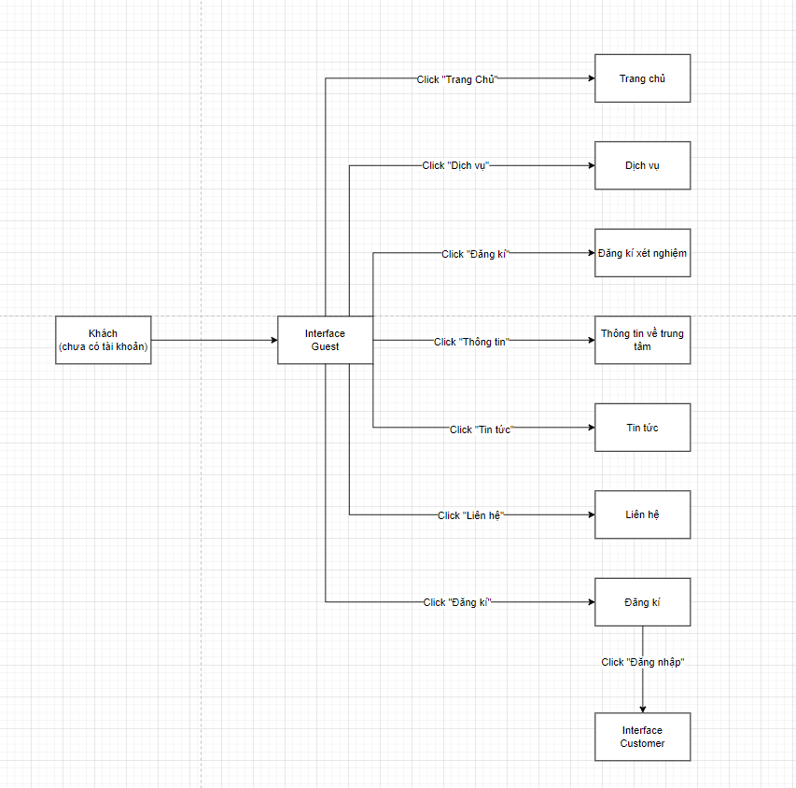
* 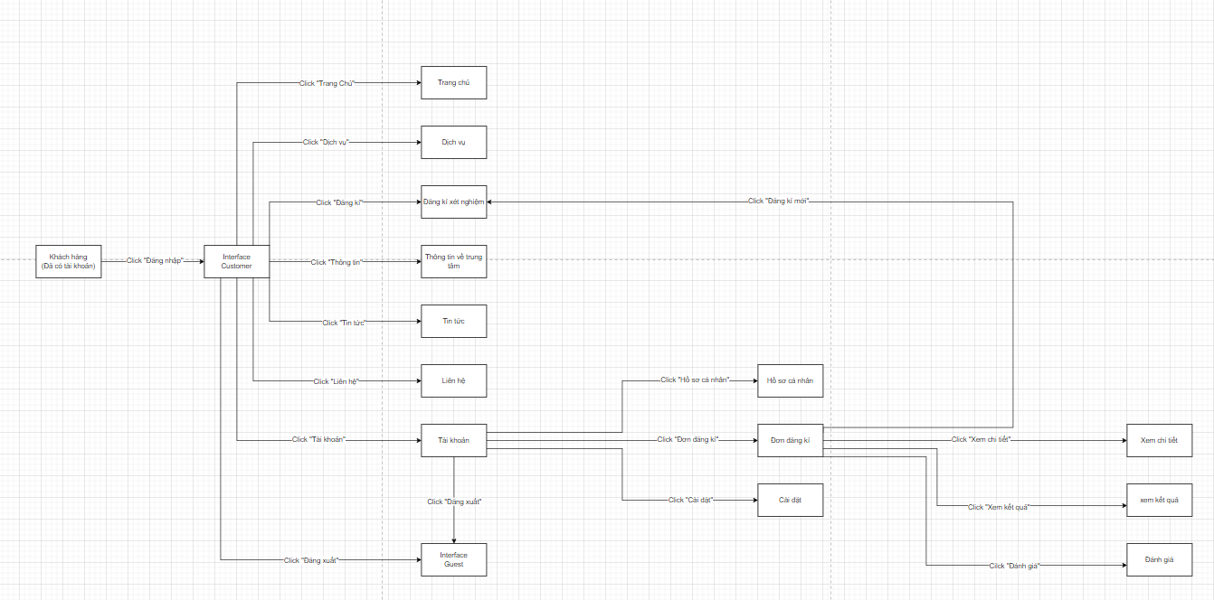
* 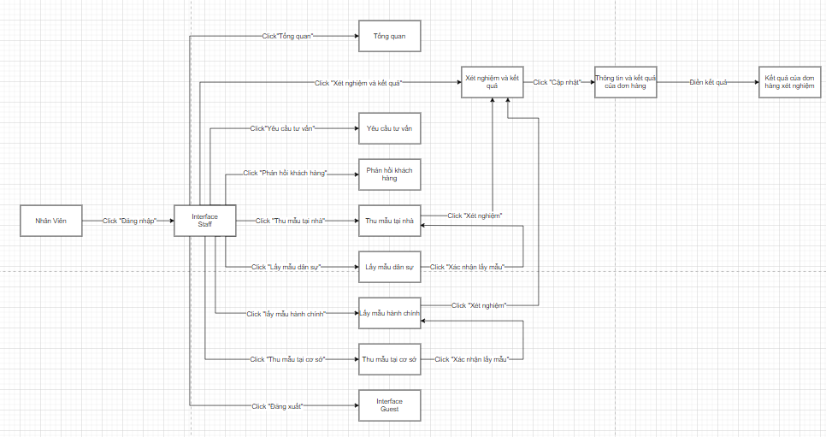
* 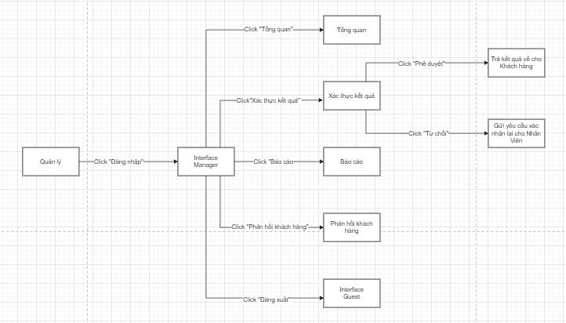
* 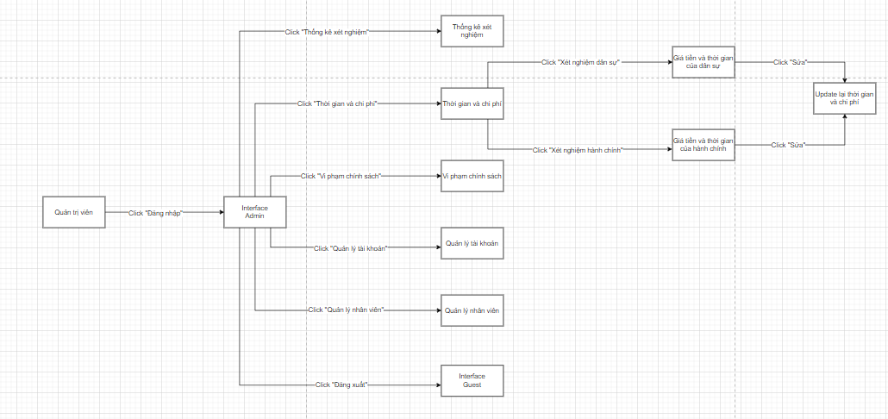

### 1.2 Screen Descriptions:

Guest

|  |  |  |  |
| --- | --- | --- | --- |
| **#** | **Screen** | **Feature** | **Description** |
| FR-01 | Home Page | View homepage | |  | | --- | |  |  |  | | --- | | Displays the landing page with an overview of the system and its services. | |
| FR-02 | |  | | --- | |  |  |  |  |  | | --- | --- | --- | | |  | | --- | |  |  |  | | --- | | Services Page | | | View services | Shows the list of available medical testing services. |
| FR-03 | |  | | --- | |  |  |  | | --- | | Registration Page | | Register for service | |  | | --- | |  |  |  | | --- | | Allows guests to fill in a form to request a test service. | |
| FR-04 | |  | | --- | | About Page |  |  | | --- | |  | | View center info | |  | | --- | |  |  |  | | --- | | Provides information about the testing center, mission, and services. | |
| FR-05 | |  | | --- | |  |  |  | | --- | | News Page | | View news | Displays health-related news and announcements. |
| FR-06 | Contact Page | Contact center | Shows contact details and a form for sending inquiries to the center. |
| FR-07 | Sign Up Page | Create account | |  | | --- | |  |  |  | | --- | | Allows users to create a new account to access additional features. | |
| FR-08 | Login Page | Login to system | |  | | --- | |  |  |  | | --- | | Enables registered users to log in and switch to the customer interface. | |

Customer

|  |  |  |  |
| --- | --- | --- | --- |
| **#** | **Screen** | **Feature** | **Description** |
| FR-09 | Login Page | Login to Customer Interface | Allows users with existing accounts to log in and access the customer interface. |
| FR-10 | |  | | --- | |  |  |  | | --- | | Home Page | | View homepage | |  | | --- | |  |  |  | | --- | | Displays the dashboard overview after logging in. | |
| FR-11 | Services Page | View services | Shows a list of available medical testing services. |
| FR-12 | Register Test Page | Register for service | Enables customers to register for a test service. |
| FR-13 | |  | | --- | |  |  |  | | --- | | About Page | | View center info | Provides information about the testing center. |
| FR-14 | News Page | View news | Displays health-related news and system announcements. |
| FR-15 | Contact Page | Contact center | |  | | --- | |  |  |  | | --- | | Shows contact information and a support form. | |
| FR-16 | Account Page | Access account section | Main page for managing personal information and test-related settings. |
| FR-17 | |  | | --- | |  |  |  | | --- | | Profile Page | | |  | | --- | |  |  |  | | --- | | View/edit profile | | Allows customers to view and edit their personal profile. |
| FR-18 | Registration History | View registration forms | |  | | --- | |  |  |  | | --- | | Lists all test registration forms submitted by the customer. | |
| FR-19 | |  | | --- | |  |  |  | | --- | | Registration Details | | View registration detail | Displays detailed information of a specific registration. |
| FR-20 | |  | | --- | |  |  |  | | --- | | Test Results Page | | View test result | Displays test results submitted by the staff. |
| FR-21 | |  | | --- | |  |  |  | | --- | | Feedback Page | | |  | | --- | |  |  |  | | --- | | Submit feedback/rating | | Enables customers to rate services and provide feedback. |
| FR-22 | |  | | --- | |  |  |  | | --- | | Settings Page | | Manage settings | Allows users to configure notification preferences and account settings. |
| FR-23 | Logout Page | Logout | Logs the user out and redirects to the Guest interface. |

Staff

|  |  |  |  |
| --- | --- | --- | --- |
| **#** | **Screen** | **Feature** | **Description** |
| FR-24 | Login Page | Login to Staff Interface | Allows staff members to log in and access internal system functions. |
| FR-25 | |  | | --- | |  |  |  | | --- | | Overview Page | | View dashboard overview | Displays overall statistics and summaries related to test processing. |
| FR-26 | Consultation Requests | View consultation requests | Shows customer requests for consultation that require staff follow-up. |
| FR-27 | Customer Feedback Page | Provide feedback | Allows staff to reply to feedback submitted by customers. |
| FR-28 | Home Sample Collection | Collect sample at home | Handles sample collection tasks at the customer's home. |
| FR-29 | |  | | --- | |  |  |  | | --- | | Civil Sample Collection | | Civil sample collection | Manages samples collected from civil-related entities. |
| FR-30 | |  | | --- | |  |  |  | | --- | | Admin Sample Collection | | Administrative sample | Manages samples collected from government or administrative bodies. |
| FR-31 | On-site Sample Collection | Collect sample at facility | Oversees sample collection done at the physical testing facility. |
| FR-32 | Test & Results Page | Manage test & result | Central page for processing test samples and accessing result input. |
| FR-33 | Result Entry Page | Enter result data | Allows staff to input and update test results into the system. |
| FR-34 | Logout Page | Logout | |  | | --- | |  |  |  | | --- | | Logs the staff out and returns to the Guest interface. | |

Manager

|  |  |  |  |
| --- | --- | --- | --- |
| **#** | **Screen** | **Feature** | **Description** |
| FR-35 | Login Page | Login to Manager Interface | Allows the manager to log in and access management-level system functions. |
| FR-36 | Overview Page | View dashboard overview | Displays system-wide summaries and key operational statistics. |
| FR-37 | Verify Results Page | Verify test results | Enables managers to review and either approve or reject submitted test results. |
| FR-38 | Reports Page | View reports | Provides access to detailed reports on test status, users, and performance. |
| FR-39 | Customer Feedback | Review customer feedback | Displays feedback from customers for service monitoring and quality control. |
| FR-40 | |  | | --- | |  |  |  | | --- | | Logout Page | | Logout | Logs the manager out and returns to the Guest interface. |

Admin

|  |  |  |  |
| --- | --- | --- | --- |
| **#** | **Screen** | **Feature** | **Description** |
| FR-41 | |  | | --- | |  |  |  | | --- | | Login Page | | Login to Admin Interface | Allows the system administrator to log in and access administrative tools. |
| FR-42 | Statistics Page | View test statistics | Displays testing volume, types, and summary analytics. |
| FR-43 | Timing & Pricing Page | View test timing & pricing | |  | | --- | |  |  |  | | --- | | Shows cost and duration data for civil and administrative test services. | |
| FR-44 | Timing & Pricing Page | Update test timing & pricing | Allows the admin to update prices and durations of test services. |
| FR-45 | |  | | --- | |  |  |  | | --- | | Policy Violations Page | | View policy violations | Displays user or staff violations against system policies. |
| FR-46 | Account Management Page | |  | | --- | |  |  |  | | --- | | Manage user accounts | | Allows admin to manage all user accounts and their roles. |
| FR-47 | Staff Management Page | Manage staff profiles | Enables profile editing and role assignment for staff members. |
| FR-48 | Logout Page | Logout | |  | | --- | |  |  |  | | --- | | Logs the administrator out and returns to the Guest interface. | |

### 1.3 Screen Authorization

|  |  |  |  |  |  |
| --- | --- | --- | --- | --- | --- |
| **Screen** | **Role1** | **Role2** | **Role3** | **Role4** | **Role5** |
| |  | | --- | |  |  |  | | --- | | Sign Up | | X |  |  |  |  |
| Login |  | X | X | X | X |
| |  | | --- | |  |  |  | | --- | | Home Page | | X | X | X | X | X |
| |  | | --- | |  |  |  | | --- | | Services | | X | X | X | X | X |
| |  | | --- | |  |  |  | | --- | | Test Registration | | X | X | X | X | X |
| |  | | --- | |  |  |  | | --- | | About the Center | | X | X | X | X | X |
| |  | | --- | |  |  |  | | --- | | News | | X | X | X | X | X |
| |  | | --- | |  |  |  | | --- | | Contact | | X | X | X | X | X |
| |  | | --- | |  |  |  | | --- | | Account | |  | X |  |  |  |
| |  | | --- | |  |  |  | | --- | | Personal Profile | |  | X |  |  |  |
| |  | | --- | |  |  |  | | --- | | Test Requests | |  | X |  |  |  |
| Request Details |  | X |  |  |  |
| |  | | --- | |  |  |  | | --- | | Test Results | |  | X |  |  |  |
| Feedback / Ratings |  | X |  |  |  |
| |  | | --- | |  |  |  | | --- | | Settings | |  | X |  |  |  |
| |  | | --- | |  |  |  | | --- | | Overview / Dashboard | |  |  | X | X | X |
| |  | | --- | |  |  |  | | --- | | Consultation Requests | |  |  | X |  |  |
| |  | | --- | |  |  |  | | --- | | Customer Feedback | |  |  | X |  |  |
| |  | | --- | |  |  |  | | --- | | Respond to Customer Feedback | |  |  | X |  |  |
| |  | | --- | |  |  |  | | --- | | Civil Sample Collection | |  |  | X |  |  |
| |  | | --- | |  |  |  | | --- | | Administrative Sample Collection | |  |  | X |  |  |
| On-site Sample Collection |  |  | X |  |  |
| |  | | --- | |  |  |  | | --- | | Test Processing & Results | |  |  | X |  |  |
| |  | | --- | |  |  |  | | --- | | Enter Test Results | |  |  | X |  |  |
| Verify Test Results |  |  |  | X |  |
| |  | | --- | |  |  |  | | --- | | Reports | |  |  |  | X |  |
| |  | | --- | |  |  |  | | --- | | Test Statistics | |  |  |  |  | X |
| Test Timing & Pricing |  |  |  |  | X |
| |  | | --- | |  |  |  | | --- | | Policy Violations | |  |  |  |  | X |
| |  | | --- | |  |  |  | | --- | | Account Management | |  |  |  |  | X |
| |  | | --- | |  |  |  | | --- | | Staff Management | |  |  |  |  | X |
| |  | | --- | |  |  |  | | --- | | Logout | | X | X | X | X | X |

In which:

* Customer: End-user of the DNA testing services. Can register, submit test requests, track progress, view results, and provide feedback.
* Guest: Unregistered users who can only view public content.
* Staff: Employees of the organization. Responsible for managing test requests, entering results, responding to consultations, and managing blog content.
* Manager: Mid-level supervisor. Has authority to verify test results, oversee staff operations, and review customer feedback.
* Admin: System administrator. Has full access to system configuration, user roles, service management, and platform maintenance.

### 1.4 Non-Screen Functions

|  |  |  |  |
| --- | --- | --- | --- |
| **#** | **System Function** | **Feature** | **Description** |
| FR-51 | Send Verification Email | Account Verification | Send a verification email when the user registers an account. |
| FR-52 | Authenticate User | Login Authentication | Authenticate user login credentials. |
| FR-53 | Encrypt User Data | Data Security | Encrypt personal data and test results to ensure security. |
| FR-54 | Role-based Authorization | Access Control | Control access based on user roles. |
| FR-55 | Save Application Data | Application Persistence | |  | | --- | |  |  |  | | --- | | Store submitted test registration data into the system. | |
| FR-56 | Log Activity | System Logging | Log user activities to support monitoring and auditing. |
| FR-57 | Notification System | User Notification | Send notifications when results are available or when the test status changes. |
| FR-58 | Backup Database | Data Backup | Automatically back up system data periodically for recovery purposes. |
| FR-59 | Generate Report | Test Result Reporting | Generate and export test result reports in PDF or Excel format. |
| FR-60 | Audit Log Management | Audit Trail | Track critical data changes to support internal audits. |

## 2. Data Requirements

### 2.1 Logical Data Model

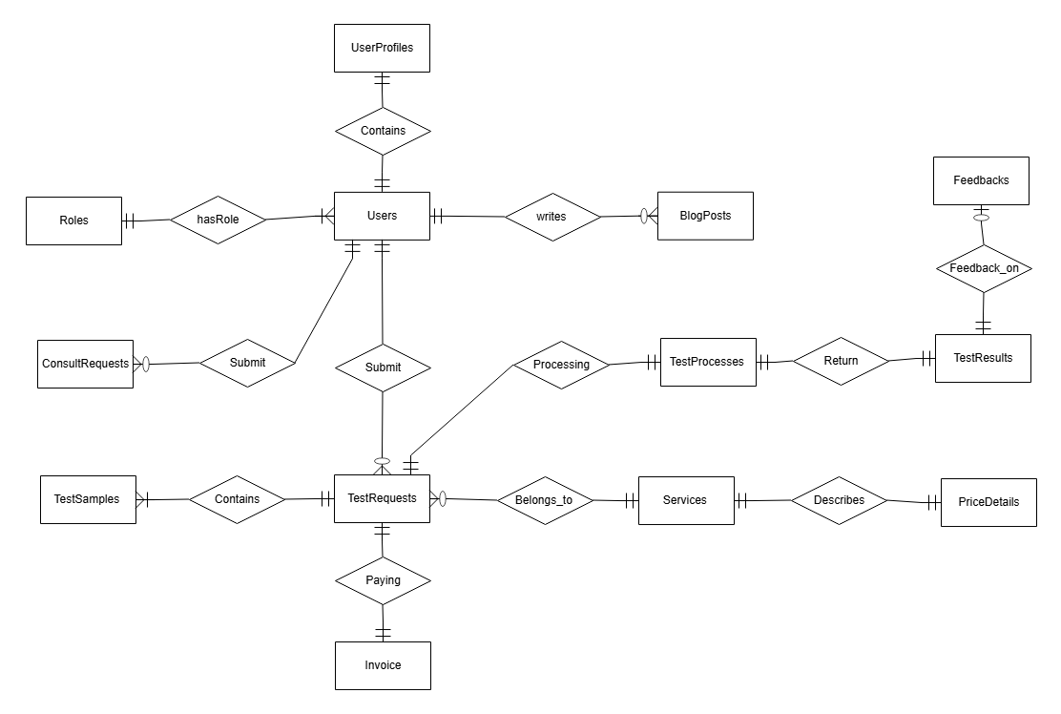

### 2.2 Data Dictionary

|  |  |  |  |  |
| --- | --- | --- | --- | --- |
| Data Element | Description | Composition or Data Type | Length | Values |
| RoleID | Auto-generated identifier for each user role in the system, used for role-based access control. | INT, Identity | N/A | Auto-increment |
| RoleName | Descriptive name representing the access level or permission set of a user (e.g., Admin, Staff, Customer). | NVARCHAR | 50 | Admin, Staff, Customer... |
| UserID | Primary key for identifying each user in the system, generated automatically. | INT, Identity | N/A | Auto-increment |
| FullName | The full legal name of the user registered in the DNA testing system. | NVARCHAR | 100 | Text |
| Phone | Contact phone number provided by the user for communication purposes. | NVARCHAR | 20 | Text |
| Email | User's email used for login and notifications, must be unique and valid. | NVARCHAR | 40 | Unique, Not Null |
| Password | Hashed password | NVARCHAR | 255 | Not Null |
| RoleID | Foreign key linking the user to a defined role (e.g., Staff, Customer). | INT, FK | N/A | FK to Roles |
| CreatedAt | Created timestamp | DATETIME | YYYY-MM-DD | Default = GETDATE() |
| UpdatedAt | Updated timestamp | DATETIME | YYYY-MM-DD | Nullable |
| Status | Status indicating whether the user account is active, inactive, or suspended. | INT | N/A | 0 = Inactive, 1 = Active |
| ProfileID | Profile ID | INT, Identity | N/A | Auto-increment |
| UserID | Linked user ID | INT, FK | N/A | FK to Users |
| Gender | User gender | NVARCHAR | 10 | Nam, Nữ, Khác |
| Address | Residential address | NVARCHAR | 255 | Text |
| DateOfBirth | Birth date | DATETIME | YYYY-MM-DD | Date |
| IdentityID | National ID or document | VARCHAR | 100 | Text |
| Fingerfile | Fingerprint file path | VARCHAR | 100 | File path |
| UpdatedAt | Last update time | DATETIME | YYYY-MM-DD | Nullable |
| PostID | Blog post ID | INT, Identity | N/A | Auto-increment |
| Title | Blog title | NVARCHAR | 255 | Text |
| Slug | SEO URL slug | NVARCHAR | 100 | Unique |
| Summary | Short blog summary | NVARCHAR | 500 | Text |
| Content | Full blog content | NVARCHAR | 500 | Text |
| AuthorID | Blog author | INT, FK | N/A | FK to Users |
| IsPublished | Is post published | BIT | N/A | 0 = Draft, 1 = Public |
| ThumbnailURL | Image link | NVARCHAR | 255 | URL |
| CreatedAt | Creation date | DATETIME | YYYY-MM-DD | Default GETDATE() |
| UpdatedAt | Last edit time | DATETIME | YYYY-MM-DD | Nullable |
| ConsultID | Unique consultation ID | INT, Identity | N/A | Auto-increment |
| StaffID | Assigned staff member | INT, FK | N/A | FK to Users |
| FullName | Full name of requester | NVARCHAR | 100 | Text |
| Phone | Phone number provided by the requester for follow-up communication. | NVARCHAR | 20 | Text |
| Category | Type of consultation requested (e.g., Test advice, Result explanation). | NVARCHAR | 50 | Text |
| ServiceID | Related service | INT, FK | N/A | FK to Services |
| Message | Detailed description of the consultation issue written by the customer. | NVARCHAR(MAX) | Text | Text |
| Status | Current state of the consultation process (e.g., Pending, Accepted, Responded). | NVARCHAR | 50 | Pending, Accepted, Canceled, Responded |
| CreatedAt | The datetime when the record was first inserted into the table. | DATETIME | YYYY-MM-DD | Default GETDATE() |
| RepliedAt | Timestamp indicating when the staff responded to the consultation. | DATETIME | YYYY-MM-DD | Nullable |
| ProcessID | Unique test process ID | INT, Identity | N/A | Auto-increment |
| RequestID | Linked request | INT, FK | N/A | FK to TestRequests |
| StaffID | Staff assigned to process | INT, FK | N/A | FK to Users |
| ClaimedAt | Time claimed | DATETIME | YYYY-MM-DD | Default GETDATE() |
| KitCode | Unique identifier or barcode of the DNA testing kit used in the request. | VARCHAR | 50 | Text |
| CurrentStatus | Describes the current activity or milestone reached in the testing process. | NVARCHAR | 50 | Text |
| ProcessState | Overall condition of the process (e.g., Pending, In Testing, Completed). | NVARCHAR | 50 | Text |
| Notes | Optional field where staff can add internal notes about the testing process. | NVARCHAR(MAX) | Text | Text |
| UpdatedAt | Timestamp indicating when the testing process was last updated. | DATETIME | YYYY-MM-DD | Nullable |
| SampleID | Unique sample ID | INT, Identity | N/A | Auto-increment |
| RequestID | Associated request ID | INT, FK | N/A | FK to TestRequests |
| ProcessID | Associated process ID | INT, FK | N/A | FK to TestProcesses |
| OwnerName | Name of the person who provided the DNA sample. | NVARCHAR | 100 | Text |
| Gender | The gender of the person who provided the DNA sample (e.g., Nam, Nữ). | VARCHAR | 10 | Male, Female, other |
| Relationship | Defines how the sample owner is related to the main testing subject. | NVARCHAR | 30 | Text |
| SampleType | Specifies the kind of biological sample (e.g., buccal swab, hair, blood). | NVARCHAR | 50 | Text |
| YOB | Year of birth of the sample provider. | INT | YYYY | Year |
| CollectedAt | Timestamp indicating when the DNA sample was collected. | DATETIME | YYYY-MM-DD | Nullable |

### 2.3 Dashboards

|  |  |  |
| --- | --- | --- |
| **#** | **Report Name** | **Description** |
| DBD-01 | Request Summary Overview | Displays summary of DNA test requests segmented by statuses such as Pending, Confirmed, Processing, and Completed. Enables staff and managers to monitor request flow and operational workload. |
| DBD-02 | Result Processing Timeline | Monitors each stage in result handling including sample reception, testing, result entry, and verification. Supports optimization of processing times and tracking of overdue results. |
| DBD -03 | Feedback Summary Report | Displays summary statistics and detailed feedback left by users after receiving test results. Useful for assessing service satisfaction and improving quality. |
| DBD -04 | Consultation Request Overview | Presents a dashboard for tracking consultation request statuses such as Pending, Accepted, and Responded. Assists staff in managing response times effectively. |
| DBD -05 | Revenue and Payment Report | Summarizes paid invoices and revenue over time across various services. Enables managers to track financial performance and analyze trends. |
| DBD -06 | User Activity Monitoring | Tracks user login activity, service selections, and interactions within the platform. Helps identify active users and system usage behavior. |

|  |  |
| --- | --- |
| Report ID: | RPT-01 |
| Report Title: | Request Summary Overview |
| Report Purpose: | Displays summary of DNA test requests segmented by statuses such as Pending, Confirmed, Processing, and Completed. Enables staff and managers to monitor request flow and operational workload. |
| Priority: | High |
| Report Users: | Manager |
| Data Sources: | TestRequests table in the DNA Testing System database |
| Frequency and Disposition; | Generated on demand or automatically during login for authorized users. Displays in web dashboard. |
| Latency: | Complete report must be displayed to Manager within 3 seconds after it is requested. |
| Visual Layout: | Web-based interface with chart and table view, landscape orientation for printed reports. |
| Header and Footer: | Includes report title, date range, and user name in header. Page number in footer. |
| Report Body: | Fields shown and column headings:   * Request ID * Customer Name * Request Date * Service Type * Sample Collection Type * Status (Pending, Confirmed, In Progress, Completed) * Assigned Staff. |
| End-of-Report Indicator: | None |
| Interactivity: | Interactive filtering, status-based color highlighting, and drill-down to request details. |
| Security Access Restrictions: | Manager cannot see details of subscribers and donors |

|  |  |
| --- | --- |
| Report ID: | RPT-02 |
| Report Title: | Result Processing Timeline |
| Report Purpose: | Monitors each stage in result handling including sample reception, testing, result entry, and verification. Supports optimization of processing times and tracking of overdue results. |
| Priority: | Medium |
| Report Users: | Manager |
| Data Sources: | TestProcesses, TestResults table in the DNA Testing System database |
| Frequency and Disposition; | Generated on a scheduled basis (daily/weekly), available in dashboard and reports. Displays in web dashboard. |
| Latency: | Complete report must be displayed to Manager within 3 seconds after it is requested. |
| Visual Layout: | Web-based interface with chart and table view, landscape orientation for printed reports. |
| Header and Footer: | Includes report title, filters, timestamp, and user identity. |
| Report Body: | Fields shown and column headings:   * Request ID * Customer Name * Request Date * Service Type * Sample Collection Type * Status (Pending, Confirmed, In Progress, Completed) * Assigned Staff. * dates |
| End-of-Report Indicator: | None |
| Interactivity: | Interactive filters, clickable rows for detail view, optional chart toggle. |
| Security Access Restrictions: | Manager cannot see details of subscribers and donors |

|  |  |
| --- | --- |
| Report ID: | RPT-03 |
| Report Title: | Feedback Summary Report |
| Report Purpose: | Displays summary statistics and detailed feedback left by users after receiving test results. Useful for assessing service satisfaction and improving quality. |
| Priority: | Medium |
| Report Users: | Manager |
| Data Sources: | Feedbacks, Users table in the DNA Testing System database |
| Frequency and Disposition; | Updated automatically after new feedback submission. Available anytime |
| Latency: | Near real-time |
| Visual Layout: | Web-based interface with chart and table view, landscape orientation for printed reports. |
| Header and Footer: | Includes report title, filters, timestamp, and user identity. |
| Report Body: | Fields shown and column headings:   * Comment * UserID * ResultID * Rate * Date |
| End-of-Report Indicator: | None |
| Interactivity: | Interactive filters, clickable rows for detail view, optional chart toggle |
| Security Access Restrictions: | Accessible to Manager via dashboard. Feedback content protected for privacy. |

|  |  |
| --- | --- |
| Report ID: | RPT-04 |
| Report Title: | Consultation Request Overview |
| Report Purpose: | Presents a dashboard for tracking consultation request statuses such as Pending, Accepted, and Responded. Assists staff in managing response times effectively. |
| Priority: | Medium |
| Report Users: | Staff, Manager |
| Data Sources: | ConsultRequests table in the DNA Testing System database |
| Frequency and Disposition; | On-demand or real-time dashboard widget. Exportable by date range. |
| Latency: | Complete report must be displayed to Staff, Manager within 3 seconds after it is requested. |
| Visual Layout: | Web-based interface with chart and table view, landscape orientation for printed reports. |
| Header and Footer: | Includes report title, filters, timestamp, and user identity. |
| Report Body: | Fields shown and column headings:   * Request ID * Customer Name * Phone * Service Type * Status (Pending, Confirmed, In Progress, Completed) * Note. |
| End-of-Report Indicator: | None |
| Interactivity: | Interactive filters, clickable rows for detail view, optional chart toggle. |
| Security Access Restrictions: | Staff and Manager access required. Customer identities partially masked for confidentiality. |

|  |  |
| --- | --- |
| Report ID: | RPT-05 |
| Report Title: | Revenue and Payment Report |
| Report Purpose: | Summarizes paid invoices and revenue over time across various services. Enables managers to track financial performance and analyze trends. |
| Priority: | High |
| Report Users: | Manager |
| Data Sources: | Invoice, Services, TestRequests table in the DNA Testing System database |
| Frequency and Disposition; | Generated monthly or filtered on request. |
| Latency: | Complete report must be displayed to Staff, Manager within 3 seconds after it is requested. |
| Visual Layout: | Web-based interface with chart and table view, landscape orientation for printed reports. |
| Header and Footer: | Includes report title, date range, and user name in header. Page number in footer. |
| Report Body: | Fields shown and column headings:   * Request ID * PaymentID * Date * Status |
| End-of-Report Indicator: | None |
| Interactivity: | Sorted by most recent request date first. |
| Security Access Restrictions: | Manager roles only due to financial data sensitivity. Access monitored and encrypted. |

|  |  |
| --- | --- |
| Report ID: | RPT-06 |
| Report Title: | User Activity Monitoring |
| Report Purpose: | Tracks user login activity, service selections, and interactions within the platform. Helps identify active users and system usage behavior. |
| Priority: | Low |
| Report Users: | Admin |
| Data Sources: | SystemLogs, Users table in the DNA Testing System database |
| Frequency and Disposition; | Updated periodically in backend. Admins can request report anytime. |
| Latency: | Complete report must be displayed to Staff, Manager within 3 seconds after it is requested. |
| Visual Layout: | Web-based interface with chart and table view, landscape orientation for printed reports. |
| Header and Footer: | Includes report title, date range, and user name in header. Page number in footer. |
| Report Body: | Fields shown and column headings:   * UserID * Status * Date * Action |
| End-of-Report Indicator: | None |
| Interactivity: | Sorted by most recent request date first. |
| Security Access Restrictions: | Admin only. Includes sensitive platform usage metrics; access is logged and audited. |

### 2.4 State transition diagram

a. State transition diagram for TestRequests

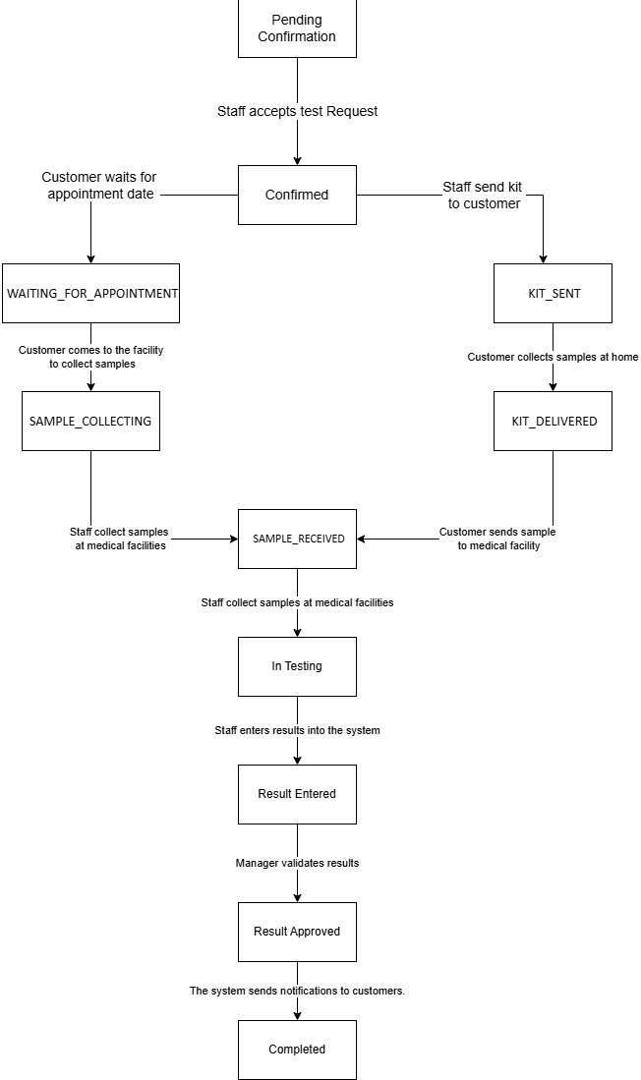

b. State transition diagram for ConsultRequests

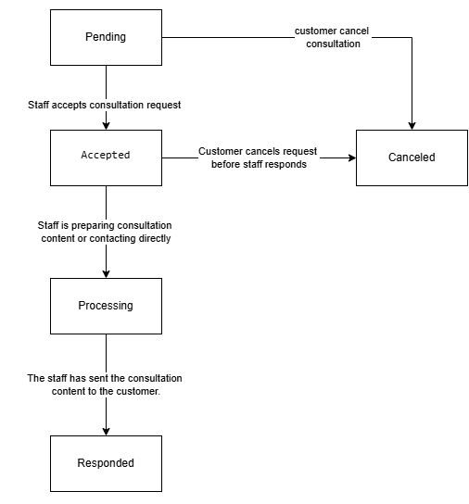

## 3. User account management

**3.1 Sign up for an account**

* **Function trigger**:  
  Go to homepage → Click “Register”
* **Function description**:
* **Actors:** Guest (person without an account)
* **Purpose:** Allows users to create customer accounts to use the service.
* **Interface:** The registration form asks for basic information.
* **Data processing:** Save information to database, redirect to login page.
* **Screen layout**:

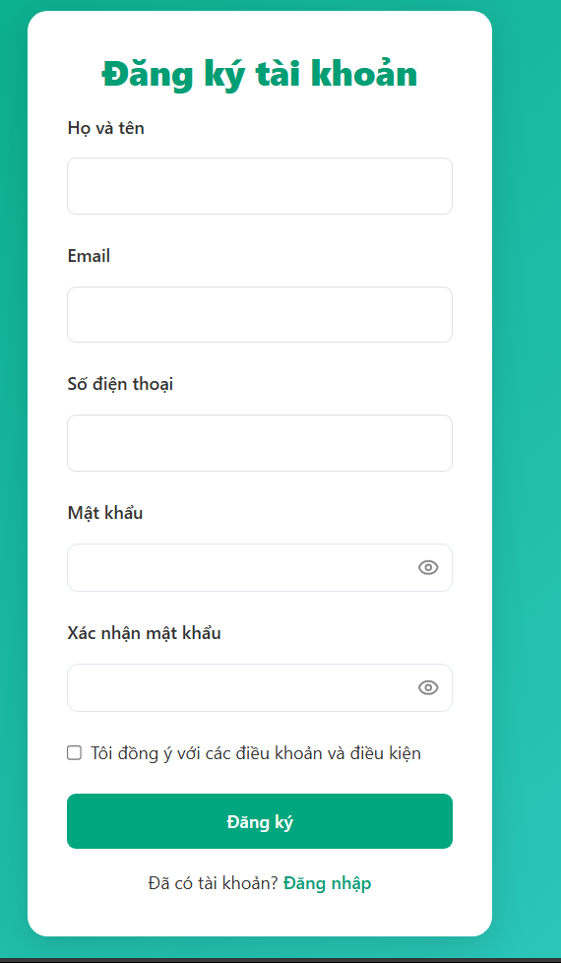

* **Function details**:
  + After registering an account, the customer will be redirected to the login page.
  + Email already exists → displays error “Email already in use”.
  + System error while saving → displays “Registration failed. Please try again.”

**3.2 Login to the system**

* **Function trigger**:  
  Go to home page → Click “Login”
* **Function description**:
* **Actors**: Customer, Staff, Manager, Admin
* **Purpose:** Authenticate users to access the system with their respective roles.
* **Interface:** Basic login screen.
* **Screen layout**:

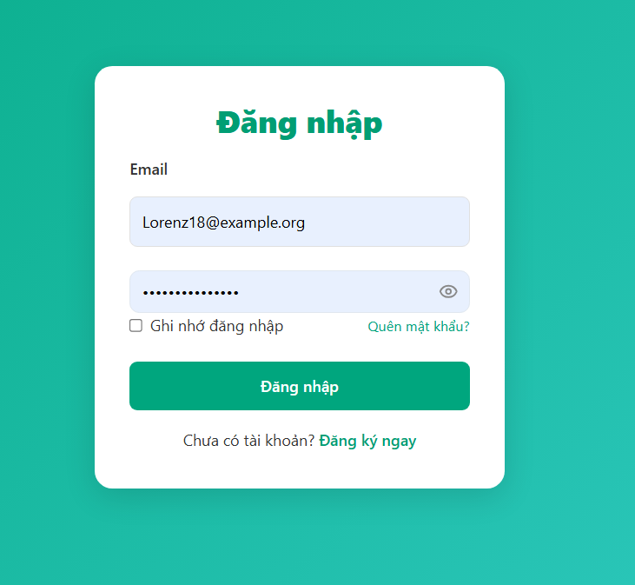

* **Function details**:
* **Handle:**:
  + Match email and password with data in DB.
  + If correct → redirect by role:
  + Customer → Customer dashboard
  + Staff → Test request processing page
  + Manager/Admin → System administration page
* **Validation**:
  + Email must be in correct format
  + Password cannot be empty
* **Abnormal cases:**
  + Wrong password → message “Incorrect email or password”.

## 4. Personal information management

**4.1 View and update personal information**

* **Function trigger**:  
  After login → Click on user avatar / menu → “Personal information”.
* **Function description**:
* **Actors:** Customer, Admin, Manager, Staff
* **Purpose:** Allows users to view and edit personal information such as full name, phone number, address, avatar.
* **Interface:** Form displays current information and can be changed
* **Screen layout**:

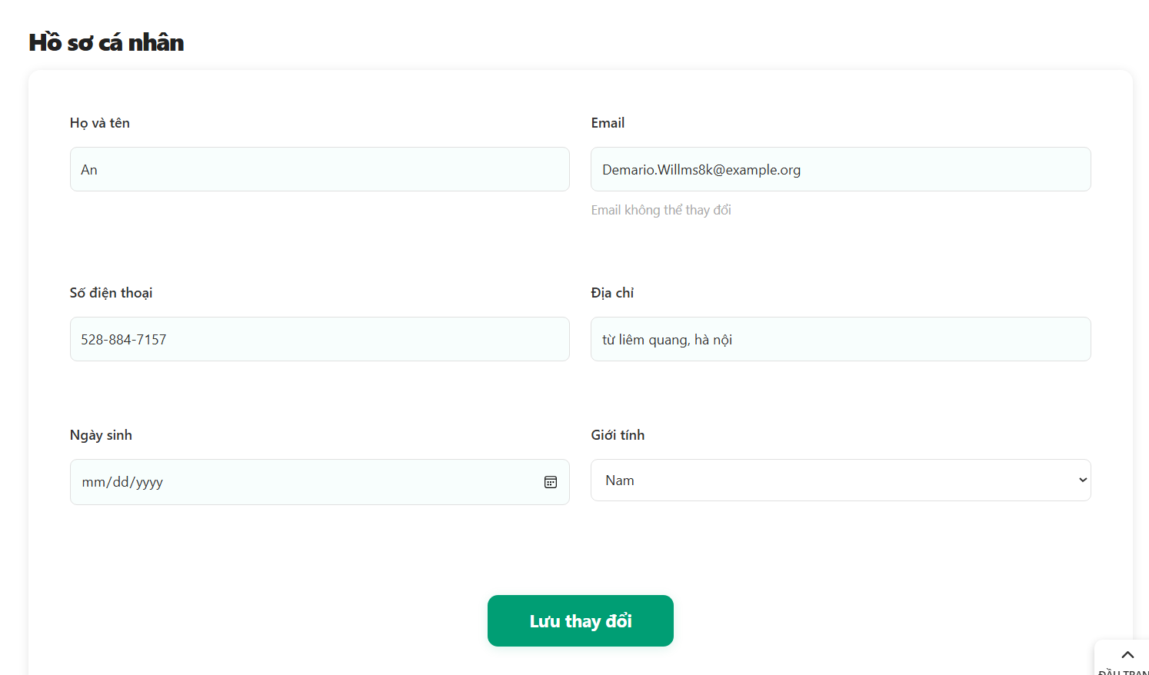

* **Function details**:
* Admin, Managers, Staffs, Users change personal information
* Phone numbers check 10 digits, only numeric characters are allowed.
* Full name cannot be left blank.
* After update:
  + System saves data.
  + Displays message "Update successful".
  + If server error → message "Unable to save, please try again."

**4.2 Change password**

* **Function trigger**:  
  On the Personal Information page → Click “Change Password”.
* **Function description**:
* **Actors:** Customer, Admin, Manager, Staff
* **Purpose:** Allows users to change their password once logged in.
* **Screen layout**:

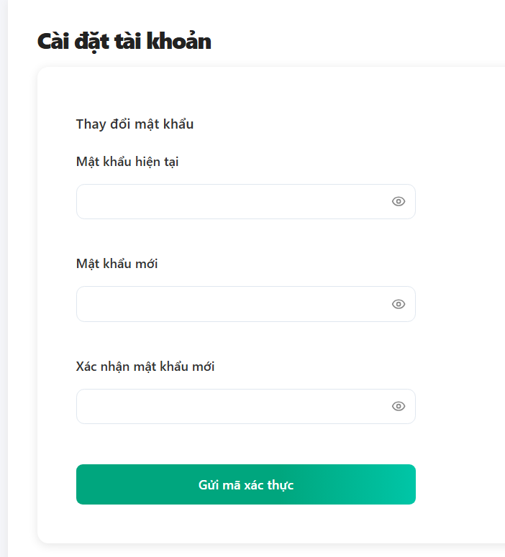

* **Function details**:
* When Customer, Admin, Manager, Staff click on change password, it will jump to the password change form.
* Show password as number when clicking on eye icon
* Check if the current password is correct.
* The new password must be different from the old password.
* If successful → request to log in again (log out).

## 5. Test requirments management

**5.1 Create test request**

* **Function trigger**:  
  User login → Dashboard page → Click "DNA Service" button → Select service type → Register service
* **Function description**:
* **Actors:** Customer
* **Purpose:** Allows customers to submit DNA testing requests for individuals or relatives.
* **Screen layout**:

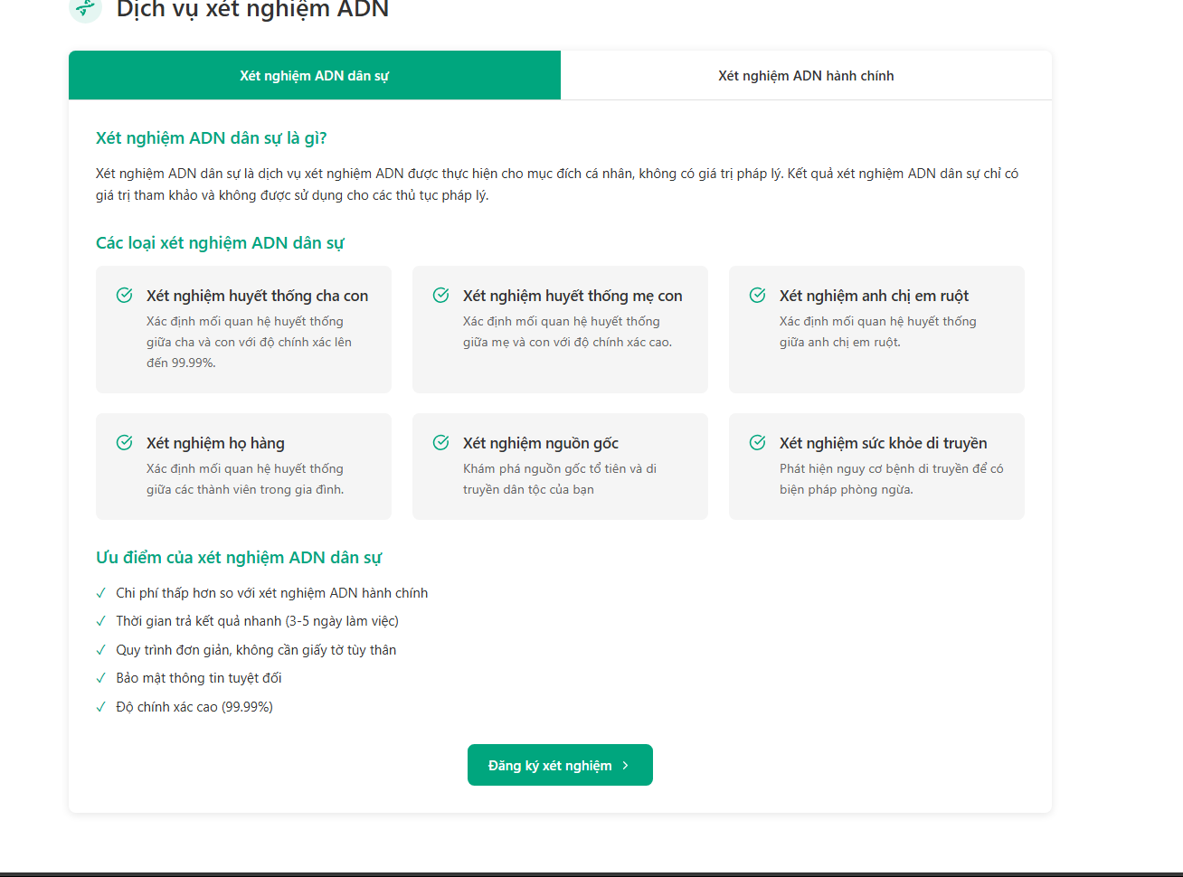

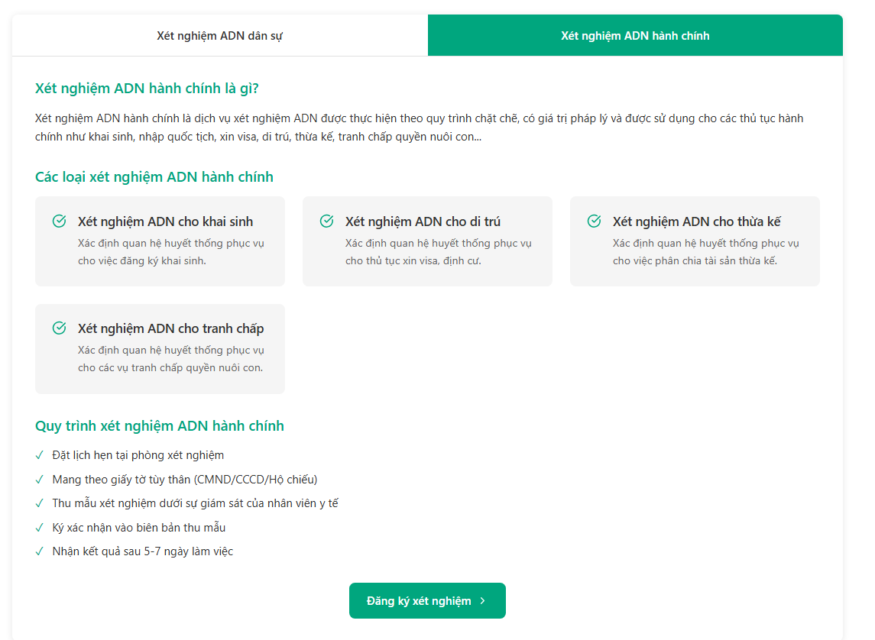

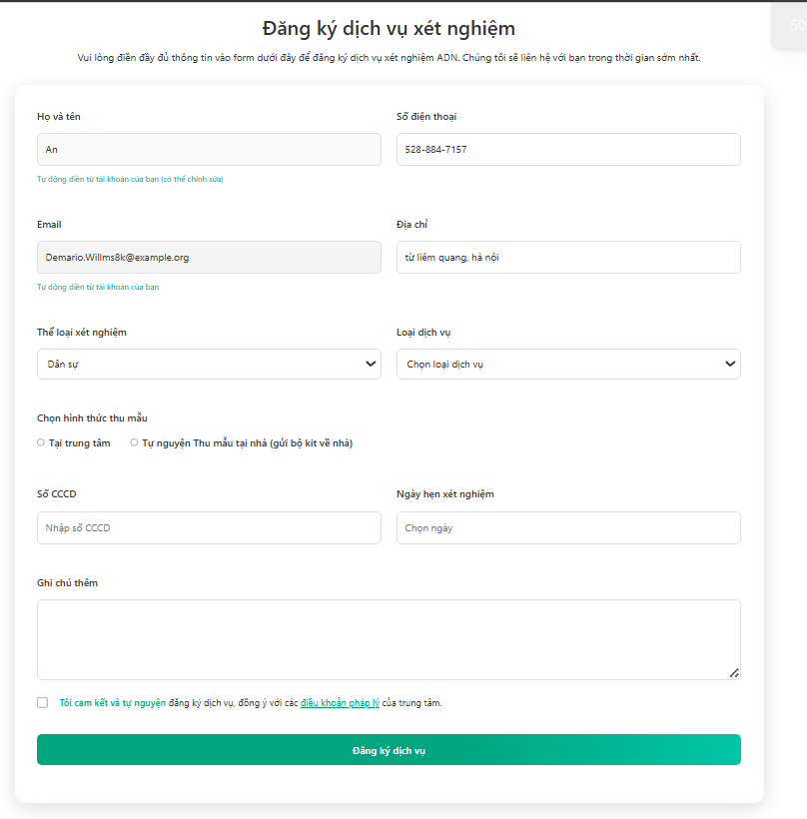

* **Function details**:
* Display board of information on service types, service names, prices
* When you click register, the service registration form will pop up.
* After filling in all the information, click on the button to agree to the terms and click register.
* Phone number format: must be 10 digits.
* Date of birth must not be greater than current date.

## 6. User account management

**6.1 Payment via VNPAY**

* **Function trigger**:  
  When the customer creates a test request → selects “Pay now” → the system transfers to the VNPAY portal.
* **Function description**:
* **Actors:** Customer
* **Purpose:** Allow customers to pay testing costs online through the VNPAY portal.
* **Screen layout**:

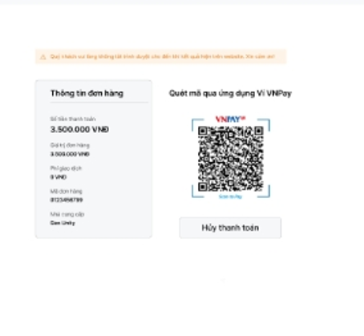

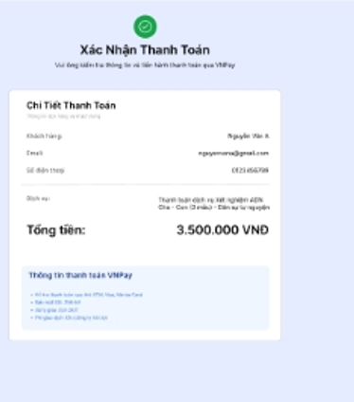

* **Function details**:
* After clicking register, you will be redirected to the payment page.
* **When clicking Pay:**
  + The system generates transaction code, order code, and total amount.
  + Sign data and redirect to VNPAY payment gateway
* **After payment:**
  + Assign the order status to “Paid”.
  + Display the message “Payment successful”.
  + If error or cancellation → display the message “Payment failed or canceled”.

**6.2 Track test status**

* **Function trigger**:  
  Customers go to Dashboard → Click on the “Request History” tab → View the list of submitted requests.
* **Function description**:
* **Actors:** Customer
* **Purpose:** Allows customers to view the progress of each request
* **Screen layout**:

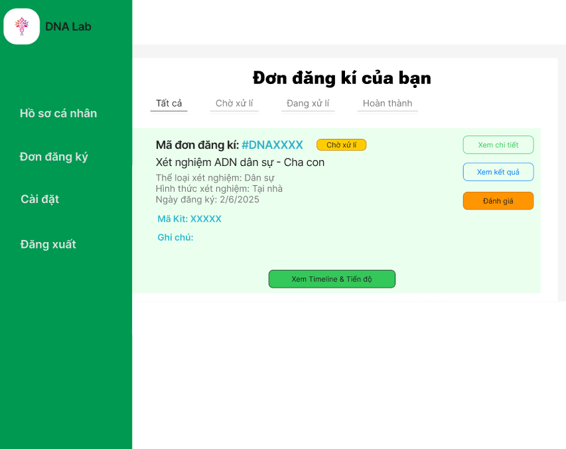 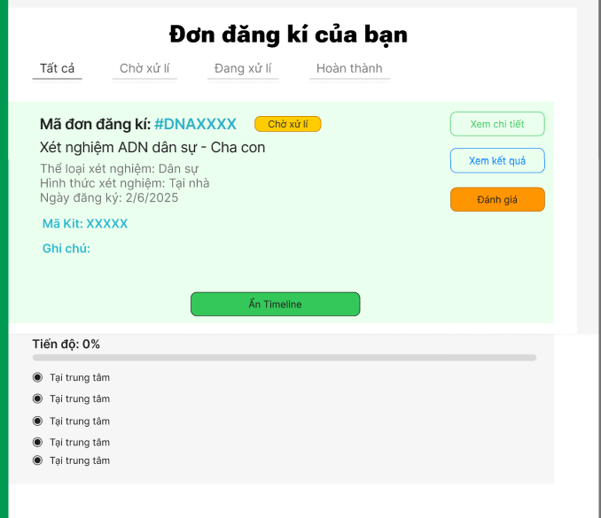

* **Function details**:
* Customers track test progress, search for results by name or kit code
* Information displayed after searching, customers can click to view details to track detailed progress step by step
* Statuses: waiting for sample to be sent, Sample received, Testing, Completed, Canceled.

**6.3 Test request management**

* **Function trigger**:  
  Staff after logging in -> click on request management -> customize test request
* **Function description**:
* **Actors:** Staff
* **Purpose:** Allow staff to customize (view details, accept, reject, history) test requests
* **Screen layout**:

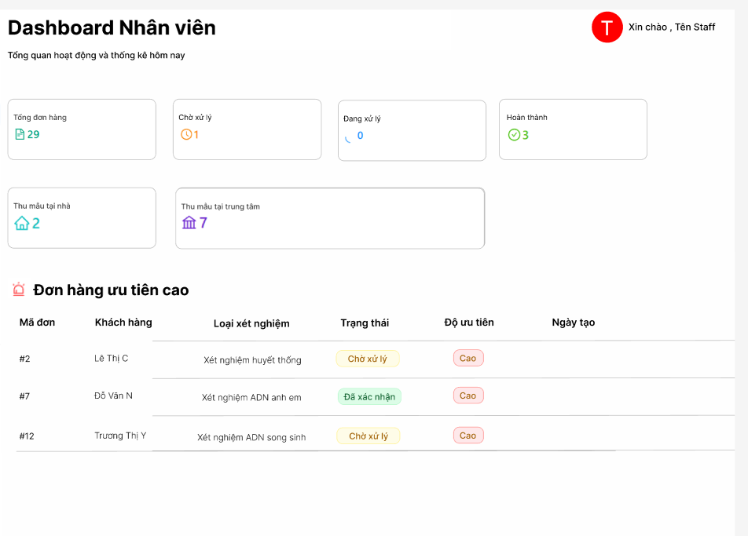

* **Function details**:
* When Staff logs in, the dashboard will display online customers, the number of orders in progress, the number of completed orders, and recent order processing activities.
* Staff manages test requests, there are 2 status:
  + Pending
  + Confirmed
* Staff searches for test requests by customer name or kit code
* Test request details include: request code, customer name, test type, location, status
* Staff can confirm request codes and view request details

**6.4 Test process management**

* **Function trigger**:  
  Staff after logging in -> click on testing process -> update testing process
* **Function description**:
* **Actors:** Staff
* **Purpose:** Allows staff to update the testing process from sample collection -> result return
* **Screen layout**:

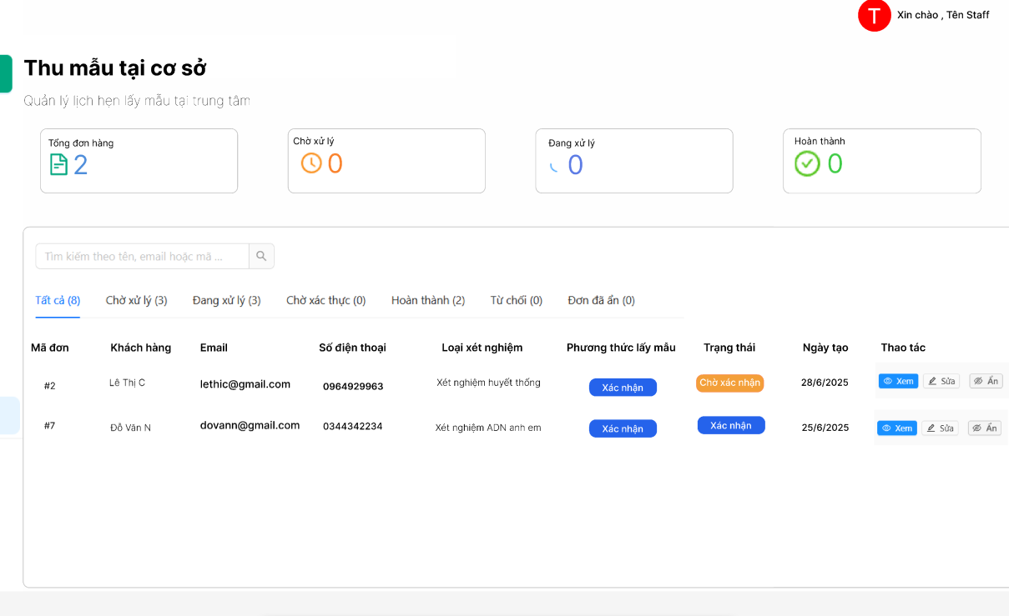

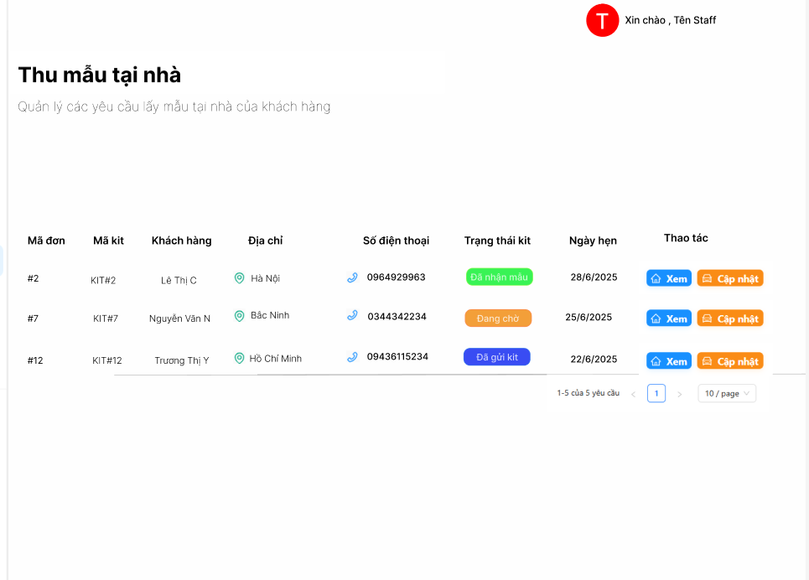

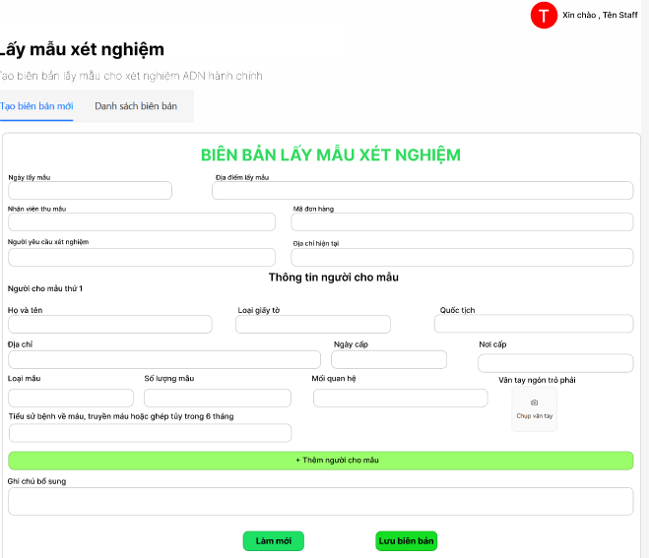

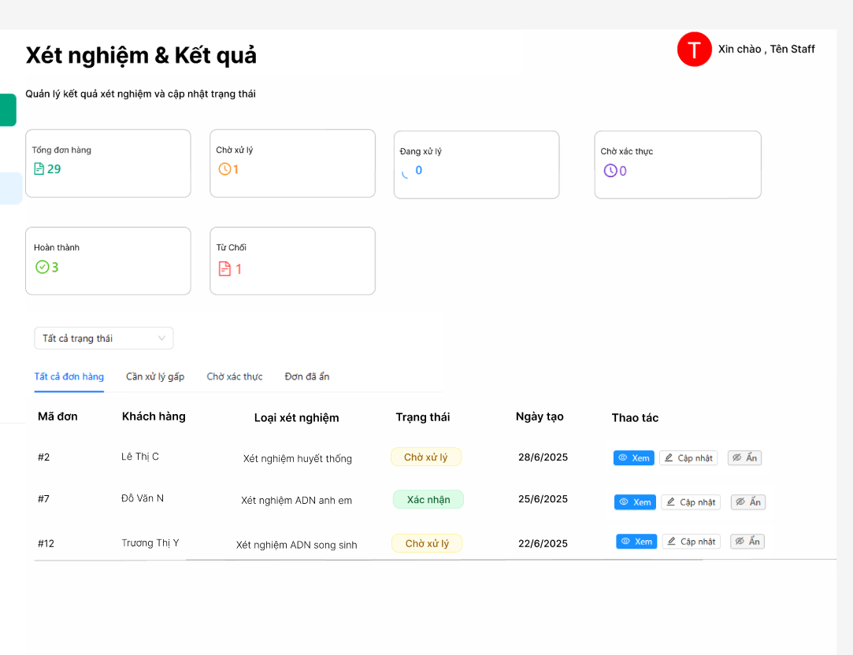

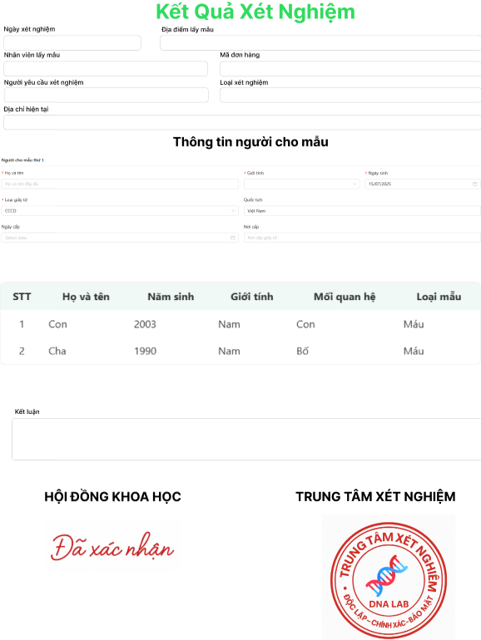

* **Function details**:
* Staff view and update testing progress
* Staff clicks to see details, in the details section Staff is updated with the testing process and fills in the test results to send to Customer
* 2 types of progress for 2 types of tests (at home, at the center)
* Contact customers if there are errors

**6.5 Test results management**

* **Function trigger**:  
  Manager after logging in -> click on test result management
* **Function description**:
* **Actors:** Manager
* **Purpose:** Allows manager to view test results information, update test results
* **Screen layout**:

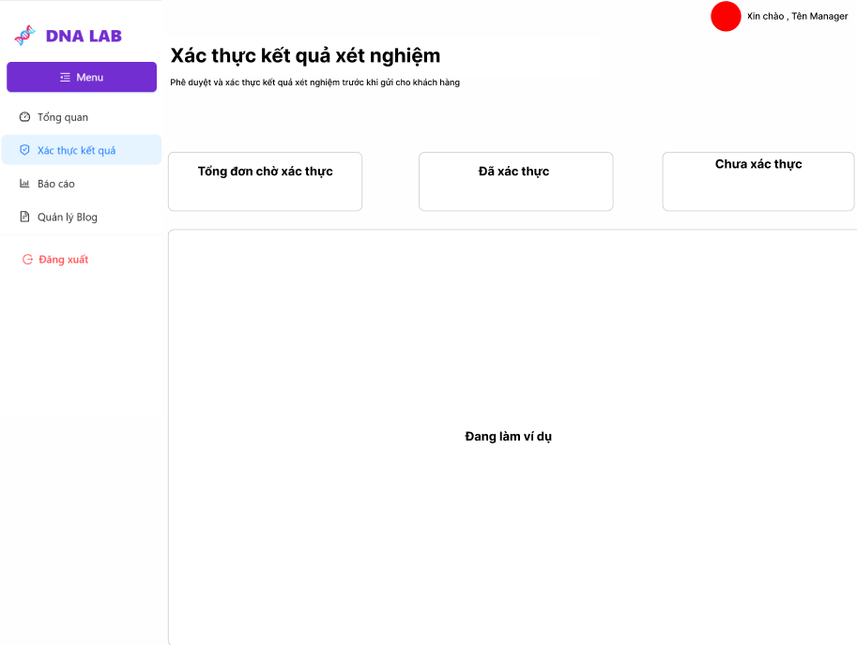

* **Function details**:
* Test results list includes test result information, status
* Display results details, update status (pending approval, approved, canceled)
* The status will change when the Manager clicks the confirm or reject button (pending, approved)
* Staff click to see details will jump to the test results detail table with information and test status

## 7. Feedback management

**7.1 Show reviews from other guest and customers**

* **Function trigger**:  
  Home → Scroll down to customer reviews
* **Function description**:
* **Actors:** Guest, Customer
* **Purpose:** Allow people to refer to real customer reviews before deciding to use the service.
* **Screen layout**:

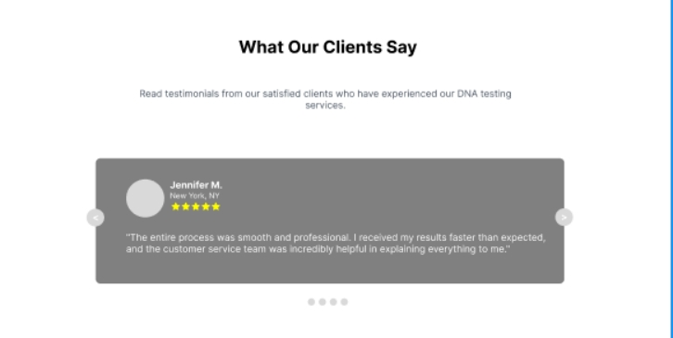

* **Function details**:
* Each review includes: name (can be anonymous), number of stars (1–5), content, time.
* Reviews are displayed publicly after being moderated.
* The system only allows people who have used the service to review

**7.2 Send feedback and reviews**

* **Function trigger**:  
  After receiving the results, the customer selects the evaluation section -> sends review and feedback.
* **Function description**:
* **Actors:** Customer
* **Purpose:** Allows users to submit ratings, reviews and feedback.
* **Screen layout**:

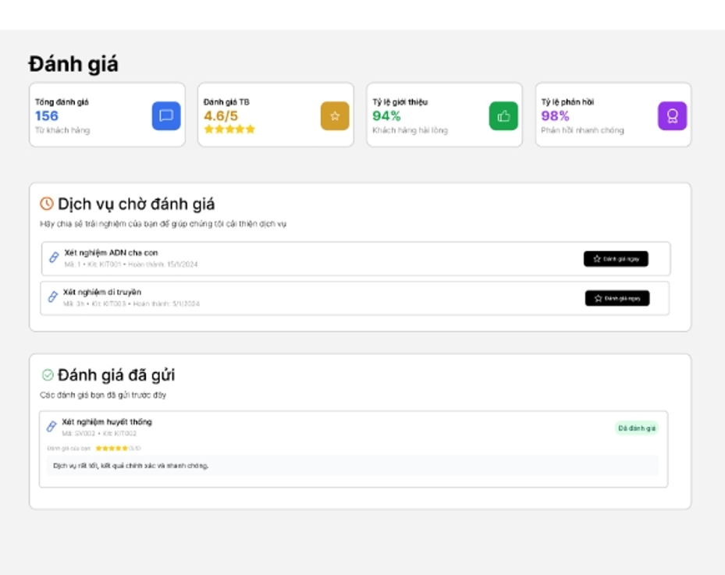

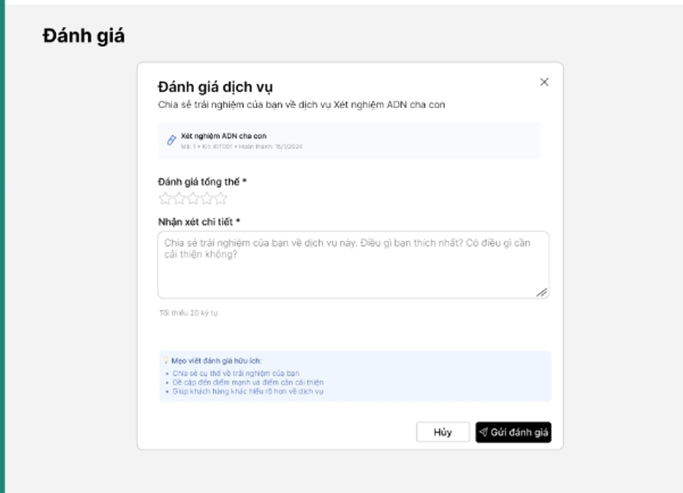

* **Function details**:
* Customer clicks on the review section, it will display information about the services used and reviews of the services.
* Previous reviews from people who have used that service are also displayed.
* Customer clicks on "Rate now" to jump to the service review page
* The service evaluation table includes information about the services used.
* Overall rating and detailed comments filled in by customer
* Show review type
* Review (1-5 stars)
* Detailed review (20 characters minimum)

**7.3 View feedback from customer**

* **Function trigger**:  
  Manager after logging in -> click on "View feedback"
* **Function description**:
* **Actors:** Manager
* **Purpose:** Manager can see feedback from customers
* **Screen layout**:

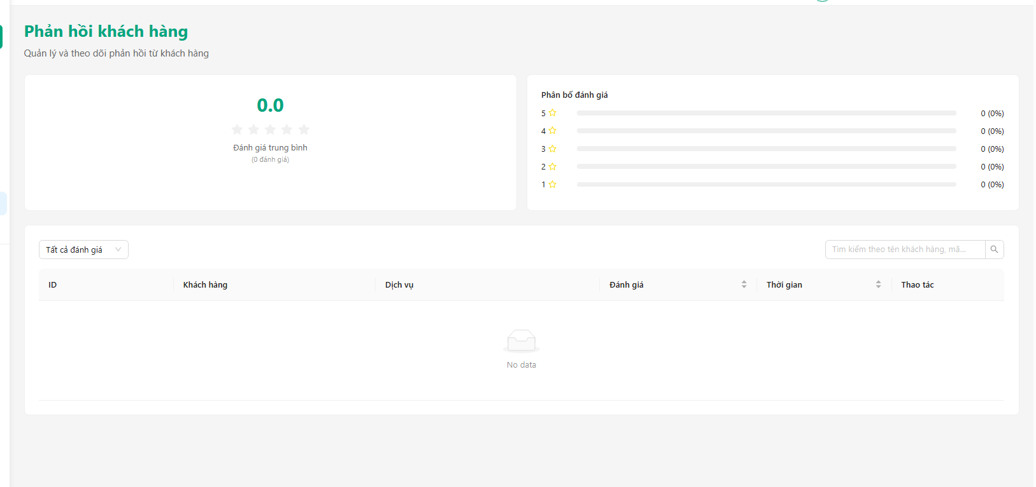

* **Function details**:
* Managers view feedback from customers including:
  + Average rating
  + Total feedback
  + Rating distribution
  + Feedback list

## 8. User account management

**8.1 Show blogs from other guest and customers**

* **Function trigger**:  
  Home → Scroll down to blogs
* **Function description**:
* **Actors:** Guest, Customer
* **Purpose:** Allow people to refer to blogs to better understand DNA testing
* **Screen layout**:

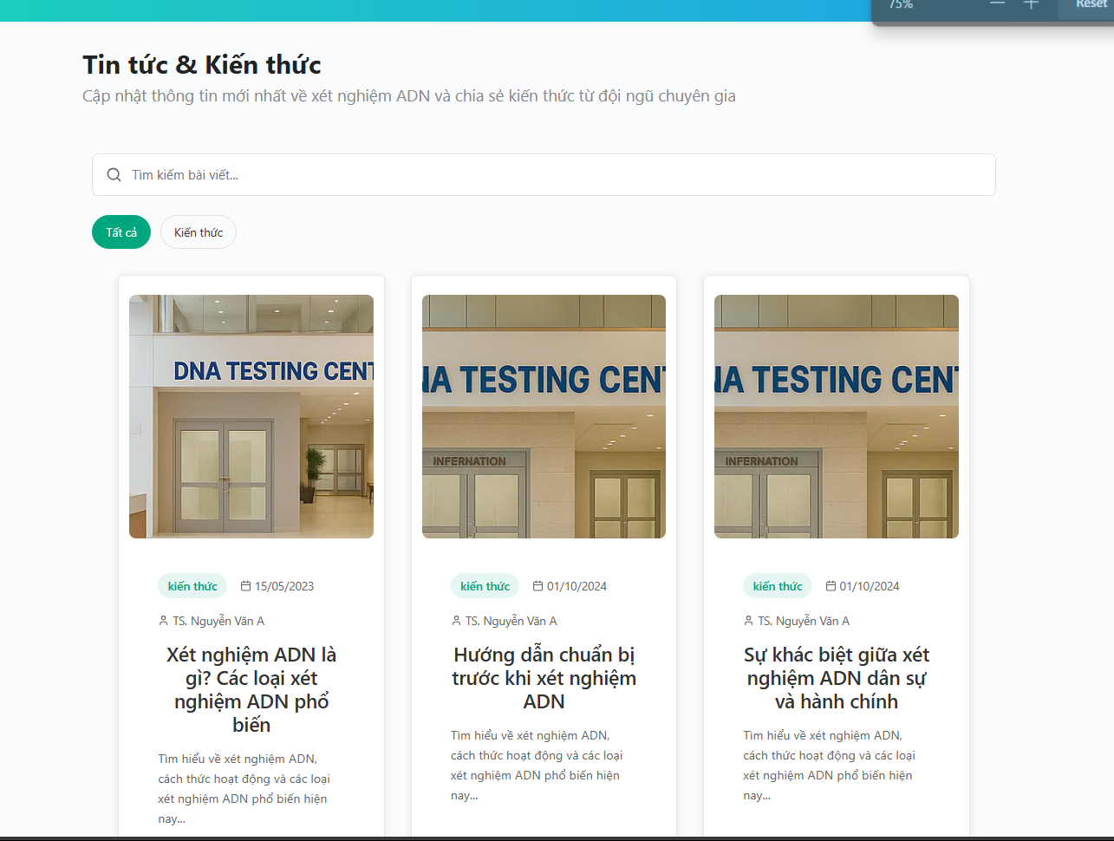

* **Function details**:
* Each review includes: name (can be anonymous), number of stars (1–5), content, time.
* Reviews are displayed publicly after being moderated.
* The system only allows people who have used the service to review

**9. Role management**

**9.1 Customer, staff, manager management**

* **Function trigger**:  
  Admin after logging in -> click on "User management"
* **Function description**:
* **Actors:** Admin
* **Purpose:** Allows viewing, adding, editing, and deleting information of managers, staff, and customers.
* **Screen layout**:

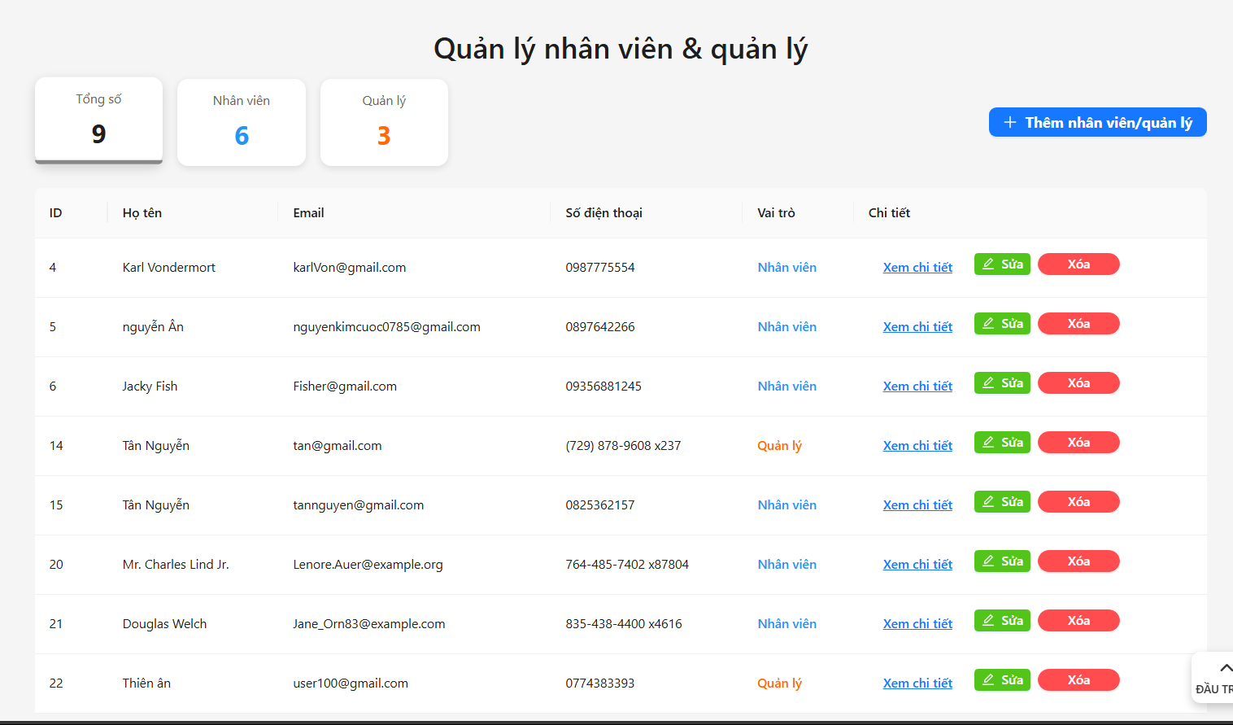

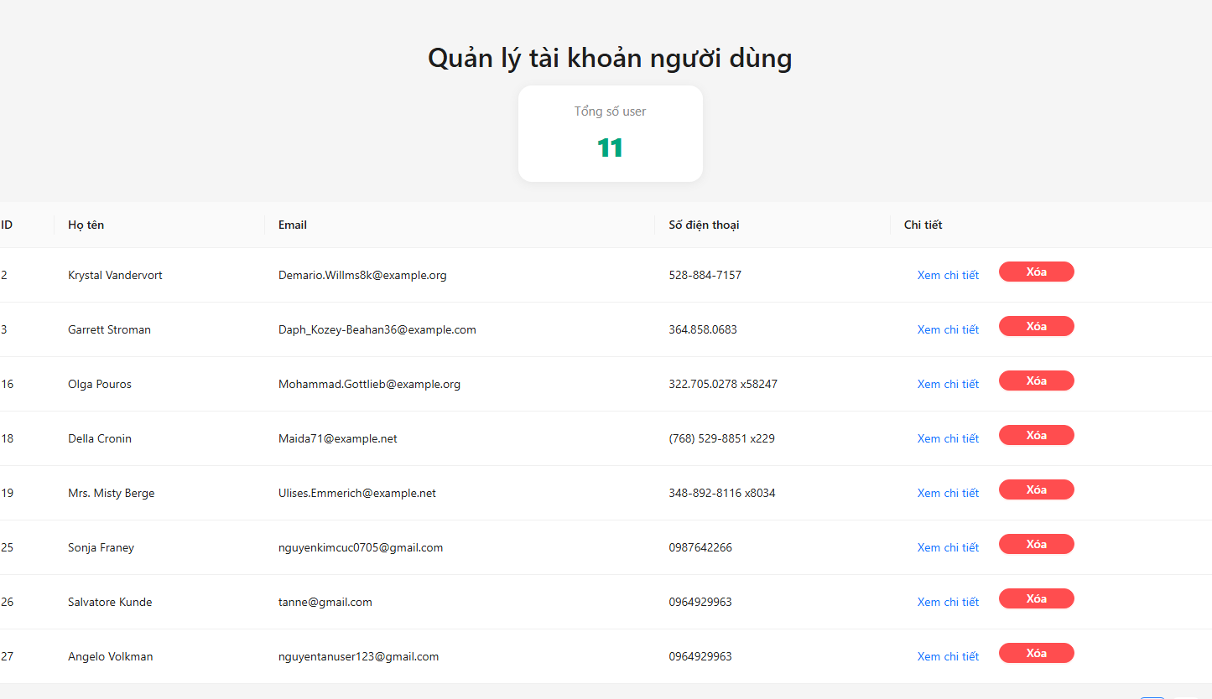

* **Function details**:
* List displays information about manager, staff, customer, view, edit and delete rights for admin
* Admin sets roles for Managers, Staffs, Customers

**10. Service Management**

**10.1 Customer, staff, manager management**

* **Function trigger**:  
  Admin after logging in -> click on "Service management"
* **Function description**:
* **Actors:** Admin
* **Purpose:** Admin can add, edit and delete services
* **Screen layout**:

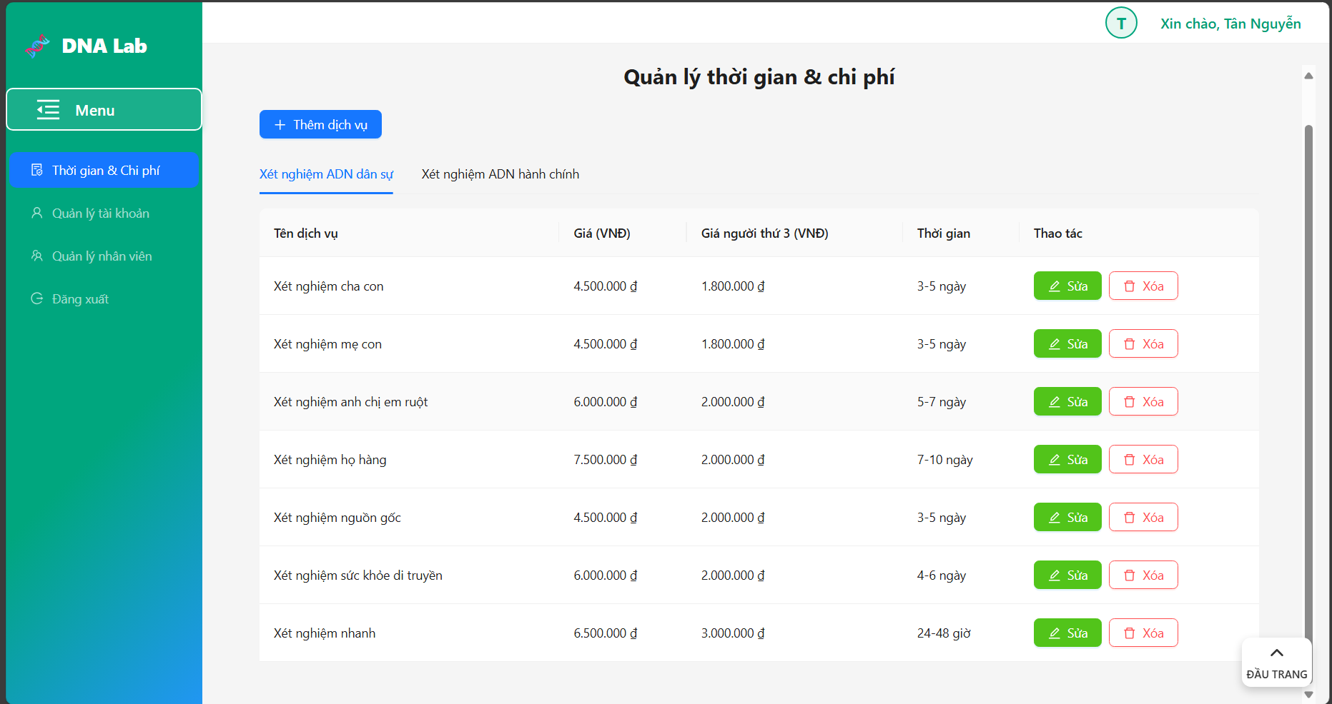

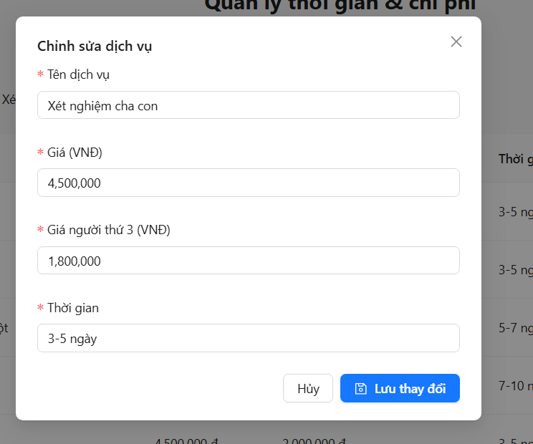

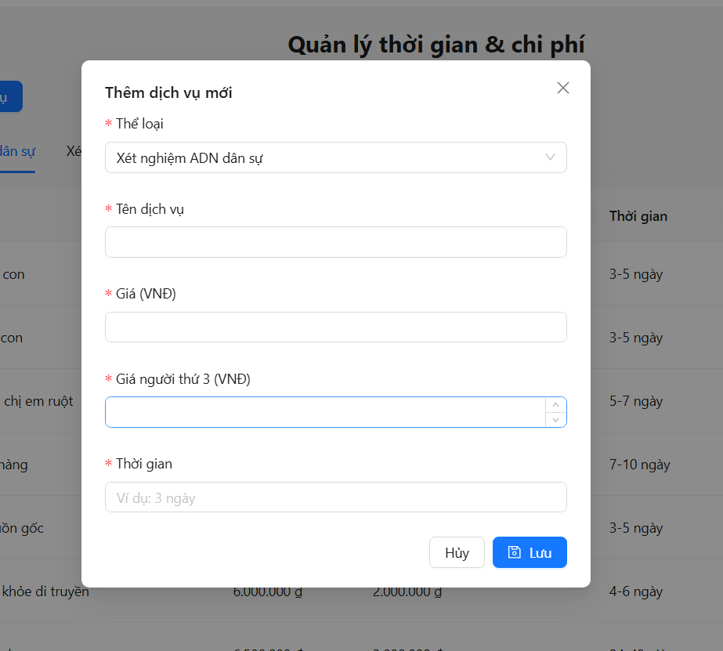

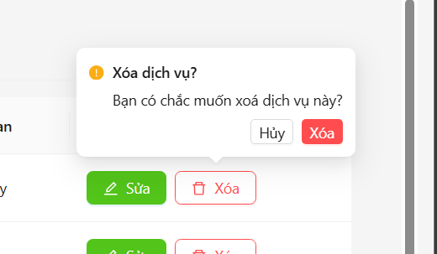

* **Function details**:
* Service management page displays:
  + Service name
  + Category
  + Service price
  + Number of samples
  + Test description
* Operation:
  + Add: click on add service to jump to the form to add new service
  + Edit: click on edit to jump to the form to edit existing service information, can update name, category, price, and description then click Update or Cancel
  + Delete: delete existing service

# V. Non-Functional Requirements

## 1. External Interface Requirements

### 1.1 User Interfaces

UI-1: UI-1: The DNA Testing Service Management System shall conform to a consistent web-based user interface standard, ensuring a uniform layout, color scheme (e.g., blue and white palette for professional appearance), and navigation structure across all screens (e.g., Home, Dashboard, Test Request, Feedback).

UI-2: Error messages shall be displayed in red, with clear, actionable instructions (e.g., “Invalid email format. Please enter a valid email address.”) and appear within 5 second of user input validation failure.

UI-3: The system shall provide responsive design, ensuring optimal display and functionality on desktop browsers (minimum 1024x768 resolution) and mobile browsers (minimum 320x568 resolution).

UI-4: The test process management interface shall display a tabular view of test requests with real-time status updates (e.g., Pending, Sample Received, Testing, Completed) and include interactive controls (e.g., “Update Status”, “Contact Customer”) for Staff to manage sample processing and handle errors. The interface shall highlight overdue tasks (e.g., samples not processed within 48 hours per) in red and provide a sortable table by Request ID, Customer Name, or Status.

UI-5: The detailed test process update interface shall provide a form-based layout for Staff to update individual test request details, including dropdowns for status (e.g., Sample Received, Testing, Completed), text fields for notes (e.g., defective sample details, and a “Contact Customer” button for initiating notifications. The form shall validate inputs (e.g., non-empty notes for defective samples) and display error messages within 5 second if validation fails (e.g., “Notes required for defective sample status”). The interface shall disable editing of results once approved by a Manager.

### 1.2 Software Interfaces

SI-1: Database Integration

SI-1.1: SI-1.1: The system shall interface with a relational database (e.g., Microsoft SQL Server) to store and retrieve user data, test requests, results, and feedback as defined in the Data Dictionary (Section IV.2.2 of Docs.docx).

SI-1.2: Data exchanges (e.g., saving test requests, retrieving results) shall use SQL queries with response times under 500 milliseconds for 95% of transactions under normal load.

SI-1.3: The system shall support data encryption for sensitive fields (e.g., Password, Test Results) during transmission to and from the database.

SI-2: Payment Gateway Integration

SI-2.1: The system shall integrate with a third-party payment gateway (e.g., Stripe, PayPal) to process payments for test requests, supporting credit/debit cards and digital wallets.

SI-2.2: Payment transactions shall be processed via secure REST API calls using HTTPS, with a maximum processing time of 5 seconds for 95% of transactions under normal load.

SI-2.3: The system shall log payment status (e.g., Success, Failed, Pending) in the database and display confirmation or error messages to Customers within 1 second of transaction completion (e.g., “Payment successful” or “Invalid card details”).

SI-4: Authentication Service Integration

SI-4.1: The system shall integrate with an authentication service (e.g., JSON Web Tokens or Firebase Authentication) to manage user login, registration, and session authentication for all roles.

SI-4.2: Authentication requests (e.g., token generation, validation) shall be processed via secure REST API calls using HTTPS, with a maximum response time of 1 second for 95% of requests under normal load.

SI-4.3: The system shall store session tokens securely in the client browser (e.g., HttpOnly cookies) and enforce account locking after 5 failed login attempts within 10 minutes.

### 1.3 Hardware Interfaces

HI-1: ***Server Configuration***

*Application Server*

CPU : Intel Xeon 8 Core 2.40 GHz

Memory Space : 64 GB RAM

Storage Space : 1 TB SSD, RAID 5 for redundancy

Operating System : Linux (Ubuntu Server 20.04) or Windows Server 2019

Software : .NET Core for application runtime

*Database Server*

CPU : Intel Xeon 12 Core 2.7 GHz or equivalent

Memory Space : 128 GB RAM

Storage Space : 2 TB SSD, RAID 10 for high availability

Operating System : Linux (Ubuntu Server 20.04) or Windows Server 2019

Software : Microsoft SQL Server 2019

HI-2: ***Client Configuration***

*PC Device*

CPU : Intel Core i5 2.5 GHz or equivalent

Memory Space : 8 GB RAM

Storage Space : 256 GB SSD

Operating System : Windows Win10/Win11

Operator Browser : Chrome 90+, Firefox 85+, or Edge 90+

Display : 15-inch, minimum 1280x720 resolutio

HI-3: ***Network***

LAN Network : Speed ≥ 1 Gbps for internal communications between application and database servers

WAN Network : Speed ≥ 50 Mbps for up to 100 concurrent users, ensuring low latency for webpage loading and data retrieval

### 1.4 Communications Interfaces

CI-1: REST API for Client-Server Communication:

* CI-1.1: The system shall use RESTful APIs over HTTPS to handle client-server data exchange for core functions, including user registration, login, test request submission, and report retrieval.
* CI-1.2: API requests shall complete within 1 second for 95% of transactions under normal load (up to 100 concurrent users), ensuring responsive user interactions.
* CI-1.3: API responses shall include JSON-formatted data with error codes and messages (e.g., 400 for invalid input) to support client-side validation and error handling.

CI-2: The system shall use HTTPS for all web communications to ensure secure data transmission between client browsers and the server.

CI-3: Logging Service Integration:

* CI-3.1: The system shall integrate with a logging service (e.g., Winston for Node.js or equivalent) to record system events, including user login attempts, test status updates, and errors (e.g., payment failures).
* CI-3.2: Log entries shall be written to the database or a secure file system within 1000 milliseconds of an event occurrence for 95% of events under normal load.
* CI-3.3: Logs shall include timestamps, user IDs (anonymized per SEC-5), and event details, accessible only to Admins for auditing purposes.

## 2. Quality Attributes

### 2.1 Usability

The system must be easy to use for both customers and medical staff. Users without technical skills should still be able to perform actions such as: booking appointments, tracking results, and downloading test reports. The system should also be mobile-friendly and support accessibility for people with disabilities.

USE-1: The system shall display success messages in green (e.g., “Login successful”) and error messages in red (e.g., “Incorrect password”) within 1 second of user actions, such as login, test request submission, or status updates.

USE-2: The login form shall require only two fields (Email, Password) and include a “Show Password” toggle to prevent input errors, ensuring Customers and Staff can log in easily.

USE-3: The system shall validate form inputs (e.g., Email, Test Type) in real-time, displaying inline error messages (e.g., “Email already in use”) within 500 milliseconds of input.

USE-4: The test progress tracking screen shall display a progress bar or status list (e.g., Pending, Sample Received, Testing, Completed) with color-coded statuses (e.g., green for Completed, yellow for Pending) for Customers to easily understand test stages.

USE-5: The system shall allow Staff to update test request statuses using a dropdown menu with predefined options (e.g., Sample Received, Testing, Completed), reducing input errors and ensuring updates in no more than 2 clicks.

USE-6: The result viewing screen shall present test results in a simple table format with clear column headers (e.g., Request ID, Test Type, Result, Date) and a “Download” button for Customers to access results easily.

USE-7: The system shall provide tooltips or help icons next to complex fields (e.g., Sample Collection Method, Report Filters) that display brief explanations (e.g., “Choose at-home or center collection”) when hovered or clicked.

USE-8: The system shall allow Managers and Admins to generate reports (by selecting predefined filters (e.g., date range, test type) from a dropdown menu, with a “Generate” button that produces the report in no more than 3 clicks.

USE-9: The system shall allow Customers to submit feedback using a form with no more than three fields (e.g., Rating, Comment, Test Request ID) and a “Submit” button, completing the process in no more than 2 clicks from the dashboard.

USE-10: The system shall display blog content in a list format with clear titles and dates, allowing Guests and Customers to access any blog post in 1 click from the homepage, with a “Read More” button for each post.

USE-11: The system shall display blog content in a list format with clear titles and dates, allowing Guests and Customers to access any blog post in 1 click from the homepage, with a “Read More” button for each post.

USE-12: The system shall allow Customers to update their profile information using a form with no more than four fields (e.g., FullName, Address, Phone, Email) and a “Save” button, completing the process in no more than 3 clicks from the account settings page, with clear labels for each field (e.g., “Enter your full name”).

### 2.2 Performance

The system needs to maintain fast response times and handle concurrent users efficiently.

PER-1: The system shall load the dashboard page within 2 seconds for 95% of requests on a standard client device (e.g., desktop with 8GB RAM, 10Mbps internet) under normal load (up to 100 concurrent users).

PER-2: The system shall process REST API calls for user login within 5 second for 95% of requests under normal load, ensuring rapid authentication.

PER-3: The system shall complete test request submission via REST API within 5 seconds for 95% of requests, including form validation and database storage.

PER-4: The system shall retrieve and display test progress details within 5 second for 95% of requests, using API calls to the database.

PER-5: The system shall load the test result viewing page within 5 seconds for 95% of requests, including retrieval of result data from the database.

PER-6: The system shall process feedback form submissions within 3 second for 95% of requests, including validation and storage in the database.

.

PER-7: The system shall load blog content within 4 seconds for 95% of requests, ensuring Guests and Customers can access public content quickly.

PER-8: The system shall validate form inputs (e.g., Email, Test Type) in real-time, providing feedback within 1000 milliseconds for 95% of inputs.

PER-9: The system shall handle up to 100 concurrent users performing core actions (e.g., login, test request submission, result viewing) with no more than a 10% increase in response times compared to a single user.

### 2.3 Security

As the system processes biological and sensitive personal data (e.g., DNA, full name, relationship), a high level of security is required.

SEC-1: The system shall use HTTPS for 100% of API communications, ensuring encrypted data transmission (e.g., login, test requests).

SEC-2: The system shall encrypt sensitive data (e.g., Password, Test Results) in the database using AES-256, protecting user privacy.

SEC-3: The system shall anonymize customer data in reports using Request ID instead of FullName or Email.

SEC-4: The system shall validate all user inputs (e.g., Email for FR-02, Test Type for FR-05) to prevent SQL injection and XSS attacks, achieving 100% detection.

SEC-5: The system shall enforce passwords of at least 8 characters, and symbols for user registration.

### 2.4 Safety

Although this is a software system, it influences critical decisions (establishing paternity, legal disputes, custody rights), and errors could lead to severe consequences. Therefore, the system must prevent serious mistakes through confirmation steps, warnings, and thorough input validation.

SAF-1: The system shall achieve a 99% success rate for test request submissions under normal load (100 concurrent users), ensuring data is stored correctly.

SAF-2: The system shall maintain 99.9% data integrity for test results (FR-10) during database operations (SI-1), preventing data loss or corruption.

SAF-3: The system shall detect 95% of invalid inputs (e.g., email, test type) and display error messages without crashing.

SAF-4: The system shall ensure 99% successful user logins with valid credentials under normal load, minimizing authentication failures.

SAF-5: The system shall complete test status updates with a 99% success rate, ensuring accurate database updates.

SAF-6: The system shall process feedback submissions with a 99% success rate, ensuring data is stored correctly in the database.

### 2.5 Availability

AVL-1: The system shall provide 24/7 access to blog content for Guests and Customers, with no downtime except during maintenance.

AVL-2: The system shall support 100 concurrent users without downtime for login, test requests, and results.

AVL-3: The system shall ensure API availability for 99% of requests, supporting test submissions and reports.

AVL-4: The system shall maintain database connectivity for 99.5% of operational time, ensuring data access for all functions.

### 2.6 Reliability

REL-1: The system shall use HTTPS for 100% of API communications, ensuring encrypted data transmission for all user interactions (e.g., login, test requests).

REL-2: The system shall maintain 99.9% data integrity for test results during database operations, preventing data loss.

REL-3: The system shall detect 100% of invalid inputs (e.g., email, test type) and display error messages without crashing.

REL-4: The system shall ensure 99% successful logins (FR-03, SI-4) with valid credentials under normal load, minimizing authentication failures.

REL-5: The system shall complete test status updates with a 99% success rate, ensuring accurate database updates.

REL-6: The system shall process feedback submissions with a 99% success rate, ensuring data is stored correctly.

### 2.7 Design Contrainsts

DES-1: The system shall use JavaScript, React, and Dotnet Framework for all client-side and server-side development to ensure a consistent web-based platform.

DES-2: The system shall use MySQL as the database , ensuring compatibility with standard SQL for data storage (e.g., test requests).

DES-3: The system shall implement a REST API for all data interactions (e.g., login, test submissions), using JSON format.

DES-4: The system shall use Bootstrap, ant design, tailwind for responsive UI design, ensuring compatibility across devices (320px to 1920px screens).

DES-5: The system shall implement static HTML/CSS for blog content, ensuring fast rendering without server-side processing.

DES-6: The system shall support a maximum of 100 concurrent users for all core functions, avoiding complex scaling mechanisms

DES-7: The system shall use standard HTTP methods (GET, POST) for all API endpoints (CI-1), ensuring compatibility with any HTTP client.