After I run npm install command, the node_modules folder will be created automatically, and after that, I run eb init to initialize the configurations for elastic beanstalk, for 4 results below, I choose 1 for the region account and Node.Js 16 to synchronize my local machine and EC2 instances environment and a default keypair on my account (provided by udacity), you can see the 1st screenshot is the region account to set up elastic beanstalk configurations

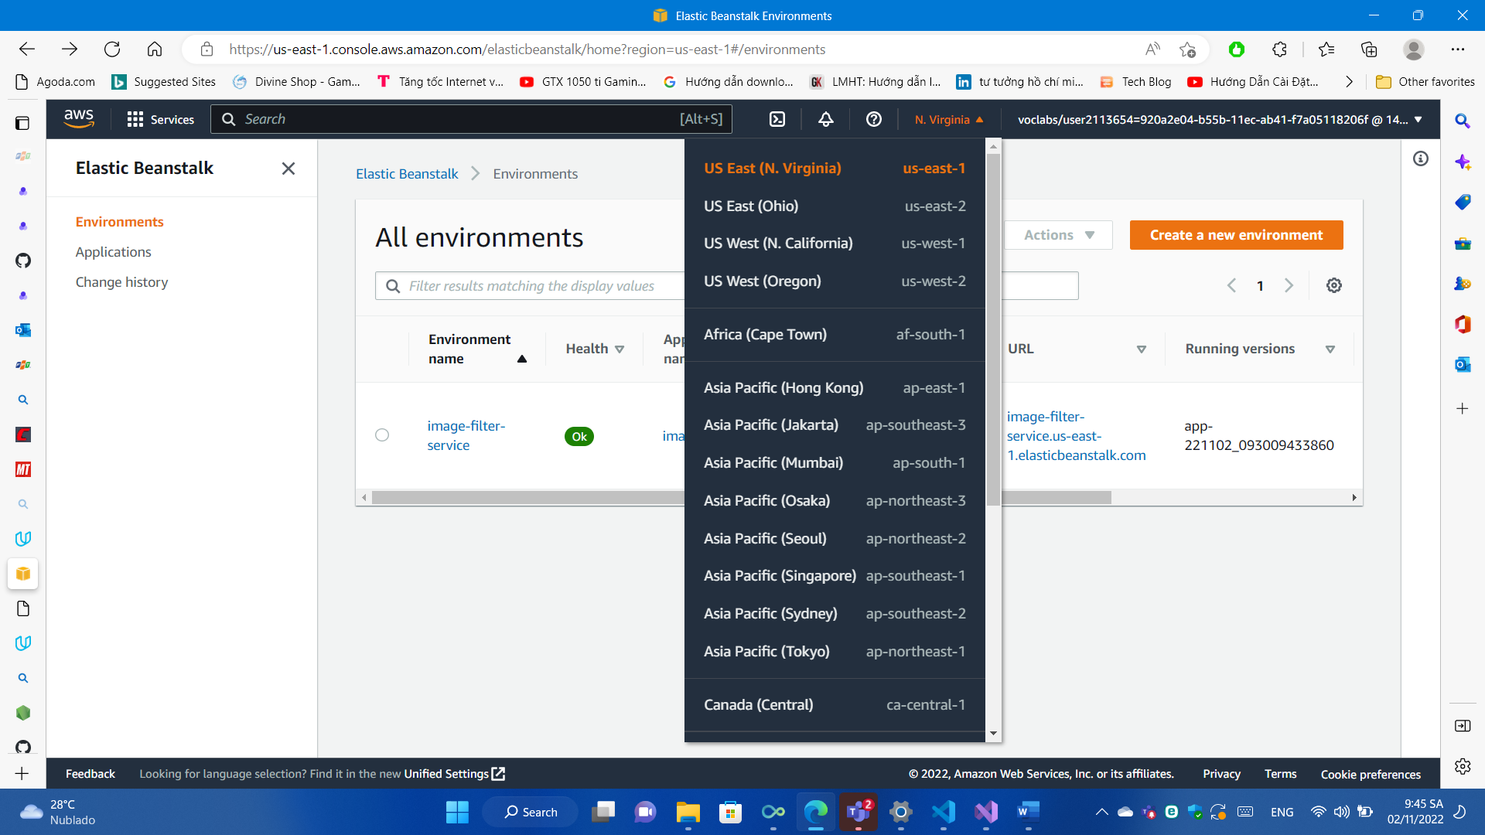

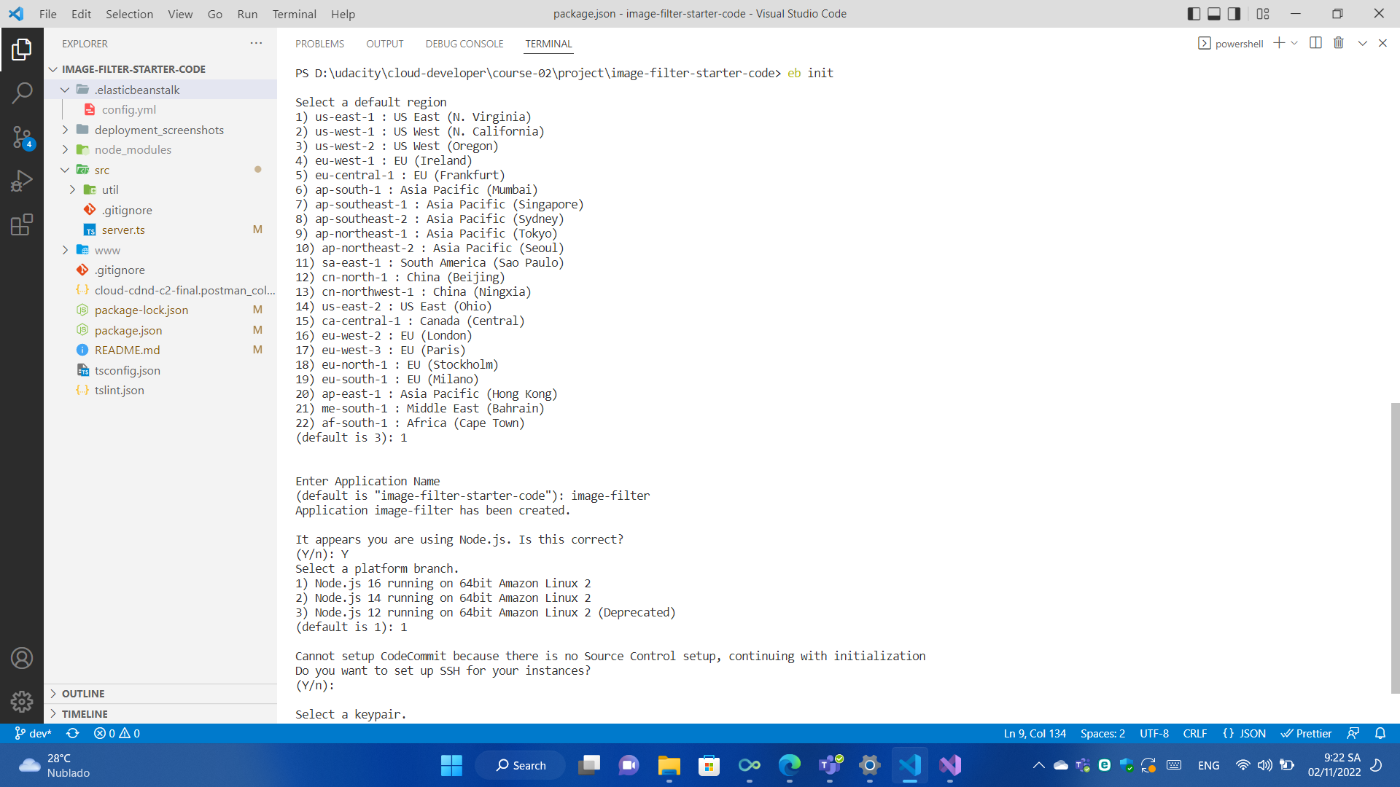

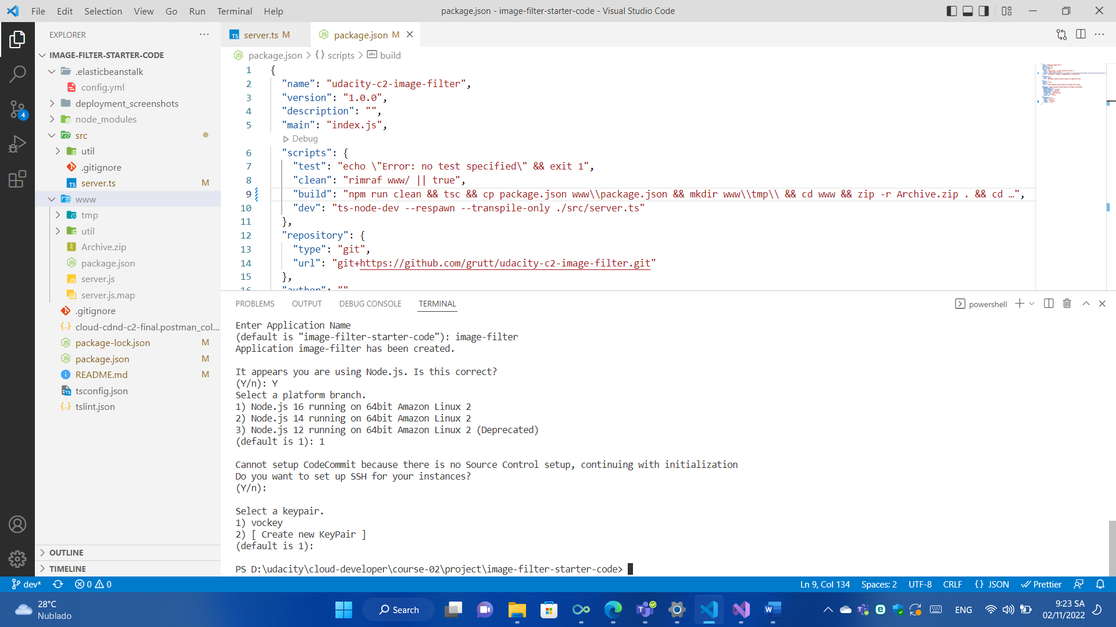

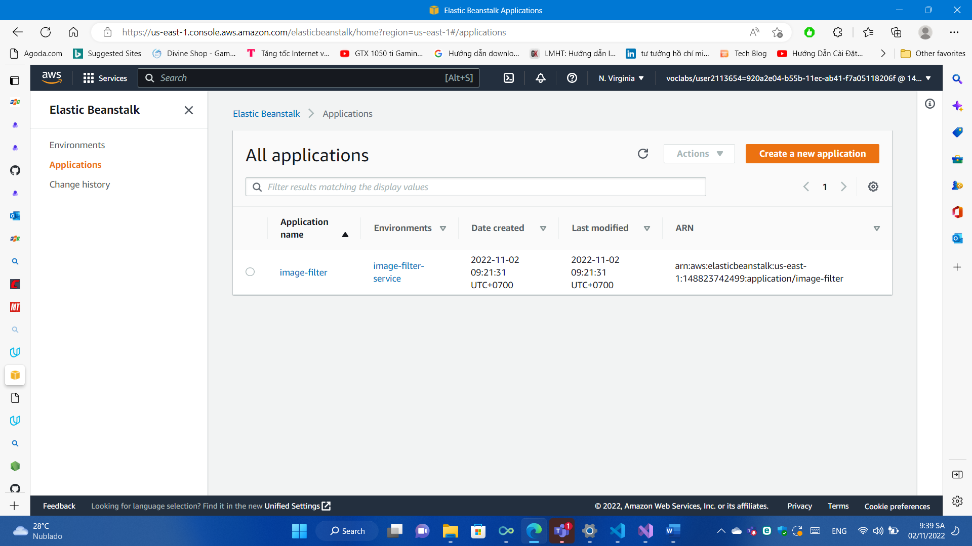

After configure the elastic beanstalk successfully, I build the project by using command npm run build. Before that, I change the code in build key according to the results below:

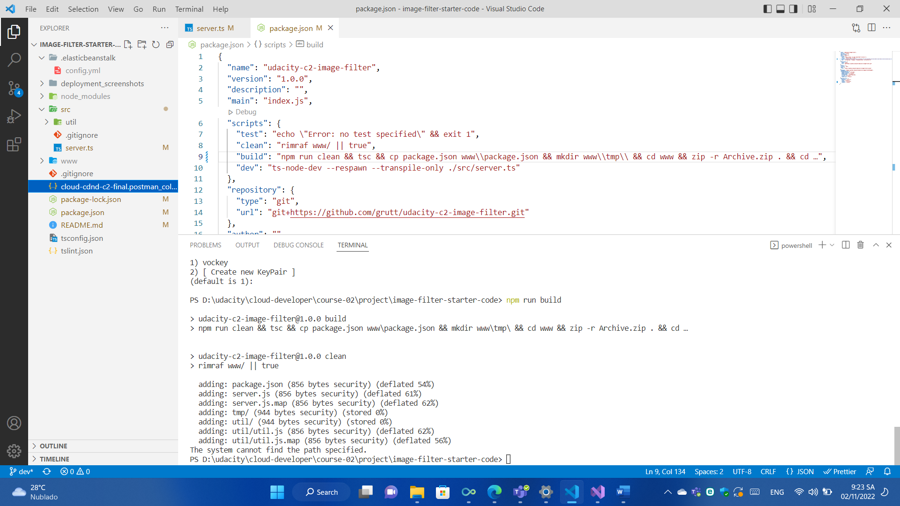

After build the project successfully, I run eb create to create the environment name “image-filter-service". Because the space of the terminal is limited, so I can only take a screenshot for the result after I run “eb create” command

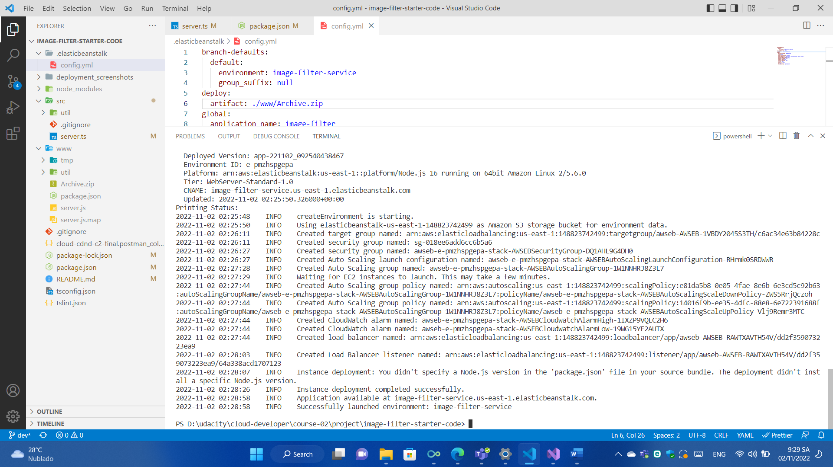

We can check the environment in AWS Web Console too

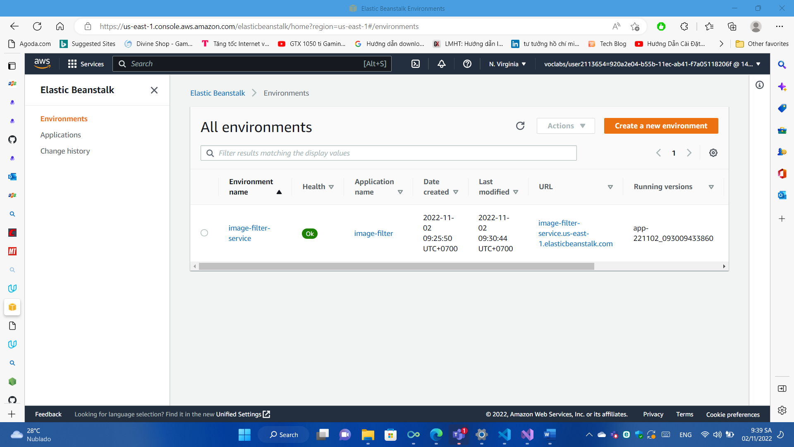

After create environment by using eb create, I can finally push all changes by using eb deploy. Because the space of the terminal is limited, so I can only take a screenshot for the result after I run “eb deploy” command

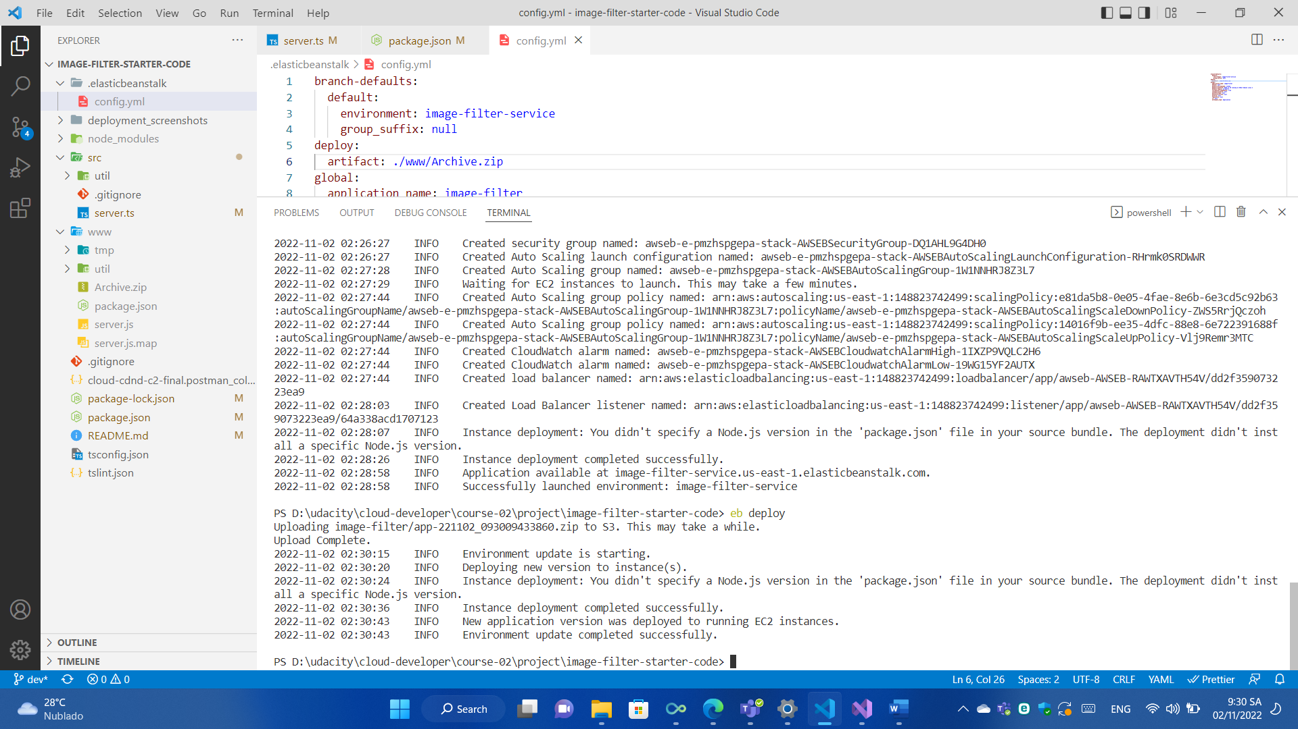

And here is the result between localhost and eb url. I have put the sample url to allow mentors to test in the readme.md. Check the section ### Elastic Beanstalk URL and localhost on local environment too

