Given database (You must use RoleDB for this)

USE [RoleDB]  
GO  
/****** Object: Table [dbo].[Features] Script Date: 10/15/2018 10:04:48 ******/  
SET ANSI_NULLS ON  
GO  
SET QUOTED_IDENTIFIER ON  
GO  
SET ANSI_PADDING ON  
GO  
CREATE TABLE [dbo].[Features](  
 [featureid] [int] NOT NULL,  
 [url] [varchar](250) NOT NULL,  
 CONSTRAINT [PK_Features] PRIMARY KEY CLUSTERED   
(  
 [featureid] ASC  
)WITH (PAD_INDEX = OFF, STATISTICS_NORECOMPUTE = OFF, IGNORE_DUP_KEY = OFF, ALLOW_ROW_LOCKS = ON, ALLOW_PAGE_LOCKS = ON) ON [PRIMARY]  
) ON [PRIMARY]  
GO  
SET ANSI_PADDING OFF  
GO  
INSERT [dbo].[Features] ([featureid], [url]) VALUES (2, N'/insert')  
INSERT [dbo].[Features] ([featureid], [url]) VALUES (3, N'/edit')  
INSERT [dbo].[Features] ([featureid], [url]) VALUES (4, N'/detail')  
  
/****** Object: Table [dbo].[Role_Feature] Script Date: 10/15/2018 10:04:48 ******/  
SET ANSI_NULLS ON  
GO  
SET QUOTED_IDENTIFIER ON  
GO  
CREATE TABLE [dbo].[Role_Feature](  
 [roleid] [int] NOT NULL,  
 [featureid] [int] NOT NULL,  
 CONSTRAINT [PK_RoleFeatureDetail] PRIMARY KEY CLUSTERED   
(  
 [roleid] ASC,  
 [featureid] ASC  
)WITH (PAD_INDEX = OFF, STATISTICS_NORECOMPUTE = OFF, IGNORE_DUP_KEY = OFF, ALLOW_ROW_LOCKS = ON, ALLOW_PAGE_LOCKS = ON) ON [PRIMARY]  
) ON [PRIMARY]  
GO  
INSERT [dbo].[Role_Feature] ([roleid], [featureid]) VALUES (1, 2)  
INSERT [dbo].[Role_Feature] ([roleid], [featureid]) VALUES (1, 3)  
INSERT [dbo].[Role_Feature] ([roleid], [featureid]) VALUES (1, 4)  
INSERT [dbo].[Role_Feature] ([roleid], [featureid]) VALUES (2, 2)  
INSERT [dbo].[Role_Feature] ([roleid], [featureid]) VALUES (3, 3)  
INSERT [dbo].[Role_Feature] ([roleid], [featureid]) VALUES (3, 4)  
INSERT [dbo].[Role_Feature] ([roleid], [featureid]) VALUES (4, 4)  
/****** Object: ForeignKey [FK_Role_Feature_Features] Script Date: 10/15/2018 10:04:48 ******/  
ALTER TABLE [dbo].[Role_Feature] WITH CHECK ADD CONSTRAINT [FK_Role_Feature_Features] FOREIGN KEY([featureid])  
REFERENCES [dbo].[Features] ([featureid])  
GO  
ALTER TABLE [dbo].[Role_Feature] CHECK CONSTRAINT [FK_Role_Feature_Features]  
GO  
/****** Object: ForeignKey [FK_Role_Feature_Role] Script Date: 10/15/2018 10:04:48 ******/  
ALTER TABLE [dbo].[Role_Feature] WITH CHECK ADD CONSTRAINT [FK_Role_Feature_Role] FOREIGN KEY([roleid])  
REFERENCES [dbo].[Roles] ([roleid])  
GO  
ALTER TABLE [dbo].[Role_Feature] CHECK CONSTRAINT [FK_Role_Feature_Role]  
GO

1. Create a page which will load all users and roles to dropdownlist at the running time



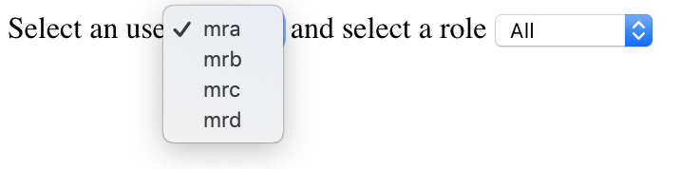

2. When users select an user from the list, output corresponding roles of selected user to the second dropdownlist

All is used for all fearures of selected user

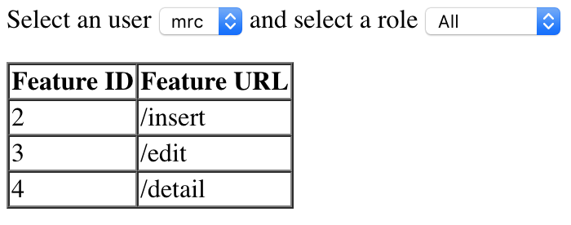

Now select a role

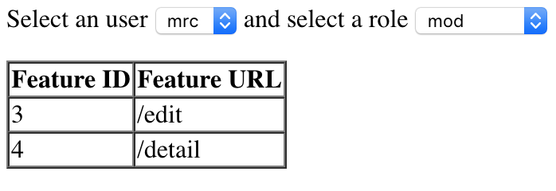

You should create class for Feature, FeatureDAO

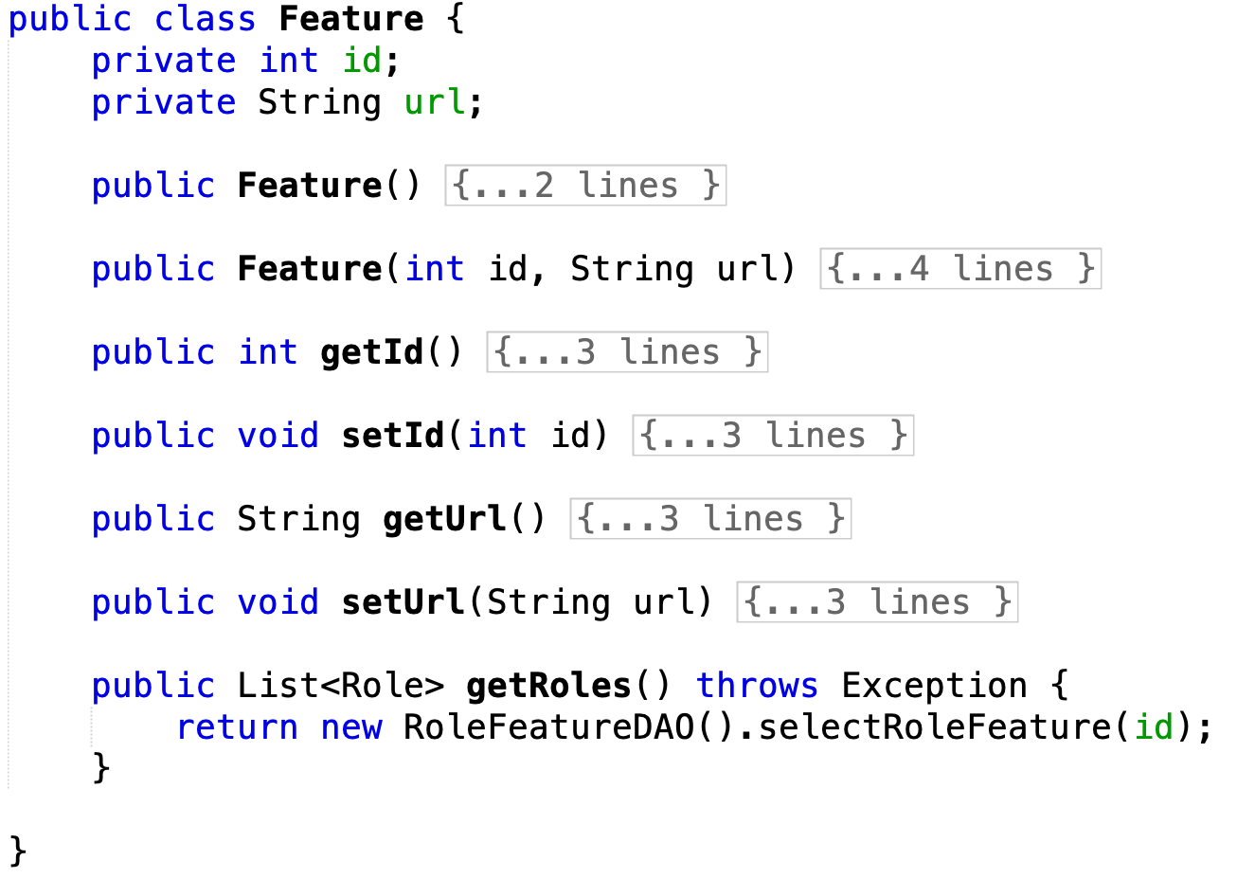

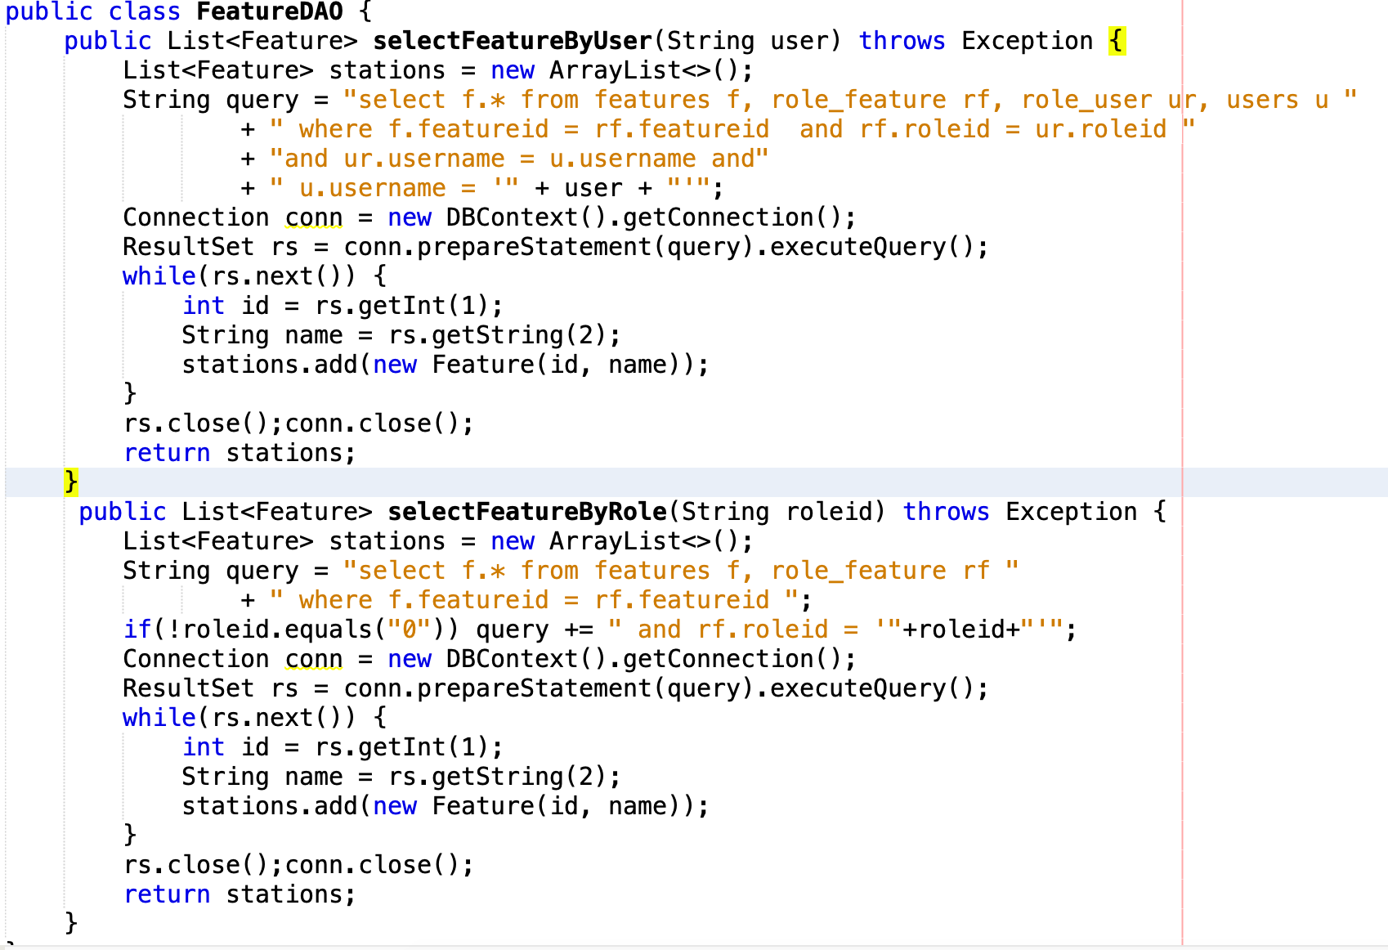

For the controller named RoleController

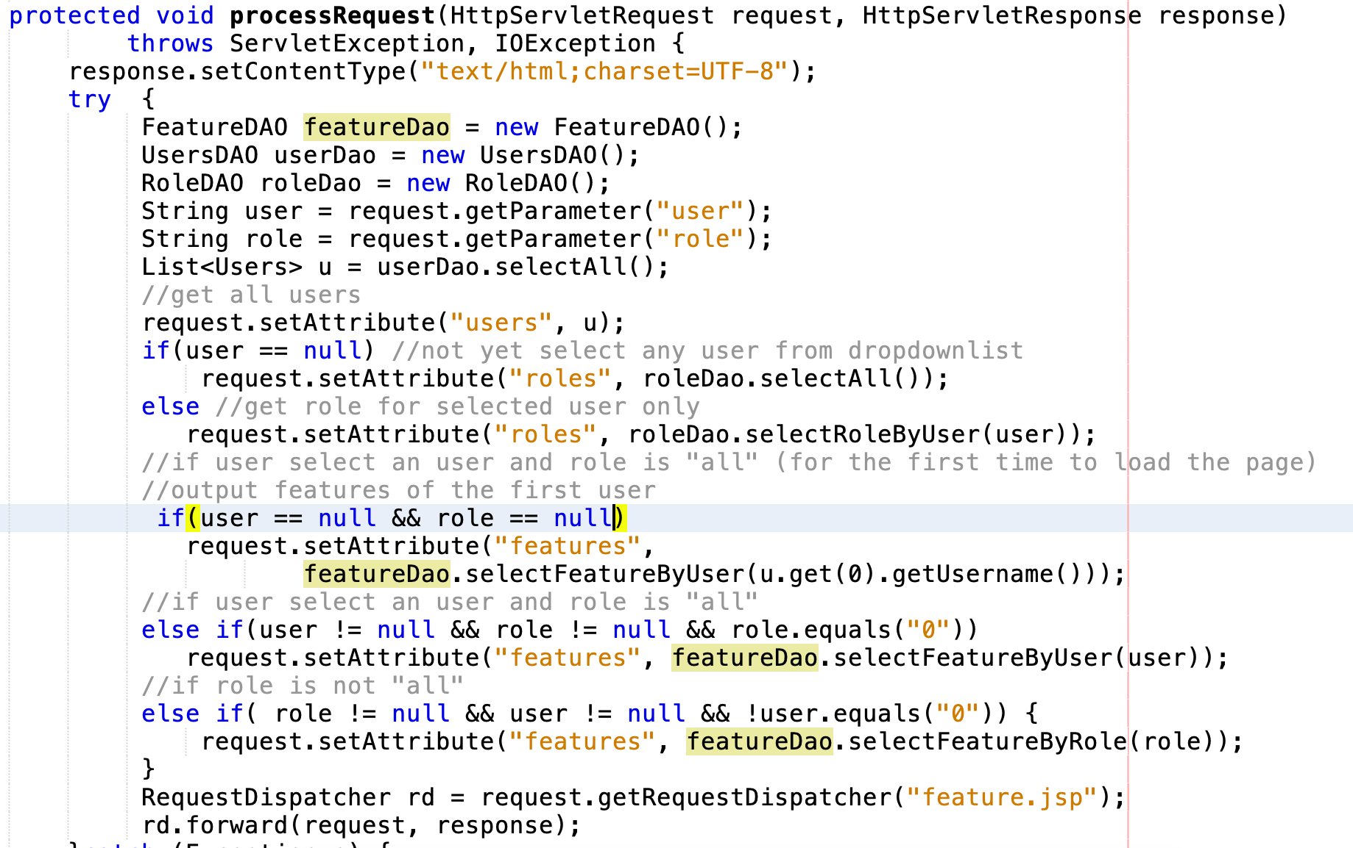

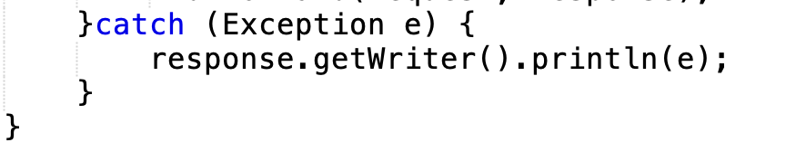

The view (feature.jsp)

