**Q1:**

Create a student.html which have a student form

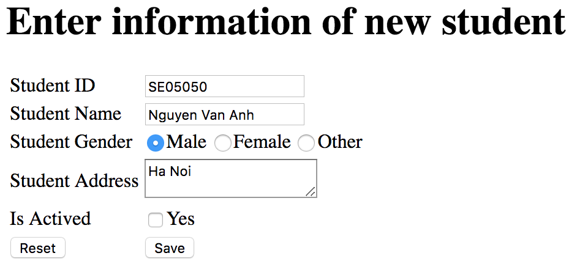

When users enter values for students and click on **Save**, submit entered data to a servlet StudentServlet and output entered student. To reset the form click **“Reset”**

**url =** [**http://localhost:8080/FinalQ1_SE05050**](http://localhost:8080/FinalQ1_SE05050)**/student.html**

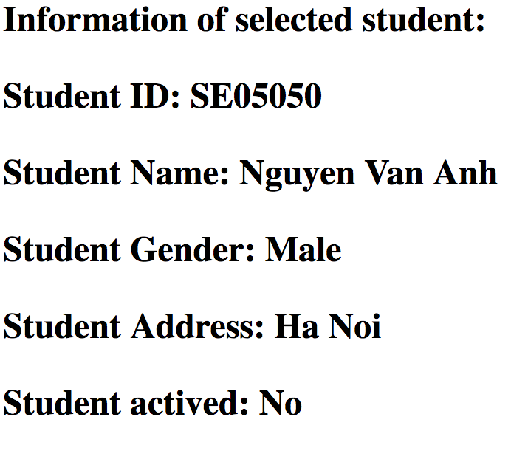

**Q2:**

You are required to use RequestDB to be able to answer the below questions.

<http://localhost:8080/FinalQ2_SE05050/EmployeeRequest/list>

http://localhost:8080/FinalQ2_SE05050/EmployeeRequest/add

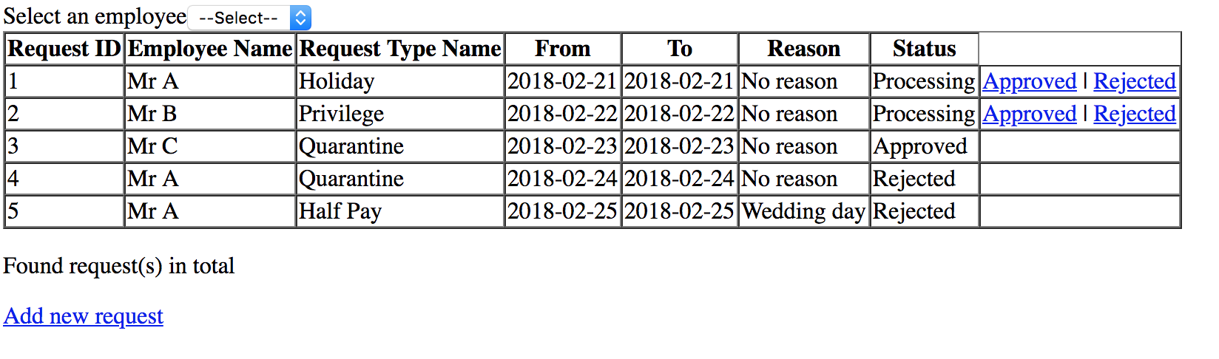

**Requirements:**

* Load all employees to dropdownlist, display employee name, by default item “—select—“ is selected
* When users select an employee from dropdownlist, output information of requests of selected employee
* For request which status is Processing, users are allowed to approved or rejected. Update current page right after the updating.

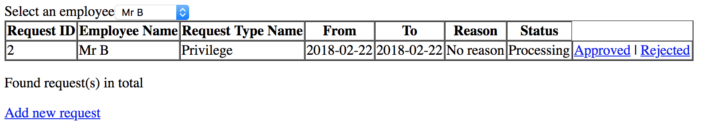

Some guideline

1. You should create some entities

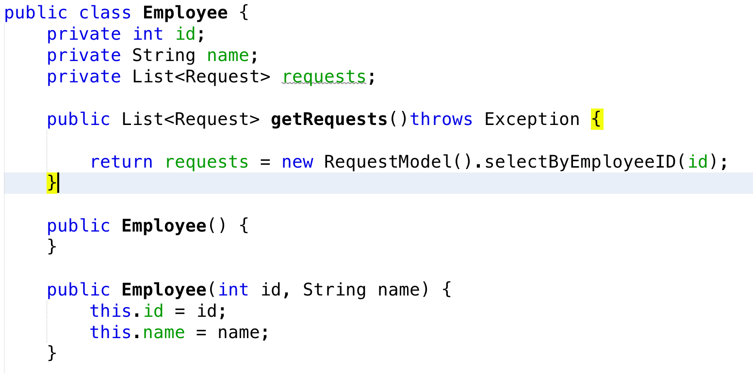

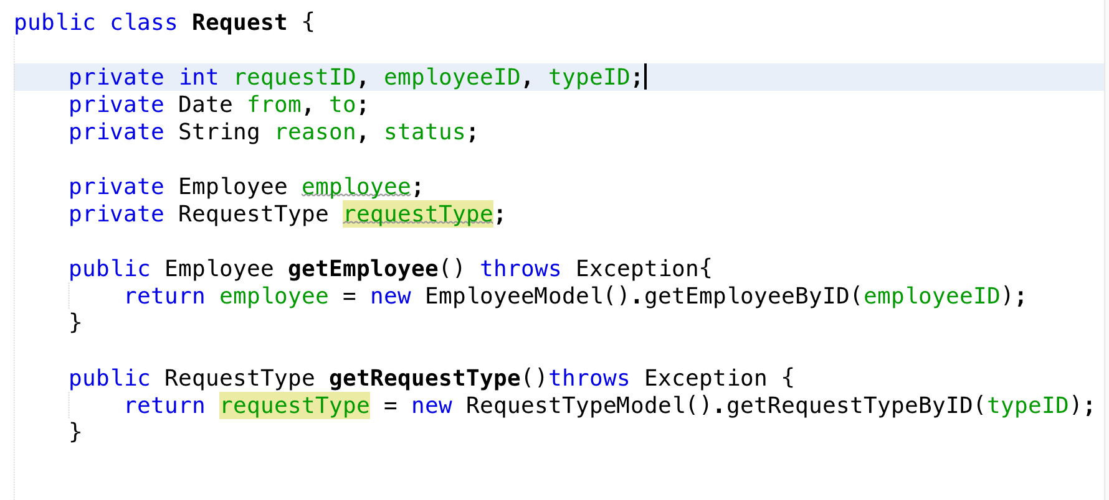

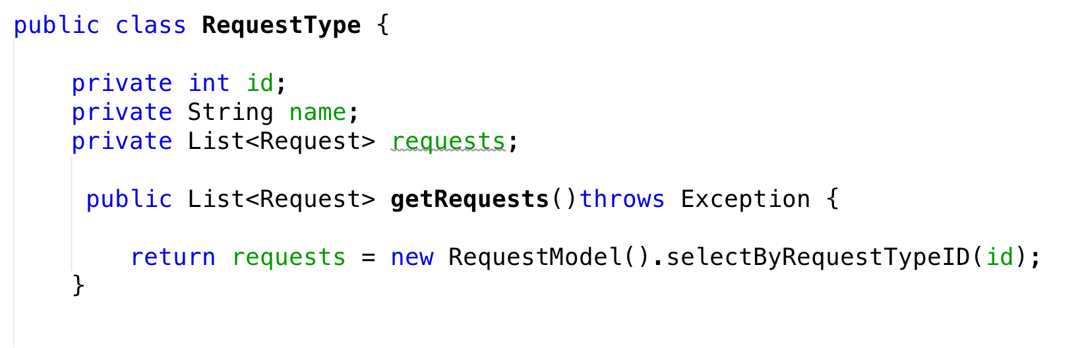

1. Some DAO classes for accessing data

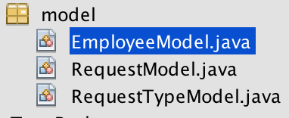

1. javabean can be used for this problem

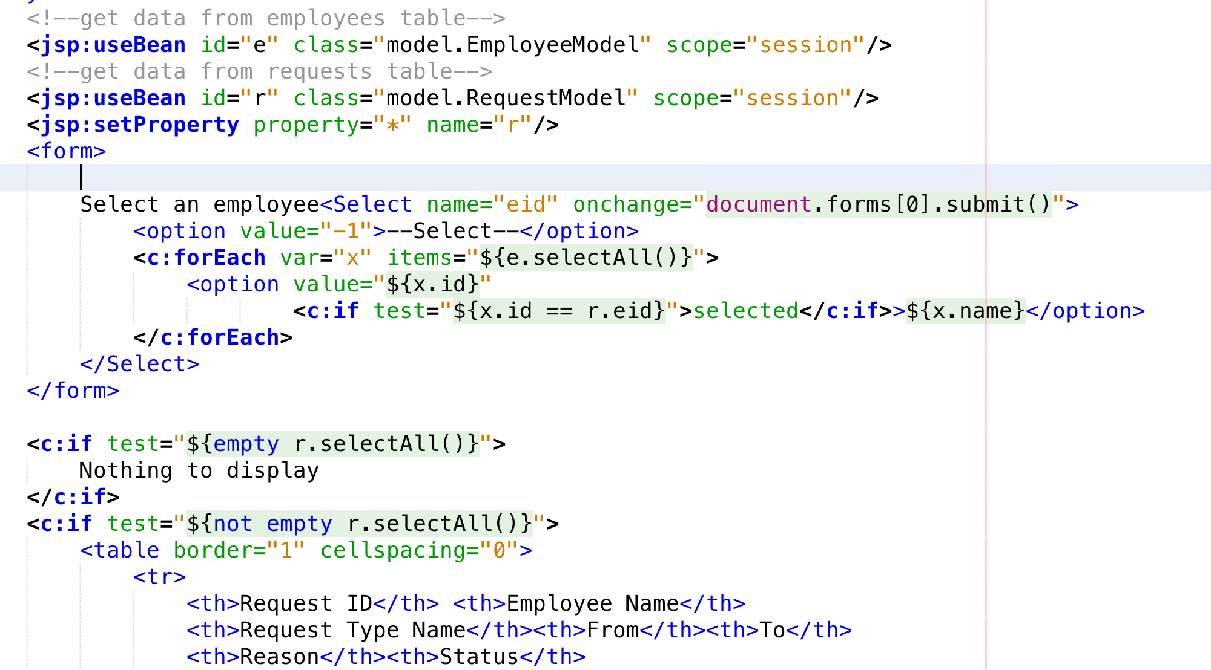

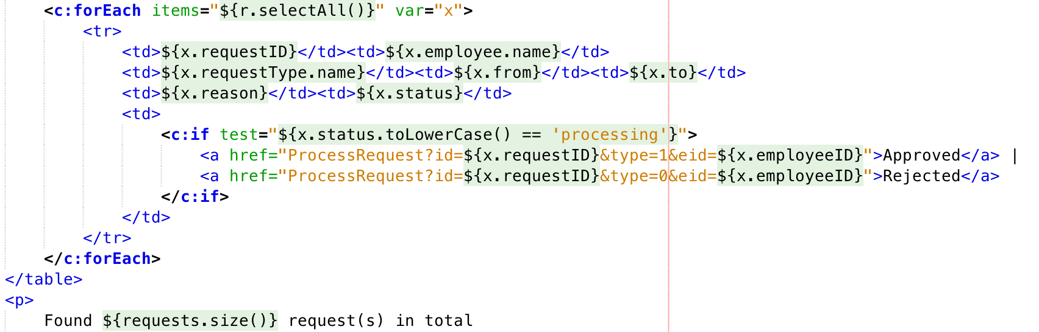

Solution 2 (use servlet and controller)

<http://localhost:8080/FinalQ2_SE05050/EmployeeRequest/list>

**1. Servlet(Controller)**

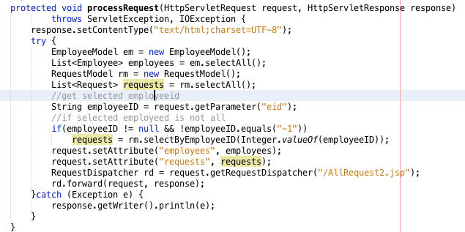

**2.JSP(view)**

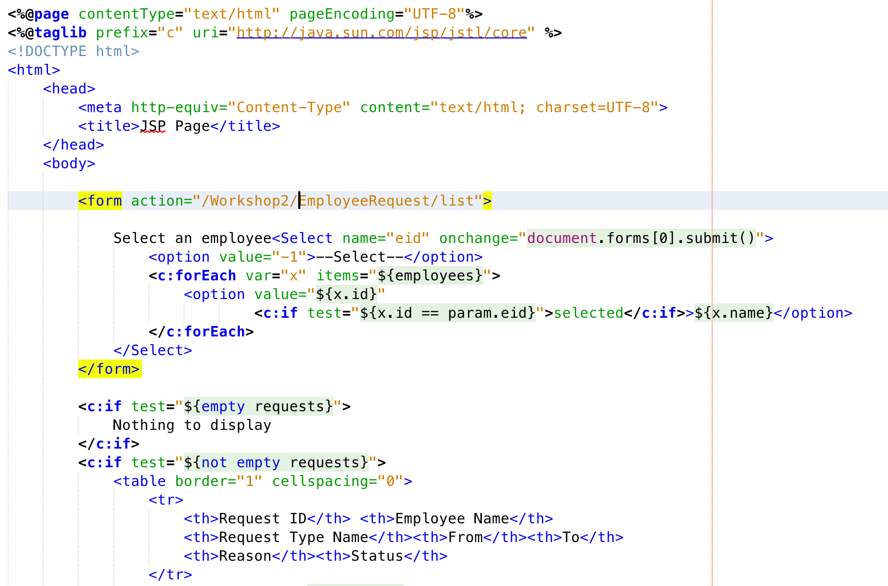

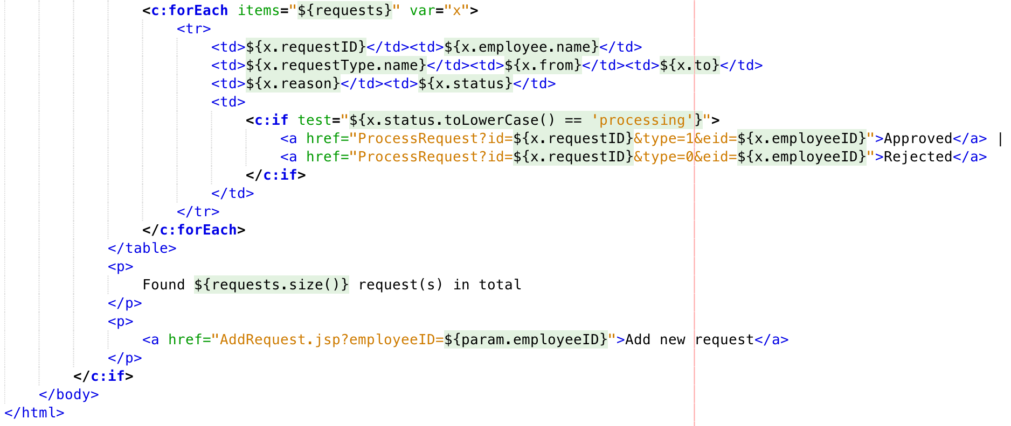

The workshop is ended here

Bonus at home for Add new request

