You must use **RoleDB** for these questions

Given url for the controller, where WS2UserRoleDB is named of project

[http://localhost:8080/WS2UserRoleDB/UserRole/Add](http://localhost:8080/UserRole/Add)

1. Create a page which will load all users and available roles (roles that are not assigned to selected username) to dropdownlist at the running time.

The list is used to output information of all assigned role to a selected username

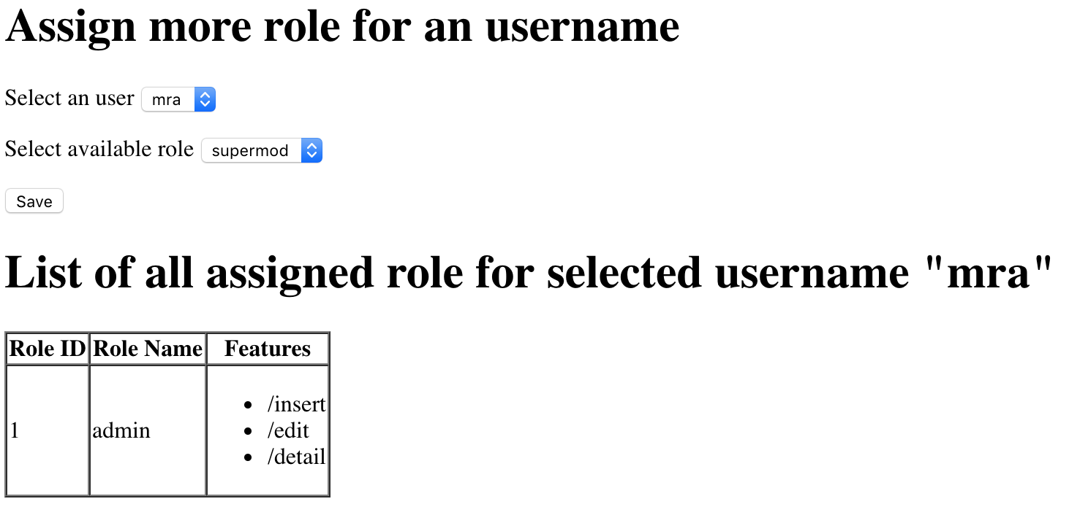

When users select an user from the list, output all available roles for selected user (the role which are not yet assigned to selected user)

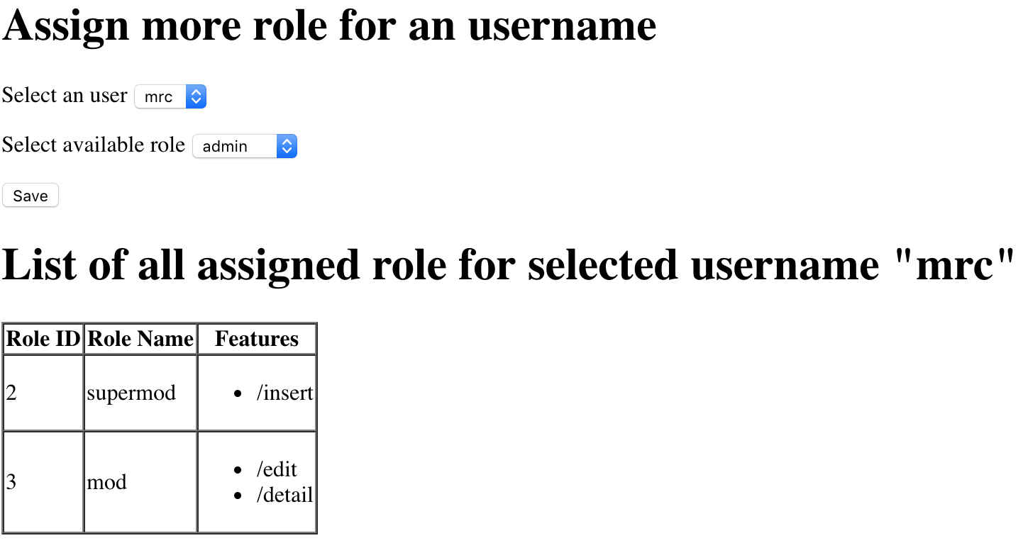

When users click on Save button, insert selected username and rolename to table User_Role, the page should be reloaded automatically.

**0. You should create class for Users, Role, Feature**

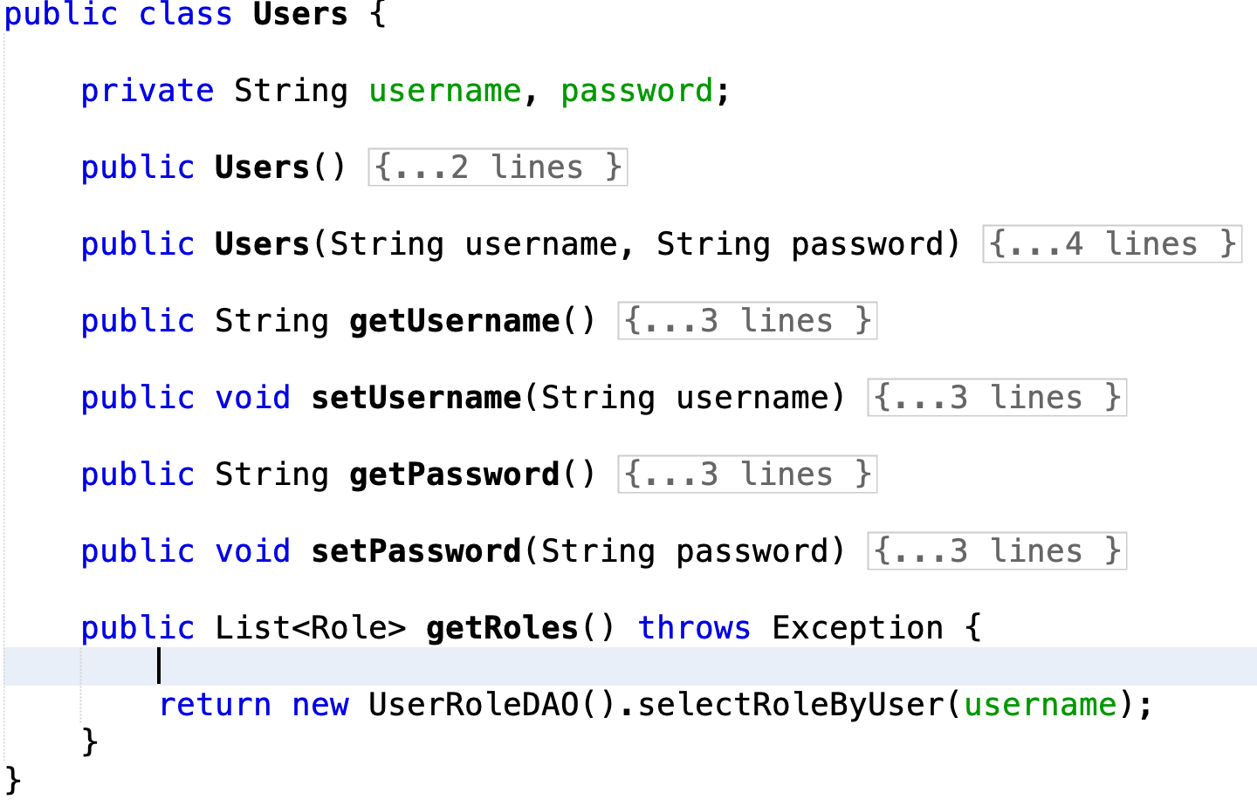

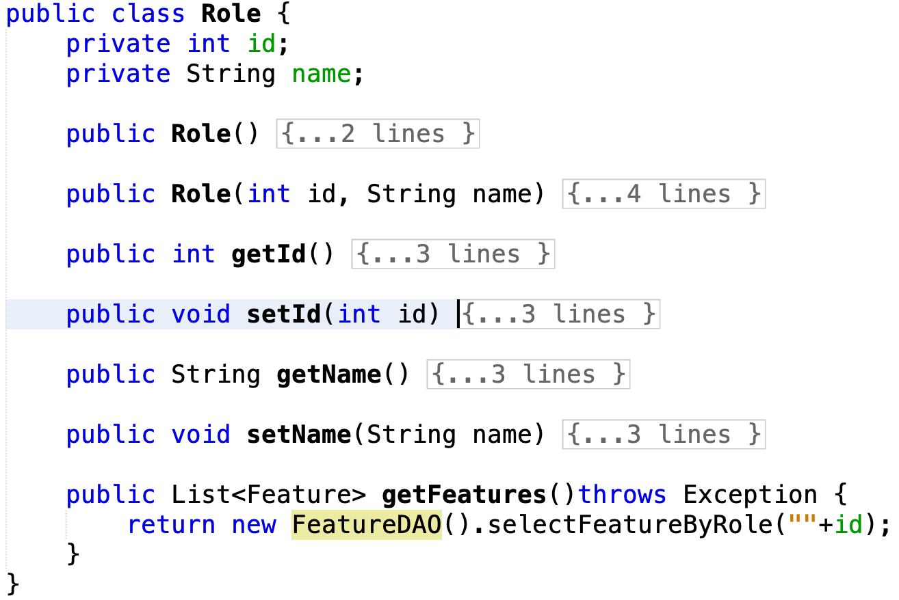

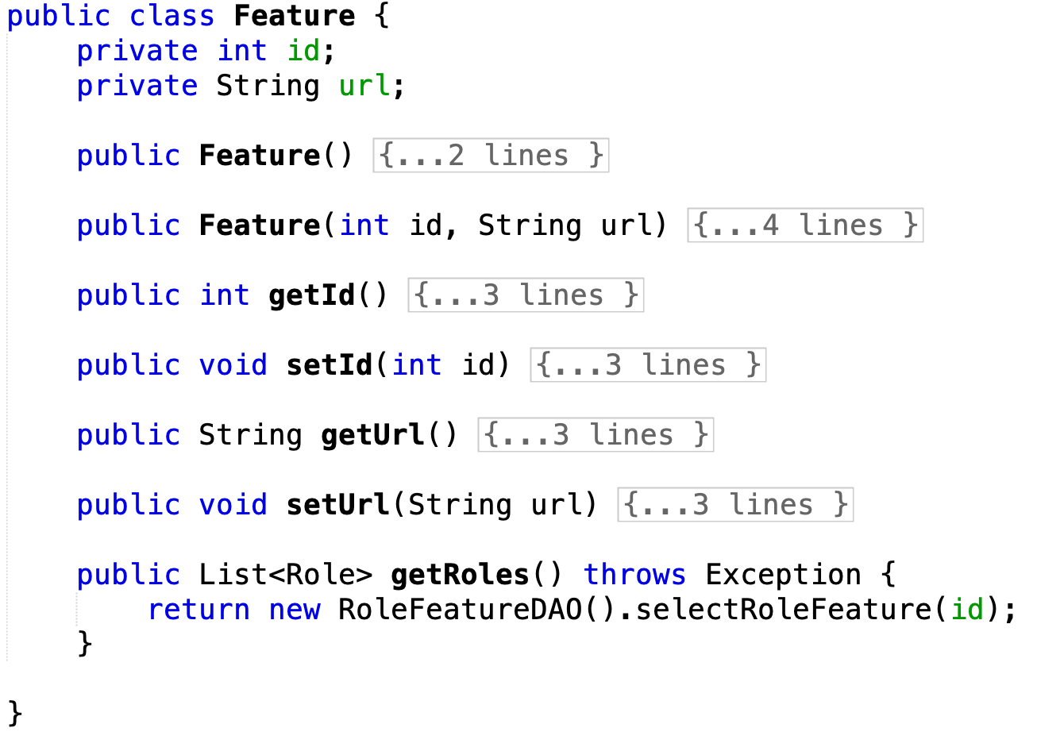

**1. DAO classes: UsersDAO, UserRoleDAO and FeatureDAO**

**UsersDAO**

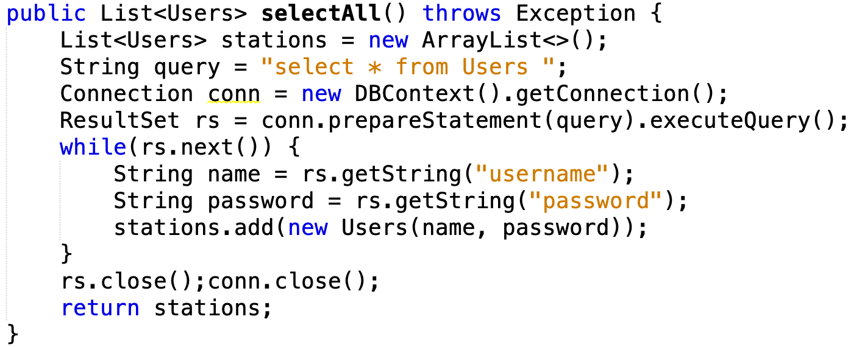

**UserRoleDAO**

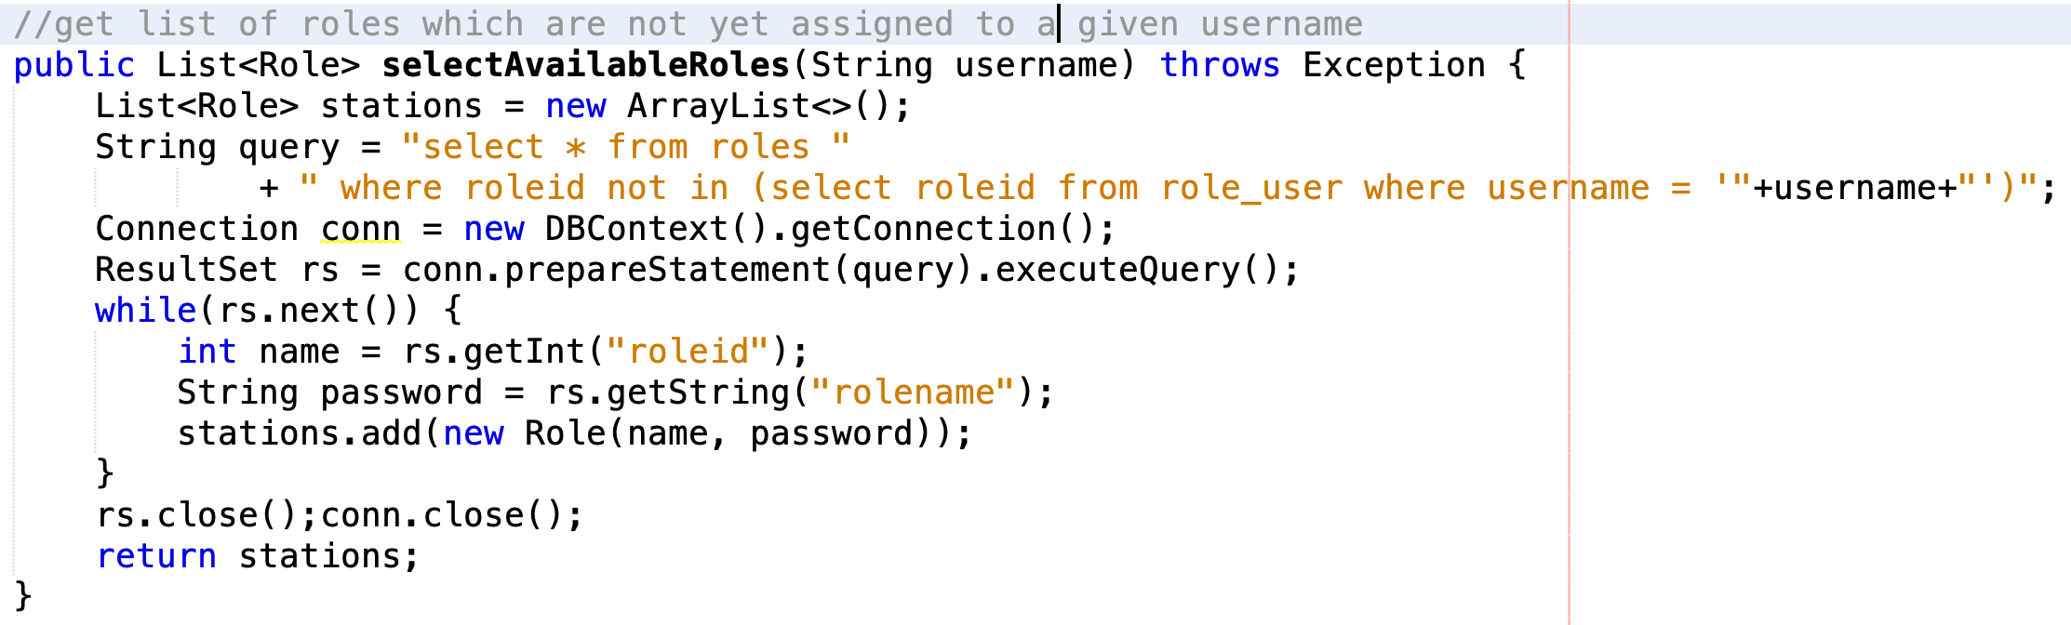

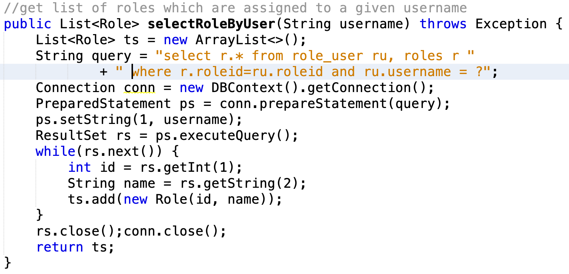

**FeatureDAO**



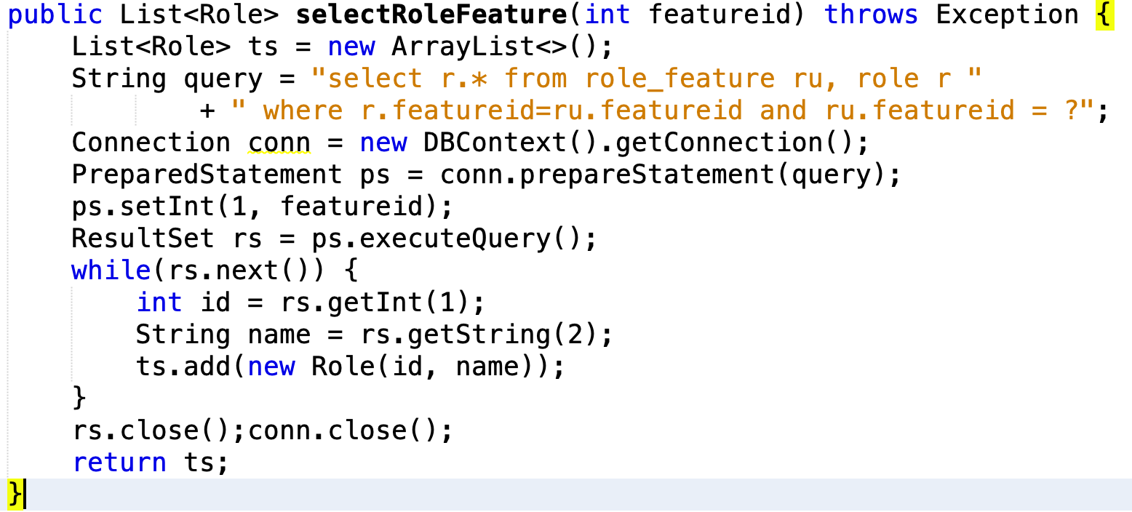

**2. For the controller named UserRoleController**

Be informed that the url of this controller is /UserRole/Add

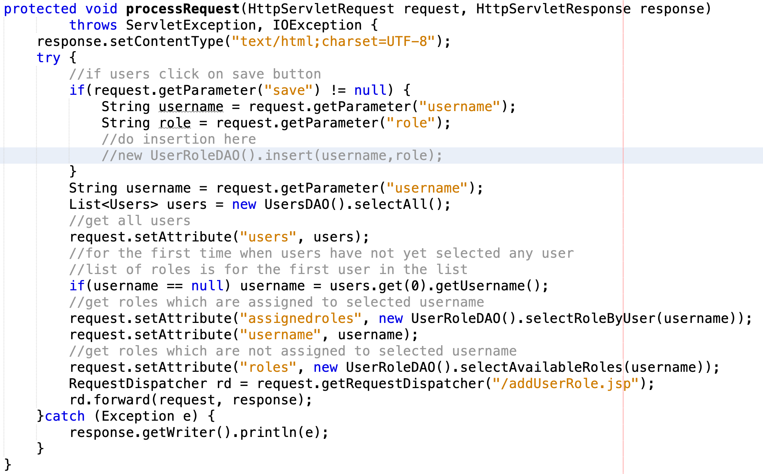

**3. The view (addUserRole.jsp)**

