SETUP REACT JS PROJECT WITH TYPESCRIPT

1. **Setup project with create-react-app**

* Run the following command:

 npx create-react-app project_name --typescript

* Remove redundant files

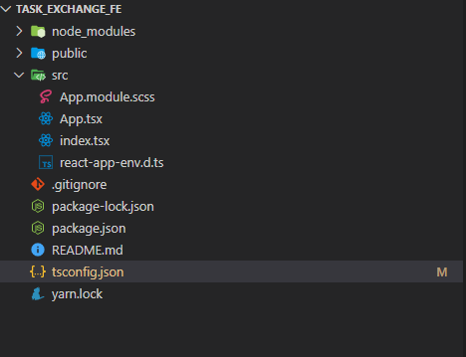

* Add base URL at tsconfig file

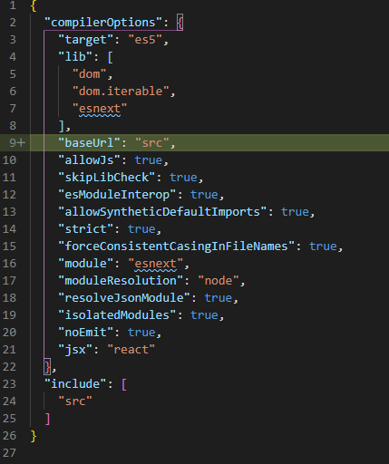

* Setup sass

Run the following command:

npm install node-sass --save

Create sass file with .sass extension or we can create style module with .module.sass extension.

* Setup react-router-dom

*Note: The issue with nested route with base URL. The issue is occurred because react-router does not strip the trailing slashes.

This issue can be found here <https://stackoverflow.com/questions/59437035/react-router-nested-routing-in-the-base-url>

Solution can be found here

<https://codesandbox.io/s/react-router-nesting-025cn?file=/example.js:998-1090>

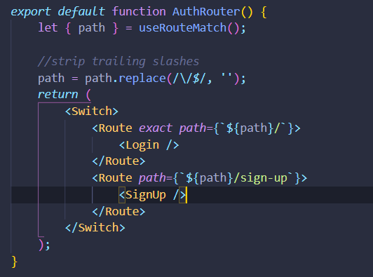

* **Setup eslint**

Follow the documentation from this page: <https://eslint.org/>

Install eslint react plugin and eslint typescript plugin

Install eslint extension

**Issues can be occurred:** Some node js version may not be supported by eslint typescript plugin.