**CAN THO UNIVERSITY**

**COLLEGE OF INFORMATION AND COMMUNICATION TECHNOLOGY**

**🙞 🕮 🙜**

**GRADUATION THESIS**

**BACHELOR OF ENGINEERING IN**

**INFORMATION TECHNOLOGY**

**(HIGH-QUALITY PROGRAM)**

**Build An E-commerce Website To Sell Books**

**Student: Dang Nguyen Phu Nguyen**

**Student ID: B1812837**

**Class: 2018-2022 (K44)**

**Advisor: Dr. Truong Quoc Dinh**

# ACKNOWLEDGEMENTS

To successfully complete this Information Technology Project – Fundamental Topics, I would like to thank Dr. Truong Quoc Dinh dedicatedly guide and support me throughout subject implementation.

At the same time, I would also like to thank the teachers of the Faculty of Information and Communication Technology has dedicated to teaching, imparting valuable knowledge to me cumulatively worked on the topic in the past semesters.

Despite trying to complete the subject as best as possible, but still did not shortcomings can be avoided. We look forward to the comments of teachers and friends.

Sincerely.

Can Tho, June 10th 2021

Student implement

Dang Nguyen Phu Nguyen

# ABSTRACT

Reading book is important because it develops our thoughts, gives us endless knowledge and lessons while keeping our minds active. Books can hold and keep all kinds of information, stories, thoughts and feelings unlike anything else in this world. The importance of a book to help us learn and understand things cannot be underestimated. Reading book is a timeless form of entertainment and information.

Nowadays, going to and buying books at stores is quite inconvenient. For example, you hardly know which book to buy or the contents of the book. But a website can help you solve that problem. You can view books with high likes, read descriptions first to decide whether to buy it or not.

Building an e-commerce website to sell books that users can easily access and buy the books they want easily. Shoppers can preview a portion of the book. It saves shoppers time. Website is built with easy to use interface for customers.

This website developed with PHP, Bootstrap, CSS, HTML, JavaScript and database is MySQL

**TABLE OF CONTAINS**

ACKNOWLEDGEMENTS i

ABSTRACT ii

CHAPTER 1: INTRODUCTION 1

1.1 Problem 1

1.2 Purpose 1

1.3 Object and scope of the study 1

1.4 Solutions 1

1.5 The functionality of the site 1

1.5.1 Customer 1

1.5.2 Manager 1

CHAPTER 2: ANALYSIS, DESIGN AND IMPLEMENTATION 2

2.3 Use case diagram 4

2.3.1 Login 4

2.3.2 Cart 5

2.3.3 Order 6

2.3.4 Product management 8

2.3.6 Account management 10

2.3.7 Search 11

2.3.8 Log out 12

Usecase: Log out 12

2.4 User interface 13

2.4.1 Homepage 13

2.4.2 View detail product 13

2.4.3 View cart 14

2.4.4 Login 15

2.4.5 Management page 16

CHAPTER 3: CONCLUSION 18

3.1 Result 18

3.2 Restrict 18

3.3 Future work 18

REFERENCES 19

**Table Of Figures**

Image 1 Contual Data Model 2

Image 2 Physical date model 3

Image 3 Function of Admin 3

Image 4 Function of Customer 4

Image 5 Login 4

Image 6 Cart 5

Image 7 Order 6

Image 8 Product management 8

Image 9 Order management 9

Image 10 Account management 10

Image 11 Search 11

Image 12 Logout 12

Image 13 Hompage 13

Image 14 Detail product 13

Image 15 Add product into cart 14

Image 16 View cart 14

Image 17 Form checkout 15

Image 18 Login page 15

Image 19 Admin page 16

Image 20 Form add new product 16

Image 21 Form update product 17

Image 22 Manage order 17

Image 23 Manage account user 17

# CHAPTER 1: INTRODUCTION

## 1.1 Problem

Nowadays, going to and buying books at stores is quite inconvenient. For example, you hardly know which book to buy or the contents of the book. But a website can help you solve that problem. You can view books with high likes, read descriptions first to decide whether to buy it or not.

## 1.2 Purpose

Building an e-commerce website to sell books that users can easily access and buy the books they want easily. Shoppers can preview a portion of the book. It saves shoppers time. Website is built with easy to use interface for customers

## 1.3 Object and scope of the study

The website is created to cater to everyone, especially book lovers. help people to access useful books in a convenient way.

## 1.4 Solutions

Theoretical basis: knowledge of DBMS MySQL, Bootstrap,PHP, HTML, CSS, Javascript, …

## 1.5 The functionality of the site

### 1.5.1 Customer

Login/logout

View product

Search product

Cart

Add product to cart

Check out

### 1.5.2 Manager

Login/logout

Manage product

Add new product

Update product

Delete product

View order detail

View account user

# CHAPTER 2: ANALYSIS, DESIGN AND IMPLEMENTATION

**2.1 Design database**

Contual Data Model



Image Contual Data Model

Physical data model



Image Physical date model

**2.2 Function diagram**

Function of Admin

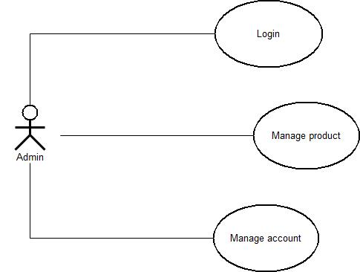

Image Function of Admin

Function of Customer

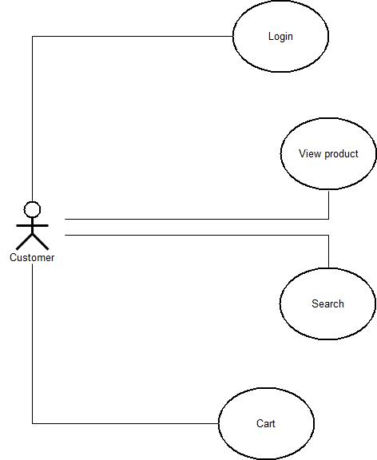

Image Function of Customer

## 2.3 Use case diagram

### 2.3.1 Login

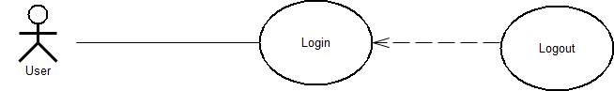

Image Login

|  |  |  |
| --- | --- | --- |
| **Usecase: Login** | | |
| **Purpose** | **Allow users to log into the system** | |
| **Brief Description** | * The customer logs in to the website * Admin login to the system | Priority: Essential |
| Complexity: Simple |
| **Actor** | Customer, admin | |
| **Ingredients and concerns** | Customers log in to the website to purchase, the administrator logs in to the system to manage. Privacy and information be safety | |
| **Relationship** | * Association: customer, admin * Include: Null * Extend: Null * Generalization: Null | |
| **Trigger Event** | Must register account | |
| **Basic Flow** | 1. The user logs in with the registered account 2. The system checks the login process 3. Notify successful or failed login results 4. End the event | |
| **Sub Flows** | None | |
| **Alternate/Exceptional flows**: | Notify successful or failed login results continue to use the function, if failed, proceed to login again. | |

### 2.3.2 Cart

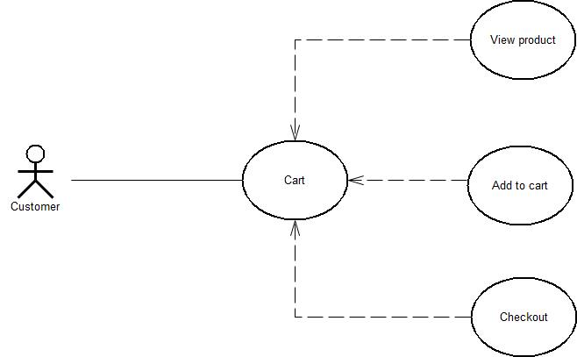

Image Cart

|  |  |  |
| --- | --- | --- |
| **Usecase: Cart** | | |
| **Purpose** | **Allows customers to add products to cart** | |
| **Brief Description** | * Customers access to the website can add products to the cart, with or without an account | Priority: Essential |
| Complexity: High |
| **Actor** | Customer | |
| **Ingredients and concerns** | Customers access to the website to choose the products that they want to buy and add it to the cart | |
| **Relationship** | * Association: customer * Include: Null * Extend: View product information, update product count, remove product from cart * Generalization: Null | |
| **Trigger Event** | Must register account | |
| **Basic Flow** | 1. Customers access the website select the add to cart button 2. Click the add to cart button 3. Successful product added notification 4. End the event | |
| **Sub Flows** | Customers can view product details before adding products to cart, detail view also supports add to cart button, when clicked, the product will be added to cart. | |
| **Alternate/Exceptional flows**: | Customers can update the number of products in the shopping cart and then proceed to checkout | |

### 2.3.3 Order

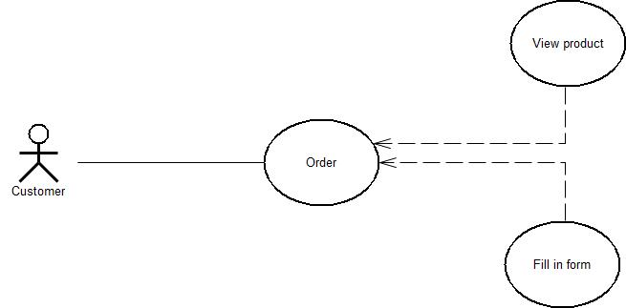

Image Order

|  |  |  |
| --- | --- | --- |
| **Usecase: Order** | | |
| **Purpose** | **Allows customers who do not have an account to order** | |
| **Brief Description** | * Customers access the website and go to cart, then press the button "order", fill in purchase information and proceed to order on the system. | Priority: Essential |
| Complexity: High |
| **Actor** | Customer | |
| **Ingredients and concerns** | Customers who do not have an account want to buy products from the website after searching and choosing the right product | |
| **Relationship** | * Association: customer * Include: Null * Extend: View order information * Generalization: Null | |
| **Trigger Event** | Having products in the cart, and complete the purchase information | |
| **Basic Flow** | 1. Find and select the appropriate product and then add it to the shopping cart. 2. Proceed to order, fill in purchase information. 3. Notice of successful order 4. End of the ordering process | |
| **Sub Flows** | Customers can update the quantity of products before making a purchase or change the shipping address, choose the shipping method and choose a payment method. | |
| **Alternate/Exceptional flows**: | Turn to the order information page to check the customer's order. | |

### 2.3.4 Product management

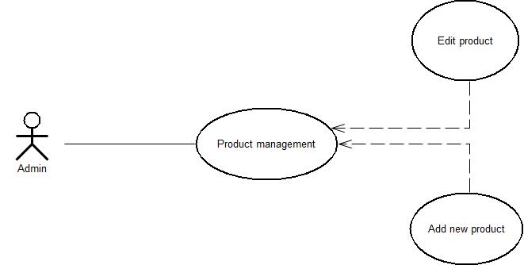

Image Product management

|  |  |  |
| --- | --- | --- |
| **Usecase: Product management** | | |
| **Purpose** | **Allow admin to manage information products.** | |
| **Brief Description** | * After logging in, the admin system can manage product information | Priority: Essential |
| Complexity: High |
| **Actor** | Admin | |
| **Ingredients and concerns** | Admin wants to see product list. Proceed to add, edit, delete and related information. | |
| **Relationship** | * Association: admin * Include: Login * Extend: View product list, add new product, edit product information, delete product * Generalization: Null | |
| **Trigger Event** | Log in to the system with the admin account | |
| **Basic Flow** | 1. Admin login to the system. 2. Select a product management category to view the product list and perform the following functions:  * Add new product: Enter full information on the form and click "add" button to add new product * Edit product information: edit necessary information and save * Delete product: Select the product you want to delete, click "delete" and confirm the deletion  1. End the event. | |
| **Sub Flows** | None | |
| **Alternate/Exceptional flows**: | Notice the successful or failed operation. | |

**2.3.5 Order management**

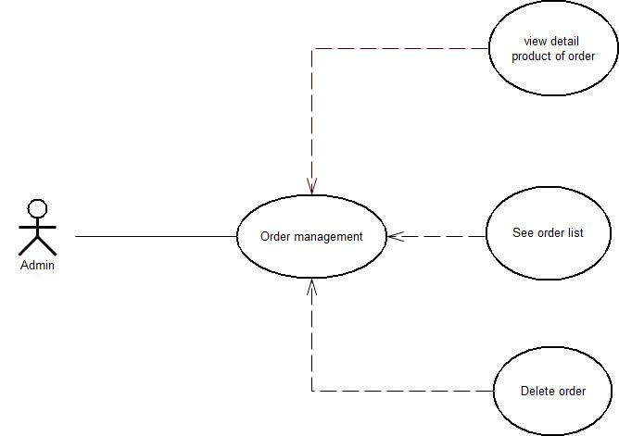

Image Order management

|  |  |  |
| --- | --- | --- |
| **Usecase: Order management** | | |
| **Purpose** | **Allow admin to manage order.** | |
| **Brief Description** | * After admin login in the system, admin can manage order | Priority: Essential |
| Complexity: High |
| **Actor** | Admin | |
| **Ingredients and concerns** | Admin wants to see information order and can delete it | |
| **Relationship** | * Association: admin * Include: Login * Extend: View order list, delete order * Generalization: Null | |
| **Trigger Event** | Log in to the system with the admin account | |
| **Basic Flow** | 1. Admin login to the system. 2. Select a order management to view the order list and perform the following functions: Deleteorder: Select the order you want to delete, click "delete" 3. End the event. | |
| **Sub Flows** | None | |
| **Alternate/Exceptional flows**: | Notice the successful or failed operation. | |

### 2.3.6 Account management

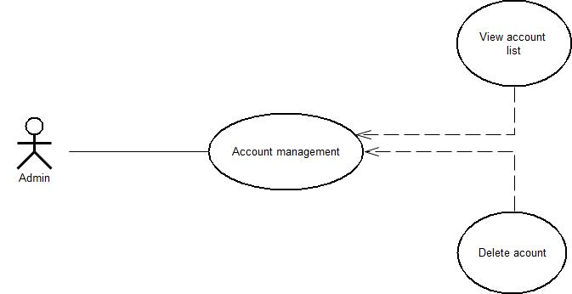

Image Account management

|  |  |  |
| --- | --- | --- |
| **Usecase: Account management** | | |
| **Purpose** | **Allow admin to manage account user.** | |
| **Brief Description** | * After admin login in the system, admin can manage account user | Priority: Essential |
| Complexity: High |
| **Actor** | Admin | |
| **Ingredients and concerns** | Admin wants to see account user and can delete it | |
| **Relationship** | * Association: admin * Include: Login * Extend: View account list, delete account user * Generalization: Null | |
| **Trigger Event** | Log in to the system with the admin account | |
| **Basic Flow** | 1. Admin login to the system. 2. Select a user management to view the account user list and perform the following functions: Delete account user: Select the account user you want to delete, click "delete" 3. End the event. | |
| **Sub Flows** | None | |
| **Alternate/Exceptional flows**: | Notice the successful or failed operation. | |

### 2.3.7 Search

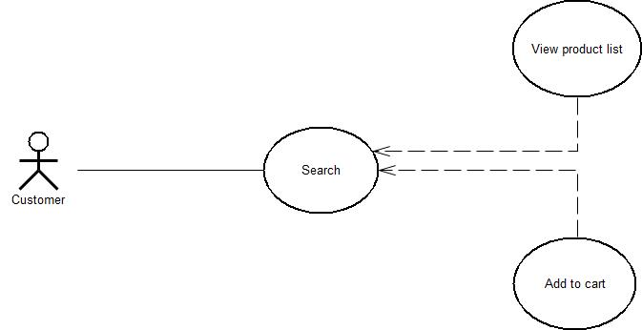

Image Search

|  |  |  |
| --- | --- | --- |
| **Usecase: Search** | | |
| **Purpose** | **Help customers find products** | |
| **Brief Description** | - The users can find the product that they want. | Priority: Essential |
| Complexity: High |
| **Actor** | User | |
| **Ingredients and concerns** | User wants to find a list of product | |
| **Relationship** | * Association: Null * Include: Null * Extend: View a list of product * Generalization: Null | |
| **Trigger Event** | Input key word into search bar | |
| **Basic Flow** | 1. Select search in header:  * Input information * Enter  1. End the event. | |
| **Sub Flows** | None | |
| **Alternate/Exceptional flows**: | Notice the successful or failed operation. | |

### 2.3.8 Log out

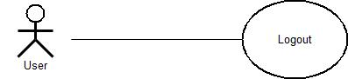

Image Logout

|  |  |  |
| --- | --- | --- |
| Usecase: Log out | | |
| **Purpose** | **Allow users to log out of the system.** | |
| **Brief Description** | Users to log out of the system. | Priority: Essential |
| Complexity: High |
| **Actor** | User | |
| **Ingredients and concerns** | User want to end the session and log out of the system | |
| **Relationship** | * Association: customer, admin * Include: Log in * Extend: Null * Generalization: Null | |
| **Trigger Event** | The user is logged in | |
| **Basic Flow** | 1. The user clicks "log out". 2. The system log out of the account, delete the archiving section, the logout from the system must execute the user request and return the results of the execution. 3. End the event | |
| **Sub Flows** | None | |
| **Alternate/Exceptional flows**: | None | |

## 2.4 User interface

### 2.4.1 Homepage

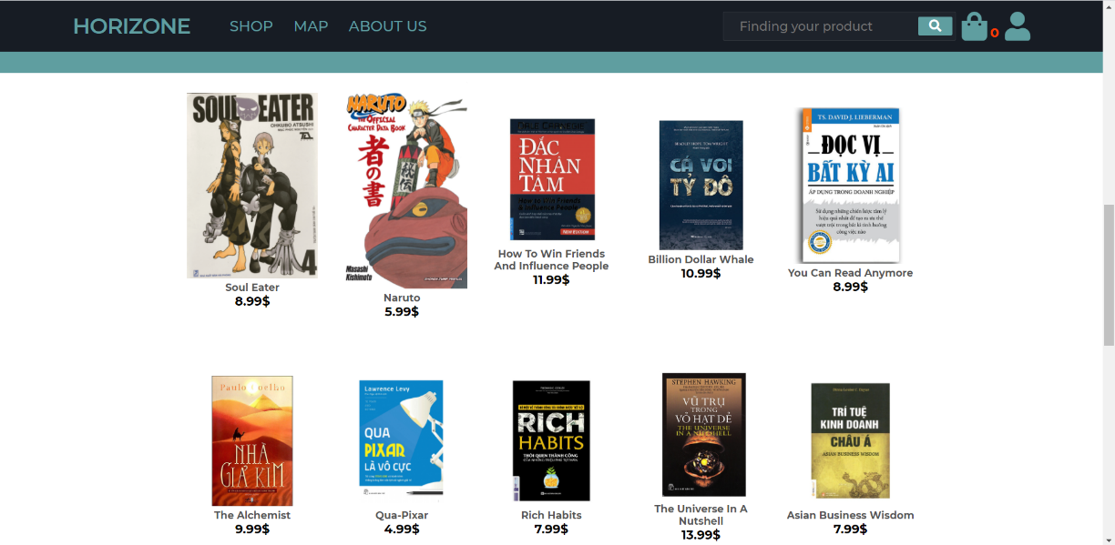

Image Hompage

### 2.4.2 View detail product

Click on product to view detail of product

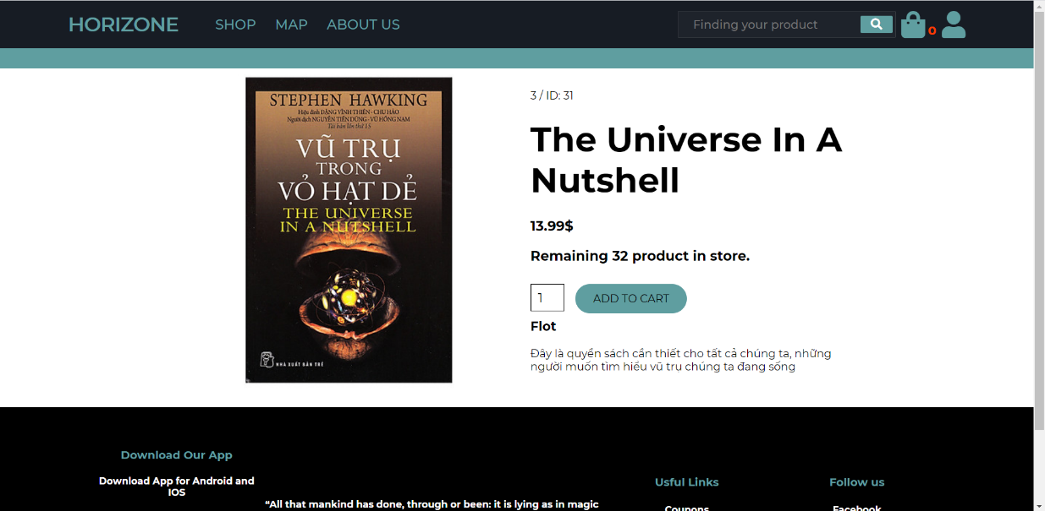

Image Detail product

### 2.4.3 View cart

Click on “Add to cart” in detail product page to add product into cart.

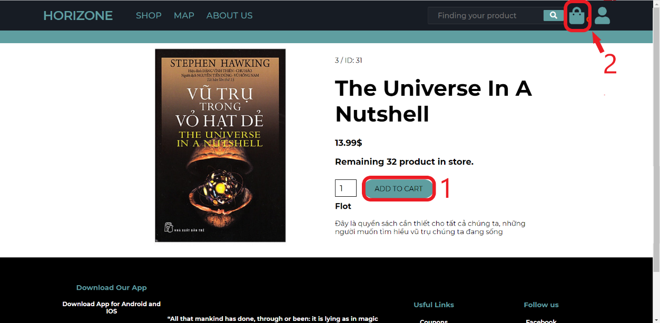

Image Add product into cart

View cart

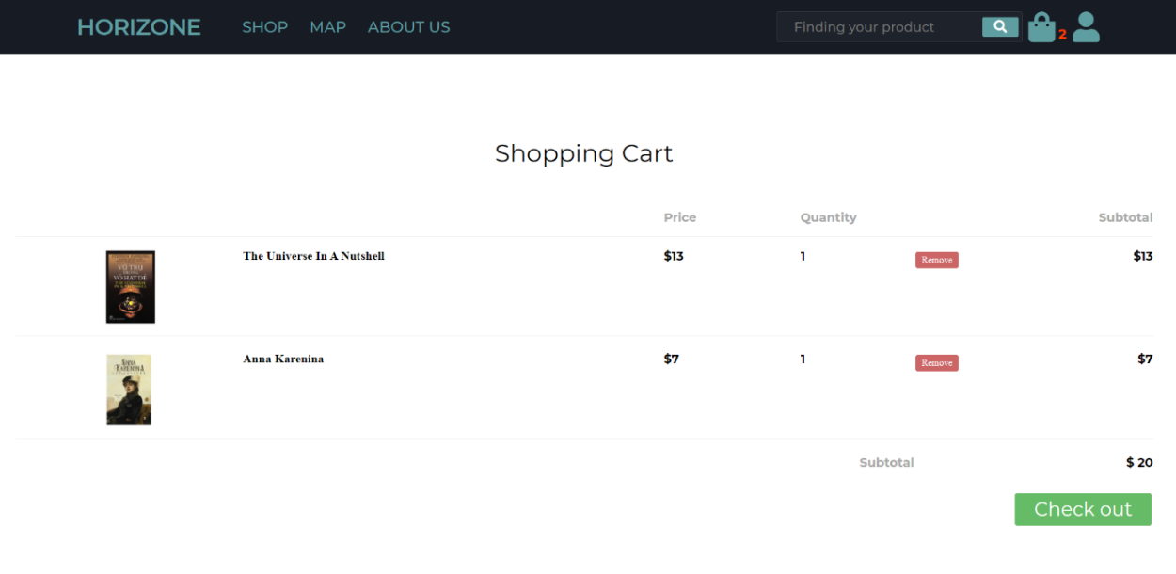

Image View cart

Check out

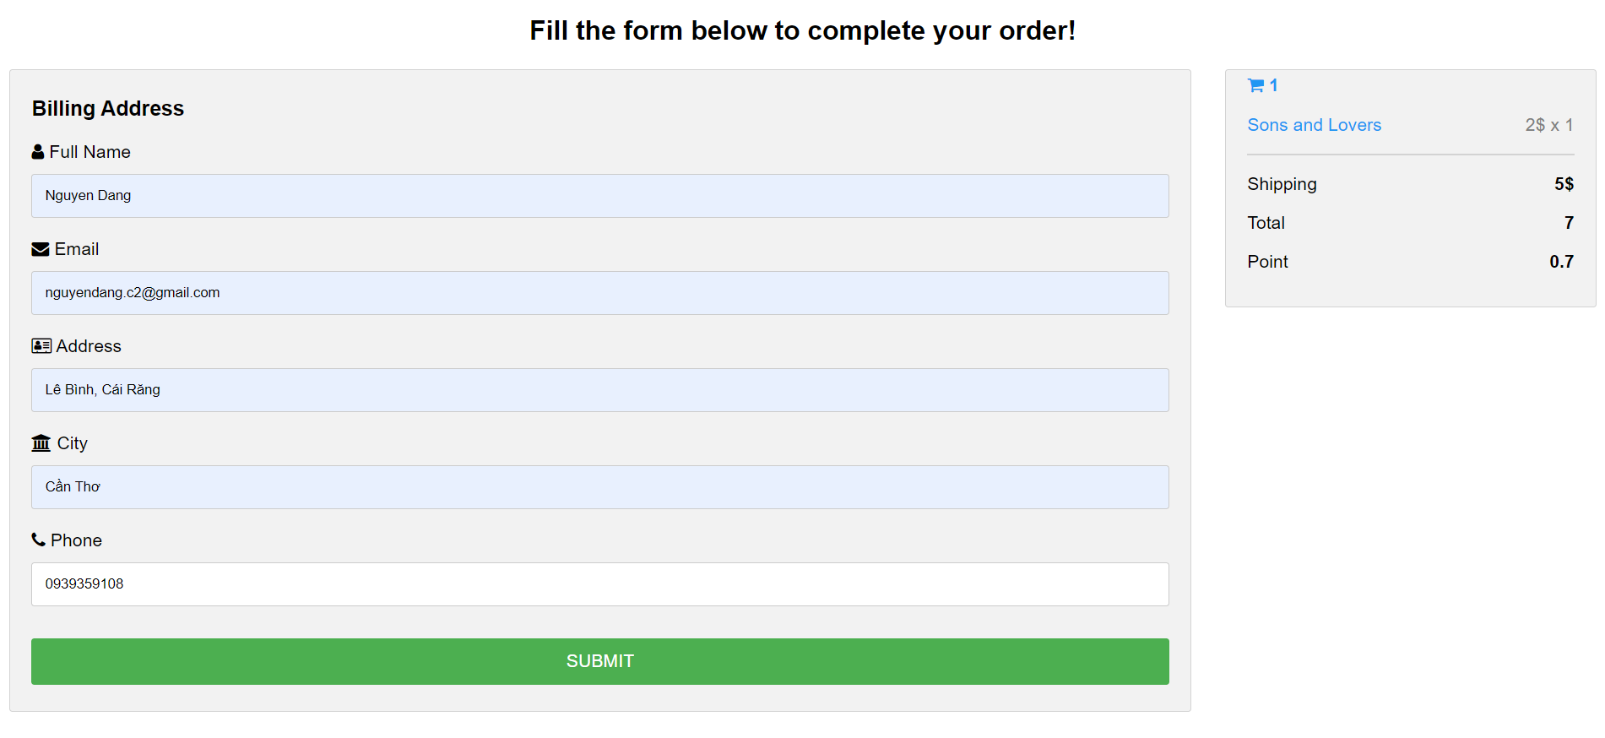

Image Form checkout

### 2.4.4 Login

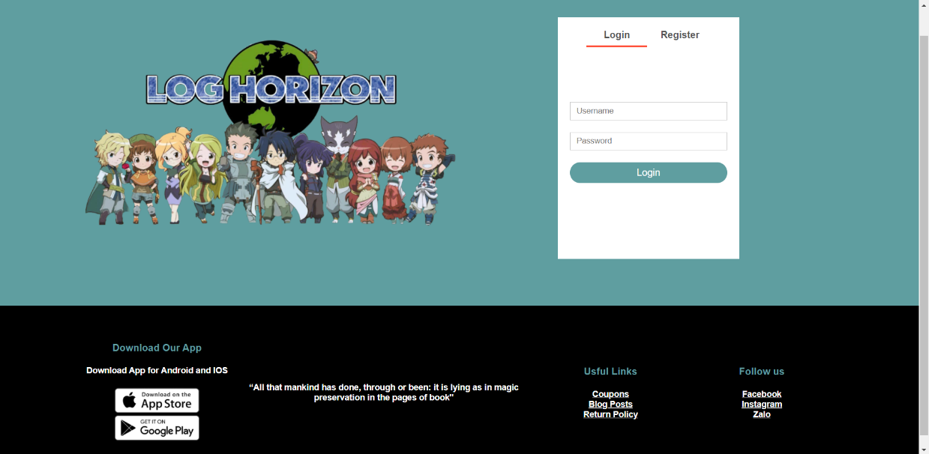

Image Login page

### 2.4.5 Management page

Interface Admin page

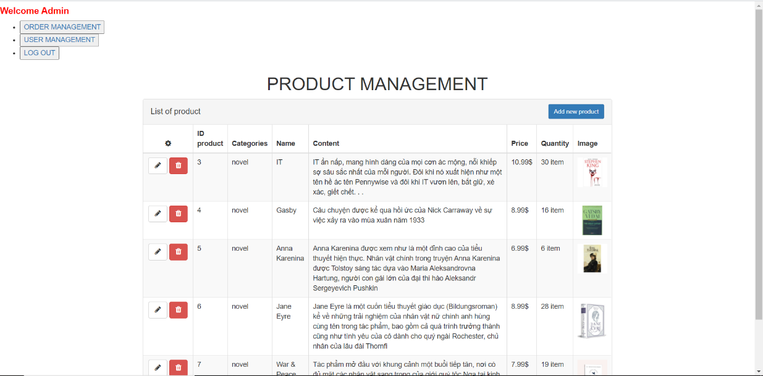

Image Admin page

Add new product

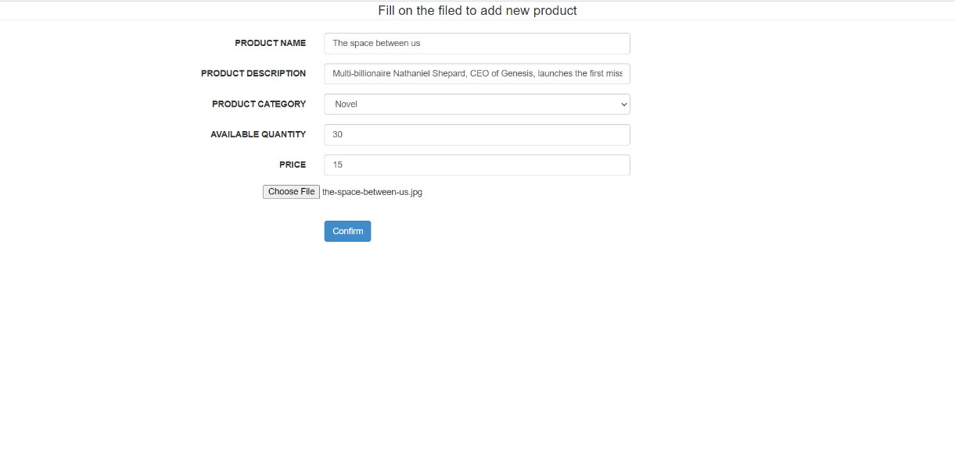

Image Form add new product

Edit product

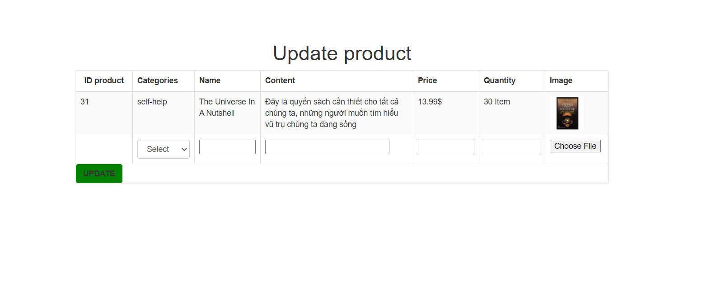

Image Form update product

Manage order detail

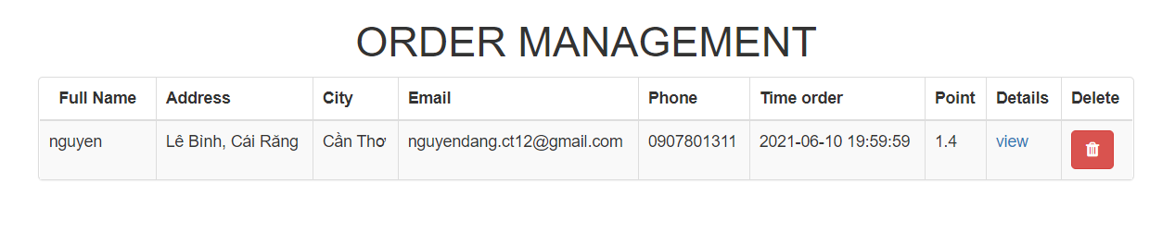

Image Manage order

Manage account user

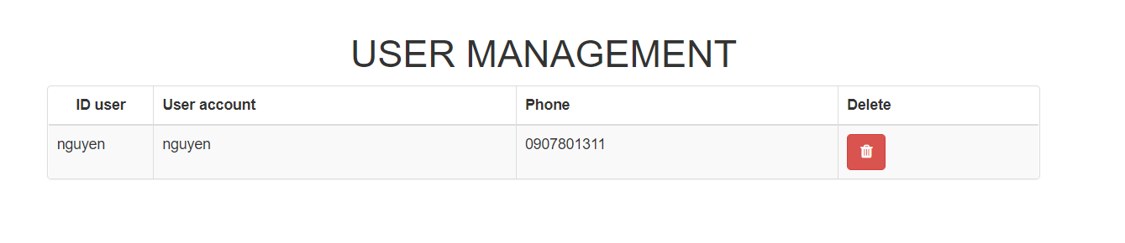

Image Manage account user

# CHAPTER 3: CONCLUSION

## 3.1 Result

“Website Selling Book” has reached the goal, created a friendly user interface and easy for user with features such as view product, search product, and cart. With a manager, we have features like manage products (add, delete, update), and manage orders (view orders details).

After this project, I know how to create an E-Commerce website, design UI for website reasonable.

## 3.2 Restrict

Because I just started designing a website, the interface is still simple and not beautiful.

Website just selling books.

Some features are limited.

## 3.3 Future work

Improve user interface of website responsive for IOS, and Android.

Integrated online customer care feature.

Integrated statistic for manager.

Variety for website.

# REFERENCES

[1]<https://www.youtube.com/watch?v=yQimoqo0-7g&t=4292s>

[2]<https://www.youtube.com/watch?v=eAK8uYtNTy4&ab_channel=DailyTuitionDailyTuition>

[3]<https://www.youtube.com/watch?v=oXrlgOEiy6o&list=PLjwm_8O3suyM_2Lo9aAIw3HqjOPor8j9g&index=4&ab_channel=EasyTutorialsEasyTutorials>

[4]<https://www.youtube.com/watch?v=vOXGuNVRGpA&t=128s&ab_channel=EasyTutorialsEasyTutorials>

[5]<https://tuhocict.com/huong-dan-tu-hoc-lap-trinh-php/>

[6]<https://www.youtube.com/watch?v=YloyMFPJyV4>

[7]<https://www.dropbox.com/s/cpkgo60du513k48/web-programming-ct214H-lab3-php1.pdf?dl=0>

[8][https://www.w3schools.com](https://www.w3schools.com/php/default.asp)