Real-World Applications of RSA:
Cryptographic Foundations, Practical Implementation, and Off-Chain Blockchain Authentication
Academic Research Paper in Cryptography, Cybersecurity, and Blockchain Technology
Abstract— The RSA algorithm remains a foundational pillar of modern public-key cryptography. While public blockchain consensus protocols predominantly utilize elliptic-curve cryptography (ECC) for on-chain state compactness, RSA plays an essential role in enterprise infrastructure, Public Key Infrastructure (PKI), and internal gateway authorization. This report provides an academic investigation of real-world RSA applications across theory, operational justification, and systems engineering. We formulate RSA's mathematical foundations, contrasting RSA-OAEP encryption with RSA-PSS digital signatures (WHAT). We analyze why RSA is favored in specific trust architectures, providing an evidence-based comparison against ECDSA and Schnorr signatures (WHY). Finally, we design, implement, and benchmark an off-chain cryptocurrency withdrawal authentication system using RSA-PSS and SHA-256 (HOW). Empirical benchmarks across RSA (2048, 3072, 4096 bits) and ECDSA (secp256k1) on identical hardware demonstrate RSA's distinct operational profile: while RSA signing is slower than ECDSA, RSA public exponent verification (e = 65,537) executes significantly faster across all tested key sizes—RSA-2048 is 13.45x faster, RSA-3072 is 8.22x faster, and RSA-4096 is 5.4x faster than ECDSA verification. At the approximately equivalent 128-bit classical security level (RSA-3072 vs. ECDSA-secp256k1), RSA-3072 verification is 8.22x faster than ECDSA, although ECDSA signing is 3.87x faster than RSA-3072 signing. Adversarial security scenario testing demonstrates that combining cryptographic digital signatures with application-level timestamp freshness and nonce replay caches significantly strengthens request authentication against payload tampering and replay attacks, although complete system security requires defense-in-depth across transport encryption, secure key storage, and operational controls. Evaluation against all 108 selected test vectors of the Google Project Wycheproof suite confirms that the verification engine correctly accepts all 63 valid test cases and rejects all 45 invalid test cases.
Keywords: RSA Cryptography, RSA-PSS, Digital Signatures, PKI, Hybrid Encryption, Cryptocurrency Security, Off-chain Authentication, Empirical Evaluation.
1. Introduction and Research Scope
Introduced by Ron Rivest, Adi Shamir, and Leonard Adleman in 1977 [1], the RSA algorithm solved the historic key distribution problem by separating the private transformation used for decryption and signing from the public transformation used for encryption and verification. For nearly five decades, RSA has underpinned digital commerce, software distribution, and enterprise identity management.
In modern blockchain environments, significant architectural debate centers on algorithm selection. Major public networks—including Bitcoin and Ethereum—rely on Elliptic Curve Cryptography (ECC) for native on-chain transaction signatures [6], [10], [11]. However, enterprise cryptocurrency exchanges do not operate solely on-chain; they rely on layered off-chain microservices, hardware security modules (HSMs), and Transport Layer Security (TLS 1.3) tunnels [2] to authenticate transactions before dispatching them to blockchain nodes. This report investigates real-world RSA applications across three dimensions: (1) WHAT: mathematical principles and operational distinctions between RSA-OAEP encryption and RSA-PSS signatures; (2) WHY: security justification of RSA and an evidence-based comparison with ECDSA and Schnorr; (3) HOW: practical design, implementation, and empirical evaluation of an off-chain cryptocurrency withdrawal authentication system using RSA-PSS.
2. RSA Fundamentals and Real-World Applications
2.1 Mathematical Foundations and Operating Mechanics
The security of RSA rests on the integer factorization problem—the computational difficulty of determining prime factors p and q from modulus n = p · q [1]. The operational lifecycle comprises: (i) computing Euler's totient φ(n) = (p − 1)(q − 1); (ii) selecting public exponent e coprime to φ(n) (standardized as Fermat prime e = 65,537 = 2¹⁶ + 1); and (iii) deriving private exponent d ≡ e⁻¹ (mod φ(n)). The public key comprises (e, n), and the private key comprises (d, n) or Chinese Remainder Theorem (CRT) parameters (p, q, dP, dQ, qInv). By Euler's theorem, for any message m coprime to n, m^(e·d) ≡ m (mod n). Textbook RSA operates directly on integers (c = m^e mod n; m = c^d mod n), but is vulnerable to algebraic homomorphic manipulation and chosen-ciphertext attacks. Secure real-world implementations mandate modern randomized padding schemes.
2.2 Distinction Between RSA Encryption and RSA Digital Signatures
RSA supports two distinct operational primitives designed for contrasting security goals:
• Asymmetric Encryption (Confidentiality): The sender encrypts plaintext using the recipient's public key (e, n); only the recipient's private key d can decrypt. Modern systems require RSA-OAEP (Optimal Asymmetric Encryption Padding, RFC 8017 [1]), which uses two hash-based masking rounds to achieve provable IND-CCA2 security.
• Digital Signatures (Authenticity, Integrity, Non-Repudiation Evidence): The signer processes message digest M using private key d to produce signature S = (EM)^d mod n. Any party possessing public key e verifies that EM ≡ S^e mod n. Under RFC 8017 and NIST FIPS 186-5 [1], [3], RSA-PSS (Probabilistic Signature Scheme) is the state-of-the-art standard. PSS incorporates a randomized salt into EMSA-PSS encoding, establishing a tight security reduction to the RSA problem in the Random Oracle Model (EUF-CMA security). Crucially, while a digital signature provides cryptographic non-repudiation evidence, full legal non-repudiation requires trusted identity binding, secure key custody, and operational controls.
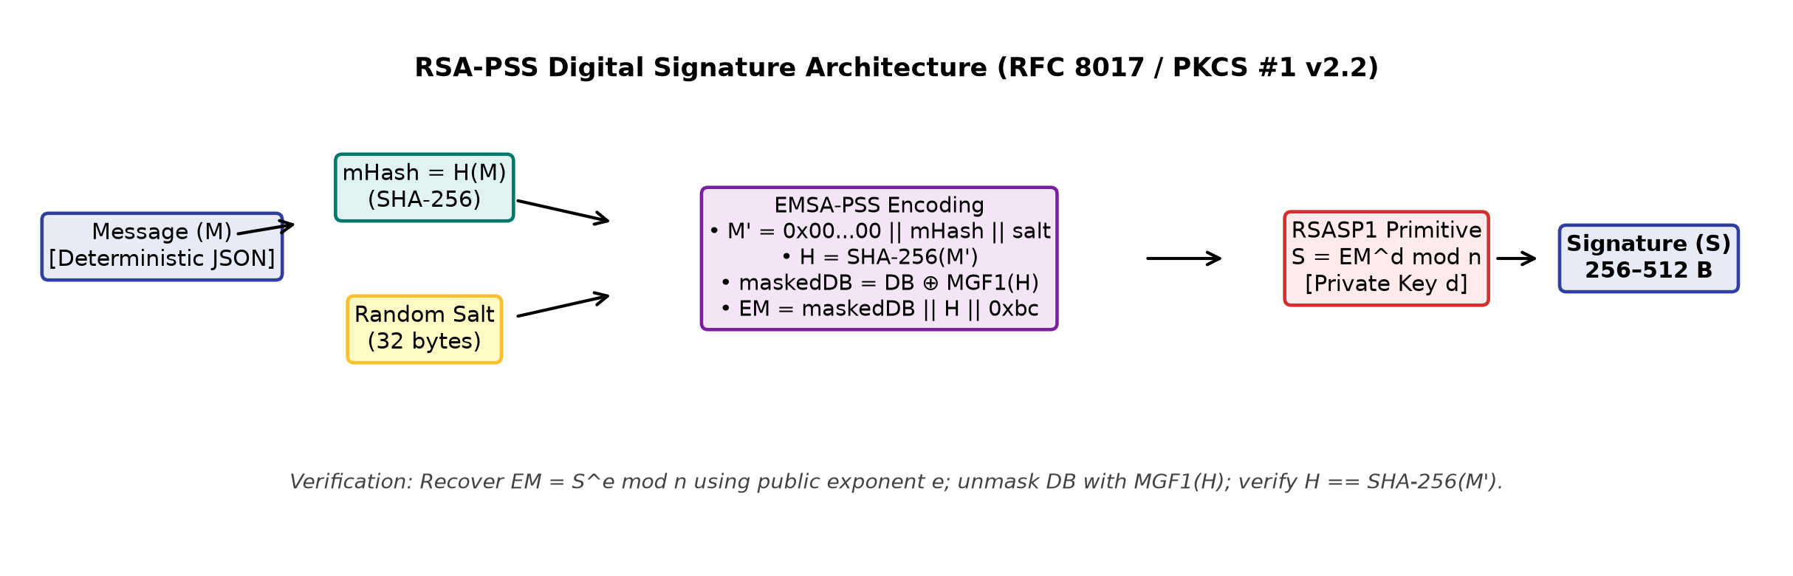
Figure 1. Operational workflow of the RSA-PSS probabilistic digital signature scheme (RFC 8017 / FIPS 186-5).
2.3 Real-World Application Breadth
In industrial systems, RSA is deployed across three primary domains: (1) Hybrid Encryption: RSA is not used to encrypt large bulk data directly due to algebraic length constraints: under RFC 8017 Section 7.1.1, the maximum plaintext size for RSA-OAEP is bounded by mLen <= k - 2hLen - 2 (for a 2048-bit key k = 256 and SHA-256 hLen = 32, mLen <= 190 bytes). Instead, RSA-OAEP encapsulates ephemeral symmetric keys (e.g., 256-bit AES-GCM), combining asymmetric key exchange with high-throughput symmetric data streaming. (2) Code Signing and Firmware Integrity: Operating systems, mobile app stores, and secure bootloaders rely on RSA-PSS signatures to verify executable authenticity before execution. (3) Digital Certificates and PKI: In TLS 1.3 (RFC 8446 [2]), static RSA key exchange was entirely removed in favor of ephemeral Diffie-Hellman ((EC)DHE) to guarantee forward secrecy. RSA's modern TLS 1.3 role is strictly endpoint authentication: RSA X.509 certificates authenticate servers, and CertificateVerify handshake messages use RSA-PSS signatures.
3. Why RSA? Security Purpose and Comparative Evaluation
RSA addresses the core security objectives of information assurance: confidentiality (via hybrid encryption), entity authentication, data integrity, and non-repudiation evidence. Table 1 compares RSA with elliptic curve alternatives: ECDSA (secp256k1) [10], [11], Schnorr (BIP 340) [6], and Ed25519 [9], with security strengths benchmarked according to NIST SP 800-56B Rev. 2 (Table 2 and Appendix D) [4] and NIST SP 800-57 Part 1 Rev. 5 [5].
Evaluation Metric | RSA-2048 | RSA-3072 | ECDSA (secp256k1) | Schnorr (BIP 340) | Ed25519 (RFC 8032)
Hard Problem | Factoring | Factoring | EC Discrete Log | EC Discrete Log | Edwards EC-DLOG
NIST Security Strength | 112 bits [4] | 128 bits [4] | 128 bits [5] | 128 bits [5] | 128 bits [5]
Key Size / Sig Size | Modulus: 256 B  Sig: 256 B  DER PubKey: ~294 B | Modulus: 384 B  Sig: 384 B  DER PubKey: ~422 B | PubKey: 33 B (comp)  Bitcoin: ~71–73 B (DER)  Ethereum: 65 B (r||s||v),  RLP fields; 64 B (ERC-2098) | PubKey: 32 B (x-only)  BIP341: 64 B (DEFAULT)  or 65 B (explicit sighash) | PubKey: 32 B  Sig: 64 B [9]
Relative Verify Speed | Empirical: 0.046 ms  (13.45x vs ECDSA) | Empirical: 0.076 ms  (8.22x vs ECDSA) | Empirical: 0.621 ms  (Baseline: 1.0x) | Batch verify supported;  not benchmarked [6] | High efficiency in lit. [9];  not benchmarked
Table 1. Systematic comparison of asymmetric cryptographic algorithms across security and operational metrics.
3.1 Storage and Verification Trade-Offs in Blockchain Consensus Layers
A central requirement of public blockchains is minimizing ledger storage bloat and bandwidth overhead. In Bitcoin and Ethereum, transaction fees and execution costs directly penalize excessive data footprints. Under Bitcoin's economic model, fees are computed by multiplying transaction virtual size (vSize in vB) by the prevailing market feerate (sat/vB), whereas Ethereum transaction execution costs are measured using gas for computational steps and calldata serialization [10], [11]. In both networks, compact cryptographic signatures and public keys are paramount for node throughput and decentralized state validation. To evaluate transaction overhead accurately under Bitcoin BIP 141 (Segregated Witness) [8], transaction weight is formulated as Weight = (Base Size * 3) + Total Size, and virtual size is vSize = ceil(Weight / 4). A standard 1-input, 2-output SegWit P2WPKH transaction has a baseline virtual size of ~141 vB (~210–220 serialized bytes), where the witness (compressed 33-byte public key and variable ~71–73 byte DER signature with sighash) comprises roughly 105 bytes [10]. In a hypothetical architecture where RSA-2048 were used for native transaction authorization, assuming that each transaction input must carry both the 256-byte RSA public key modulus and the 256-byte RSA signature in its witness stack (totaling 512 witness bytes per input vs. ~105 bytes for standard P2WPKH), this adds approximately 407 witness bytes per input. Because witness bytes are discounted by 4 in BIP 141 weight calculation, this adds ~407 weight units, or approximately 102 virtual bytes (vB) per input. For a representative 1-input, 2-output P2WPKH transaction (~141 vB), adding ~102 vB expands virtual size by approximately 72% (to ~243 vB), proportionally increasing miner fees. Crucially, this ~102 vB overhead applies under the assumption that the full public modulus is carried in every input's witness; if public keys were stored or referenced elsewhere (such as in an on-chain key directory, smart-contract registry, or script hash), the per-transaction witness overhead would be substantially lower. Furthermore, Bitcoin script lacks native RSA verification opcodes; supporting RSA natively on-chain would require consensus protocol hard or soft forks. Similarly, native Ethereum Externally Owned Account (EOA) transaction authorization mandates ECDSA over secp256k1 [11]. In network-level transaction envelopes (legacy, EIP-2930, and EIP-1559), Ethereum serializes signatures as discrete Recursive Length Prefix (RLP) fields encoding r, s, and v (or yParity for typed envelopes). While off-chain systems commonly concatenate these into a 65-byte r||s||v string, ERC-2098 also defines a compact 64-byte representation that packs yParity into the upper bit of s. While Ethereum smart contracts can execute raw modular exponentiation via the EVM precompile at address 0x05 (EIP-198), this precompile computes B^E mod M only; complete RSA-PSS verification additionally requires separate contract bytecode to execute MGF1 mask generation, extract the encoded message, and validate hash/padding integrity. For native transaction envelopes, consensus rules strictly require ECC. In contrast, BIP 340 Schnorr signatures over secp256k1 integrated via BIP 341 (Taproot) are exactly 64 bytes under SIGHASH_DEFAULT (or 65 bytes when an explicit non-default sighash byte is appended), paired with 32-byte x-only public keys, and enable two-round multi-signature aggregation via MuSig2 (BIP 327 [7]), allowing n-of-n signers to publish a single compact 64-byte signature on-chain—a capability unattainable with standard RSA.
3.2 The Operational Value of RSA in Off-Chain Systems
Despite on-chain limitations, RSA provides distinct benefits in off-chain exchange backends: (1) Asymmetric Verification Speed: RSA public exponentiation (e = 65,537) requires only 17 modular multiplications, enabling rapid verification. For an off-chain API gateway verifying incoming requests, RSA provides high verification throughput. (2) Hardware Security Module (HSM) Integration: Enterprise banking infrastructure and secure enclaves feature mature hardware support for RSA modular arithmetic. (3) Avoidance of Scalar Nonce Reuse Hazards: Standard ECDSA is fragile against nonce failure: if the signing nonce k repeats or exhibits slight bit bias, the private key is algebraically exposed. While RSA-PSS eliminates scalar nonce leakage, it does not remove all side-channel risks: implementations must employ base blinding (randomizing the base integer with a secret factor r prior to modular exponentiation: x' = x · r^e mod n) to mitigate timing side-channel attacks. Crucially, blinding alone does not prevent hardware fault injection such as the Bellcore attack on Chinese Remainder Theorem (CRT) implementations (where an induced fault during one prime exponentiation yields gcd(s - s', n) = p); defending against CRT fault attacks requires separate countermeasures, such as post-computation signature verification (confirming s^e mod n == m before releasing the signature) or redundant fault-detection hardware.
4. Proposed System Design and Implementation
We design and evaluate an educational, off-chain architecture: Using RSA-PSS Digital Signatures to Authenticate Off-Chain Withdrawal Requests in Cryptocurrency Exchanges. Important Technical Boundary: This system operates strictly off-chain within the exchange's internal authorization boundary to authenticate withdrawal requests before they reach hot-wallet signers; it does not replace on-chain ECDSA/Schnorr consensus signatures on Bitcoin or Ethereum.
4.1 Architecture and Component Decomposition
As illustrated in Figure 2, the authentication pipeline decouples request origination from on-chain broadcast across four components:
1. Withdrawal Service (Client/Frontend): Formats the withdrawal request: blockchain network, recipient address, withdrawal amount (in exact integer atomic units, e.g., wei), a UUIDv4 nonce, and a UNIX epoch timestamp.
2. RSA Signing Component: Encapsulated within a secure enclave or signing service. It formats the payload using deterministic JSON serialization, computes the SHA-256 digest, and signs via RSA-PSS using the exchange private key.
3. Verification Service: An edge gateway that extracts the exchange RSA public key, reconstructs the message digest, and validates the PSS signature.
4. Request Validation Engine: Enforces stateful application rules: evaluates timestamp freshness (±300s skew) and checks nonce uniqueness against a replay cache.
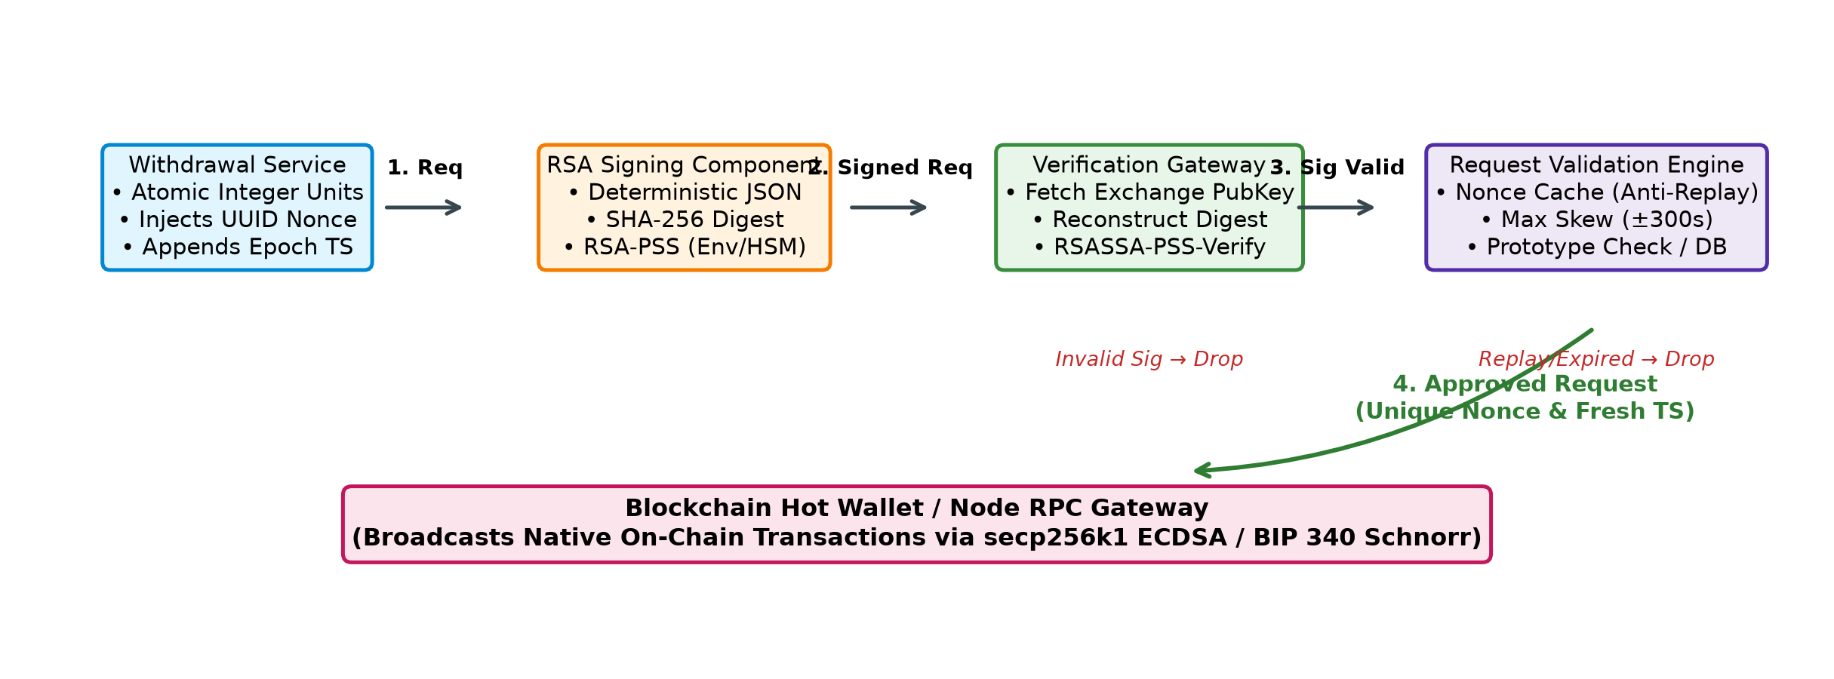
Figure 2. Proposed off-chain cryptocurrency withdrawal authentication architecture using RSA-PSS.
4.2 Deterministic JSON Serialization and Pipeline Algorithm
Cryptographic signature verification fails if distributed microservices serialize JSON keys or whitespace inconsistently. Our system implements deterministic JSON serialization (sorting dictionary keys lexicographically, eliminating whitespace, and encoding to UTF-8). Note: While inspired by canonical formatting, this custom serialization does not implement full RFC 8785 (which requires ECMAScript number formatting and UTF-16 code unit ordering); it provides deterministic byte-level consistency for the defined data schema. Algorithm 1 details the complete lifecycle.
Algorithm 1: Off-Chain Withdrawal Authentication Pipeline
Input: Request R = {id, net, addr, amt_atomic, nonce, ts}, Private Key SK_rsa, Public Key PK_rsa
Output: Decision ∈ {ACCEPT, REJECT_SIG, REJECT_REPLAY, REJECT_EXPIRED}
1: M_canon ← DeterministicJSON(R) // Lexicographical keys, compact separators, UTF-8
2: σ ← RSASSA-PSS-Sign(SK_rsa, M_canon, SHA-256, sLen=32)
3: // Gateway Verification Phase
4: valid_sig ← RSASSA-PSS-Verify(PK_rsa, M_canon, σ, SHA-256, sLen=32)
5: if ¬ valid_sig then return REJECT_SIG // Tampering detected
6: if |CurrentTime() − R.ts| > Δ_skew then return REJECT_EXPIRED
7: if R.nonce ∈ NonceStore then return REJECT_REPLAY // Replay detected
8: NonceStore.Add(R.nonce); return ACCEPT
4.3 Prototype Scope and Vital Security Considerations
To maintain academic defensibility, the prototype implementation scope must be clearly delineated from production requirements:
1. In-Memory Demonstration vs. Distributed Persistence: The prototype stores processed nonces in an in-memory Python set. A production cryptocurrency exchange requires a durable, transactional, distributed datastore (e.g., Redis or an ACID SQL database) to prevent replays across service restarts and distributed clusters.
2. Key Storage: Prototype private keys are held in process memory. Production deployments require storage in dedicated HSMs or cloud key management enclaves.
3. Integrity vs. Confidentiality: RSA digital signatures guarantee payload integrity and authenticity, but do not provide confidentiality. Transport encryption (TLS 1.3) remains mandatory to prevent payload eavesdropping.
5. Experimental Results and Analysis
The system was implemented in Python 3.15 using the cryptography library (v50.0.2) backed by OpenSSL 4.0.3. Experiments were executed on an AMD Ryzen 5 7520U processor (4 cores, 8 threads @ 2.80 GHz) running Windows 11 Build 26200. High-resolution timings were captured using time.perf_counter_ns() across 10 key generation trials and 100 signature generation and verification trials. Both RSA (2048, 3072, 4096 bits) and ECDSA (secp256k1) were benchmarked independently under identical conditions.
5.1 Adversarial Security Testing Scenarios
Execution of rsa_pss_experiment.py validated all five target security scenarios:
• Scenario 1 (Valid Request): Authentic request (12.5 ETH in atomic units) verified and validated -> Outcome: ACCEPTED.
• Scenario 2 (Tampered Amount): Amount modified to 50.0 ETH equivalent; signature verification returned False -> Outcome: REJECTED.
• Scenario 3 (Tampered Recipient): Address modified to attacker account; verification returned False -> Outcome: REJECTED.
• Scenario 4 (Rogue Public Key): Signature evaluated against an unauthorized RSA public key -> Outcome: REJECTED.
• Scenario 5 (Replay Attack): Identical request resubmitted. Cryptographic verification passed (True), but the validation engine detected duplicate nonce 'a8f9c10e-8215-4c07-b649-1d2e3f4a5b6c' -> Outcome: REJECTED BY APPLICATION STATE ENGINE.
5.2 Expanded Wycheproof Test Suite Validation
To evaluate implementation compliance against authoritative test vectors, our test harness loaded and executed the complete Google Project Wycheproof test suite (rsa_pss_2048_sha256_mgf1_32_test.json) [12]. The suite comprises 108 test vectors: 63 expected-valid signatures and 45 expected-invalid signatures. Our verification engine successfully passed all 108 test cases (100% agreement, 0 failures), correctly accepting every valid signature and rejecting all corrupted or edge-case invalid signatures. This validates the implementation against the specific Wycheproof test cases, without claiming exhaustive mathematical proof of all possible RFC 8017 edge cases.
5.3 Empirical Benchmarking and Performance Analysis
Table 2 reports empirical benchmarks comparing RSA configurations with ECDSA (secp256k1). Figure 3 illustrates the latency distributions.
Algorithm | NIST Security | Keygen Median | Sign Median | Verify Median | Sig Size | Internal Asymmetry
RSA-2048 | 112 bits [4] | 50.0708 ms | 0.9005 ms | 0.0462 ms | 256 B | 19.49x (Sign / Verify)
RSA-3072 | 128 bits [4] | 253.9132 ms | 2.7834 ms | 0.0756 ms | 384 B | 36.82x (Sign / Verify)
RSA-4096 | 152 bits [4] | 633.0616 ms | 6.5425 ms | 0.115 ms | 512 B | 56.89x (Sign / Verify)
ECDSA-secp256k1 | 128 bits [5] | 0.7158 ms | 0.7196 ms | 0.6214 ms | 71 B (DER) | 1.16x (Sign / Verify)
Table 2. Empirical benchmark measurements (AMD Ryzen 5 7520U, Python 3.15, OpenSSL 4.0.3, median of 10 keygen / 100 crypto trials).
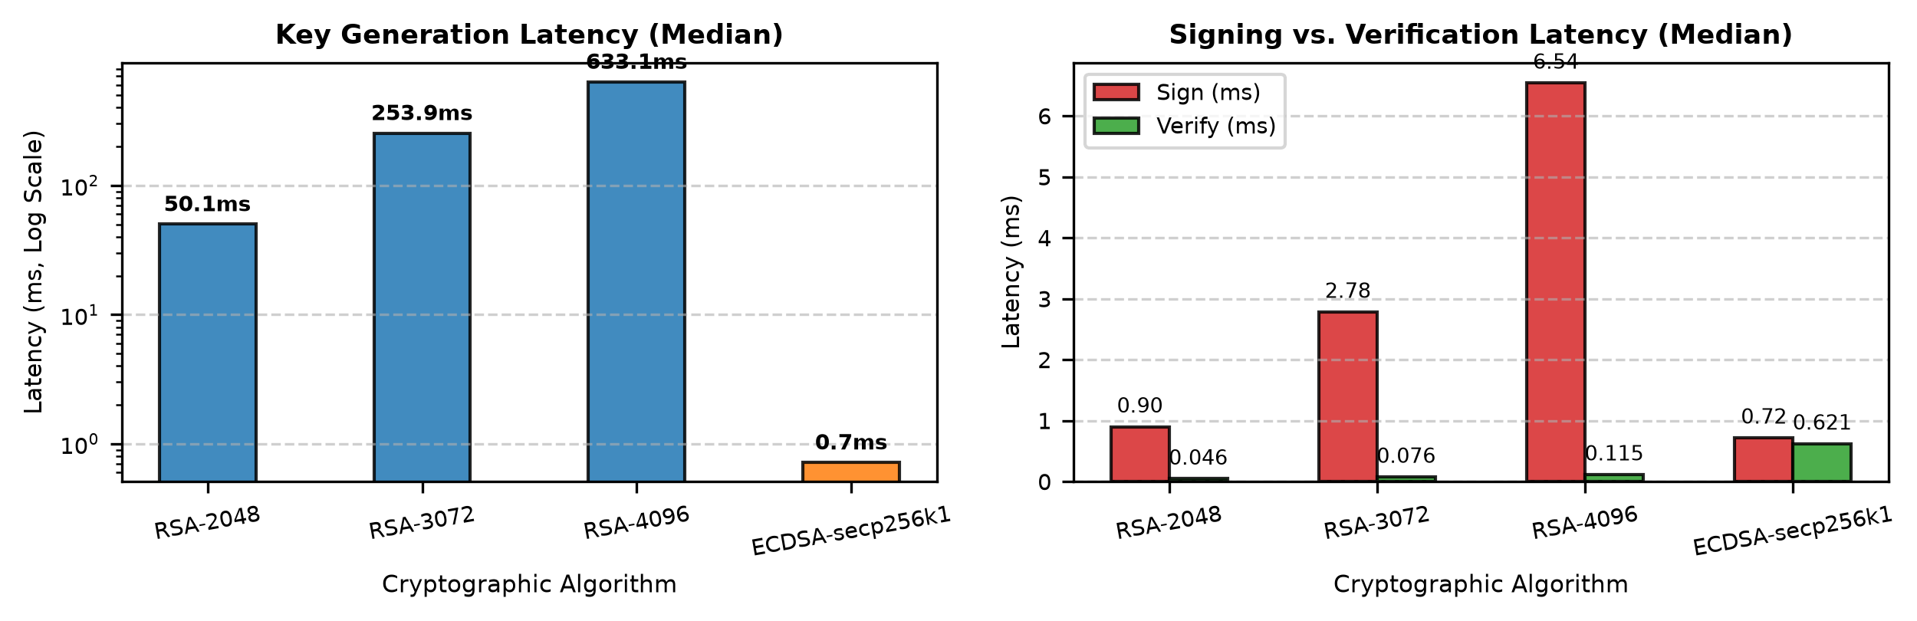
Figure 3. Empirical latency distributions for RSA and ECDSA key generation, signing, and verification.
The empirical measurements demonstrate three decisive performance characteristics:
1. RSA Asymmetric Cost Structure: RSA displays a pronounced internal asymmetry: verification is 19.49x (RSA-2048) to 56.89x (RSA-4096) faster than its own signing operation. Because public exponent e = 65,537 contains only two non-zero bits, verification requires just 17 multiplications, whereas private exponent d requires full modular exponentiation.
2. Head-to-Head Comparison with ECDSA: Comparing equivalent 128-bit security levels (RSA-3072 vs. ECDSA-secp256k1), ECDSA signing is 3.87x faster than RSA signing (0.7196 ms vs 2.7834 ms), and ECDSA key generation is over 354.7x faster (0.7158 ms vs 253.9132 ms). Conversely, RSA-3072 signature verification (0.0756 ms) is 8.22x faster than ECDSA verification (0.6214 ms), while RSA-2048 verification (0.0462 ms) is 13.45x faster, and RSA-4096 verification (0.115 ms) is 5.4x faster than ECDSA. ECDSA verification requires two elliptic-curve point multiplications, whereas RSA verification requires minimal modular arithmetic.
3. Theoretical Throughput: At 0.0756 ms per verification, a single CPU core can theoretically evaluate ~13,227 RSA-3072 signatures per second (vs ~1,609 for ECDSA). Crucially, these figures represent theoretical cryptographic-operation estimates; real-world system throughput is bounded by network I/O, database persistence, and TLS handshakes.
6. Conclusion
This research examined the cryptographic foundations, operational trade-offs, and practical deployment of RSA in modern security architectures. While elliptic-curve cryptography (ECDSA and Schnorr) rightfully dominates public blockchain consensus layers due to compact public keys and signatures that minimize transaction virtual size (reducing Bitcoin miner fees) and storage serialization (reducing Ethereum transaction execution and data gas overhead), RSA is not universally superior or inferior to ECC; rather, each algorithm serves distinct architectural domains. RSA remains a supported and deployed cryptographic option in enterprise PKI and selected off-chain authentication systems, particularly where existing infrastructure, interoperability, and verification performance are relevant. Our prototype implementation of an off-chain withdrawal authentication system confirmed that RSA-PSS with SHA-256 provides verifiable message integrity with rapid gateway verification. However, cryptographic digital signatures alone do not guarantee complete system security; robust authorization requires defense-in-depth across deterministic serialization, stateful replay prevention, secure key custody (such as HSM storage), and transport encryption (TLS 1.3).
At an approximately equivalent 128-bit classical security strength, RSA-3072 provides robust resistance against conventional mathematical cryptanalysis, though it incurs substantially larger key and signature footprints than 256-bit elliptic curves. Looking toward future cryptographic horizons, RSA-PSS is vulnerable to polynomial-time integer factorization via Shor's algorithm on fault-tolerant quantum computers, as is standard elliptic-curve cryptography under discrete logarithm quantum attacks. Neither algorithm provides post-quantum security. Consequently, organizations deploying RSA-3072 today must maintain crypto-agility and actively prepare migration pathways toward standardized post-quantum digital signature algorithms, including NIST FIPS 204 (ML-DSA) and FIPS 205 (SLH-DSA).
7. References
[1] K. Moriarty, B. Kaliski, J. Jonsson, and A. Rusch, "PKCS #1: RSA Cryptography Specifications Version 2.2," RFC 8017, IETF, Nov. 2016. https://www.rfc-editor.org/rfc/rfc8017
[2] E. Rescorla, "The Transport Layer Security (TLS) Protocol Version 1.3," RFC 8446, IETF, Aug. 2018. https://www.rfc-editor.org/rfc/rfc8446
[3] National Institute of Standards and Technology (NIST), "Digital Signature Standard (DSS)," FIPS 186-5, Feb. 2023. https://csrc.nist.gov/pubs/fips/186-5/final
[4] E. Barker and L. Chen, "Recommendation for Pair-Wise Key-Establishment Schemes Using Integer Factorization Cryptography," NIST SP 800-56B Rev. 2, Table 2 & App. D, Mar. 2019. https://csrc.nist.gov/pubs/sp/800/56b/r2/final
[5] E. Barker, "Recommendation for Key Management: Part 1 – General," NIST SP 800-57 Part 1 Rev. 5, May 2020. https://csrc.nist.gov/pubs/sp/800/57/pt1/r5/final
[6] P. Wuille, J. Nick, and T. Ruffing, "Schnorr Signatures for secp256k1," Bitcoin Improvement Proposal (BIP) 340, Jan. 2020. https://github.com/bitcoin/bips/blob/master/bip-0340.mediawiki
[7] J. Nick, T. Ruffing, and E. Jin, "MuSig2 for BIP340-compatible Multi-Signatures," Bitcoin Improvement Proposal (BIP) 327, 2023. https://github.com/bitcoin/bips/blob/master/bip-0327.mediawiki
[8] E. Lombrozo, J. Lau, and P. Wuille, "Segregated Witness (Consensus layer)," Bitcoin Improvement Proposal (BIP) 141, Dec. 2015. https://github.com/bitcoin/bips/blob/master/bip-0141.mediawiki
[9] S. Josefsson and I. Liusvaara, "Edwards-Curve Digital Signature Algorithm (EdDSA)," RFC 8032, IETF, Jan. 2017. https://www.rfc-editor.org/rfc/rfc8032
[10] Bitcoin Core Developers, "Bitcoin Developer Guide: Transactions," Bitcoin Project, n.d. [Online; accessed 2026]. https://developer.bitcoin.org/devguide/transactions.html
[11] Ethereum Foundation, "Ethereum Developer Documentation: Transactions and Cryptographic Signatures," n.d. [Online; accessed 2026]. https://ethereum.org/en/developers/docs/transactions/
[12] Google Security Research, "Project Wycheproof: Cryptographic Test Vectors for Asymmetric Algorithms," GitHub repository, n.d. [Online; accessed 2026]. https://github.com/google/wycheproof

