STARHUB: Create a simple site to demo for Client
Base on request from customers, we want to create a simple site to demonstrate programming skills about frontend, backend, database, and software architecture.
Simple site must have the mobile page as same as http://www.starhub.com/personal/mobile.html, the web site has two sides, one for client and one for server. Both of them have header, main content, and footer. On client side, we will provide a simple page which main content contain a banner and tab. Banner is a rotate banner. On server side, we provide a web admin page to edit content of banner and tab section.

Design Proposal
We will use tile definition to create layout template, bootstrap for styles and angularjs to process data content on web page. Angularjs controllers will call rest services to crud data. At backend, we will build web services to handle request, when we receive a request, controller will call to services, dao, model and return data through Hibernate.
On mobile page, we will show banner and tab content on main area. We use admin page to edit information of tab content. We using spring security for authentication and authorisation.
Database Diagram
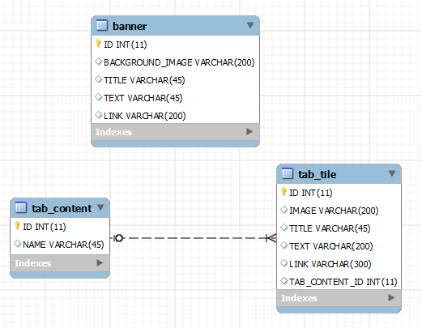

Sequence Diagram
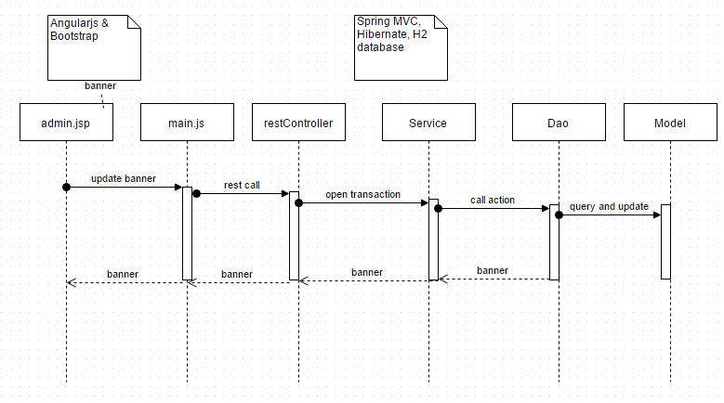

FEAT00.1
Create a simple demo website for Starhub

Project Setting (0.5)
- Create maven project
- Import libraries

Web Interface (2.0)
- Personal page (0.5)
- Create HTML static
- Loading Banner block
- Loading Tab Content block
- Admin page (0.5)
- Create HTML static
- Loading admin block
- Java Script (1.0)
- Study AngularJS and apply

Java Class (0.5)
- Build Controller, Service, Dao, Model

Database (0.5)
- Create Database
- Check ORM mapping when using Hibernate

Unit Test (0.5)

Design screen

