**Hanoi University of Science and Technology**

**School of electrical engineering**



**GRADUATION THESIS**

**Energy efficient in wireless sensor network using Grey Wolf Optimization algorithm**

|  |  |
| --- | --- |
| **Author:**  **Supervisor:** | Dao Duc Nguyen  Dr. Nguyen Thanh Huong  Chữ ký của GVHD |
| **Department:** | Department of instrumentation and industrial informatics |
| **School:** | School of electrical engineering |
| **HÀ NỘI, 6/2021** | |

i

**CỘNG HÒA XÃ HỘI CHỦ NGHĨA VIỆT NAM**

**Độc lập - Tự do - Hạnh phúc**

-----------------

**BỘ GIÁO DỤC VÀ ĐÀO TẠO**

**TRƯỜNG ĐẠI HỌC BÁCH KHOA HÀ NỘI**

--***--

**NHIỆM VỤ**

**THIẾT KẾ TỐT NGHIỆP**

Họ và tên: Dao Duc Nguyen Mã số sinh viên: 20162982

Khóa:  **61**

Viện: **Điện**

Ngành: **Kỹ thuật đo và Tin học công nghiệp**

*1. Đầu đề thiết kế/Tên đề tài*

* Energy efficient in wireless sensor network using Grey Wolf Optimization algorithm

*2. Các số liệu ban đầu*

*3. Các nội dung tính toán, thiết kế*

*4. Cán bộ hướng dẫn:* TS. Nguyễn Thanh Hường

*5. Ngày giao nhiệm vụ thiết kế: 01/2021*

*6. Ngày hoàn thành nhiệm vụ: 04/2021*

*Ngày...... tháng...... năm......*

CHỦ NHIỆM BỘ MÔN CÁN BỘ HƯỚNG DẪN

*(Ký, ghi rõ họ tên) (Ký, ghi rõ họ tên)*

SINH VIÊN THỰC HIỆN

*(Ký, ghi rõ họ tên)*

# ACKNOWLEDGEMENTS

I would like to thank all of the people who made this thesis possible, starting with my wonderful supervisor - Dr. Nguyen Thanh Huong for her support, patience, and guidance in almost every step throughout my thesis. I am grateful to all the members in the class AP Automatic Control K61. It is their kind help and support that have made my study and life at the university a wonderful time. Further, I would like to express my sincere gratitude to Hanoi University of Science and Technology and all its member’s staff for all the considerate guidance. Also, I would like to thank my friends I have made along the way when I was studying at Hanoi University of Science and Technology. They have left wonderful memories for me. Finally, I would like to express my gratitude to my parents. Without their tremendous understanding and encouragement in the past few years, it would be impossible for me to complete my study.

# ABSTRACT

Wireless sensor network (WSN) nodes are devices with limited power and extending the network lifetime is the main objectives of the WSN’s routing protocol. However, many types of energy level in sensor nodes will lead to imbalance of heterogeneous WSNs (HWSNs). Therefore, in this thesis, a routing protocol based on grey wolf optimization (GWO) is proposed. First, initial clusters are formed based on the fitness value of each node, these values are used as initial weights of GWO. After that, the weights will be updated according to GWO algorithm to search for better sets of clusters. Parameters which are used to select the cluster heads are: initial energy of a node, residual energy of a node, distance to cluster heads and distance to the base station. If a clusters set have a better fitness value, it will become the new optimal set and replace the current set. For analysis, the proposed routing protocol will be compared its performance to LEACH protocol and E-DEEC protocol. The result showed that protocol based GWO out-performed LEACH protocol in network lifetime and energy consumption, and have a better performance in general when comparing to E-DEEC.

Sinh viên thực hiện

Ký và ghi rõ họ tên

ACKNOWLEDGEMENTS 3

ABSTRACT 3

TABLE OF CONTENTS 5

LIST OF FIGURES 6

LIST OF ABBREVIATIONS 7

LIST OF TABLES 8

Chapter 1. INTRODUCTION 9

1.1 Introduction and motivation 9

1.2 Related works 14

1.2.1 LEACH protocol 15

1.2.2 DEEC protocol 16

1.3 Performance comparison 17

1.4 Objectives 18

1.5 Thesis Organization 19

Chapter 2. THEORETICAL BACKGROUND 20

2.1. Wireless sensor network 20

2.1.1. Structure 20

2.1.2. Architecture and protocol of wireless sensor networks 23

2.2. Routing protocol 25

2.2.1. Hierarchical routing 26

2.3. Meta-heuristic approach 28

2.4. Grey wolf optimization 31

2.4.1. Inspiration 31

2.1.1. Mathematical model and algorithm 32

Chapter 3. Proposed model and algorithm 37

3.1. Proposed network model 37

3.1.1. Network model and assumptions 37

3.1.2. Energy consumption 37

3.2. Proposed algorithm 40

3.2.1. Selection of Initial Clusters 40

3.2.2. Modified Grey Wolf Optimizer 40

3.2.3. Selection of the Optimal Cluster Set 42

3.3. Pseudo code 43

Chapter 4. RESULTS AND ANALYSIS 45

4.1. Kịch bản thử nghiệm 45

4.2. Cluster formation result 45

4.3. Performance analysis 48

CONCLUSION 51

REFERENCE 52

# TABLE OF CONTENTS

# LIST OF FIGURES

Figure 1. WSN applications in healthcare 10

Figure 2. Application in home automation 11

Figure 3. Application of WSNs in the military 12

Figure 4. Wireless sensor networks 13

Figure 5. Routing technique based clustering 14

Figure 6. The LEACH protocol for Wireless Sensor Network. 15

Figure 7. Comparison of LEACH-C, TEEN, DEEC, SEP in terms of nodes alive 18

Figure 8. Structure of a sensor node 21

Figure 9. Structure of wireless sensor network 22

Figure 10. Architecture and protocol of wireless sensor networks 24

Figure 11. Single-hop routing model vs Multi-hop routing model 25

Figure 12. Category of routing protocol 26

Figure 13. Clustering with single-hop (left) vs with multi-hop (right) connection. 27

Figure 14. Particle Swarm Optimization algorithm 29

Figure 15. Ant Colony Optimization algorithm 29

Figure 16. Artificial Bee Colony algorithm 30

Figure 17. Hierarchy of grey wolf 31

Figure 18. Hunting behaviour of grey wolves 32

Figure 19. Social hierarchy of grey wolves 33

Figure 20. Position updating in GWO 35

Figure 21. Approaching prey vs searching for pery 36

Figure 22. Send information to base station 46

Figure 23. Cluster formation 46

Figure 24. Cluster formation 47

Figure 25. First node dead occurs 47

Figure 26. All nodes dead 48

Figure 27. Network stability period with respect to the number of rounds 49

Figure 28. Residual energy relative to the number of rounds 50

# LIST OF ABBREVIATIONS

|  |  |
| --- | --- |
| **Abbreviations** | **Explanation** |
| WSN | Wireless Sensor Network |
| HWSN | Heterogeneous Wireless Sensor Network |
| CH | Cluster Head |
| BS | Base Station |
| GWO | Grey Wolf Optimizer |
| MGWO | Modified Grey Wolf Optimizer |
| LEACH | Low Energy Adaptive Clustering Hierarchy Protocol |
| SEP | SEP Stable Election Protocol |
| DEEC | Distributed Energy-Efficient Clustering Algorithm |
| E-DEEC | Enhanced-Distributed Energy-Efficient Clustering Algorithm |
|  |  |
|  |  |
|  |  |
|  |  |
|  |  |

# LIST OF TABLES

Table 1. Performance comparison of some protocols 17

Table 2. Simulation parameters 45

# Chapter 1. INTRODUCTION

Sensors bridge the gap between the physical and digital worlds by recording and exposing real-world events and transforming them into data that can be interpreted, stored, and acted upon. Sensors, which are embedded in a wide range of products, computers, and environments, provide significant societal benefits.

## Introduction and motivation

In recent years, wireless sensor networks (WSNs) have a wide range of application area, such as military reconnaissance, medical aid, urban management, smart home and target tracking thanks to the development of low-power digital circuits and wireless communication technology. WSNs consists of a base station (BS) and a large number of randomly distributed sensor nodes. The energy of the sensor node is mainly powered by the battery and it is very difficult to charge or replace the battery.

WSN consists of compact sensor nodes that adapt to harsh environments. These sensor nodes, sensing their surroundings, then send the obtained information to the center for application processing. Nodes can not only communicate with nodes around it, but can also process data obtained before sending it to other nodes. WSN provides many useful applications in many areas of life.

**Industrial monitoring and control**:

The characteristic of industrial monitoring and control is a large noise environment, which does not require large amounts of data to be transmitted but very high requirements for real-time reliability and response. Wireless sensor network is used in this field mainly for collecting information, monitoring the operating status of the system, such as valve status, device status, temperature and pressure of raw materials. stored data, ...

In addition, in a number of wide area control applications, the wireless sensor network also demonstrates many outstanding features. It's advertising light wireless control system. A lot of costs are involved in installing light bulbs in a large building (wired switches, lights turned on / off together, bulb control, ...). A flexible wireless system can take advantage of a remote controller that can be programmed to control a number of bulbs in one in nearly limitless ways, while still delivering Security level is required by an advertising installation department. Or the use of wireless sensor networks in industrial safety applications.

Wireless sensor networks can leverage sensors to detect the presence of hazardous substances or hazardous materials, provide early detection and identification of gaps, or detect spillages. chemical or biological before serious damage has occurred (and before substances move out of control). Because wireless networks can use distributed routing algorithms, have multiple routing paths, and can be self-healing and self-sustaining, they can scale in the outer surface of boom or damage. Other harms to industrial machines, providing authoritative power with decision machine status information under very difficult conditions.

In another application, the process of monitoring and controlling rotational or spatial motion is a well-suited area for wireless sensor networks (aircraft, flying objects, etc.). Another application in this area of ​​wireless sensor networks is the boiler, ventilation and air-conditioning (HVAC) systems of buildings. A HVAC system equipped with wireless thermostats and anti-vibration will provide better human protection if the same HVAC system is equipped with a single wired thermostat.

**Wireless sensor networks for environment and agriculture**:

Some of the environmental applications of wireless sensor networks include bird, mammal, and insect movement tracking; check environmental conditions affecting crops and animals; condition of irrigation water; macro tools for wide-ranging ground surveillance and planetary exploration; chemical and biological discovery; calculating in agriculture; check the environment of the air, land, and sea; forest fire detection; meteorology and geography research; flood detection; Complex biological mapping of the environment and environmental pollution research. The applications of wireless sensor networks are also used on livestock farms. The wireless sensor network can be used for monitoring the temperature throughout the house, ensuring herd safety.

**Medical applications**:

Some medical applications of wireless sensor networks are to provide communication capabilities for people with disabilities; check the patient's condition; diagnose; pharmaceutical management in hospitals; examines the movement and internal biological mechanisms of insects and other small organisms; remote check of data on human physiology; supervise, check with doctors and patients inside the hospital.

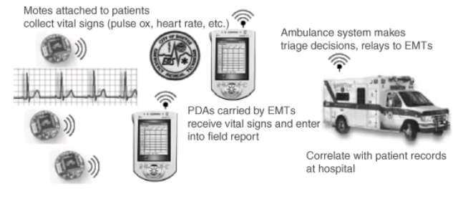

Figure 1. WSN applications in healthcare

**Home automation and civil electricity**

Home is a huge application space for wireless sensor networks. Smart home is the term to refer to a smart home with comprehensive application of wireless sensor devices. A universal remote control app that can control TVs, DVD players, stereos and other home electronics or lights, doors, and locks are also included. with wireless sensor network connection. With the universal remote control, one unit can control the house from the convenience of a chair.

However, the most compelling possibilities come from a combination of services, like the doors that close automatically when the TV is turned on, or maybe automatically shutting down the home entertainment system when a call is received on the device. phone or doorbell ring. The intended major purpose of wireless home wireless sensor networks is that low power consumption is an essential condition of wireless sensor networks. Another household application is support for car family services. With wireless sensor networks, wireless locks, door and window sensors, and wireless light bulb controllers, homeowners have a device similar to a key with the push of a node. At the push of a node, the device locks all indoor doors and windows, turns off most indoor lights (with the exception of a few sleeping lights), turns on outdoor safety lights, and sets the system up. HVAC to sleep mode. The user receives a beep once in response to indicate that all has done successfully, and is fully rested, making the house safe.

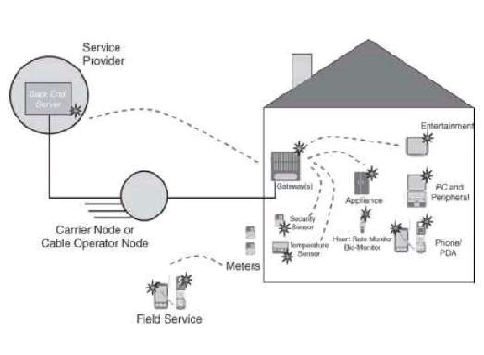

Figure 2. Application in home automation

**The prospects of wireless sensor networks in the military**:

Wireless sensor networks are an indispensable part of today's military applications with command systems, control, intelligence gathering, computation, suspect tracking, reconnaissance. and find a target. The rapid deployment, self-organization and fault tolerance characteristics of sensor networks indicate a promising technology in the military field. Since sensor networks are based on a dense deployment of cheap and disposable nodes, having the enemy destroyed some of the nodes does not affect the overall functioning of traditional sensors, so they approach the battlefield. better school. Some of the applications of sensor networks are: force check, equipment, ammunition, battlefield surveillance, area and enemy force reconnaissance, targeting, battle damage assessment, reconnaissance and detection. chemical - biological - nuclear weapons.

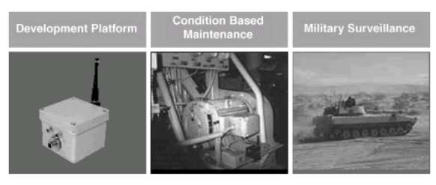

Figure 3. Application of WSNs in the military

Military and security applications, especially useful for people staying away from dangerous areas (especially war zones) while monitoring field operations.

Because many network applications require hundreds or thousands of sensor nodes and they often deployed in remote and inaccessible areas, a wireless sensor now includes not only sensing feature but also on-board processing, communication, and storage. With these improvements, a sensor node is now responsible for not only data collection, but also in-network analysis, correlation, and fusion of its own sensor data as well as data from other sensor nodes. Sensor nodes communicate not only with each other but also with a base station (BS), enabling them to send sensor data to remote processing, visualization, analysis, and storage systems. For example, Figure 1.3 shows two sensor fields monitoring two different geographic regions and connecting to the Internet using their base stations.

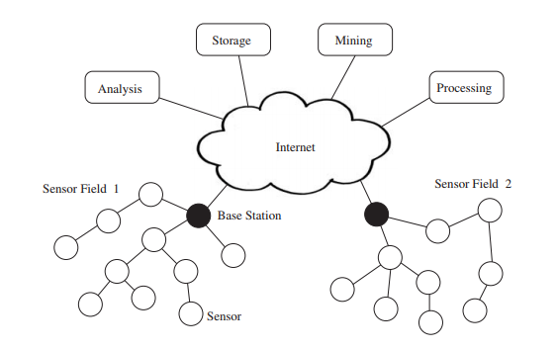

Figure 4. Wireless sensor networks

Sensor nodes operate with small energy budgets, which is the most common constraint associated with sensor network design. Typically, they are powered through batteries, which must be either replaced or recharged (e.g., using solar power) when depleted. For certain nodes, neither choice is suitable, and they will be discarded once their energy supply has been exhausted. Whether or not the battery can be recharged has a huge impact on the energy consumption. Therefore, to increase the lifetime of the network, energy efficiency is the most important and critical task in the design WSN routing protocols.

The routing protocol is a process to select suitable path for the data to travel from source to destination. The process encounters several difficulties while selecting the route, which depends upon, type of network, channel characteristics and the performance metrics.

In the routing protocol of WSNs, clustering algorithms are considered to be one of the most energy efficient approach for wireless sensor networks. Clustering divides the nodes into multiple regions, a region is known as a cluster. For each cluster, there is a sensor node which is chosen as a leader, called the cluster head (CH). All the remaining node in that cluster send their perceived data information to CH, which will conduct data information fusion and send date to the BS. Clustering avoids long distance communication of member nodes and only cluster heads are communicating to base station.

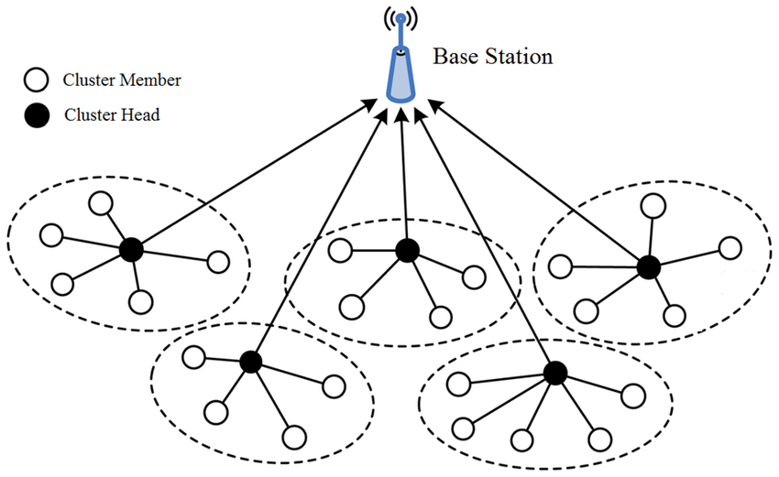

Figure 5. Routing technique based clustering

Many routing algorithms, such as LEACH, SEP, or DEEC, have introduced square field regions in recent years of research to increase the energy efficiency and stability of WSNs. Since the network nodes deployed do not move in response to a non-mobile sink, throughput results are poor. Furthermore, we are aware that there is always a need to improve energy and stability parameters in heterogeneous environmental conditions in order to deal with real-time scenarios. Therefore, in my research, these requirements are fulfilled by introducing an algorithm based Grey Wolf Optimization. With this work, the network performance is greatly enhanced.

## Related works

In recent years, the routing protocols of WSNs have attracted the attention of many scholars because of the rapid evolution and development of wireless sensor networks. Clustering routing protocol is an efficient way to reduce the energy consumption of sensor nodes and lengthen the life cycle of networks.

Thus, many routing protocols based on clustering have been presented, such as Low-Energy Adaptive Clustering Hierarchy (LEACH), Threshold Sensitive Energy Efficient Sensor Network Protocol (TEEN), Adaptive TEEN (APTEEN), The power-efficient gathering in sensor information systems (PEGASIS), Hybrid Energy-Efficient Distributed Clustering (HEED), LEACH-centralized (LEACH-C), etc.

However, heterogeneous wireless sensor networks (HWSNs) which consider heterogeneity of energy are now widely used in practice; meanwhile, most clustering routing protocol of WSNs are based on homogenous network. Many HWSNs routing protocols with heterogeneity of nodes energy have been proposed such as Power-Efficient Gathering in Sensor Information Systems (PEGASIS), Stable Election Protocol (SEP), Modified SEP (M-SEP), Distributed Energy-Efficient Clustering Algorithm (DEEC), etc.

### LEACH protocol

LEACH is the most famous clustering routing protocol among homogeneous WSNs.

Low-energy adaptive clustering hierarchy (LEACH) is a TDMA-based MAC protocol which is integrated with clustering and a simple routing protocol in wireless sensor networks (WSNs). This is the protocol for collecting and distributing data to sinks especially base stations. The main goals of LEACH are:

* Expand network lifetime.
* Reduce energy consumption by each sensor node.
* Use data concentration to reduce message transmission in the network.

To achieve these goals, LEACH adopted a hierarchical model to organize the network into clusters, each managed by the master node. The master node is responsible for performing many tasks. This master node is called cluster head (CH). This routing algorithm uses cluster formation based on the received signal strength and uses the CHs as the local sink while BS receives all the gathered data from cluster heads. Network topology of LEACH which uses single hop routing is shown below in Figure 1.

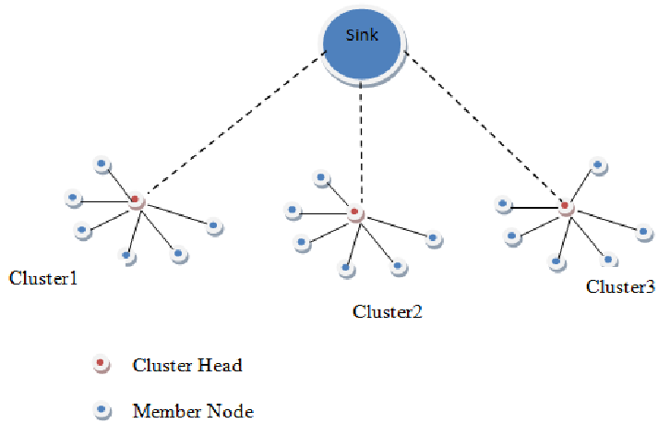

Figure 6. The LEACH protocol for Wireless Sensor Network.

the CHs are chosen at random, and the sensor nodes are rotated into CHs on a regular basis. To extend the network's life cycle and increase throughput, the network's energy consumption is distributed equally among the sensor nodes. For P rounds, nodes that have previously been cluster heads are unable to become cluster heads again, where P is the ideal percentage of cluster heads. Following that, each node has a 1/P chance of being a cluster head once more. Each node that isn't a cluster head chooses the closest cluster head and joins it at the end of each round. The cluster head then produces a transmission schedule for each node in the cluster.

The advantage of LEACH is significant energy savings. And this saving depends mainly on the data concentration coefficient of the cluster's master nodes.

However, LEACH also has some of the following shortcomings: It is impractical to assume that all of the host nodes in the network transmit to the base station in a single hop, and because the energy reserves and capabilities of the nodes change over time from node to node. In addition, the steady-state interval is key to achieving the energy reduction required to compensate for the amount of crest caused by cluster selection processing. Short cycle will increase the amount of overhead, long cycle will quickly consume the energy of the host node.

Many improved protocols based on LEACH have been proposed, such as LEACH-B, LEACH-C, E-LEACH, H-LEACH, O-LEACH, etc. The lifecycle of these above protocols raised relative to LEACH in homogeneous WSN, but they still perform poorly in HWSNs.

B-LEACH [25] communication is entirely depending upon the position of the cluster heads which requires no knowledge about the other nodes in the cluster. As a result, the CHs' remaining energy is depleted, reducing the network's lifespan even more.

In E-LEACH [14], the cluster head communication between different clusters is highly efficient, but in the case of larger networks, it fails to select the nodes with low energy.

LEACH-C [26, 27] outperforms LEACH-A, LEACH-B because the CPU handles locations and energy of all the nodes; therefore, formation and maintenance of the cluster is not affected. The only drawback is that it is not particularly vigorous. In the case of multi-hop communication E-LEACH is much energy efficient. It improves the cluster head selection process by taking into account the higher residual energy available within a cluster at any given time.

### DEEC protocol

As we know LEACH is introduced as a cluster-based protocol in homogenous networks. However, in heterogeneous networks, there are more than a type of nodes; therefore, many clustering algorithm which have been proposed for homogenous network such as LEACH, PEGASIS, HEED could not perform well in heterogeneous network. Thus, to prolonging this type of network lifetime, many other protocols are introduced. One of those is DEEC protocol.

Distributed Energy Efficient Clustering (DEEC) is an algorithm based clustering in which the cluster head selection depends on basis of probability of ratio of average energy and residual energy of the network. In this algorithm, the more energy that the node has, the more reasonable that node becoming a cluster head. Therefore, it could prolong the lifetime of the network.

DEEC implements LEACH's ideas by rotating the cluster-head function among all nodes, allowing each node to spend energy uniformly. Cluster heads are chosen using a probability formula based on the ratio of each node's residual energy to the network's average energy. The round number of each node's rotating epoch varies depending on its original and residual energy, i.e., DEEC adjusts each node's rotating epoch to its energy.

L. Qing, Q. Zhu and M. Wang [7] worked on heterogeneous WSN and suggested a protocol named as DEEC in which the CH is chosen based on the basis of probability of the ratio of residual energy and average energy of the network.

Brahim Elbhiri, et. al. [8] worked on heterogeneous WSNs and proposed the DDEEC protocol, which is based on residual energy for CH selection and network balance. As a result, advanced nodes are more likely to be chosen as CH during the initial transmission rounds, and as their energy decreases, they will have the same CH election like the regular nodes.

In E-DEEC [5], Parul Saini, et. al. introduced E-DEEC (Enhanced Distributed Energy Efficient Clustering) scheme is based on DEEC with addition of super nodes. They have extended the DEEC to three-level heterogeneity and its simulation results show that E-DEEC performs better than SEP.

## Performance comparison

The following analysis is taken from the author [21]. In terms of nodes dead, nodes alive, and packet delivery ratio, experimental comparison results of the two protocols, SEP and DEEC, were obtained. The number of packets sent from the source to the number of packets received at the destination, expressed as a percentage. The higher the value of PDR, the better the protocol's performance.

|  |  |  |  |  |
| --- | --- | --- | --- | --- |
| PERFORMANCE | Cluster  Stability | Energy Efficient | Cluster heads Selection criterion | Network lifetime |
| LEACH | Lower than SEP and DEEC | Lower than SEP and DEEC | Moderate | Moderate |
| SEP | Moderate | Moderate | Low | Moderate |
| DEEC | High | High | Low | Higher than SEP and LEACH |
| TEEN | Medium High | High | High | Higher than SEP and DEEC |

Table . Performance comparison of some protocols

In terms of network lifetime, we will have a comparison in the number of alive nodes per round. The analysis was taken from author in [22].

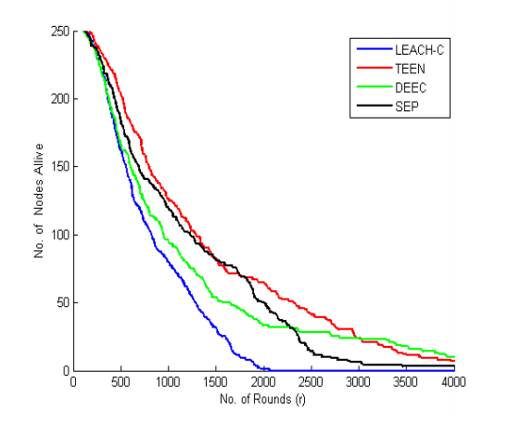

Figure 7. Comparison of LEACH-C, TEEN, DEEC, SEP in terms of nodes alive

Figure 7 depicts a plot of the number of nodes alive versus the number of rounds of various protocols such as LEACH-C, TEEN, DEEC, and SEP. It can be seen that, when compared to other protocols, the TEEN protocol performs better and has more stability, whereas the LEACH-C protocol performs the worst. TEEN and DEEC protocols revealed the average performance.

The results under various performance metrics are used to evaluate the performance of these protocols. As a result, among 4 protocols, we can conclude that TEEN is more energy efficient, while DEEC is more reliable. Therefore, we can incorporate a mobility concept into existing protocols to extend network lifetime.

## Objectives

Although there are many routing protocols built and published, however, these models have not really achieved high efficiency. We need a protocol which is suitable for heterogeneous networks which could extend the network lifetime and reduce energy consumption. Therefore, I decided to choose the topic "Energy efficient in wireless sensor network using Grey Wolf Optimization algorithm" as my graduate project topic.

The main objectives of this thesis are:

* To implement and simulate a wireless sensor networks (WSNs) using MATLAB simulation.
* To implement a modified GWO algorithm that solves the energy consumption problem in wireless sensor networks.
* To compare and evaluate the performance of the GWO algorithm and other network protocols.

## Thesis Organization

The organization of this thesis is as follows.

Chapter 1 includes a brief background on main concepts of wireless sensor network, LEACH protocol and DEEC protocol.

Chapter 2 presents the theoretical basis about wireless sensor network and its structures, routing protocol. The ideas and formulas of some meta-heuristic approach and Grey Wolf Optimization is explained as well.

Chapter 3 presents the model which will be used to simulate the energy consumed in the sensor network. This chapter also explains how the GWO algorithm applying in wireless sensor network step by step.

Chapter 4 shows the cluster formation. It also compares the proposed algorithm’s results to which of LEACH and E-DEEC protocol. In this chapter, network lifetime and number of dead nodes will be analyzed.

Finally, some potential problems and possible future works will be presented in the conclusion

# Chapter 2. THEORETICAL BACKGROUND

With the problems and motivations mentioned in chapter one, a hierarchy based protocol - GWO is the right direction to build a model to achieve the goal of the topic. Although meta-heuristic optimization techniques have become very popular over the last two decades, GWO is still relatively new. In the other hand, to apply it into a wireless sensor network, we first need to review all the concept theoretically. In this chapter, we will point out the background knowledge and theoretical basis of wireless sensor network, routing protocol and GWO algorithm.

## Wireless sensor network

Wireless Sensor Networks (WSNs) can be defined as a self-configured and infrastructure-less wireless networks to monitor physical or environmental conditions, such as temperature, sound, vibration, pressure, motion or pollutants and to cooperatively pass their data through the network to a main location or sink where the data can be observed and analyzed.

A sink or base station acts like an interface between users and the network. One can retrieve required information from the network by injecting queries and gathering results from the sink. Typically, a wireless sensor network contains hundreds of thousands of sensor nodes. The sensor nodes can communicate among themselves using radio signals. A wireless sensor node is equipped with sensing and computing devices, radio transceivers and power components. The individual nodes in a wireless sensor network (WSN) are inherently resource constrained: they have limited processing speed, storage capacity, and communication bandwidth. After the sensor nodes are deployed, they are responsible for self-organizing an appropriate network infrastructure often with multi-hop communication with them. Then the onboard sensors start collecting information of interest. Wireless sensor devices also respond to queries sent from a “control site” to perform specific instructions or provide sensing samples. The working mode of the sensor nodes may be either continuous or event driven.

### Structure

The basic components of a digital communication system are the sensor unit, processing unit, transceiver and the power generator.

1. **Sensor node**

Each sensor node consists of four basic components: the sensor, the processor, the wireless transceiver, and the power source. Depending on the specific application, the sensor node may also have additional components such as a location finder system, a power generator, and a mobile device. Components in a sensor node are shown in figure 2.

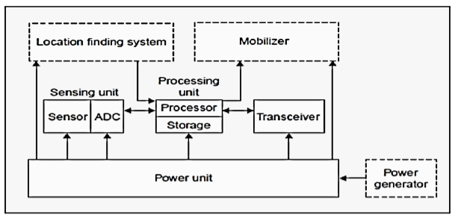

Figure 8. Structure of a sensor node

* **Sensor unit**

Sensor allows sensor node to have the ability to interact with the physical world. A sensor is usually composed of two component units, the sensor probe (sensor) and the analog / digital converter (ADC). The analog signals are received from the probe, then converted to digital signals using the ADC converter, then sent to the processor.

* **Processing unit (Microcontroller)**

The microcontroller manages the operating behavior of the sensor node. It is a small microprocessor on which it runs the software programs of the sensor node, connected to the radio transceiver and sensors. A microcontroller is a microprocessor that has internal memory, timers and hardware to connect external devices such as sensors and radio transceivers.

Due to cost and power constraints, the microcontrollers used in sensor nodes are much simpler than the microprocessors used in personal computers. Typically, a microcontroller used in the sensor node has several KB of the chip's memory and operates at a clock speed of several MHz

Microcontrollers have two types of memory: read-only memory (ROM) and random access memory (RAM). ROM is used to store software program code and RAM is used for software program temporary data.

* **Transceiver**

Allows the sensor nodes to communicate with each other. A communication device is usually a radio transceiver connected to an antenna. A radio transceiver has both functions of receiving and transmitting messages. It is the largest source of feed energy consumption. This is due to requirements for processing of radio signal modulation.

* **Power generator**

A key component of the sensor node is the power supply. The power supply is usually the battery, powers the sensor node and is not replaceable so the node's power source is usually limited. The power supply can be powered by electrical generating devices, for example small solar panels.

Most routing technologies in sensor networks and sensing tasks require highly accurate location awareness. Therefore, sensor nodes often have a location finder system. Mobile devices are also sometimes needed to move sensor nodes as required to secure assigned tasks.

1. **Nodes organization**

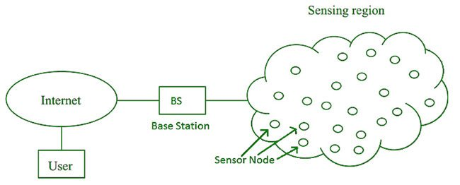

Figure 9. Structure of wireless sensor network

A wireless sensor network consists of a large number of nodes that are deployed densely inside or very close to the object to be probed or collected. The position of the sensors is not predetermined so it allows for random deployment in inaccessible or hazardous areas. The ability to self-organize the network and collaborate on wireless sensors are very basic features of this network. With a large number of wireless sensors deployed in close proximity, multi-link communication is selected for minimum power consumption (compared to single-link communication) and provides better signal transmission efficiency. compared with long distance transmission.

The basic structure of the wireless sensor network is shown in Figure 2. The sensor nodes are deployed in a sensor field. Each sensor node distributed in the network has the ability to collect data, route data back to the receiver (User), and route messages with the request from the Sink node. to the sensor nodes. Data are routed towards the receiver (Sink) in a multi-link structure without the foundation infrastructure (Multi-hop Infrastructureless Architecture), for example: without base stations or control centers. The receiver can communicate directly with the operator's (Task Manager Node) of the user or indirectly via the Internet or satellite (Satellite).

The network design perceived as the model in Figure 3 depends on many factors such as:

**Error tolerance**: Some sensor nodes may no longer function due to lack of power, physical damage or environmental influences. Error tolerance is shown in the fact that the network is still functioning properly, maintaining its functions even when some of the network nodes are down.

**Scalability**: When studying a phenomenon, the number of deployed sensor nodes can reach hundreds of thousands of nodes, depending on the application that this number can exceed hundreds of thousands of nodes. Therefore, the network architecture must be scalable to suit each specific application.

**Manufacturing cost**: Since the sensor network consists of a large number of sensor nodes, the cost per node is very important in regulating the network cost. Hence the cost per node sensor should be kept low.

**Hardware integration**: Because the number of sensor nodes in the network is so many, the sensor node requires the following hardware constraints: small size, low energy consumption, low production cost, adaptive environment field, self-configuring and unattended.

**Operating environment**: Sensor nodes are usually quite dense and distributed directly in the environment (including polluted, toxic or underwater environments ...) => sensor nodes must adapt to many types of environments. school and environmental changes.

**Transmission medium**: In sensor network, nodes are connected together in a wireless environment, the transmission medium can be radio waves, infrared or optical means. In order to establish a coherent workforce for these networks, the appropriate transmission mediums must be chosen around the world.

**Sensor network configuration**: The sensor network consists of a large number of sensor nodes, so a stable configuration must be set up.

**Energy Consumption**: Each sensor node is equipped with a limited power source. In some applications, the addition of an energy source is not possible. Therefore, the lifetime of the network depends on the lifetime of the sensor node, the lifetime of the sensor node depends on the lifetime of the battery. Therefore, scientists are currently trying to find algorithms and design protocols for the network node to save this limited energy source.

### Architecture and protocol of wireless sensor networks

The protocol architecture applied to the perceptible network is shown in Figure 4. This architecture consists of layers and management planes. These management planes make it possible for the nodes to work together in the most efficient way, routing data in the mobile sensing network, and sharing resources between sensor nodes.

**Physical layer**: It is responsible for frequency selection, carrier frequency generation, signal detection, signal modulation and coding.

: Responsible for joining data streams, detecting data frames, accessing transmission methods and handling errors. Since the environment is noisy and the sensor nodes are mobile, the environmental access control protocol (MAC) must take into account the issue of power and must be able to minimize collisions with broadcast messages. of neighboring nodes.

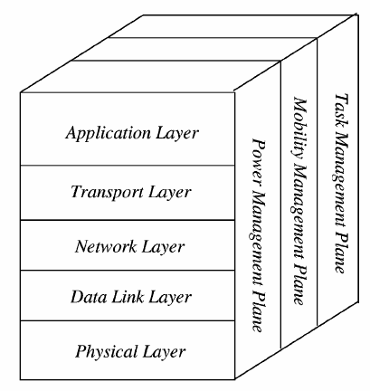

Figure 10. Architecture and protocol of wireless sensor networks

**Network layer**: Consider choosing the data line provided by the transport layer.

**Transport Layer**: Helps maintain the flow of data if the network application senses the request. The transport layer is only needed when the system is planning to be accessed through the Internet or other external networks.

**Application layer**: Depending on the sensor mission, different types of application software can be built and used at the application layer.

**Power management plane**: Control the power use of the sensor node. Example: The sensor node may turn off the receiver after it has received a message to avoid generating identical messages. When the sensor node's power level is low, it broadcasts to neighboring sensor nodes informing that its power level is low and it cannot participate in routing. The remaining power is devoted to sensor duty.

**Mobility management plane**: It is responsible for detecting and registering the movement of nodes. From there you can determine who is your neighbor node.

**Task management plane**: Responsible for balancing and aligning sensor tasks between nodes in an area of ​​interest. However, not all nodes in that region are performing sensing duties at the same time.

## Routing protocol

Data collected by sensor nodes in a WSN is usually sent to a base station (gateway) that connects the WSN to other networks and allows the data to be visualized, analyzed, and acted upon. Direct (single-hop) communication between all sensor nodes and the gateway may be possible in small sensor networks where sensor nodes and a gateway are close together. However, most WSN applications necessitate a multi-hop communication approach since they involve a large number of sensor nodes to cover a large region. Sensor nodes must, in other words, not only generate and disseminate their own data, but also act as relays or forwarding nodes for other sensor nodes. The process of establishing paths from a source to a sink (e.g., a gateway device) across one or more relays is called routing, and it is a key responsibility of the communication protocol stack's network layer.

The network layer's main job is to find paths from data sources to sink computers (e.g., gateways). All sensor nodes will communicate directly with the sink system in the single-hop routing model (left graph in Figure 7.1). The easiest solution is direct communication, in which all data travels a single hop to reach its destination. In practice, however, a single-hop communication model (right graph in Figure 7.1) is unworkable, and a multi-hop communication model is needed. The network layer of all sensor nodes' critical task in this case is to find a path from the sensor to the sink through multiple other sensor nodes acting as relays.

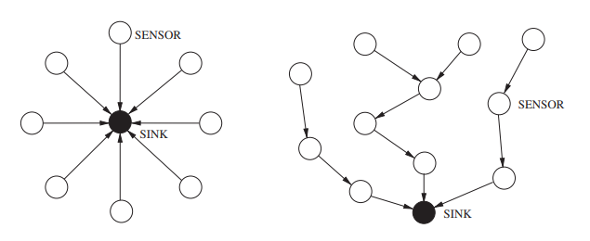

Figure 11. Single-hop routing model vs Multi-hop routing model

Routing protocols are classified in a variety of ways. The network structure or organization, the route discovery process, and the protocol activity are all classified differently in Figure 7.2. (Al-Karaki and Kamal 2004).

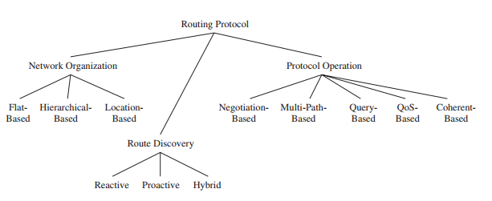

Figure 12. Category of routing protocol

Most routing protocols fall into one of three categories in terms of network organization. Flat-based routing protocols treat all nodes as if they have the same functionality or role. In hierarchical-based routing protocols, on the other hand, different nodes may play different roles in the routing process, such as forwarding data on behalf of others while only generating and propagating their own sensor data. Routing decisions are made using location information from nodes in location-based routing protocols.

The route discovery method can also be used to differentiate between various routing protocols. Reactive protocols discover routes on-demand, that is, if a source needs to send data to a receiver and no route exists. When it comes to reactive route exploration, proactive routing protocols create routes before they are actually required, causing delays before actual data transmission can occur. Hybrid routing protocols are those that combine the features of reactive and proactive routing protocols.

Finally, routing protocols also differ in their operation. Negotiation-based protocols, for example, attempt to eliminate redundant data transmissions by relying on the exchange of negotiation messages between adjacent sensor nodes prior to actual data transfers. To achieve higher performance or fault tolerance, multipath-based protocols use multiple routes at the same time. Sensor nodes submit data in response to queries provided by the destination node in receiver-initiated query-based routing protocols. Finally, routing protocols vary in how they enable data processing in the network. Until sensor data is sent to receivers and data aggregators, coherent-based protocols conduct only a minimal amount of processing (e.g., removing duplicates, time-stamping).

### Hierarchical routing

Based on the structure of WSNs, routing protocols can be classified as flat or Hierarchical. All sensors are treated equally in flat routing protocols. The data produced by sensors may be routed multi-hops to the BS to save transmission energy costs. Despite this, unlike traditional wireless networks, WSNs have a ‘‘many to one" characteristic, which means that sensors close to the BS will use more energy relaying data for others. Flat routing protocols are unable to avoid the energy-hole problem due to unbalanced energy dissipation rates.

In hierarchical approaches, Nodes are grouped together, and a cluster head is chosen to handle routing based on a set of criteria. Typically, a two-layer approach is used in hierarchical routing, with one layer sensing the physical environment and the other layer routing. Low-energy nodes are used for sensing, while high-energy nodes are frequently used for data collection, aggregation, and transmission. Clustering is the most widely used technique for achieving scalability and effective communication when it comes to energy efficiency. Cluster-based hierarchical approaches have a number of advantages, including increased scalability, efficient data aggregation, and efficient channel bandwidth utilization [14].

The clustering approach is depicted in two different ways in Figure 12. The routing problem is reduced to the cluster formation problem when all cluster heads communicate directly with the sink node (left graph). A cluster-based routing protocol must establish multi-hop routes from all cluster heads to the sink when cluster heads do not directly communicate with the sink (right graph).

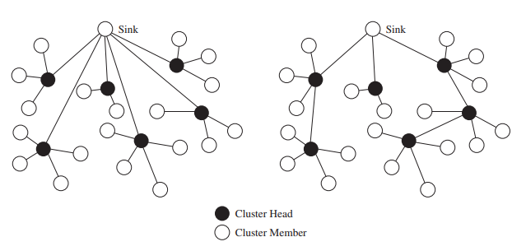

Figure 13. Clustering with single-hop (left) vs with multi-hop (right) connection.

Clustering approaches are used to simplify node management, reduce energy consumption, achieve scalability, improve load balancing, robustness, and data aggregation, and improve load balancing and robustness. Clusters are formed by grouping nodes.

Clustering approaches are used to simplify node management, reduce energy consumption, achieve scalability, improve load balancing, robustness, and data aggregation, and improve load balancing and robustness. Clusters are formed by grouping nodes. A cluster head (CH) is tasked with collecting data from member nodes (MN), aggregating it, and then forwarding it to the BS directly or through an intermediate CH. The data collected by the sensor node is sent to the BS via a gateway (CH). There can be more than one BS in a multilevel clustering hierarchy (if needed). Some examples of protocol that based hierarchy can be mentioned are LEACH[16], PEGASIS[15], TEEN[17], APTEEN[18], TTDD[19], etc.

Clustering protocols in WSNs typically face two challenges, despite the benefits of clustering. For starters, CH-selection is an NP-hard problem. As a result, determining the best cluster category for a given fitness function is difficult. More importantly, the fitness function's sub-functions have a significant impact on the final system performance.

Clustering protocols must build the fitness function in a reasonable manner. Second, key parameters such as the cluster head ratio and the weight factors between the different sub-functions are typically sensitive to clustering protocols. A clustering protocol must be able to fine-tune the critical parameters in accordance with the various application specifications.

## Meta-heuristic approach

A large number of clustering protocols have been proposed in recent years to improve network performance. To solve NP-hard optimization problems, meta-heuristic algorithms are commonly used. Many clustering protocols have been proposed that use metaheuristic approaches to construct the cluster.

One of the interesting branches of the population-based meta-heuristics is Swarm Intelligence (SI). The inspirations of SI techniques originate mostly from natural colonies, flock, herds, and schools. Some of the most popular SI techniques are Ant Colony Optimization (ACO) [], Particle Swarm Optimization (PSO) [], and Artificial Bee Colony (ABC) []. We'll go over these three clustering protocols in this section.

**Particle Swarm Optimization (PSO) Model**

Particle swarm optimization (PSO) is a population-based stochastic optimized data routing technique that routes data in a wireless sensor network by mimicking the social behavior of a flock of birds or a school of fish. The system is first initialized with a population of randomly generated solutions. The fitness of each of these solutions as a source of information is then calculated. The global best solution is the one with the highest fitness. Every node strives to find a solution that is closest to the global best solution. This is done by calculating the fitness of its local neighbors once more. The neighbor with the highest fitness is designated as the local best, and data is routed from the sensor node to the global best in the direction of the local best solution. Global and local solutions are calculated in this approach to produce a solution that is the most fit for the given objective function.

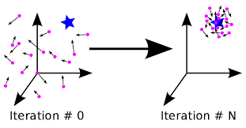

Figure 14. Particle Swarm Optimization algorithm

**Ant Colony Optimization (ACO) Model**

Ant colony optimization is a probabilistic method for determining the shortest path between two network sensor nodes. The algorithm routing table setup, data communication, and route maintenance are all divided into three phases. The algorithm begins with an initialization phase in which the fitness of each sensor node's solution is determined. The node from which the information is obtained is the solution with the highest fitness of solution. The shortest path to the destination node is chosen using an experience-based iteration technique, and data is transmitted only along that path while the other nodes remain idle. It provides statistically higher performance than conventional network routing techniques due to real-time computation techniques and lower control overhead used in ant colony optimization based techniques.

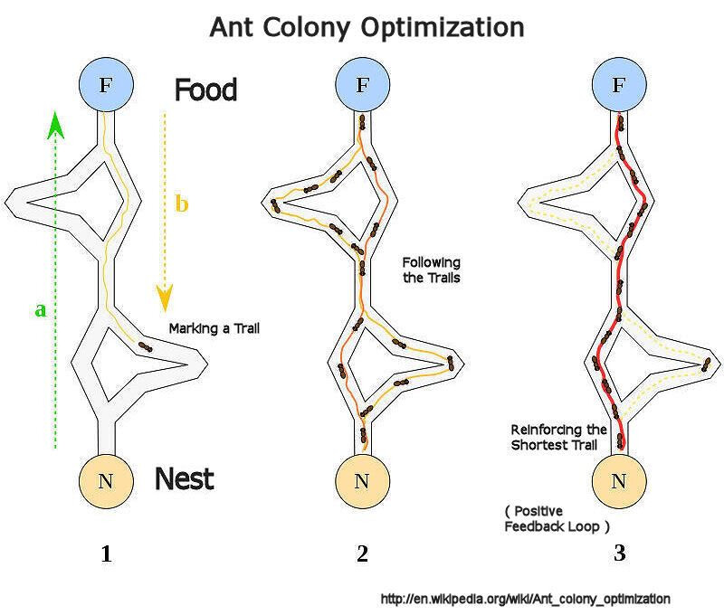

Figure 15. Ant Colony Optimization algorithm

**Artificial Bee Colony (ABC) based Protocols**

An evolutionary data routing path algorithm that mimics the foraging behavior of bees in a swarm is the artificial bee colony meta heuristic. The algorithm is intended to optimize continuous multivariable and multimodal functions. Three types of agents, also known as bees, make up the artificial bee colony model. Scout bees, onlooker bees, and employed bees are three types of bees. While the network is in various stages of operation, these individual agents have specific functions to perform.

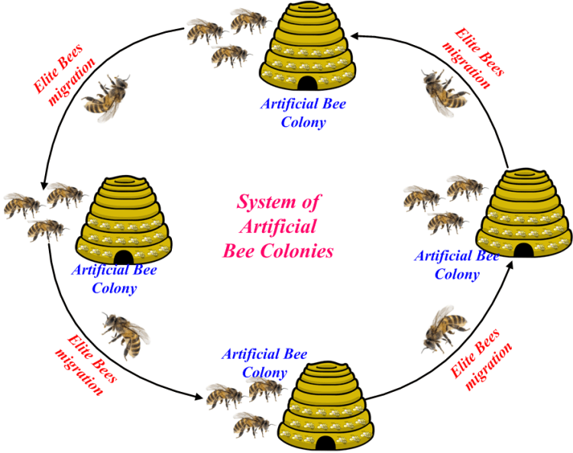

Figure 16. Artificial Bee Colony algorithm

There are many SI techniques proposed so far, many of them were inspired by hunting and searching behaviors. However, there is a few techniques in the literature mimicking the leadership hierarchy of grey wolves, well known for their pack hunting. This motivated our attempt to mathematically model the social behavior of grey wolves, propose an algorithm inspired by Grey Wolf Optimization, and investigate its abilities in routing wireless sensor networks.

## Grey wolf optimization

The proposed method's inspiration is first discussed in this section. The mathematical model is then presented.

### Inspiration

Grey wolf (Canis lupus) belongs to Canidae family. Grey wolves are considered as apex predators, meaning that they are at the top of the food chain. Grey wolves mostly prefer to live in a pack. The group size is 5-12 on average. Of particular interest is that they have a very strict social dominant hierarchy.

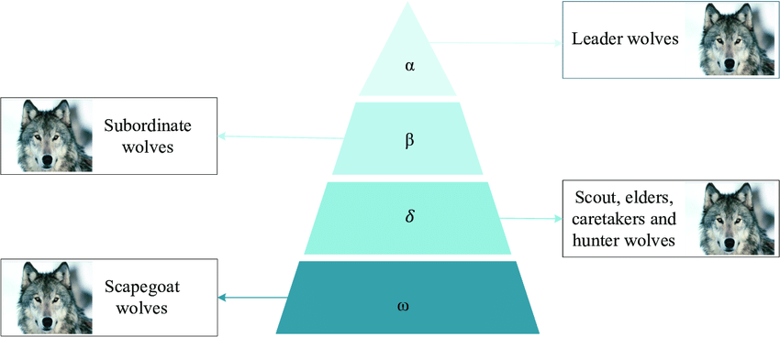

Figure 17. Hierarchy of grey wolf

The leaders are a male and a female, called alphas. The alpha is mostly responsible for making decisions about hunting, sleeping place, time to wake, and so on. The alpha’s decisions are dictated to the pack. However, some kind of democratic behavior has also been observed, in which an alpha follows the other wolves in the pack. In gatherings, the entire pack acknowledges the alpha by holding their tails down. The alpha wolf is also called the dominant wolf since his/her orders should be followed by the pack. The alpha wolves are only allowed to mate in the pack. Interestingly, the alpha is not necessarily the strongest member of the pack but the best in terms of managing the pack. This shows that the organization and discipline of a pack is much more important than its strength.

The second level in the hierarchy of grey wolves is beta. The betas are subordinate wolves that help the alpha in decision-making or other pack activities. The beta wolf can be either male or female, and he/she is probably the best candidate to be the alpha in case one of the alpha wolves passes away or becomes very old. The beta wolf should respect the alpha, but commands the other lower-level wolves as well. It plays the role of an adviser to the alpha and discipliner for the pack. The beta reinforces the alpha's commands throughout the pack and gives feedback to the alpha.

The lowest ranking grey wolf is omega. The omega plays the role of scapegoat. Omega wolves always have to submit to all the other dominant wolves. They are the last wolves that are allowed to eat. It may seem the omega is not an important individual in the pack, but it has been observed that the whole pack faced internal fighting and problems in case of losing the omega. This is due to the venting of violence and frustration of all wolves by the omega(s). This assists in satisfying the entire pack and maintaining the dominance structure. In some cases, the omega is also the babysitters in the pack.

If a wolf is not an alpha, beta, or omega, he/she is called subordinate (or delta in some references). Delta wolves have to submit to alphas and betas, but they dominate the omega. Scouts, sentinels, elders, hunters, and caretakers belong to this category. Scouts are responsible for watching the boundaries of the territory and warning the pack in case of any danger. Sentinels protect and guarantee the safety of the pack. Elders are the experienced wolves who used to be alpha or beta. Hunters help the alphas and betas when hunting prey and providing food for the pack. Finally, the caretakers are responsible for caring for the weak, ill, and wounded wolves in the pack.

In addition to the social hierarchy of wolves, group hunting is another interesting social behavior of grey wolves. According to Muro et al.[1] the main phases of gray wolf hunting are as follows:

* Tracking, chasing, and approaching the prey.
* Pursuing, encircling, and harassing the prey until it stops moving.
* Attack towards the prey.

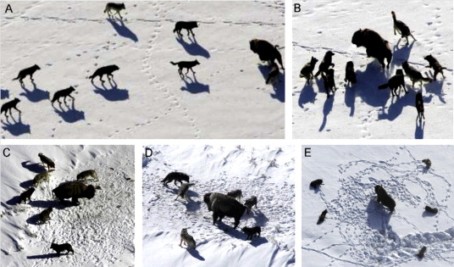

Figure 18. Hunting behaviour of grey wolves

### Mathematical model and algorithm

1. Social hierarchy

In order to mathematically model the social hierarchy of wolves when designing GWO, we consider the fittest solution as the alpha (α). Consequently, the second and third best solutions are named beta (β) and delta (δ) respectively. The rest of the candidate solutions are assumed to be omega (ω). In the GWO algorithm the hunting (optimization) is guided by α, β, and δ. The ω wolves follow these three wolves.

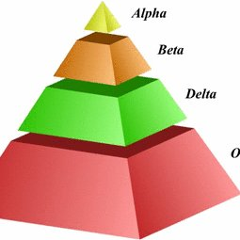

Figure 19. Social hierarchy of grey wolves

1. Encircling process

Grey wolves have the ability to recognize the location of prey and encircle them. The hunt is usually guided by the alpha. The beta and delta might also participate in hunting occasionally. However, in an abstract search space, we have no idea about the location of the optimum (prey). In order to mathematically simulate the hunting behavior of grey wolves, we suppose that the alpha (best candidate solution) beta and delta have better knowledge about the potential location of prey. Therefore, we save the first three best solutions obtained so far and oblige the other search agents (including the omegas) to update their positions according to the position of the best search agent.

During hunting, the location of the prey is assessed by α, β, and δ wolves, and the remaining wolves calculate the distance between themselves and the prey; then, the wolves encircle the prey.

The following is the calculation formula of the wolf’s position:

|  |  |  |
| --- | --- | --- |
|  | $${\vec{X_{p}}}^{t+1}= {\vec{X_{p}}}^{t} -\vec{A}×\vec{D}$$ | Eq 1 |

|  |  |  |  |  |
| --- | --- | --- | --- | --- |
|  |  | | Eq 2 | |
|  |  |  | |

Where:

* ${\vec{X_{p}}}^{t+1}$ is the wolf’s position in the (t+1)th iteration
* ${\vec{X_{p}}}^{t}$ is the prey’s position at the tth iteration
* $\vec{a}$ linearly decreases from 2 to 0 over the course of iterations
* $\vec{A}$ is the convergence factor
* $\vec{r_{1}}$ is a random vector in the range [0,1]
* $\vec{D}$ is the distance from the wolves to the prey, and is calculated as follow:

|  |  |  |
| --- | --- | --- |
|  |  | Eq 3 |
|  |  |  |
|  | $$\vec{C}=2×\vec{r_{2}}$$ | Eq 4 |
|  |  |  |

Where

* ${\vec{X_{p}}}^{t}$ and ${\vec{X_{p}}}^{t}$ are the positions of the prey and the wolf at the tth iteration
* $\vec{C}$ is the convergence factor
* $\vec{r_{2}}$ is a random vector in the range [0, 1]

1. Hunting process

Grey wolves have the ability to recognize the location of prey and encircle them. The hunt is usually guided by the alpha. The beta and delta might also participate in hunting occasionally. However, in an abstract search space we have no idea about the location of the optimum (prey). In order to mathematically simulate the hunting behavior of grey wolves, we suppose that the alpha (best candidate solution) beta, and delta have better knowledge about the potential location of prey. Therefore, we save the first three best solutions obtained so far and oblige the other search agents (including the omegas) to update their positions according to the position of the best search agent. The following formulas are proposed in this regard.

|  |  |  |
| --- | --- | --- |
|  | $${\vec{X_{p}}}^{t+1}= \frac{{\vec{X_{α}}}^{t+1}+{\vec{X_{β}}}^{t+1}+{\vec{X_{δ}}}^{t+1}}{3}$$ | Eq 5 |

Where:

* ${\vec{X_{p}}}^{t+1}$ is the prey’s position at the (t+1)th iteration
* ${\vec{X_{α}}}^{t+1}, {\vec{X_{β}}}^{t+1}and {\vec{X_{δ}}}^{t+1}$ are the positions of alpha wolf, beta wolf and delta wolf at the (t+1)th iteration. They are calculated by equation (3.1).

At the end of the iteration times, α wolves have the highest fitness value.

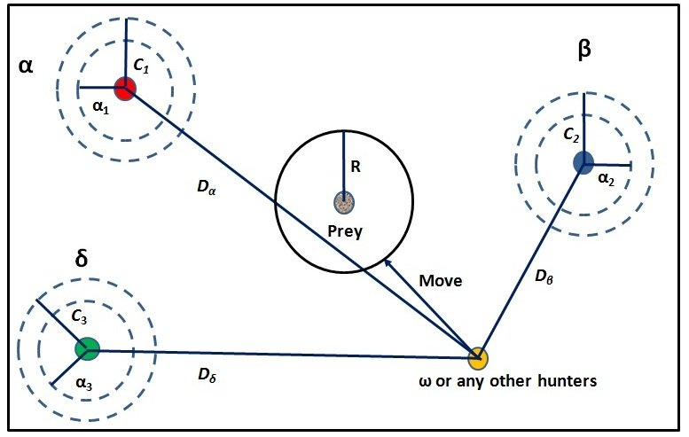

Figure 20. Position updating in GWO

shows how a search agent updates its position according to alpha, beta, and delta in a 2D search space. It can be observed that the final position would be in a random place within a circle which is defined by the positions of alpha, beta, and delta in the search space. In other words, alpha, beta, and delta estimate the position of the prey, and other wolves updates their positions randomly around the prey.

1. Seeking and attacking the prey

As mentioned above the grey wolves finish the hunt by attacking the prey when it stops moving. In order to mathematically model approaching the prey we decrease the value of $\vec{a}$. Note that the fluctuation range of $\vec{A}$ is also decreased by $\vec{a}$. In other words, is a random value in the interval [-a, a] where a is decreased from 2 to 0 over the course of iterations. When random values of $\vec{A}$ are in [-1, 1], the next position of a search agent can be in any position between its current position and the position of the prey. Fig shows that |A| < 1 forces the wolves to attack towards the prey.

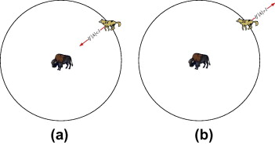

Figure 21. Approaching prey vs searching for pery

With the operators proposed so far, the GWO algorithm allows its search agents to update their position based on the location of the alpha, beta, and delta; and attack towards the prey. However, the GWO algorithm is prone to stagnation in local solutions with these operators. It is true that the encircling mechanism proposed shows exploration to some extent, but GWO needs more operators to emphasize exploration.

To sum up, the search process starts with creating a random population of grey wolves (candidate solutions) in the GWO algorithm. Over the course of iterations, alpha, beta, and delta wolves estimate the probable position of the prey. Each candidate solution updates its distance from the prey. The parameter a is decreased from 2 to 0 in order to emphasize exploration and exploitation, respectively. Candidate solutions tend to diverge from the prey when || > 1 and converge towards the prey when || < 1. Finally, the GWO algorithm is terminated by the satisfaction of an end criterion.

# Chapter 3. Proposed model and algorithm

In this chapter, the routing protocol for HWSN based on the GWO is detailed. The proposed study's main goals are to extend the network life cycle and increase network throughput. To simulate and analyze the efficiency of the proposed algorithm, we assume a simple model for network model. The energy consumption model is used based on the suggestions of the author in [20].

# Proposed network model

### Network model and assumptions

In the network model, the following assumptions are made:

1. All nodes are randomly distributed in the two-dimensional geographical area. Once the location is determined, no matter what happens, the location of the nodes will not change.
2. In HWSNs, all sensor nodes are assigned different initial energy levels.
3. The BS is located in the center of the sensing area, and its power is externally supplied.
4. The energy of the sensor node is limited, and the battery cannot be charged.
5. When the sensor node power is exhausted, the node will be considered dead.

### Energy consumption

In WSNs, nodes are randomly deployed, and the locations of the nodes are not pre-designed. Most of the energy of a node is dissipated due to communication between nodes, depending on the distance between the nodes. Both data transmission and reception consume energy. Therefore, to transmit an (m − bit)-long data packet over the distance d, the required energy is:

|  |  |  |
| --- | --- | --- |
|  | $$E_{TX}\left(m,d\right)= \left\{\begin{aligned}m×E_{elec}+m×ε_{fs}×d^{2} , if d ≤ d_{crossover} \\ m×E_{elec}+m×ε_{mp}×d^{4} , if d> d_{crossover}\end{aligned}\right.$$ | Eq 6 |

Where:

* $E_{TX}$ is the energy consumed when the node transmits data.
* $E_{elec}$ is the energy dissipation of the process of transmitting 1 bit of data and the process of receiving 1 bit of data.
* $ε_{fs}$ is the coefficient of energy dissipation in the free-space model
* $ε_{mp}$ is the coefficient of energy dissipation in the multi-path attenuation model
* $d_{crossover}$ is the threshold of the transmission distance, which is calculated as:

|  |  |  |
| --- | --- | --- |
|  | $$d_{crossover}= \sqrt{\frac{ε_{fs}}{ε_{mp}}}$$ | Eq 7 |

The energy consumption required by the receiving node to receive an m bit data packet is calculated as follows:

|  |  |  |
| --- | --- | --- |
|  | $$E_{RX} (m)=m×E_{elec}$$ | Eq 8 |

The energy consumption of CH can be calculated by the above model. The energy consumption of CH mainly includes three aspects: the energy consumption of receiving data packets of member nodes, fusing data and transmitting fusing data to the base station. The calculation formula is as follows:

|  |  |  |
| --- | --- | --- |
|  | $$E_{CH }=E_{RX }\left(m\right)×{CM}_{num}+m×E_{DA}×{(CM}_{num}+1)+ E_{TX}\left(m,d\right)$$ | Eq 9 |

Where:

* ${CM}_{num}$ is the number of member nodes in the cluster.
* $E_{DA}$ is 1 bit of data aggregation energy cost.
* $m$ is the packet length.

The energy consumption of the non-CH node is only the energy consumption of sending data to the CH, and its mathematical expression is as follows:

|  |  |  |
| --- | --- | --- |
|  | $$E_{non-CH}=E_{TX}\left(m,d\right)$$ | Eq 10 |

The total residual energy in the rth round is calculated as follows:

|  |  |
| --- | --- |
| $$E_{totR}\left(r\right)=E_{totR}\left(r-1\right)-(\sum_{i=1}^{{CH}_{num}(r)}{E_{CH }\left(i\right)+ \sum_{j=1}^{{N_{alive}(r)- CH}_{num}(r)}{E_{non-CH }\left(j\right) }})$$ | Eq 11 |

Where:

* $E_{totR}\left(r-1\right)$ is the total residual energy in the (r − 1)th round
* ${CH}_{num}(r)$ is the number of CHs in the rth round
* $N_{alive}(r)$ is the number of alive nodes in the network in the rth round
* $E_{CH }\left(i\right)$ is the energy consumed by the ith CH
* $E_{non-CH }\left(j\right)$ is the energy consumed by the jth non-CH.

## Proposed algorithm

In order to avoid the randomness of CHs selection, an algorithm is proposed. In the first stage of cluster formation, all the sensors in network send their positions and initial energy to the base station and then the base station saves them. It should be noted that the sensors’ locations are all fixed and cannot be changed. After receiving these information, energy consumed each round can be calculated; therefore, locations and energy are sent to the BS once only.

### Selection of Initial Clusters

To establish the initial clusters of the network, energy of the nodes and the distance of them to the BS are 2 parameters that the protocol uses, thereby limiting the number of CHs in each round. The following rules are used to select the initial clusters. All the sensors are divided into m sets of clusters and the cluster heads of these clusters are chosen based on the result of fitness value ranked from high to low. Nodes which are close to the BS and have high residual energy should be selected as the CH. All the remaining nodes join the nearest CH based on Euclidean distance to form cluster. It should be noted that, if the distance from node to the BS is less than that node to any CHs, it should transfer data straight to the BS. This make the formation of cluster more reasonable hence the BS can be powered externally and reduce the energy consumption for CHs. Here, it is proposed to use the remaining energy and distance between the nodes to the BS as parameters of fitness function. The fitness function is expressed as:

|  |  |  |
| --- | --- | --- |
|  | $$F_{1}=\left\{\begin{aligned}a_{1}×\frac{E_{r}}{E_{i}}+\left(1-a_{1}\right)×\left(\frac{d_{MAXBS}-d_{toBS}}{d_{MAXBS}-d_{MINBS}}\right), E_{r}>0 \\ 0 , { E}_{r} ≤ 0\end{aligned}\right.$$ | Eq 12 |

Where:

* $a_{1}$ is the weight.
* $E_{i}$ is the initial energy of the node.
* $E_{r}$ is the residual energy of the node.
* $d_{toBS}$ is the distance from the node to the BS.
* $d_{MAXBS}$ and $d_{MINBS}$ are respectively the maximum and the minimum distance between a node and the BS of the network.

Node with the higher fitness value are more likely to become the BS.

### Modified Grey Wolf Optimizer

After the initial cluster is established, the MGWO is used to form new clusters and select new CHs. In the original GWO, based on the average weight of alpha, beta and delta wolves, the prey’s position was calculated. The three best wolves are chosen based on Equation 12. They are 3 nodes which have the highest fitness value F1. Consequently, based on the GWO and formula (12), the initial position of prey is computed as:

|  |  |  |
| --- | --- | --- |
|  | $${\vec{X_{p}}}^{0}=ω_{Iα}{\vec{X_{α}}}^{0}+ω_{Iβ}{\vec{X_{β}}}^{0}+ω_{Iδ} {\vec{X_{δ}}}^{0}$$ | Eq 13 |
|  |  |  |
|  | $$ω_{Iα}=\frac{F_{α}}{F_{α}+ F_{β}+F_{δ}} \\ ω_{Iβ}=\frac{F_{β}}{F_{α}+ F_{β}+F_{δ}} \\ ω_{Iδ}=\frac{F_{δ}}{F_{α}+ F_{β}+F_{δ}}$$ | Eq 14 |

Where:

* α, β and δ are the 3 respective nodes have the highest fitness value calculated through Equation 12.
* $ω_{Iα}$, $ω_{Iβ}$ and $ω_{Iδ}$ are respectively the initial weights of alpha, beta and delta wolf.
* $F_{α}$, $F_{β}$ and $F_{δ}$ are respectively the first, the second and the third best fitness value calculated through Equation 12.

It should be noted that, if we use GWO algorithm to implement the protocol, the fitness of all the nodes change after completing one data transmission. However, the weight of alpha, beta and delta wolf will not change. Thus, to further improve the global search capacity of GWO, the weights should be updated for each transmission. A modified algorithm for GWO is proposed to update the weights based on vectors A and D. A is the coefficient vector, D is the distance between the wolf and the prey and they are calculated according to Equations 2 and 3. At the (t + 1)th iteration, the location of the prey and the weight updating formula are as follows:

|  |  |  |
| --- | --- | --- |
|  | $${\vec{X_{p}}}^{t+1}=ω_{α}^{t+1}{\vec{X_{α}}}^{t+1}+ω_{β}^{t+1}{\vec{X_{β}}}^{t+1}+ω_{δ}^{t+1} {\vec{X_{δ}}}^{t+1}$$ | Eq 15 |

|  |  |  |
| --- | --- | --- |
|  |  |  |
|  | $$ω_{α}^{t+1}=\frac{{\vec{D_{α}}}^{t+1}×{\vec{A_{α}}}^{t+1}}{{\vec{D_{α}}}^{t+1}×{\vec{A_{α}}}^{t+1}+{\vec{D_{β}}}^{t+1}×{\vec{A_{β}}}^{t+1}+{\vec{D_{δ}}}^{t+1}×{\vec{A_{δ}}}^{t+1} } \\ ω_{β}^{t+1}=\frac{{\vec{D_{β}}}^{t+1}×{\vec{A_{β}}}^{t+1}}{{\vec{D_{α}}}^{t+1}×{\vec{A_{α}}}^{t+1}+{\vec{D_{β}}}^{t+1}×{\vec{A_{β}}}^{t+1}+{\vec{D_{δ}}}^{t+1}×{\vec{A_{δ}}}^{t+1}} \\ ω_{δ}^{t+1}=\frac{{\vec{D_{δ}}}^{t+1}×{\vec{A_{δ}}}^{t+1}}{{\vec{D_{α}}}^{t+1}×{\vec{A_{α}}}^{t+1}+{\vec{D_{β}}}^{t+1}×{\vec{A_{β}}}^{t+1}+{\vec{D_{δ}}}^{t+1}×{\vec{A_{δ}}}^{t+1}}$$ | Eq 16 |

Where:

* ${\vec{X_{α}}}^{t+1}$, ${\vec{X_{β}}}^{t+1}$ and ${\vec{X_{δ}}}^{t+1}$ are respectively the positions of alpha, beta and delta wolf in the (t + 1)th iteration. They can be calculated by using equation 1.

After the iteration done, the node closer to the prey is more likely to become the CH. However, distance is not the only parameter we care about. The remaining energy of that node could not be enough to complete tasks of the CH, causing the node to die soon. Therefore, node which has more residual energy and close to the prey is consider to be selected as the CH. The fitness function to select the CH is then proposed based on the above parameters. It should be noted that the node with smaller fitness value will indicate that the CH selection is more reasonable. Dead nodes cannot become cluster head. The fitness function is defined as:

|  |  |  |
| --- | --- | --- |
|  | $$F_{2}=\left\{\begin{aligned}a_{2}×\frac{E_{MAX}-E_{r}}{E_{MAX}-E_{MIN}}+\left(1-a_{2}\right)×\left(\frac{d_{MAXP}-d_{toP}}{d_{MAXP}-d_{MINP}}\right), E_{r}>0 \\ +∞ , { E}_{r} ≤ 0\end{aligned}\right.$$ | Eq 17 |

Where:

* $a_{2}$ is the weight.
* $E_{r}$ is the residual energy of the node.
* $E_{MAX}$ and $E_{MIN}$ are the maximum and minimum residual energy in the cluster.
* $d_{toP}$ is the distance from the node to the prey.
* $d_{MAXP}$ and $d_{MINP}$ are respectively the maximum and the minimum distance between a node and the prey in the cluster.

## Selection of the Optimal Cluster Set

According to the clustering algorithm, a network can be divided into multiple clusters, and multiple clusters in the network are called a cluster set. To get the optimal cluster set; first, the initial cluster set which was calculated in 5.1 is taken as the current optimal set and its objective function is calculated. This cluster set is then randomly changed by MGWO algorithm to form new cluster sets and these new sets’ objective value are calculated. When the objective value of the new set is better than the old one, this set is accepted as the current optimal set. At the end of the iteration, the optimal cluster set is established. The objective function is expressed as:

|  |  |  |  |  |  |  |  |  |  |  |  |
| --- | --- | --- | --- | --- | --- | --- | --- | --- | --- | --- | --- |
| |  |  |  | | --- | --- | --- | |  |  | Eq 18 | | |  |  |  | | --- | --- | --- | |  |  | Eq 12 | | |  |  |  | | --- | --- | --- | |  |  | Eq 12 | |

Where:

* is the weight.
* is the number of cluster heads.
* is the residual energy of a cluster head.
* is the number of alive nodes.
* is the total distance from nodes to their cluster heads.
* is the total distance from cluster heads to the base station.
* is the distance from a node to the base station.

The objective function is designed based on the intra-cluster communication distance, the total communication distance from the CH to the BS and the residual energy of the nodes. A smaller objective value makes the CH selection more reasonable.

## Pseudo code

1. Initialize the grey wolf population Xi (i = 1, 2, … , n);
2. **While** (r < Max number of iterations)
3. **For** each grey wolf
4. Calculate the fitness value of each grey wolf by Equation 12;
5. **End For**
6. Select 3 best fitness value to find ;
7. Calculate the prey position by Equation 14;
8. Initial CHs selection;
9. Each of the remaining nodes decides to join its nearest CH or the BS according to the Euclidean distance;
10. **If** (the number of cluster members >3)
11. Form the initial cluster sets;
12. **Else**
13. All the nodes in that cluster are regarded as normal nodes
14. **End Else**
15. **End If**
16. **While** (t < Max number of iterations)
17. Update position by Equation 1;
18. Calculate the new prey’s position by Equation 15;
19. **For** each grey wolf
20. Calculate the fitness value of each grey wolf by Equation 17;
21. **End for**
22. Initial CHs selection;
23. Each of the remaining nodes decides to join its nearest CH or the BS according to the Euclidean distance;
24. **If** (the number of cluster members >3)
25. Form the initial cluster sets;
26. **Else**
27. All the nodes in that cluster are regarded as normal nodes
28. **End Else**
29. **End If**
30. Calculate the objective function value of the new cluster set (Fnew) by Equation 18;
31. **If** (Fnew < Fopt)
32. Current optimal cluster set = new cluster set;
33. Fopt = Fnew;
34. **End if**
35. **End While**
36. **End While**

# Chapter 4. RESULTS AND ANALYSIS

## Kịch bản thử nghiệm

Chạy với số lượng nút khác nhau, sink khác nhau.

## Cluster formation result

To verify the performance, we use MATLAB software to simulate the MGWO algorithm. The simulation parameters are shown below:

|  |  |
| --- | --- |
| **Parameter** | **Value** |
| The area of the sensing region | 100 (m2) |
| Number of Sensor Nodes | 100 |
| Packet Size | l = 4000 bits |
| Data Aggregation Energy Cost | $E_{DA}$ = 5 nJ/bit |
| Energy Cost of Transmitter/Receiver | $E_{elec}$ = 50 nJ/bit |
| Transmission Coefficient of Amplifier (free space) | $ε_{fs}$ = 10 pJ/bit/m2 |
| Transmission Coefficient of Amplifier (multi-path space) | $ε_{mp}$ = 0.0013 pJ/bit/m4 |
| Initial energy of normal node | 0.05 J |
| Ratio of Advanced Node | 0.2 |
| Weight of Fitness Function | a1 = a2 = a3 = 0.2 |
|  |  |

Table 2. Simulation parameters

At the beginning of each round, the BS selects CHs using algorithm as described above and each round last for 1 second. The maximum number of cluster heads is 10.

First, all sensor nodes send the information of their locations and energy to the base station.

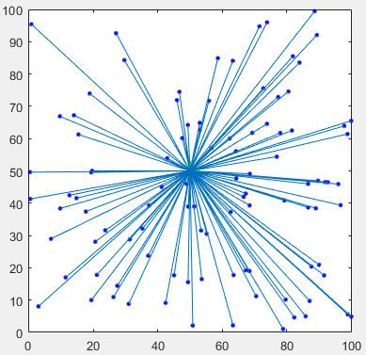

Figure 22. Send information to base station

After getting the necessary information, the base station will calculate and run the algorithm to find the best routing based on the method proposed.

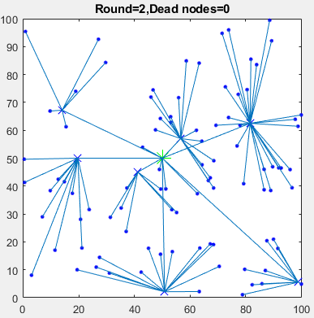

Figure 23. Cluster formation

In the beginning of every round, the base station calculates the residual energy and find the next best routing in order to maximize the network’s lifetime.

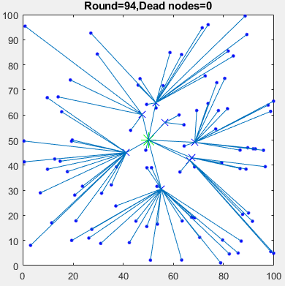

Figure 24. Cluster formation

First node dead (FND): is the total active time of the WSN till the death of the first node. The longer this interval is, the more stable will be the network.

In this simulation, the “First node dead occurs” event happens in round 144.

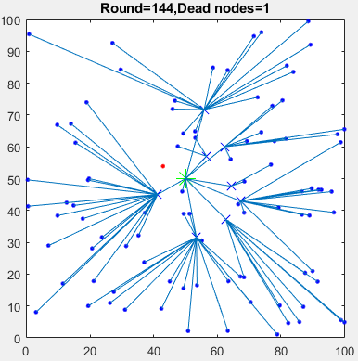

Figure 25. First node dead occurs

After 90 rounds, all the nodes in the network became dead nodes.

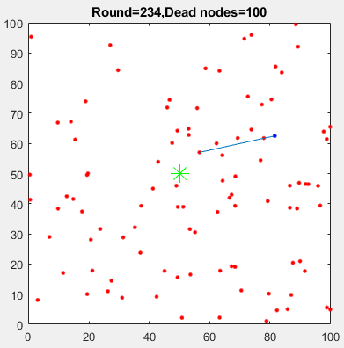

Figure 26. All nodes dead

## Performance analysis

To analyze the performance of the proposed algorithm, MGWO will be compared its performance to LEACH’s and E-DEEC. For efficient performance analysis, the algorithms are executed until all the nodes died.

As can be seen from Figure 13, the death time of the first node of MGWO was later than that of LEACH and E-DEEC. Furthermore, after the first node death event happened, there was a significant drop in the dead nodes of LEACH, straight from 100 to 0 in just about 10 rounds. Meanwhile, MGWO extended to keep nodes alive greatly when comparing to the other protocol. It needs about 100 rounds after the first node died to come when the number of death nodes reach 100%.

Although E-DEEC could keep the sensor network alive longer than MGWO, its ‘first node dead’ event occur much sooner than MGWO and even sooner than LEACH. Moreover, the time for MGWO reached 90% of nodes dead is way later than that of E-DEEC.

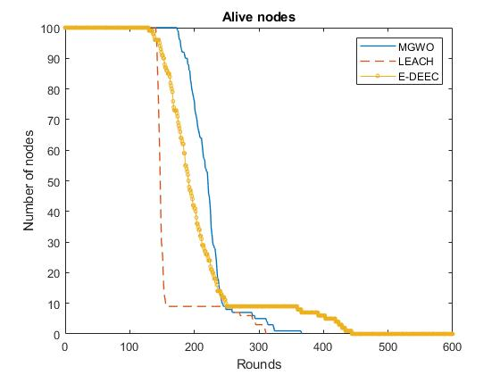

Figure 27. Network stability period with respect to the number of rounds

In the energy consumption section, it is obviously that the MGWO had higher total residual energy, which means that its lifetime is longer than that of the LEACH protocol. In Figure 14, the MGWO effectively reduce residual energy deviation compared to LEACH.

When comparing to E-DEEC, MGWO was slightly more efficient in the first 200 rounds; after that, E-DEEC had done a better job in reducing the energy consumption low enough to keep the network alive.

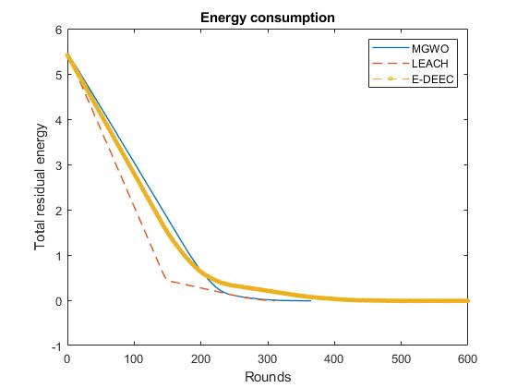

Figure 28. Residual energy relative to the number of rounds

# CONCLUSION

After learning, researching and developing a routing protocol based GWO algorithm, I have completed the following tasks:

* Learned about wireless sensor network and many routing protocols of it such as LEACH, DEEC, etc.
* Learned the Grey Wolf Optimization algorithm and applied it for a specific topic.
* Successfully simulated the wireless sensor network in MATLAB and applied GWO algorithm to optimize the network’s lifetime.
* Simulated LEACH and E-DEEC routing protocols to have a comparison with the routing protocol based GWO algorithm.
* GWO algorithm outperformed LEACH protocol in optimization energy consumption and have a better result when comparing to E-DEEC in extending network lifetime generally.

However, the subject met some difficulties such as:

* With a large number of sensor nodes (>200), the simulation is time-consuming. It took a while to find the best route.
* When comparing to E-DEEC, the proposed algorithm could not perform better in the total network lifetime.

Further development and future work:

Since the system is not really optimal, I would like to suggest some development directions for the system as follows:

* Find a better fitness function for selecting optimal sets of clusters.
* Find a better fitness function for selecting cluster heads.
* Find a solution to avoid exceeding crossover distance such as make it becoming a parameter in selecting cluster heads.
* Propose a new algorithm in which cluster heads could send data to others.

# REFERENCE

|  |  |
| --- | --- |
| [1] | Heinzelman, W.R.; Chandrakasan, A.; Balakrishnan, H., "Energy-Efficient Communication Protocol for Wireless Microsensor Networks," in *33rd Annual Hawaii International Conference on System Sciences*, 2000. |
| [2] | Tong, M.; Tang, M, "LEACH-B: An Improved LEACH Protocol for Wireless Sensor Network," in *2010 6th International Conference on Wireless Communications Networking and Mobile Computing (WiCOM), Chengdu, China)*, 2010. |
| [3] | Marappan, P.; Rodrigues, P, "An energy efficient routing protocol for correlated data using CL-LEACH in WSN," *Wirel. Netw,* p. 1415–1423, 2015. |
| [4] | Vinod Kumar, Ajay Khunteta, "Energy Efficient PEGASIS Routing Protocol for Wireless Sensor Networks," in *2nd International Conference on Micro-Electronics and Telecommunication Engineering*, 2018 . |
| [5] | Parul Saini, Ajay.K.Sharma, "E-DEEC- Enhanced Distributed Energy Efficient Clustering Scheme for heterogeneous WSN," in *1st International Conference on Parallel, Distributed and Grid Computing*, 2010. |
| [6] | T. N. Qureshi, N. Javaid, M. Malik, U. Qasim‡, Z. A. Khan§, "On Performance Evaluation of Variants of DEEC in WSNs," in *2012 Seventh International Conference on Broadband, Wireless Computing, Communication and Applications*. |
| [7] | L. Qing, Q. Zhu, M. Wang, "Design of a distributed energy-efficient clustering algorithm for heterogeneous wireless sensor network," *ELSEVIER, Computer Communications 29,* pp. 2230- 2237, 2006. |
| [8] | Elbhiri, B. , Saadane, R. , El Fkihi, S. , Aboutajdine, D, "Developed Distributed Energy-Efficient Clustering (DDEEC) for heterogeneous wireless sensor networks," in *5th International Symposium on I/V Communications and Mobile Network (ISVC)*, 2010. |
| [9] | Xiaoqiang Zhao, Shaoya Ren, Heng Quan and Qiang Gao , "Routing Protocol for Heterogeneous Wireless Sensor Networks Based on a Modified Grey Wolf Optimizer," *Sensors,* 4 February 2020. |
| [10] | Ramson, S.R.J.; Moni, D.J, "Applications of wireless sensor networks—A survey," in *International Conference on Innovations in Electrical, Electronics, Instrumentation and Media Technology*, 2017. |
| [11] | Al-Aboody, N.A.; Al-Raweshidy, H.S, "Grey wolf optimization-based energy-efficient routing protocol for heterogeneous wireless sensor networks," in *4th International Symposium on Computational and Business Intelligence (ISCBI), Olten, Switzerland*, 2016. |
| [12] | Zhao, X.Q.; Zhu, H.; Aleksic, S.; Gao, Q, "Energy-Efficient Routing Protocol for Wireless Sensor Networks Based on Improved Grey Wolf Optimizer," *KSII T. Internet Inf,* p. 2644–2657, 2018. |
| [13] | Mirjalili, S.; Mirjalili, S.M.; Lewis, "A. Grey Wolf Optimizer," *Adv. Eng. Softw,* p. 46–61, 2014. |
| [14] | Bilal Jan, Haleem Farman, Huma Javed, Bartolomeo Montrucchio, Murad Khan and Shaukat Ali, "Energy Efficient Hierarchical Clustering Approaches in Wireless Sensor Networks: A Survey," *Wireless Communications and Mobile Computing,* 2017. |
| [15] | Lindsey S,Raghavendra C, "PEGASIS:Power-efficient Gatgering in Sensor Information Systems," in *IEEE Aerospace Conference*, Montana, 2002. |
| [16] | Heinzelman W,Chandrakasan A,Balakrishnan H, "Energy-efficient Communication Protocol for Wireless Microsensor Networks," in *33rd Annual Hawaii Int’l Conf.on System Sciences.Maui:IEEE Computer Society*, 2000. |
| [17] | Manjeshwar A,Agrawal D, "TEEN:A Protocol for Enhanced Efficiency in Wireless Sensor Networks," in *Proceedings 15th International Parallel and Distributed Processing Symposium. IPDPS 2001*, San Francisco, CA, USA, 2001. |
| [18] | Manjeshwar A,Agrawal D, "APTEEN: A Hybrid Protocol for Efficient Routing and Comprehensive Information Retrieval in Wireless Sensor Networks," in *Conference: 16th International Parallel and Distributed Processing Symposium (IPDPS 2002)*, Fort Lauderdale, FL, USA, 2002. |
| [19] | Ye F,Luo H,Cheng J,et al, "A Two-tier Data Dissemination Model for Large-scale Wireless Sensor Networks," in *Proceeding of the 8th Annual International Conference on Mobile Computing and Net-working*, Atlanta, 2002. |
| [20] | Wendi B. Heinzelman, Member, IEEE, Anantha P. Chandrakasan, "An Application-Specific Protocol Architecture for Wireless Microsensor Networks," *IEEE TRANSACTIONS ON WIRELESS COMMUNICATIONS,* vol. 1, p. 4, 2002. |
| [21] | Anitha Amaithi Rajan, Aravind Swaminathan, Brundha, "A Novel Clustering Algorithm for DEEC Protocol Based on Game Theory in WSN Sensors," *International Journal of Advanced Research in Computer Engineering & Technology (IJARCET),* vol. 08, 2019. |