**Hanoi University of Science and Technology**

**School of electrical engineering**



**UNDERGRADUATE THESIS**

**Energy efficient in wireless sensor network using Grey Wolf Optimization algorithm**

|  |  |
| --- | --- |
| **Author:**  **Supervisor:** | Dao Duc Nguyen  Dr. Nguyen Thanh Huong  Chữ ký của GVHD |
| **Department:** | Department of instrumentation and industrial informatics |
| **School:** | School of electrical engineering |
| **HÀ NỘI, 6/2021** | |

i

**CỘNG HÒA XÃ HỘI CHỦ NGHĨA VIỆT NAM**

**Độc lập - Tự do - Hạnh phúc**

-----------------

**BỘ GIÁO DỤC VÀ ĐÀO TẠO**

**TRƯỜNG ĐẠI HỌC BÁCH KHOA HÀ NỘI**

--***--

**NHIỆM VỤ**

**THIẾT KẾ TỐT NGHIỆP**

Họ và tên: Dao Duc Nguyen Mã số sinh viên: 20162982

Khóa:  **61**

Viện: **Điện**

Ngành: **Kỹ thuật đo và Tin học công nghiệp**

*1. Đầu đề thiết kế/Tên đề tài*

* Energy efficient in wireless sensor network using Grey Wolf Optimization algorithm

*2. Các số liệu ban đầu*

*3. Các nội dung tính toán, thiết kế*

*4. Cán bộ hướng dẫn:* TS. Nguyễn Thanh Hường

*5. Ngày giao nhiệm vụ thiết kế: 01/2021*

*6. Ngày hoàn thành nhiệm vụ: 04/2021*

*Ngày...... tháng...... năm......*

CHỦ NHIỆM BỘ MÔN CÁN BỘ HƯỚNG DẪN

*(Ký, ghi rõ họ tên) (Ký, ghi rõ họ tên)*

SINH VIÊN THỰC HIỆN

*(Ký, ghi rõ họ tên)*

# ACKNOWLEDGEMENTS

I would like to thank all of the people who made this thesis possible, starting with my wonderful supervisor - Dr. Nguyen Thanh Huong for her support, patience, and guidance in almost every step throughout my thesis. I am grateful to all the members in the class AP Automatic Control K61. It is their kind help and support that have made my study and life at the university a wonderful time. Further, I would like to express my sincere gratitude to Hanoi University of Science and Technology and all its member’s staff for all the considerate guidance. Also, I would like to thank my friends I have made along the way when I was studying at Hanoi University of Science and Technology. They have left wonderful memories for me. Finally, I would like to express my gratitude to my parents. Without their tremendous understanding and encouragement in the past few years, it would be impossible for me to complete my study.

# ABSTRACT

Wireless sensor network (WSN) nodes are devices with limited power and extending the network lifetime is the main objectives of the WSN’s routing protocol. However, many types of energy level in sensor nodes will lead to imbalance of heterogeneous WSNs (HWSNs). Therefore, in this thesis, a routing protocol based on grey wolf optimization (GWO) is proposed. First, initial clusters are formed based on the fitness value of each node, these values are used as initial weights of GWO. After that, the weights will be updated according to GWO algorithm to search for better sets of clusters. Parameters which are used to select the cluster heads are: initial energy of a node, residual energy of a node, distance to cluster heads and distance to the base station. If a clusters set have a better fitness value, it will become the new optimal set and replace the current set. For analysis, the proposed routing protocol will be compared its performance to LEACH protocol and E-DEEC protocol. The result showed that protocol based GWO out-performed LEACH protocol in network lifetime and energy consumption, and have a better performance in general when comparing to E-DEEC.

Sinh viên thực hiện

Ký và ghi rõ họ tên

ACKNOWLEDGEMENTS 3

ABSTRACT 3

TABLE OF CONTENTS 5

LIST OF FIGURES 6

LIST OF ABBREVIATIONS 7

LIST OF TABLES 8

Chapter 1. INTRODUCTION 9

1.1 Introduction and motivation 9

1.2 Related works 14

1.2.1 LEACH protocol 15

1.2.2 DEEC protocol 16

1.3 Performance comparison 17

1.4 Objectives 19

1.5 Thesis Organization 19

Chapter 2. THEORETICAL BACKGROUND 20

2.1. Wireless sensor network 20

2.1.1. Structure 20

2.1.2. Architecture and protocol of wireless sensor networks 23

2.2. Routing protocol 25

2.2.1. Hierarchical routing 26

2.3. Meta-heuristic approach 28

2.4. Grey wolf optimization 31

2.4.1. Inspiration 31

2.1.1. Mathematical model and algorithm 32

Chapter 3. Proposed model and algorithm 37

3.1. Proposed network model 37

3.1.1. Network model and assumptions 37

3.1.2. Energy consumption 37

3.2. Proposed algorithm 39

3.2.1. Selection of Initial Clusters 39

3.2.2. Modified Grey Wolf Optimizer 39

3.2.3. Selection of the Optimal Cluster Set 41

3.3. Pseudo code 42

Chapter 4. RESULTS AND ANALYSIS 44

4.1. Assumption and properties of the network 44

4.2. Cluster formation result 44

4.3. Performance analysis 47

4.3.1. Homogenous network 47

4.3.2. Heterogeneous network 50

CONCLUSION 54

REFERENCE 55

# TABLE OF CONTENTS

# LIST OF FIGURES

Figure 1. WSN applications in healthcare [34] 10

Figure 2. Application in home automation [35] 11

Figure 3. Application of WSNs in the military [36] 12

Figure 4. Wireless sensor networks [28] 13

Figure 5. Routing technique based clustering [37] 14

Figure 6. The LEACH protocol for Wireless Sensor Network [23]. 15

Figure 7. Comparison of LEACH-C, TEEN, DEEC, SEP in terms of nodes alive [22]. 18

Figure 8. Structure of a sensor node [33] 21

Figure 9. Structure of wireless sensor network [38] 22

Figure 10. Architecture and protocol of wireless sensor networks [27]. 24

Figure 11. Single-hop routing model vs Multi-hop routing model [28]. 25

Figure 12. Category of routing protocol [28]. 26

Figure 13. Clustering with single-hop (left) vs with multi-hop (right) connection [28]. 27

Figure 14. Particle Swarm Optimization algorithm [32] 29

Figure 15. Ant Colony Optimization algorithm [30]. 29

Figure 16. Artificial Bee Colony algorithm [31]. 30

Figure 17. Hierarchy of grey wolf [13]. 31

Figure 18. Hunting behaviour of grey wolves [13]. 32

Figure 19. Social hierarchy of grey wolves [13]. 33

Figure 20. Position updating in GWO [13]. 35

Figure 21. Approaching prey vs searching for pery [13]. 36

Figure 22. Send information to base station 45

Figure 23. Cluster formation 45

Figure 24. Cluster formation 46

Figure 25. First node dead occurs 46

Figure 26. All nodes dead 47

Figure 27. Network stability period with respect to the number of rounds in homogeneous network 48

Figure 28. Residual energy relative to the number of rounds in homogeneous 49

Figure 29. Network lifetime with respect to number of rounds in homogeneous network 49

Figure 30. Network stability period with respect to the number of rounds in 2-level heterogeneous network (left) and 3-level heterogeneous (right) 51

Figure 31. Residual energy relative to the number of rounds in 2-level heterogeneous (left) and 3-level heterogeneous (right) network 52

Figure 32. Network lifetime with respect to number of rounds in 2-level heterogeneous network 52

Figure 33. Network lifetime with respect to number of rounds in 3-level heterogeneous network 53

# LIST OF ABBREVIATIONS

|  |  |
| --- | --- |
| **Abbreviations** | **Explanation** |
| WSN | Wireless Sensor Network |
| HWSN | Heterogeneous Wireless Sensor Network |
| CH | Cluster Head |
| BS | Base Station |
| GWO | Grey Wolf Optimizer |
| MGWO | Modified Grey Wolf Optimizer |
| LEACH | Low Energy Adaptive Clustering Hierarchy Protocol |
| SEP | SEP Stable Election Protocol |
| DEEC | Distributed Energy-Efficient Clustering Algorithm |
| E-DEEC | Enhanced-Distributed Energy-Efficient Clustering Algorithm |
|  |  |
|  |  |
|  |  |
|  |  |
|  |  |

# LIST OF TABLES

Table 1. Performance comparison of some protocols [21]. 18

Table 2. Simulation parameters 45

Table 3. Simulation parameters of homogenous network 48

Table 4. Simulation parameters of heterogeneous network 51

# Chapter 1. INTRODUCTION

Sensors bridge the gap between the physical and digital worlds by recording and exposing real-world events and transforming them into data that can be interpreted, stored, and acted upon. Sensors, which are embedded in a wide range of products, computers, and environments, provide significant societal benefits.

## Introduction and motivation

In recent years, wireless sensor networks (WSNs) have a wide range of application area, such as military reconnaissance, medical aid, urban management, smart home and target tracking thanks to the development of low-power digital circuits and wireless communication technology. WSNs consists of a base station (BS) and a large number of randomly distributed sensor nodes. The energy of the sensor node is mainly powered by the battery and it is very difficult to charge or replace the battery.

WSN consists of compact sensor nodes that adapt to harsh environments. These sensor nodes, sensing their surroundings, then send the obtained information to the center for application processing. Nodes can not only communicate with nodes around it, but can also process data obtained before sending it to other nodes. WSN provides many useful applications in many areas of life.

**Industrial monitoring and control**:

The characteristic of industrial monitoring and control is a large noise environment, which does not require large amounts of data to be transmitted but very high requirements for real-time reliability and response. Wireless sensor network is used in this field mainly for collecting information, monitoring the operating status of the system, such as valve status, device status, temperature and pressure of raw materials. stored data, ...

In addition, in a number of wide area control applications, the wireless sensor network also demonstrates many outstanding features. It's advertising light wireless control system. A lot of costs are involved in installing light bulbs in a large building (wired switches, lights turned on / off together, bulb control, ...). A flexible wireless system can take advantage of a remote controller that can be programmed to control a number of bulbs in one in nearly limitless ways, while still delivering Security level is required by an advertising installation department. Or the use of wireless sensor networks in industrial safety applications.

Wireless sensor networks can leverage sensors to detect the presence of hazardous substances or hazardous materials, provide early detection and identification of gaps, or detect spillages. chemical or biological before serious damage has occurred (and before substances move out of control). Because wireless networks can use distributed routing algorithms, have multiple routing paths, and can be self-healing and self-sustaining, they can scale in the outer surface of boom or damage. Other harms to industrial machines, providing authoritative power with decision machine status information under very difficult conditions.

In another application, the process of monitoring and controlling rotational or spatial motion is a well-suited area for wireless sensor networks (aircraft, flying objects, etc.). Another application in this area of ​​wireless sensor networks is the boiler, ventilation and air-conditioning (HVAC) systems of buildings. A HVAC system equipped with wireless thermostats and anti-vibration will provide better human protection if the same HVAC system is equipped with a single wired thermostat.

**Wireless sensor networks for environment and agriculture**:

Some of the environmental applications of wireless sensor networks include bird, mammal, and insect movement tracking; check environmental conditions affecting crops and animals; condition of irrigation water; macro tools for wide-ranging ground surveillance and planetary exploration; chemical and biological discovery; calculating in agriculture; check the environment of the air, land, and sea; forest fire detection; meteorology and geography research; flood detection; Complex biological mapping of the environment and environmental pollution research. The applications of wireless sensor networks are also used on livestock farms. The wireless sensor network can be used for monitoring the temperature throughout the house, ensuring herd safety.

**Medical applications**:

Some medical applications of wireless sensor networks are to provide communication capabilities for people with disabilities; check the patient's condition; diagnose; pharmaceutical management in hospitals; examines the movement and internal biological mechanisms of insects and other small organisms; remote check of data on human physiology; supervise, check with doctors and patients inside the hospital.

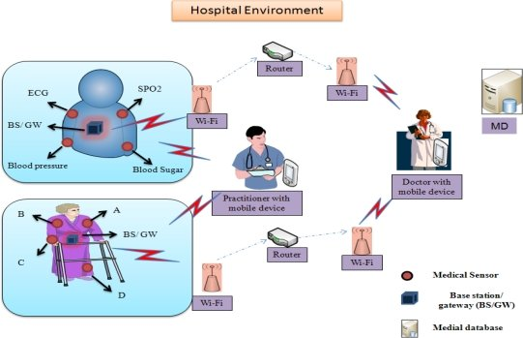

Figure 1. WSN applications in healthcare [34]

**Home automation and civil electricity**

Home is a huge application space for wireless sensor networks. Smart home is the term to refer to a smart home with comprehensive application of wireless sensor devices. A universal remote control app that can control TVs, DVD players, stereos and other home electronics or lights, doors, and locks are also included. with wireless sensor network connection. With the universal remote control, one unit can control the house from the convenience of a chair.

However, the most compelling possibilities come from a combination of services, like the doors that close automatically when the TV is turned on, or maybe automatically shutting down the home entertainment system when a call is received on the device. phone or doorbell ring. The intended major purpose of wireless home wireless sensor networks is that low power consumption is an essential condition of wireless sensor networks. Another household application is support for car family services. With wireless sensor networks, wireless locks, door and window sensors, and wireless light bulb controllers, homeowners have a device similar to a key with the push of a node. At the push of a node, the device locks all indoor doors and windows, turns off most indoor lights (with the exception of a few sleeping lights), turns on outdoor safety lights, and sets the system up. HVAC to sleep mode. The user receives a beep once in response to indicate that all has done successfully, and is fully rested, making the house safe.

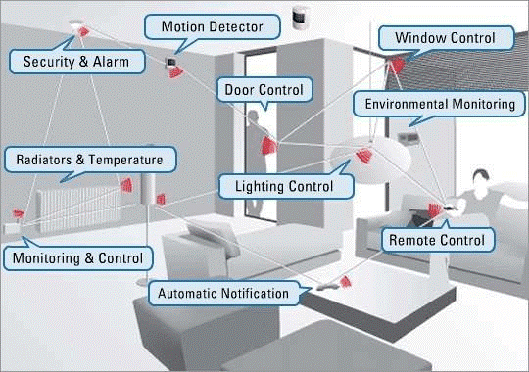

Figure 2. Application in home automation [35]

**The prospects of wireless sensor networks in the military**:

Wireless sensor networks are an indispensable part of today's military applications with command systems, control, intelligence gathering, computation, suspect tracking, reconnaissance. and find a target. The rapid deployment, self-organization and fault tolerance characteristics of sensor networks indicate a promising technology in the military field. Since sensor networks are based on a dense deployment of cheap and disposable nodes, having the enemy destroyed some of the nodes does not affect the overall functioning of traditional sensors, so they approach the battlefield. better school. Some of the applications of sensor networks are: force check, equipment, ammunition, battlefield surveillance, area and enemy force reconnaissance, targeting, battle damage assessment, reconnaissance and detection. chemical - biological - nuclear weapons.

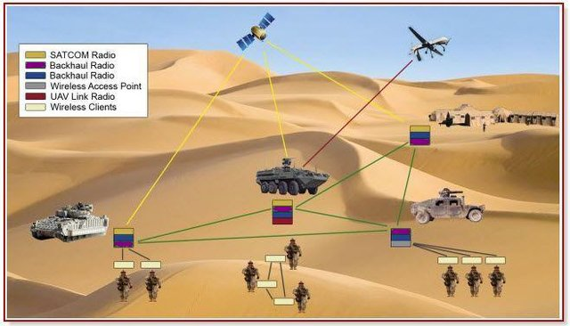

Figure 3. Application of WSNs in the military [36]

Military and security applications, especially useful for people staying away from dangerous areas (especially war zones) while monitoring field operations.

Because many network applications require hundreds or thousands of sensor nodes and they often deployed in remote and inaccessible areas, a wireless sensor now includes not only sensing feature but also on-board processing, communication, and storage. With these improvements, a sensor node is now responsible for not only data collection, but also in-network analysis, correlation, and fusion of its own sensor data as well as data from other sensor nodes. Sensor nodes communicate not only with each other but also with a base station (BS), enabling them to send sensor data to remote processing, visualization, analysis, and storage systems. For example, Figure 1.3 shows two sensor fields monitoring two different geographic regions and connecting to the Internet using their base stations.

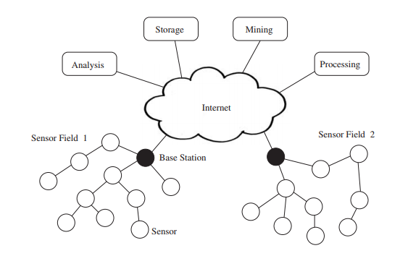

Figure 4. Wireless sensor networks [28]

Sensor nodes operate with small energy budgets, which is the most common constraint associated with sensor network design. Typically, they are powered through batteries, which must be either replaced or recharged (e.g., using solar power) when depleted. For certain nodes, neither choice is suitable, and they will be discarded once their energy supply has been exhausted. Whether or not the battery can be recharged has a huge impact on the energy consumption. Therefore, to increase the lifetime of the network, energy efficiency is the most important and critical task in the design WSN routing protocols.

The routing protocol is a process to select suitable path for the data to travel from source to destination. The process encounters several difficulties while selecting the route, which depends upon, type of network, channel characteristics and the performance metrics.

In the routing protocol of WSNs, clustering algorithms are considered to be one of the most energy efficient approach for wireless sensor networks. Clustering divides the nodes into multiple regions, a region is known as a cluster. For each cluster, there is a sensor node which is chosen as a leader, called the cluster head (CH). All the remaining node in that cluster send their perceived data information to CH, which will conduct data information fusion and send date to the BS. Clustering avoids long distance communication of member nodes and only cluster heads are communicating to base station.

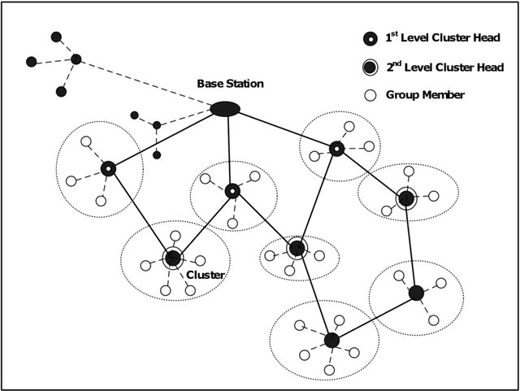

Figure 5. Routing technique based clustering [37]

Many routing algorithms, such as LEACH, SEP, or DEEC, have introduced square field regions in recent years of research to increase the energy efficiency and stability of WSNs. Since the network nodes deployed do not move in response to a non-mobile sink, throughput results are poor. Furthermore, we are aware that there is always a need to improve energy and stability parameters in heterogeneous environmental conditions in order to deal with real-time scenarios. Therefore, in my research, these requirements are fulfilled by introducing an algorithm based Grey Wolf Optimization. With this work, the network performance is greatly enhanced.

## Related works

In recent years, the routing protocols of WSNs have attracted the attention of many scholars because of the rapid evolution and development of wireless sensor networks. Clustering routing protocol is an efficient way to reduce the energy consumption of sensor nodes and lengthen the life cycle of networks.

Thus, many routing protocols based on clustering have been presented, such as Low-Energy Adaptive Clustering Hierarchy (LEACH), Threshold Sensitive Energy Efficient Sensor Network Protocol (TEEN), Adaptive TEEN (APTEEN), The power-efficient gathering in sensor information systems (PEGASIS), Hybrid Energy-Efficient Distributed Clustering (HEED), LEACH-centralized (LEACH-C), etc.

However, heterogeneous wireless sensor networks (HWSNs) which consider heterogeneity of energy are now widely used in practice; meanwhile, most clustering routing protocol of WSNs are based on homogenous network. Many HWSNs routing protocols with heterogeneity of nodes energy have been proposed such as Power-Efficient Gathering in Sensor Information Systems (PEGASIS), Stable Election Protocol (SEP), Modified SEP (M-SEP), Distributed Energy-Efficient Clustering Algorithm (DEEC), etc.

### LEACH protocol

LEACH is the most famous clustering routing protocol among homogeneous WSNs.

Low-energy adaptive clustering hierarchy (LEACH) is a TDMA-based MAC protocol which is integrated with clustering and a simple routing protocol in wireless sensor networks (WSNs). This is the protocol for collecting and distributing data to sinks especially base stations. The main goals of LEACH are:

* Expand network lifetime.
* Reduce energy consumption by each sensor node.
* Use data concentration to reduce message transmission in the network.

To achieve these goals, LEACH adopted a hierarchical model to organize the network into clusters, each managed by the master node. The master node is responsible for performing many tasks. This master node is called cluster head (CH). This routing algorithm uses cluster formation based on the received signal strength and uses the CHs as the local sink while BS receives all the gathered data from cluster heads. Network topology of LEACH which uses single hop routing is shown below in Figure 1.

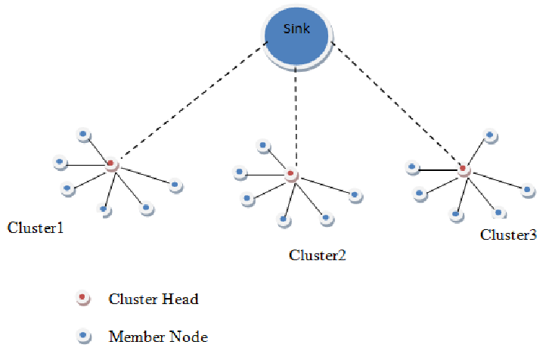

Figure 6. The LEACH protocol for Wireless Sensor Network [23].

the CHs are chosen at random, and the sensor nodes are rotated into CHs on a regular basis. To extend the network's life cycle and increase throughput, the network's energy consumption is distributed equally among the sensor nodes. For P rounds, nodes that have previously been cluster heads are unable to become cluster heads again, where P is the ideal percentage of cluster heads. Following that, each node has a 1/P chance of being a cluster head once more. Each node that isn't a cluster head chooses the closest cluster head and joins it at the end of each round. The cluster head then produces a transmission schedule for each node in the cluster.

The advantage of LEACH is significant energy savings. And this saving depends mainly on the data concentration coefficient of the cluster's master nodes.

However, LEACH also has some of the following shortcomings: It is impractical to assume that all of the host nodes in the network transmit to the base station in a single hop, and because the energy reserves and capabilities of the nodes change over time from node to node. In addition, the steady-state interval is key to achieving the energy reduction required to compensate for the amount of crest caused by cluster selection processing. Short cycle will increase the amount of overhead, long cycle will quickly consume the energy of the host node.

Many improved protocols based on LEACH have been proposed, such as LEACH-B, LEACH-C, E-LEACH, H-LEACH, O-LEACH, etc. The lifecycle of these above protocols raised relative to LEACH in homogeneous WSN, but they still perform poorly in HWSNs.

B-LEACH [2] communication is entirely depending upon the position of the cluster heads which requires no knowledge about the other nodes in the cluster. As a result, the CHs' remaining energy is depleted, reducing the network's lifespan even more.

In E-LEACH [24], the cluster head communication between different clusters is highly efficient, but in the case of larger networks, it fails to select the nodes with low energy.

LEACH-C [25, 26] outperforms LEACH-A, LEACH-B because the CPU handles locations and energy of all the nodes; therefore, formation and maintenance of the cluster is not affected. The only drawback is that it is not particularly vigorous. In the case of multi-hop communication E-LEACH is much energy efficient. It improves the cluster head selection process by taking into account the higher residual energy available within a cluster at any given time.

### DEEC protocol

As we know LEACH is introduced as a cluster-based protocol in homogenous networks. However, in heterogeneous networks, there are more than a type of nodes; therefore, many clustering algorithm which have been proposed for homogenous network such as LEACH, PEGASIS, HEED could not perform well in heterogeneous network. Thus, to prolonging this type of network lifetime, many other protocols are introduced. One of those is DEEC protocol.

Distributed Energy Efficient Clustering (DEEC) is an algorithm based clustering in which the cluster head selection depends on basis of probability of ratio of average energy and residual energy of the network. In this algorithm, the more energy that the node has, the more reasonable that node becoming a cluster head. Therefore, it could prolong the lifetime of the network.

DEEC implements LEACH's ideas by rotating the cluster-head function among all nodes, allowing each node to spend energy uniformly. Cluster heads are chosen using a probability formula based on the ratio of each node's residual energy to the network's average energy. The round number of each node's rotating epoch varies depending on its original and residual energy, i.e., DEEC adjusts each node's rotating epoch to its energy.

L. Qing, Q. Zhu and M. Wang [7] worked on heterogeneous WSN and suggested a protocol named as DEEC in which the CH is chosen based on the basis of probability of the ratio of residual energy and average energy of the network.

Brahim Elbhiri, et. al. [8] worked on heterogeneous WSNs and proposed the DDEEC protocol, which is based on residual energy for CH selection and network balance. As a result, advanced nodes are more likely to be chosen as CH during the initial transmission rounds, and as their energy decreases, they will have the same CH election like the regular nodes.

In E-DEEC [5], Parul Saini, et. al. introduced E-DEEC (Enhanced Distributed Energy Efficient Clustering) scheme is based on DEEC with addition of super nodes. They have extended the DEEC to three-level heterogeneity and its simulation results show that E-DEEC performs better than SEP.

## Performance comparison

The following analysis is taken from the author [21]. In terms of nodes dead, nodes alive, and packet delivery ratio, experimental comparison results of the two protocols, SEP and DEEC, were obtained. The number of packets sent from the source to the number of packets received at the destination, expressed as a percentage. The higher the value of PDR, the better the protocol's performance.

|  |  |  |  |  |
| --- | --- | --- | --- | --- |
| PERFORMANCE | Cluster  Stability | Energy Efficient | Cluster heads Selection criterion | Network lifetime |
| LEACH | Lower than SEP and DEEC | Lower than SEP and DEEC | Moderate | Moderate |
| SEP | Moderate | Moderate | Low | Moderate |
| DEEC | High | High | Low | Higher than SEP and LEACH |
| TEEN | Medium High | High | High | Higher than SEP and DEEC |

Table 1. Performance comparison of some protocols [21].

In terms of network lifetime, we will have a comparison in the number of alive nodes per round. The analysis was taken from author in [22].

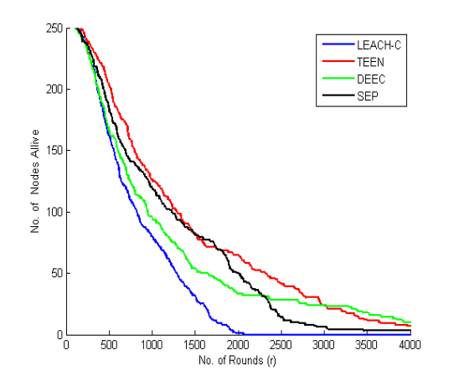

Figure 7. Comparison of LEACH-C, TEEN, DEEC, SEP in terms of nodes alive [22].

Figure 7 depicts a plot of the number of nodes alive versus the number of rounds of various protocols such as LEACH-C, TEEN, DEEC, and SEP. It can be seen that, when compared to other protocols, the TEEN protocol performs better and has more stability, whereas the LEACH-C protocol performs the worst. TEEN and DEEC protocols revealed the average performance.

The results under various performance metrics are used to evaluate the performance of these protocols. As a result, among 4 protocols, we can conclude that TEEN is more energy efficient, while DEEC is more reliable. Therefore, we can incorporate a mobility concept into existing protocols to extend network lifetime.

## Objectives

Although there are many routing protocols built and published, however, these models have not really achieved high efficiency. We need a protocol which is suitable for heterogeneous networks which could extend the network lifetime and reduce energy consumption. Therefore, I decided to choose the topic "Energy efficient in wireless sensor network using Grey Wolf Optimization algorithm" as my graduate project topic.

The main objectives of this thesis are:

* To implement and simulate a wireless sensor networks (WSNs) using MATLAB simulation.
* To implement a modified GWO algorithm that solves the energy consumption problem in wireless sensor networks.
* To compare and evaluate the performance of the GWO algorithm and other network protocols.

## Thesis Organization

The organization of this thesis is as follows.

Chapter 1 includes a brief background on main concepts of wireless sensor network, LEACH protocol and DEEC protocol.

Chapter 2 presents the theoretical basis about wireless sensor network and its structures, routing protocol. The ideas and formulas of some meta-heuristic approach and Grey Wolf Optimization is explained as well.

Chapter 3 presents the model which will be used to simulate the energy consumed in the sensor network. This chapter also explains how the GWO algorithm applying in wireless sensor network step by step.

Chapter 4 shows the cluster formation. It also compares the proposed algorithm’s results to which of LEACH and E-DEEC protocol. In this chapter, network lifetime and number of dead nodes will be analyzed.

Finally, some potential problems and possible future works will be presented in the conclusion

# Chapter 2. THEORETICAL BACKGROUND

With the problems and motivations mentioned in chapter one, a hierarchy based protocol - GWO is the right direction to build a model to achieve the goal of the topic. Although meta-heuristic optimization techniques have become very popular over the last two decades, GWO is still relatively new. In the other hand, to apply it into a wireless sensor network, we first need to review all the concept theoretically. In this chapter, we will point out the background knowledge and theoretical basis of wireless sensor network, routing protocol and GWO algorithm.

## Wireless sensor network

Wireless Sensor Networks (WSNs) can be defined as a self-configured and infrastructure-less wireless networks to monitor physical or environmental conditions, such as temperature, sound, vibration, pressure, motion or pollutants and to cooperatively pass their data through the network to a main location or sink where the data can be observed and analyzed.

A sink or base station acts like an interface between users and the network. One can retrieve required information from the network by injecting queries and gathering results from the sink. Typically, a wireless sensor network contains hundreds of thousands of sensor nodes. The sensor nodes can communicate among themselves using radio signals. A wireless sensor node is equipped with sensing and computing devices, radio transceivers and power components. The individual nodes in a wireless sensor network (WSN) are inherently resource constrained: they have limited processing speed, storage capacity, and communication bandwidth. After the sensor nodes are deployed, they are responsible for self-organizing an appropriate network infrastructure often with multi-hop communication with them. Then the onboard sensors start collecting information of interest. Wireless sensor devices also respond to queries sent from a “control site” to perform specific instructions or provide sensing samples. The working mode of the sensor nodes may be either continuous or event driven.

### Structure

The basic components of a digital communication system are the sensor unit, processing unit, transceiver and the power generator.

1. **Sensor node**

Each sensor node consists of four basic components: the sensor, the processor, the wireless transceiver, and the power source. Depending on the specific application, the sensor node may also have additional components such as a location finder system, a power generator, and a mobile device. Components in a sensor node are shown in figure 2.

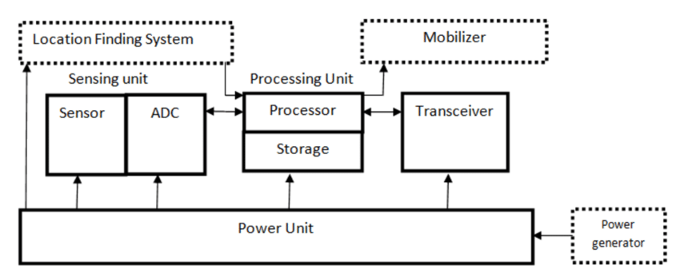

Figure 8. Structure of a sensor node [33]

* **Sensor unit**

Sensor allows sensor node to have the ability to interact with the physical world. A sensor is usually composed of two component units, the sensor probe (sensor) and the analog / digital converter (ADC). The analog signals are received from the probe, then converted to digital signals using the ADC converter, then sent to the processor.

* **Processing unit (Microcontroller)**

The microcontroller manages the operating behavior of the sensor node. It is a small microprocessor on which it runs the software programs of the sensor node, connected to the radio transceiver and sensors. A microcontroller is a microprocessor that has internal memory, timers and hardware to connect external devices such as sensors and radio transceivers.

Due to cost and power constraints, the microcontrollers used in sensor nodes are much simpler than the microprocessors used in personal computers. Typically, a microcontroller used in the sensor node has several KB of the chip's memory and operates at a clock speed of several MHz

Microcontrollers have two types of memory: read-only memory (ROM) and random access memory (RAM). ROM is used to store software program code and RAM is used for software program temporary data.

* **Transceiver**

Allows the sensor nodes to communicate with each other. A communication device is usually a radio transceiver connected to an antenna. A radio transceiver has both functions of receiving and transmitting messages. It is the largest source of feed energy consumption. This is due to requirements for processing of radio signal modulation.

* **Power generator**

A key component of the sensor node is the power supply. The power supply is usually the battery, powers the sensor node and is not replaceable so the node's power source is usually limited. The power supply can be powered by electrical generating devices, for example small solar panels.

Most routing technologies in sensor networks and sensing tasks require highly accurate location awareness. Therefore, sensor nodes often have a location finder system. Mobile devices are also sometimes needed to move sensor nodes as required to secure assigned tasks.

1. **Nodes organization**

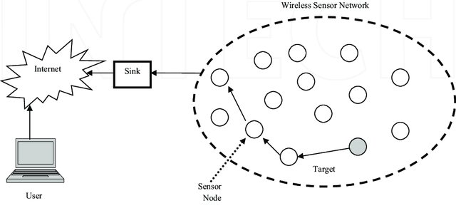

Figure 9. Structure of wireless sensor network [38]

A wireless sensor network consists of a large number of nodes that are deployed densely inside or very close to the object to be probed or collected. The position of the sensors is not predetermined so it allows for random deployment in inaccessible or hazardous areas. The ability to self-organize the network and collaborate on wireless sensors are very basic features of this network. With a large number of wireless sensors deployed in close proximity, multi-link communication is selected for minimum power consumption (compared to single-link communication) and provides better signal transmission efficiency. compared with long distance transmission.

The basic structure of the wireless sensor network is shown in Figure 2. The sensor nodes are deployed in a sensor field. Each sensor node distributed in the network has the ability to collect data, route data back to the receiver (User), and route messages with the request from the Sink node. to the sensor nodes. Data are routed towards the receiver (Sink) in a multi-link structure without the foundation infrastructure (Multi-hop Infrastructureless Architecture), for example: without base stations or control centers. The receiver can communicate directly with the operator's (Task Manager Node) of the user or indirectly via the Internet or satellite (Satellite).

The network design perceived as the model in Figure 3 depends on many factors such as:

**Error tolerance**: Some sensor nodes may no longer function due to lack of power, physical damage or environmental influences. Error tolerance is shown in the fact that the network is still functioning properly, maintaining its functions even when some of the network nodes are down.

**Scalability**: When studying a phenomenon, the number of deployed sensor nodes can reach hundreds of thousands of nodes, depending on the application that this number can exceed hundreds of thousands of nodes. Therefore, the network architecture must be scalable to suit each specific application.

**Manufacturing cost**: Since the sensor network consists of a large number of sensor nodes, the cost per node is very important in regulating the network cost. Hence the cost per node sensor should be kept low.

**Hardware integration**: Because the number of sensor nodes in the network is so many, the sensor node requires the following hardware constraints: small size, low energy consumption, low production cost, adaptive environment field, self-configuring and unattended.

**Operating environment**: Sensor nodes are usually quite dense and distributed directly in the environment (including polluted, toxic or underwater environments ...) => sensor nodes must adapt to many types of environments. school and environmental changes.

**Transmission medium**: In sensor network, nodes are connected together in a wireless environment, the transmission medium can be radio waves, infrared or optical means. In order to establish a coherent workforce for these networks, the appropriate transmission mediums must be chosen around the world.

**Sensor network configuration**: The sensor network consists of a large number of sensor nodes, so a stable configuration must be set up.

**Energy Consumption**: Each sensor node is equipped with a limited power source. In some applications, the addition of an energy source is not possible. Therefore, the lifetime of the network depends on the lifetime of the sensor node, the lifetime of the sensor node depends on the lifetime of the battery. Therefore, scientists are currently trying to find algorithms and design protocols for the network node to save this limited energy source.

### Architecture and protocol of wireless sensor networks

The protocol architecture applied to the perceptible network is shown in Figure 4. This architecture consists of layers and management planes. These management planes make it possible for the nodes to work together in the most efficient way, routing data in the mobile sensing network, and sharing resources between sensor nodes.

**Physical layer**: It is responsible for frequency selection, carrier frequency generation, signal detection, signal modulation and coding.

: Responsible for joining data streams, detecting data frames, accessing transmission methods and handling errors. Since the environment is noisy and the sensor nodes are mobile, the Media Access Control protocol (MAC) must take into account the issue of power and must be able to minimize collisions with broadcast messages. of neighboring nodes.

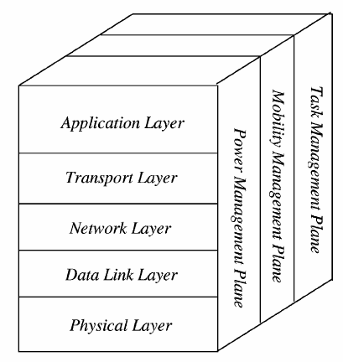

Figure 10. Architecture and protocol of wireless sensor networks [27].

**Network layer**: Consider choosing the data line provided by the transport layer.

**Transport Layer**: Helps maintain the flow of data if the network application senses the request. The transport layer is only needed when the system is planning to be accessed through the Internet or other external networks.

**Application layer**: Depending on the sensor mission, different types of application software can be built and used at the application layer.

**Power management plane**: Control the power use of the sensor node. Example: The sensor node may turn off the receiver after it has received a message to avoid generating identical messages. When the sensor node's power level is low, it broadcasts to neighboring sensor nodes informing that its power level is low and it cannot participate in routing. The remaining power is devoted to sensor duty.

**Mobility management plane**: It is responsible for detecting and registering the movement of nodes. From there you can determine who is your neighbor node.

**Task management plane**: Responsible for balancing and aligning sensor tasks between nodes in an area of ​​interest. However, not all nodes in that region are performing sensing duties at the same time.

## Routing protocol

Data collected by sensor nodes in a WSN is usually sent to a base station (gateway) that connects the WSN to other networks and allows the data to be visualized, analyzed, and acted upon. Direct (single-hop) communication between all sensor nodes and the gateway may be possible in small sensor networks where sensor nodes and a gateway are close together. However, most WSN applications necessitate a multi-hop communication approach since they involve a large number of sensor nodes to cover a large region. Sensor nodes must, in other words, not only generate and disseminate their own data, but also act as relays or forwarding nodes for other sensor nodes. The process of establishing paths from a source to a sink (e.g., a gateway device) across one or more relays is called routing, and it is a key responsibility of the communication protocol stack's network layer.

The network layer's main job is to find paths from data sources to sink computers (e.g., gateways). All sensor nodes will communicate directly with the sink system in the single-hop routing model (left graph in Figure 11). The easiest solution is direct communication, in which all data travels a single hop to reach its destination. In practice, however, a single-hop communication model (right graph in Figure 11) is unworkable, and a multi-hop communication model is needed. The network layer of all sensor nodes' critical task in this case is to find a path from the sensor to the sink through multiple other sensor nodes acting as relays.

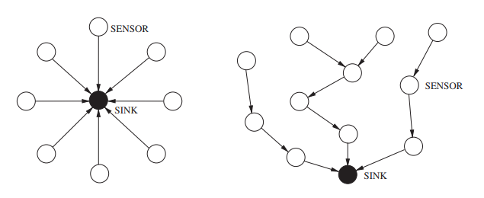

Figure 11. Single-hop routing model vs Multi-hop routing model [28].

Routing protocols are classified in a variety of ways. The network structure or organization, the route discovery process, and the protocol activity are all classified differently in Figure 12. (Al-Karaki and Kamal 2004 [29]).

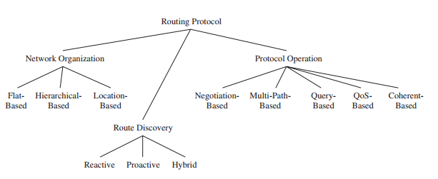

Figure 12. Category of routing protocol [28].

Most routing protocols fall into one of three categories in terms of network organization. Flat-based routing protocols treat all nodes as if they have the same functionality or role. In hierarchical-based routing protocols, on the other hand, different nodes may play different roles in the routing process, such as forwarding data on behalf of others while only generating and propagating their own sensor data. Routing decisions are made using location information from nodes in location-based routing protocols.

The route discovery method can also be used to differentiate between various routing protocols. Reactive protocols discover routes on-demand, that is, if a source needs to send data to a receiver and no route exists. When it comes to reactive route exploration, proactive routing protocols create routes before they are actually required, causing delays before actual data transmission can occur. Hybrid routing protocols are those that combine the features of reactive and proactive routing protocols.

Finally, routing protocols also differ in their operation. Negotiation-based protocols, for example, attempt to eliminate redundant data transmissions by relying on the exchange of negotiation messages between adjacent sensor nodes prior to actual data transfers. To achieve higher performance or fault tolerance, multipath-based protocols use multiple routes at the same time. Sensor nodes submit data in response to queries provided by the destination node in receiver-initiated query-based routing protocols. Finally, routing protocols vary in how they enable data processing in the network. Until sensor data is sent to receivers and data aggregators, coherent-based protocols conduct only a minimal amount of processing (e.g., removing duplicates, time-stamping).

### Hierarchical routing

Based on the structure of WSNs, routing protocols can be classified as flat or Hierarchical. All sensors are treated equally in flat routing protocols. The data produced by sensors may be routed multi-hops to the BS to save transmission energy costs. Despite this, unlike traditional wireless networks, WSNs have a ‘‘many to one" characteristic, which means that sensors close to the BS will use more energy relaying data for others. Flat routing protocols are unable to avoid the energy-hole problem due to unbalanced energy dissipation rates.

In hierarchical approaches, Nodes are grouped together, and a cluster head is chosen to handle routing based on a set of criteria. Typically, a two-layer approach is used in hierarchical routing, with one layer sensing the physical environment and the other layer routing. Low-energy nodes are used for sensing, while high-energy nodes are frequently used for data collection, aggregation, and transmission. Clustering is the most widely used technique for achieving scalability and effective communication when it comes to energy efficiency. Cluster-based hierarchical approaches have a number of advantages, including increased scalability, efficient data aggregation, and efficient channel bandwidth utilization [14].

The clustering approach is depicted in two different ways in Figure 12. The routing problem is reduced to the cluster formation problem when all cluster heads communicate directly with the sink node (left graph). A cluster-based routing protocol must establish multi-hop routes from all cluster heads to the sink when cluster heads do not directly communicate with the sink (right graph).

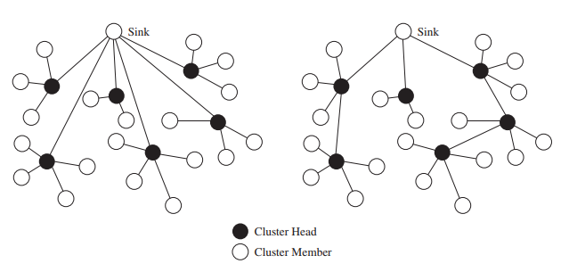

Figure 13. Clustering with single-hop (left) vs with multi-hop (right) connection [28].

Clustering approaches are used to simplify node management, reduce energy consumption, achieve scalability, improve load balancing, robustness, and data aggregation, and improve load balancing and robustness. Clusters are formed by grouping nodes.

Clustering approaches are used to simplify node management, reduce energy consumption, achieve scalability, improve load balancing, robustness, and data aggregation, and improve load balancing and robustness. Clusters are formed by grouping nodes. A cluster head (CH) is tasked with collecting data from member nodes (MN), aggregating it, and then forwarding it to the BS directly or through an intermediate CH. The data collected by the sensor node is sent to the BS via a gateway (CH). There can be more than one BS in a multilevel clustering hierarchy (if needed). Some examples of protocol that based hierarchy can be mentioned are LEACH[16], PEGASIS[15], TEEN[17], APTEEN[18], TTDD[19], etc.

Clustering protocols in WSNs typically face two challenges, despite the benefits of clustering. For starters, CH-selection is an NP-hard problem. As a result, determining the best cluster category for a given fitness function is difficult. More importantly, the fitness function's sub-functions have a significant impact on the final system performance.

Clustering protocols must build the fitness function in a reasonable manner. Second, key parameters such as the cluster head ratio and the weight factors between the different sub-functions are typically sensitive to clustering protocols. A clustering protocol must be able to fine-tune the critical parameters in accordance with the various application specifications.

## Meta-heuristic approach

A large number of clustering protocols have been proposed in recent years to improve network performance. To solve NP-hard optimization problems, meta-heuristic algorithms are commonly used. Many clustering protocols have been proposed that use metaheuristic approaches to construct the cluster.

One of the interesting branches of the population-based meta-heuristics is Swarm Intelligence (SI). The inspirations of SI techniques originate mostly from natural colonies, flock, herds, and schools. Some of the most popular SI techniques are Ant Colony Optimization (ACO) [30], Particle Swarm Optimization (PSO) [32], and Artificial Bee Colony (ABC) [31]. We'll go over these three clustering protocols in this section.

**Particle Swarm Optimization (PSO) Model**

Particle swarm optimization (PSO) is a population-based stochastic optimized data routing technique that routes data in a wireless sensor network by mimicking the social behavior of a flock of birds or a school of fish. The system is first initialized with a population of randomly generated solutions. The fitness of each of these solutions as a source of information is then calculated. The global best solution is the one with the highest fitness. Every node strives to find a solution that is closest to the global best solution. This is done by calculating the fitness of its local neighbors once more. The neighbor with the highest fitness is designated as the local best, and data is routed from the sensor node to the global best in the direction of the local best solution. Global and local solutions are calculated in this approach to produce a solution that is the most fit for the given objective function.

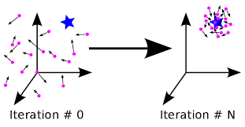

Figure 14. Particle Swarm Optimization algorithm [32]

**Ant Colony Optimization (ACO) Model**

Ant colony optimization is a probabilistic method for determining the shortest path between two network sensor nodes. The algorithm routing table setup, data communication, and route maintenance are all divided into three phases. The algorithm begins with an initialization phase in which the fitness of each sensor node's solution is determined. The node from which the information is obtained is the solution with the highest fitness of solution. The shortest path to the destination node is chosen using an experience-based iteration technique, and data is transmitted only along that path while the other nodes remain idle. It provides statistically higher performance than conventional network routing techniques due to real-time computation techniques and lower control overhead used in ant colony optimization based techniques.

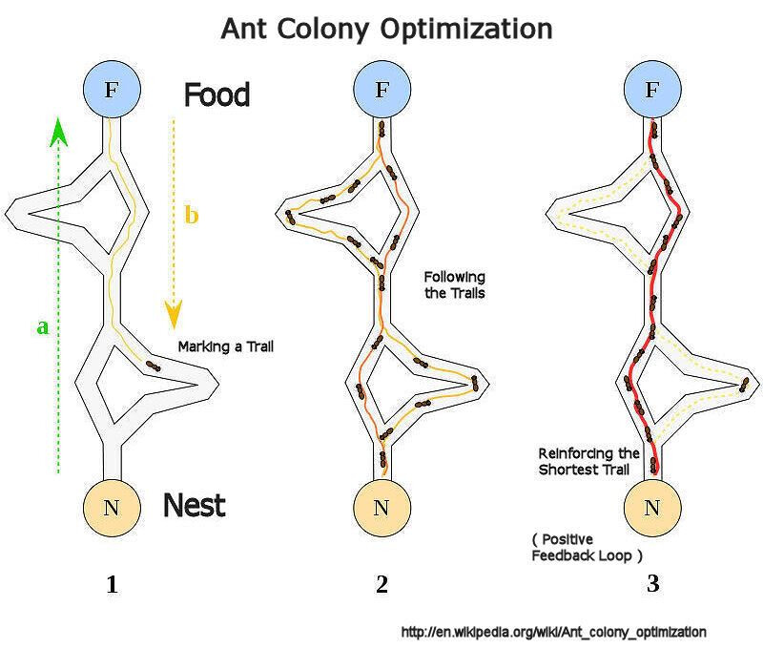

Figure 15. Ant Colony Optimization algorithm [30].

**Artificial Bee Colony (ABC) based Protocols**

An evolutionary data routing path algorithm that mimics the foraging behavior of bees in a swarm is the artificial bee colony meta heuristic. The algorithm is intended to optimize continuous multivariable and multimodal functions. Three types of agents, also known as bees, make up the artificial bee colony model. Scout bees, onlooker bees, and employed bees are three types of bees. While the network is in various stages of operation, these individual agents have specific functions to perform.

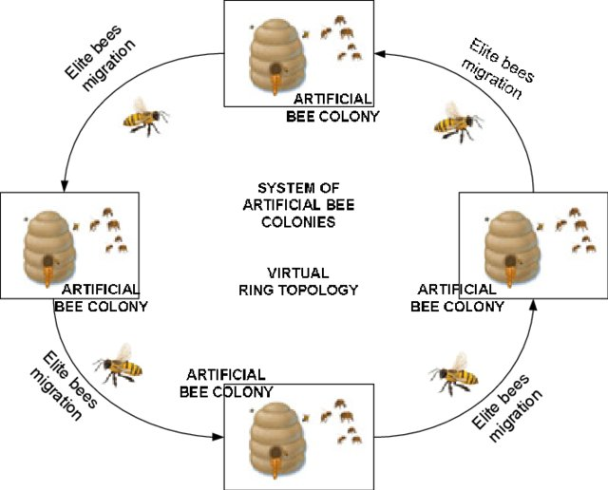

Figure 16. Artificial Bee Colony algorithm [31].

There are many SI techniques proposed so far, many of them were inspired by hunting and searching behaviors. However, there is a few techniques in the literature mimicking the leadership hierarchy of grey wolves, well known for their pack hunting. This motivated our attempt to mathematically model the social behavior of grey wolves, propose an algorithm inspired by Grey Wolf Optimization, and investigate its abilities in routing wireless sensor networks.

## Grey wolf optimization

The proposed method's inspiration is first discussed in this section. The mathematical model is then presented.

### Inspiration

The grey wolf (Canis lupus) is a member of the Canidae family. Grey wolves are apex predators, which means they are at the very top of the food chain. Grey wolves prefer to be part of a pack. The average group size is 5-12 people. They have a very strict social dominant hierarchy, which is particularly interesting.

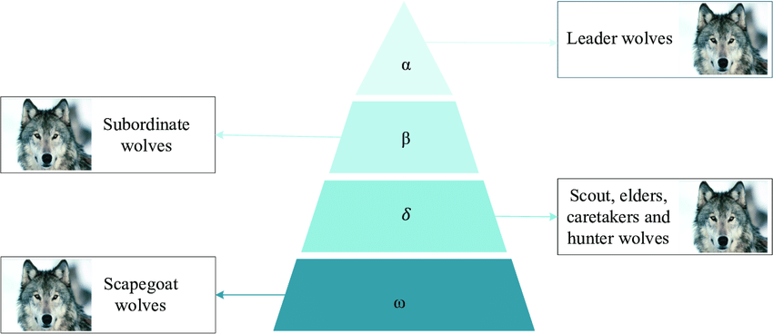

Figure 17. Hierarchy of grey wolf [13].

The leaders, known as alphas, are a male and a female. The alpha is primarily in charge of hunting, sleeping arrangements, and waking times, among other things. The pack dictates the alpha's decisions. The alpha wolf is also known as the dominant wolf because the pack must obey his or her commands. Only the pack's alpha wolves are allowed to mate. Surprisingly, the alpha is not always the strongest member of the pack, but rather the best at managing it. This demonstrates that a pack's organization and discipline are far more important than its strength.

Beta is the second level in the grey wolf hierarchy. The betas are wolves who assist the alpha in making decisions and other pack activities. The beta wolf can be male or female, and he or she is the most likely candidate to become the alpha wolf if one of the alpha wolves dies or becomes too old. The beta wolf should respect the alpha, but he or she should also command the lower-level wolves. It serves as an advisor to the alpha and a pack disciplinarian. Throughout the pack, the beta reinforces the alpha's commands and provides feedback to the alpha.

Omega is the lowest-ranking grey wolf. The omega is used as a scapegoat. Omega wolves are required to submit to all other dominant wolves at all times. They are the last of the wolves who can eat. Although the omega may appear to be a minor member of the pack, it has been observed that if the omega is lost, the entire pack experiences internal fighting and problems. This contributes to the satisfaction of the entire pack and the maintenance of the dominance structure.

A wolf is called subordinate if he or she is not an alpha, beta, or omega (or delta in some references). Although delta wolves must submit to alphas and betas, they rule the omega. This group includes scouts, sentinels, elders, hunters, and caretakers. Scouts are in charge of keeping an eye on the territory's boundaries and alerting the pack if there is any danger. Sentinels protect and ensure the pack's safety. Elders are wolves who have been alpha or beta in the past. When hunting prey and providing food for the pack, hunters assist the alphas and betas. Finally, the pack's weak, ill, and wounded wolves must be cared for by the caretakers.

In addition to the social hierarchy of wolves, group hunting is another interesting social behavior of grey wolves. According to Muro et al.[1] the main phases of gray wolf hunting are as follows:

* Tracking, chasing, and approaching the prey.
* Pursuing, encircling, and harassing the prey until it stops moving.
* Attack towards the prey.

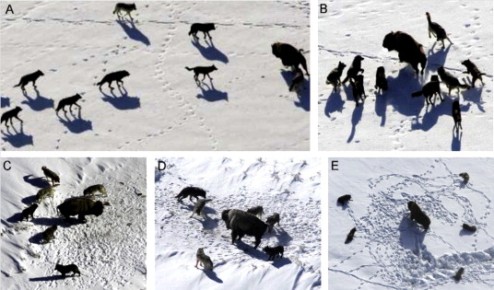

Figure 18. Hunting behaviour of grey wolves [13].

### Mathematical model and algorithm

1. Social hierarchy

We use the fittest solution as the alpha (α) to mathematically model the social hierarchy of wolves when designing GWO. As a result, the second and third best solutions are known as beta (β) and delta (δ). Omega (ω) is assumed for the remaining candidate solutions. The hunting (optimization) in the GWO algorithm is guided by α, β, and δ. These three wolves are pursued by the wolves ω.

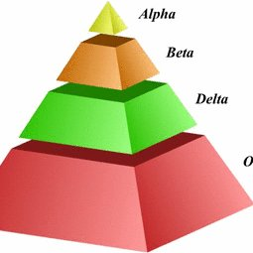

Figure 19. Social hierarchy of grey wolves [13].

1. Encircling process

Grey wolves encircle prey during the hunt, as previously stated. The following equations are proposed to mathematically model encircling behavior.:

|  |  |  |
| --- | --- | --- |
|  |  | Eq 1 |

|  |  |  |  |  |
| --- | --- | --- | --- | --- |
|  |  | | Eq 2 | |
|  |  |  | |

Where:

* is the wolf’s position in the (t+1)th iteration
* is the prey’s position at the tth iteration
* linearly decreases from 2 to 0 over the course of iterations
* is the convergence factor
* is a random vector in the range [0,1]
* is the distance from the wolves to the prey, and is calculated as follow:

|  |  |  |
| --- | --- | --- |
|  |  | Eq 3 |
|  |  |  |
|  |  | Eq 4 |
|  |  |  |

Where

* and are the positions of the prey and the wolf at the tth iteration
* is the convergence factor
* is a random vector in the range [0, 1]

1. Hunting process

Grey wolves have the ability to recognize the location of prey and encircle them. The hunt is usually guided by the alpha. The beta and delta might also participate in hunting occasionally. However, in an abstract search space, we have no idea about the location of the optimum (prey). In order to mathematically simulate the hunting behavior of grey wolves, we suppose that the alpha (best candidate solution) beta and delta have better knowledge about the potential location of prey. Therefore, we save the first three best solutions obtained so far and oblige the other search agents (including the omegas) to update their positions according to the position of the best search agent.

During hunting, the location of the prey is assessed by α, β, and δ wolves, and the remaining wolves calculate the distance between themselves and the prey; then, the wolves encircle the prey.

The following is the calculation formula of the wolf’s position:

|  |  |  |
| --- | --- | --- |
|  |  | Eq 5 |

Where:

* is the prey’s position at the (t+1)th iteration
* are the positions of alpha wolf, beta wolf and delta wolf at the (t+1)th iteration. They are calculated by equation (3.1).

At the end of the iteration times, α wolves have the highest fitness value.

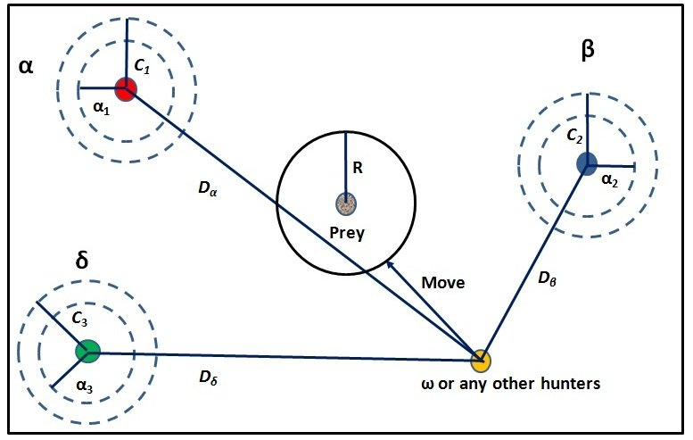

Figure 20. Position updating in GWO [13].

In a 2D search space, Figure 20 shows how a search agent updates its position based on alpha, beta, and delta. The final position is observed to be in a random location within a circle defined by the positions of alpha, beta, and delta in the search space. To put it another way, alpha, beta, and delta estimate the prey's location, while other wolves update their positions at random around the prey.

1. Seeking and attacking the prey

Grey wolves finish the hunt by attacking the prey when it stops moving, as stated earlier. We lower the value of to mathematically model approaching the prey. Note that the fluctuation range of is also decreased by . In other words, is a random value in the interval [-a, a] where a is decreased from 2 to 0 over the course of iterations. When random values of are in [-1, 1], a search agent's next position can be anywhere between its current position and the position of the prey. Fig shows that |A| < 1 forces the wolves to attack towards the prey.

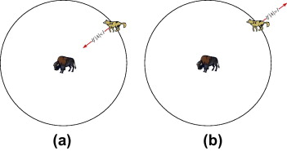

Figure 21. Approaching prey vs searching for pery [13].

The GWO algorithm allows its search agents to update their position based on the location of the alpha, beta, and delta, and attack towards the prey, using the operators proposed so far. With these operators, however, the GWO algorithm is prone to local solution stagnation. True, the proposed encircling mechanism exhibits some exploration, but GWO requires more operators to emphasize exploration.

To summarize, the search process begins with the GWO algorithm creating a random population of grey wolves (candidate solutions). Alpha, beta, and delta wolves estimate the likely position of the prey over the course of iterations. The distance between the prey and each candidate solution is updated. To emphasize exploration and exploitation, the parameter an is reduced from 2 to 0. Candidate solutions tend to diverge from the prey when || > 1 and converge towards the prey when || < 1. Finally, the GWO algorithm is terminated by the satisfaction of an end criterion.

# Chapter 3. Proposed model and algorithm

In this chapter, the routing protocol for HWSN based on the GWO is detailed. The proposed study's main goals are to extend the network life cycle and increase network throughput. To simulate and analyze the efficiency of the proposed algorithm, we assume a simple model for network model. The energy consumption model is used based on the suggestions of the author in [20].

# Proposed network model

### Network model and assumptions

In the network model, the following assumptions are made:

1. All nodes are randomly distributed in the two-dimensional geographical area. Once the location is determined, no matter what happens, the location of the nodes will not change.
2. In HWSNs, all sensor nodes are assigned different initial energy levels.
3. The BS is located in the center of the sensing area, and its power is externally supplied.
4. The energy of the sensor node is limited, and the battery cannot be charged.
5. When the sensor node power is exhausted, the node will be considered dead.

### Energy consumption

Nodes in WSNs are deployed at random and their locations are not pre-determined. Communication between nodes dissipates the majority of a node's energy, depending on the distance between them. Energy is used in both data transmission and reception. As a result, the required energy to transmit a (m bit)-long data packet over the distance d is:

|  |  |  |
| --- | --- | --- |
|  |  | Eq 6 |

Where:

* is the energy consumed when the node transmits data.
* is the energy dissipation of the process of transmitting 1 bit of data and the process of receiving 1 bit of data.
* is the coefficient of energy dissipation in the free-space model
* is the coefficient of energy dissipation in the multi-path attenuation model
* is the threshold of the transmission distance, which is calculated as:

|  |  |  |
| --- | --- | --- |
|  |  | Eq 7 |

The energy consumption required by the receiving node to receive an m bit data packet is as follows:

|  |  |  |
| --- | --- | --- |
|  |  | Eq 8 |

The above model can be used to calculate CH's energy consumption. The energy consumption of CH is divided into three categories: receiving member node data packets, fusing data, and transmitting fusing data to the base station. The formula for the calculation is as follows:

|  |  |  |
| --- | --- | --- |
|  |  | Eq 9 |

Where:

* is the number of member nodes in the cluster.
* is 1 bit of data aggregation energy cost.
* is the packet length.

The non-CH node's energy consumption is equal to the energy used to send data to the CH, and its mathematical expression is as follows:

|  |  |  |
| --- | --- | --- |
|  |  | Eq 10 |

The total residual energy in the rth round is calculated as follows:

|  |  |
| --- | --- |
|  | Eq 11 |

Where:

* is the total residual energy in the (r − 1)th round
* is the number of CHs in the rth round
* is the number of alive nodes in the network in the rth round
* is the energy consumed by the ith CH
* is the energy consumed by the jth non-CH.

## Proposed algorithm

In order to avoid the randomness of CHs selection, an algorithm is proposed. In the first stage of cluster formation, all the sensors in network send their positions and initial energy to the base station and then the base station saves them. It should be noted that the sensors’ locations are all fixed and cannot be changed. After receiving these information, energy consumed each round can be calculated; therefore, locations and energy are sent to the BS once only.

### Selection of Initial Clusters

To establish the initial clusters of the network, energy of the nodes and the distance of them to the BS are 2 parameters that the protocol uses, thereby limiting the number of CHs in each round. The following rules are used to select the initial clusters. All the sensors are divided into m sets of clusters and the cluster heads of these clusters are chosen based on the result of fitness value ranked from high to low. Nodes which are close to the BS and have high residual energy should be selected as the CH. All the remaining nodes join the nearest CH based on Euclidean distance to form cluster. It should be noted that, if the distance from node to the BS is less than that node to any CHs, it should transfer data straight to the BS. This make the formation of cluster more reasonable hence the BS can be powered externally and reduce the energy consumption for CHs. Here, it is proposed to use the remaining energy and distance between the nodes to the BS as parameters of fitness function. The fitness function is expressed as:

|  |  |  |
| --- | --- | --- |
|  |  | Eq 12 |

Where:

* is the weight.
* is the initial energy of the node.
* is the residual energy of the node.
* is the distance from the node to the BS.
* and are respectively the maximum and the minimum distance between a node and the BS of the network.

Node with the higher fitness value are more likely to become the BS.

### Modified Grey Wolf Optimizer

After the initial cluster is established, the MGWO is used to form new clusters and select new CHs. In the original GWO, based on the average weight of alpha, beta and delta wolves, the prey’s position was calculated. The three best wolves are chosen based on Equation 12. They are 3 nodes which have the highest fitness value F1. Consequently, based on the GWO and formula (12), the initial position of prey is computed as:

|  |  |  |
| --- | --- | --- |
|  |  | Eq 13 |
|  |  |  |
|  |  | Eq 14 |

Where:

* α, β and δ are the 3 respective nodes have the highest fitness value calculated through Equation 12.
* , and are respectively the initial weights of alpha, beta and delta wolf.
* , and are respectively the first, the second and the third best fitness value calculated through Equation 12.

It should be noted that, if we use GWO algorithm to implement the protocol, the fitness of all the nodes change after completing one data transmission. However, the weight of alpha, beta and delta wolf will not change. Thus, to further improve the global search capacity of GWO, the weights should be updated for each transmission. A modified algorithm for GWO is proposed to update the weights based on vectors A and D. A is the coefficient vector, D is the distance between the wolf and the prey and they are calculated according to Equations 2 and 3. At the (t + 1)th iteration, the location of the prey and the weight updating formula are as follows:

|  |  |  |
| --- | --- | --- |
|  |  | Eq 15 |

|  |  |  |
| --- | --- | --- |
|  |  |  |
|  |  | Eq 16 |

Where:

* , and are respectively the positions of alpha, beta and delta wolf in the (t + 1)th iteration. They can be calculated by using equation 1.

After the iteration done, the node closer to the prey is more likely to become the CH. However, distance is not the only parameter we care about. The remaining energy of that node could not be enough to complete tasks of the CH, causing the node to die soon. Therefore, node which has more residual energy and close to the prey is consider to be selected as the CH. The fitness function to select the CH is then proposed based on the above parameters. It should be noted that the node with smaller fitness value will indicate that the CH selection is more reasonable. Dead nodes cannot become cluster head. The fitness function is defined as:

|  |  |  |
| --- | --- | --- |
|  |  | Eq 17 |

Where:

* is the weight.
* is the residual energy of the node.
* and are the maximum and minimum residual energy in the cluster.
* is the distance from the node to the prey.
* and are respectively the maximum and the minimum distance between a node and the prey in the cluster.

## Selection of the Optimal Cluster Set

According to the clustering algorithm, a network can be divided into multiple clusters, and multiple clusters in the network are called a cluster set. To get the optimal cluster set; first, the initial cluster set which was calculated in 5.1 is taken as the current optimal set and its objective function is calculated. This cluster set is then randomly changed by MGWO algorithm to form new cluster sets and these new sets’ objective value are calculated. When the objective value of the new set is better than the old one, this set is accepted as the current optimal set. At the end of the iteration, the optimal cluster set is established. The objective function is expressed as:

|  |  |  |  |  |  |  |  |  |  |  |  |
| --- | --- | --- | --- | --- | --- | --- | --- | --- | --- | --- | --- |
| |  |  |  | | --- | --- | --- | |  |  | Eq 18 | | |  |  |  | | --- | --- | --- | |  |  | Eq 12 | | |  |  |  | | --- | --- | --- | |  |  | Eq 12 | |

Where:

* is the weight.
* is the number of cluster heads.
* is the residual energy of a cluster head.
* is the number of alive nodes.
* is the total distance from nodes to their cluster heads.
* is the total distance from cluster heads to the base station.
* is the distance from a node to the base station.

The objective function is designed based on the intra-cluster communication distance, the total communication distance from the CH to the BS and the residual energy of the nodes. A smaller objective value makes the CH selection more reasonable.

## Pseudo code

1. Initialize the grey wolf population Xi (i = 1, 2, … , n);
2. **While** (r < Max number of iterations)
3. **For** each grey wolf
4. Calculate the fitness value of each grey wolf by Equation 12;
5. **End For**
6. Select 3 best fitness value to find ;
7. Calculate the prey position by Equation 14;
8. Initial CHs selection;
9. Each of the remaining nodes decides to join its nearest CH or the BS according to the Euclidean distance;
10. **If** (the number of cluster members >3)
11. Form the initial cluster sets;
12. **Else**
13. All the nodes in that cluster are regarded as normal nodes
14. **End Else**
15. **End If**
16. **While** (t < Max number of iterations)
17. Update position by Equation 1;
18. Calculate the new prey’s position by Equation 15;
19. **For** each grey wolf
20. Calculate the fitness value of each grey wolf by Equation 17;
21. **End for**
22. Initial CHs selection;
23. Each of the remaining nodes decides to join its nearest CH or the BS according to the Euclidean distance;
24. **If** (the number of cluster members >3)
25. Form the initial cluster sets;
26. **Else**
27. All the nodes in that cluster are regarded as normal nodes
28. **End Else**
29. **End If**
30. Calculate the objective function value of the new cluster set (Fnew) by Equation 18;
31. **If** (Fnew < Fopt)
32. Current optimal cluster set = new cluster set;
33. Fopt = Fnew;
34. **End if**
35. **End While**
36. **End While**

# Chapter 4. RESULTS AND ANALYSIS

## Assumption and properties of the network

Some assumptions were made for both the sensor nodes and the network in the network model described in the previous section. Hence, the network and sensor nodes' assumptions and properties are:

* Sensor Nodes are uniformly randomly distributed in the network.
* There is one Base Station which is located at the center of the sensing field.
* There are 3 kinds of nodes: normal nodes, advanced nodes and super nodes. Advanced nodes will have 2 times the initial energy of the normal nodes and super nodes will have 4 times of that.
* All nodes have the capabilities to become a cluster head.

Additionally, to have a better result in analyzing the performance of the algorithm, 3 kinds network will be used to simulation. These 3 kinds of network are: homogenous network, 2-level heterogeneous network and 3-level heterogeneous network. Moreover, the Modified Grey Wolf algorithm will also be compared to 2 another routing algorithm.

## Cluster formation result

To verify the performance, we use MATLAB software to simulate the MGWO algorithm. This result is from the homogenous network. The simulation parameters are shown below:

|  |  |
| --- | --- |
| **Parameter** | **Value** |
| The area of the sensing region | 100 (m2) |
| Number of Sensor Nodes | 100 |
| Packet Size | l = 4000 bits |
| Data Aggregation Energy Cost | = 5 nJ/bit |
| Energy Cost of Transmitter/Receiver | = 50 nJ/bit |
| Transmission Coefficient of Amplifier (free space) | = 10 pJ/bit/m2 |
| Transmission Coefficient of Amplifier (multi-path space) | = 0.0013 pJ/bit/m4 |
| Initial energy of normal node | 0.05 J |
| Ratio of Advanced Node | 0 |
| Ratio of Super Node | 0 |
| Weight of Fitness Function | a1 = a2 = a3 = 0.2 |
|  |  |

Table 2. Simulation parameters

At the beginning of each round, the BS selects CHs using algorithm as described above and each round last for 1 second. The maximum number of cluster heads is 10.

First, all sensor nodes send the information of their locations and energy to the base station.

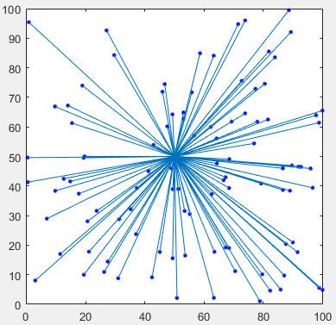

Figure 22. Send information to base station

After getting the necessary information, the base station will calculate and run the algorithm to find the best routing based on the method proposed.

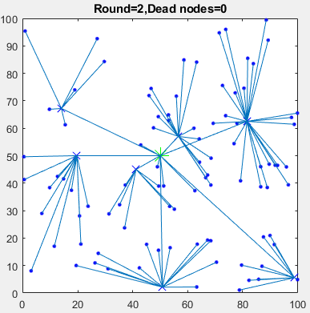

Figure 23. Cluster formation

In the beginning of every round, the base station calculates the residual energy and find the next best routing in order to maximize the network’s lifetime.

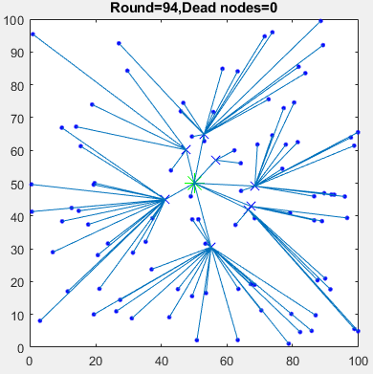

Figure 24. Cluster formation

First node dead (FND): is the total active time of the WSN till the death of the first node. The longer this interval is, the more stable will be the network.

In this simulation, the “First node dead occurs” event happens in round 144.

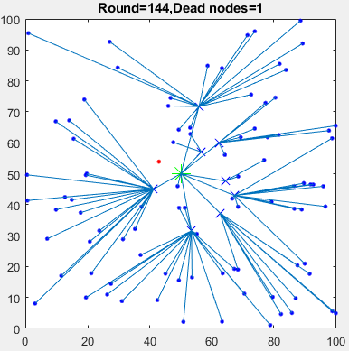

Figure 25. First node dead occurs

After 234 rounds, all the nodes in the network became dead nodes. The simulation ended.

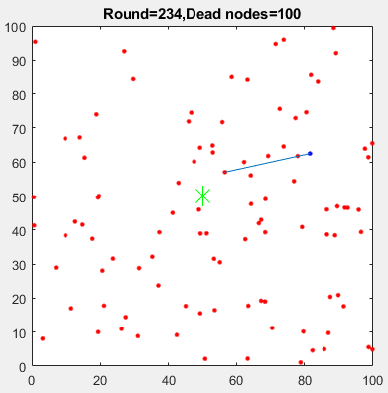

Figure 26. All nodes dead

## Performance analysis

To analyze the performance of the proposed algorithm, MGWO will be compared its performance to LEACH’s and E-DEEC. For efficient performance analysis, the algorithms are executed until all the nodes died.

### Homogenous network

The following parameters are used to simulate a homogenous network. LEACH and E-DEEC will also use these parameters to guarantee a fair analysis.

|  |  |
| --- | --- |
| **Parameter** | **Value** |
| The area of the sensing region | 100 (m2) |
| Number of Sensor Nodes | 100 |
| Packet Size | l = 4000 bits |
| Data Aggregation Energy Cost | = 5 nJ/bit |
| Energy Cost of Transmitter/Receiver | = 50 nJ/bit |
| Transmission Coefficient of Amplifier (free space) | = 10 pJ/bit/m2 |
| Transmission Coefficient of Amplifier (multi-path space) | = 0.0013 pJ/bit/m4 |
| Initial energy of normal node | 0.05 J |
| Ratio of Advanced Node | 0 |
| Ratio of Super Node | 0 |
| Weight of Fitness Function | a1 = a2 = a3 = 0.2 |

Table 3. Simulation parameters of homogenous network

Figure 27 shows that the MGWO was superior to LEACH and E-DEEC in terms of network lifespan in the first 200 rounds. In around round 150th, we can see that the first node’s death event occurred in all 3 protocols. Overall, MGWO recorded the latest first node’s death event among 3 protocols. For LEACH, there was a significant drop in the number of alive nodes after the death of the first node. It only took a few rounds for the network to become entirely dead. It clearly can be seen that LEACH protocol had the lowest efficiency among 3. When compared to E-DEEC, the performance of MGWO is more satisfactory initially. However, when the number of dead nodes reached 30, E-DEEC had a better solution to increase the network lifespan as the number of dead nodes decreased compared to MGWO.

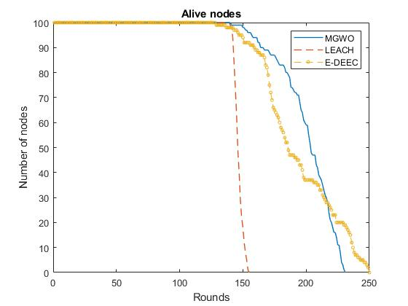

Figure 27. Network stability period with respect to the number of rounds in homogeneous network

Figure 28 illustrates how much energy is consumed each round in 3 protocols: LEACH, MGWO and E-DEEC. Initially, the performance of MGWO is much more satisfactory compared to LEACH and E-DEEC. Thanks to the fitness function, as the number of iterations increases, the residual energy of the sensors is decreasing slowly due to the proper cluster head selections. For LEACH protocol, the residual energy decreased steadily and stopped at 0 after about 155 rounds. It is obvious that this is the least energy efficient in 3 protocols. Comparing E-DEEC and MGWO, we can see that our proposed protocol had a better performance in the first 200 rounds in terms of energy consumed. When the energy of the network is nearly exhausted, E-DEEC showed a slightly more proficient way to keep the network alive than MGWO although this different is not much and it was hard to recognize.

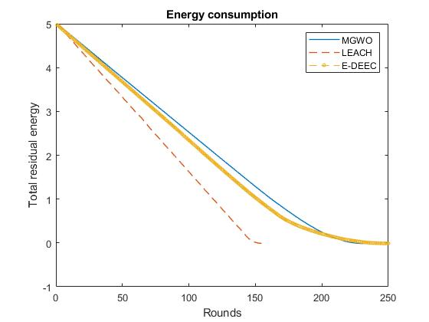

Figure 28. Residual energy relative to the number of rounds in homogeneous

In figure 29, the dead time with respect to the percentage of dead nodes is analyzed. For the LEACH protocol, the time from first node dead to all nodes dead is nearly the same. This means that LEACH has the low potential of extending network lifetime compared to 2 other protocols. E-DEEC had the ‘first node death’ event occurred sooner than 2 other protocols; however, when the number of iterations increased, it provided a better solution as in the section 90% of nodes dead, E-DEEC had nearly the same result as of MGWO, they both were at round 230 while LEACH only recorded that at round 150. When coming to the end of the network’s life, E-DEEC beat MGWO due to extending the lifespan of the whole network, finishing at round 250 when MGWO could only reach 240.

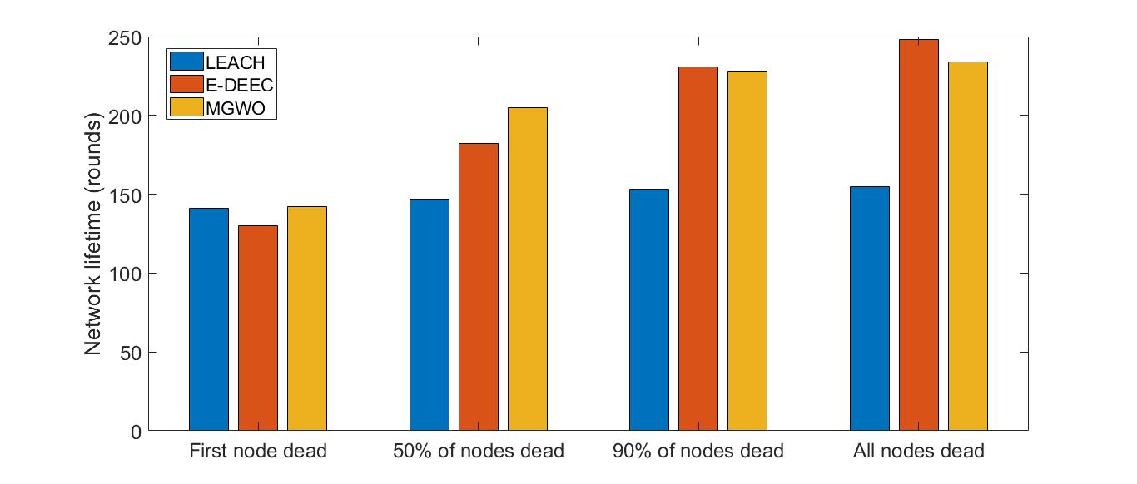

Figure 29. Network lifetime with respect to number of rounds in homogeneous network

To sum up, in homogeneous network, our proposed algorithm outperformed LEACH in terms of energy efficiency and ability to keep sensor nodes alive. Compared to LEACH, MGWO is 46% more energy efficient and it could extend the network lifetime by 60%. With regard to E-DEEC; initially, MGWO had the higher efficiency as can be seen in Figure 28, the number of alive nodes of MGWO is also more than that of E-DEEC for the first 70% of rounds. However; from later on, E-DEEC has more possibility to keep the nodes alive than our proposed algorithm. In the end of the simulation, E-DEEC extended the network lifespan 4% when comparing to our proposed algorithm.

### Heterogeneous network

In the heterogeneous network experiment, two kinds of network will be simulated to have more results. The same as in homogenous network, 3 kinds of protocols: LEACH, E-DEEC and MGWO – our proposed protocol will be experienced 2-level network and 3-level network before being compared. These following parameters are used in simulation.

|  |  |
| --- | --- |
| **Parameter** | **Value** |
| The area of the sensing region | 100 (m2) |
| Number of Sensor Nodes | 100 |
| Packet Size | l = 4000 bits |
| Data Aggregation Energy Cost | = 5 nJ/bit |
| Energy Cost of Transmitter/Receiver | = 50 nJ/bit |
| Transmission Coefficient of Amplifier (free space) | = 10 pJ/bit/m2 |
| Transmission Coefficient of Amplifier (multi-path space) | = 0.0013 pJ/bit/m4 |
| Initial energy of normal node | 0.05 J |
| Ratio of Advanced Node | 0.1 |
| Ratio of Super Node | 0 or 0.05 |
| Weight of Fitness Function | a1 = a2 = a3 = 0.2 |

Table 4. Simulation parameters of heterogeneous network

As can be seen from the left graph of Figure 30, the death time of the first node of MGWO was later than that of LEACH and E-DEEC. Furthermore, after the first node death event happened, there was a significant drop in the dead nodes of LEACH, straight from 100 to 0 in just about 10 rounds. Meanwhile, MGWO extended to keep nodes alive greatly when compared to the other protocol. It needs about 100 rounds after the first node dies to come when the number of death nodes reach 100%. Although E-DEEC could keep the sensor network alive longer than MGWO, its ‘first node dead’ event occurs much sooner than MGWO and even sooner than LEACH. Moreover, the time for MGWO reached 90% of nodes dead is way later than that of E-DEEC.

In the right graph of Figure 30; before the number of dead nodes reached 90%, the same trend was recorded as the left graph. However; from later on, there was a big difference from the 2-level network. When there was only about 4 nodes alive, LEACH showed a better ability than MGWO to keep these nodes alive. Although we can see from the graph that MGWO failed to beat LEACH in the section of alive nodes, there was one sensor left alive in round 500, and it was dead until round 760. This makes the overall network lifetime of MGWO longer than LEACH. Additionally, E-DEEC outperformed our proposed algorithm as it provided a better result in keeping the nodes alive. It extended the network lifetime to 760 rounds; while that result from LEACH and MGWO was 600 and 760 respectively.

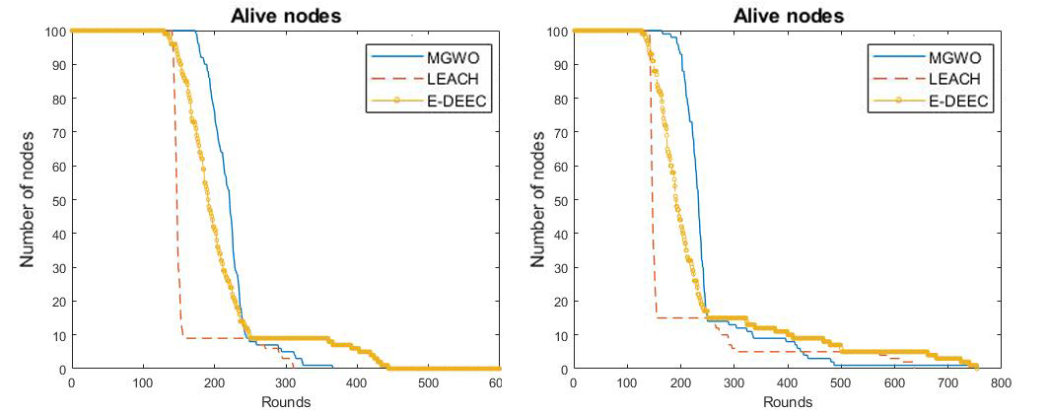

Figure 30. Network stability period with respect to the number of rounds in 2-level heterogeneous network (left) and 3-level heterogeneous (right)

Figure 31 illustrates how much energy is consumed each round in 3 protocols: LEACH, MGWO and E-DEEC in 2 simulations: 2-level network and 3-level network. As can be seen from the left graph of Figure 31; initially, the performance of MGWO is much more satisfactory compared to LEACH and slightly better than E-DEEC. Due to proper cluster head selections, the residual energy of the sensors gradually decreases as the number of iterations increases thanks to the fitness function. From the starting point of 5.5, the residual energy for the LEACH protocol steadily decreased until it reached about 0.5 after about 155 rounds. After that, the decreased slope became more gentle and the whole network became entirely dead at about round 300. Obviously, this is the least energy efficient among the three protocols. When compared to E-DEEC, MGWO was slightly more efficient in the first 200 rounds; after that, E-DEEC had done a better job in reducing the energy consumption low enough to keep the network alive and finished at round 460..

In the right graph; overall, the trend of each protocol in terms of energy consumption did not have much from the 2-level network. However, when comparing them to each other, there were some dissimilarities that had to be analyzed. First, after the decrease slope of LEACH became gentle, it then intersected with the MGWO chart. This means that when the energy of the network became nearly exhausted, LEACH found a better solution to reduce energy deviation and beat our proposed algorithm in terms of efficiency. This event happened at about round 250, when the residual energy was only 15% of total energy. Meanwhile, with regard to E-DEEC, having a poorer efficiency compared to MGWO initially, it still achieved the best results in the energy usage section.

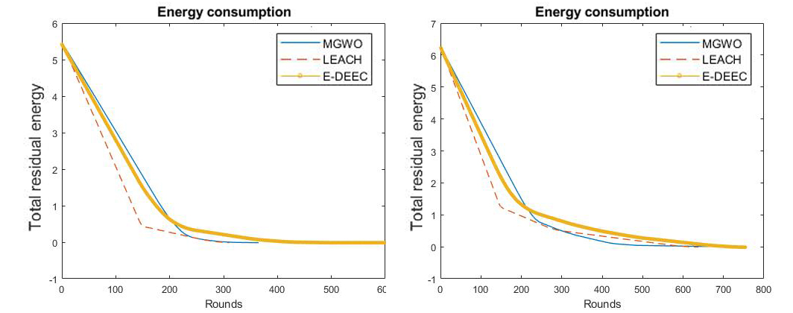

Figure 31. Residual energy relative to the number of rounds in 2-level heterogeneous (left) and 3-level heterogeneous (right) network

Figure 32 shows the dead time in relation to the percentage of dead nodes in 2 level-network. Overall; as usual, LEACH protocol witnessed the lowest lifetime among three protocols in all 4 sections except in first node death; it recorded a slightly better record than that of E-DEEC. When first node death occurred, there was a significant drop in the number of alive nodes, the dead nodes number quickly increased from 1 node to 90% of the nodes in just few rounds. However, it took moore than 150 rounds from LEACH to make the sensor nodes died entirely from 10% of the nodes alive. Having the soonest first node dead, E-DEEC, however, got better results in 3 other events. At the time of 90% of the nodes dead, E-DEEC had the same alive nodes of MGWO. After that, it finished no nodes alive in round 460, which was the best among three protocols while MGWO and LEACH finished at around the 300th.

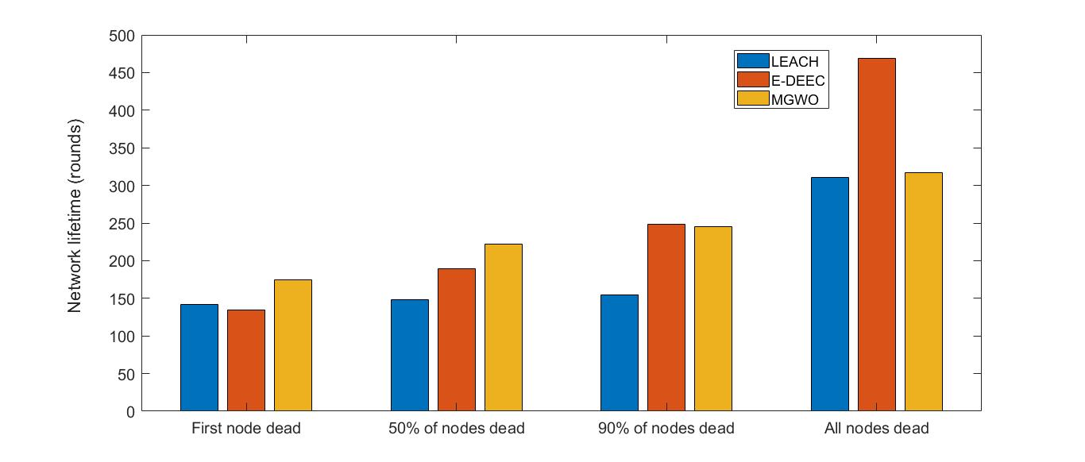 In Figure 33, the dead time as a function of the percentage of nodes that are dead is demonsatrated. Overall, the LEACH protocol had the shortest lifetime of the three protocols in all four sections, with the exception of first node death, where it was slightly better than E-DEEC. It can be seen that our proposed algorithm outperformed LEACH in number of alive nodes as it had better results in all 4 sections. On the other hand, E-DEEC had a faster ‘first node death' event than two other protocols, but it provided a better solution as the number of iterations increased as it provided a better solution when 90% of the nodes dead, E-DEEC had a better results than MGWO and LEACH (round 400 compared to round 350 and 300 respectively). In the section of the network entirely dead, the final results of MGWO, E-DEEC and LEACH were 760, 760 and 650 respectively.

Figure 32. Network lifetime with respect to number of rounds in 2-level heterogeneous network

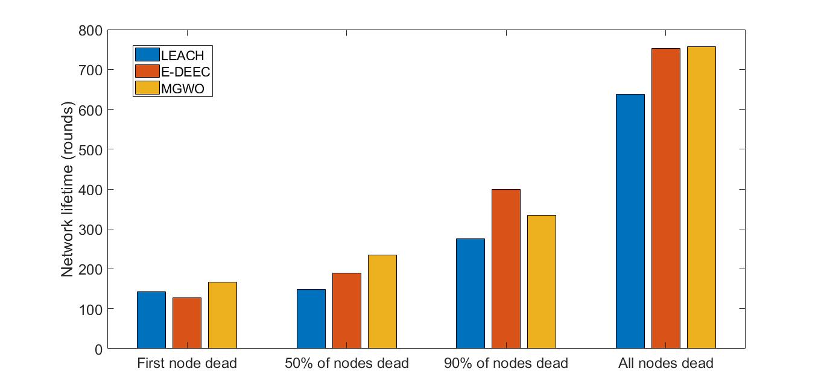

Figure 33. Network lifetime with respect to number of rounds in 3-level heterogeneous network

In conclusion, we succeeded in simulating the Modified GWO algorithm in a heterogeneous network and got some results. To begin with, our proposed algorithm outperformed LEACH in terms of energy efficiency and ability to keep sensor nodes alive in a 2-level heterogeneous network. However, in a 3-level heterogeneous network, theoretically, routing protocol based MGWO algorithm should have beaten LEACH in all aspects because LEACH is not designed for a heterogeneous network. On the contrary, our proposed algorithm did not have satisfactory performance over LEACH in some small aspects but overall, MGWO had better solutions to LEACH. When compared to E-DEEC, which is a protocol designed for solving energy efficiency problems of heterogeneous networks, our proposed protocol showed a slightly more efficient solution initially but when the energy of the network becomes exhausted, E-DEEC found better ways to approach solving the energy problems than MGWO. This shows that we need to work more on the algorithm to maximize the potential of MGWO to get the results we expect.

# CONCLUSION

After learning, researching and developing a routing protocol based GWO algorithm, I have completed the following tasks:

* Learned about wireless sensor network and many routing protocols of it such as LEACH, DEEC, etc.
* Learned the Grey Wolf Optimization algorithm and applied it for a specific topic.
* Successfully simulated the wireless sensor network in MATLAB and applied GWO algorithm to optimize the network’s lifetime.
* Simulated LEACH and E-DEEC routing protocols to have a comparison with the routing protocol based GWO algorithm.
* GWO algorithm outperformed LEACH protocol in optimization energy consumption and have a better result when comparing to E-DEEC in extending network lifetime generally.

However, the subject met some difficulties such as:

* With a large number of sensor nodes (>200), the simulation is time-consuming. It took a while to find the best route.
* When comparing to E-DEEC, the proposed algorithm could not perform better in the total network lifetime.

Further development and future work:

Since the system is not really optimal, I would like to suggest some development directions for the system as follows:

* Find a better fitness function for selecting optimal sets of clusters.
* Find a better fitness function for selecting cluster heads.
* Find a solution to avoid exceeding crossover distance such as make it becoming a parameter in selecting cluster heads.
* Propose a new algorithm in which cluster heads could send data to others.

# REFERENCE

|  |  |
| --- | --- |
| [1] | Heinzelman, W.R.; Chandrakasan, A.; Balakrishnan, H., "Energy-Efficient Communication Protocol for Wireless Microsensor Networks," in *33rd Annual Hawaii International Conference on System Sciences*, 2000. |
| [2] | Tong, M.; Tang, M, "LEACH-B: An Improved LEACH Protocol for Wireless Sensor Network," in *2010 6th International Conference on Wireless Communications Networking and Mobile Computing (WiCOM), Chengdu, China)*, 2010. |
| [3] | Marappan, P.; Rodrigues, P, "An energy efficient routing protocol for correlated data using CL-LEACH in WSN," *Wirel. Netw,* p. 1415–1423, 2015. |
| [4] | Vinod Kumar, Ajay Khunteta, "Energy Efficient PEGASIS Routing Protocol for Wireless Sensor Networks," in *2nd International Conference on Micro-Electronics and Telecommunication Engineering*, 2018 . |
| [5] | Parul Saini, Ajay.K.Sharma, "E-DEEC- Enhanced Distributed Energy Efficient Clustering Scheme for heterogeneous WSN," in *1st International Conference on Parallel, Distributed and Grid Computing*, 2010. |
| [6] | T. N. Qureshi, N. Javaid, M. Malik, U. Qasim‡, Z. A. Khan§, "On Performance Evaluation of Variants of DEEC in WSNs," in *2012 Seventh International Conference on Broadband, Wireless Computing, Communication and Applications*. |
| [7] | L. Qing, Q. Zhu, M. Wang, "Design of a distributed energy-efficient clustering algorithm for heterogeneous wireless sensor network," *ELSEVIER, Computer Communications 29,* pp. 2230- 2237, 2006. |
| [8] | Elbhiri, B. , Saadane, R. , El Fkihi, S. , Aboutajdine, D, "Developed Distributed Energy-Efficient Clustering (DDEEC) for heterogeneous wireless sensor networks," in *5th International Symposium on I/V Communications and Mobile Network (ISVC)*, 2010. |
| [9] | Xiaoqiang Zhao, Shaoya Ren, Heng Quan and Qiang Gao , "Routing Protocol for Heterogeneous Wireless Sensor Networks Based on a Modified Grey Wolf Optimizer," *Sensors,* 4 February 2020. |
| [10] | Ramson, S.R.J.; Moni, D.J, "Applications of wireless sensor networks—A survey," in *International Conference on Innovations in Electrical, Electronics, Instrumentation and Media Technology*, 2017. |
| [11] | Al-Aboody, N.A.; Al-Raweshidy, H.S, "Grey wolf optimization-based energy-efficient routing protocol for heterogeneous wireless sensor networks," in *4th International Symposium on Computational and Business Intelligence (ISCBI), Olten, Switzerland*, 2016. |
| [12] | Zhao, X.Q.; Zhu, H.; Aleksic, S.; Gao, Q, "Energy-Efficient Routing Protocol for Wireless Sensor Networks Based on Improved Grey Wolf Optimizer," *KSII T. Internet Inf,* p. 2644–2657, 2018. |
| [13] | Mirjalili, S.; Mirjalili, S.M.; Lewis, "A. Grey Wolf Optimizer," *Adv. Eng. Softw,* p. 46–61, 2014. |
| [14] | Bilal Jan, Haleem Farman, Huma Javed, Bartolomeo Montrucchio, Murad Khan and Shaukat Ali, "Energy Efficient Hierarchical Clustering Approaches in Wireless Sensor Networks: A Survey," *Wireless Communications and Mobile Computing,* 2017. |
| [15] | Lindsey S,Raghavendra C, "PEGASIS:Power-efficient Gatgering in Sensor Information Systems," in *IEEE Aerospace Conference*, Montana, 2002. |
| [16] | Heinzelman W,Chandrakasan A,Balakrishnan H, "Energy-efficient Communication Protocol for Wireless Microsensor Networks," in *33rd Annual Hawaii Int’l Conf.on System Sciences.Maui:IEEE Computer Society*, 2000. |
| [17] | Manjeshwar A,Agrawal D, "TEEN:A Protocol for Enhanced Efficiency in Wireless Sensor Networks," in *Proceedings 15th International Parallel and Distributed Processing Symposium. IPDPS 2001*, San Francisco, CA, USA, 2001. |
| [18] | Manjeshwar A,Agrawal D, "APTEEN: A Hybrid Protocol for Efficient Routing and Comprehensive Information Retrieval in Wireless Sensor Networks," in *Conference: 16th International Parallel and Distributed Processing Symposium (IPDPS 2002)*, Fort Lauderdale, FL, USA, 2002. |
| [19] | Ye F,Luo H,Cheng J,et al, "A Two-tier Data Dissemination Model for Large-scale Wireless Sensor Networks," in *Proceeding of the 8th Annual International Conference on Mobile Computing and Net-working*, Atlanta, 2002. |
| [20] | Wendi B. Heinzelman, Member, IEEE, Anantha P. Chandrakasan, "An Application-Specific Protocol Architecture for Wireless Microsensor Networks," *IEEE TRANSACTIONS ON WIRELESS COMMUNICATIONS,* vol. 1, p. 4, 2002. |
| [21] | Anitha Amaithi Rajan, Aravind Swaminathan, Brundha, "A Novel Clustering Algorithm for DEEC Protocol Based on Game Theory in WSN Sensors," *International Journal of Advanced Research in Computer Engineering & Technology (IJARCET),* vol. 08, 2019. |
| [22] | Divya Mishra, Deepak Sethi, Partha Pratim, "Modeling and Simulation of A Clustered WSN in Precision Agriculture," *International Journal of Computational Science, Information technology and Control Engineering (IJCSITCE),* vol. 3, 2016. |
| [23] | Mohammed Joda Usman, Zhang Xing, Haruna Chiroma, Tutut Herawan, "Modified Low Energy Adaptive Clustering Hierarchy Protocol for Efficient Energy Consumption in Wireless Sensor Networks," *International Review on Computers and Software (IRECOS) 9(11),* pp. 1904-1915, 2014. |
| [24] | F. Xiangning, and S. Yulin, "Improvement on LEACH protocol of wireless sensor network," *2007 International Conference on Sensor Technologies and Applications,* pp. 260-264, 2007. |
| [25] | W. Xinhua, and W. Sheng, "Performance comparison of LEACH and LEACH-C protocols by NS2," *2010 Ninth International Symposium on Distributed Computing and Applications to Business, Engineering and Science,* pp. 254-258, 2010. |
| [26] | P. Dabas, and N. Gupta, "LEACH-and-its-Improved-Versions-A-Survey," *International Journal of Scientific & Engineering Research, vol. 6, no. 6,* pp. 184-188, 2015. |
| [27] | S. Tarannum, "Energy Conservation Challenges in Wireless Sensor Network: A Comprehensive Study," *Wireless Sensor Network,* pp. 483-491, 2010. |
| [28] | Waltenegus Dargie and Christian Poellabauer, Fundamentals of Wireless Sensor Networks: Theory and practice, A John Wiley and Sons, Ltd., Publication, 2010. |
| [29] | Al-Karaki and Kamal, "Routing Techniques in Wireless Sensor Networks: A Survey," 2004. |
| [30] | YAHUI LIU AND BUYANG CAO , "A Novel Ant Colony Optimization Algorithm With Levy Flight," *Digital Object Identifier 10,* 2020. |
| [31] | PLAMENKA BOROVSKA, OGNIAN NAKOV, GEORGI YANCHEV, "Parallel Metaheuristics for Resource Scheduling of Virtualized Multicore Plarforms," in *International Conference on Applied Computer Science*. |
| [32] | J. Becker, "An Introduction to Particle Swarm Optimization (PSO) with Applications to Antenna Optimization Problems," Available at "https://wirelesstechthoughts.blogspot.com/2013/06/an-introduction-to-particle-swarm.html", 2013. |
| [33] | A. Rahim, "Adaptive-Reliable Medium Access Control Protocol for Wireless Body Area Networks," COMSATS Institute of Information Technology. |
| [34] | Pardeep Kumar, Sang-Gon Lee, Hoon-Jae Lee, "E-SAP: Efficient-Strong Authentication Protocol for Healthcare Applications Using Wireless Medical Sensor Networks," in *Sensors*, 2012. |
| [35] | Aleksejs Jurenoks, Viktorija Ponomarenko, Leonids Novickis, "Transfer and Validation of Adaptive Method for Assessing the Life Expectancy of a Wireless Sensor Network in Smart Environments Applications," ResearcherGate, 2017. |
| [36] | Satyam Gupta, Manpreet Singh, Saumya Srivastava, "Wireless Sensor Network: A Survey," INTERNATIONAL CONFERENCE ON AUTOMATION AND COMPUTATIONAL ENGINEERING (ICACE-2018), 2018. |
| [37] | Harmanpreet Singh, Damanpreet Singh, "Taxonomy of Routing Protocols in Wireless Sensor Networks: A Survey," in *Conference: 2nd International Conference on Contemporary Computing and Informatics (IC3I)*, 2017. |
| [38] | P. Shrivastava, "A Hybrid Sink Repositioning Technique for Data Gathering in Wireless Sensor Networks," in *Wireless Sensor Networks - Insights and Innovations*, INTECH, 2017. |