1_Ảnh chụp về IAM User và IAM Group đã tạo

* ASM1-user nằm trong ASM1-group

2_Ảnh chụp VPC và Security Group đã tạo.

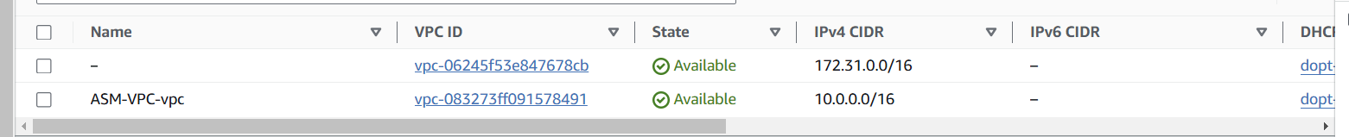

3_Ảnh chụp Target Group đã tạo.

4_Ảnh chụp Application Load Balancer được tạo.

5_Ảnh chụp Launch Template đã tạo.

6_Ảnh chụp Auto Scaling Group được tạo.

Tăng tải:

Scale out

7_Ảnh chụp Email được báo về từ Notifications.

8_ **Tạo Snapshot cho EC2**

