Author: Benjamin Seang, Nguyen Dinh, Isabel Pham, Yi-En Laih (Emily), Abey John, T.K. Bui

Description:

This is a crowd-sourced rating web application that allows users with a valid SJSU ID to rate and vote on various items. Users are be able to create their own polls and questions regarding anything from courses to restaurants to events, and other users are able to anonymously interact with these polls/questions and see how their peers interact with those polls/questions. Users are also be able to search for topics they are interested in.

Instruction for running the app:

1. NodeJS: Go to [Node.js (nodejs.org)](https://nodejs.org/en/) . Download the version that’s Recommend For Most Users. Install it. To test if you installed it correctly. Open up any terminal. Try node -v This should give you a version number. Then, type node in the terminal. This will let you code javascript in the terminal. Try console.log(“Hello”) If your terminal responds hello, you are good to move to the next step. (To exit js coding mode, press ctrl+C, or just simply close your terminal)

4. MongoDB: (Windows users) Go to [MongoDB Community Download | MongoDB](https://www.mongodb.com/try/download/community?jmp=docs) Choose MongoDB Cmmunity Sever and your operating system. During installation, choose to do a complete installation and leave all other things default. You might be asked to reboot your computer after installation. (Mac users: refer to this doc [MongoDB Installation - Google Docs](https://docs.google.com/document/d/1W3vdC0B-Kpu7t3wo0Lcrpb9A6IvzqZIEuhBX2pW7ME8/edit))

5. To test if you installed MongoDB corrected. Open up a terminal, try mongo If it says mongo is not recognizable. You’ll need to manually include it in your environment variable. Click Windows key, search for Edit Environment Variable -> Environment Variables -> Inside System variables -> double-click Path -> Browse -> Locate your MongoDB’s folder -> Click on bin (don’t need to go into it, just click on it.) -> ok. For me, the path is “C:\Program Files\MongoDB\Server\5.0\bin” Yours may vary.

6. Close any previous terminal and open up a new one. Yes, it must be a new terminal. Try mongo again. If there’s no longer errors and returns some version number and other information. You are good to move to the next step.

7. Go to Visual Studio Code, open the project folder. Open a terminal in VS code.

8. cd server This step is to go into the server folder.

9. npm install express mongoose cors dotenv cookie-parser jsonwebtoken

10. npm install --global nodemon

11. You also need to create a .env file inside your server folder. The file’s name should be .env No postfix, no prefix. Do not type it wrong. And you’ll write your port#, database name and secret key (for accessing cookies later) inside .env file. We don’t upload .env onto Github for security reason. But if you are unsure about how to write it, you can use the following:

MY_PORT = 8000  
DB_NAME = 'polldb'  
JWT_SECRET = '821DSs9)FTaSF'

12. To test your backend. nodemon server.js If you see:

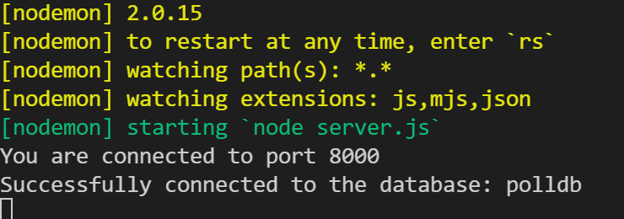

Good job. Make sure the last two lines say connect to 8000 and to polldb. If you see undefined, it means your .env is not correct.

13. Now we can begin working on frontend. First, split the terminal

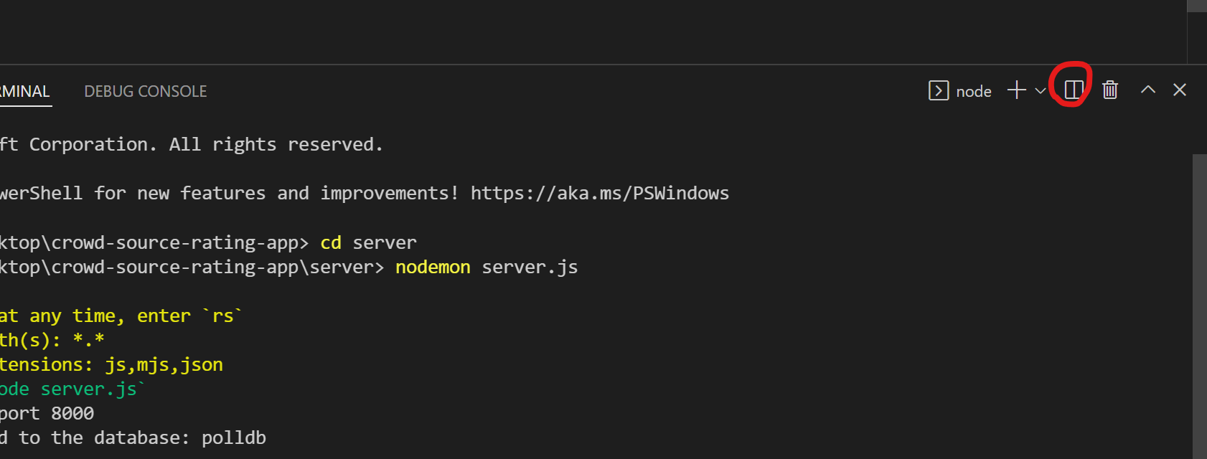

14. in the new terminal, cd client Go into client folder, this is our frontend.

15. npm install Wait for it to finish

16. npm install --save react-chartjs-2 chart.js

17. npm install react-step-range-slider --save

18. In client’s terminal, npm start It will take a few seconds. Then, the app’s webpage will automatically be opened in your browser. Feel free to play with it.

19. Congratulation, the app is ready to go.

Note: Make sure you are in the correct folder when writing the commands. In other words, don’t use the commands for server folder inside client’s folder and vice versa.