Homework-1 CIS 147

1. Given the following instruction format, OpCode and the machine code for a simple CPU in hex, show the assembly language program correspond to the machine code (in hex):

***57 18 39 9B 78 E0***

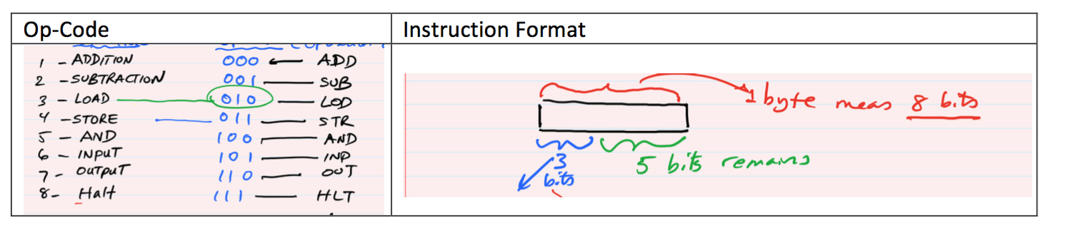



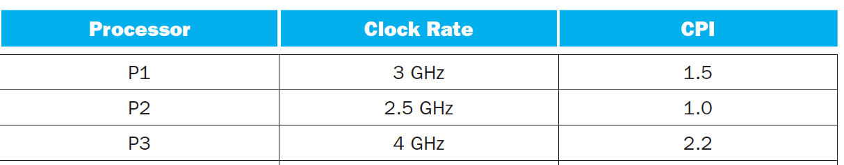

1. Which processor has the lowest performance expressed in instructions per second.
2. If the processors each execute a program in 20 seconds, find the number of cycles and number of instructions.
3. We are trying to reduce the execution time by 40%, but this leads to an increase of 30% in the CPI. What clock rate should we have to get this time reduction?
4. What is the 2’s complement representation of -122 in 32 bits?
5. An 8-bit register contains 87h. If this computer represents the numbers in 2’s complement system, what negative number in decimal does these 8 bits represent?