CURRICULUM MANAGEMENT PLATFORM
Data Model &
Data Relationships
Proposed logical model for curriculum authoring, audio versioning, quality assurance, drills, roleplay and localization.
Document status | Proposed MVP baseline
Prepared for | Yapsu product and engineering review
Prepared date | 11 June 2026
Source context | README, UI review transcript and current prototype

Core design decision
Stable business identities are separated from editable revisions. Audio and QA records always point to the exact content revision they were created from.

Internal use only · Version 1.0

Contents
- 1. Purpose and scope
- 2. Modeling principles
- 3. Domain relationship overview
- 4. Entity catalog
- 5. Detailed data dictionary
- 6. Status and versioning rules
- 7. Change propagation and dependency matrix
- 8. Validation and business rules
- 9. Use-case mapping
- 10. Recommended implementation sequence
- Appendix A. Enumerations
- Appendix B. Open decisions
Document intent
This is a logical data specification for product alignment. Physical PostgreSQL/Supabase DDL should be produced only after open decisions are confirmed.

1. Purpose and scope
This document defines the proposed logical data model for the Yapsu Curriculum Management Platform. It covers the complete authoring pipeline from curriculum import to content editing, audio production, AI and human QA, drill assignment, roleplay configuration, localization and release to the mobile app.
The model is designed to answer the main product questions raised during the UI review: which fields are editable, how completion and enablement are represented, how an audio file is tied to the correct script version, and which downstream records become invalid when a vocab, sentence or tutor script changes.

1.1 In scope
- Logical entities, keys and relationships.
- Versioning and audit history for curriculum content and audio.
- Localization coverage by language pair and lesson.
- AI QA and Human QA as separate stages.
- Exclusive Drill versus Extra Drill assignment.
- Roleplay description and goal mapping to the mobile app.
- Import traceability and publish-readiness rules.

1.2 Out of scope
- Authentication provider details and final Row Level Security policies.
- Gemini API request/response payloads and storage provider configuration.
- Final analytics, learner progress and mobile runtime data.
- Exact SQL indexes and performance tuning.

2. Modeling principles
Principle | Meaning
Stable identity, versioned content | A content item keeps one stable ID; each edit creates a new content revision.
Explicit source linkage | Audio, QA and drill records reference a concrete source revision, never only free text.
No silent invalidation | When source content changes, affected downstream records receive an explicit status.
Structured configuration | Drill configuration stores typed fields or token ranges instead of freestyle text fragments.
Localization as first-class data | Native-language coverage and enablement are modeled per locale and lesson.
Auditability | Imports, revisions, QA decisions and publish transitions keep timestamps and actor IDs.
Mobile mapping before UI fields | A CMS field exists only when it has a defined business purpose or mobile mapping.

3. Domain relationship overview
Figure 1 shows the proposed domain boundaries and the primary relationship direction.
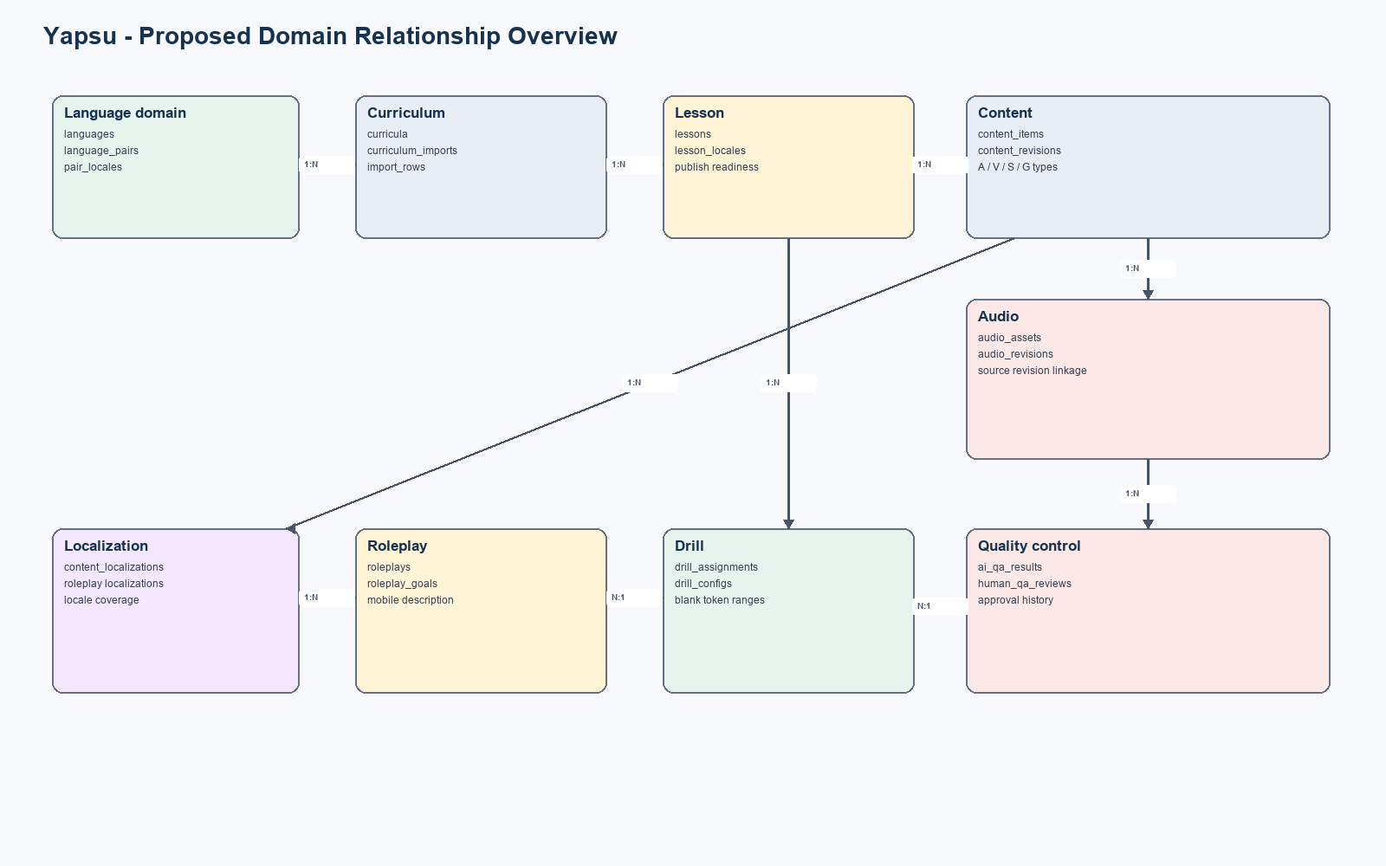
Figure 1. Proposed logical domain relationship overview.

3.1 Cardinality summary
Parent | Child | Cardinality | Rule
Language | Language Pair | 1:N | A language can participate in many learning/native pairs.
Language Pair | Curriculum | 1:N | A pair can have multiple curricula or curriculum versions.
Curriculum | Lesson | 1:N | A curriculum contains ordered lessons.
Lesson | Content Item | 1:N | A lesson owns Tutor, Vocab, Sentence and Grammar items.
Content Item | Content Revision | 1:N | Every edit produces a revision while identity remains stable.
Content Revision | Audio Revision | 1:N | Audio is generated/uploaded from one exact source revision.
Audio Revision | AI QA Result | 1:N | AI QA may be rerun and results are retained.
Audio Revision | Human QA Review | 1:N | Human decisions are auditable and may be superseded.
Content Item | Drill Assignment | 0:1 | One source card may be unassigned, Drill or Extra Drill.
Lesson | Roleplay | 0:1 | A lesson may have one roleplay configuration.
Roleplay | Roleplay Goal | 1:N | Goals are ordered and can be enabled independently.
Content Revision | Localization | 1:N | Each revision can have multiple locale overlays.

4. Entity catalog
Entity | Category | Purpose | UC
languages | Master | Supported languages and locale metadata. | UC01
language_pairs | Master | Learning language to native language configuration. | UC01
curricula | Core | Imported or authored curriculum container. | UC01
curriculum_imports | Audit | Upload batch, validation and import result. | UC01
lessons | Core | Ordered lesson metadata and release status. | UC01
lesson_locales | Localization | Locale availability, coverage and enablement per lesson. | UC01/04
content_items | Core | Stable identity for Tutor/Vocab/Sentence/Grammar cards. | UC01
content_revisions | Versioned | Editable content snapshots and revision metadata. | UC01
content_localizations | Localization | Native translations tied to a content revision. | UC01/02/03
audio_assets | Media | Stable audio identity for a content item. | UC02
audio_revisions | Versioned | Uploaded/generated files tied to source revision. | UC02
ai_qa_results | QA | Automated quality checks and details. | UC02
human_qa_reviews | QA | Human Pass/Fail decisions and reasons. | UC02
drill_assignments | Interactive | Exclusive Drill/Extra Drill placement. | UC03
drill_configs | Interactive | Typed drill configuration. | UC03
roleplays | Interactive | Mobile-facing roleplay description and status. | UC04
roleplay_goals | Interactive | Ordered success goals and native descriptions. | UC04
publish_checks | Derived/Audit | Readiness checks and blocking reasons. | All

5. Detailed data dictionary
The following fields define the MVP baseline. UUID is recommended for primary keys; timestamps use UTC.

5.1 languages
Field | Type | Constraint | Purpose
id | uuid | PK | Stable language ID.
code | varchar(10) | UK, required | BCP-47/ISO-like code, e.g. zh, vi, ja.
name | varchar(100) | required | Display name.
native_name | varchar(100) | required | Native display name.
is_active | boolean | required | Whether language can be selected.

5.2 language_pairs
Field | Type | Constraint | Purpose
id | uuid | PK | Stable pair ID.
learning_language_id | uuid | FK languages | Language being learned.
native_language_id | uuid | FK languages | Learner UI/support language.
status | enum | required | draft, active, disabled.
created_at / updated_at | timestamptz | required | Audit timestamps.

5.3 curricula
Field | Type | Constraint | Purpose
id | uuid | PK | Curriculum identity.
language_pair_id | uuid | FK language_pairs | Pair served by curriculum.
code | varchar(50) | UK, required | Stable business code.
title | varchar(255) | required | Curriculum name.
version_label | varchar(50) | optional | Human-readable release label.
status | enum | required | draft, validating, ready, published, archived.
current_import_id | uuid | FK curriculum_imports | Latest accepted import batch.

5.4 curriculum_imports
Field | Type | Constraint | Purpose
id | uuid | PK | Import batch.
curriculum_id | uuid | FK curricula | Target curriculum.
file_name / file_url | text | required | Source Excel reference.
status | enum | required | uploaded, validating, valid, invalid, imported, cancelled.
valid_row_count / error_row_count | integer | required | Preview summary.
validation_report | jsonb | required | Structured row/field errors.
created_by / created_at | uuid / timestamptz | required | Audit data.

5.5 lessons
Field | Type | Constraint | Purpose
id | uuid | PK | Lesson identity.
curriculum_id | uuid | FK curricula | Owning curriculum.
lesson_code | varchar(50) | UK within curriculum | Example CN_L101.
level / order_index | integer | required | Curriculum ordering.
title | varchar(255) | required | Inherited by Roleplay; edited here.
description | text | optional | Lesson summary.
status | enum | required | draft, incomplete, ready, published, disabled, needs_review.
is_enabled | boolean | required | Operator-controlled availability after validation.
published_revision_at | timestamptz | optional | Last successful publish.

5.6 lesson_locales
Field | Type | Constraint | Purpose
id | uuid | PK | Locale coverage record.
lesson_id | uuid | FK lessons | Lesson.
locale_language_id | uuid | FK languages | Native locale.
is_enabled | boolean | required | Locale available for this lesson.
coverage_status | enum | required | missing, partial, complete, needs_review.
coverage_percent | numeric(5,2) | derived/cache | UI progress indicator.

5.7 content_items
Field | Type | Constraint | Purpose
id | uuid | PK | Stable card identity.
lesson_id | uuid | FK lessons | Owning lesson.
code | varchar(80) | UK, required | Example CN_L101_V6.
content_type | enum | required | tutor, vocab, sentence, grammar.
order_index | integer | required | Display/teaching sequence.
is_enabled | boolean | required | Whether item participates in release.
current_revision_id | uuid | FK content_revisions | Currently selected revision.
status | enum | required | incomplete, ready, disabled, needs_review.

5.8 content_revisions
Field | Type | Constraint | Purpose
id | uuid | PK | Immutable revision snapshot.
content_item_id | uuid | FK content_items | Stable item.
revision_no | integer | required | Monotonic revision number.
script_text | text | conditional | Target-language text or Tutor script.
reading | text | optional | Pinyin/kana/romanization.
meaning_en | text | optional | Canonical English meaning/explanation.
content_hash | varchar(64) | required | Detects exact content changes.
change_note | text | optional | Reason for revision.
created_by / created_at | uuid / timestamptz | required | Audit metadata.

5.9 content_localizations
Field | Type | Constraint | Purpose
id | uuid | PK | Localization record.
content_revision_id | uuid | FK content_revisions | Exact source revision.
locale_language_id | uuid | FK languages | Target locale.
localized_text | text | required | Native translation/description.
status | enum | required | draft, reviewed, approved, outdated.
reviewed_by / reviewed_at | uuid / timestamptz | optional | Localization QA.

5.10 audio_assets and audio_revisions
Field | Type | Constraint | Purpose
audio_assets.id | uuid | PK | Stable audio identity per content item/voice role.
audio_assets.content_item_id | uuid | FK content_items | Source card.
audio_revisions.id | uuid | PK | Audio file revision.
audio_revisions.audio_asset_id | uuid | FK audio_assets | Stable audio identity.
audio_revisions.source_revision_id | uuid | FK content_revisions | Exact script used.
source_type | enum | required | uploaded or generated.
file_url / mime_type / duration_ms | text | required after ready | Media metadata.
provider / voice_config | text / jsonb | optional | Gemini/provider settings.
status | enum | required | missing, generating, ready, failed, outdated, approved.
generation_message | text | optional | Provider error or status detail.

5.11 ai_qa_results and human_qa_reviews
Field | Type | Constraint | Purpose
audio_revision_id | uuid | FK audio_revisions | Audio under review.
result | enum | required | pending, passed, failed, error.
checks | jsonb | AI QA | Pronunciation, silence, clipping, alignment, etc.
score | numeric | AI QA optional | Normalized quality score.
reason | text | Human QA required on fail | Reviewer explanation.
reviewed_by | uuid | Human QA | Reviewer ID.
created_at | timestamptz | required | Decision timestamp.
is_current | boolean | required | Latest applicable result for revision.

5.12 drill_assignments and drill_configs
Field | Type | Constraint | Purpose
drill_assignments.id | uuid | PK | Assignment identity.
lesson_id | uuid | FK lessons | Owning lesson.
source_content_item_id | uuid | FK content_items, UK | One assignment per source card.
placement | enum | required | drill or extra_drill.
drill_type | enum | required | listen_repeat, fill_blank, sentence_order.
status | enum | required | draft, ready, needs_review, disabled.
source_revision_id | uuid | FK content_revisions | Revision last reviewed.
config | jsonb | typed by drill_type | Type-specific structured data.
blank_start / blank_end | integer | fill_blank | Contiguous token range.

5.13 roleplays and roleplay_goals
Field | Type | Constraint | Purpose
roleplays.id | uuid | PK | Roleplay identity.
lesson_id | uuid | FK lessons, UK | One roleplay per lesson.
description | text | required | Mobile-facing context/description.
status | enum | required | draft, ready, disabled, needs_review.
roleplay_goals.id | uuid | PK | Goal identity.
roleplay_id | uuid | FK roleplays | Parent roleplay.
order_index | integer | required | Display/evaluation order.
goal_en | text | required | Canonical success criterion.
description_native | text | required per enabled locale | Learner-facing native description.
is_enabled | boolean | required | Whether goal is active.

6. Status and versioning rules

6.1 Content revision rule
Editing script_text, reading, meaning_en or another release-significant field creates a new immutable content revision. The content item points current_revision_id to the new revision. Previous revisions remain available for audit and rollback.

6.2 Audio synchronization rule
An audio revision is synchronized only when audio_revisions.source_revision_id equals content_items.current_revision_id. If they differ, the UI must display Outdated and offer Upload New Audio or Regenerate.

6.3 QA applicability rule
AI and Human QA results apply to one audio revision only. A new audio revision starts with AI QA Pending and Human QA Pending. Old decisions remain historical but cannot approve the new file.

6.4 Publish readiness
Check | Rule | Severity
Required content | All enabled cards have a complete current revision. | Blocking
Localization | All enabled lesson locales meet required coverage. | Blocking
Audio | Required cards have synchronized, ready audio. | Blocking
AI QA | Latest required AI QA result is Passed. | Configurable blocking
Human QA | Latest Human QA result is Passed. | Blocking
Drill | Assignments reference the current reviewed content revision. | Blocking when enabled
Roleplay | Description exists and at least one enabled valid goal exists. | Blocking when roleplay enabled

7. Change propagation and dependency matrix
Figure 2 describes the required system response when source content changes.
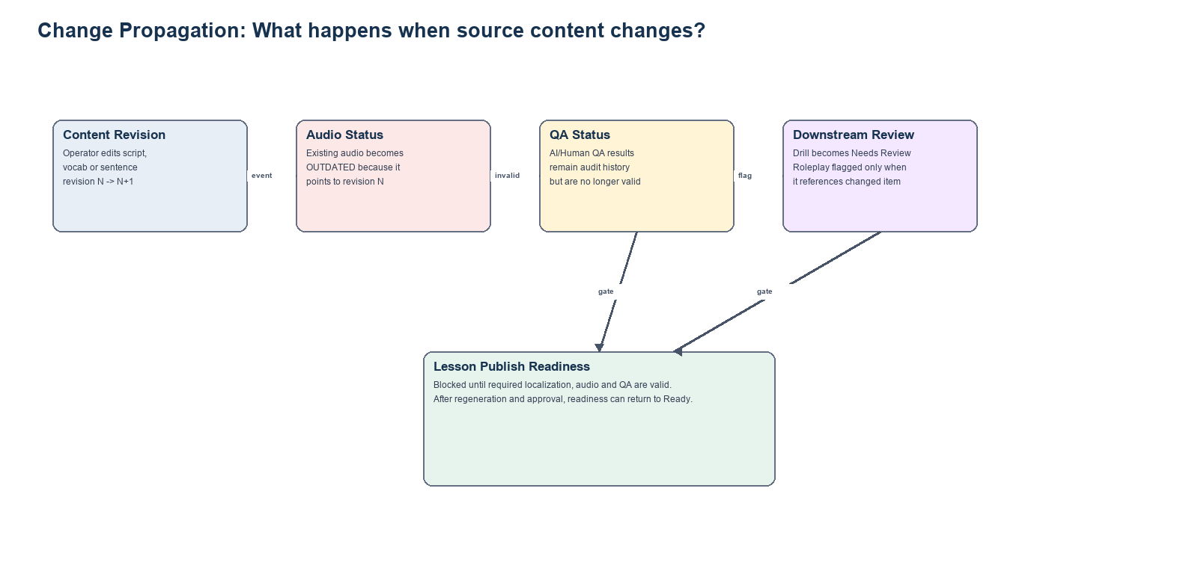
Figure 2. Source edit propagation and release gate.
Changed field | Primary effect | Audio | Downstream | Release impact
Lesson title | Roleplay header/mobile lesson title | No audio impact | Roleplay preview refresh | Revalidate mobile mapping
Tutor script | Tutor content revision | Audio Outdated | Reset applicable QA | Lesson Needs Review
Vocab script/reading | Vocab revision | Audio Outdated | Drill Needs Review | Localization may become Outdated
Sentence script/reading | Sentence revision | Audio Outdated | Fill Blank/Sentence Order Needs Review | Token ranges must be revalidated
Meaning/translation | Localization/current revision | No TTS impact unless spoken | Drill native meaning refresh | Locale coverage may become partial
Disable content item | Release composition | Audio retained as history | Disable dependent assignment | Recalculate readiness
Audio file | Audio revision | New current audio | AI/Human QA Pending | Cannot publish until approved
Language locale enable | lesson_locales | No direct impact | Requires localization coverage | Block locale publish if incomplete

8. Validation and business rules
ID | Rule | Enforcement
BR-01 | A language pair cannot use the same learning and native language. | Database constraint
BR-02 | lesson_code is unique within a curriculum. | Unique constraint
BR-03 | content item code is unique and its type prefix must match content_type. | Validation + unique constraint
BR-04 | An enabled content item must have a complete current revision. | Application + publish check
BR-05 | Audio Approved requires synchronized source revision and current Human QA Passed. | State transition guard
BR-06 | A source content item can have at most one active Drill Assignment. | Unique constraint
BR-07 | Drill and Extra Drill are mutually exclusive placements. | Enum + unique constraint
BR-08 | Fill Blank selection must be a non-empty contiguous token range. | Typed config validation
BR-09 | Roleplay requires at least one enabled, complete goal when enabled. | Publish check
BR-10 | Lesson locale cannot be enabled when required localization coverage is incomplete. | State transition guard
BR-11 | Hard/master fields are selected from controlled values, not free edited. | UI + FK constraint
BR-12 | Delete operations on referenced records default to soft delete or restrict. | FK/repository policy

9. Use-case mapping
Use Case | Primary entities | Output
UC01 Curriculum Editor | curricula, imports, lessons, content_items, content_revisions, lesson_locales | Validated curriculum with explicit readiness and locale coverage.
UC02 Audio QA | audio_assets, audio_revisions, ai_qa_results, human_qa_reviews | Approved audio synchronized to the current script revision.
UC03 Drill Editor | drill_assignments, drill_configs, content_items/revisions | Typed Drill/Extra Drill configurations without duplicate assignment.
UC04 Roleplay Editor | roleplays, roleplay_goals, lessons, lesson_locales | Mobile description plus ordered active success goals.

10. Recommended implementation sequence
Phase | Scope | Tables/Capability
1 | Master and core structure | languages, language_pairs, curricula, lessons
2 | Versioned curriculum content | content_items, content_revisions, content_localizations
3 | Import workflow | curriculum_imports, validation report and preview mapping
4 | Audio and QA | audio assets/revisions, AI QA, Human QA, stale detection
5 | Interactive modules | drill assignments/configs, roleplay/goals
6 | Release controls | publish checks, status transitions and mobile export view
7 | Security and operations | Supabase RLS, audit events, storage policies and jobs

Appendix A. Enumerations
Enum | Values
content_type | tutor, vocab, sentence, grammar
lesson_status | draft, incomplete, ready, published, disabled, needs_review
coverage_status | missing, partial, complete, needs_review
audio_status | missing, generating, ready, failed, outdated, approved
qa_result | pending, passed, failed, error
drill_placement | drill, extra_drill
drill_type | listen_repeat, fill_blank, sentence_order
record_status | draft, ready, disabled, needs_review
import_status | uploaded, validating, valid, invalid, imported, cancelled

Appendix B. Open decisions
Decision | Question to confirm
AI QA blocking? | Confirm whether AI QA Passed is mandatory for publish or advisory before Human QA.
Audio granularity | Confirm which content types require audio: Tutor only or Tutor/Vocab/Sentence/Grammar.
Canonical English | Confirm whether English is a fixed canonical meaning or another localization.
Roleplay prompt ownership | Confirm that operators edit only mobile description/goals, not the internal system prompt.
Multiple curricula | Confirm whether one language pair can have multiple active curricula or only archived versions.
Import merge behavior | Define replace, merge and duplicate handling for an existing lesson/card code.
Deletion policy | Confirm soft-delete retention period and whether published records can ever be hard deleted.
Mobile export contract | Define final JSON/API schema and which statuses are visible to mobile.
Approval recommendation
Review and confirm the open decisions first. After approval, convert this logical model into Supabase SQL migrations, RLS policies and typed TypeScript models. UI implementation should use the same status and dependency rules.

