Full name: Doan Cong Thanh
Class: 22TT2
Id: 22125096

Ex01:
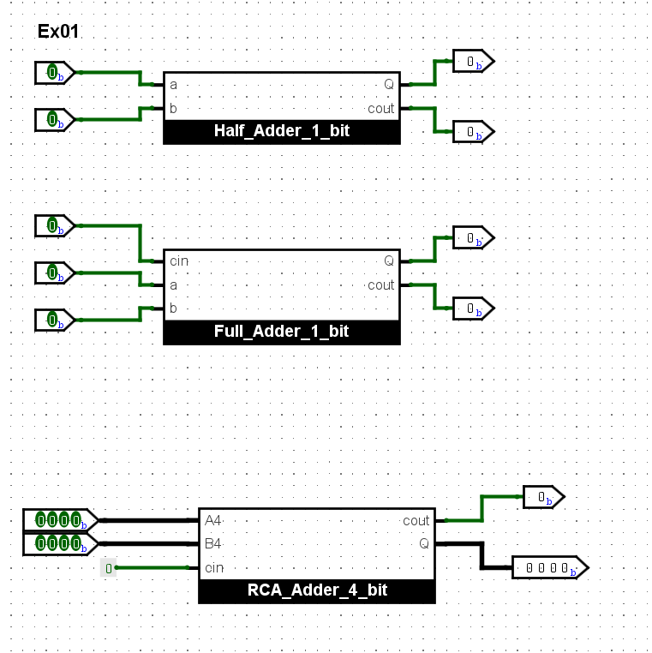

Half Adder 1 bit: we have 2 inputs (1 bit) with c value equals to 0.
We have the following truth table for the sum of these 2 data.
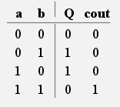
And we have the function:
Q = a⊕b
cout = a⋅b

Full Adder 1 bit: we have 2 inputs (1 bit) with cin value (1 bit).
We have the following truth table for the sum of these 2 data.
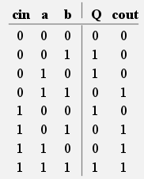
K-map (Q):
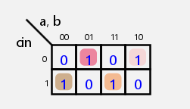
Q = ~cin⋅~a⋅b+~cin⋅a⋅~b+cin⋅~a⋅~b+cin⋅a⋅b
K-map(cout):
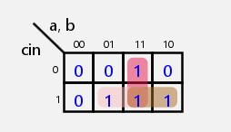
cout = a⋅b+cin⋅b+cin⋅a

RCA Adder 4 bit:

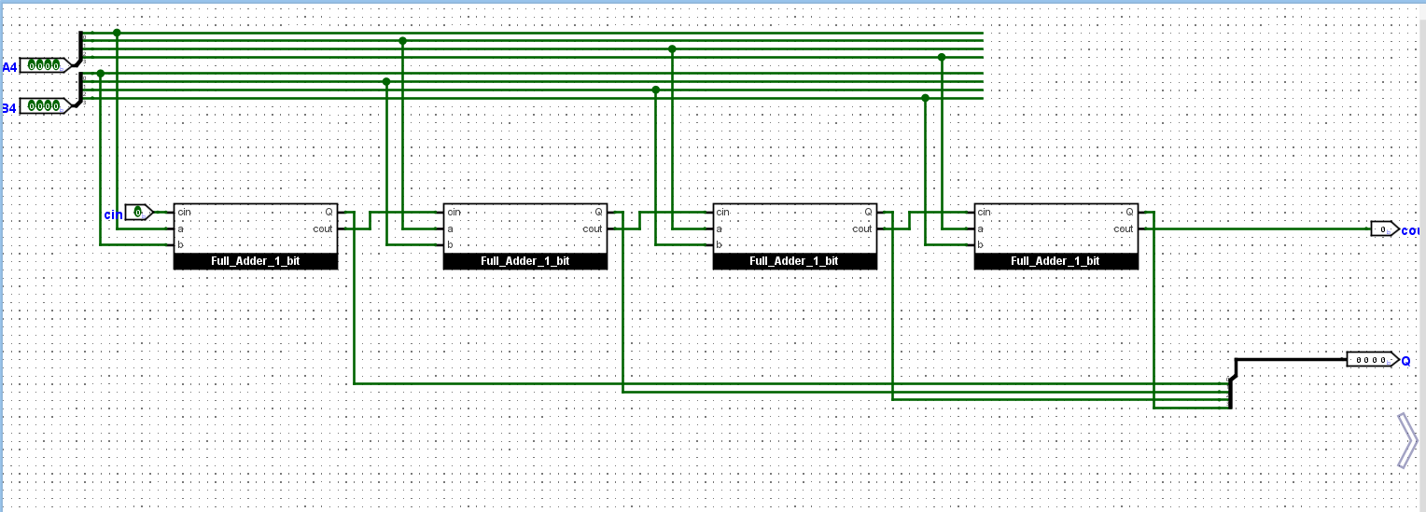

To sum 2 input (more than 1 bit), we use the RCA (Ripple Carrier Adder) method.
Assume:
A4(a0a1a2a3) and B4(b0b1b2b3). We use the first full adder 1 bit with cin equals to 0 to sum a0 and b0.
Then use cout_{i} as cin_{i+1} to sum a_{i+1} and b_{i+1} (with i = 0,1,2). Repeated this procedure until we add the last two bits.
The result is in format of 4 bit(Q0Q1Q2Q3Q4)

Ex02:
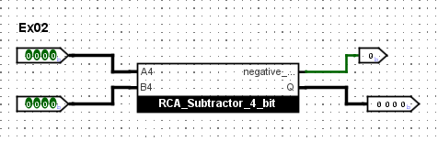
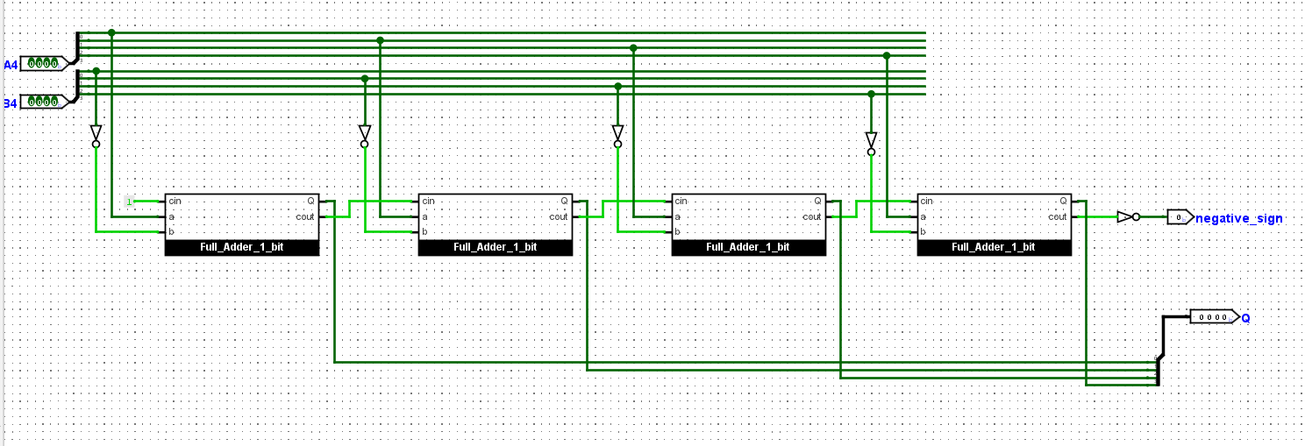

To compute A-B. We make the use of 2’s complement. So A – B = A + ~B + 1.
So we use the not gate before any bits in B4. Then set cin equals to constant 1.
As we can see, the method is similar to the one explained in Ex01. The only difference is that the negative_sign = ~cout. The reason is that in sum operation, when the last cout carry is 1, we detect the overflow. The opposite condition can be seen when we manipulate the subtraction, which means the carry out is 0. So we negate the cout to get correct negative_sign.

Ex03:
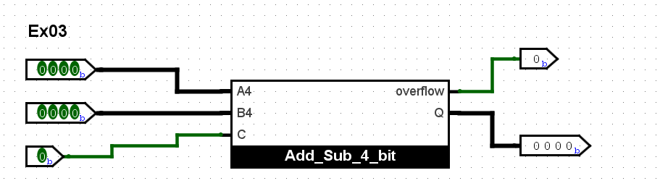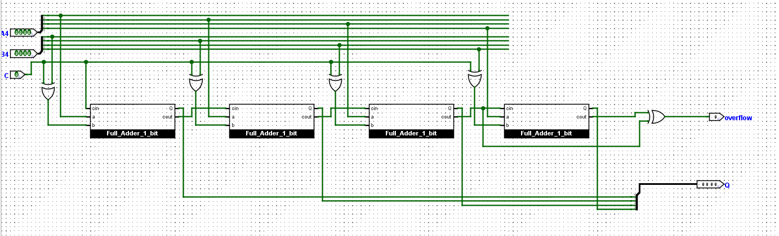
We use the same idea applied to build the RCA Adder 4 bit with some modification:
To handle the addition/subtraction operation, we use the c value which manage to flip B (c XOR b_{i}(i = 0,1,2,3))
When c = 1 (B negates, cin = 1)
When c = 0 (B remains unchanged, cin = 0)
Overflow occurs when carry-in to MSB is different from carry-out of MSB.
Overflow = c_{n-1}⊕c_{n}

Ex04:
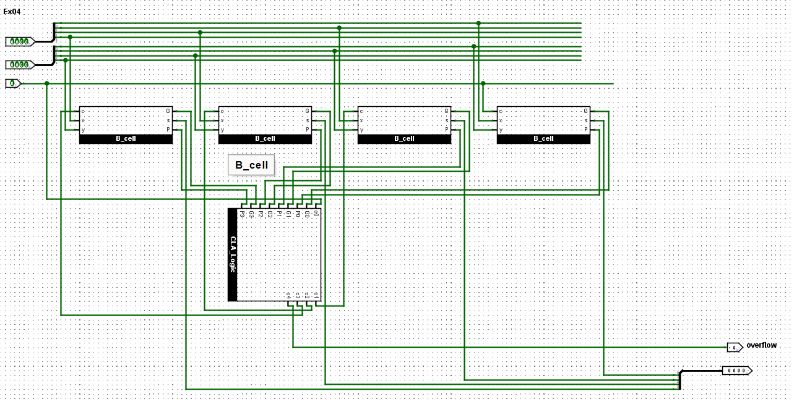
Recall some equation:
c_{i+1} = x_{i}⋅y_{i}+x_{i}⋅c_{i}+y_{i}⋅c_{i} = x_{i}⋅y_{i}+(x_{i}+y_{i})⋅c_{i}
Q_{i} = x_{i}⊕ y_{i} ⊕ c_{i}
Let denote G_{i} = x_{i}⋅y_{i}, P_{i} = x_{i}+y_{i}
We can write c_{i+1} = G_{i} + P_{i}c_{i}
The general formula for c_{i+1} depend only c₀:
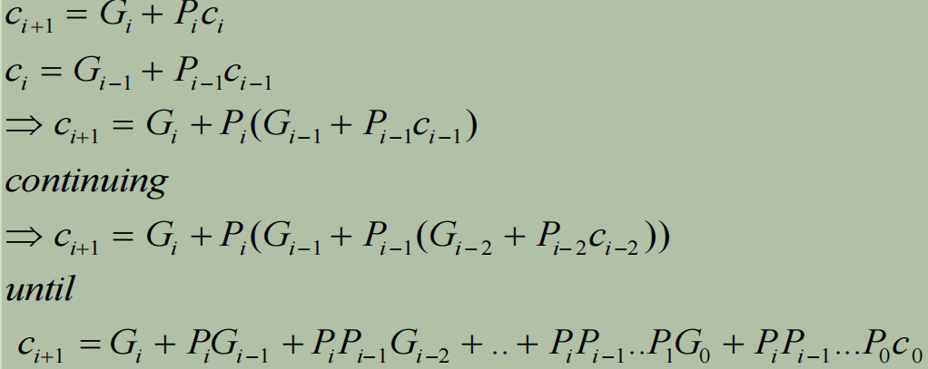
By the expectation, when we want to compute c_{i+1}, the efficient way is:
c_{i+1} = (c_{i} AND P_{i}) OR G_{i} with (i=1,2,3,…)
The idea to build CLA following this picture:
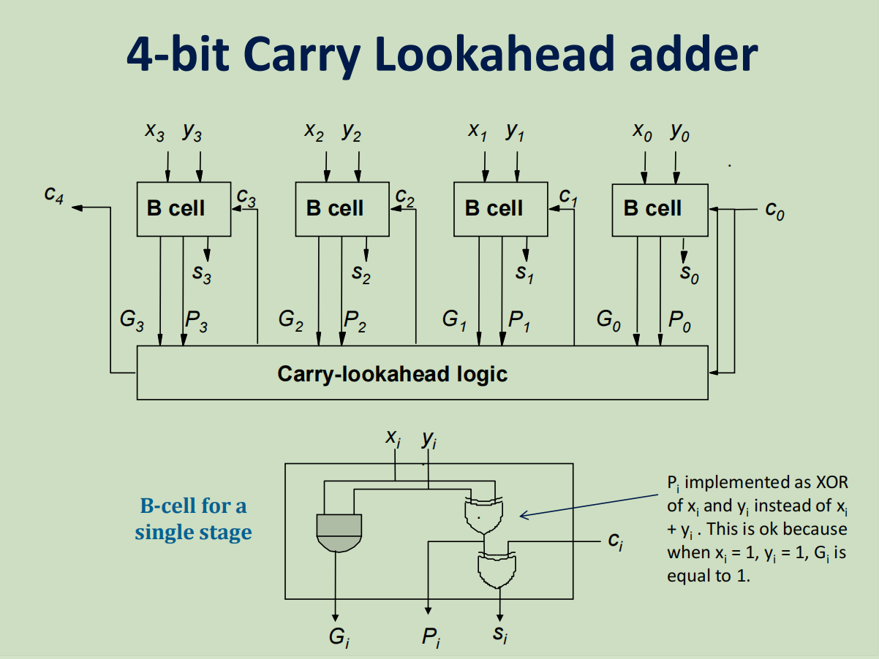

To minimize the cost, we can treat X OR Y equivalent to X XOR Y since the truth table of these two expressions is quite similar. The only one difference when xi = 1, y1 = 1 do not affect the answer ci+1 since Gi is still 1 in this situation, and so c_{i+1} = (c_{i} AND P_{i}) OR G_{i} with (i=1,2,3,…) = 1.
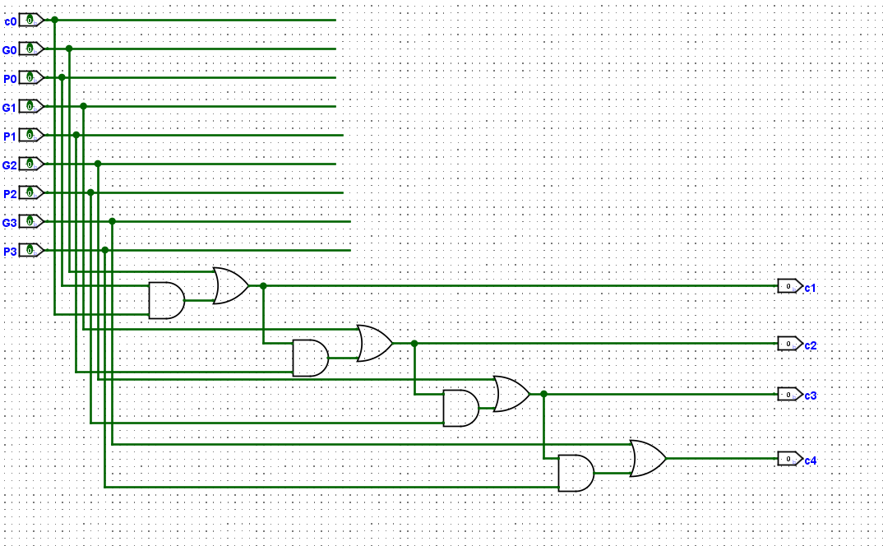
The picture above describes the way I compute c1,c2,c3,c4.
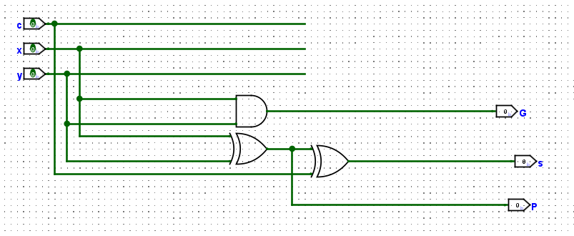
And the last one shows how S,P,G are calculated.

Ex05:
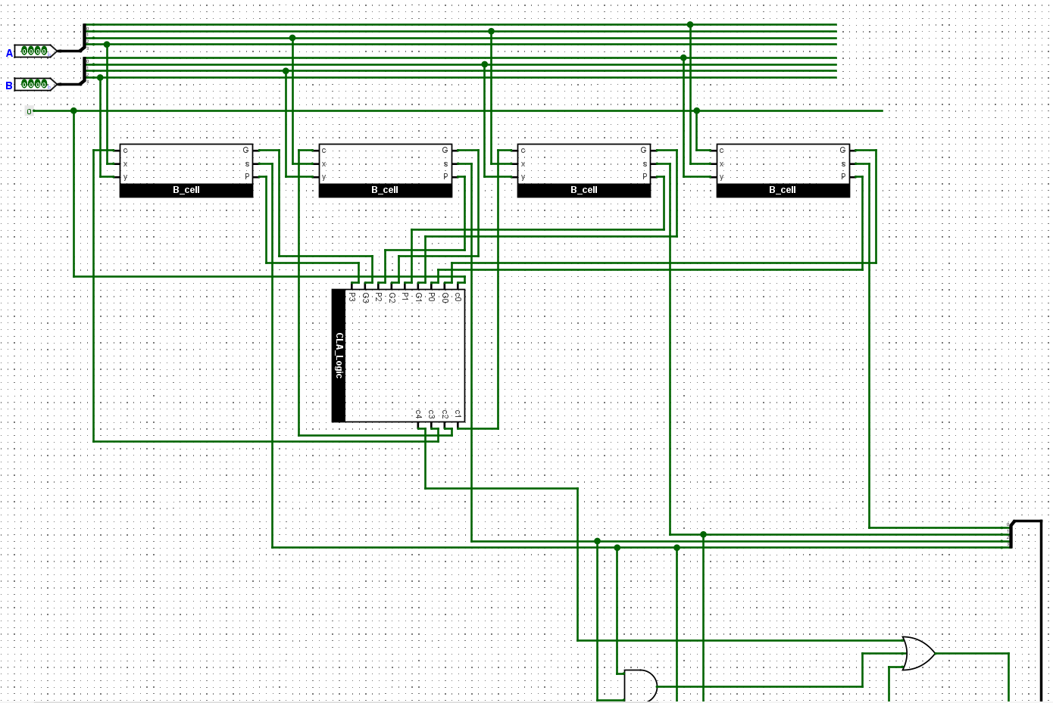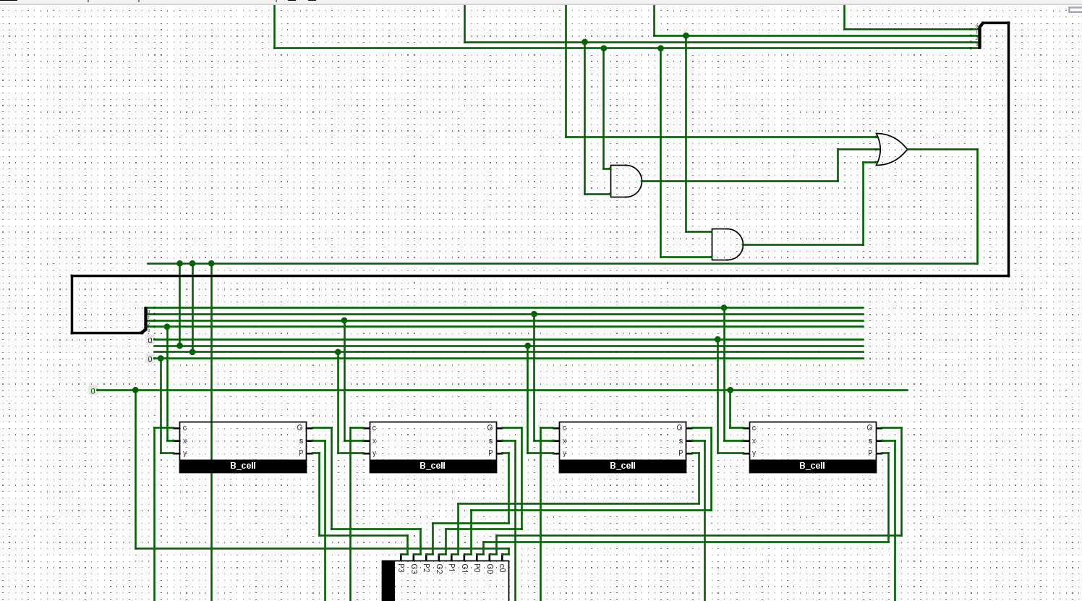

The key idea to build the BCD adder is make the most use of the CLA – Adder to handle the operation fast and efficient.
The way to convert Binary form to BCD form is check the Binary form of the result when adding two number. If the value is greater than 9, the adding procedure, again, will manipulate to increase the first output up to 6 units. Then showing the BCD result in the format: BCD_Output Q3 Q2 Q2 Q0.
To check whether the value is greater than 9 or not, we build the truth table
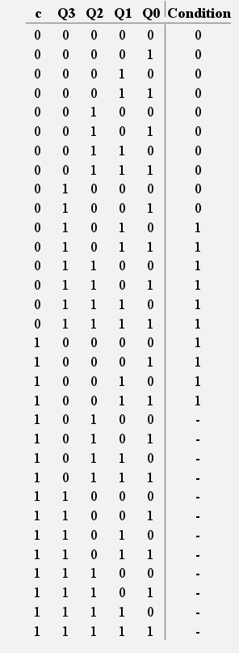

K-map (Condtion):
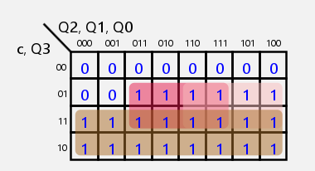
Condition = c+Q3⋅Q1+Q3⋅Q2

So I will set up for the second addition:
A = first result
B (0 Condition Condition 0) 4 bits’s data

BCD_Sum = A + B
BCD_Output = Condition

