Full name: Doan Cong Thanh
Class: 22TT2
Id: 22125096

Ex01:
State diagram:
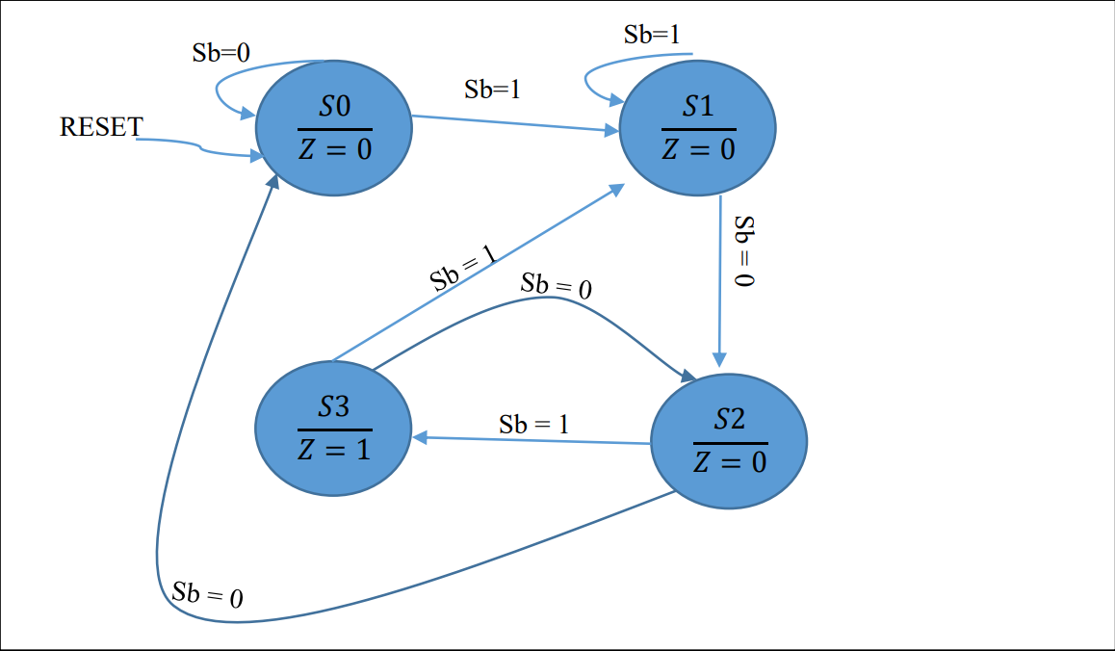

State table:
Current State | Next State |  | Output Z
 | Sb = 0 | Sb = 1
S0 | S0 | S1 | 0
S1 | S2 | S1 | 0
S2 | S0 | S3 | 0
S3 | S2 | S1 | 1

State |  | Q1Q0
S0 |  | 00
S1 |  | 01
S2 |  | 10
S3 |  | 11
Current State  Q1Q0 | Next State  Q1Q0 |  | D1D0 |  |  | Z
 | Sb = 0 | Sb = 1 | Sb = 0 | Sb = 1
00 | 00 | 01 | 00 | 01 |  | 0
01 | 10 | 01 | 10 | 01 |  | 0
10 | 00 | 11 | 00 | 11 |  | 0
11 | 10 | 01 | 10 | 01 |  | 1

K-map (D0):
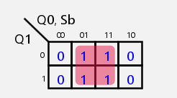
D0 = Sb
K-map (D1):
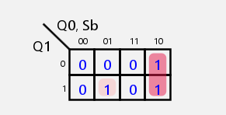
D1 = Q0⋅~Sb+Q1⋅~Q0⋅Sb
Z = Q1⋅Q0

Ex02:
State diagram:
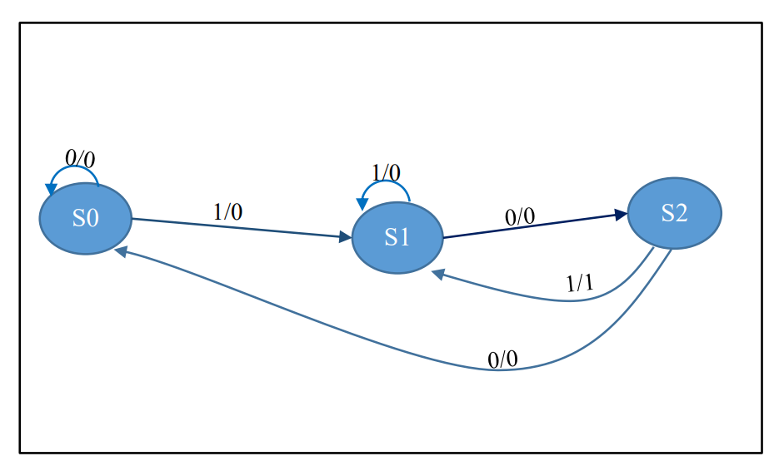
State table:
State | Q1Q0
S0 | 00
S1 | 01
S2 | 10

Sb | Current State | Next State | Z
0 | S0 | S0 | 0
1 | S0 | S1 | 0
0 | S1 | S2 | 0
1 | S1 | S1 | 0
0 | S2 | S0 | 1
1 | S2 | S1 | 0

Sb | Current State  Q1Q0 | Next State  Q1Q0 | D1D0 | Z
0 | 00 | 00 | 00 | 0
1 | 00 | 01 | 01 | 0
0 | 01 | 10 | 10 | 0
1 | 01 | 01 | 01 | 0
0 | 10 | 00 | 00 | 0
1 | 10 | 01 | 01 | 1

K-map (D0):
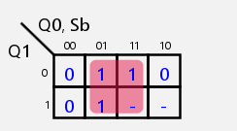
D0 = Sb
K-map (D1):
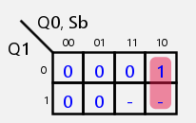
D1 = Q0⋅~Sb
K-map (Z):
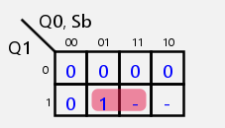
Z = Q1⋅Sb

Ex03:
State diagram:
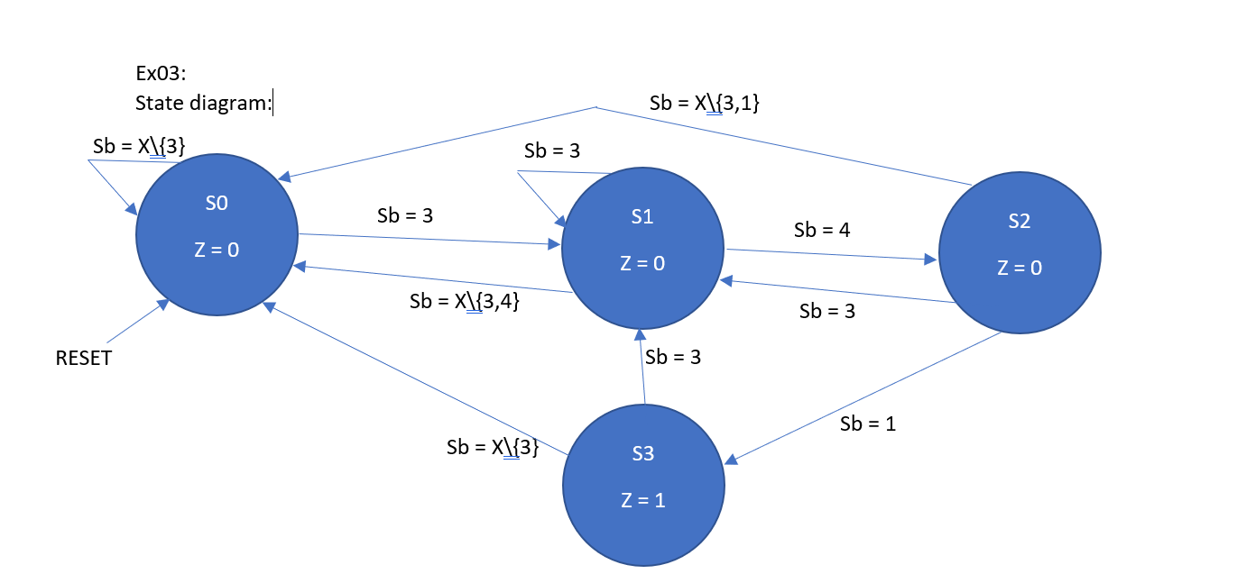
Encoder table:
Sb (Binary) | Sb (Binary)  Sb3Sb2Sb1Sb0 | I1I0
0 | 0000 | 11
1 | 0001 | 10
2 | 0010 | 11
3 | 0011 | 00
4 | 0100 | 01
5 | 0101 | 11
6 | 0110 | 11
7 | 0111 | 11
8 | 1000 | 11
9 | 1001 | 11

K-map (I1):
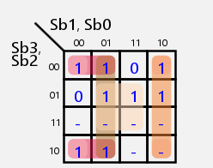
I1 = ~Sb2⋅~Sb1+~Sb2⋅~Sb0+~Sb3⋅~Sb1⋅Sb0+Sb1⋅~Sb0+~Sb3⋅Sb2⋅Sb0+Sb3⋅~Sb2+Sb2⋅Sb1
K-map(I0):
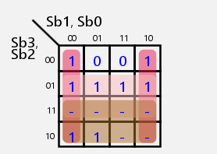
I0 = ~Sb0+Sb2+Sb3
I1I0 | Current State  Q1Q0 | Next State  Q1Q0 | Z
00 | 00 | 01 | 0
01 | 00 | 00 | 0
10 | 00 | 00 | 0
11 | 00 | 00 | 0
00 | 01 | 01 | 0
01 | 01 | 10 | 0
10 | 01 | 00 | 0
11 | 01 | 00 | 0
00 | 10 | 01 | 0
01 | 10 | 00 | 0
10 | 10 | 11 | 0
11 | 10 | 00 | 0
00 | 11 | 01 | 1
01 | 11 | 00 | 1
10 | 11 | 00 | 1
11 | 11 | 00 | 1

K-map (D1):
D1 = ~I1⋅I0⋅~Q1⋅Q0+I1⋅~I0⋅Q1⋅~Q0

K-map (D0):
D0 = ~I1⋅~I0+~I0⋅Q1⋅~Q0

K-map (Z):
Z = Q1⋅Q0

