-- HW04
-- Doan Cong Thanh
-- 22125096

Question 1
(i) To consider whether or not the schedule is conflict-serializable, I will apply the Precedence graph for each schedule and find if it is acyclic.
(a) w3(B); w3(A); w1(B); r2(B); r2(A); w1(A);
Since w3(B) is ahead of w1(B) and r2(B) in S $→T_{3}<_{s}T_{1}$ and $T_{3}<_{s}T_{2}$
Since w1(B) is ahead of r2(B) in S $→T_{1}<_{s}T_{2}$
Since r2(A) is ahead of w1(A) in S $→$ $T_{2}<_{s}T_{1}$
We have the graph:
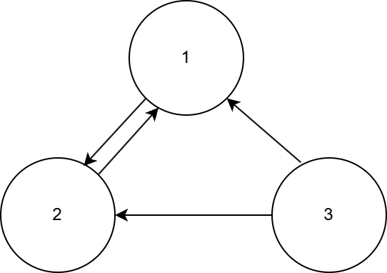
There is a loop in this graph $→$ Cyclic $→$ Not conflict-serializable
(b) r1(A); r2(B); w1(C); r3(B); r3(C); w2(B); w3(A);
Since r1(A) is ahead of w3(A) in S $→T_{1}<_{s}T_{3}$
Since r3(B) is ahead of w2(B) in S $→T_{3}<_{s}T_{2}$
We have the graph:
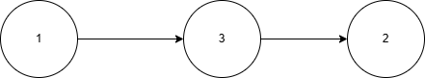
There is no loop in this graph $→$ Acylic $→$ Conflict-serializable
(ii)
(a) S = w3(B); w3(A); w1(B); r2(B); r2(A); w1(A);
Since S is not conflict-serializable $→$ There is no conflict-equivalent serial schedule
(b) S = r1(A); r2(B); w1(C); r3(B); r3(C); w2(B); w3(A);
The conflict - equivalent serial order is: $1→3→2$
Serial schedule: r1(A); w1(C); r3(B); r3(C); w3(A); r2(B); w2(B);

Question 2
(a) S1 = w1(A); w2(B); w3(C); c1; r3(A); c2; r3(B); c3;
Determine pairs of $(T_{j},T_{i})$ which means $T_{j}$ reads from $T_{i}$
Since w1(A) $<_{s}$ r3(A) and there is no a1 $<_{s}$ r3(A) $→$ $T_{3}$ reads from $T_{1}$
Since w2(B) $<_{s}$ r3(B) and there is no a2 $<_{s}$ r3(B) $→$ $T_{3}$ reads from $T_{2}$
Since $T_{3}$ reads from $T_{1}$ and c1 $<_{s}$ c3, $T_{3}$ reads from $T_{2}$ and c2 $<_{s}$ c3
$⇒$ S1 is recoverable
Since w1(A) is ahead of r3(A) in S1 $→$ T1 $<_{s}$ T3
Since w2(B) is ahead of r3(B) in S1 $→$ T2 $<_{s}$ T3
We have the graph
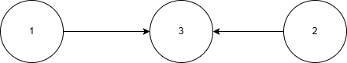
Since there is no loop in this graph $→$ Acyclic $→$ Conflict-serializable
(b) S2 = r1(A); w2(A); w2(B); c2; r1(B); c1;
Determine pairs of $(T_{j},T_{i})$ which means $T_{j}$ reads from $T_{i}$
Since w2(B) $<_{s}$ r1(B) and there is no a2 $<_{s}$ r1(B) $→$ $T_{1}$ reads from $T_{2}$
Since $T_{1}$ reads from $T_{2}$ and c2 $<_{s}$ c1
$⇒$ S2 is recoverable
Since r1(A) is ahead of w2(A) in S2 $→$ T1 $<_{s}$ T2
Since w2(B) is ahead of r1(B) in S2 $→$ T2 $<_{s}$ T1
We have the graph:
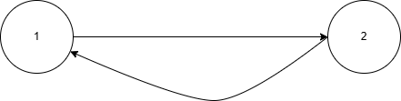
Since there is a loop (1->2,2->1) $→$ Cyclic $→$ Not conflict-serializable
(c) S3 = w1(A); w1(B); r2(A); w2(B); a2; w1(C); c1; r3(B); w3(C); c3;
Determine pairs of $(T_{j},T_{i})$ which means $T_{j}$ reads from $T_{i}$
Since w1(A) $<_{s}$ r2(A) and there is no a1 $<_{s}$ r2(A) $→$ $T_{2}$ reads from $T_{1}$
Since w1(B) $<_{s}$ r3(B) and there is w1(B) $<_{s}$ w2(B) $<_{s}$ r3(B) and a2 $<_{s}$ r3(B) $→$ $T_{3}$ reads from $T_{1}$
Since $T_{3}$ reads from $T_{1}$ and $c_{1}<_{s}c_{3}$
$⇒$ S3 is unrecoverable
Since w1(A) is ahead of r2(A) in S $→$ T1 $<_{s}$ T2
Since w1(B) is ahead of r3(B) in S $→$ T1 $<_{s}$ T3
Since w2(B) is ahead of r3(B) in S $→$ T2 $<_{s}$ T3
We have the graph:
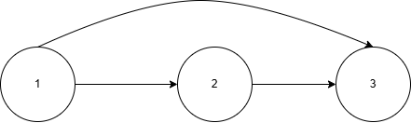
Since there is no loop in this graph $→$ Acyclic $→$ Conflict-serializable

Question 3
(a) T1 = L1(C); w1(C); L1(A); r1(A); w1(A); L1(B); r1(B); w1(B); Commit; U1(A); U1(C); U1(B);
Since there is no unlock operation before L1(B), which is the last lock operation in the transaction and there is no existence of lock operation after U1(A), which is the first unlock action in the transaction. $→$ T1 follows two-phase locking
T2 = L2(B); r2(B); w2(B); L2(A); r2(A); w2(A); Commit; U2(A); U2(B);
Since there is no unlock operation before L2(A), which is the last lock operation in the transaction and there is no existence of lock operation after U2(A), which is the first unlock action in the transaction. $→$ T2 follows two-phase locking
(b)
T1  L1(C)  w1(C)  L1(A)  r1(A)  w1(A)  L1(B)  r1(B)  w1(B)  Commit  U1(A)  U1(C)  U1(B); |  | T2  L2(B)  r2(B)  w2(B)  L2(A)  r2(A)  w2(A)  Commit  U2(A)  U2(B);
This schedule satisfies:
- Consistency of transactions
- Legality of schedules
- Two-phase locked transactions
$→$ S will be converted to a conflict-equivalent serial schedule
$→$ S is conflict-serializable
(c)
T1  L1(C)  w1(C)  L1(A)  r1(A)  w1(A)  L1(B)  r1(B)  w1(B)  Commit  U1(A)  U1(C)  U1(B); |  | T2  L2(B)  r2(B)  w2(B)  L2(A)  r2(A)  w2(A)  Commit  U2(A)  U2(B);
Determine pairs of $\left(T_{j},T_{i}\right)$ which means $T_{j}$ reads from $T_{i}$
Since w2(B) $<_{s}$ r1(B) and there is no a2 $<_{s}$ r1(B) $→$ T1 reads from T2
Since T1 reads from T2 and $c_{2}<_{s}c_{1}$ in S
$→$ This schedule S is recoverable
(d)
T1  L1(C)  w1(C)  L1(A)  r1(A)  w1(A)  L1(B)  r1(B)  w1(B)  Commit  U1(A)  U1(C)  U1(B); |  | T2  L2(B)  r2(B)  w2(B)  L2(A)  r2(A)  w2(A)  Commit  U2(A)  U2(B);
Determine pairs of $\left(T_{j},T_{i}\right)$ which means $T_{j}$ reads from $T_{i}$
Since w2(B) $<_{s}$ r1(B) and there is no a2 $<_{s}$ r1(B) $→$ T1 reads from T2
Since T1 reads from T2, and T2 is completed before transaction T1 reads value.
$→$ This schedule S avoids cascading rollback
(e) Yes, these annotated transactions can result in a deadlock
T1  L1(C)  w1(C)  L1(A)  r1(A)  w1(A)  L1(B)  r1(B)  w1(B)  Commit  U1(A)  U1(C)  U1(B); |  | T2  L2(B)  r2(B)  w2(B)  L2(A)  r2(A)  w2(A)  Commit  U2(A)  U2(B);
From this schedule. Firstly, the transaction T1 will request a lock on element C, then T2 locks on B and performs some operations. Move on, T1 locks on A. And when T2 request another lock on A (which is occupied by T1), all of the actions after this one will be denied and wait until T1 unlock A. However, when we execute actions in T1, it asks for a lock on B (which is used by T2) $→$ Deadlock problem occurs.

Question 4
(a) The system uses UNDO logging only
<T1, start>  <T1, X, 10>  <T2, start>  <T2, Z, 12>  <T2, Y, 20>  <T2, commit> |  | <T2, commit>: T2 is completed, do not undo this transaction.  T1 is incomplete, undo this transaction.  Actions performed by the recovery manager:  - Undo T1:  + Write(X,10)  + Abort(T1)

(b) The system uses REDO logging only
<T1, start>  <T1, X, 10>  <T2, start>  <T2, Z, 12>  <T2, Y, 20>  <T2, commit> |  | <T2, commit>: T2 is completed, redo this transaction.  T1 is incomplete, do not redo this transaction.  Actions performed by the recovery manager:  - Redo T2:  + Write(Z,12)  + Write(Y,20)  + Abort(T1)

(c) The system uses UNDO/REDO logging with checkpoint
<T1, start>  <T1, X, 10, 11>  <T1, commit>  <checkpoint>  <T2, start>  <T2, Y, 20, 21>  <T3, start>  <T3, Z, 30, 31>  <T4, start>  <T3, commit>  <T4, W, 40, 41>  <T2, Z, 80, 30> |  | <checkpoint>: The recovery manager just performs action from bottom upward until find the checkpoint.  T2 and T4 are incomplete, undo these transactions, do not redo these ones.  <T3, commit>: T3 is complete, redo this transaction, do not undo this one.  Actions performed by the recovery manager:  - Redo:  + Write(Z,31)  - Undo:  + Write(Z,80)  + Write(W,40)  + Write(Y,20)  + Abort(T2)  + Abort(T4)

