Homework 05
Student ID: 22125096
Student Name: Doan Cong Thanh
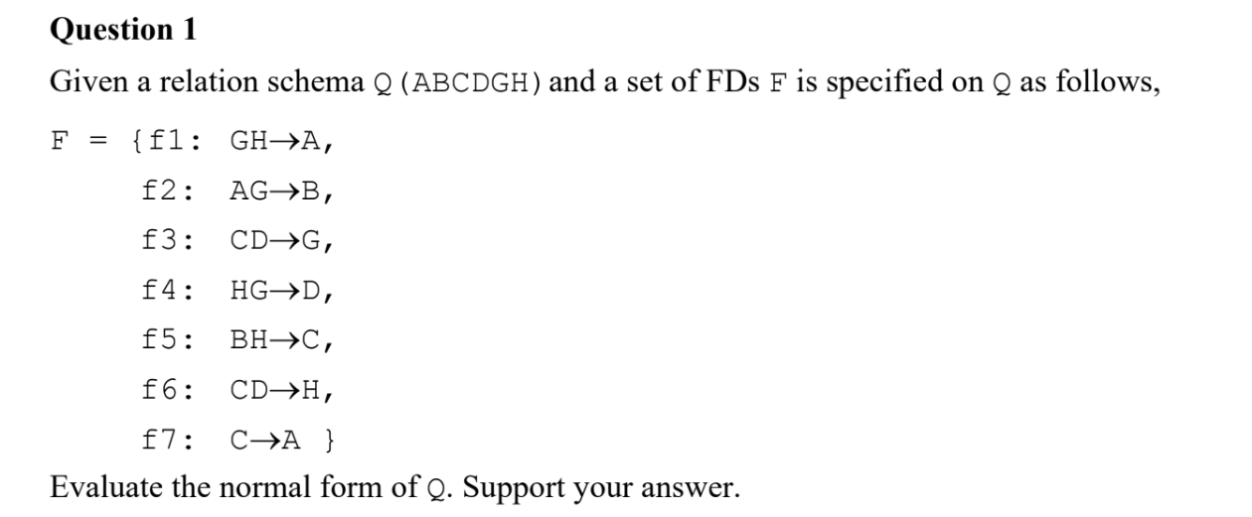
Consider F is good or not?
- Split the right-hand sides attributes F is already satisfied
- Remove extraneous attributes in the left-hand sides
  - GH A: {G}⁺ = {G} does not contain H, and {H}⁺ = {H} does not contain G, so we keep GH A
  - AG → B: {G}⁺ = {G} does not contain A, and {A^{}+} = {A} does not contain G, so we keep AG → B
  - CD → G: {C}⁺ = {C, A} does not contain D, and {D}⁺ = {D} does not contain C, so we keep CD → G
  - HG → D: {G}⁺ = {G} does not contain H, and {H}⁺ = {H} does not contain G, so we keep HG → D
  - BH → C: {B}⁺ = {B} does not contain H, and {H}⁺ = {H} does not contain B, so we keep BH → C
  - CD → H: {C}⁺ = {C, A} does not contain D, and {D}⁺ = {D} does not contain C, so we keep CD → H
- Remove excessive functional dependencies
  - {GH}⁺ _{F−{GH→A}} = {G, H, D} does not contain A, so we keep GH → A
  - {AG}⁺ _{F−{AG→B}} = {A, G} does not contain B, so we keep AG → B
  - {CD}⁺ _{F−{CD→G}} = {C, D, H, A} does not contain G, so we keep CD → G
  - {HG}⁺ _{F−{HG→D}} = {G, H, A} does not contain D, so we keep HG → D
  - {CD}⁺ _{F−{CD→H}} = {C, D, G, A} does not contain H, so we keep CD → H
  - {C}⁺ _{F−{C→A}} = {C} does not contain A, so we keep C → A
F is minimal.

Graph of FDS:
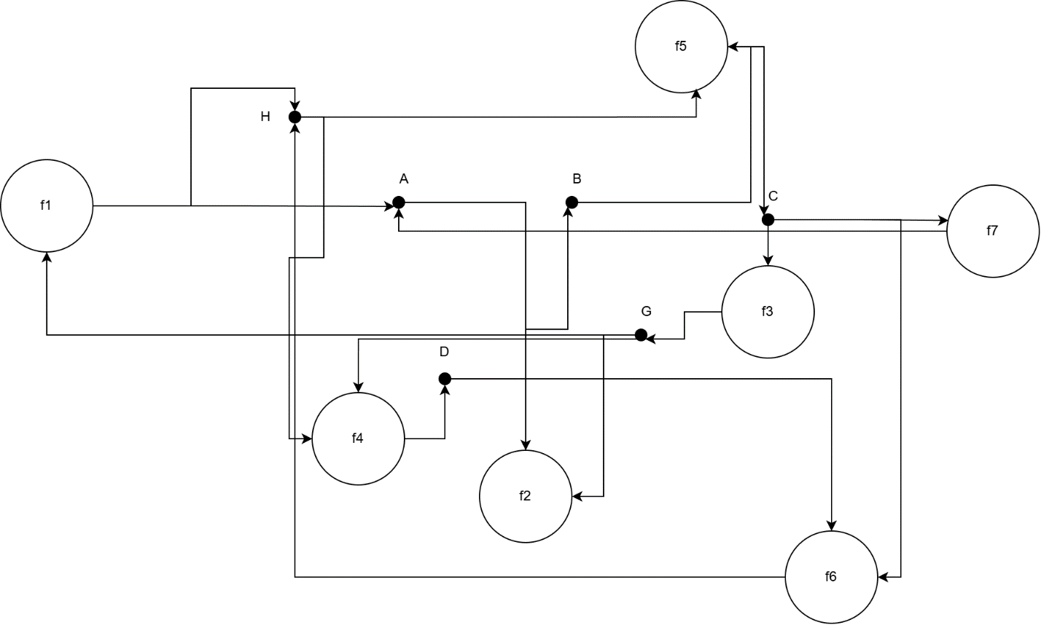
Since there is no any source in the graph of FDs, meaning that there is no key with only 1 attribute.
From the set of FDs F, we have closure of some set of attributes:
- {G, H}⁺ = {G, H, A, D, B, C} → We don’t need to consider the combination that include G, H
- {A, G}⁺ = {A, G, B}
- {A, G, C}⁺ = {A, G, B, C}
- {A, G, D}⁺ = {A, G, B, D}
- {A, G, C, D}⁺ = {A, G, B, C, D, H}
- {C, D}⁺ = {C, D, G, H, A, B} → We don’t need to consider the combination that include C, D
- {B, H}⁺ = {B, H, C, A}
- {B, H, D} ⁺ = {B, H, D, C, A, G} → We don’t need to consider the combination that include B, H,D
With {A, G, C, D} and {C, D}, we choose {C, D} as key because it is minimal. So, the key of relation schema Q is GH, CD, BHD
Evaluate the Normal Form:
- Q does not satisfy the BCNF: there is a functional dependency whose lefthand side does not contain the key (f5:BH → C)
- Q does not satisfy the 3NF: there is a functional dependency whose right-hand side is not a member of the key. (f7: C→ A)
- Q does not satisfy the 2NF: there is a functional dependency whose non-prime attributes are not fully dependent on the key. (f7: C→ A)
So, we conclude that Q satisfies the 1NF.
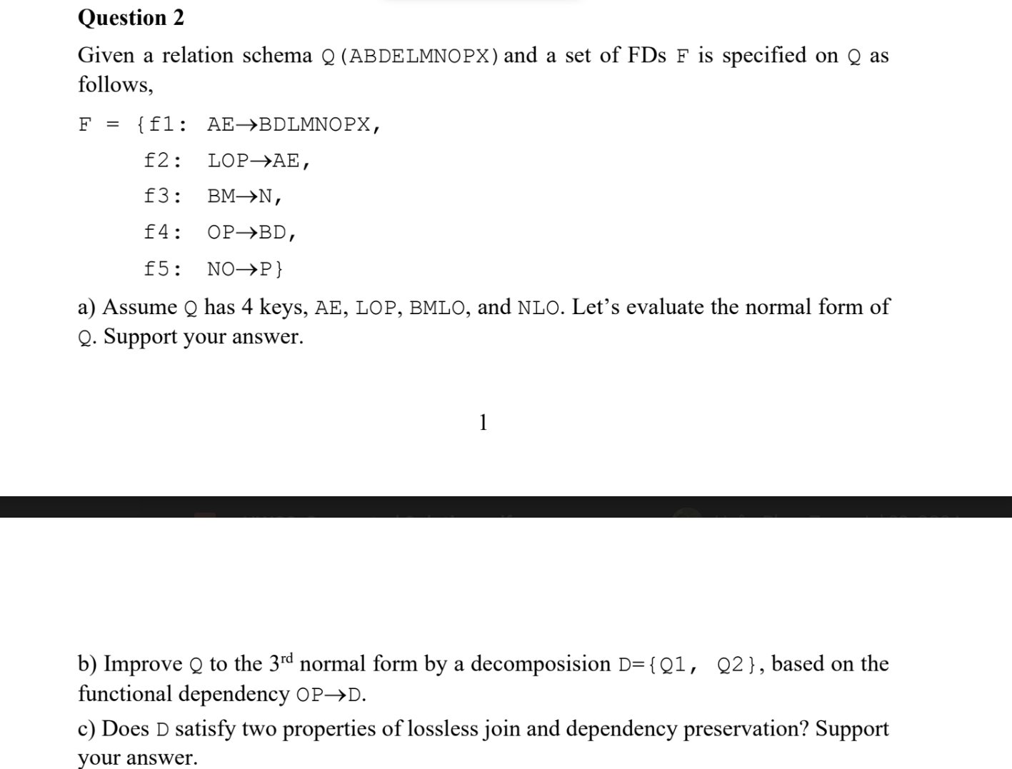
Consider F is good or not:
- Split the right-hand sides attributes
F’ = { AE → B, AE → D, AE → L, AE → M, AE → N, AE → O, AE → P, AE →X, LOP → A, LOP → E, BM → N, OP → B, OP → D, NO → P}
- Remove extraneous attributes in the left-hand sides
  - AE → B: {A}⁺ = {A} does not contain E, {E}⁺ = {E} does not contain A, so we keep AE → B
  - Similarly, we keep AE → D, AE → L, AE → M, AE → N, AE → O, AE → P, AE →X
  - LOP → A: {OP}⁺ = {OPBD} does not contain L, {LO}⁺ = {LO} does not contain P, {LP}⁺ = {LP} does not contain O, so we keep LOP → A
  - LOP → E: {OP}⁺ = {OPBD} does not contain L, {LO}⁺ = {LO} does not contain P, {LP}⁺ = {LP} does not contain O, so we keep LOP → E
  - BM → N: {B}⁺ = {B} does not contain M, {M}⁺ = {M} does not contain B, so we keep BM → N
  - OP → B: {O}⁺ = {O} does not contain P, {P}⁺ = {P} does not contain O, so we keep OP → B
  - OP → D: {O}⁺ = {O} does not contain P, {P}⁺ = {P} does not contain O, so we keep OP → D
  - NO → P: {O}⁺ = {O} does not contain N, {N}⁺ = {N} does not contain O, so we keep NO → P
- Remove excessive functional dependencies
  - {AE}⁺ _{F’−{AE→B}} = {AEBDLMNOPX} contains B, so we remove AE → B
  - {AE}⁺ _{F’−{AE→D}} = {AEBDLMNOPX} contains D, so we remove AE → D
  - {AE}⁺ _{F’−{AE→L}} = {AEBDMNOPX} does not contain L, so we keep AE → L
  - {AE}⁺ _{F’−{AE→M}} = {AEBDLNOPX} does not contain M, so we keep AE → M
  - {AE}⁺ _{F’−{AE→N}} = {AEBDLMNOPX} contains N, so we remove AE → N
  - {AE}⁺ _{F’−{AE→O}} = {AELMPX} does not contain O, so we keep AE → O
  - {AE}⁺ _{F’−{AE→P}} = {AELMOX} does not contain P, so we keep AE → P
  - {AE}⁺ _{F’−{AE→X}} = {AELMOP} does not contain X, so we keep AE → X
  - {LOP}⁺ _{F’−{LOP→A}} = {LOPEBD} does not contain A, so we keep LOP → A
  - {LOP}⁺ _{F’−{LOP→E}} = {LOPABD} does not contain E, so we keep LOP → E
  - {BM}⁺ _{F’−{BM→N}} = {BM} does not contain N, so we keep BM → N
  - {OP}⁺ _{F’−{OP→B}} = {OPD} does not contain B, so we keep OP → B
  - {OP}⁺ _{F’−{OP→D}} = {OPB} does not contain D, so we keep OP → D
  - {NO}⁺ _{F’−{NO→P}} = {NO} does not contain P, so we keep NO → P
Then we have:
F’’ = {AE → L, AE → M, AE → O, AE → P, AE →X, LOP → A, LOP → E, BM → N, OP → B, OP → D, NO → P}
After rewriting we have:
F’’ = {AE → LMOPX, LOP → AE, BM → N, OP → BD, NO → P}
We see that F ≠ F’’, so F is not minimal
a) Assume Q has 4 keys, AE, LOP, BMLO, and NLO. Let’s evaluate the normal form of Q. Support your answer.
- Q does not satisfy the BCNF: there is a functional dependency whose left-hand side does not contain the key (NO → P)
- Q does not satisfy the 3NF: there is a functional dependency whose right-hand side is not a member of the key (OP → BD)
- Q does not satisfy the 2NF: there is a functional dependency whose non-prime attributes are not fully dependent on the key (OP → BD)
So, we conclude that Q satisfies the 1NF
b) Improve Q to the 3rd normal form by a decomposition D = {Q1, Q2}, based on the functional dependency OP → D
- The functional dependency OP → D is causing Q to violate 3NF because OP is not a key, and D is a non-prime attribute. We will split Q into Q1 and Q2
- Q1 (OPD)
  - Key: OP
  - F1 = {OP → D}
- Q2 (AEBLMNOPX)
  - Key: AE, LOP, BMLO, and NLO
  - F2 = {AE → LMOPX, LOP → AE, BM → N, OP → B, NO → P}
Check whether Q1 and Q2 satisfy 2NF or not:
- Q1 satisfies 2NF because with all functional dependencies, their non-prime attributes are fully functionally dependent on the key
- Q2 satisfies 2NF because with all functional dependencies, their non-prime attributes are fully functionally dependent on the key
Check whether Q1 and Q2 satisfy 3NF or not:
- Q1 (OPD)
  - OP is key → O, P is prime attribute and D is non-prime attribute
  - OP → D: OP is key, and D is non-prime attribute → satisfy 3NF
- Q2 (ABELMNOPX)
  - AE, BMLO, LOP, NLO are key → A, B, E, M, N, L, O, P is prime attribute and X is non-prime attribute
  - AE → LMNOPX: AE is key, and X is non-prime attribute → satisfy 3NF
  - LOP → AE: AE, LOP are both key → satisfy 3NF
  - BM → N: B, M, N are prime attributes → satisfy 3NF
  - OP → B: B, P, O are prime attributes → satisfy 3NF
  - NO → P: N, O, P are prime attributes → satisfy 3NF
So, decomposition D = {Q1, Q2} satisfies the 3NF
c) Does D satisfy two properties of lossless join and dependency preservation? Support your answer
Q(ABDELMNOPX) has key AE, LOP, BMLO, and NLO
F₀ = {AE → LMOPX, LOP → AE, BM → N, OP → BD, NO → P}
Q1 (OPD) has key OP
F1 = {OP → D}
Q2 (AEBLMNOPX) has key AE, LOP, BMLO, and NLO
F2 = {AE → LMOPX, LOP → AE, BM → N, OP → B, NO → P}
- Lossless join
 | A | B | D | E | L | M | N | O | P | X
Q1 | b11 | b12 | b13 | b14 | b15 | b16 | b17 | b18 | b19 | b110
Q2 | b21 | b22 | b23 | b24 | b25 | b26 | b27 | b28 | b29 | b210

 | A | B | D | E | L | M | N | O | P | X
Q1 | b11 | b12 | a3 | b14 | b15 | b16 | b17 | a8 | a9 | b110
Q2 | a1 | a2 | b23 | a4 | a5 | a6 | a7 | a8 | a9 | a10

Use OP D

 | A | B | D | E | L | M | N | O | P | X
Q1 | b11 | b12 | a3 | b14 | b15 | b16 | b17 | a8 | a9 | b110
Q2 | a1 | a2 | a3 | a4 | a5 | a6 | a7 | a8 | a9 | a10

Since all of the letters "a" are present in the second row of the table, we may conclude that the decomposition D fulfills the lossless join property.
- Dependency preservation:
The decomposition D satisfies property of dependency preservation as
F₀ = {f1: AE → LMOPX, f2: LOP → AE, f3: BM → N, f4: OP → BD, f5: NO → P}
Q1 (OPD) has key OP
F1 = {OP → D}
Q2 (AEBLMNOPX) has key AE, LOP, BMLO, and NLO
F2 = {AE → LMOPX, LOP → AE, BM → N, OP → B, NO → P}
We have F’ = F1 ∪ F2 = {OP → D, AE → LMOPX, LOP → AE, BM → N, OP → B, NO → P} = {AE → LMOPX, LOP → AE, BM → N, OP → BD, NO → P}
We have F’ ≡ F0, so the decomposition D satisfies dependency preservation.

