The problem of concurrency control occurs when the customer performs transaction T3 first, then another user runs T4, which could lead to a phantom read issue. Since T3 reads a database element whose delete action committed by T4 first. Here is the screen shot to depict the scenario.
Scenario 1: There is only one T3 performs.
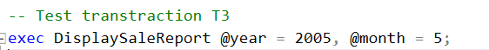
Result:
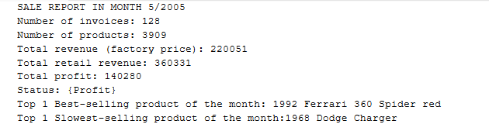
Scenario 2: T3 performs, then T4 comes next, which cause a concurrency issue.
Result:
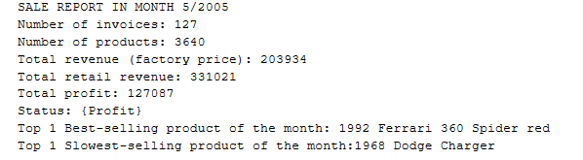
The result looks quite different from the previous one. Since there are some invoices has been deleted.
To handle this problem. I would attach the isolation level 3 (repeated read) to procedure DisplaySaleReport and implement UPLOCK.
Result:
After first execution of T3,T4
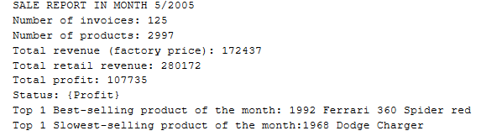
After second execution of T3
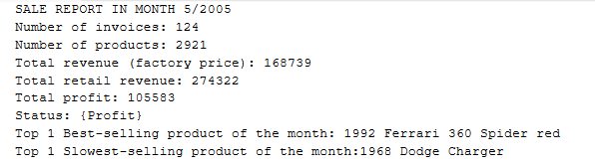

The problem of concurrency control occurs when the customer performs transaction T4 first, then another user runs T3, which could lead to a phantom read issue. Since T3 reads a database element whose delete action committed by T4 first. Similar to the first problem. I will implement isolation level 3 for T4 and implement UPLOCK to ensure that no action will be performed on the data which is locked earlier.
When run T4 before T3. T3 will wait for T4 and display the result:
