Consider this data:
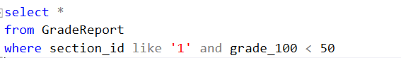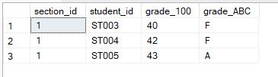
When we delay the procedure RetrieveFailedStudents 5 seconds and execute simultaneously two procedures, we will encounter the error. Since the UpdateGrades works first, then the data will be modified.

Propose method to fix:
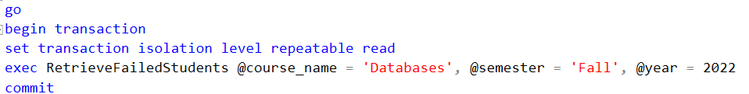
This transaction will isolate the procedure RetrieveFailedStudents until this procedure finish.
The result:
