Name: Doan Cong Thanh
Class: 22CTT2
Id: 22125096
Exercise 4:
a)
$β_{2}$: Negative (-), I would expect this coefficient to be negative sign since when you purchase the great amount of cocaine, you might have discount.
$β_{3}:$ Positive (+), the higher the quality of the products are, the more money you have to pay.
$β_{4}:$ Positive (+), just in case the price of cocaine has generally increased over the years due to factors like inflation, increased enforcement, or higher production costs.
b)
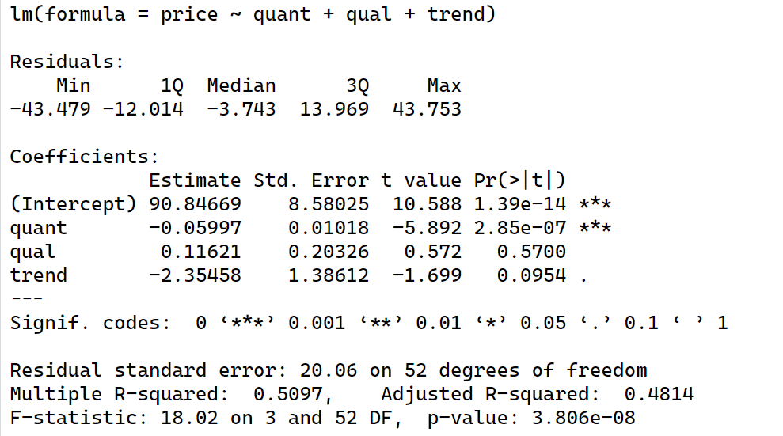
After apply the linear regression model on the data, we have the formula:
$$PRICE = 90.84669-0.05997.QUANT+0.11621.QUAL-2.35458.TREND+ε$$
Coefficient interpretation:
$β_{1}$: The free coefficient (90.84669) represents the expected value of the cocaine’s price when all independent variables (QUANT, QUAL and TREND) equal 0, which mean we ignore the effect of these factors.
Assume other factors remain constant:
- $β_{2}$: If the quantity increases by 1 unit, the price is expected to decrease by 0.05997 units.
- $β_{3}$: If the quality increases by 1 unit, the price is expected to increase by 0.11621 units.
- $β_{4}$: If the trend increases by 1 unit (one year later), the price is expected to decrease by 2.35458 units.
All the factor’s signs I guess nearly correct, except for the TREND one.
c)
$R^{2}=0.5097$, so approximately 50.97% of variation in cocaine price is explained jointly by variation in quantity, quality, and time
d)
$$\left\{\begin{aligned}H_{0}:β_{2}=0 \\ H_{1}:β_{2}<0\end{aligned}\right.$$
$$T=\frac{\hat{β_{2}}-β_{2}}{se(\hat{β_{2}})}\sim St(n-(k+1)$$
When we accept $H_{0}⟹T_{0}=\frac{-0.0597-0}{0.01018}≈-5.89$
Since $n>30$, we can use z for the pivot. Assume $α=0.05⟹z_{α}=1.645$
Since $T_{0}<-1.645⟹$ Reject $H_{0}$
Thus, we have sufficient proof to support the claim: “The greater the number of sales, the higher the risk of getting caught”.
e)
$$\left\{\begin{aligned}H_{0}:β_{3}=0 \\ H_{1}:β_{3}>0\end{aligned}\right.$$
$$T=\frac{\hat{β_{3}}-β_{3}}{se(\hat{β_{3}})}\sim St(n-(k+1)$$
When we accept $H_{0}⟹T_{0}=\frac{0.11621-0}{0.20326}≈0.57$
Since $n>30$, we can use z for the pivot. Assume $α=0.05⟹z_{α}=1.645$
Since $T_{0}<1.645⟹$ Fail to reject $H_{0}$
Thus, we don’t have sufficient proof to reject the claim: “The quality of cocaine has no influence on price”.
f)
The average annual change in the cocaine price is denoted by β4 = –2.35458, which means that, on average, the price of cocaine decreases by approximately $2.35 each year.
The price might be changed in this direct for these reasons:
- Economic conditions: Due to the downturns of the general economic, people had less money to spend, including on drug like cocaine.
- Better transportation techniques: Advances in transportation make it cheaper and easier to move cocaine, which help the sellers get more profits.
- More cocaine supplies: Nowadays, the drug industry has developed so fast and thus, the cocaine is planted and grow everywhere. The more available cocaine is, the cheaper it is.
Exercise 5:
a)
(i)
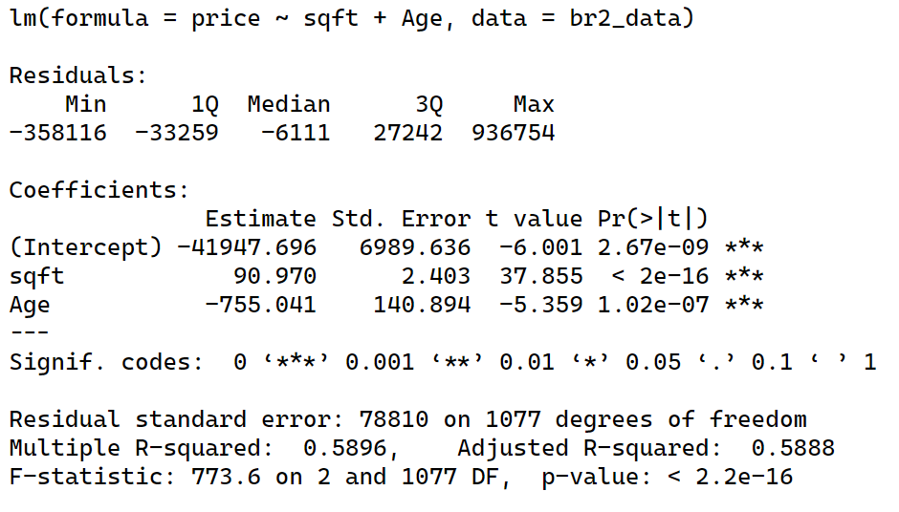
After apply the linear regression model on the data, we have the formula:
$$PRICE = -41947.696+90.970.SQFT-755.041.AGE+ε$$
Coefficient interpretation:
$β_{1}$: The free coefficient ($-41947.696$) represents the expected value of the house’s price when all independent variables (SQFT, AGE) equal 0, which mean we ignore the effect of these factors.
Assume other factors remain constant:
- $β_{2}$: If the size of the house increases by 1 unit, the price is expected to increase by 90.970 units.
- $β_{3}$: If the age increases by 1 unit, the price is expected to decrease by 755.041 units.
(ii)
We have $\frac{∂PRICE}{∂SQFT}=β_{2}$
Since $n=1080>30$ is large, we can use $z_{α/2}=1.96$
The $95\%$ interval estimate for the price increase for an extra square foot of living space is:
$$\hat{β_{2}}±z_{α/2}×se\left(β_{2}\right)=90.97±1.96×2.403=[86.26012,95.67988]$$
(iii)
$$\left\{\begin{aligned}H_{0}:β_{3}≥-1000 \\ H_{1}:β_{3}<-1000\end{aligned}\right.$$
$$T=\frac{\hat{β_{3}}-β_{3}}{se(\hat{β_{3}})}\sim St(n-(k+1)$$
When we accept $H_{0}⟹T_{0}=\frac{-755.041-\left(-1000\right)}{140.894}≈1.74$
Since $n>30$, we can use z for the pivot. Assume $α=0.05⟹z_{α}=1.645$
Since $T_{0}>-1.645⟹$ Fail to reject $H_{0}$
Thus, a house a year older decreases price by 1000 or less at $α=0.05$ level of significance.
b)
$$PRICE=β_{1}+β_{2}SQFT+β_{3}AGE+β_{4}SQFT^{2}+β_{5}AGE^{2}+ε$$
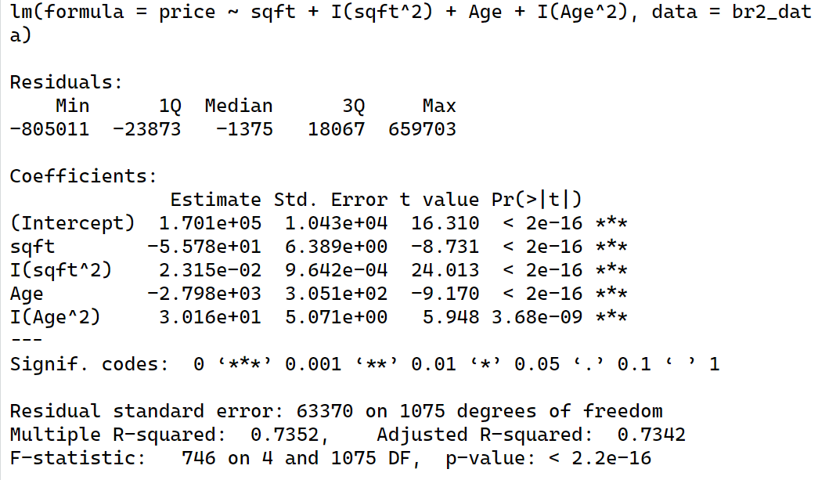
We obtain the equation:
$$PRICE=170100+55.78×SQFT+2798×AGE+0.02315×SQFT^{2}+30.16×AGE^{2}+ε$$
(i)
We have $\frac{∂PRICE}{∂SQFT}=β_{2}+2β_{4}×SQFT=-55.78+2×0.02315×SQFT$
The smallest house (SQFT = 662):
$$\frac{∂PRICE}{∂SQFT}=-55.78+2×0.02315×662=-25.1294$$
The largest house (SQFT = 7879):
$$\frac{∂PRICE}{∂SQFT}=-55.78+2×0.02315×7879=309.0177$$
The house with SQFT = 2300:
$$\frac{∂PRICE}{∂SQFT}=-55.78+2×0.02315×2300=50.71$$
Comment:
- Smallest house (SQFT = 662):
- This result suggests that for the smallest house in the sample, increasing the square footage would decrease the price. This negative marginal effect is unrealistic, as increasing the size of a house typically increases its price.
- Largest house (SQFT = 7879):
- For the largest house in the sample, the marginal effect is positive and quite large. This implies that increasing the square footage of an already large house further increases its price significantly. This is more realistic since larger houses generally do command higher prices, but the magnitude of the marginal effect seems very high.
- House with SQFT = 2300:
- For a house with 2300 square feet, the marginal effect is positive and moderate. This suggests that increasing the size of a house of this size would also increase its price, which is realistic.
(ii)
We have $\frac{∂PRICE}{∂AGE}=β_{3}+2β_{5}×AGE=-2798+2×30.16×AGE$
The newest house (AGE = 1):
$$\frac{∂PRICE}{∂AGE}=-2798+2×30.16×1=-2737.68$$
The oldest house (AGE = 80):
$$\frac{∂PRICE}{∂AGE}=-2798+2×30.16×80=2027.6$$
The house with AGE = 20:
$$\frac{∂PRICE}{∂AGE}=-2798+2×30.16×20=-1591.6$$

Comment:
- Newest house (AGE = 1):
- This result suggests that for the newest house in the sample, increasing the age by one year would decrease the price by approximately 2737.68 units. This negative marginal effect is realistic as newer houses typically lose value as they age.
- Oldest house (AGE = 80):
- For the oldest house in the sample, the marginal effect is positive. This implies that increasing the age of an already old house would increase its price, which is unrealistic. Generally, older houses do not increase in value simply because they are older unless there is a specific factor such as historical significance.
- House with AGE = 20:
- For a house that is 20 years old, the marginal effect is negative and moderate. This suggests that as the house ages, its price decreases, which is realistic and aligns with typical depreciation patterns for houses
For a house with 2300 square feet, the marginal effect is positive and moderate. This suggests that increasing the size of a house of this size would also increase its price, which is realistic.
(iii)
The house with SQFT = 2300:
$$\frac{∂PRICE}{∂SQFT}=-55.78+2×0.02315×2300=50.71$$
Since n is large, assume $α=0.05, we get z_{α/2}=1.96$
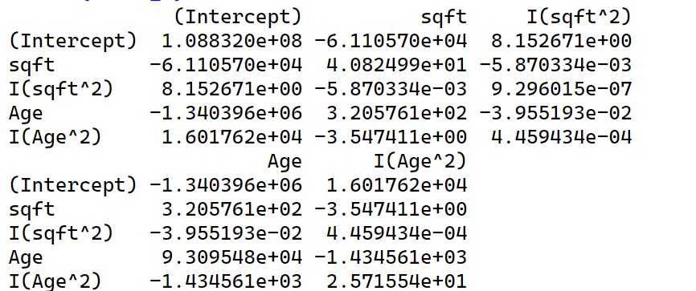

From this matrix, we can obtain:
$$Var\left(β_{2}\right)=40.82499$$
$$Var\left(β_{4}\right)=9.296015×{10}^{-7}$$
$$Cov\left(β_{2},β_{4}\right)=-0.005870334$$
Calculate $se\left(\frac{∂PRICE}{∂SQFT}\right)=\sqrt{Var\left(β_{2}\right)+{\left(2×2300\right)}^{2}×Var\left(β_{4}\right)+2×(2×2300)×Cov\left(β_{2},β_{4}\right)}≈2.55$
Hence, the $95\%$ interval estimate for the marginal effect $\frac{∂PRICE}{∂SQFT}$ for a house with 2300 square feet is:
$$\frac{∂PRICE}{∂SQFT}±z_{α/2}×se\left(\frac{∂PRICE}{∂SQFT}\right)≈50.71±1.96×2.55=[45.712,55.708]$$
(iv)
The house with AGE = 20:
$$\frac{∂PRICE}{∂AGE}=-1591.6$$
From the matrix in part (iii), we obtain:
$$Var\left(β_{3}\right)=93095.48$$
$$Var\left(β_{5}\right)= 25.71554$$
$$Cov\left(β_{3},β_{5}\right)=-1434.561$$
Calculate $se\left(\frac{∂PRICE}{∂AGE}\right)=\sqrt{Var\left(β_{3}\right)+{\left(2×20\right)}^{2}×Var\left(β_{5}\right)+2×(2×20)×Cov\left(β_{3},β_{5}\right)}≈139.55$

$$\left\{\begin{aligned}H_{0}:\frac{∂PRICE}{∂AGE}≥-1000 \\ H_{1}:\frac{∂PRICE}{∂AGE}<-1000\end{aligned}\right.$$
$$T=\frac{Estimated-Hypothesis}{se}\sim St(n-(k+1)$$
When we accept $H_{0}⟹T_{0}=\frac{-1591.6-\left(-1000\right)}{139.55}≈-4.24$
Since $n>30$, we can use z for the pivot. Assume $α=0.05⟹z_{α}=1.645$
Since $T_{0}<-1.645⟹$ Reject $H_{0}$
Hence, there is enough evidence to conclude that the marginal effect of age is less than –1000 for a house that is 20 years old at α = 0.05 level of significance.
c)
$$PRICE=β_{1}+β_{2}SQFT+β_{3}AGE+β_{4}SQFT^{2}+β_{5}AGE^{2}+β_{6}SQFT×AGE+ε$$
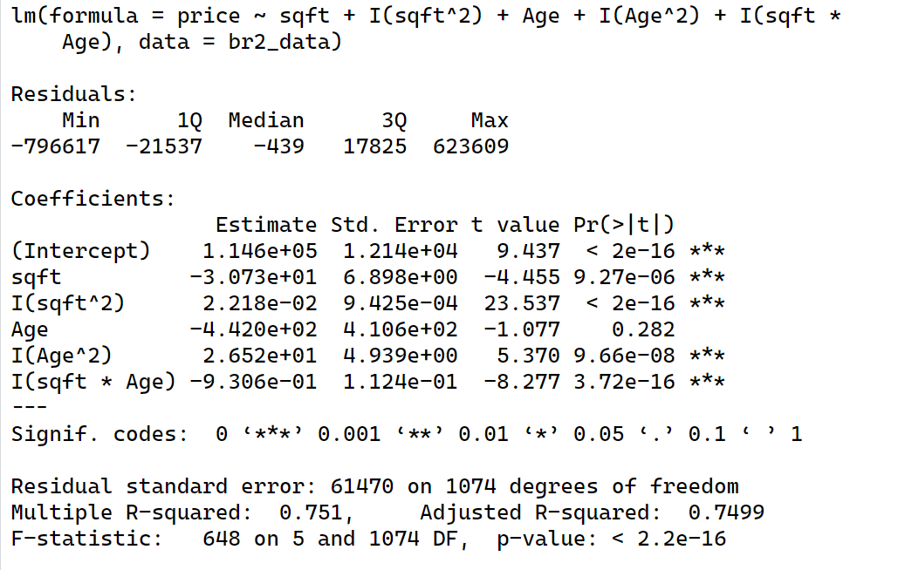
We obtain the equation: $PRICE=114600-30.73×SQFT-442×AGE+0.02218×SQFT^{2}+26.52×AGE^{2}-0.9306×SQFT×AGE+ε$
(i)
We have $\frac{∂PRICE}{∂SQFT}=β_{2}+2β_{4}×SQFT+β_{6}×AGE=-30.73+2×0.02218×SQFT-0.9306×AGE$
The smallest house (SQFT = 662, AGE = 25):
$$\frac{∂PRICE}{∂SQFT}=-30.73+2×0.02218×662-0.9306×25=-24.62868$$
The largest house (SQFT = 7879, AGE = 1):
$$\frac{∂PRICE}{∂SQFT}=-30.73+2×0.02218×7879-0.9306×1=317.85184$$
The house with SQFT = 2300, AGE = 20:
$$\frac{∂PRICE}{∂SQFT}=-30.73+2×0.02218×2300-0.9306×20=52.686$$
Comment:
- Smallest house (SQFT = 662, AGE = 25):
- This result suggests that for the smallest house in the sample, increasing the square footage would decrease the price. This negative marginal effect is unrealistic, as increasing the size of a house typically increases its price.
- Largest house (SQFT = 7879, AGE = 1):
- For the largest house in the sample, the marginal effect is positive and quite large. This implies that increasing the square footage of an already large house further increases its price significantly. This is more realistic since larger houses generally do command higher prices, but the magnitude of the marginal effect seems very high.
- House with SQFT = 2300, AGE = 20:
- For a house with 2300 square feet, the marginal effect is positive and moderate. This suggests that increasing the size of a house of this size would also increase its price, which is realistic.
(ii)
We have $\frac{∂PRICE}{∂AGE}=β_{3}+2β_{5}×AGE+β_{6}×SQFT=-442+2×26.52×AGE-0.9306×SQFT$
The newest house (AGE = 1, SQFT = 1062):
$$\frac{∂PRICE}{∂AGE}=-442+2×26.52×1-0.9306×1062=-1377.2572$$
The oldest house (AGE = 80, SQFT = 3580):
$$\frac{∂PRICE}{∂AGE}=-442+2×26.52×80-0.9306×3580=469.652$$
The house with AGE = 20, SQFT = 2300:
$$\frac{∂PRICE}{∂AGE}=-442+2×26.52×20-0.9306×2300=-1521.58$$

Comment:
- Newest house (AGE = 1, SQFT = 1062):
- This result suggests that for the newest house in the sample, increasing the age by one year would decrease the price by approximately 2737.68 units. This negative marginal effect is realistic as newer houses typically lose value as they age.
- Oldest house (AGE = 80, SQFT = 3580):
- For the oldest house in the sample, the marginal effect is positive. This implies that increasing the age of an already old house would increase its price, which is unrealistic. Generally, older houses do not increase in value simply because they are older unless there is a specific factor such as historical significance.
- House with AGE = 20, SQFT = 2300:
- For a house that is 20 years old, the marginal effect is negative and moderate. This suggests that as the house ages, its price decreases, which is realistic and aligns with typical depreciation patterns for houses
For a house with 2300 square feet, the marginal effect is positive and moderate. This suggests that increasing the size of a house of this size would also increase its price, which is realistic.
(iii)
The house with SQFT = 2300, AGE = 20:
$$\frac{∂PRICE}{∂SQFT}=-30.73+2×0.02218×2300-0.9306×20=52.686$$
Since n is large, assume $α=0.05, we get z_{α/2}=1.96$
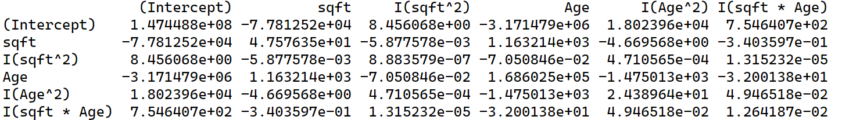

From this matrix, we can obtain:
$$Var\left(β_{2}\right)=47.57635$$
$$Var\left(β_{4}\right)=8.883579×{10}^{-7}$$
$$Var\left(β_{6}\right)=0.01264187$$
$$Cov\left(β_{2},β_{4}\right)=-0.005877578$$
$$Cov\left(β_{2},β_{6}\right)=-0.3403597$$
$$Cov\left(β_{4},β_{6}\right)=1.315232×{10}^{-5}$$
Calculate
$$se\left(\frac{∂PRICE}{∂SQFT}\right)=\sqrt{Var\left(β_{2}\right)+{\left(2×2300\right)}^{2}×Var\left(β_{4}\right)+{20}^{2}×Var\left(β_{6}\right)+2×\left(2×2300\right)×Cov\left(β_{2},β_{4}\right)+2×20×Cov\left(β_{2},β_{6}\right)}$$
$$\sqrt{+2×(2×2300)×20×Cov(β_{4},β_{6})}≈2.48$$
Hence, the $95\%$ interval estimate for the marginal effect $\frac{∂PRICE}{∂SQFT}$ for a house with 2300 square feet is:
$$\frac{∂PRICE}{∂SQFT}±z_{α/2}×se\left(\frac{∂PRICE}{∂SQFT}\right)≈52.868±1.96×2.48=[47.8252,57.5468]$$
(iv)
The house with AGE = 20, SQFT = 2300:
$$\frac{∂PRICE}{∂AGE}=-442+2×26.52×20-0.9306×2300=-1521.58$$
From the matrix in part (iii), we obtain:
$$Var\left(β_{3}\right)=168602.5$$
$$Var\left(β_{5}\right)=24.38964$$
$$Var\left(β_{6}\right)=0.01264187$$
$$Cov\left(β_{3},β_{5}\right)=-1475.013$$
$$Cov\left(β_{3},β_{6}\right)=-32.00138$$
$$Cov\left(β_{5},β_{6}\right)=0.04946518$$
Calculate
$$se\left(\frac{∂PRICE}{∂AGE}\right)=\sqrt{Var\left(β_{3}\right)+{\left(2×20\right)}^{2}×Var\left(β_{5}\right)+{2300}^{2}×Var\left(β_{6}\right)+2×\left(2×20\right)×Cov\left(β_{3},β_{5}\right)+2×2300×Cov\left(β_{3},β_{6}\right)}$$
$$\sqrt{+2×(2×20)×2300×Cov(β_{5},β_{6})}≈135.63$$

$$\left\{\begin{aligned}H_{0}:\frac{∂PRICE}{∂AGE}≥-1000 \\ H_{1}:\frac{∂PRICE}{∂AGE}<-1000\end{aligned}\right.$$
$$T=\frac{Estimated-Hypothesis}{se}\sim St(n-(k+1)$$
When we accept $H_{0}⟹T_{0}=\frac{-1521.58-\left(-1000\right)}{135.63}≈-3.85$
Since $n>30$, we can use z for the pivot. Assume $α=0.05⟹z_{α}=1.645$
Since $T_{0}<-1.645⟹$ Reject $H_{0}$
Hence, there is enough evidence to conclude that the marginal effect of age is less than –1000 for a house that is 20 years old at α = 0.05 level of significance.
d)
Comment on sensitivity:
- Linear model (a)
  - Assumes a constant marginal effect of SQFT and AGE across all values.
  - Simplifies the relationship but may miss complexities such as diminishing returns.
- Quadratic model (b)
  - Captures the curvature in the relationship by adding squared terms
  - The marginal effects vary with SQFT and AGE, providing a more realistic representation of diminishing returns or increasing marginal costs.
- Interaction model (c)
  - Introduces interactions between SQFT and AGE.
  - Reflects a more complex and realistic scenario where the impact of one variable depends on the level of the other.
Conclusion:
- Simpler models may provide biased estimates if the true relationship is more complex.
- More sophisticated models, while harder to interpret, offer better predictive accuracy and insights into how different factors interplay.
The results are highly sensitive to model specification. While the linear model offers simplicity, it may not capture the true dynamics. Quadratic and interaction models provide a more accurate and realistic depiction of the marginal effects, reflecting the nonlinearity and interactions between variables. Thus, careful consideration of model specification is crucial for deriving meaningful insights from the data.

