PW

System Requirement Specification

Business Partner Recognition & Verification Platform (NFT / Blockchain)
Version: 1.2

INTRODUCTION

Purpose
This System Requirement Specification (SRS) is the common reference for the PW platform. It turns the business processes, calculation logic (Class-based pricing, loyalty discount, reward points, ranking) and control rules (KYC, one-time transfer, soulbound Awards, Admin-only revocation) defined in the BRD and BPMN into detailed, testable use cases. It gives the Development and QA teams an exact basis to build and test the system, gives the business mentor and Product Owner a single place to agree on the solution, and serves as the baseline for acceptance and change management throughout the project.

Project scope
PW is an international web platform that uses NFT / blockchain to recognize and authenticate business-partner relationships. PW acts as the issuing authority: Companies and Individuals can purchase a Title (Philanthropist, Investor, Bridge) for themselves or as a gift, which is issued as a Distinction NFT, or be granted an Award by PW, which is issued as a soulbound Award NFT. Every recognition is publicly listed in the Public Directory and can be verified on-chain by anyone.
- Estimation for the project is about 2 months (8 weeks), including: 01 PM, 01 BA, 01 UI/UX, 02 APP, 02 BE, 01 Tester.
- Elicitation & Design: 4–5 weeks (business analysis and BA deliverables, UI/UX design).
- Development: 3 weeks for development and bug fixing (proposed split).
- Test: 1 week (proposed).
- Total: 8 weeks.

In-Scope Item | Out-of-Scope Item
Item 1: Landing Page (Waitlist) and onboarding: Register Account, Submit KYC, Admin KYC review, Classify Business (Class 0–7). | Item 1: Deploying source code and operating blockchain nodes (Alchemy is used).
Item 2: Account & wallet: Log in, custodial wallet created on demand via Circle, View Wallet, View My NFTs, Link / Unlink non-custodial wallet. | Item 2: End-user training.
Item 3: Title purchase: Browse Titles, View Pricing by Class, Purchase for myself, Gift to another Member, Mint Distinction NFT. Payment by credit/debit card. | Item 3: Building custom wallet / node / KYC infrastructure (Circle and Alchemy are used).
Item 4: Transfer: one-time transfer of a Distinction NFT (to own non-custodial wallet), custody tracking, periodic reconciliation. | Item 4: Accept / decline step for gifted or granted NFTs (NFTs are minted directly and active).
Item 5: Points & pricing: price by Class, 20% Year-2 discount, reward points 10/10/10, point balance, use points. | Item 5: Manual "Create wallet" action for users; manual NFT minting screen.
Item 6: Public Directory, automatic Ranking and on-chain verification (Valid / Revoked / Invalid). | Item 6: Peer-to-peer mutual verification between companies (PW is always the issuer).
Item 7: Admin Portal: Review KYC, Grant Award (soulbound Award NFT), Revoke NFT, Adjust Points, Audit Logs. | Item 7: Trading / resale marketplace for NFTs; transferring an issued NFT to another owner; transferring or selling an Award NFT (soulbound by design).
Item 8: AI Assistant: Q&A, NFT lookup, platform guidance, Title recommendation. | Item 8: Non-card payment methods (bank transfer, crypto, PW-held account balances).

Conventions (Acronyms)
Acronym | Reference
PW | The PW platform (issuing authority of recognition NFTs)
NFT | Non-Fungible Token
KYC | Know Your Customer – identity verification
Title | Purchasable honor: Philanthropist, Investor, Bridge
Distinction NFT | NFT issued for a purchased Title; transferable once
Award NFT | NFT issued for an Award granted by PW; soulbound (non-transferable)
Member | Registered Company or Individual user
Class | Company tier 0–7 by headcount; determines the Title price
CHF | Swiss franc; 1 CHF = 1 Point (rounded up)
Custodial wallet | Wallet managed by PW via Circle on the Member's behalf
Non-custodial wallet | Wallet whose keys the Member controls
UC / BR / NFR | Use Case / Business Rule / Non-functional Requirement (BR-nn and NFR-nnn are BRD codes; BRnn / NFRnn inside a use case are local to that use case)
FR | Functional requirement in the BRD (FR-001 – FR-035 (FR-014 and FR-015 merged into FR-010 and FR-011))
BPMN D0–D7.2 | PW TO-BE process diagrams
TBD | To be decided

Text in [[red]] marks an open item that needs a decision from the business mentor / Product Owner (see OPEN ISSUES). Text in {{gold}} marks an assumption made by the BA to keep a requirement testable; it must be confirmed.

References
Title | Reference | Description
FDD | PW Function Decomposition (see Overall structure) | Function decomposition of the project.
BPMN | [PW] BPMN TO-BE D0–D7.2 | TO-BE business processes (source of the flows in this SRS).
BRD | [PW] Business Requirements Document | FR-001 – FR-035 (FR-014 and FR-015 merged into FR-010 and FR-011), NFR-001 – NFR-010.
Project brief | [MindX K18] ITBA Career Kickstart – PW business case | Original business problem and rules.
User story | PW_US_AC | 36 user stories with acceptance criteria.
UI design | WF_PW_WIP (Figma export) | Screens referenced in the screen descriptions.

OVERALL DESCRIPTION

Background and origin
Today, recognition between business partners relies on word of mouth, paper certificates, letters or press articles. These proofs are not stored durably, cannot be verified publicly by a third party and are easy to copy, edit or forge. This lowers trust in international business relationships and reduces the honor value of genuine partners.
PW digitalizes this process end-to-end: after registration and KYC, a business or individual can buy a Title or be granted an Award, and PW issues the recognition as an immutable NFT on the blockchain (via Circle custodial wallets and Alchemy). All recognitions are listed in a Public Directory, ranked automatically and verifiable on-chain as Valid, Revoked or Invalid. Reward points and a Year-2 loyalty discount encourage long-term relationships with PW.

Overall structure
Function decomposition of PW (groups and use cases specified in this document):
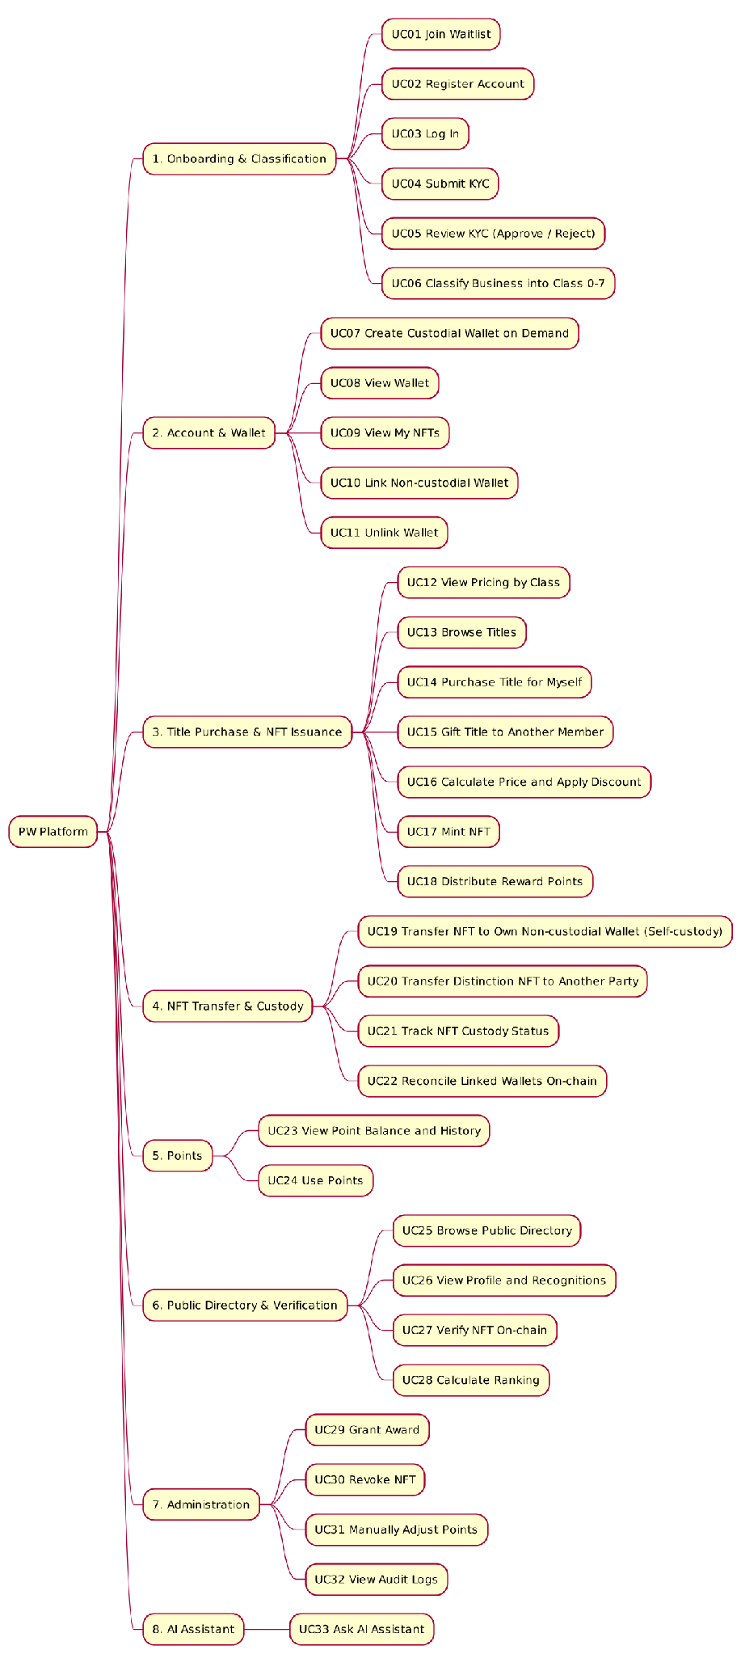

D0 – Join Waitlist
Before launch: Visitor enters an e-mail → duplicate check → save → confirmation. A duplicate e-mail is answered with an "already registered" message.

D1 – Onboarding & Classification
Register → Submit KYC → Admin review → (approved) Classify Business, activate account, show the result / (rejected) show the rejection reason.
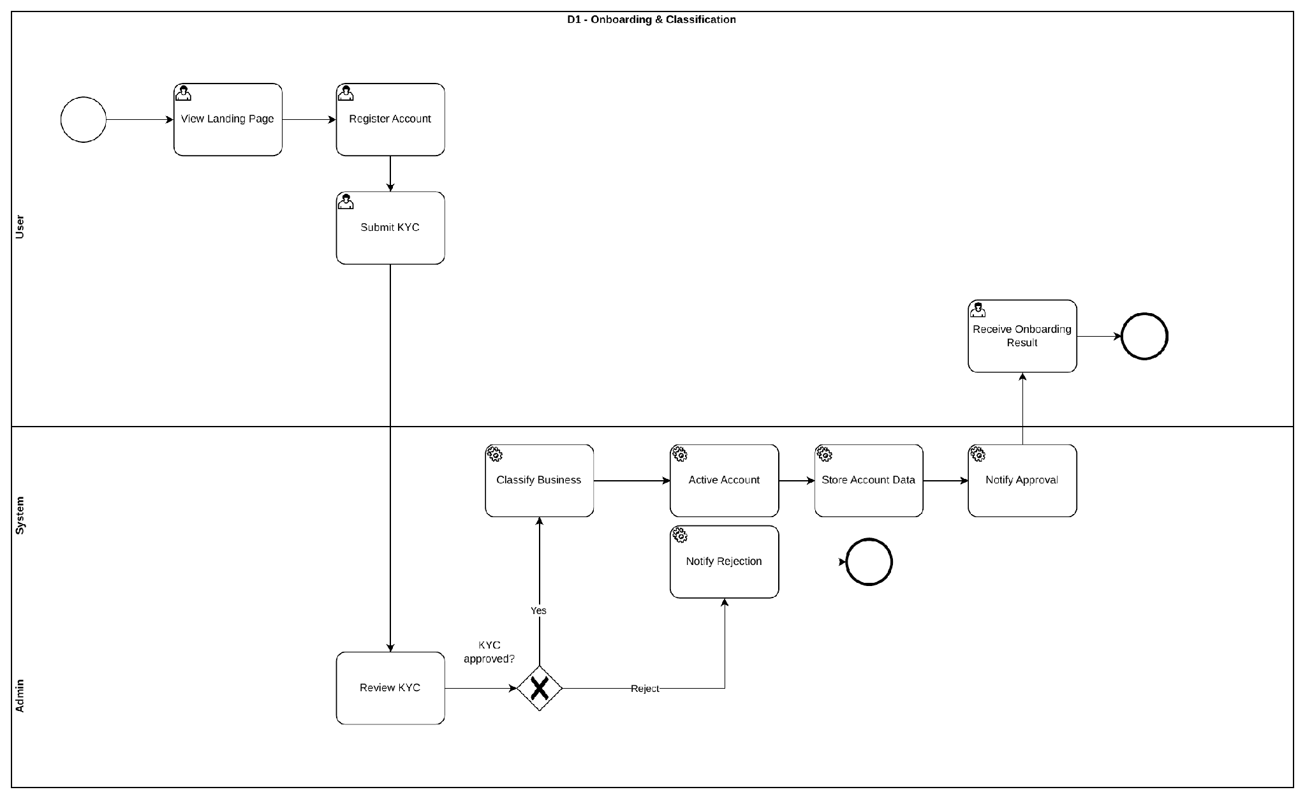

D2 – Purchase / Gift
Select Title → specify recipient (self / other) → recipient KYC check → card payment (saved card or new card) → wallet check / creation (Circle) → mint Distinction NFT → assign to recipient → points 10/10/10 → notify recipient (gift) → Ranking → Audit Log → notify buyer.
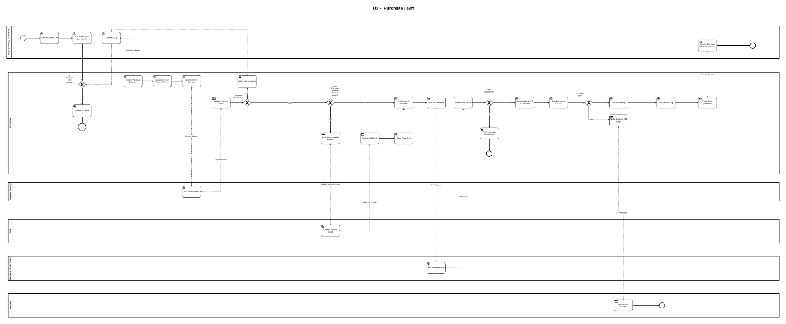

D3 – Grant Award
Admin selects recipient → KYC check → wallet check / creation → mint soulbound Award NFT → assign → Ranking → Audit Log.
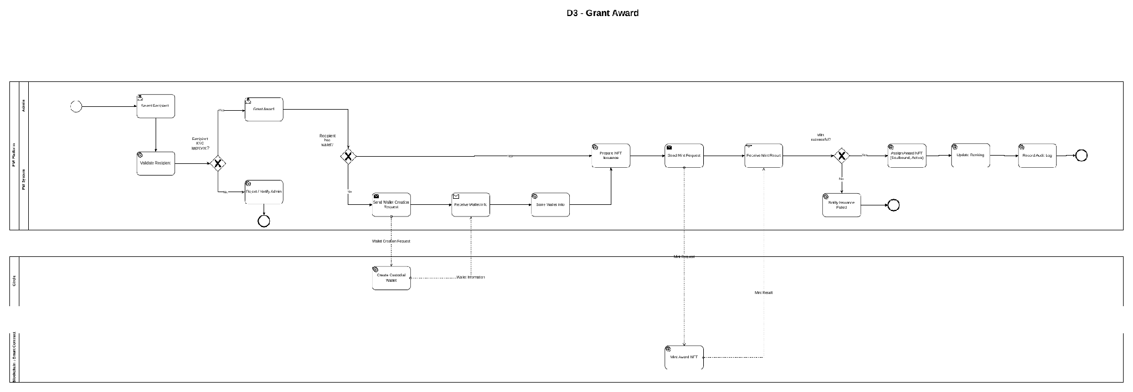

D4.1 / D4.2 – Link Wallet and Transfer
D4.1: Member connects a wallet and signs a message → wallet linked (one wallet ↔ one account). D4.2: Owner initiates transfer → NFT type check (Award blocked) → already transferred once? → destination (own non-custodial wallet) → on-chain transfer → mark consumed + lock → Ranking → Audit Log.
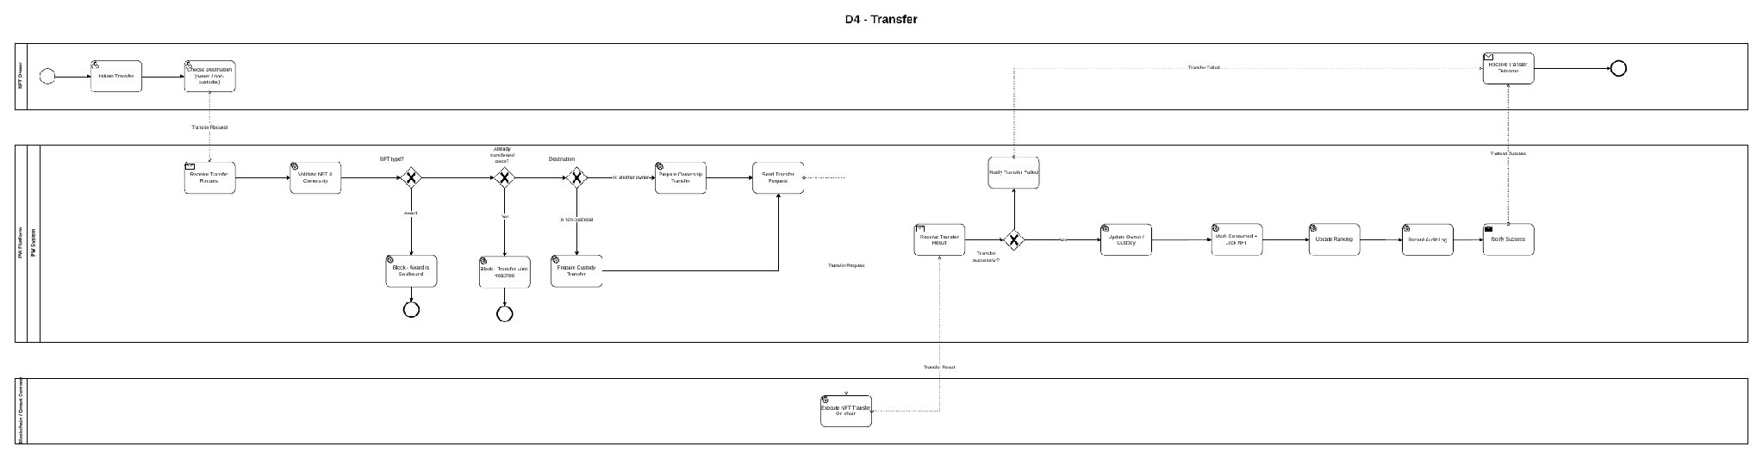

D5 – Revoke
Admin selects NFT with reason → permission check → on-chain revoke → status Revoked → Audit Log.
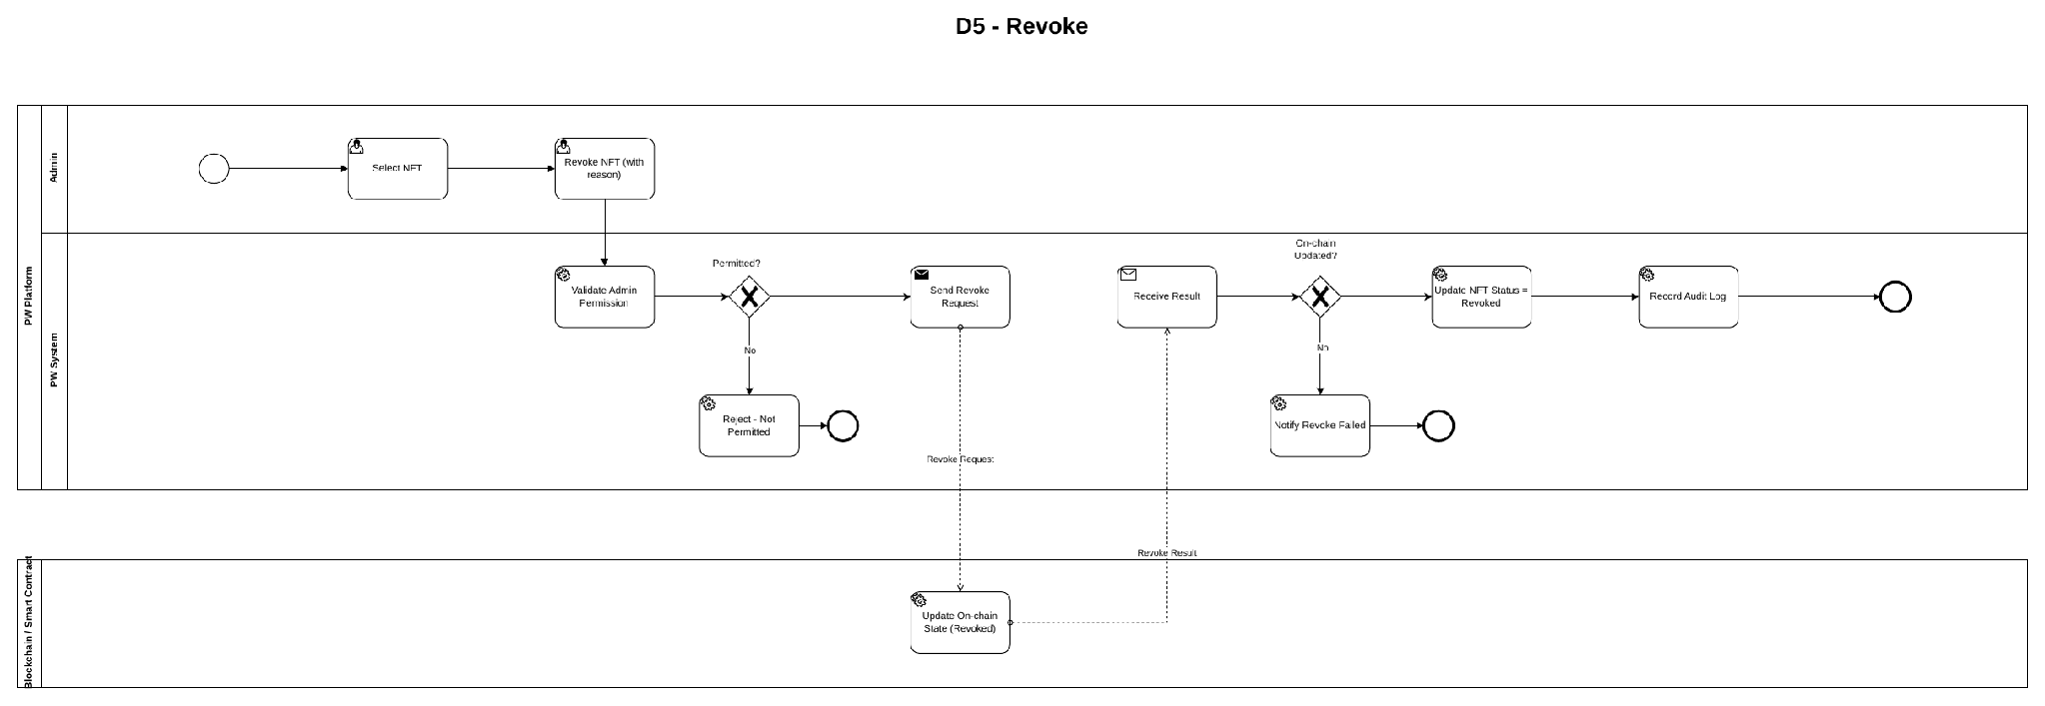

D6 – Public Directory & Verification
Browse Directory → view profile / NFT → request verification → on-chain query → Valid / Revoked / Invalid.

D7.1 / D7.2 – AI Assistant
PW updates the knowledge base (D7.1); the assistant answers only from that knowledge base and gives no investment, legal or tax advice (D7.2, UC33).
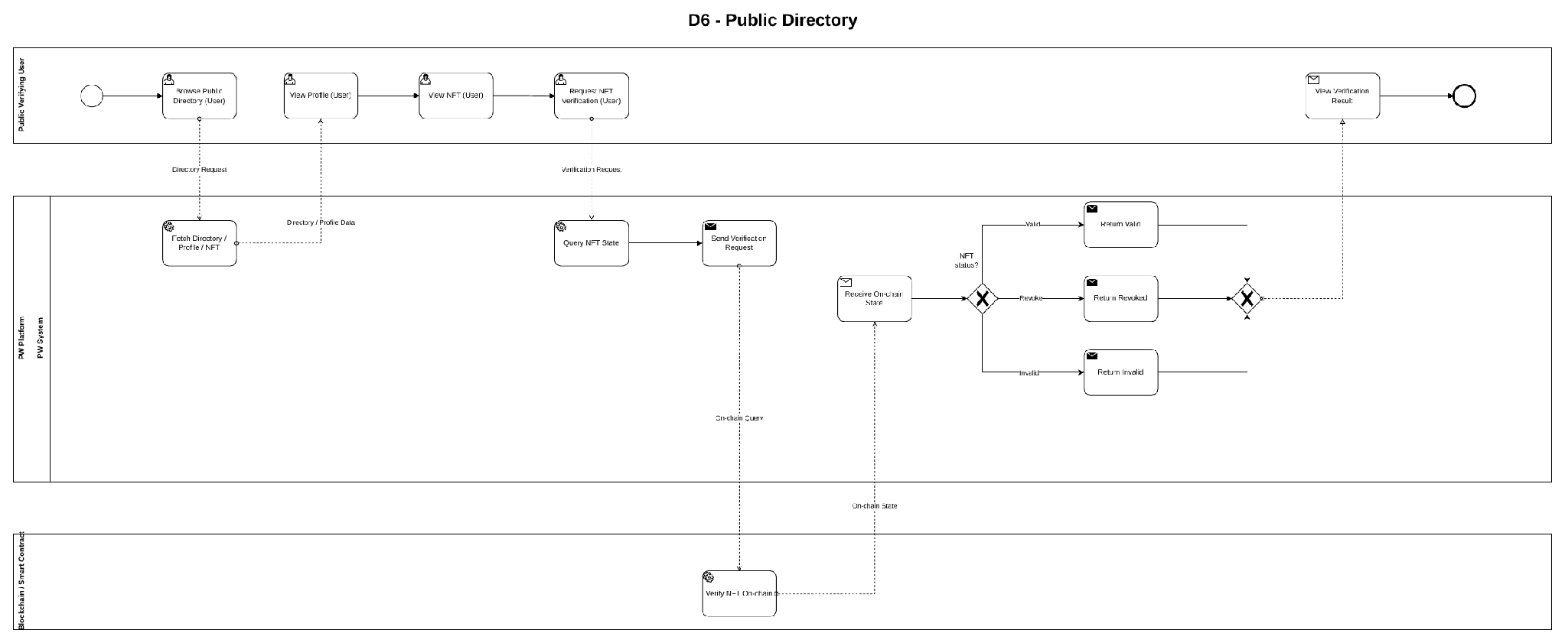

Users and permissions

Users
Role code | Role name | Description
R01 | Visitor / Public Verifying User | Anyone without login: joins the waitlist, views pricing, browses the Directory, verifies NFTs, asks general AI questions.
R02 | Company | Registered business Member: KYC, Class 0–7, buys/gifts Titles, holds and transfers NFTs, earns/uses points.
R03 | Individual / Public Figure | Registered personal Member with the same capabilities as a Company except headcount-based Class.
R04 | PW Admin | PW operator: reviews KYC, corrects Class, grants Awards, revokes NFTs, adjusts points, views Audit Logs.
R05 | PW System | Automated capabilities: classification, wallet creation, pricing, minting, points, ranking, custody tracking, reconciliation.

External systems (not user roles): Circle (custodial wallets), Blockchain / Smart Contract via Alchemy, Payment Gateway, AI Service, Email service.

Permission matrix
Use Case | R01 | R02 | R03 | R04 | R05 | Note
1/ Onboarding & Classification
UC01 Join Waitlist | ✅ | ❌ | ❌ | ❌ | ❌ | Anyone, no login
UC02 Register Account | ✅ | ❌ | ❌ | ❌ | ❌ | Visitor becomes R02/R03
UC03 Log In | ❌ | ✅ | ✅ | ✅ | ❌
UC04 Submit KYC | ❌ | ✅* | ✅* | ❌ | ❌ | Own account only
UC05 Review KYC (Approve / Reject) | ❌ | ❌ | ❌ | ✅ | ❌
UC06 Classify Business into Class 0–7 | ❌ | ❌ | ❌ | ✅* | ✅* | System auto-assigns; Admin corrects during KYC review
2/ Account & Wallet
UC07 Create Custodial Wallet on Demand | ❌ | ❌ | ❌ | ❌ | ✅* | Automatic on first issuance
UC08 View Wallet | ❌ | ✅* | ✅* | ❌ | ❌ | Own wallet only
UC09 View My NFTs | ❌ | ✅* | ✅* | ❌ | ❌ | Own NFTs only
UC10 Link Non-custodial Wallet | ❌ | ✅* | ✅* | ❌ | ❌ | KYC-approved; max 1 linked wallet
UC11 Unlink Wallet | ❌ | ✅* | ✅* | ❌ | ❌ | Own linked wallet
3/ Title Purchase & NFT Issuance
UC12 View Pricing by Class | ✅ | ✅ | ✅ | ✅ | ❌
UC13 Browse Titles | ❌ | ✅* | ✅* | ❌ | ❌ | Purchase actions only when KYC Approved
UC14 Purchase Title for Myself | ❌ | ✅* | ✅* | ❌ | ❌ | KYC Approved
UC15 Gift Title to Another Member | ❌ | ✅* | ✅* | ❌ | ❌ | Buyer and recipient KYC-verified
UC16 Calculate Price and Apply Discount | ❌ | ❌ | ❌ | ❌ | ✅* | Automatic
UC17 Mint NFT | ❌ | ❌ | ❌ | ❌ | ✅* | Triggered only by payment or grant
UC18 Distribute Reward Points | ❌ | ❌ | ❌ | ❌ | ✅* | Paid transactions only
UC34 Refund After Mint Failure | ❌ | ❌ | ❌ | ✅* | ✅* | Automatic; the Admin acts only if the refund request fails
4/ NFT Transfer & Custody
UC19 Transfer NFT to Own Non-custodial Wallet (Self-custody) | ❌ | ✅* | ✅* | ❌ | ❌ | Own Active Distinction, transfer unused
UC21 Track NFT Custody Status | ❌ | ❌ | ❌ | ❌ | ✅* | Automatic
UC22 Reconcile Linked Wallets On-chain | ❌ | ❌ | ❌ | ❌ | ✅* | Scheduler
5/ Points
UC23 View Point Balance and History | ❌ | ✅* | ✅* | ❌ | ❌ | Own points only
UC24 Use Points | ❌ | ✅* | ✅* | ❌ | ❌ | Within balance (BR-04)
6/ Public Directory & Verification
UC25 Browse Public Directory | ✅ | ✅ | ✅ | ✅ | ❌ | Public data only
UC26 View Profile and Recognitions | ✅ | ✅ | ✅ | ✅ | ❌ | Public data only
UC27 Verify NFT On-chain | ✅ | ✅ | ✅ | ✅ | ❌
UC28 Calculate Ranking | ❌ | ❌ | ❌ | ❌ | ✅* | Automatic
7/ Administration
UC29 Grant Award | ❌ | ❌ | ❌ | ✅ | ❌
UC30 Revoke NFT | ❌ | ❌ | ❌ | ✅ | ❌
UC31 Manually Adjust Points | ❌ | ❌ | ❌ | ✅ | ❌
UC32 View Audit Logs | ❌ | ❌ | ❌ | ✅ | ❌ | Read-only
8/ AI Assistant
UC33 Ask AI Assistant | ✅* | ✅ | ✅ | ❌ | ❌ | Visitors: general questions only

Legend:
- ✅: Full permission
- ✅* : Permission with limits (see Note)
- ❌ : No permission

Assumptions and dependencies

Assumptions
The following are assumed to be ready or true for the use cases to work:
- Authentication and authorization: every user performing a use case other than the public ones (UC01, UC12, UC25–UC27, UC33) is authenticated and authorized according to the permission matrix (role-based access control).
- Identity data: Members complete KYC before buying, being gifted, being granted or owning an NFT; KYC data is kept up to date.
- Recipient model: a gift recipient is a KYC-verified PW Member selected by the buyer, and a custodial wallet is created for the recipient if missing (BRD To-Be and BPMN D2). User stories US-TN03 and US-AW01 are aligned with this model in PW_US_AC_final.
- Wallet signing: Members who want self-custody have a non-custodial wallet able to sign messages.
- Configuration: the Class table and the Title price table (BRD BR-01) and the Year-2 threshold (1,000 points, BA proposal) are configured before go-live.
- Payment: Titles are paid by credit/debit card only (BRD Scope). The Payment Gateway is PCI DSS–compliant and keeps saved cards as tokens; PW stores only the card brand, last 4 digits and expiry.

Dependencies
External services the platform depends on; an outage affects the listed use cases:
- Circle – custodial wallet creation (UC07, UC14, UC15, UC29).
- Blockchain / Smart Contract via Alchemy – mint, transfer, revoke, verification and reconciliation (UC17, UC19–UC22, UC27, UC30).
- Payment Gateway – card payments for Titles and saved-card tokens (UC14, UC15).
- AI Service – AI Assistant (UC33).
- Email service – notifications (UC01, UC05, UC15, UC29, UC30).

USE CASE ANALYSIS AND MAIN BUSINESS FLOWS
The table below lists all use cases and their traceability to the BRD functional requirements and the BPMN diagrams.
UC ID | Use case | Primary actor | BRD FR | BPMN
1/ Onboarding & Classification
UC01 | Join Waitlist | Visitor (R01) | FR-001 | D0 – Join Waitlist
UC02 | Register Account | Visitor (R01) becoming a Company (R02) or Individual (R03) | FR-002, FR-005 | D1 – Register Account
UC03 | Log In | Company (R02), Individual (R03), PW Admin (R04) | FR-006 | —
UC04 | Submit KYC | Company (R02), Individual (R03) | FR-003 | D1 – Submit KYC
UC05 | Review KYC (Approve / Reject) | PW Admin (R04) | FR-004, FR-005 | D1 – Review KYC / KYC approved?
UC06 | Classify Business into Class 0–7 | PW System (R05) | FR-005 | D1 – Classify Business / Active Account
2/ Account & Wallet
UC07 | Create Custodial Wallet on Demand | PW System (R05) | FR-007 | D2, D3 – Does recipient already have a wallet? / Circle
UC08 | View Wallet | Company (R02), Individual (R03) | FR-008 | —
UC09 | View My NFTs | Company (R02), Individual (R03) | FR-009 | —
UC10 | Link Non-custodial Wallet | Company (R02), Individual (R03) | FR-031 | D4.1 – Link Wallet
UC11 | Unlink Wallet | Company (R02), Individual (R03) | FR-032 | —
3/ Title Purchase & NFT Issuance
UC12 | View Pricing by Class | Visitor (R01), Company (R02), Individual (R03) | FR-011 | —
UC13 | Browse Titles | Company (R02), Individual (R03) | FR-011 | D2 – Browse & Select Title
UC14 | Purchase Title for Myself | Buyer – Company (R02) / Individual (R03) | FR-012, FR-013, FR-016, FR-017, FR-018 | D2 – Purchase (self)
UC15 | Gift Title to Another Member | Buyer – Company (R02) / Individual (R03) | FR-012, FR-013, FR-018 | D2 – Purchase (gift) / Notify Recipient
UC16 | Calculate Price and Apply Discount | PW System (R05) | FR-016, FR-017 | D2 – Calculate Price + Discount/Points
UC17 | Mint NFT | PW System (R05) | FR-013 | D2, D3 – Prepare NFT Issuance / Mint
UC18 | Distribute Reward Points | PW System (R05) | FR-018 | D2 – Distribute Points 10/10/10
UC34 | Refund After Mint Failure | PW System (R05) | FR-035 | D2 – Mint failed branch
4/ NFT Transfer & Custody
UC19 | Transfer NFT to Own Non-custodial Wallet (Self-custody) | NFT owner – Company (R02) / Individual (R03) | FR-010, FR-031, FR-033 | D4.2 – Transfer NFT to own wallet (links the wallet via D4.1)
UC21 | Track NFT Custody Status | PW System (R05) | FR-033 | D4.2 – Receive Transfer Result / Update Owner
UC22 | Reconcile Linked Wallets On-chain | PW System (R05, scheduler) | FR-034 | —
5/ Points
UC23 | View Point Balance and History | Company (R02), Individual (R03) | FR-019 | —
UC24 | Use Points | Company (R02), Individual (R03) | FR-020 | D2 – Discount/Points
6/ Public Directory & Verification
UC25 | Browse Public Directory | Public Verifying User / Visitor (R01) (also Members and Admin) | FR-021 | D6 – Browse Public Directory
UC26 | View Profile and Recognitions | Public Verifying User / Visitor (R01) | FR-022, FR-023 | D6 – View Profile / View NFT
UC27 | Verify NFT On-chain | Public Verifying User / Visitor (R01) | FR-024 | D6 – Request NFT Verification / NFT status?
UC28 | Calculate Ranking | PW System (R05) | FR-025 | D2, D3, D4.2 – Update Ranking
7/ Administration
UC29 | Grant Award | PW Admin (R04) | FR-026 | D3 – Grant Award
UC30 | Revoke NFT | PW Admin (R04) | FR-027 | D5 – Revoke
UC31 | Manually Adjust Points | PW Admin (R04) | FR-028 | —
UC32 | View Audit Logs | PW Admin (R04) | FR-029 | D2–D5 – Record Audit Log
8/ AI Assistant
UC33 | Ask AI Assistant | Visitor (R01), Company (R02), Individual (R03) | FR-030 | —

UC01: Join Waitlist

Use Case Description
UC ID | UC01
UC Name | Join Waitlist
Objective | Allow an anonymous visitor to leave an email address on the Landing Page so that PW can notify them when registration opens.
Actor | Visitor (R01); PW System (R05)
Trigger | The Visitor clicks "Join Waitlist" on the Landing Page.
Pre-condition | - The Landing Page is publicly accessible; no login is required.
Post-condition | Success:  • The email is stored once in the waitlist with the submission timestamp.  • The confirmation message is displayed.  Failure:  • No waitlist record is created; an inline error message is displayed.
Basic flow | 1. Visitor opens the Landing Page.  2. System displays the waitlist section with the Email field and the "Join Waitlist" button.  3. Visitor enters an email address and clicks "Join Waitlist".  4. System validates that the email is not empty and has a valid format.  5. System checks that the email does not already exist in the waitlist.  6. System saves the email with the submission timestamp.  7. System displays "You're on the list. We'll email you when PW opens."
Alternative flow | A1 – Email already on the waitlist  1. At step 5 the email already exists.  2. System does not create a duplicate record.  3. System displays "This email is already on the waitlist."  4. End of use case.
Exception flow | E1 – Empty or invalid email  1. At step 4 validation fails.  2. System displays "Please enter a valid email address." under the field.  3. The email is not saved; Visitor may correct it and resume at step 3.  E2 – System error  1. Saving fails.  2. System displays a generic error "Something went wrong. Please try again." and no record is created.
Business rule | • BR01 – An email address can exist in the waitlist only once (comparison is case-insensitive – assumption).  • BR02 – Joining the waitlist does not create a PW account.
Non-functional requirement | • NFR01 – The confirmation or error message is displayed within 2 seconds after clicking "Join Waitlist" (proposed).
Acceptance criteria | AC01 – Join with a valid email  Given the visitor is on the Landing Page, when a valid email is submitted, then the email is saved and "You're on the list. We'll email you when PW opens." is displayed.  AC02 – Duplicate email  Given the email already exists in the waitlist, when it is submitted again, then no duplicate is created and "This email is already on the waitlist." is displayed.  AC03 – Invalid email  Given the field is empty or the format is wrong, when the visitor submits, then "Please enter a valid email address." is displayed and nothing is saved.
Traceability | BRD: FR-001 · BPMN: D0 – Join Waitlist

Activity Diagram
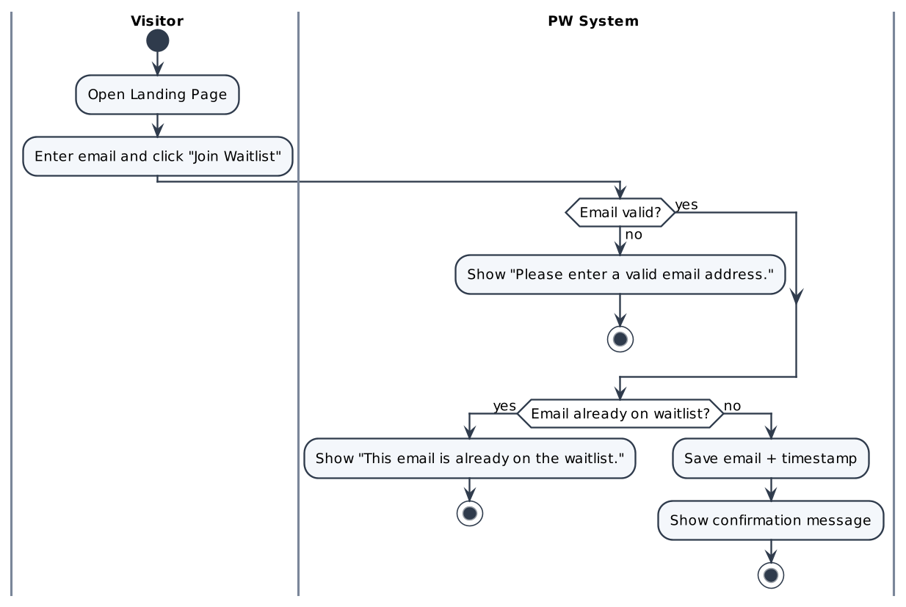

Screen Description
Screen 1: Landing Page – Waitlist section
[Screenshot: Figma frame "PW — Landing Page (Optimized Flow) / (Error) / (Confirmed)"]
# | Name | Control type | Data type | Required | Description
1 | Email address | Textbox | String | Yes | Placeholder "Enter your email". Validated on submit: not empty, valid email format (max 254 characters – assumption).
2 | Join Waitlist | Button | N/A |  | Submits the email. Disabled while the request is being processed.
3 | Success message | Label | String |  | "You're on the list. We'll email you when PW opens." Shown after a successful save (Confirmed state).
4 | Error message | Label (inline) | String |  | "Please enter a valid email address." or "This email is already on the waitlist." (Error state).

UC02: Register Account

Use Case Description
UC ID | UC02
UC Name | Register Account
Objective | Allow a new user to create a PW account as a Company or an Individual (Public Figure). A Company declares its headcount band, which gives a provisional Class. After registration the user continues to KYC (UC04).
Actor | Visitor (R01) becoming a Company (R02) or Individual (R03); PW System (R05)
Trigger | The Visitor opens "Create your account" and clicks "Create account".
Pre-condition | - The Visitor is not logged in.  - The email is not yet registered in PW.
Post-condition | Success:  • An account is created with type = Company or Individual and KYC status = "Not yet KYC".  • Company: the headcount band and provisional Class are stored.  • The user is signed in and redirected to "Verify your identity" (UC04).  Failure:  • No account is created; errors are shown on the form.
Basic flow | 1. Visitor opens "Create your account".  2. System displays the account type selector (Company selected by default (assumption)) and the Company form.  3. Visitor selects the account type.  4. Visitor fills in the fields of the selected type (see Screen 1).  5. Company only: when a headcount band is selected, System shows the live preview "Your class: Class X (based on headcount)" (UC06).  6. Visitor ticks "I agree to the Terms of Service and Privacy Policy".  7. Visitor clicks "Create account".  8. System validates all fields and checks that the email is not already registered.  9. System creates the account with KYC status = "Not yet KYC" (Company: stores headcount band and provisional Class).  10. System writes an Audit Log entry (account created) and redirects the user to "Verify your identity".
Alternative flow | A1 – Switch account type  1. At step 3/4 the Visitor switches between Company and Individual.  2. System shows only the fields of the selected type; values of hidden fields are not submitted.  3. Resume at step 4.  A2 – Individual account  1. At step 3 Visitor selects Individual.  2. System shows Full name, Email, Country, Password, Confirm password; no headcount and no Class.  3. Resume at step 6; at step 9 the account is created with type = Individual and no Class.
Exception flow | E1 – Email already registered  1. At step 8 the email exists.  2. System displays "This email is already registered. Log in instead?" with a link to Log in.  3. No account is created.  E2 – Missing or invalid fields  1. At step 8 a required field is empty, the email format is invalid, the password is shorter than 8 characters or has no number/symbol, or Confirm password does not match.  2. System shows an inline error under each invalid field; no account is created.  E3 – Terms not accepted  1. The Terms checkbox is not ticked.  2. "Create account" stays disabled (or System shows "Please accept the Terms of Service and Privacy Policy.").
Business rule | • BR01 – One email address = one PW account.  • BR02 – Password: at least 8 characters including at least one number/symbol (exact complexity rule to be confirmed); Confirm password must match.  • BR03 – Headcount is chosen from a fixed list of bands; each band maps to exactly one Class 0–7. The Class is provisional until KYC is approved.  • BR04 – An Individual / Public Figure is a full user (one entity with two views: account user and public Directory profile); Individuals have no headcount and no Class.  • BR05 – Registration does not create a wallet (wallet is created on demand – UC07).
Non-functional requirement | • NFR01 – The Class preview updates within 1 second after a band is selected (proposed).  • NFR02 – Passwords are stored only as a salted hash (NFR-003).
Acceptance criteria | AC01 – Register Company  Given type = Company and all fields are valid, when the user clicks "Create account", then the account is created with KYC = "Not yet KYC", headcount and provisional Class saved, and the user is redirected to KYC.  AC02 – Register Individual  Given type = Individual and all fields are valid, when the user clicks "Create account", then the account is created with type = Individual, no Class, and the user is redirected to KYC.  AC03 – Duplicate email  Given the email already exists, when the user clicks "Create account", then "This email is already registered. Log in instead?" is displayed and no account is created.  AC04 – Invalid fields  Given any field breaks a rule, when the user clicks "Create account", then inline errors are shown and no account is created.
Traceability | BRD: FR-002, FR-005 · BPMN: D1 – Register Account

Activity Diagram
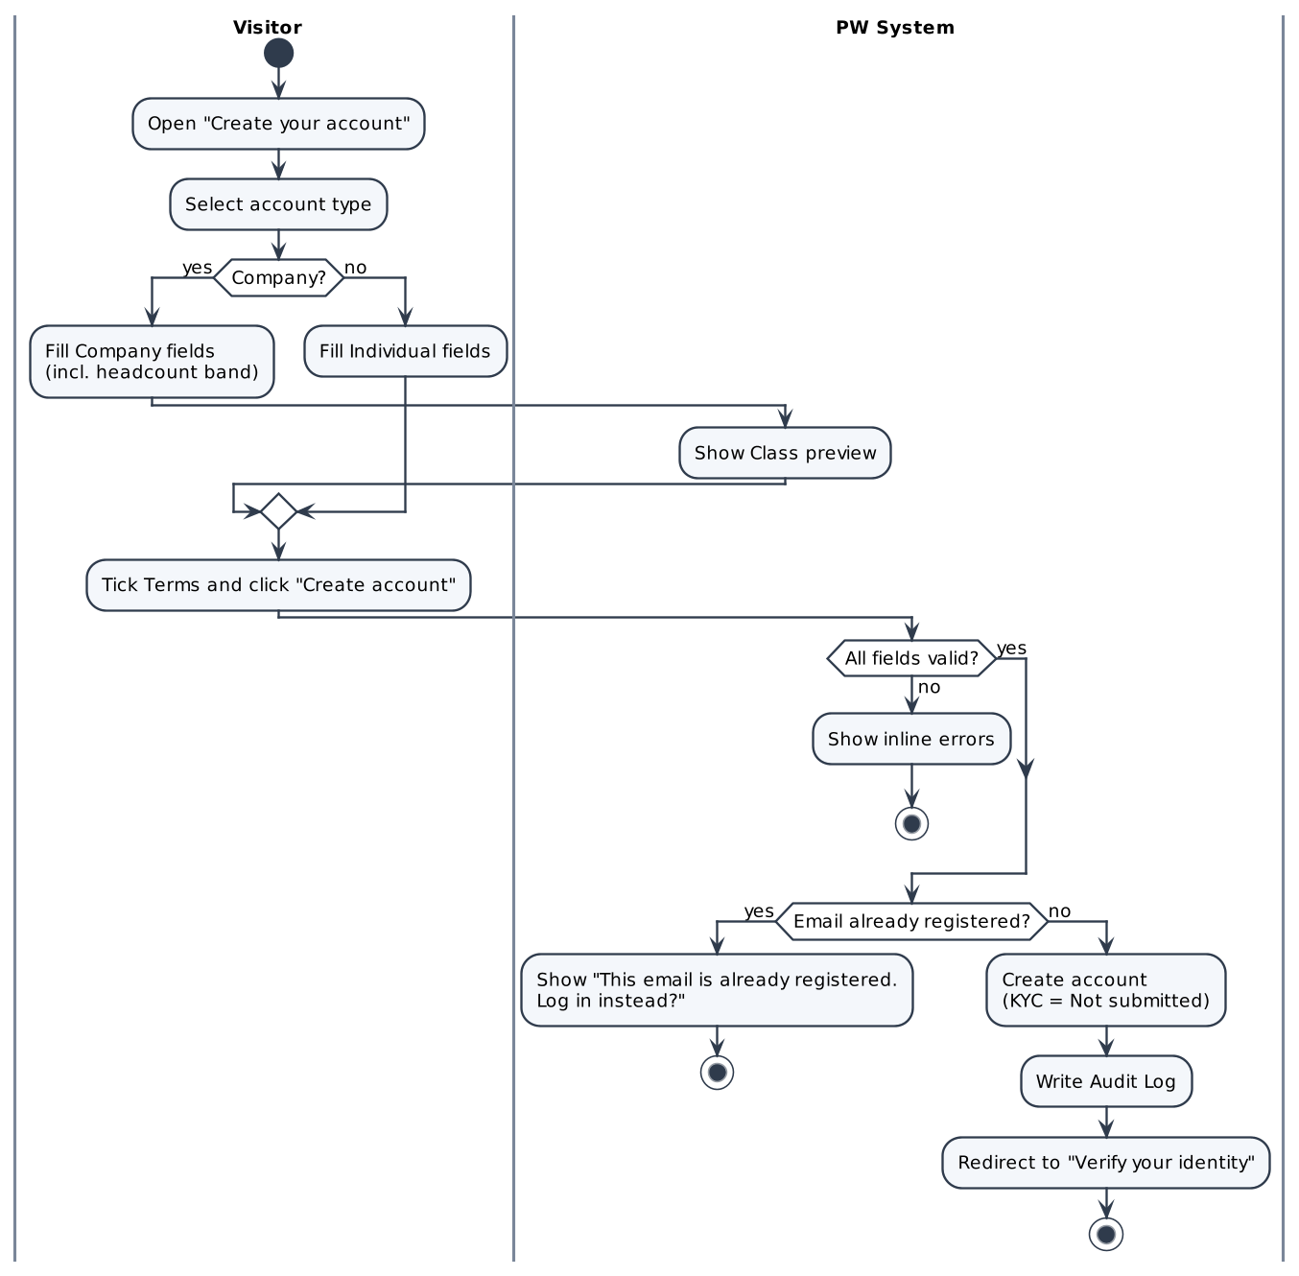

Screen Description
Screen 1: Create your account – Company
[Screenshot: Figma frame "PW — Create Account (Company)"]
# | Name | Control type | Data type | Required | Description
I. Account type
1 | Account type | Segmented control | Enum | Yes | Company | Individual. Switching shows only the fields of the selected type.
II. Company information
1 | Registered legal entity name | Textbox | String | Yes | Legal name of the company.
2 | Authorized representative full name | Textbox | String | Yes | Person acting on behalf of the company.
3 | Work email | Textbox | String | Yes | Valid email format; must be unique in PW (BR01). Used as login ID.
4 | Organization headcount | Dropdown | Enum | Yes | Fixed headcount bands; each band maps to one Class 0–7 (1–10 → 0; 11–50 → 1; 51–200 → 2; 201–500 → 3; 501–1,000 → 4; 1,001–5,000 → 5; 5,001–9,999 → 6; 10,000+ → 7; BRD FR-005)..
5 | Class preview | Label | String |  | "Your class: Class X (based on headcount)" – read-only, updated on band change. Displayed as "Company Class".
6 | Country of incorporation | Dropdown | String | Yes | Country list.
III. Security & consent
1 | Password | Textbox (masked) | String | Yes | Min. 8 characters incl. at least one number/symbol (BR02). Show/hide toggle.
2 | Confirm password | Textbox (masked) | String | Yes | Must match Password.
3 | I agree to the Terms of Service and Privacy Policy | Checkbox | Boolean | Yes | "Create account" is disabled until ticked.
4 | Create account | Button | N/A |  | Validates and creates the account (steps 8–10).
5 | Log in | Link | N/A |  | Navigates to the Log in screen (UC03).

Screen 2: Create your account – Individual
[Screenshot: Figma frame "PW — Create Account (Individual)"]
# | Name | Control type | Data type | Required | Description
1 | Account type | Segmented control | Enum | Yes | Individual selected.
2 | Full name | Textbox | String | Yes | Legal full name.
3 | Email | Textbox | String | Yes | Valid format; unique (BR01).
4 | Country | Dropdown | String | Yes | Country of residence.
5 | Password / Confirm password | Textbox (masked) | String | Yes | Same rules as the Company form.
6 | Terms checkbox | Checkbox | Boolean | Yes | Same rule as the Company form.
7 | Create account | Button | N/A |  | Creates the Individual account (no headcount, no Class).

UC03: Log In

Use Case Description
UC ID | UC03
UC Name | Log In
Objective | Authenticate a registered Member or Admin with email and password and open the appropriate portal.
Actor | Company (R02), Individual (R03), PW Admin (R04); PW System (R05)
Trigger | The user clicks "Log in".
Pre-condition | - The user has a PW account.
Post-condition | Success:  • An authenticated session is created.  • Member → Member Dashboard (full mode if KYC Approved, otherwise limited mode). Admin → Admin Portal.  Failure:  • No session is created; an error message is displayed.
Basic flow | 1. User opens the Log in screen.  2. User enters email and password and clicks "Log in".  3. System verifies the credentials.  4. System creates an authenticated session and identifies the user's role.  5. System opens the Member Dashboard (KYC status = "Approved").
Alternative flow | A1 – KYC not yet approved  1. At step 5 the KYC status is "Not yet KYC", "In Review" or "Rejected".  2. System opens the Dashboard in limited mode with a banner showing the current KYC status and the next step (e.g. "Complete your identity verification").  3. Purchase / Gift Title is disabled.  A2 – Admin user  1. At step 4 the user holds the Admin role.  2. System opens the Admin Portal.
Exception flow | E1 – Wrong credentials  1. At step 3 verification fails.  2. System displays "Email or password is incorrect." and does not reveal which field is wrong.  3. User may retry from step 2.
Business rule | • BR01 – Error messages must not disclose whether the email exists.  • BR02 – The Admin Portal is accessible only to users with the Admin role; a Member session can never open Admin screens.
Non-functional requirement | • NFR01 – Strong authentication and secure session handling (NFR-003).  • NFR02 – Log in response within 2 seconds under normal load (proposed).
Acceptance criteria | AC01 – Successful login  Given a Member with KYC Approved, when correct credentials are submitted, then the Member Dashboard opens.  AC02 – Wrong credentials  Given the user is on Log in, when a wrong email or password is submitted, then "Email or password is incorrect." is displayed.  AC03 – KYC not approved  Given KYC status ≠ Approved, when the user logs in, then the Dashboard opens in limited mode with a KYC banner.
Traceability | BRD: FR-006 · BPMN: —

Activity Diagram
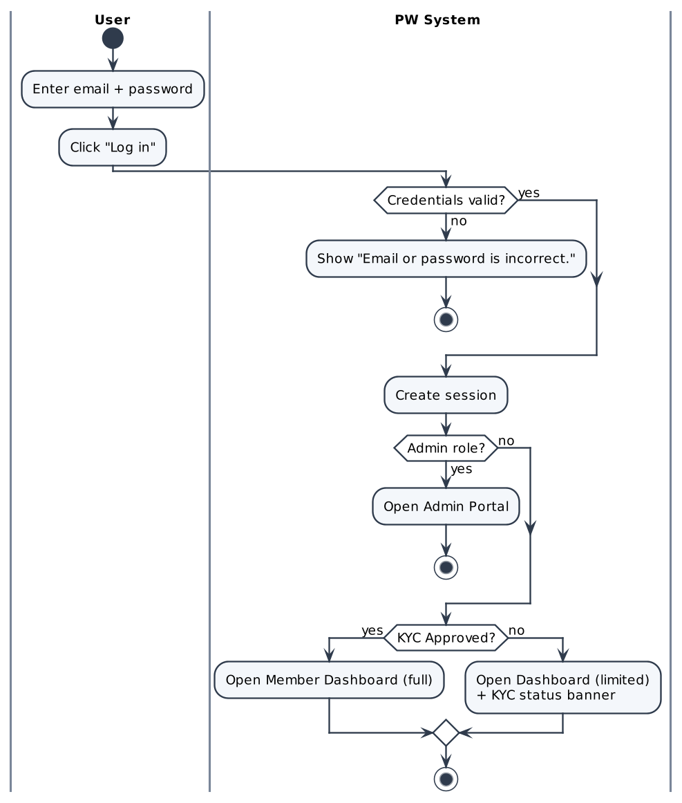

Screen Description
Screen 1: Log in
[Screenshot: Figma frame "PW — Log In / Log In (Error)"]
# | Name | Control type | Data type | Required | Description
1 | Email | Textbox | String | Yes | Registered email.
2 | Password | Textbox (masked) | String | Yes | Show/hide toggle.
3 | Log in | Button | N/A |  | Authenticates the user (steps 3–5).
4 | Error message | Label | String |  | "Email or password is incorrect."
5 | Create account | Link | N/A |  | Navigates to UC02.

UC04: Submit KYC

Use Case Description
UC ID | UC04
UC Name | Submit KYC
Objective | Allow a Member to submit identity information and supporting documents so that PW can verify the entity before it buys, receives or owns an NFT.
Actor | Company (R02), Individual (R03); PW System (R05)
Trigger | The Member clicks "Submit for verification" (or "Re-submit documents") on "Verify your identity".
Pre-condition | - The Member is logged in.  - KYC status = "Not yet KYC" (first submission) or "Rejected" (re-submission).
Post-condition | Success:  • KYC status = "In Review"; a unique KYC reference number is generated.  • The request appears in the Admin KYC queue (UC05).  • An Audit Log entry is written.  Draft:  • Data is saved; KYC status remains "Not yet KYC".  Failure:  • KYC is not submitted; errors are shown.
Basic flow | 1. Member opens "Verify your identity".  2. System displays the KYC form (pre-filled with the account name).  3. Member enters Legal entity or personal name, Verification document type and Document identification / Registry no.  4. Member uploads at least one document (PDF, JPG or PNG, max 25 MB each).  5. System validates each file on upload and lists accepted files.  6. Member clicks "Submit for verification".  7. System validates the required fields and that at least one document is attached.  8. System sets KYC status = "In Review", generates the KYC reference number and writes an Audit Log entry.  9. System displays "Your documents are under review" with the reference number and the estimated review time (1–2 business days).  10. System adds the request to the Admin KYC queue.
Alternative flow | A1 – Remove an uploaded file  1. Before step 6 Member clicks the delete icon on a file.  2. System removes the file from the submission.  A2 – Save draft and exit  1. Before step 6 Member clicks "Save Draft & Exit".  2. System saves the draft; KYC status stays "Not yet KYC".  3. When Member returns, the form is restored from the draft.  A3 – Re-submit after rejection  1. KYC status = "Rejected".  2. At step 2 System also displays the rejection reason and the resubmission requirements.  3. Member updates information/documents and clicks "Re-submit documents"; continue at step 7.
Exception flow | E1 – Missing required information  1. At step 7 a required field is empty or no document is uploaded.  2. System highlights the missing field; KYC is not submitted.  E2 – Unsupported or oversized file  1. At step 5 the file is not PDF/JPG/PNG or is larger than 25 MB.  2. System rejects the file with "Accepts PDF, JPG, or PNG up to 25MB." and does not add it.  E3 – Upload/network error  1. Upload fails.  2. System marks the file as failed and allows retry.
Business rule | • BR01 – KYC status lifecycle: Not yet KYC → In Review → Approved | Rejected; Rejected → In Review on re-submission.  • BR02 – Accepted files: PDF, JPG, PNG; max 25 MB per file; at least one document.  • BR03 – While KYC ≠ Approved, Purchase / Gift Title is disabled and the Member cannot be selected as a gift or Award recipient.  • BR04 – Final list of KYC fields and accepted document types to be confirmed with Compliance.
Non-functional requirement | • NFR01 – KYC documents are stored encrypted and accessible only to the owner and Admins (NFR-008).  • NFR02 – File upload progress is shown; a 25 MB file uploads within 30 seconds on a 10 Mbps connection (proposed).
Acceptance criteria | AC01 – Submit successfully  Given KYC = Not yet KYC and all required data + ≥1 valid file, when "Submit for verification" is clicked, then KYC = In Review, a reference number and "Your documents are under review" (1–2 business days) are shown, and the request is in the Admin queue.  AC02 – Invalid file  Given a non-PDF/JPG/PNG or >25 MB file, when it is uploaded, then "Accepts PDF, JPG, or PNG up to 25MB." is shown and the file is not added.  AC03 – Save draft  Given some data is entered, when "Save Draft & Exit" is clicked, then the draft is saved and KYC stays Not yet KYC.  AC04 – Re-submit  Given KYC = Rejected, when updated documents are re-submitted, then the rejection reason was shown and KYC = In Review.
Traceability | BRD: FR-003 · BPMN: D1 – Submit KYC

Activity Diagram
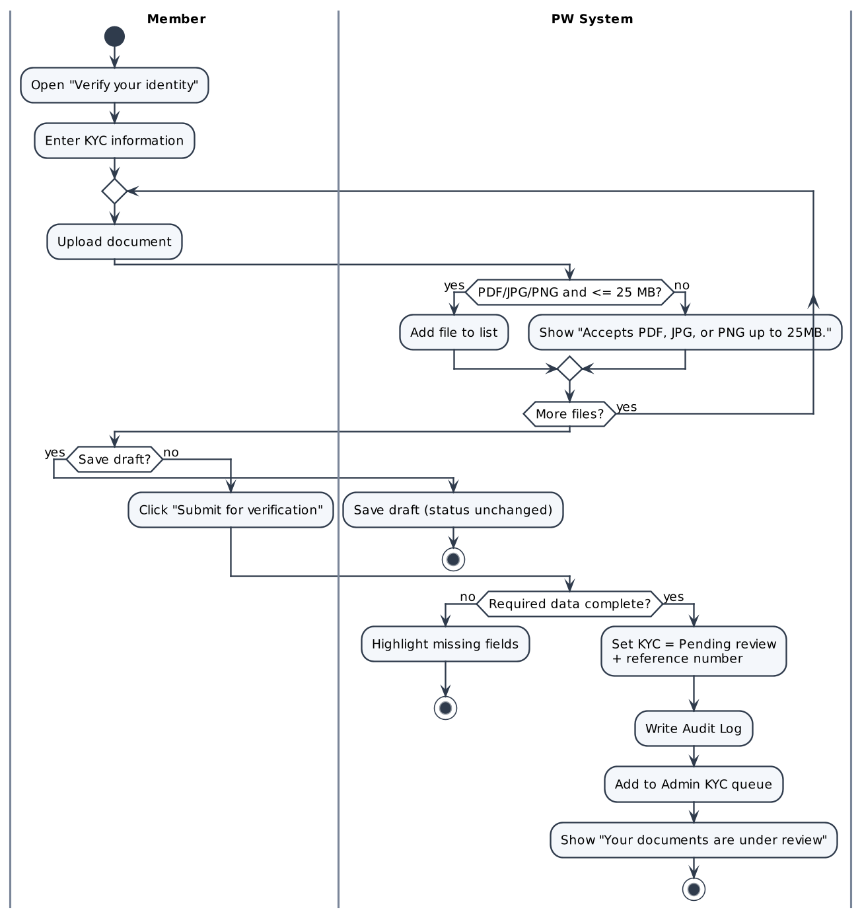

Screen Description
Screen 1: Verify your identity (KYC)
[Screenshot: Figma frame "PW — KYC Verification Hub / (In Review) / (Action Required)"]
# | Name | Control type | Data type | Required | Description
I. Identity information
1 | Legal entity or personal name | Textbox | String | Yes | Pre-filled from the account; editable.
2 | Verification document type | Dropdown | Enum | Yes | Company: Articles of Incorporation / Certificate of Good Standing / Business Registration Extract; Individual: Passport / National ID Card / Driver's Licence (BRD FR-003).
3 | Document identification / Registry no. | Textbox | String | Yes | Number printed on the document.
II. Documents
1 | Upload area | File upload (drag & drop) | File | Yes | PDF, JPG, PNG; max 25 MB per file; ≥1 file. Helper text "Accepts PDF, JPG, or PNG up to 25MB."
2 | Uploaded file list | List | File |  | File name, size, status; delete icon per file (A1).
III. Actions & status
1 | Save Draft & Exit | Button | N/A |  | Saves the draft (A2).
2 | Submit for verification / Re-submit documents | Button | N/A |  | Submits the KYC (steps 6–10).
3 | Rejection reason | Alert | String |  | Shown only when KYC = Rejected (A3).
4 | Under-review panel | Panel | String |  | "Your documents are under review", KYC reference number, estimated review time 1–2 business days.

UC05: Review KYC (Approve / Reject)

Use Case Description
UC ID | UC05
UC Name | Review KYC (Approve / Reject)
Objective | Allow a PW Admin to review pending KYC requests and approve or reject them so that only verified entities can own and receive NFTs. On approval, the Company Class is confirmed and the account is activated.
Actor | PW Admin (R04); PW System (R05); Member (notified)
Trigger | The Admin opens a request from the KYC queue.
Pre-condition | - The Admin is logged in with the Admin role.  - The request has KYC status = "In Review".
Post-condition | Approved:  • KYC status = "Approved"; Class confirmed (Company) – UC06; account activated.  • Member sees the Approved result and is able to purchase Titles.  • Audit Log entry written.  Rejected:  • KYC status = "Rejected"; reason stored; the reason is shown to the Member, who can re-submit without limit (BR-09).  • Audit Log entry written.
Basic flow | 1. Admin opens "KYC Review" in the Admin Portal.  2. System lists requests with status "In Review" (oldest first) showing reference number, name, account type, submission date.  3. Admin selects a request.  4. System displays the submitted information, documents, declared headcount band and provisional Class.  5. Admin reviews the documents and clicks "Approve".  6. System sets KYC status = "Approved".  7. System confirms the Class (Company) and activates the account (UC06).  8. System notifies the Member ("Your identity has been verified") and writes an Audit Log entry (admin, action, target, time).
Alternative flow | A1 – Reject  1. At step 5 Admin clicks "Reject".  2. System displays the Reason field (required).  3. Admin selects/enters the reason and confirms.  4. System sets KYC status = "Rejected", shows the Member the reason and writes an Audit Log entry.  A2 – Change Class during review  1. At step 4 the documents show a different headcount.  2. Admin selects the correct Class and enters a mandatory reason.  3. System saves the new Class and records old Class, new Class, admin and time in the Audit Log; continue at step 5.
Exception flow | E1 – Reject without reason  1. In A1 no reason is provided.  2. System blocks the action with "Reason is required."  E2 – Request already processed  1. Another Admin has already decided the request.  2. System displays "This request has already been processed." and refreshes the queue.
Business rule | • BR01 – Only the Admin role can approve or reject KYC.  • BR02 – A rejection reason and a Class-change reason are mandatory.  • BR03 – Every KYC decision and Class change is written to the Audit Log (NFR-002).  • BR04 – The Class becomes final only on approval (BR-01).
Non-functional requirement | • NFR01 – Documents open in an in-browser viewer without downloading (proposed).  • NFR02 – Review target: 1–2 business days per request (communicated to Members).
Acceptance criteria | AC01 – Approve  Given a request is In Review, when the Admin clicks "Approve", then KYC = Approved, Class confirmed, Member sees the result, Audit Log written.  AC02 – Reject  Given a request is In Review, when the Admin rejects with a reason, then KYC = Rejected, the reason is shown to the Member, Audit Log written.  AC03 – Reject without reason  Given the Admin clicks "Reject", when no reason is given, then "Reason is required." is displayed.  AC04 – Change Class  Given the documents show another headcount, when the Admin changes the Class with a reason, then the new Class is saved and the change is logged.
Traceability | BRD: FR-004, FR-005 · BPMN: D1 – Review KYC / KYC approved?

Activity Diagram
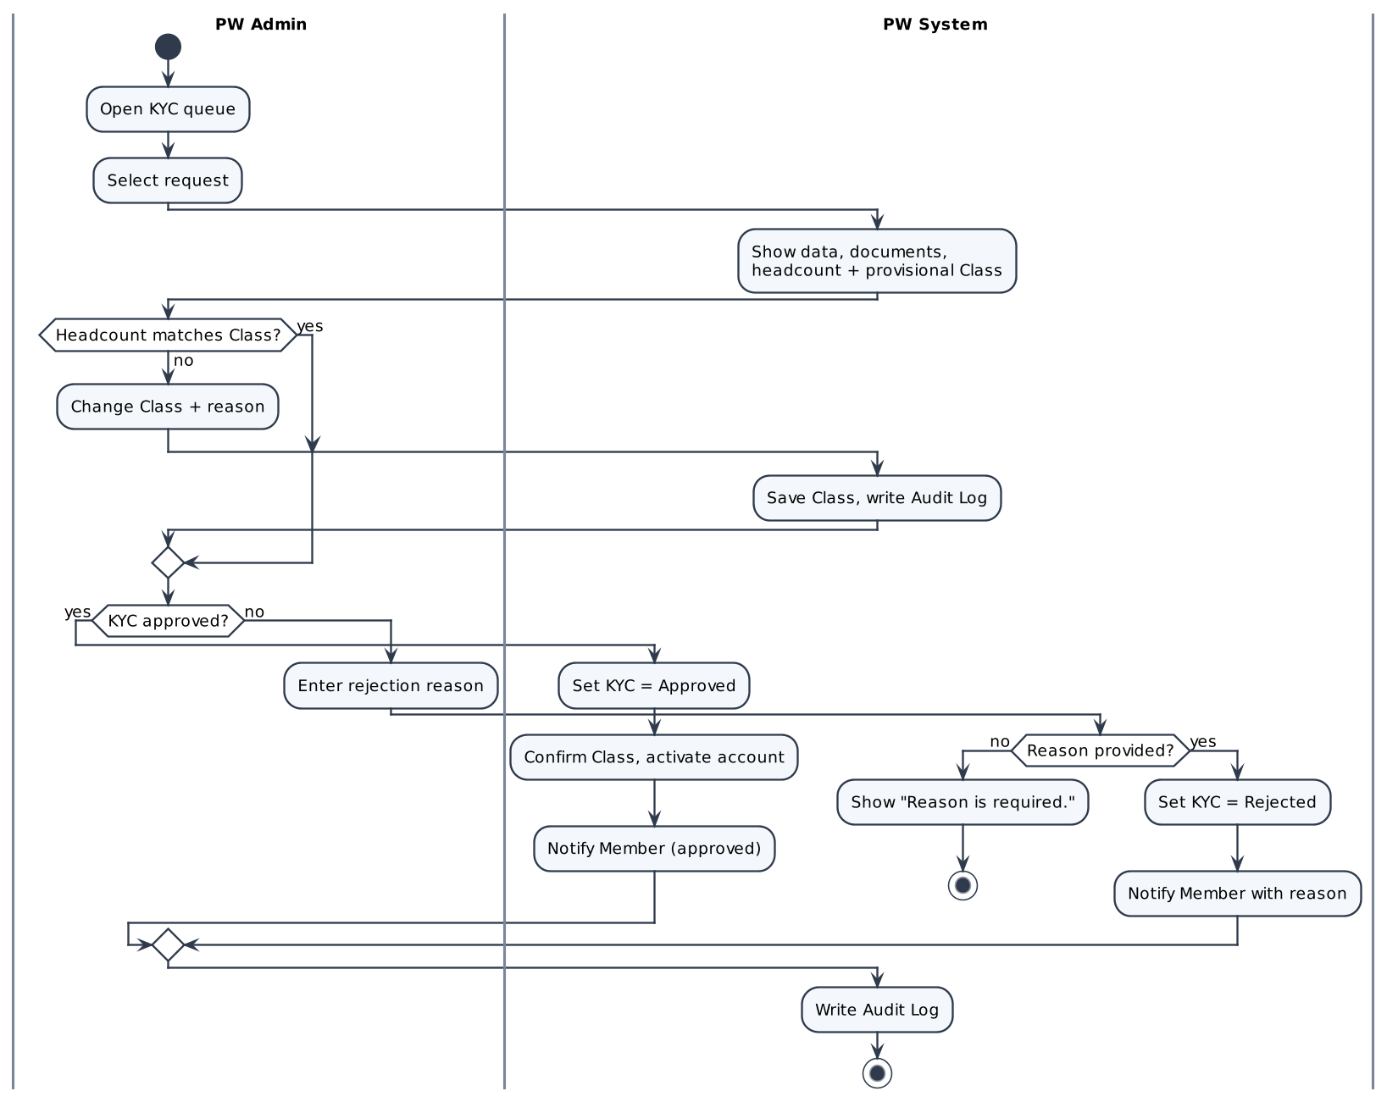

Screen Description
Screen 1: KYC Review – queue
[Screenshot: Figma frame "Admin Portal (KYC Review)"]
# | Name | Control type | Data type | Required | Description
1 | Pending requests table | Table / Grid | Mixed |  | Columns: KYC reference, Name, Account type, Declared headcount, Provisional Class, Submitted on. Sorted oldest first.
2 | Search | Textbox | String |  | Search by name or reference.
3 | Open | Row action | N/A |  | Opens the request detail.

Screen 2: KYC Review – request detail
[Screenshot: Figma frame "Admin Portal (KYC Review – detail)"]
# | Name | Control type | Data type | Required | Description
1 | Applicant information | Label group | String |  | Name, account type, email, country, headcount band, provisional Class, KYC reference.
2 | Documents | Viewer / List | File |  | Opens each uploaded document.
3 | Company Class | Dropdown | Enum 0–7 |  | Pre-set to the provisional Class; editable by Admin (A2).
4 | Class change reason | Textarea | String | Cond. | Required when the Class is changed.
5 | Approve | Button | N/A |  | Approves the KYC (steps 5–8).
6 | Reject | Button | N/A |  | Opens the rejection reason (A1).
7 | Rejection reason | Dropdown + Textarea | String | Cond. | Required on reject; shown to the Member.

UC06: Classify Business into Class 0–7

Use Case Description
UC ID | UC06
UC Name | Classify Business into Class 0–7
Objective | Automatically assign each Company to one of eight Classes (0–7) from its declared headcount band, confirm the Class when KYC is approved and activate the account. The Class determines the Title price (UC16).
Actor | PW System (R05); Company (R02) declares headcount; PW Admin (R04) may correct the Class (UC05-A2)
Trigger | (a) A headcount band is selected at registration (preview); (b) KYC is approved (confirmation).
Pre-condition | - Account type = Company.
Post-condition | Success:  • The account holds exactly one current Class (0–7) and is Active.  • The Dashboard shows "Class X · Auto-assigned" (or the Admin-corrected Class).
Basic flow | 1. System receives the KYC approval event for a Company account (UC05).  2. System reads the stored headcount band.  3. System maps the band to exactly one Class using the Class table.  4. System stores the Class as confirmed, together with the date and source (Auto-assigned / Admin).  5. System activates the account (status = Active) and stores the account data.  6. System displays "Class X · Auto-assigned" on the Member Dashboard.
Alternative flow | A1 – Live preview at registration  1. During UC02, when a band is selected, System maps it to a Class and shows "Your class: Class X (based on headcount)" without saving it as final.  A2 – Admin correction  1. During UC05 the Admin changes the Class with a reason.  2. System stores the corrected Class (source = Admin) and logs old/new Class, admin and time.  A3 – Individual account  1. Account type = Individual → no Class is assigned; the account is activated at step 5 without a Class.
Exception flow | E1 – Band not mapped  1. The band has no Class in the Class table (configuration error).  2. System does not activate the account, logs the error and shows the request as "Needs attention" in the Admin queue.
Business rule | • BR01 – 8 Classes (0–7) by headcount → pricing tier (BR-01).  • BR02 – One band ↔ exactly one Class; one account ↔ one current Class.  • BR03 – The Class is provisional until KYC approval; only the Admin can change it, with a reason.  • BR04 – Price calculation always uses the current Class (UC16).  • BR05 – Headcount bands: 1–10 → 0; 11–50 → 1; 51–200 → 2; 201–500 → 3; 501–1,000 → 4; 1,001–5,000 → 5; 5,001–9,999 → 6; 10,000+ → 7. An Individual is Class 0 (BR-01).
Non-functional requirement | • NFR01 – The Class table is configuration data (changeable without code release).
Acceptance criteria | AC01 – Preview  Given a Company user selects a band, when the band changes, then "Your class: Class X (based on headcount)" is shown.  AC02 – Confirm on approval  Given a Company has a provisional Class, when KYC is approved, then the Class is confirmed, the account is Active and the Dashboard shows "Class X · Auto-assigned".  AC03 – Admin correction  Given the Admin changes the Class with a reason, when the change is saved, then the new Class applies and the change is logged.  AC04 – Individual  Given account type = Individual, when KYC is approved, then the account is activated with no Class.
Traceability | BRD: FR-005 · BPMN: D1 – Classify Business / Active Account

Activity Diagram
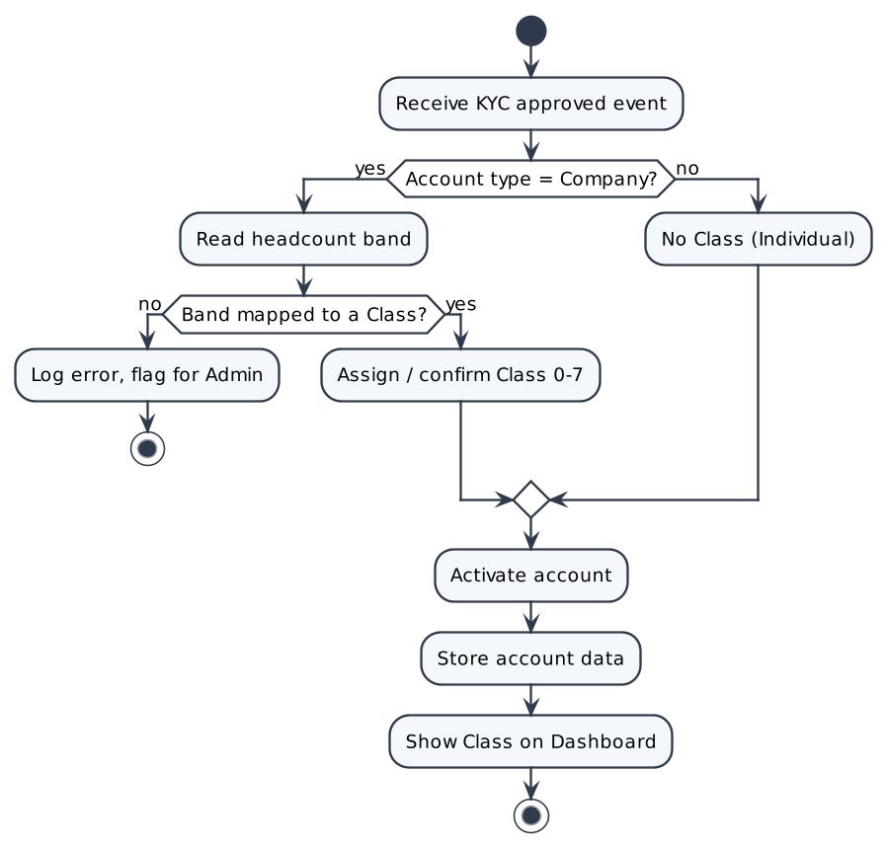

Screen Description
Screen 1: Member Dashboard – Class card
[Screenshot: Figma frame "PW — KYC Verification (Approved) / Member Dashboard"]
# | Name | Control type | Data type | Required | Description
1 | Company Class | Label / Badge | String |  | "Class X · Auto-assigned" (or "Class X · Set by PW" after Admin correction). Hidden for Individuals.
2 | KYC status | Badge | Enum |  | "Verified" after approval.

UC07: Create Custodial Wallet on Demand

Use Case Description
UC ID | UC07
UC Name | Create Custodial Wallet on Demand
Objective | Automatically create one custodial wallet per account through Circle at the moment it is first needed – when an NFT is about to be issued to a recipient who has no wallet (paid purchase or gift in D2, Award grant in D3).
Actor | PW System (R05); Circle (external); Member (wallet owner)
Trigger | Payment is confirmed (UC14 / UC15) or an Award grant is confirmed (UC29), and the recipient has no custodial wallet.
Pre-condition | - The recipient's KYC status = "Approved".  - The recipient has no custodial wallet.
Post-condition | Success:  • A custodial wallet (address, type = "Custodial", provider = Circle) is stored on the recipient's account.  • Minting continues to that wallet (UC17).  • Audit Log entry written (WALLET_CREATE).  Failure:  • No wallet record is stored; the NFT is not minted; the event is logged for follow-up.
Basic flow | 1. System receives the issuance request with the recipient account.  2. System checks whether the recipient already has a custodial wallet.  3. System sends a wallet-creation request to Circle.  4. Circle creates the custodial wallet and returns the wallet information (address).  5. System stores the wallet (address, type = "Custodial") on the recipient's account.  6. System writes an Audit Log entry and continues with minting (UC17).
Alternative flow | A1 – Wallet already exists  1. At step 2 the recipient has a custodial wallet.  2. System skips wallet creation and continues with minting to the existing wallet.
Exception flow | E1 – Circle error or timeout  1. At step 3/4 Circle returns an error or does not respond within the timeout.  2. System stores no wallet record and does not mint.  3. Purchase / gift: the order is cancelled and a full refund is requested (UC34). Grant: the Admin sees "Award could not be issued because the recipient's wallet could not be created. Please try again."  4. There is no automatic retry in this version (BR-11).
Business rule | • BR01 – No manual "Create wallet" action exists for users; no wallet is created at registration.  • BR02 – One custodial wallet per account.  • BR03 – A wallet is created only when an NFT is about to be issued to a KYC-approved recipient without a wallet (self-purchase, gift recipient per BPMN D2, Award recipient per D3).  • BR04 – PW never stores or exposes private keys; keys are managed by Circle.
Non-functional requirement | • NFR01 – Circle calls use a timeout and retry policy; failures leave no partial records (NFR-004).  • NFR02 – Wallet creation completes within 10 seconds under normal conditions (proposed).
Acceptance criteria | AC01 – First issuance, no wallet  Given a KYC-approved recipient has no wallet, when payment or grant is confirmed, then Circle creates a wallet, it is stored as Custodial and the NFT is minted to it.  AC02 – Existing wallet  Given the recipient already has a wallet, when a new NFT is issued, then no new wallet is created.  AC03 – Circle failure  Given Circle errors or times out, when wallet creation is requested, then no wallet is stored, no NFT is minted and the event is logged.
Traceability | BRD: FR-007 · BPMN: D2, D3 – Does recipient already have a wallet? / Circle

Activity Diagram
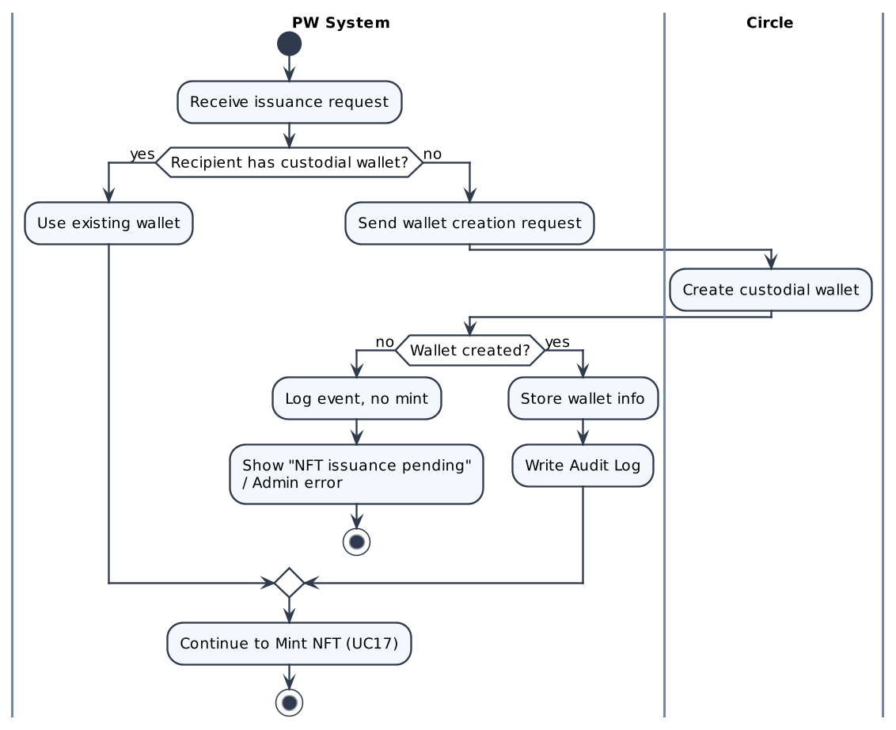

Screen Description
N/A – background system process with no dedicated screen. Results are shown in the screens of the calling use cases.

UC08: View Wallet

Use Case Description
UC ID | UC08
UC Name | View Wallet
Objective | Show the Member's wallet details: custodial wallet address, custody type, number of NFTs held and the linked non-custodial wallet (if any).
Actor | Company (R02), Individual (R03)
Trigger | The Member opens "Wallet".
Pre-condition | - The Member is logged in.
Post-condition | Success:  • Wallet information or the empty state is displayed. No data is changed.
Basic flow | 1. Member opens "Wallet".  2. System retrieves the custodial wallet and the linked non-custodial wallet of the account.  3. System displays the custodial wallet address (with copy action), type "Custodial" and the number of NFTs held.  4. System displays the linked non-custodial wallet with status "Linked – Verified" and its number of NFTs, with an "Unlink" action (UC11).  5. If no non-custodial wallet is linked, System shows the "Link wallet" action (UC10).
Alternative flow | A1 – No wallet yet  1. At step 2 the account has no custodial wallet.  2. System shows "Your wallet will be created automatically when you buy your first Title or receive an Award." and a "Browse Titles" action.  A2 – Copy address  1. Member clicks the copy icon.  2. System copies the address and shows "Copied".
Exception flow | E1 – Data cannot be loaded  1. System shows "Wallet information is temporarily unavailable. Please try again."
Business rule | • BR01 – The same linked-wallet list is shown on Dashboard, Wallet and Transfer screens.  • BR02 – "Link wallet" is hidden while a wallet is already linked (1 linked wallet per account).
Non-functional requirement | • NFR01 – Screen loads within 2 seconds (proposed).
Acceptance criteria | AC01 – Has wallet  Given the Member has a custodial wallet, when "Wallet" is opened, then address (copyable), type and number of NFTs are shown, plus the linked wallet if any.  AC02 – No wallet  Given the Member has no wallet, when "Wallet" is opened, then the empty-state message and "Browse Titles" are shown.
Traceability | BRD: FR-008 · BPMN: —

Activity Diagram
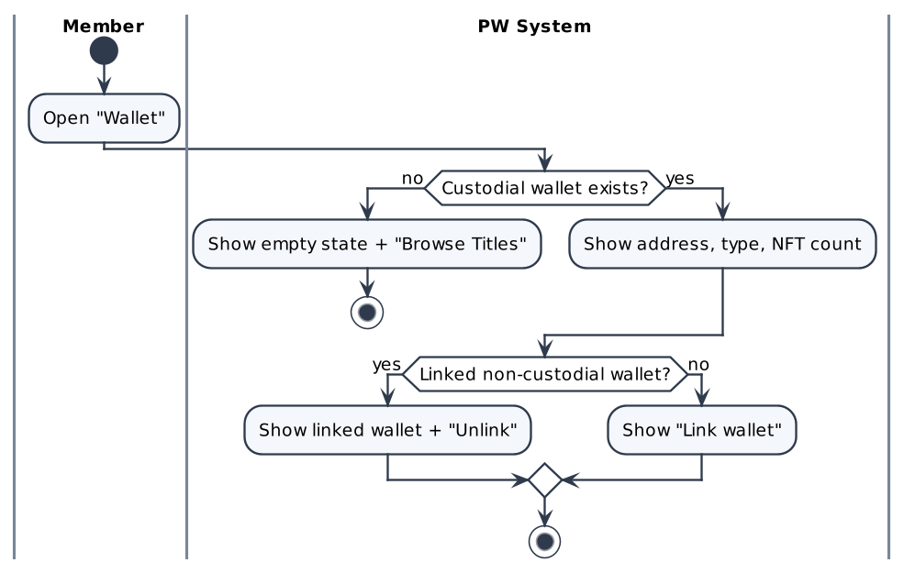

Screen Description
Screen 1: Wallet
[Screenshot: Figma frame "PW — Wallet / Dashboard (wallet card)"]
# | Name | Control type | Data type | Required | Description
I. Custodial wallet
1 | Wallet address | Label + Copy icon | String |  | Shortened address (0x1234…abcd); full address copied on click.
2 | Custody type | Badge | Enum |  | "Custodial (managed by PW via Circle)".
3 | NFTs held | Label | Integer |  | Number of NFTs in this wallet.
II. Linked non-custodial wallet
1 | Linked wallet address | Label | String |  | Shown when linked; status "Linked – Verified".
2 | Unlink | Button | N/A |  | Starts UC11.
3 | Link wallet | Button | N/A |  | Starts UC10; shown only when no wallet is linked.
III. Empty state
1 | Empty message | Label | String |  | "Your wallet will be created automatically when you buy your first Title or receive an Award."
2 | Browse Titles | Button | N/A |  | Navigates to UC13.

UC09: View My NFTs

Use Case Description
UC ID | UC09
UC Name | View My NFTs
Objective | List all NFTs (Distinctions and Awards) owned by the Member with their status, custody and remaining transfer rights.
Actor | Company (R02), Individual (R03)
Trigger | The Member opens "My Titles" (My NFTs).
Pre-condition | - The Member is logged in.
Post-condition | Success:  • The NFT list or the empty state is displayed. No data is changed.
Basic flow | 1. Member opens "My Titles".  2. System retrieves the NFTs owned by the account (custodial and linked wallets).  3. System displays one card per NFT: name, category (Philanthropist / Investor / Bridge), type (Distinction / Award), status (Active / Revoked), custody (Custodial / Transfer pending / Self-custody (verified)), token ID and issue date.  4. For each Distinction, System shows "One-time transfer available" with a "Transfer" action, or "Transfer used".  5. For each Award, System shows "Soulbound – non-transferable" and no transfer action.  6. Member selects an NFT to open its detail (token ID, transaction link, verification link – UC27).
Alternative flow | A1 – No NFTs  1. At step 2 no NFT is found.  2. System shows "You don't own any NFTs yet" with a "Browse Titles" action.  A2 – Revoked NFT  1. An NFT has status Revoked.  2. System shows the badge "Revoked" and no transfer action.
Exception flow | E1 – Data cannot be loaded  1. System shows a retry message.
Business rule | • BR01 – Award = soulbound; Distinction = transferable once (BR-06).
Non-functional requirement | • NFR01 – List loads within 2 seconds for up to 100 NFTs (proposed).
Acceptance criteria | AC01 – Owns NFTs  Given the Member owns NFTs, when "My Titles" is opened, then each NFT shows name, category, type, status, custody, token ID, issue date and its transfer availability.  AC02 – No NFTs  Given the Member owns none, when "My Titles" is opened, then "You don't own any NFTs yet" with "Browse Titles" is shown.  AC03 – Revoked  Given an NFT is revoked, when the list is shown, then it shows "Revoked" and no transfer action.
Traceability | BRD: FR-009 · BPMN: —

Activity Diagram
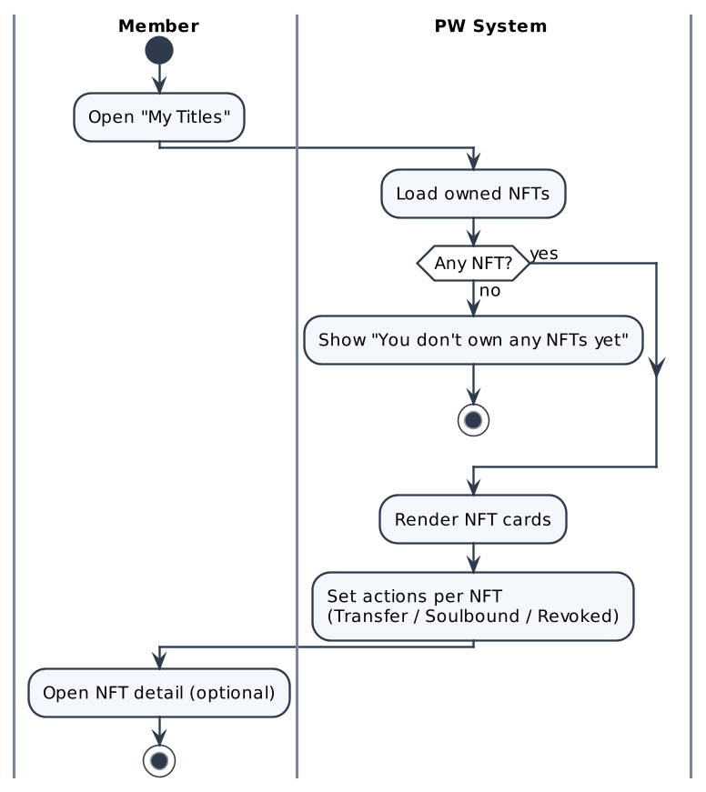

Screen Description
Screen 1: My Titles (My NFTs)
[Screenshot: Figma frame "PW — My Titles / Title detail"]
# | Name | Control type | Data type | Required | Description
1 | NFT card – Name & category | Card | String |  | e.g. "Investor" + type label "Distinction" or "Award".
2 | Status | Badge | Enum |  | Active | Revoked.
3 | Custody | Badge | Enum |  | Custodial | Transfer pending | Self-custody (verified).
4 | Token ID | Label | String |  | On-chain token ID.
5 | Issue date | Label | Date |  | DD/MM/YYYY.
6 | Transfer availability | Label | String |  | "One-time transfer available" / "Transfer used" / "Soulbound – non-transferable".
7 | Transfer | Button | N/A |  | Shown only for Active Distinctions with the transfer unused (UC19).
8 | View on-chain / Verify | Link | N/A |  | Opens the verification result (UC27).

UC10: Link Non-custodial Wallet

Use Case Description
UC ID | UC10
UC Name | Link Non-custodial Wallet
Objective | Allow a Member to prove ownership of a non-custodial wallet by connecting it and signing a verification message, so that NFTs moved there keep counting toward Ranking.
Actor | Company (R02), Individual (R03); user's non-custodial wallet
Trigger | The Member clicks "Link wallet" (or ticks "This is my wallet" during a transfer – UC19-A1).
Pre-condition | - The Member is logged in and KYC-approved.  - The account has no linked non-custodial wallet.
Post-condition | Success:  • The wallet is stored as "Linked – Verified" and appears in the shared linked-wallet list.  • Audit Log entry written (WALLET_LINK).  Failure:  • The wallet is not stored.
Basic flow | 1. Member clicks "Link wallet".  2. System opens Step 1 "Connect wallet".  3. Member connects the wallet; the wallet returns its address.  4. System checks that the address is not linked to another PW account.  5. System opens Step 2 "Sign message" and sends a one-time verification message (includes account ID and a nonce).  6. Member signs the message in the wallet.  7. System verifies the signature and that the signed address equals the connected address.  8. System stores the wallet as "Linked – Verified" and writes an Audit Log entry.  9. System displays "Wallet linked successfully."
Alternative flow | A1 – Cancel  1. Member closes the modal before signing → nothing is stored.
Exception flow | E1 – Signature rejected or invalid  1. At step 6/7 the Member rejects the request or the signature is invalid.  2. System displays "Wallet not linked. Signature was not completed." and stores nothing.  E2 – Wallet linked to another account  1. At step 4 the address is already linked to another account.  2. System displays "This wallet is already linked to another PW account." and refuses the link.  E3 – Account already has a linked wallet  1. At step 1 a wallet is already linked.  2. System asks the Member to unlink the current wallet first (UC11).
Business rule | • BR01 – 1 wallet ↔ 1 account; max one linked non-custodial wallet per account.  • BR02 – Ownership is proven only by a valid message signature; the nonce is single-use.  • BR03 – Only NFTs in the custodial wallet or in a linked, signature-verified wallet count toward Ranking.
Non-functional requirement | • NFR01 – The signing message is human-readable and states that it does not trigger any transaction or fee.
Acceptance criteria | AC01 – Link successfully  Given no wallet is linked, when the Member connects and signs, and the addresses match, then the wallet is saved as "Linked – Verified" and appears in the linked-wallet list.  AC02 – Signature rejected  Given a wallet is connected, when the signature is rejected or invalid, then "Wallet not linked. Signature was not completed." is displayed.  AC03 – Linked elsewhere  Given the address is linked to another account, when the Member tries to link it, then "This wallet is already linked to another PW account." is displayed.  AC04 – Already linked  Given the account has a linked wallet, when the Member tries to link another, then the Member is asked to unlink first.
Traceability | BRD: FR-031 · BPMN: D4.1 – Link Wallet

Activity Diagram
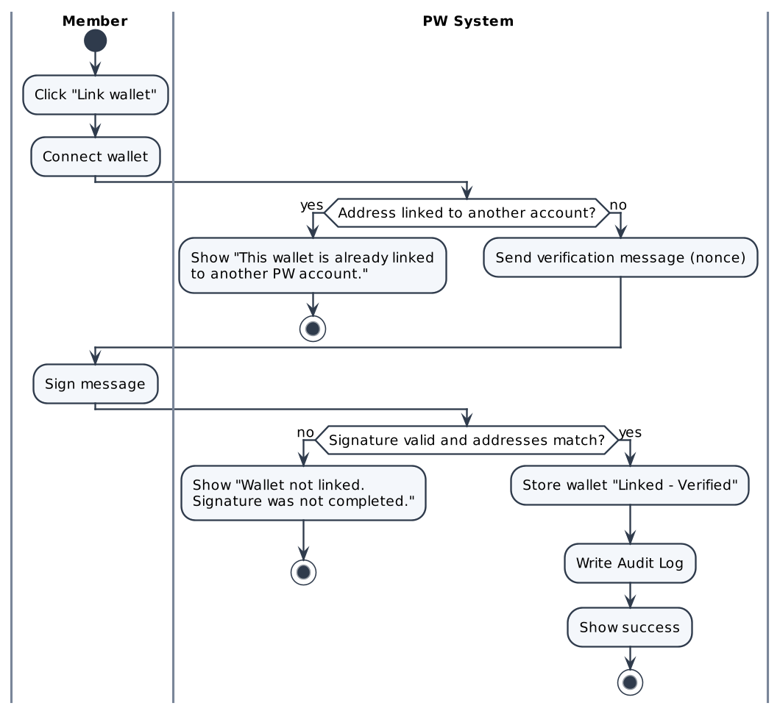

Screen Description
Screen 1: Link wallet – Step 1 Connect / Step 2 Sign
[Screenshot: Figma frame "PW — Link Wallet (modal)"]
# | Name | Control type | Data type | Required | Description
1 | Stepper | Stepper | N/A |  | Step 1 Connect wallet → Step 2 Sign message.
2 | Connect wallet | Button | N/A |  | Opens the wallet connection.
3 | Connected address | Label | String |  | Shown after connection.
4 | Message preview | Label | String |  | Text to be signed incl. account ID and nonce; states that no transaction/fee is involved.
5 | Sign message | Button | N/A |  | Requests the signature in the wallet.
6 | Error message | Alert | String |  | E1/E2 messages.
7 | Cancel | Button | N/A |  | Closes without linking.

UC11: Unlink Wallet

Use Case Description
UC ID | UC11
UC Name | Unlink Wallet
Objective | Allow a Member to unlink the non-custodial wallet after a warning; NFTs in that wallet stop counting toward Ranking and the Directory profile until the wallet is linked again.
Actor | Company (R02), Individual (R03)
Trigger | The Member clicks "Unlink" on the linked wallet.
Pre-condition | - The Member has a linked non-custodial wallet.
Post-condition | Confirmed:  • The wallet is removed from the linked list; its NFTs are excluded from Ranking and the Directory profile; Ranking is recalculated (UC28); Audit Log written (WALLET_UNLINK).  Cancelled:  • Nothing changes.
Basic flow | 1. Member clicks "Unlink".  2. System displays the confirmation dialog: "NFTs in this wallet will no longer count toward your ranking."  3. Member clicks "Unlink wallet".  4. System removes the wallet from the linked list.  5. System excludes the NFTs held in that wallet from the Member's Ranking and Directory profile and triggers a Ranking recalculation.  6. System writes an Audit Log entry and displays "Wallet unlinked."
Alternative flow | A1 – Cancel  1. At step 3 Member clicks "Cancel" → nothing changes.
Exception flow | E1 – System error  1. The unlink cannot be saved → the wallet stays linked and an error is shown.
Business rule | • BR01 – NFTs in an unlinked wallet are not counted until the wallet is linked again (re-sign required).  • BR02 – Unlinking does not move any NFT on-chain.
Non-functional requirement | • NFR01 – Ranking reflects the unlink within 1 minute (proposed).
Acceptance criteria | AC01 – Confirm unlink  Given a wallet is linked, when the Member confirms the warning, then the wallet is removed and its NFTs are removed from Ranking and the Directory profile.  AC02 – Cancel  Given the warning is shown, when the Member clicks "Cancel", then nothing changes.
Traceability | BRD: FR-032 · BPMN: —

Activity Diagram
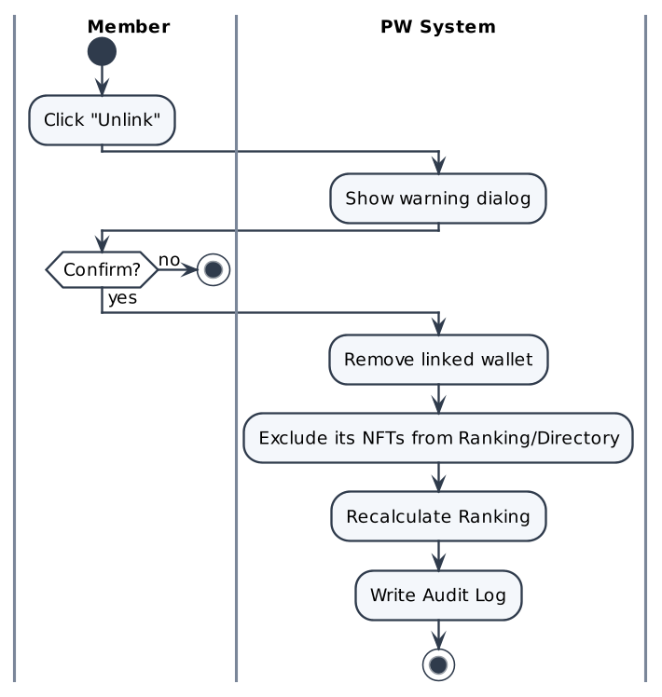

Screen Description
Screen 1: Unlink wallet – confirmation
[Screenshot: Figma frame "PW — Unlink Wallet (dialog)"]
# | Name | Control type | Data type | Required | Description
1 | Warning text | Label | String |  | "NFTs in this wallet will no longer count toward your ranking."
2 | Wallet address | Label | String |  | Address to be unlinked.
3 | Unlink wallet | Button (destructive) | N/A |  | Confirms the unlink.
4 | Cancel | Button | N/A |  | Closes the dialog.

UC12: View Pricing by Class

Use Case Description
UC ID | UC12
UC Name | View Pricing by Class
Objective | Display the Title price table for Classes 0–7 in CHF so that users understand the price before purchasing.
Actor | Visitor (R01), Company (R02), Individual (R03)
Trigger | The user opens "Pricing".
Pre-condition | - None (public page).
Post-condition | Success:  • The price table is displayed. No data is changed.
Basic flow | 1. User opens "Pricing".  2. System loads the active price table.  3. System displays one row per Class (0–7) and one column per Title (Philanthropist, Investor, Bridge), amounts in CHF.  4. If the user is a logged-in Company, System highlights the user's Class and shows "Your class".
Alternative flow | A1 – Visitor or Individual  1. The table is shown without a highlighted Class; Individuals see the Class 0 prices (BR-01).
Exception flow | E1 – Price table not configured  1. System shows "Pricing is being updated. Please check back soon."
Business rule | • BR01 – Price depends on Title × Class (BR-01).  • BR02 – Prices are shown in CHF; 1 CHF = 1 Point for rewards (BR-03).  • BR03 – Price values per Class × Title are in BRD BR-01; an Individual is priced as Class 0.
Non-functional requirement | • NFR01 – Prices are configuration data; a change is effective without code release.
Acceptance criteria | AC01 – Logged-in Company  Given a logged-in Company of Class X, when "Pricing" is opened, then all Classes 0–7 × 3 Titles are shown in CHF and Class X is highlighted.  AC02 – Visitor  Given not logged in, when "Pricing" is opened, then the full table is shown without highlight.
Traceability | BRD: FR-011 · BPMN: —

Activity Diagram
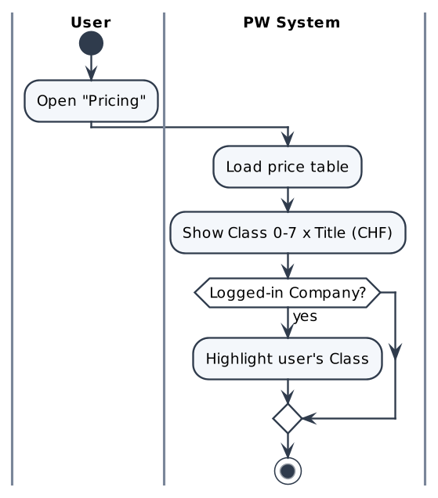

Screen Description
Screen 1: Pricing
[Screenshot: Figma frame "PW — Pricing (to be designed)"]
# | Name | Control type | Data type | Required | Description
1 | Price table | Table | Decimal (CHF) |  | Rows Class 0–7; columns Philanthropist, Investor, Bridge.
2 | Your class | Highlight / Badge | String |  | Only for logged-in Companies.
3 | Buy a Title | Button | N/A |  | Navigates to UC13 (login required).

UC13: Browse Titles

Use Case Description
UC ID | UC13
UC Name | Browse Titles
Objective | Display the three purchasable Titles with description and the price for the Member's Class, and let the Member start a purchase for themselves or a gift.
Actor | Company (R02), Individual (R03)
Trigger | The Member opens "Titles".
Pre-condition | - The Member is logged in.
Post-condition | Success:  • The Title catalogue is displayed; purchase actions are enabled only if KYC = Approved.
Basic flow | 1. Member opens "Titles".  2. System lists the 3 Titles: Philanthropist, Investor, Bridge – each with description and the price for the Member's Class (UC16).  3. System shows "Buy for myself" and "Gift" on each Title.  4. Member selects a Title and an action → UC14 (Buy for myself) or UC15 (Gift).
Alternative flow | A1 – KYC not approved  1. At step 3 KYC ≠ Approved.  2. Titles and prices are visible; purchase actions are disabled with "Complete KYC to purchase a Title." and a link to UC04.
Exception flow | E1 – Price not available  1. The Class/price cannot be resolved → price shows "—" and purchase actions are disabled.
Business rule | • BR01 – Exactly three Titles: Philanthropist, Investor, Bridge.  • BR02 – Purchasing a Title issues a Distinction NFT.  • BR03 – Individuals are priced as Class 0 (BR-01).
Non-functional requirement | • NFR01 – Catalogue loads within 2 seconds (proposed).
Acceptance criteria | AC01 – KYC approved  Given the Member is KYC-approved, when "Titles" is opened, then 3 Titles with description, price for the Member's Class and "Buy for myself" / "Gift" are shown.  AC02 – KYC not approved  Given KYC ≠ Approved, when "Titles" is opened, then actions are disabled with "Complete KYC to purchase a Title.".
Traceability | BRD: FR-011 · BPMN: D2 – Browse & Select Title

Activity Diagram
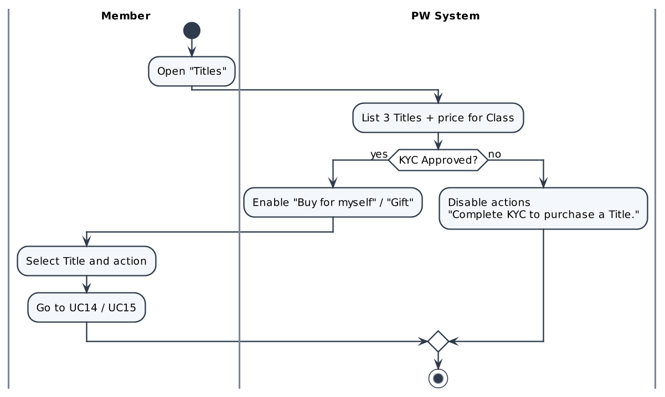

Screen Description
Screen 1: Select Title (Step 1)
[Screenshot: Figma frame "PW — Acquisition & Gifting (Step 1: Select Title)"]
# | Name | Control type | Data type | Required | Description
1 | Title card | Card | N/A |  | One per Title: Philanthropist / Investor / Bridge (no Class label on the card).
2 | Description | Label | String |  | Short meaning of the Title.
3 | Price | Label | Decimal (CHF) |  | Price for the Member's Class, e.g. "3,500 CHF".
4 | Buy for myself | Button | N/A |  | Starts UC14.
5 | Gift | Button | N/A |  | Starts UC15.
6 | KYC notice | Alert | String |  | "Complete KYC to purchase a Title." when KYC ≠ Approved.

UC14: Purchase Title for Myself

Use Case Description
UC ID | UC14
UC Name | Purchase Title for Myself
Objective | Allow a KYC-approved Member to buy a Title for themselves. After the Payment Gateway confirms payment, PW creates a custodial wallet if needed, mints a Distinction NFT directly to the buyer (Active immediately), distributes points, updates Ranking and records the audit trail.
Actor | Buyer – Company (R02) / Individual (R03); PW System (R05); Payment Gateway, Circle, Blockchain (external)
Trigger | The Member clicks "Buy for myself" on a Title.
Pre-condition | - The buyer is logged in and KYC = "Approved".  - The Title price for the buyer's Class is configured.
Post-condition | Success:  • Payment captured; Purchase Request status = Completed.  • Distinction NFT minted to the buyer's custodial wallet, status Active, one-time transfer available.  • Points credited (UC18); Ranking updated (UC28); Audit Log written; success notification sent.  Failure:  • Payment declined/cancelled: no NFT, no points, status = Failed/Cancelled.  • Payment OK but issuance failed: the order is cancelled and a full refund is requested (UC34, see E3).
Basic flow | 1. Buyer selects a Title and clicks "Buy for myself" (recipient = self).  2. System confirms that the recipient (buyer) is KYC-verified.  3. System calculates the price summary (UC16): base price for the buyer's Class, Year-2 discount if eligible, points used if any (UC24), final price in CHF.  4. System displays Step 2 "Review": Title, recipient = "Myself", price summary, estimated points to be earned.  5. Buyer clicks "Continue to payment".  6. System displays Step 3 "Payment": the buyer's saved card is preselected (default card first).  7. Buyer keeps the saved card and clicks "Pay".  8. System validates the card selection, creates the Purchase Request (status = Pending payment) and sends the card payment to the Payment Gateway.  9. Payment Gateway processes the card payment and returns the result.  10. System receives "payment successful" and sets the Purchase Request to Paid.  11. System checks whether the buyer has a custodial wallet; if not, creates it via Circle (UC07).  12. System prepares the NFT issuance and mints the Distinction NFT to the buyer's wallet (UC17).  13. System receives the mint result = success, assigns wallet & NFT to the buyer and sets the NFT status = Active.  14. System distributes points 10/10/10 (UC18).  15. System updates Ranking (UC28) and records the Audit Log (PURCHASE, MINT).  16. System notifies the buyer and displays the success screen "Your Title has been issued" with the NFT details (Title, token ID, issue date, links to My Titles and Verify).
Alternative flow | A1 – Buyer goes back / cancels  1. At step 5 or step 7 Buyer clicks "Back" → no Purchase Request is created; return to the previous step (or UC13).  A2 – Buyer already has a wallet  1. At step 11 the wallet exists → no wallet is created; continue at step 12.  A3 – Pay with a new card  1. At step 7 Buyer clicks "+ Add new card" (top right of the Payment section).  2. System opens the New card form: card number, expiry date, security code, name on card, billing country, "Save this card for future purchases" (checked by default), "Set as default payment method".  3. Buyer fills in the form and clicks "Pay"; continue at step 8.  4. On payment success (step 10), if "Save this card" is ticked, System saves the card token returned by the Payment Gateway; if "Set as default" is ticked, it becomes the default card.  A4 – No saved card (first purchase)  1. At step 6 the buyer has no saved card → System shows the New card form directly (no "+ Add new card" link); continue at A3 step 3.
Exception flow | E1 – Buyer not KYC-verified  1. At step 2 KYC ≠ Approved → System shows the KYC error "Complete KYC to purchase a Title."; the flow ends.  E2 – Card declined  1. At step 9 the Payment Gateway declines the card.  2. System sets the Purchase Request = Failed and displays "Your card was declined. Try another card."  3. No NFT is minted; no points are credited; used points (if any) are returned. Buyer can choose another card (back to step 7).  E3 – Wallet creation or minting fails after payment  1. At step 11 or 12–13 Circle or the blockchain fails.  2. System cancels the order (no NFT is Active, no points are credited), informs the buyer and starts the refund (UC34).  3. There is no automatic retry in this version (BR-11).  E4 – Payment Gateway timeout  1. No result within the timeout → status = Pending payment; System re-checks the payment status before any retry to avoid double charge.  E5 – Invalid card details  1. At step 8 a card field is invalid (card number fails the check, expiry date in the past, security code missing).  2. System shows the error under the field – "This card number isn't valid. Check the digits and try again." / "This card has expired." – and does not send the payment.  3. Buyer corrects the field; back to step 7.
Business rule | • BR01 – Only KYC-approved Members can purchase (BR-08).  • BR02 – The recipient type (self / other) is fixed before payment (BR-08).  • BR03 – Mint only after payment confirmation; the NFT is minted directly to the recipient and is Active immediately – no accept step.  • BR04 – One Purchase Request can be paid only once (idempotent payment reference).  • BR05 – Points: 10% buyer / 10% recipient / 10% system of the amount paid (BR-03); if buyer = recipient the buyer earns 10% once.  • BR06 – A purchased Title is a Distinction NFT: transferable once (BR-06).  • BR07 – Titles are paid by credit/debit card only, via the Payment Gateway (BRD Scope); other payment methods are out of scope.  • BR08 – Saved cards are stored as tokens by the payment provider; PW keeps only brand, last 4 digits and expiry. Only one saved card can be the default.
Non-functional requirement | • NFR01 – Price summary displayed within 1 second after the Title is selected (proposed).  • NFR02 – Card payments are processed by a PCI DSS–compliant Payment Gateway; PW never stores the full card number, only a tokenized reference (NFR-003).  • NFR03 – Minting runs asynchronously; the buyer sees a progress state and is never charged twice (NFR-004, NFR-010).
Acceptance criteria | AC01 – Purchase successfully  Given a KYC-approved buyer selects "Buy for myself", when the buyer pays with a valid card and the payment succeeds, then a wallet is created if needed, a Distinction NFT is minted Active to the buyer, points are credited, Ranking and Audit Log are updated and the success screen is shown.  AC02 – Card declined  Given the buyer is on Payment, when the gateway declines the card, then "Your card was declined. Try another card." is shown and no NFT/points are issued.  AC03 – Back / cancel  Given the buyer is on Review or Payment, when "Back" is clicked before paying, then no Purchase Request is created.  AC04 – Issuance fails  Given payment succeeded, when minting fails, then the order is cancelled, a full refund request is sent (UC34), the buyer is informed and the event is logged.  AC05 – Pay with saved card  Given the buyer has a saved card, when the Payment step opens, then the default card is preselected and the buyer can pay without entering card details.  AC06 – Add and save a new card  Given the buyer clicks "+ Add new card" and enters valid details with "Save this card" ticked, when the payment succeeds, then the card is added to the buyer's saved cards.  AC07 – Invalid card details  Given the buyer enters an invalid card number or an expired date, when the buyer clicks "Pay", then the error is shown under that field and the payment is not sent.  AC08 – First purchase  Given the buyer has no saved card, when the Payment step opens, then the New card form is shown directly.
Traceability | BRD: FR-012, FR-013, FR-016, FR-017, FR-018, FR-035, NFR-003 · BPMN: D2 – Purchase (self) · US: US-TN02

Activity Diagram
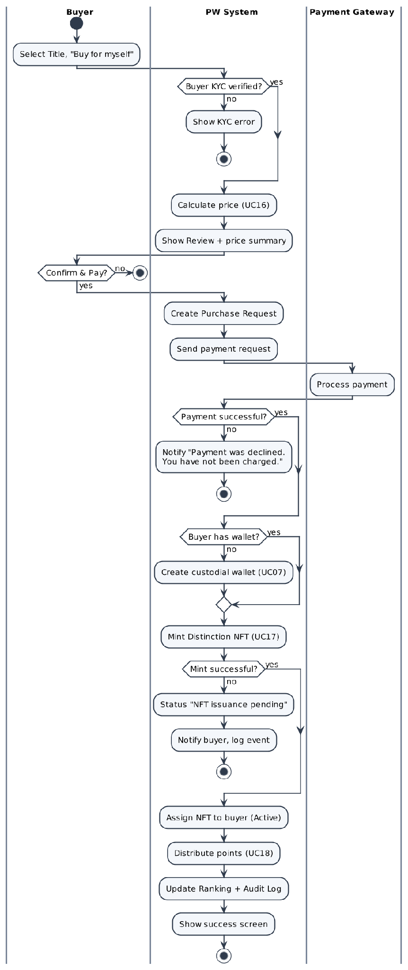

Screen Description
Screen 1: Review & pay (Step 2 – For myself)
[Screenshot: Figma frame "PW — Acquisition & Gifting (Step 2: For Myself)"]
# | Name | Control type | Data type | Required | Description
I. Order
1 | Title | Label | String |  | Selected Title (e.g. Investor) with type "Distinction NFT".
2 | Recipient | Label | String |  | "Myself" + account name.
II. Price summary
1 | Base price | Label | Decimal (CHF) |  | Price of the Title for the buyer's Class.
2 | Year-2 loyalty discount | Label | Decimal (CHF) |  | "–20%" line shown only when eligible (UC16).
3 | Points used | Numeric input / Toggle | Integer |  | Up to the balance and the Title price after the Year-2 discount (BR-04).
4 | Final price | Label | Decimal (CHF) |  | Amount charged.
5 | Points you will earn | Label | Integer |  | 10% of the final price, rounded up.
III. Actions
1 | Continue to payment | Button | N/A |  | Opens Step 3 "Payment" (Screen 2). No payment is taken yet.
2 | Back | Button | N/A |  | Returns to Step 1 without creating a request.

Screen 2: Payment (Step 3)
[Screenshot: Figma frame "PW — Acquisition & Gifting (Step 3: Payment)" – states: Saved card selected / Adding a new card / Card error / No saved cards]
# | Name | Control type | Data type | Required | Description
I. Payment method
1 | Section header | Label + Text button | N/A |  | "Payment method – Pay by credit or debit card." with the text button "+ Add new card" at the top right (hidden when there is no saved card).
2 | Saved card | Radio | Mixed |  | Card brand, "•••• last 4 digits", expiry date and "Default" chip. The default card is preselected.
II. New card form
1 | Card number | Textbox | Number | Yes | 13–19 digits, formatted in groups of 4; brand detected automatically. Error: "This card number isn't valid. Check the digits and try again."
2 | Expiry date | Textbox | MM / YY | Yes | Must not be in the past. Error: "This card has expired."
3 | Security code | Textbox (masked) | Number | Yes | 3–4 digits (CVC).
4 | Name on card | Textbox | String | Yes | Name as shown on the card.
5 | Billing country | Dropdown | List | Yes | Default = account country.
6 | Save this card for future purchases | Checkbox | Boolean |  | Default: checked. The card is saved as a token by the payment provider (BR08).
7 | Set as default payment method | Checkbox | Boolean |  | Default: unchecked.
III. Summary & actions
1 | Order summary | Label | Decimal (CHF) |  | Title, recipient, base price, discount, points used, final price (UC16, UC24).
2 | Security note | Label | String |  | "Payments are processed securely by our payment provider. PW never stores your full card number." + Visa / Mastercard / Amex logos.
3 | Pay | Button | N/A |  | Sends the card payment to the Payment Gateway (step 8). Enabled when a saved card is selected or all required New card fields are filled.
4 | Back | Button | N/A |  | Returns to Step 2 without paying.

Screen 3: Purchase result
[Screenshot: Figma frame "PW — Title issued (success) / Payment declined / Issuance failed"]
# | Name | Control type | Data type | Required | Description
1 | Result title | Label | String |  | "Your Title has been issued" | "Your card was declined. Try another card." | "We could not issue your Title. A full refund has been requested.".
2 | NFT details | Card | Mixed |  | Title, type Distinction, token ID, issue date, status Active.
3 | Points earned | Label | Integer |  | Credited points.
4 | View My Titles | Button | N/A |  | Opens UC09.
5 | Verify on-chain | Link | N/A |  | Opens UC27.

UC15: Gift Title to Another Member

Use Case Description
UC ID | UC15
UC Name | Gift Title to Another Member
Objective | Allow a KYC-approved buyer to buy a Title for another KYC-verified PW Member. The Distinction NFT is minted directly to the recipient (wallet created via Circle if missing), is Active immediately and the recipient receives a one-way Gift Notification.
Actor | Buyer – Company (R02) / Individual (R03); Recipient (Member, notified); PW System (R05); Payment Gateway, Circle, Blockchain
Trigger | The Member clicks "Gift" on a Title.
Pre-condition | - The buyer is logged in and KYC = "Approved".
Post-condition | Success:  • Distinction NFT minted Active to the recipient's custodial wallet; the recipient's one-time transfer is NOT consumed.  • Points: 10% buyer, 10% recipient, 10% system; Gift Notification sent; Ranking and Audit Log updated.  Failure:  • As in UC14 (declined / cancelled / issuance failed → refund, UC34).
Basic flow | 1. Buyer selects a Title and clicks "Gift".  2. System displays Step 2 "Choose recipient".  3. Buyer searches for the recipient by registered name, email or PW member ID (search keys – assumption) and selects one.  4. System checks that the recipient is KYC-verified.  5. System calculates the price summary on the BUYER's Class (assumption) (UC16) and displays Review: Title, recipient name, price summary.  6. Buyer clicks "Continue to payment".  7. System displays Step 3 "Payment" (same as UC14 – Screen 2); Buyer keeps the saved card (or adds a new card – UC14 A3/A4) and clicks "Pay".  8. System validates the card, creates the Purchase Request (type = Gift) and sends the card payment to the Payment Gateway.  9. Payment Gateway returns "payment successful".  10. System checks whether the recipient has a custodial wallet; if not, creates it via Circle (UC07).  11. System mints the Distinction NFT directly to the recipient's wallet (UC17) and sets it Active.  12. System distributes points: 10% buyer, 10% recipient, 10% system (UC18).  13. System sends the Gift Notification to the recipient (in-app + email): Title, buyer's name, link to the NFT – no action required.  14. System updates Ranking for the recipient, records the Audit Log (GIFT, MINT) and shows the buyer the success screen "Your gift has been issued to [Recipient]".
Alternative flow | A1 – Recipient = buyer  1. At step 3 the buyer selects their own account → the order is treated as "Buy for myself" (UC14).  A2 – Change recipient  1. Before step 6 the buyer clicks "Change" → back to step 3.  A3 – Back / cancel  1. At step 6 or step 7 the buyer clicks "Back" → no Purchase Request is created.  A4 – Pay with a new card / no saved card  1. At step 7 → same as UC14 A3 / A4.
Exception flow | E1 – Recipient not KYC-verified  1. At step 4 → System shows "This member must complete identity verification before receiving a Title." and does not allow "Continue to payment".  E2 – Recipient not found  1. At step 3 no Member matches → "No verified member found."  E3 – Card declined / timeout / invalid card details  1. Same as UC14-E2 / E4 / E5.  E4 – Wallet creation or minting fails  1. Same as UC14-E3; the recipient is not notified until the NFT is Active.
Business rule | • BR01 – The recipient must be a KYC-verified PW Member (locked rule; BPMN D2 "Is Recipient KYC Verified?").  • BR02 – A gift is a variation of Purchase, not a Transfer: it does NOT consume the recipient's one-time transfer.  • BR03 – No accept/decline step: the NFT is Active on issue; the notification is one-way.  • BR04 – If the recipient has no wallet, PW creates one via Circle (BPMN D2).  • BR05 – Price is based on the BUYER's Class (assumption).  • BR06 – Aligned with US-TN03 and US-AW01 (PW_US_AC_final).  • BR07 – Payment by credit/debit card only; saved cards handled as in UC14 (BR07, BR08).
Non-functional requirement | • NFR01 – Recipient search returns results within 2 seconds (proposed).  • NFR02 – Gift Notification delivered within 1 minute after mint confirmation (proposed).
Acceptance criteria | AC01 – Gift successfully  Given the recipient is a KYC-verified Member, when the buyer pays successfully, then the NFT is minted Active to the recipient (wallet created if needed), 10%/10%/10% points are credited, the recipient gets the Gift Notification and the recipient's transfer stays available.  AC02 – Recipient not verified  Given the selected member is not KYC-verified, when the buyer tries to continue, then the KYC error is shown and "Continue to payment" is unavailable.  AC03 – Self as recipient  Given the buyer selects their own account, when the recipient is confirmed, then the order is processed as "Buy for myself".  AC04 – Card payment  Given the buyer is on Payment, when the buyer pays with a saved or new card, then the same card rules as UC14 AC02, AC05–AC08 apply.
Traceability | BRD: FR-012, FR-013, FR-018, FR-035, NFR-003 · BPMN: D2 – Purchase (gift) / Notify Recipient · US: US-TN03

Activity Diagram
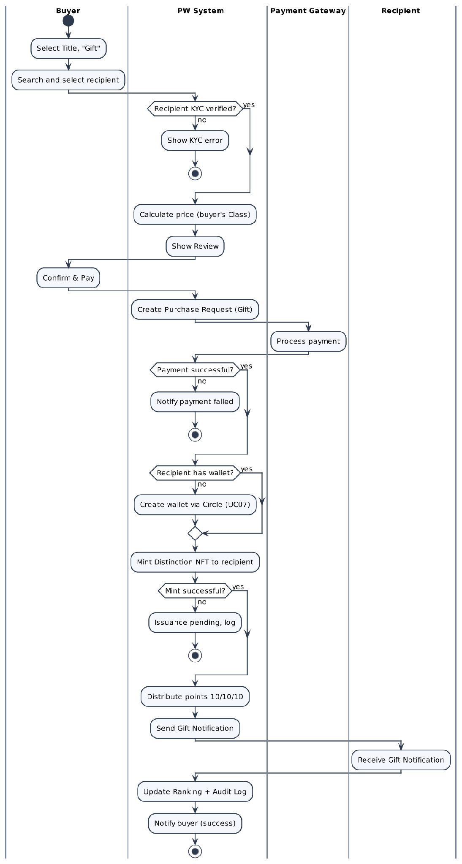

Screen Description
Screen 1: Choose recipient & review (Step 2 – Gift)
[Screenshot: Figma frame "PW — Acquisition & Gifting (Step 2: Gift)"]
# | Name | Control type | Data type | Required | Description
I. Recipient
1 | Search recipient | Search box (autocomplete) | String | Yes | Search KYC-verified Members by name, email or member ID (assumption); min. 3 characters.
2 | Selected recipient | Card | Mixed |  | Name, type (Company/Individual), "Verified" badge.
3 | Change | Link | N/A |  | Clears the selection (A2).
4 | KYC error | Alert | String |  | "This member must complete identity verification before receiving a Title."
II. Price summary
1 | Base price / discount / final price | Label | Decimal (CHF) |  | Same rules as UC14, calculated on the buyer's Class.
2 | Points | Label | Integer |  | "You earn X points · Recipient earns X points".
III. Actions
1 | Continue to payment | Button | N/A |  | Enabled only when a verified recipient is selected; opens Step 3 "Payment" (Screen 2).
2 | Back | Button | N/A |  | Leaves without creating a request.

Screen 2: Payment (Step 3 – Gift)
Same as UC14 – Screen 2 (Payment); the order summary shows the recipient's name.

Screen 3: Gift Notification (recipient)
[Screenshot: Figma frame "PW — Notification (Gift received)"]
# | Name | Control type | Data type | Required | Description
1 | Title | Label | String |  | "You have received the [Title] Title from [Buyer name]".
2 | NFT link | Link | N/A |  | Opens the NFT in My Titles (UC09).
3 | Channel | In-app + Email | N/A |  | One-way; no action required.

UC16: Calculate Price and Apply Discount

Use Case Description
UC ID | UC16
UC Name | Calculate Price and Apply Discount
Objective | Calculate the amount payable for a Title from the buyer's Class, apply the 20% Year-2 loyalty discount when both conditions are met and (if enabled) points used, and present a transparent price summary.
Actor | PW System (R05)
Trigger | The buyer reaches the Review step of UC14/UC15, or the Purchase Request is received.
Pre-condition | - The buyer's Class is known.  - The price table is configured.
Post-condition | Success:  • Base price, discount, points used and final price (CHF) are calculated, displayed and stored on the Purchase Request.
Basic flow | 1. System reads the price of the selected Title for the buyer's current Class (base price).  2. System checks Year-2 eligibility: account active for at least 2 years since KYC approval AND point balance ≥ 1,000 points (BR-02).  3. If eligible, System applies discount = base price × 20%.  4. If points redemption is enabled and the buyer chooses to use points, System applies them (UC24).  5. System calculates final price = base price − discount − points value (never below 0).  6. System displays the summary and stores all amounts on the Purchase Request.
Alternative flow | A1 – Not eligible for discount  1. At step 2 a condition is not met → no discount; System shows what is still required (time remaining or points missing).  A2 – Gift  1. The Class used is the BUYER's Class (assumption).
Exception flow | E1 – Price missing for the Class  1. System blocks the purchase and logs a configuration error.
Business rule | • BR01 – Base price = price(Title, buyer's Class) (BR-01).  • BR02 – Year-2 discount = 20% of the list price when the account has been active for at least 2 years since KYC approval AND holds at least 1,000 points (BR-02; the 1,000-point threshold is a BA proposal for the Business to confirm).  • BR03 – Amounts in CHF with 2 decimals; points conversion 1 CHF = 1 Point, rounded up (BR-03).  • BR04 – The price is re-calculated when the Purchase Request is created; if it differs from the displayed price, the buyer must confirm again.  • BR05 – Individuals are priced as Class 0 (BR-01); points are redeemed as in BR-04.
Non-functional requirement | • NFR01 – Calculations are exact and auditable (NFR-010).
Acceptance criteria | AC01 – No discount  Given the buyer is not eligible, when the summary is calculated, then final price = base price for the buyer's Class.  AC02 – With discount  Given the buyer is eligible and base price = 1,000 CHF, when the summary is calculated, then discount = 200 CHF and final price = 800 CHF, labelled "Year-2 loyalty discount –20%".  AC03 – Not eligible – hint  Given the account is younger than 2 years, when the summary is shown, then the missing condition (time remaining) is displayed.
Traceability | BRD: FR-016, FR-017 · BPMN: D2 – Calculate Price + Discount/Points

Activity Diagram
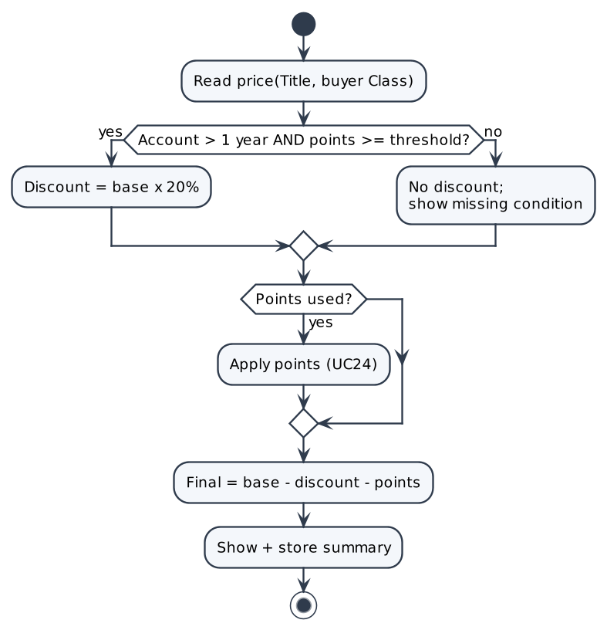

Screen Description
N/A – background system process with no dedicated screen. Results are shown in the screens of the calling use cases.

UC17: Mint NFT

Use Case Description
UC ID | UC17
UC Name | Mint NFT
Objective | Mint an NFT on-chain through the PW smart contract (via Alchemy) whenever a purchase is paid (Distinction NFT) or an Award is granted (soulbound Award NFT). There is no manual mint screen.
Actor | PW System (R05); Blockchain / Smart Contract (external)
Trigger | Payment confirmed (UC14/UC15) or Award grant confirmed (UC29), after the recipient wallet is available.
Pre-condition | - The recipient wallet address is known.  - For purchases: payment is confirmed.
Post-condition | Success:  • NFT on-chain; token ID, transaction hash, owner, type, category, issue date stored; status Active; Audit Log (MINT / AWARD_MINT).  Failure:  • No Active NFT; event logged; caller flow handles the error.
Basic flow | 1. System prepares the issuance: type (Distinction for purchase, Award for grant), category, recipient wallet, metadata.  2. System sends the mint request to the smart contract via Alchemy.  3. Blockchain executes the mint and returns the transaction hash.  4. System waits for on-chain confirmation.  5. System stores token ID, transaction hash, owner, type, category, issue date and sets status = Active.  6. System writes the Audit Log entry and returns success to the calling use case.
Alternative flow | A1 – Award  1. For a grant, the token is minted as soulbound (non-transferable).
Exception flow | E1 – Mint failed / timeout  1. At step 3/4 the transaction fails or is not confirmed within the timeout.  2. System does not set the NFT Active, logs the event and returns failure (purchase → order cancelled and refund requested, UC34; grant → Admin error).
Business rule | • BR01 – Minting is triggered only by a confirmed payment or an Admin grant; no manual mint function.  • BR02 – PW is the sole issuing authority; the NFT is minted directly to the recipient and is Active immediately.  • BR03 – Every mint is recorded in the Audit Log.
Non-functional requirement | • NFR01 – NFTs are immutable and publicly verifiable on-chain (NFR-005).  • NFR02 – Mint confirmation is typically obtained within 2 minutes (proposed; depends on chain).
Acceptance criteria | AC01 – Mint on purchase  Given payment is confirmed, when the mint succeeds, then a Distinction NFT is Active for the recipient with token ID, tx hash and issue date stored.  AC02 – Mint on grant  Given a grant is confirmed, when the mint succeeds, then a soulbound Award NFT is Active for the recipient.  AC03 – Mint fails  Given a mint is requested, when the blockchain call fails, then no Active NFT exists and the event is logged.
Traceability | BRD: FR-013 · BPMN: D2, D3 – Prepare NFT Issuance / Mint

Activity Diagram
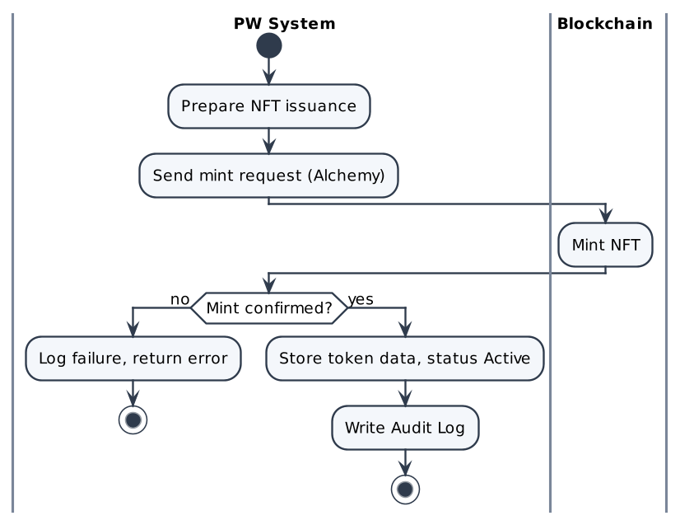

Screen Description
N/A – background system process with no dedicated screen. Results are shown in the screens of the calling use cases.

UC18: Distribute Reward Points

Use Case Description
UC ID | UC18
UC Name | Distribute Reward Points
Objective | After a paid transaction, award points on the amount paid: 10% to the buyer, 10% to the recipient and 10% to the system pool, using 1 CHF = 1 Point rounded up (BR-03).
Actor | PW System (R05)
Trigger | The NFT of a paid Purchase Request is Active (UC14/UC15).
Pre-condition | - The transaction is paid (not an Admin grant).
Post-condition | Success:  • Point transactions created (account, amount, type Earned, reason, reference, time); balances updated.
Basic flow | 1. System reads the final paid amount (CHF) of the Purchase Request.  2. System calculates each share = amount × 10%, rounded UP to a whole point.  3. System credits the buyer share.  4. System credits the recipient share.  5. System credits the system-pool share.  6. System creates one point transaction per credit, linked to the Purchase Request, and writes an Audit Log entry (POINTS_EARN).
Alternative flow | A1 – Admin grant  1. For an Award grant no points are credited (0 points).  A2 – Buyer = recipient  1. The buyer receives 10% once (BR-03).
Exception flow | E1 – Credit fails  1. The whole credit is rolled back and retried; no partial credit is kept.
Business rule | • BR01 – 10% buyer / 10% recipient / 10% system of the amount paid (BR-03); paid transactions only.  • BR02 – 1 CHF = 1 Point, rounded up (BR-03).  • BR03 – Points are credited only once per Purchase Request.
Non-functional requirement | • NFR01 – Exact, auditable calculation (NFR-010).
Acceptance criteria | AC01 – Gift 1,255 CHF  Given a gift is paid 1,255 CHF, when points are distributed, then buyer 126, recipient 126, system 126 points (125.5 → 126) and 3 point transactions exist.  AC02 – Admin grant  Given an Award is granted, when the NFT is issued, then no points are credited.
Traceability | BRD: FR-018 · BPMN: D2 – Distribute Points 10/10/10

Activity Diagram
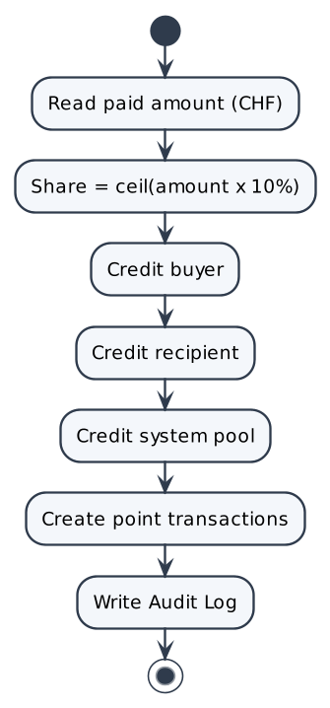

Screen Description
N/A – background system process with no dedicated screen. Results are shown in the screens of the calling use cases.

UC34: Refund After Mint Failure

Use Case Description
UC ID | UC34
UC Name | Refund After Mint Failure
Objective | When a paid purchase or gift cannot be minted, cancel the order and request a full refund so that the buyer is not charged for a Title that was never issued.
Actor | PW System (R05); Payment Gateway (external); Buyer (informed); PW Admin (R04, only if the refund request fails)
Trigger | Payment is confirmed (UC14 / UC15) and minting fails (UC17) or the custodial wallet cannot be created (UC07).
Pre-condition | - Payment is confirmed for the Purchase Request.  - Minting or wallet creation failed.
Post-condition | Success:  • The order is Cancelled (mint failed); no NFT is Active; no points are credited; points used in the order are returned.  • A refund request for the full amount is sent to the Payment Gateway; the buyer is informed; an Audit Log entry is written.  Failure:  • The refund request fails: the Admin is notified to refund manually and the event is logged.
Basic flow | 1. System detects a mint failure after a confirmed payment (UC17 E1 or UC07 E1).  2. System cancels the Purchase Request (Cancelled – mint failed). There is no automatic retry (BR-11).  3. System returns the points used in the order, if any.  4. System sends a refund request for the full amount to the Payment Gateway immediately (BR-12).  5. System tells the buyer: "We could not issue your Title. A full refund has been requested to your original card. Your bank usually takes 5–10 business days to show it."  6. System writes an Audit Log entry with the order reference and the amount.
Alternative flow | A1 – Gift  1. The gift recipient is not notified, because no NFT was issued (UC15).
Exception flow | E1 – Refund request fails  1. At step 4 the Payment Gateway rejects the request or does not answer.  2. System notifies the Admin to refund manually and logs the event (BR-12).  3. The message to the buyer in step 5 does not change.
Business rule | • BR01 – If payment succeeded but minting fails, the order is cancelled and a full refund is requested; there is no automatic retry (BR-11).  • BR02 – The refund request is sent immediately. The money returns to the original card; the card issuer usually takes 5–10 business days to show it. This is not a PW commitment (BR-12).  • BR03 – If the refund request fails, the Admin refunds manually (BR-12).
Non-functional requirement | • NFR01 – Every refund request and its result are written to the Audit Log (NFR-002).
Acceptance criteria | AC01 – Refund requested  Given payment succeeded, when minting fails, then the order is cancelled, a full refund request is sent to the Payment Gateway, the buyer is informed and an Audit Log entry is written.  AC02 – No points  Given a refund was requested, then no points are credited and points used in the order are returned.  AC03 – Refund request fails  Given the Payment Gateway rejects the refund request, then the Admin is notified and the event is logged.
Traceability | BRD: FR-035, BR-11, BR-12 · BPMN: D2 – Mint failed branch · US: US-TN10

Activity Diagram
See BPMN D2 (Purchase / Gift): the "Mint failed" branch leads to the refund request.

Screen Description
The buyer sees the issuance-failed message on the result screen (see UC14, result screen "Issuance failed"). No other screen.

UC19: Transfer NFT to Own Non-custodial Wallet (Self-custody)

Use Case Description
UC ID | UC19
UC Name | Transfer NFT to Own Non-custodial Wallet (Self-custody)
Objective | Allow the owner to move an Active Distinction NFT from the PW custodial wallet to their own verified non-custodial wallet. This uses the one-time transfer; the NFT is then locked in that wallet and keeps counting toward Ranking.
Actor | NFT owner – Company (R02) / Individual (R03); PW System (R05); Blockchain
Trigger | The owner clicks "Transfer" on a Distinction NFT and chooses "To my own wallet".
Pre-condition | - The NFT is an Active Distinction in the custodial wallet.  - Its one-time transfer is unused.
Post-condition | Success:  • NFT transferred on-chain; one-time transfer consumed; custody = "Self-custody (verified)"; NFT locked; still counted in Ranking; Audit Log (TRANSFER_SELF).  Failure:  • No transfer; custody stays Custodial; one-time transfer NOT consumed.
Basic flow | 1. Owner opens the NFT and clicks "Transfer".  2. System validates the NFT: type = Distinction, status = Active, transfer not yet used.  3. System displays "Choose destination" with the shared linked-wallet list.  4. Owner selects the linked, verified wallet.  5. System displays the Review: NFT, destination, notice "This uses your one-time transfer. The NFT will be locked in the destination wallet."  6. Owner clicks "Confirm transfer".  7. System submits the on-chain transfer (no new signature needed) and sets custody = "Transfer pending" (UC21).  8. Blockchain executes the transfer.  9. System receives the confirmation, marks the one-time transfer as consumed, locks the NFT and sets custody = "Self-custody (verified)".  10. System keeps the NFT counted in Ranking (UC28), writes the Audit Log and notifies "Transfer completed."
Alternative flow | A1 – New wallet "This is my wallet"  1. At step 4 the destination is not linked.  2. Owner enters the address and ticks "This is my wallet".  3. System runs Connect + Sign (UC10); if the signed address equals the destination, the wallet is linked automatically.  4. Continue at step 5.  A2 – Cancel  1. At step 6 Owner cancels → no transfer.
Exception flow | E1 – Award NFT  1. At step 2 type = Award → "Award NFTs are soulbound and cannot be transferred." (Transfer action is normally hidden).  E2 – Transfer already used  1. At step 2 → "This NFT has already used its one-time transfer."  E3 – Revoked NFT  1. At step 2 status = Revoked → transfer blocked.  E4 – Signature mismatch  1. In A1 the signed address differs → "The signed wallet doesn't match the destination address."; no transfer.  E5 – On-chain failure  1. At step 8/9 the transaction fails → custody back to Custodial; transfer NOT consumed; "Transfer failed. Your NFT is still in your PW wallet."
Business rule | • BR01 – Award = soulbound; Distinction = one transfer only; Revoked = no transfer (BR-06).  • BR02 – Self-custody uses the one-time transfer; the NFT cannot be transferred again afterwards.  • BR03 – After the transfer the NFT is locked in the destination wallet.  • BR04 – Only a linked, signature-verified wallet keeps the NFT in Ranking; 1 wallet ↔ 1 account.  • BR05 – The transfer is consumed only after on-chain success.
Non-functional requirement | • NFR01 – Status shows "Transfer pending" until on-chain confirmation; no duplicate submission possible.
Acceptance criteria | AC01 – To linked wallet  Given an Active Distinction with transfer unused and a linked verified wallet, when the owner confirms, then the NFT moves on-chain without a new signature, transfer is consumed, custody = Self-custody (verified) and it still counts in Ranking.  AC02 – New wallet signed  Given destination not linked, "This is my wallet" ticked, when the owner signs and addresses match, then the wallet is auto-linked and the transfer proceeds.  AC03 – Signature mismatch  Given "This is my wallet" ticked, when the signed address differs, then "The signed wallet doesn't match the destination address." and no transfer.  AC04 – Award  Given the NFT is an Award, when a transfer is requested, then "Award NFTs are soulbound and cannot be transferred.".
Traceability | BRD: FR-010, FR-031, FR-033 · BPMN: D4.2 – Transfer NFT to own wallet (links the wallet via D4.1)

Activity Diagram
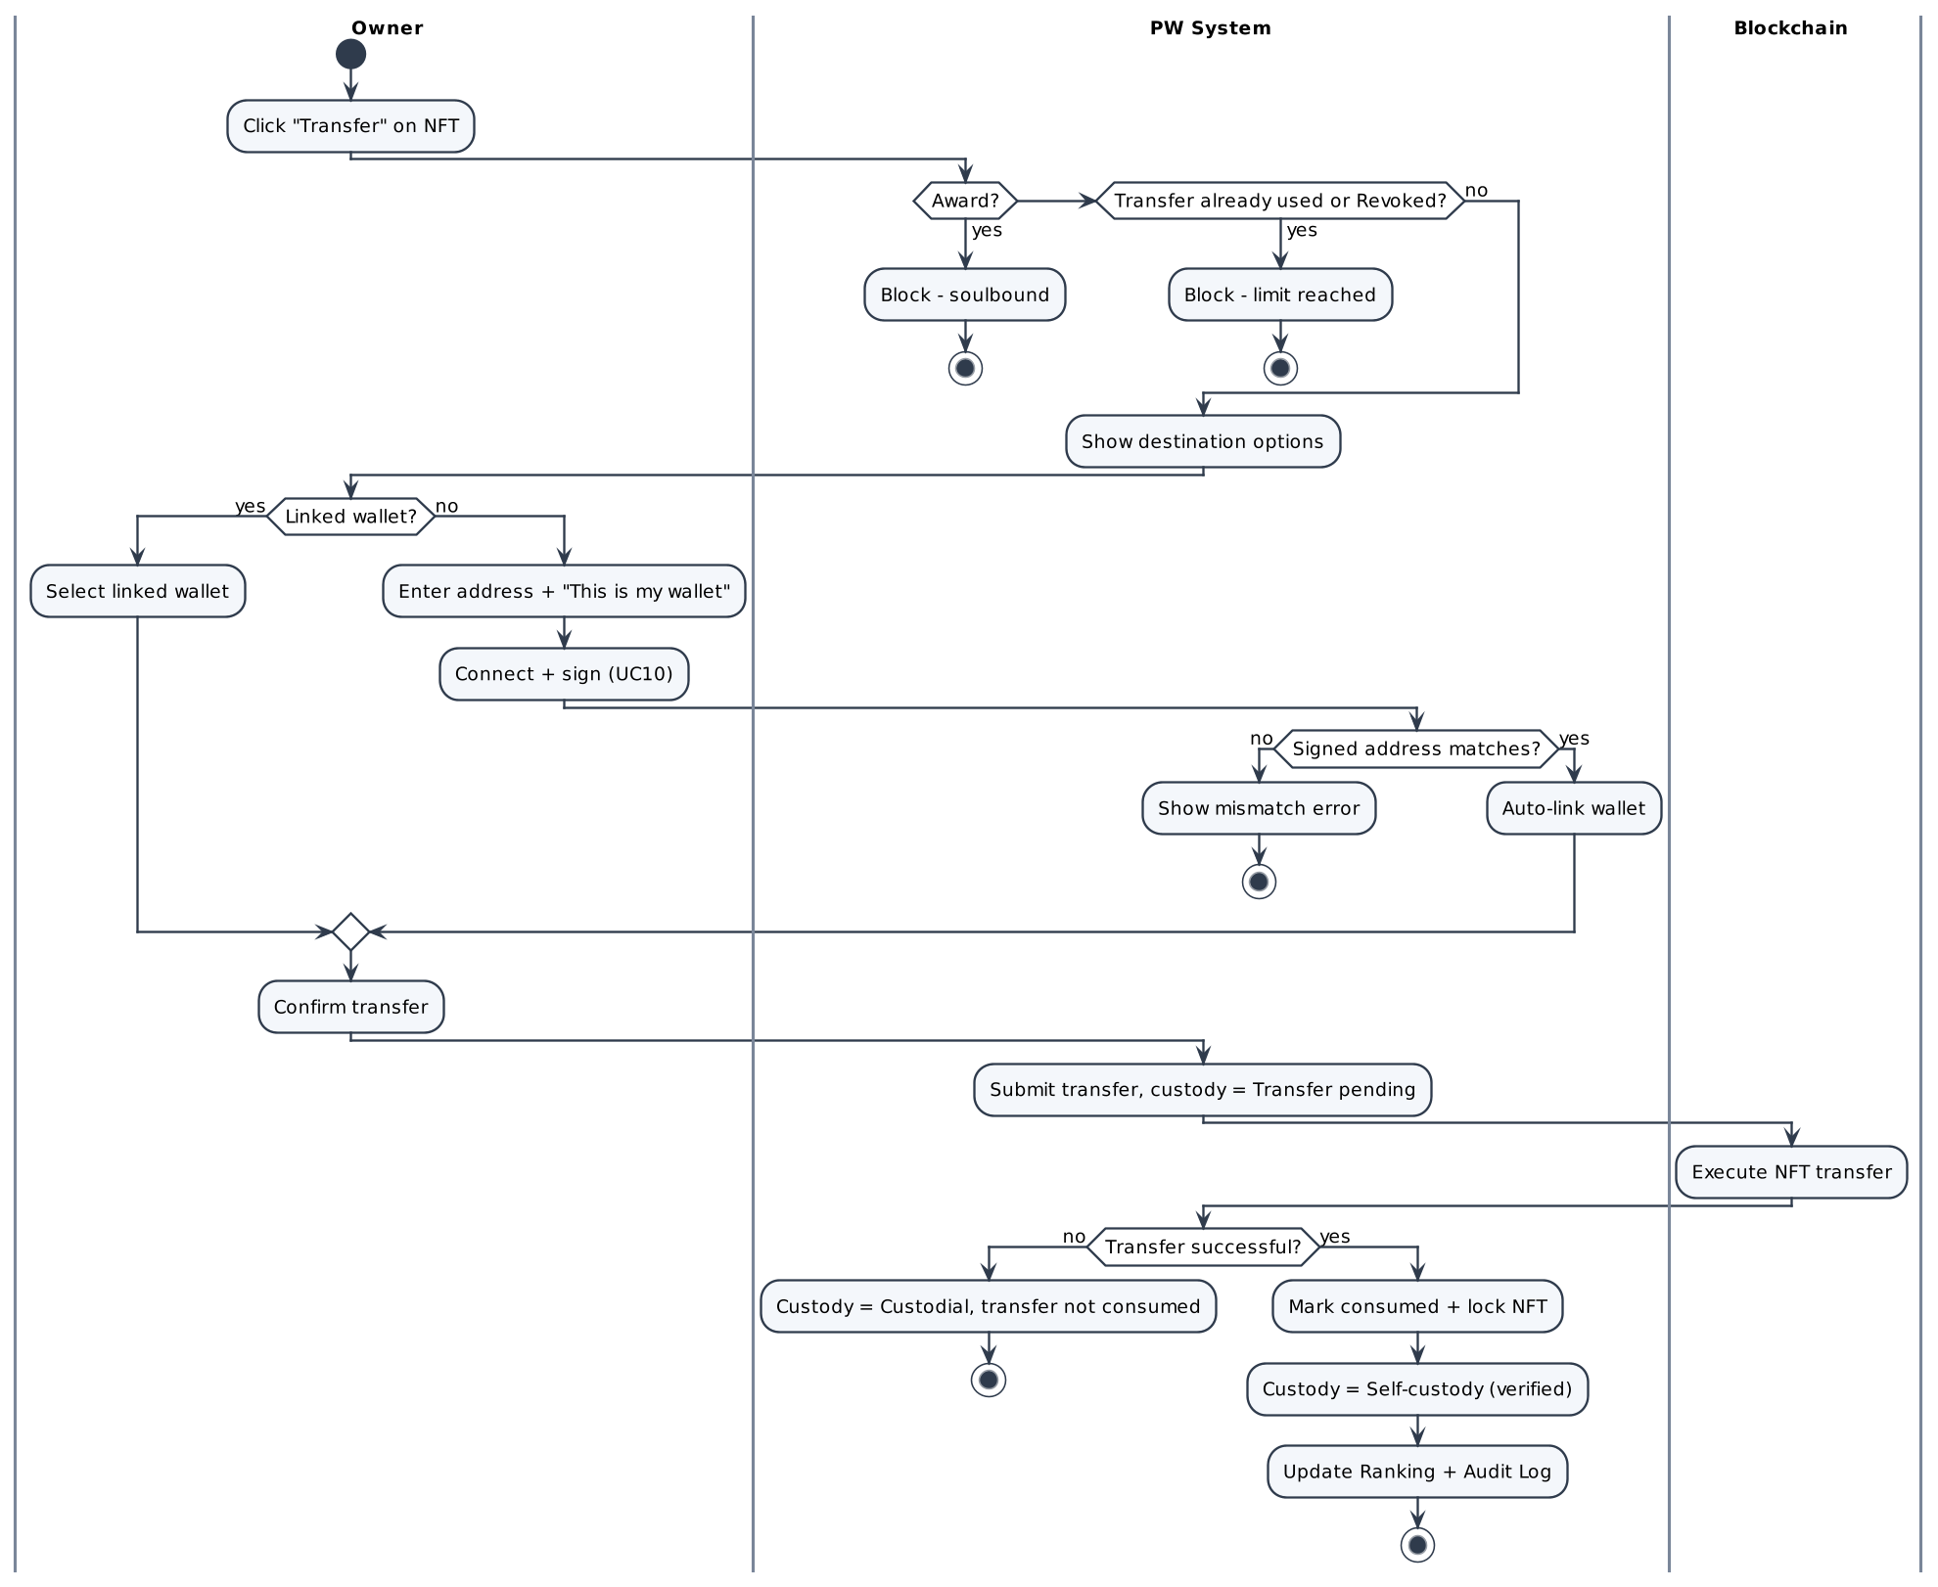

Screen Description
Screen 1: Transfer – choose destination & review
[Screenshot: Figma frame "PW — Transfer NFT (Choose destination / Review)"]
# | Name | Control type | Data type | Required | Description
I. Destination
1 | Destination type | Radio | Enum | Yes | "My linked wallet".
2 | Linked wallet list | Radio list | String | Cond. | Shared linked-wallet list; shows address and "Verified".
3 | Wallet address | Textbox | String | Cond. | For a new own wallet; format/network validated.
4 | This is my wallet | Checkbox | Boolean |  | Triggers Connect + Sign (A1).
II. Review
1 | One-time transfer notice | Alert | String |  | "This uses your one-time transfer. The NFT will be locked in the destination wallet."
2 | Confirm transfer | Button | N/A |  | Submits the transfer.
3 | Cancel | Button | N/A |  | Leaves without transfer.
4 | Status | Badge | Enum |  | Transfer pending → Self-custody (verified) / Failed.

UC21: Track NFT Custody Status

Use Case Description
UC ID | UC21
UC Name | Track NFT Custody Status
Objective | Keep each NFT's custody status in sync with the blockchain: Custodial → Transfer pending → Self-custody (verified) or Transferred; on failure the NFT stays Custodial and the one-time transfer is not used.
Actor | PW System (R05); Blockchain
Trigger | A transfer transaction is submitted (UC19).
Pre-condition | - A transfer transaction has been submitted.
Post-condition | Success:  • Custody status reflects the on-chain result; Audit Log entry per change.
Basic flow | 1. System sets custody = "Transfer pending" when the transaction is submitted.  2. System monitors the transaction status on-chain.  3. On confirmation, System sets custody = "Self-custody (verified)" (own linked wallet).  4. System marks the one-time transfer as consumed and writes an Audit Log entry.
Alternative flow | N/A
Exception flow | E1 – Transaction failed or dropped  1. System sets custody back to "Custodial", does NOT consume the transfer, logs the event and notifies the owner.
Business rule | • BR01 – Custody values: Custodial, Transfer pending, Self-custody (verified), Transferred.  • BR02 – The transfer counter changes only on on-chain success.
Non-functional requirement | • NFR01 – Status polling interval ≤ 30 seconds while pending (proposed).
Acceptance criteria | AC01 – Confirmed  Given a transfer to a linked wallet is submitted, when it is confirmed on-chain, then custody = Self-custody (verified) and an Audit Log entry exists.  AC02 – Pending  Given the transaction is unconfirmed, when the owner views the NFT, then "Transfer pending" is shown.  AC03 – Failed  Given the transaction fails, when the failure is received, then custody = Custodial and the transfer is not consumed.
Traceability | BRD: FR-033 · BPMN: D4.2 – Receive Transfer Result / Update Owner

Activity Diagram
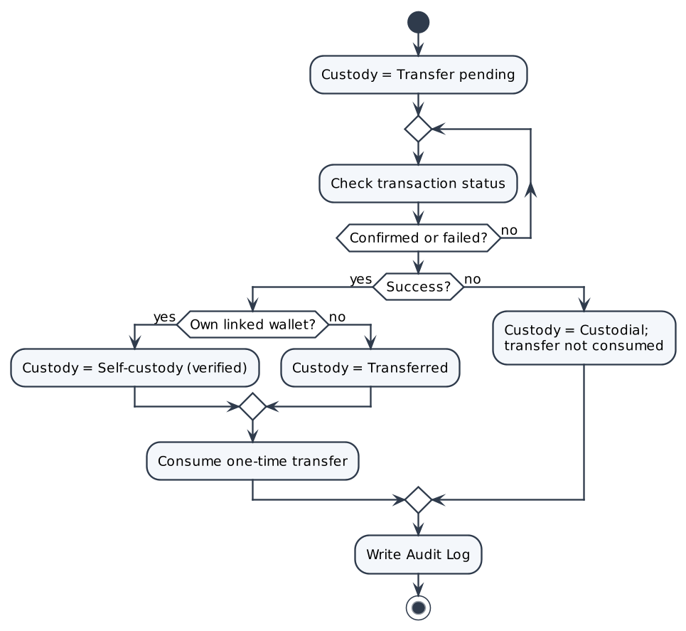

Screen Description
N/A – background system process with no dedicated screen. Results are shown in the screens of the calling use cases.

UC22: Reconcile Linked Wallets On-chain

Use Case Description
UC ID | UC22
UC Name | Reconcile Linked Wallets On-chain
Objective | Periodically compare the on-chain holdings of every linked non-custodial wallet with platform records; NFTs no longer held there are removed from the owner's Ranking and Directory profile and each finding is logged.
Actor | PW System (R05, scheduler); Blockchain
Trigger | Scheduled job.
Pre-condition | - At least one linked non-custodial wallet exists.
Post-condition | Success:  • Mismatches flagged, excluded from Ranking/Directory, written to the Audit Log (RECONCILE).
Basic flow | 1. Scheduler starts the reconciliation job.  2. System reads the list of linked wallets and the NFTs recorded in each.  3. System queries the on-chain holdings of each wallet.  4. System compares on-chain holdings with the records.  5. For each NFT no longer in the linked wallet, System flags the mismatch, removes it from the owner's Ranking and Directory profile and writes an Audit Log entry.  6. System triggers a Ranking recalculation if any change was found (UC28).
Alternative flow | A1 – No mismatch  1. No change is made; the job run is logged.
Exception flow | E1 – Blockchain query fails  1. The wallet is skipped and retried in the next run; the error is logged.
Business rule | • BR01 – TBD: check frequency (owner: Tech lead with Compliance, end of Week 3; BRD Appendix).  • BR02 – The job never moves NFTs; it only updates records and Ranking.
Non-functional requirement | • NFR01 – The job must not degrade user-facing performance (runs in background).
Acceptance criteria | AC01 – Mismatch  Given an NFT recorded in a linked wallet is no longer there on-chain, when the job runs, then it is removed from Ranking and Directory profile and logged.  AC02 – No mismatch  Given all records match, when the job runs, then no ranking change is made.
Traceability | BRD: FR-034 · BPMN: —

Activity Diagram
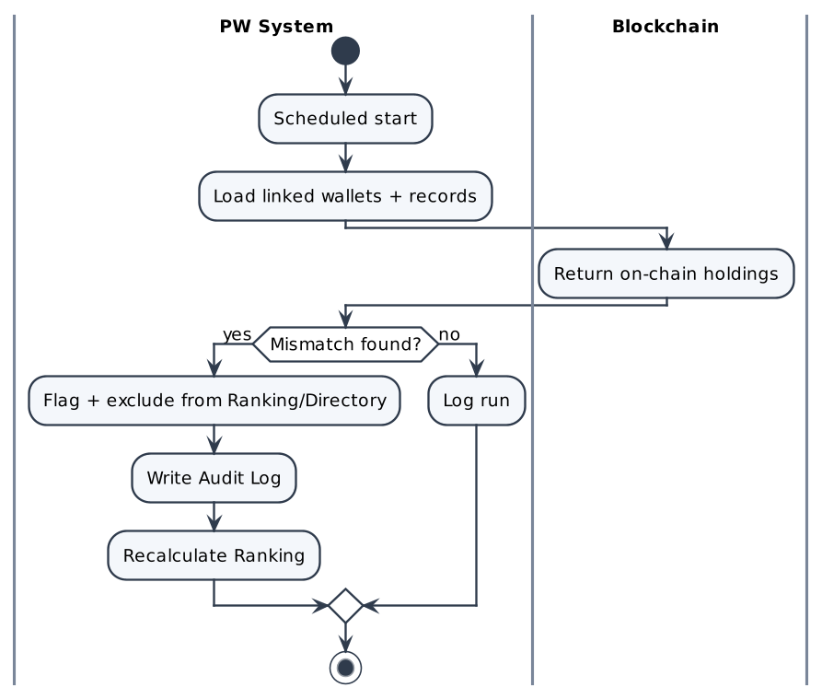

Screen Description
N/A – background system process with no dedicated screen. Results are shown in the screens of the calling use cases.

UC23: View Point Balance and History

Use Case Description
UC ID | UC23
UC Name | View Point Balance and History
Objective | Show the Member's current point balance and the history of point transactions.
Actor | Company (R02), Individual (R03)
Trigger | The Member opens "Points".
Pre-condition | - The Member is logged in.
Post-condition | Success:  • Balance and history displayed. No data is changed.
Basic flow | 1. Member opens "Points".  2. System displays the current balance.  3. System displays the history (date, type Earned / Used / Adjusted, amount ±, reference, balance after), newest first, 20 rows per page (assumption).  4. System shows the Year-2 discount progress (account age and points vs threshold).
Alternative flow | A1 – No points  1. Balance 0 and "Earn points when you buy or receive a Title."
Exception flow | E1 – Load error  1. Retry message.
Business rule | • BR01 – Balance = sum of all point transactions; never below 0.
Non-functional requirement | • NFR01 – History loads within 2 seconds (proposed).
Acceptance criteria | AC01 – Has points  Given the Member has transactions, when "Points" is opened, then balance and history (newest first) are shown.  AC02 – No points  Given no transactions, when "Points" is opened, then balance 0 and the hint message are shown.
Traceability | BRD: FR-019 · BPMN: —

Activity Diagram
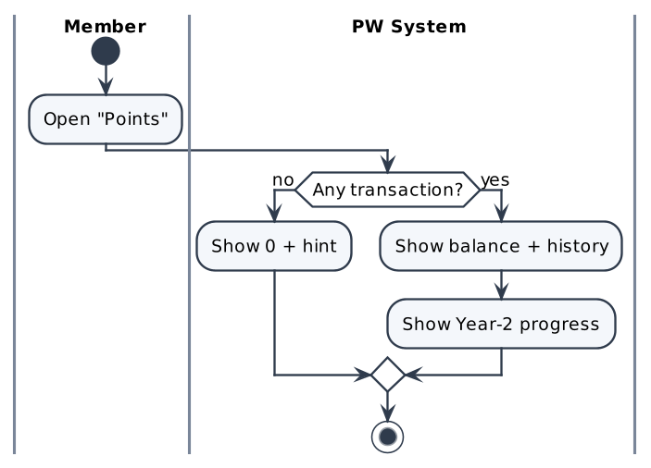

Screen Description
Screen 1: Points
[Screenshot: Figma frame "PW — Points (to be designed)"]
# | Name | Control type | Data type | Required | Description
1 | Current balance | Label / KPI card | Integer |  | Total points.
2 | Year-2 discount progress | Progress bar | Mixed |  | Account age and points vs threshold (threshold 1,000 points, BA proposal).
3 | History table | Table | Mixed |  | Date, Type (Earned/Used/Adjusted), Amount (±), Reference (order/NFT/admin), Balance after.
4 | Pagination | Pager | N/A |  | 20 rows per page (assumption).

UC24: Use Points

Use Case Description
UC ID | UC24
UC Name | Use Points
Objective | Allow the Member to use earned points during a purchase within the available balance; used points are linked to the order and returned if the order is cancelled or payment fails.
Actor | Company (R02), Individual (R03); PW System (R05)
Trigger | The buyer chooses to use points on the Review step of UC14/UC15.
Pre-condition | - The buyer has a positive point balance.  - Points are deducted from the price (BR-04).
Post-condition | Success:  • A "Used" point transaction linked to the order; balance reduced.  Order cancelled / payment failed:  • Used points returned ("Returned" transaction).
Basic flow | 1. Buyer enables "Use points" and enters the number of points.  2. System checks that the amount ≤ available balance.  3. System recalculates the price summary (UC16).  4. When the buyer clicks "Pay", System reserves the points on the order.  5. On payment success, System records a "Used" transaction linked to the order.
Alternative flow | A1 – Order cancelled / payment failed  1. System releases the reserved points back to the balance.
Exception flow | E1 – Amount exceeds balance  1. "You can use up to [balance] points."; input rejected.
Business rule | • BR01 – Balance never below 0.  • BR02 – 1 point reduces the total by CHF 1, up to the balance and the Title price after the Year-2 discount; points are deducted only after payment succeeds (BR-04).
Non-functional requirement | • NFR01 – Reservation and release are atomic with the order status (NFR-010).
Acceptance criteria | AC01 – Within balance  Given balance 500, when the buyer uses 200 and pays, then a Used transaction of 200 is linked to the order and balance = 300.  AC02 – Exceeds balance  Given balance 100, when the buyer enters 150, then the input is rejected.  AC03 – Payment fails  Given points reserved, when payment fails, then points are returned.
Traceability | BRD: FR-020 · BPMN: D2 – Discount/Points

Activity Diagram
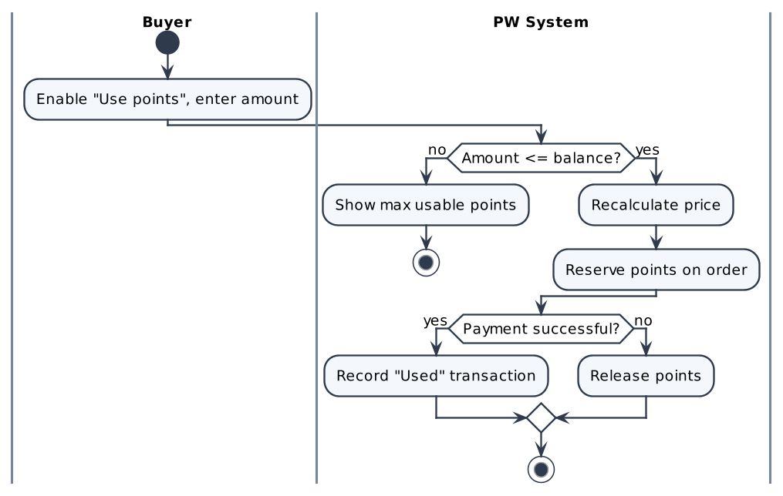

Screen Description
N/A – background system process with no dedicated screen. Results are shown in the screens of the calling use cases.

UC25: Browse Public Directory

Use Case Description
UC ID | UC25
UC Name | Browse Public Directory
Objective | Provide a public, login-free directory of KYC-approved Companies and Individuals recognized by PW, ordered by Ranking, with search and filters.
Actor | Public Verifying User / Visitor (R01) (also Members and Admin)
Trigger | The user opens the Public Directory.
Pre-condition | - None.
Post-condition | Success:  • Matching profiles displayed. No data is changed.
Basic flow | 1. User opens the Public Directory.  2. System fetches directory data and lists KYC-approved public profiles: rank, name, type (Company / Individual), Class, number of counted NFTs, ordered by Ranking.  3. User searches by name or filters by type, Class or Title category.  4. System displays only matching profiles (paginated).  5. User selects a profile → UC26.
Alternative flow | A1 – No result  1. "No results for '[keyword]'." with a "Clear filters" action.
Exception flow | E1 – Load error  1. Retry message.
Business rule | • BR01 – Only KYC-approved entities are listed.  • BR02 – Order = Ranking (UC28).
Non-functional requirement | • NFR01 – Directory first page loads within 2 seconds (proposed).  • NFR02 – Public data only; no personal contact data.
Acceptance criteria | AC01 – Browse  Given the Directory is opened without login, when the page loads, then approved profiles are listed by Ranking.  AC02 – Filter  Given the user filters by Title category, when the filter is applied, then only matching profiles are shown.  AC03 – No result  Given nothing matches, when the search runs, then "No results for '[keyword]'." is shown.
Traceability | BRD: FR-021 · BPMN: D6 – Browse Public Directory

Activity Diagram
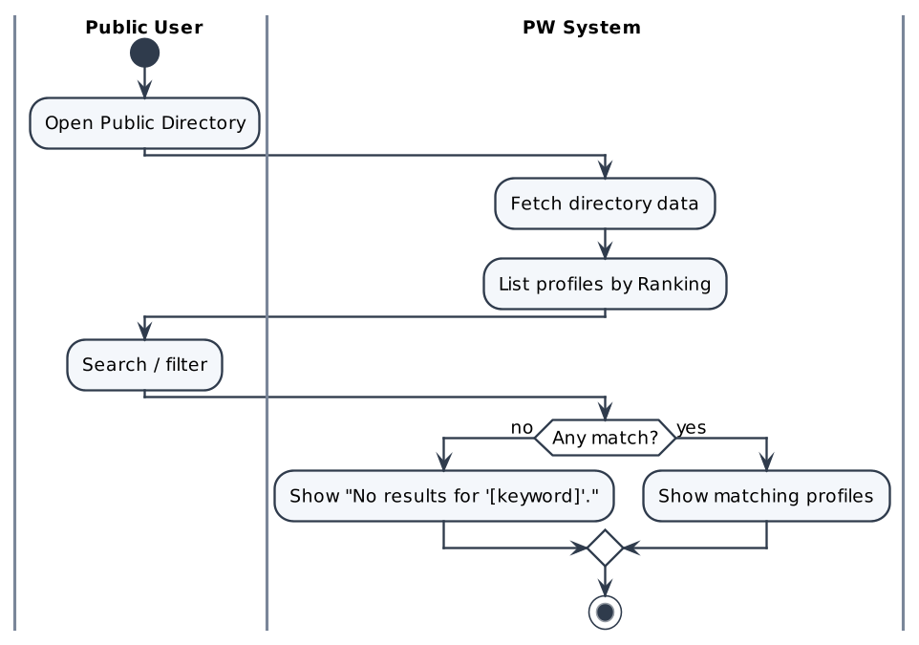

Screen Description
Screen 1: Public Directory
[Screenshot: Figma frame "PW — Public Directory"]
# | Name | Control type | Data type | Required | Description
1 | Search | Textbox | String |  | Search by name.
2 | Type filter | Dropdown | Enum |  | All / Company / Individual.
3 | Class filter | Multi-select | Enum |  | Class 0–7.
4 | Title category filter | Multi-select | Enum |  | Philanthropist / Investor / Bridge.
5 | Directory list | Table / Cards | Mixed |  | Rank, name, type, Class, number of NFTs; row click → UC26.
6 | Empty state | Label | String |  | "No results for '[keyword]'."

UC26: View Profile and Recognitions

Use Case Description
UC ID | UC26
UC Name | View Profile and Recognitions
Objective | Show the public profile of a Company or Individual and the NFTs counted for it, so that third parties can see which recognitions it holds.
Actor | Public Verifying User / Visitor (R01)
Trigger | The user selects a profile in the Directory or opens a profile link.
Pre-condition | - The profile belongs to a KYC-approved account.
Post-condition | Success:  • Profile and NFT list displayed. No data is changed.
Basic flow | 1. User opens a profile.  2. System displays public information: name, type, Class, rank.  3. System lists the counted NFTs: name, category, type (Distinction / Award), "Issued by PW", issue date, status.  4. User clicks "Verify" on an NFT → UC27.
Alternative flow | A1 – Revoked NFT  1. The NFT is shown with the label "Revoked".  A2 – No NFTs  1. "No recognitions yet."
Exception flow | E1 – Profile not found / not public  1. "This profile is not available."
Business rule | • BR01 – Only public data is shown (no email, KYC data or point balance).  • BR02 – NFTs in an unlinked wallet are not shown.
Non-functional requirement | • NFR01 – Profile loads within 2 seconds (proposed).
Acceptance criteria | AC01 – View  Given a profile with NFTs, when it is opened, then name, type, Class, rank and each NFT's name, category, type, issuer, date and status are shown.  AC02 – Revoked  Given one NFT is revoked, when the profile is shown, then that NFT is labelled "Revoked".  AC03 – No NFTs  Given no NFT, when the profile is opened, then "No recognitions yet." is shown.
Traceability | BRD: FR-022, FR-023 · BPMN: D6 – View Profile / View NFT

Activity Diagram
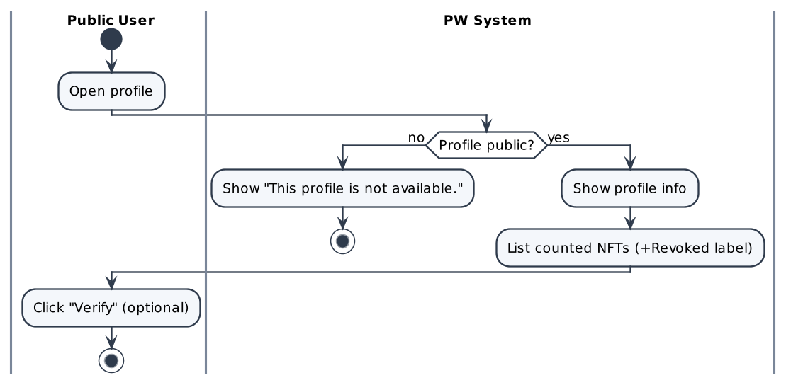

Screen Description
Screen 1: Public profile
[Screenshot: Figma frame "PW — Public Profile"]
# | Name | Control type | Data type | Required | Description
1 | Profile header | Label group | String |  | Name, type, Company Class (Companies only), rank.
2 | Recognitions list | Cards | Mixed |  | Name, category, type, "Issued by PW", issue date, status.
3 | Verify | Button | N/A |  | Opens UC27 for the NFT.
4 | Empty state | Label | String |  | "No recognitions yet."

UC27: Verify NFT On-chain

Use Case Description
UC ID | UC27
UC Name | Verify NFT On-chain
Objective | Allow anyone to verify an NFT against the blockchain and PW's contract and receive one of three results: Valid, Revoked or Invalid.
Actor | Public Verifying User / Visitor (R01); PW System (R05); Blockchain
Trigger | The user enters a token ID on "Verify" or clicks "Verify" on a profile/NFT.
Pre-condition | - None.
Post-condition | Success:  • Exactly one result is displayed. No data is changed.
Basic flow | 1. User opens "Verify" and enters a token ID (or it is pre-filled from a profile).  2. User clicks "Verify".  3. System sends the verification request and queries the on-chain state (existence, issuing contract, revocation state).  4. System determines the status.  5. Valid: System shows "Valid" with owner, type, category, issue date and transaction link.
Alternative flow | A1 – Revoked  1. Token issued by PW but revoked → "Revoked" with the revocation date.  A2 – Invalid  1. Token does not exist or was not issued by PW's contract → "Invalid – this NFT was not issued by PW."
Exception flow | E1 – Empty token ID  1. "Please enter a token ID."  E2 – Blockchain unavailable  1. "Verification is temporarily unavailable. Please try again."
Business rule | • BR01 – Exactly one of Valid / Revoked / Invalid.  • BR02 – The on-chain state is the source of truth (NFR-005).
Non-functional requirement | • NFR01 – Result within 3 seconds under normal conditions (proposed).
Acceptance criteria | AC01 – Valid  Given an existing PW token not revoked, when it is verified, then "Valid" with owner, type, category, issue date and tx link.  AC02 – Revoked  Given a revoked PW token, when it is verified, then "Revoked" with revocation date.  AC03 – Invalid  Given a non-PW or non-existent token, when it is verified, then "Invalid – this NFT was not issued by PW.".
Traceability | BRD: FR-024 · BPMN: D6 – Request NFT Verification / NFT status?

Activity Diagram
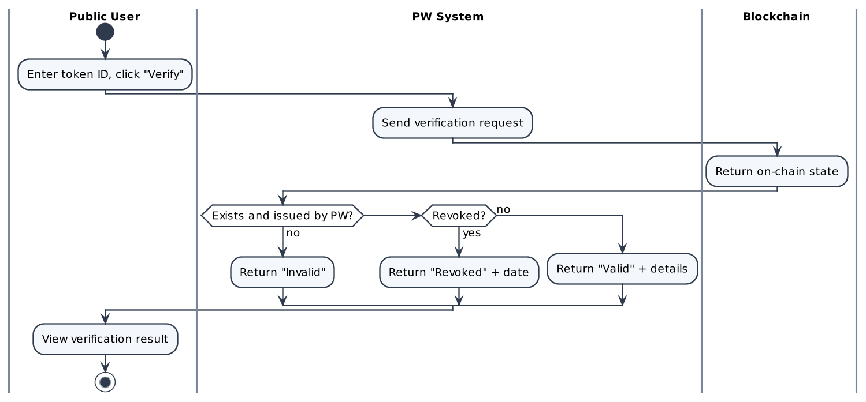

Screen Description
Screen 1: Verify NFT
[Screenshot: Figma frame "PW — Verify / Verification Result"]
# | Name | Control type | Data type | Required | Description
1 | Token ID | Textbox | String | Yes | Token ID to verify.
2 | Verify | Button | N/A |  | Runs the verification.
3 | Result badge | Badge | Enum |  | Valid (green) / Revoked (red) / Invalid (grey).
4 | Details | Label group | Mixed |  | Owner, type, category, issue date, transaction link (Valid); revocation date (Revoked).

UC28: Calculate Ranking

Use Case Description
UC ID | UC28
UC Name | Calculate Ranking
Objective | Automatically rank accounts by the total number of counted NFTs and recalculate after every event that changes holdings.
Actor | PW System (R05)
Trigger | Mint, transfer, revoke, link/unlink or reconciliation event.
Pre-condition | - At least one KYC-approved account exists.
Post-condition | Success:  • Every account has an up-to-date rank used by the Directory.
Basic flow | 1. System receives a ranking event.  2. System counts, per account, NFTs in the PW custodial wallet + NFTs in the linked signature-verified wallet.  3. System excludes NFTs in unlinked wallets.  4. System orders accounts by the counted total, highest first, and stores the rank.  5. System refreshes the Directory order.
Alternative flow | N/A
Exception flow | E1 – Calculation error  1. The previous ranking is kept and the error is logged; recalculation is retried.
Business rule | • BR01 – Ranking by total counted NFTs (BR-05).  • BR02 – Every NFT counts equally (Award = Distinction); revoked NFTs are not counted; ties list registered members first (BR-05).
Non-functional requirement | • NFR01 – Ranking reflects an event within 1 minute (proposed).
Acceptance criteria | AC01 – Order  Given A has 3 counted NFTs, B has 5, when ranking runs, then B ranks above A.  AC02 – Unlinked wallet  Given A unlinks a wallet holding one NFT, when ranking runs, then A's count decreases by 1.  AC03 – Self-custody  Given A moves an NFT to its linked wallet, when ranking runs, then A's count is unchanged.
Traceability | BRD: FR-025 · BPMN: D2, D3, D4.2 – Update Ranking

Activity Diagram
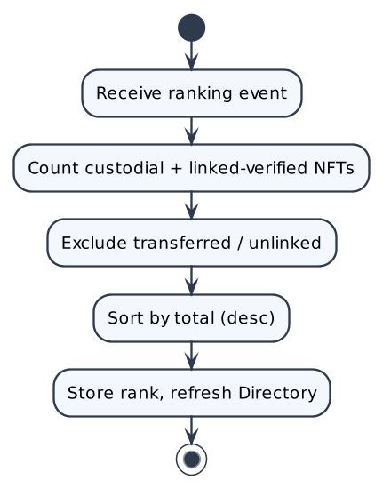

Screen Description
N/A – background system process with no dedicated screen. Results are shown in the screens of the calling use cases.

UC29: Grant Award

Use Case Description
UC ID | UC29
UC Name | Grant Award
Objective | Allow a PW Admin to grant a free Award (Investor / Philanthropist / Bridge) to a KYC-verified Member. A soulbound Award NFT is minted directly to the recipient; a custodial wallet is created first if needed.
Actor | PW Admin (R04); PW System (R05); Circle; Blockchain; Recipient (notified)
Trigger | The Admin clicks "Grant Award".
Pre-condition | - The Admin is logged in with the Admin role.
Post-condition | Success:  • Soulbound Award NFT Active for the recipient; 0 points; Ranking updated; recipient notified; Audit Log (AWARD_MINT).  Failure:  • No Active Award; Admin sees the error and can retry.
Basic flow | 1. Admin opens "Grant Award".  2. Admin searches and selects the recipient.  3. System validates the recipient: KYC = Approved.  4. Admin selects the Award category (Investor / Philanthropist / Bridge), enters the citation and clicks "Grant Award".  5. System displays the confirmation "Grant a soulbound [category] Award to [recipient]? 0 points will be credited."; Admin confirms.  6. System checks whether the recipient has a custodial wallet (creates it via Circle if not – UC07).  7. System prepares the issuance and mints the soulbound Award NFT (UC17).  8. System assigns the Award NFT (Soulbound, Active) to the recipient.  9. System updates Ranking, records the Audit Log and notifies the recipient ("PW has granted you the [category] Award").  10. System shows "Award granted successfully."
Alternative flow | A1 – Recipient has no wallet  1. At step 6 System creates the wallet via Circle, stores it and continues at step 7.  A2 – Cancel  1. At step 5 Admin cancels → nothing is issued.
Exception flow | E1 – Recipient not KYC-verified  1. At step 3 → "Recipient must be KYC-verified before receiving an Award."; grant blocked.  E2 – Wallet creation fails  1. "Award could not be issued because the recipient's wallet could not be created. Please try again."  E3 – Mint fails  1. "Award could not be issued. Please try again."; no Active Award.  E4 – Missing category or citation  1. Inline error; "Grant Award" disabled.
Business rule | • BR01 – Only the Admin role can grant.  • BR02 – Award uses the same 3 categories as Titles but is free and soulbound (e.g. "Investor Award").  • BR03 – Recipient must be KYC-verified.  • BR04 – Grants credit 0 points.  • BR05 – No accept step; Active immediately.
Non-functional requirement | • NFR01 – Issuance progress shown until mint confirmation.
Acceptance criteria | AC01 – Grant with wallet  Given a KYC-approved recipient with a wallet, when the Admin confirms, then a soulbound Award NFT is Active, 0 points, Ranking updated, recipient notified, Audit Log written.  AC02 – Grant without wallet  Given a KYC-approved recipient without a wallet, when the Admin confirms, then a custodial wallet is created and the Award is minted to it.  AC03 – Not KYC-verified  Given the recipient is not approved, when the Admin tries to grant, then the grant is blocked with the KYC message.  AC04 – Mint fails  Given the grant is confirmed, when the mint fails, then "Award could not be issued. Please try again.".
Traceability | BRD: FR-026 · BPMN: D3 – Grant Award

Activity Diagram
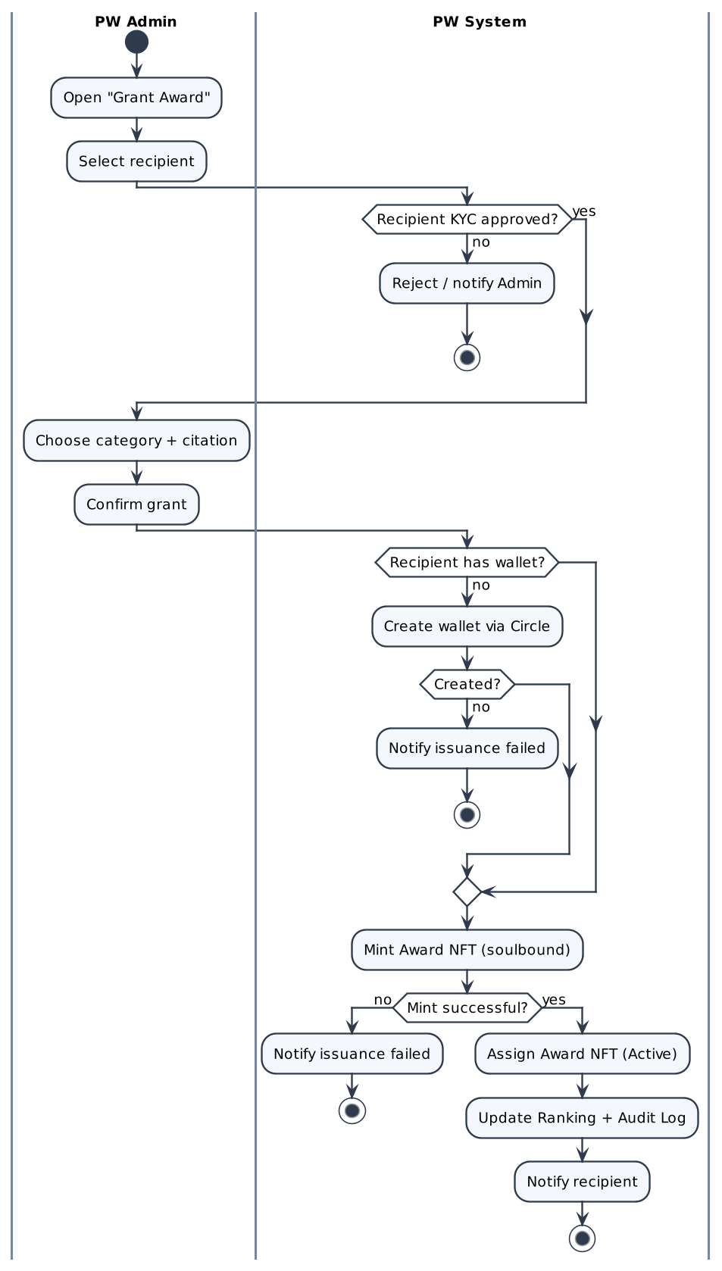

Screen Description
Screen 1: Grant Award
[Screenshot: Figma frame "Admin Portal (Grant Award)"]
# | Name | Control type | Data type | Required | Description
1 | Recipient | Search / Select | String | Yes | KYC-approved Members only; shows name, type, KYC badge, wallet status.
2 | Award category | Radio / Dropdown | Enum | Yes | Investor / Philanthropist / Bridge.
3 | Citation | Textarea | String | Yes | Reason for the Award shown on the NFT (max 500 characters – assumption).
4 | What happens | Info panel | String |  | Soulbound Award NFT · 0 points · Ranking updated · recipient notified.
5 | Preview | Card | N/A |  | Award badge preview.
6 | Grant Award | Button | N/A |  | Opens the confirmation dialog.
7 | Cancel | Button | N/A |  | Leaves without granting.
8 | Result message | Toast / Alert | String |  | Success or E1–E3 messages.

UC30: Revoke NFT

Use Case Description
UC ID | UC30
UC Name | Revoke NFT
Objective | Allow a PW Admin to irreversibly revoke a Distinction or Award NFT so that it is no longer presented as valid; the revocation is written on-chain.
Actor | PW Admin (R04); PW System (R05); Blockchain; NFT owner (notified)
Trigger | The Admin clicks "Revoke NFT".
Pre-condition | - The Admin is logged in.  - The NFT status = Active.
Post-condition | Success:  • NFT status = Revoked on-chain and in PW; Verify returns Revoked; owner notified; Ranking recalculated; Audit Log (NFT_REVOKE).  Failure:  • Status unchanged; Admin notified "Revoke failed".
Basic flow | 1. Admin opens "Revoke NFT" and finds the NFT by token ID or owner.  2. System displays the NFT record: name, type (Distinction / Award), owner, current wallet, token ID, issue date.  3. Admin selects a reason (required), optionally adds a note (max 500 characters) and ticks "I understand this action is irreversible".  4. Admin clicks "Revoke NFT".  5. System validates the Admin permission.  6. System sends the revoke request to the smart contract.  7. Blockchain updates the on-chain state to Revoked and returns the result.  8. System sets NFT status = Revoked, records the Audit Log, recalculates Ranking and notifies the owner.  9. System shows "NFT revoked."
Alternative flow | A1 – Cancel  1. Before step 4 → nothing changes.
Exception flow | E1 – Not permitted  1. At step 5 the user lacks the Admin role → "Access denied."  E2 – Missing reason or confirmation  1. "Revoke NFT" stays disabled.  E3 – On-chain update fails  1. At step 7 → status unchanged; "Revoke failed. Please try again."; event logged.  E4 – NFT not found  1. "No NFT found for this token ID or owner."
Business rule | • BR01 – Only Admin can revoke (BR-13); applies to Distinction and Award.  • BR02 – Revocation is irreversible.  • BR03 – A reason is mandatory.
Non-functional requirement | • NFR01 – Revocation is visible in Verify immediately after on-chain confirmation.
Acceptance criteria | AC01 – Revoke  Given an Active NFT, when the Admin gives a reason, ticks the confirmation and revokes, then status = Revoked, Verify returns Revoked, owner notified, Audit Log written.  AC02 – Missing reason  Given no reason or checkbox, when the Admin tries to revoke, then the button stays disabled.  AC03 – On-chain fails  Given the revoke is sent, when the on-chain update fails, then status unchanged and "Revoke failed" shown.
Traceability | BRD: FR-027 · BPMN: D5 – Revoke

Activity Diagram
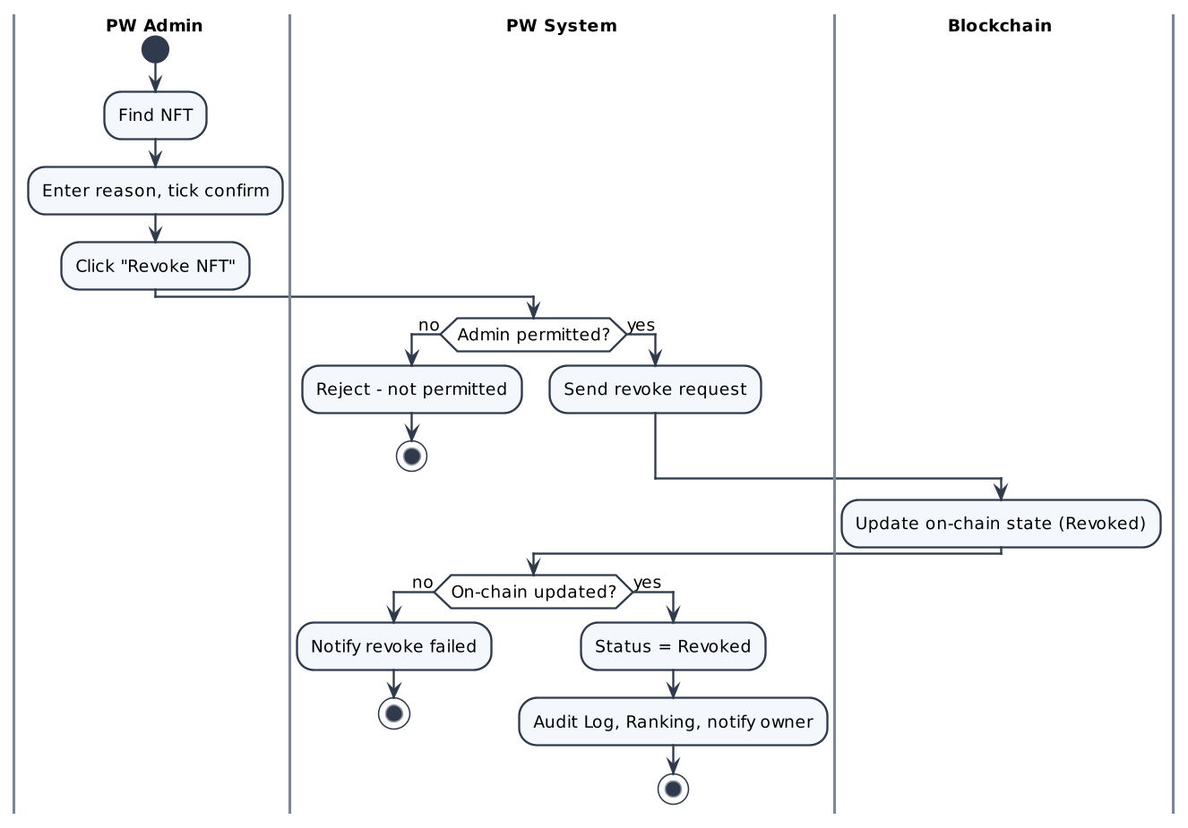

Screen Description
Screen 1: Revoke NFT
[Screenshot: Figma frame "Admin Portal (Revoke NFT)"]
# | Name | Control type | Data type | Required | Description
1 | Find NFT | Search | String | Yes | By token ID or owner name.
2 | NFT record | Label group | Mixed |  | Name, type (Distinction NFT / Award NFT · Soulbound), owner, current wallet, token ID, issue date.
3 | Reason | Dropdown | Enum | Yes | e.g. Fraud / misuse, Issued in error, Legal request, Other.
4 | Note | Textarea | String |  | Max 500 characters with counter.
5 | Irreversible confirmation | Checkbox | Boolean | Yes | Enables "Revoke NFT".
6 | Revoke NFT | Button (destructive) | N/A |  | Submits the revocation.
7 | Recent revocations | Table | Mixed |  | Last revocations (token, reason, admin, date).

UC31: Manually Adjust Points

Use Case Description
UC ID | UC31
UC Name | Manually Adjust Points
Objective | Allow a PW Admin to add or deduct points on a Member account with a mandatory reason, for corrections and exceptions.
Actor | PW Admin (R04); PW System (R05)
Trigger | The Admin confirms an adjustment.
Pre-condition | - The Admin is logged in.
Post-condition | Success:  • Balance updated; "Adjusted" point transaction; Audit Log (POINTS_ADJUST) with old/new balance and reason.
Basic flow | 1. Admin opens "Adjust Points" and selects the Member.  2. System shows the current balance and recent point history.  3. Admin enters a delta (+ credit / − debit) and a reason.  4. System previews the new balance.  5. Admin clicks "Apply adjustment".  6. System validates the new balance ≥ 0, updates the balance, creates an "Adjusted" transaction and writes the Audit Log.
Alternative flow | A1 – Cancel  1. No change.
Exception flow | E1 – Negative balance  1. "Balance cannot go below 0."  E2 – Missing reason or zero delta  1. Inline error; button disabled.
Business rule | • BR01 – Only Admin.  • BR02 – Reason mandatory.  • BR03 – Balance never below 0.
Non-functional requirement | • NFR01 – Every adjustment traceable (NFR-002, NFR-010).
Acceptance criteria | AC01 – Adjust  Given a Member with balance 300, when the Admin applies −100 with a reason, then balance = 200, an Adjusted transaction exists and the Audit Log shows old 300 / new 200.  AC02 – Negative  Given balance 50, when the Admin applies −100, then "Balance cannot go below 0.".
Traceability | BRD: FR-028 · BPMN: —

Activity Diagram
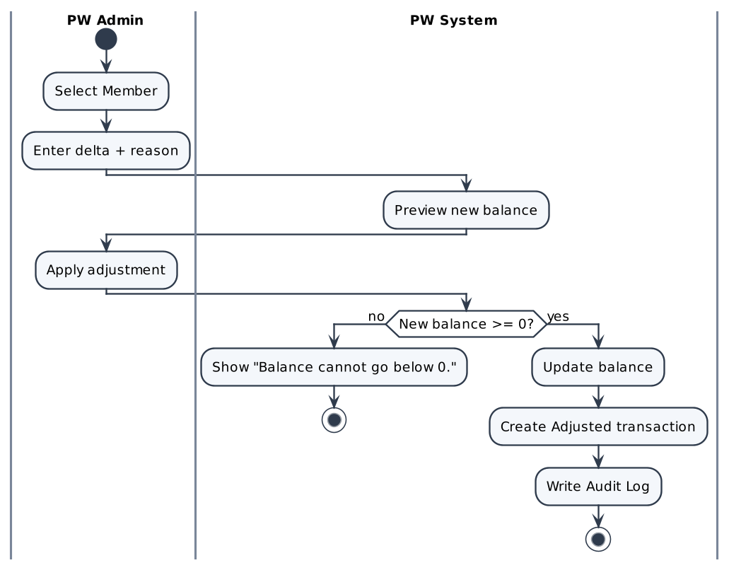

Screen Description
Screen 1: Adjust Points
[Screenshot: Figma frame "Admin Portal (Adjust Points)"]
# | Name | Control type | Data type | Required | Description
1 | Target member | Search / Select | String | Yes | Member account.
2 | Current points | Label | Integer |  | Current balance.
3 | Adjustment type | Toggle | Enum | Yes | + Credit / − Debit.
4 | Amount | Numeric input | Integer | Yes | > 0.
5 | Reason | Textarea | String | Yes | Shown in the Audit Log.
6 | New balance preview | Label | Integer |  | Calculated live.
7 | Apply adjustment | Button | N/A |  | Applies the change.

UC32: View Audit Logs

Use Case Description
UC ID | UC32
UC Name | View Audit Logs
Objective | Give the Admin a read-only, filterable trail of all important actions for compliance and traceability.
Actor | PW Admin (R04)
Trigger | The Admin opens "Audit Logs".
Pre-condition | - The Admin is logged in.
Post-condition | Success:  • Entries displayed; nothing can be changed.
Basic flow | 1. Admin opens "Audit Logs".  2. System lists entries newest first: time, actor, action, target, reference, details.  3. Admin filters by date range, actor, action type (KYC, Class, Mint, Transfer, Revoke, Points, Wallet, Reconcile) or target.  4. System shows matching entries (paginated).
Alternative flow | A1 – No result  1. "No log entries match your filters."
Exception flow | E1 – Load error  1. Retry message.
Business rule | • BR01 – Entries are immutable: no edit or delete for any role (NFR-002).  • BR02 – Logged actions: account created, KYC decisions, Class changes, wallet create/link/unlink, purchase/gift, mint, transfer, custody change, revoke, grant, points earn/use/adjust, reconciliation findings.
Non-functional requirement | • NFR01 – Filter results within 3 seconds for 1 year of data (proposed).
Acceptance criteria | AC01 – View  Given the Admin opens Audit Logs, when the page loads, then entries are listed newest first and cannot be edited or deleted.  AC02 – Filter  Given filters applied, when results load, then only matching entries are shown.  AC03 – No result  Given nothing matches, when filter applied, then "No log entries match your filters.".
Traceability | BRD: FR-029 · BPMN: D2–D5 – Record Audit Log

Activity Diagram
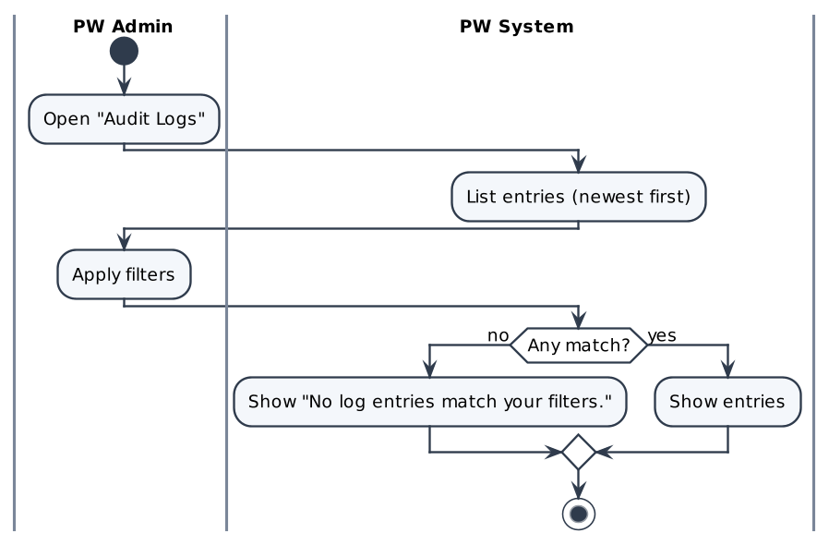

Screen Description
Screen 1: Audit Logs
[Screenshot: Figma frame "Admin Portal (Audit Logs)"]
# | Name | Control type | Data type | Required | Description
1 | Date range | Date range picker | Date |  | From / to.
2 | Actor | Search | String |  | Admin, Member or System.
3 | Action type | Multi-select | Enum |  | KYC_APPROVE, KYC_REJECT, CLASS_CHANGE, WALLET_*, PURCHASE, MINT, AWARD_MINT, TRANSFER_*, NFT_REVOKE, POINTS_*, RECONCILE.
4 | Target / reference | Textbox | String |  | Token ID, account, order.
5 | Log table | Table / Grid | Mixed |  | Time, actor, action, target, reference, details; read-only.

UC33: Ask AI Assistant

Use Case Description
UC ID | UC33
UC Name | Ask AI Assistant
Objective | Provide an AI Assistant that answers questions about PW, looks up the logged-in Member's own NFTs, gives platform guidance and recommends a Title category.
Actor | Visitor (R01), Company (R02), Individual (R03); AI Service (external)
Trigger | The user opens the AI Assistant and sends a message.
Pre-condition | - NFT lookup requires login.
Post-condition | Success:  • An answer is displayed. No business data is changed.
Basic flow | 1. User opens the AI Assistant.  2. User types a question (e.g. "How do points work?") and sends it.  3. System sends the question with PW context (and, if logged in, the user's own NFT data) to the AI Service.  4. System displays the answer within 2–5 seconds.
Alternative flow | A1 – NFT lookup  1. A logged-in user asks about their NFT → type, status, custody and transfer availability of that NFT.  A2 – Title recommendation  1. User describes their business → the Assistant suggests Philanthropist, Investor or Bridge with a short reason.  A3 – Out of scope  1. "I can only help with questions about PW."
Exception flow | E1 – AI Service unavailable  1. "The assistant is unavailable right now. Please try again later."
Business rule | • BR01 – Never discloses another user's private data.  • BR02 – The Assistant is read-only; it cannot buy, transfer or change data.  • BR03 – Scope decided (BRD Appendix): Q&A from the platform documentation, NFT lookup (own NFTs and public entity data), platform guidance and Title recommendations by purpose; no investment, legal or tax advice.
Non-functional requirement | • NFR01 – Response within 2–5 seconds under normal conditions (NFR-001).
Acceptance criteria | AC01 – Question  Given the Assistant is open, when a PW question is sent, then an answer appears within 2–5 seconds.  AC02 – NFT lookup  Given logged in, when the user asks about their NFT, then that NFT's type, status, custody and transfer availability are returned.  AC03 – Out of scope  Given an unrelated question, when it is sent, then the Assistant replies it can only help with PW topics.
Traceability | BRD: FR-030 · BPMN: —

Activity Diagram
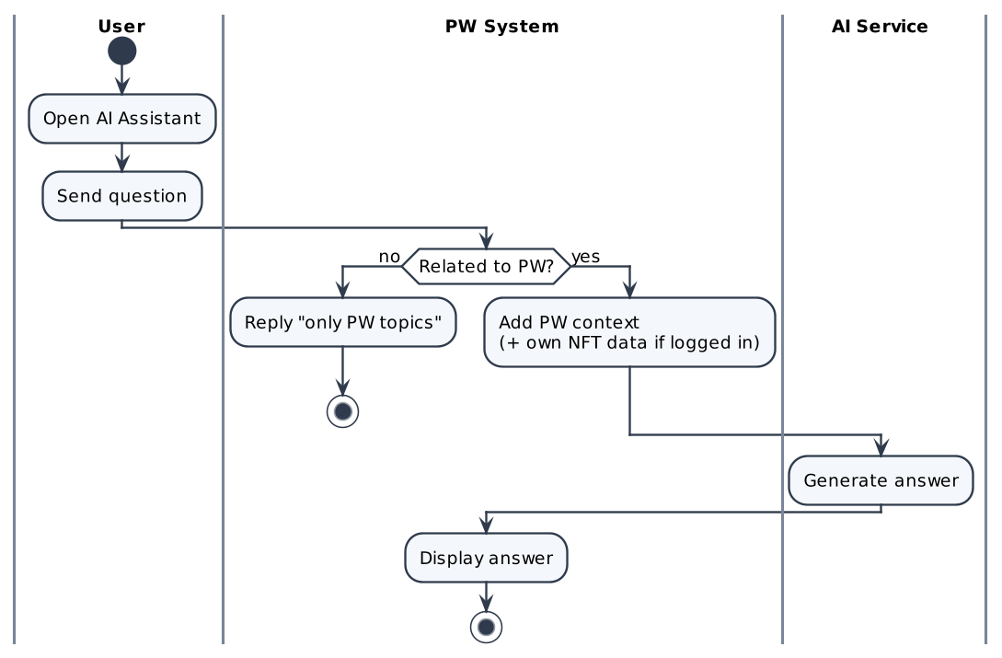

Screen Description
Screen 1: AI Assistant
[Screenshot: Figma frame "PW — AI Assistant (to be designed)"]
# | Name | Control type | Data type | Required | Description
1 | Chat panel | Panel | N/A |  | Floating panel available on all pages.
2 | Suggested questions | Chips | String |  | e.g. "How do points work?", "Which Title fits me?".
3 | Message input | Textbox | String | Yes | Max 500 characters (assumption).
4 | Send | Button | N/A |  | Sends the question.
5 | Answer | Label | String |  | Assistant reply.

OPEN ISSUES
ID | Open issue (decision needed) | Related UC
OI-01 | Closed (BRD v2.1, FR-005 and BR-01): Headcount range of each Class and Title price per Class × Title. | UC06, UC12, UC16
OI-02 | Closed (BRD v2.1, BR-01): an Individual is priced as Class 0. Pricing basis for Individuals (Class 0 or a separate table). | UC06, UC12, UC13, UC16
OI-03 | Partly closed (BRD v2.1, BR-02): "Year 2" = 2 years since KYC approval; the 1,000-point threshold is a BA proposal for the Business to confirm. Year-2 discount: point threshold and how "Year 2" is counted. | UC16, UC23
OI-04 | Closed (BRD v2.1, BR-03): the buyer earns 10% once. Self-purchase points: buyer = recipient → 10% or 20%? | UC14, UC18
OI-05 | Closed (BRD v2.1, BR-04): points are deducted from the price, 1 point = CHF 1. Points redemption: discount gate only, or deductible from the price (rate)? | UC16, UC24
OI-06 | Closed (BRD v2.1, BR-05): all NFTs count equally; revoked NFTs are not counted; ties list registered members first. Ranking: Award vs Distinction weighting, tie-break, revoked NFTs counted or not. | UC28
OI-07 | Closed (BRD v2.1, BR-11, BR-12, FR-035): no retry; the order is cancelled and a full refund is requested; Finance confirms the refund wording. Payment succeeded but wallet creation / minting failed: retry policy and refund rule. | UC07, UC14, UC15, UC17
OI-08 | Closed: US-TN03 and US-AW01 updated in PW_US_AC_final. Align US-TN03 / US-AW01 with BRD + BPMN D2 (gift recipient = KYC-verified Member; wallet created if missing). | UC07, UC15
OI-09 | Frequency of the linked-wallet reconciliation job. | UC22
OI-10 | Closed (BRD v2.1 Appendix): scope decided. Official scope of the AI Assistant. | UC33
OI-11 | Closed (BRD v2.1, FR-003): document types listed. Final KYC field and document list (Compliance). | UC04, UC05

Assumptions shown in gold (e.g. gift priced on the buyer's Class, recipient search keys, proposed NFR timings) must be confirmed together with these issues.

