
International School
Capstone Project 1
CMU-SE 450_C1SE.70

Project Proposal
Version 1.1
Date: October 30th, 2026
DBCAS – AI-Assisted Database Competency Assessment and Skill Gap Analysis

Submitted by C1SE.70
Thu, Nguyen Ngoc Anh - 29209245799
Nguyen, Nguyen Nhat - 26211227029
Truong, Nguyen Quang - 29212730635
Do, Nguyen Quoc - 29211156881
Han, Nguyen Ngoc - 29204423268

Review Panel Representative

Name Signature Date

Capstone Project 1 - Mentor:

Name MSc Viet, Huynh Duc Signature Date

PROJECT INFORMATION
Project acronym | DBCAS
Project Title | DBCAS – AI-Assisted Database Competency Assessment and Skill Gap Analysis
Start Date | 14/09/2026 | End Date | 26/12/2026
Lead Institution | International School, Duy Tan University
Project Mentor | MSc Viet, Huynh Duc
Scrum master / Project Leader & contact details | Thu, Nguyen Ngoc Anh  Email: 01258319907anhthu@gmail.com  Tel: 0919334040
Partner Organization | Duy Tan University
Project Web URL
Team members | Name | Email | Tel
 | Thu, Nguyen Ngoc Anh | 01258319907anhthu@gmail.com | 0919334040
 | Nguyen, Nguyen Nhat | nhnguyen240602@gmail.com | 0355772330
 | Truong, Nguyen Quang | quangtruongtt8@gmail.com | 0349039023
 | Do, Nguyen Quoc | nguyenquocdodary@gmail.com | 0388496885
 | Han, Nguyen Ngoc | Hannguyenngoc0506@gmail.com | 0899455605

DOCUMENT INFORMATION
Document Title | Capstone Project Proposal Document
Author(s) | Do, Nguyen Quoc & C1SE.70 Team
Role | Backend Developer
Date | 30/10/2026 | File name | DBCAS-Proposal-v1.1.docx
URL
Access | Project and CMU Program
DOCUMENT APPROVALS
The following signatures are required for approval of this document.
Thu, Nguyen Ngoc Anh - Student ID: 29209245799 - Project Manager / Scrum Master / Frontend Developer | Signature | Date
Nguyen, Nguyen Nhat - Student ID: 26211227029 - Backend Developer / QA Tester | Signature | Date
Truong, Nguyen Quang - Student ID: 29212730635 - Database Developer | Signature | Date
Do, Nguyen Quoc - Student ID: 29211156881 - Backend Developer | Signature | Date
Han, Nguyen Ngoc - Student ID: 29204423268 - Frontend Developer / QA Tester | Signature | Date

REVISION HISTORY

Version | Date | Comments | Author
1.0 | 18/09/2026 | Initial release | C1SE.70 Team
1.1 | 30/10/2026 | Update | C1SE.70 Team

Table of Contents
1. Project Title 1
2. Team Members 2
3. Supervisor(s) 3
4. Problem Statement 4
4.1. One Overall Grade Hides Real Strengths and Weaknesses 4
4.2. Lack of Detailed Explanations for Mistakes 4
4.3. Heavy Grading Workload in Large Classes 4
4.4. Problem Identification Through Online Research 5
4.5. How DBCAS Solves These Problems 7
5. Survey / Existing Solutions 7
5.1. Online Query Practice Sites 7
5.2. Traditional Learning Management Systems (LMS) 7
5.3. Conversational AI Chatbots 8
6. Objectives and Scope 10
6.1. SMART Objectives 10
6.2. Project Scope 11
7. Key Features & Requirements 14
7.1. Seven Key System Features 14
7.2. Functional Requirements 16
7.3. Non-Functional Requirements 22
8. Constraints and Assumptions 25
9. Target Users / Stakeholders 27
10. Technology Stack 29
11. Methodology & Development Plan 31
11.1. Agile Scrum Development Methodology 31
11.2. Official Capstone Timeline & Sprint Roadmap 32
11.3. Team Role Assignment & RACI Matrix 36
12. System Architecture Overview 37
12.1. System Context Diagram 37
12.2. Multi-Tier Logical System Architecture 41
12.3. Evidence-Based Competency & Gap Evaluation Pipeline 42
12.4. Multi-Format Assessment & How Scores Are Calculated 44
12.5. AI Integration & Prompt Engineering 45
13. Potential Risks and Mitigation Strategies 46
14. Expected Outcomes / Deliverables 48
15. References 50

List of Tables
Table 1: Project Team Members and Role Assignment 2
Table 2: Capstone Project Supervisor Information 3
Table 3: Common Database Learning Difficulties Identified from Online Research 5
Table 4: Comparison of Existing Solutions vs. Proposed DBCAS Platform 8
Table 5: SMART Project Objectives Breakdown 10
Table 6: Knowledge Scope and Assessment Exam Structure 12
Table 7: Core Functional Modules and System Features Overview 14
Table 8: Functional Requirements Specification (FR01 – FR16) 17
Table 9: Non-Functional Requirements Specification (NFR01 – NFR09) 23
Table 10: Technical & Academic Constraints and Project Assumptions Matrix 25
Table 11: Stakeholder Analysis Matrix 28
Table 12: Technology Stack and Development Toolchain 30
Table 13: Official Capstone Plan and Agile Scrum Schedule 32
Table 14: RACI Responsibility Assignment Matrix across Major Workstreams 36
Table 15: AI Evaluation Guardrails and Prompt Design Rules 45
Table 16: Project Risk Assessment Matrix and Mitigation Strategies 47
Table 17: Capstone Project Deliverables and Expected Outcomes 49

List of Figures
Figure 1: Agile Scrum Sprint Roadmap & Official Faculty Milestones 36
Figure 2: DBCAS System Context Diagram 38
Figure 3: DBCAS Logical System Architecture Diagram 41
Figure 4: Evidence-based Competency & Gap Evaluation Pipeline 43

1. Project Title
Project Title: DBCAS – AI-Assisted Database Competency Assessment and Skill Gap Analysis
Field of Study: Educational Technology, Database Systems, Software Engineering, Applied Artificial Intelligence.
Academic Affiliation: Capstone Project 1, Team C1SE.70, International School, Duy Tan University.
Project Timeline: September 14, 2026 – December 26, 2026 (Fall Semester 2026).
Target Audience: Undergraduate students taking relational database courses and computing disciplines requiring structured database design and querying skills.
DBCAS is an educational web application designed to help university learners and academic administrators get a clear, detailed picture of database skills. In regular university courses, exams and quizzes usually give students just one overall score, such as 7 or 8 out of 10. While this number shows whether a student passed, it does not explain which specific topics they understand well and where they need more practice. For example, two students might receive the exact same grade, but one is good at writing SQL queries while struggling with database normalization, and the other has the opposite problem. A single overall grade treats both students as if they have identical skills, which makes it hard for them to know what to study next.
To solve this problem, DBCAS connects course learning goals to the Core PostgreSQL Knowledge Domain: SQL querying, data manipulation and definition, integrity constraints, views, and database design fundamentals. Before a session, learners choose the skills to be assessed and a difficulty band (EASY 1–2, MEDIUM 3, or HARD 4–5). New formal adaptive assessments use the standard 13-question, 60-minute contract (10 multiple-choice, 2 SQL, and 1 essay item); a session always follows the configuration frozen when it starts, so historical published definitions keep their own duration and mix. Shorter practice sessions contain exactly 1, 2, 3, 5, 10, or 13 questions and use the formats available for the chosen skills. Each session fixes its skills, difficulty band, question source and length before question one. A practice session assembles its complete plan from the validated bank at that moment, so every selected skill is covered, the exact length is met with the formats the bank allows, and question versions are not duplicated. A formal session keeps the configured mix and duration but selects each later question from accumulated evidence: three basic MCQs open the session, the chosen band only sets where selection starts and moves at most one band at a time inside the allowed range, and the required mix is served in strict MCQ → SQL → essay. The three question formats are multiple-choice questions, read-only SQL queries run in a secure PostgreSQL 17 Docker sandbox, and short conceptual written answers evaluated using clear grading rubrics. The system combines answer evidence into a per-concept competency profile. After the radar and bar charts, it shows a “What to study next” list of below-benchmark concepts ranked by the size of each shortfall; each item names the concept and shows its description when available. Results are released immediately or, when the assessment requires it, after administrator review, and the learner's cumulative profile pools evidence from published sessions only.

2. Team Members
Our capstone team, C1SE.70, consists of five software engineering students from the International School at Duy Tan University. The team follows the Agile Scrum method, and each member has clear responsibilities across the project:
Table 1: Project Team Members and Role Assignment
Team member and contact | Primary role | Key responsibilities
1. Nguyen Ngoc Anh Thu  ID: 29209245799  Email: 01258319907anhthu@gmail.com  Phone: 0919334040 | Project Manager, Scrum Master, Frontend Developer | Leads project planning, coordinates team meetings, tracks overall progress, manages project risks, and develops frontend user interfaces and interactive dashboards.
2. Nguyen Nhat Nguyen  ID: 26211227029  Email: nhnguyen240602@gmail.com  Phone: 0355772330 | Backend Developer, QA Tester | Supports backend API implementation and server-side logic, designs functional test cases, and performs system and user testing.
3. Nguyen Quang Truong  ID: 29212730635  Email: quangtruongtt8@gmail.com  Phone: 0349039023 | Database Developer | Designs relational database schemas, writes and optimizes SQL queries, and manages question banks, rubrics, and benchmark datasets.
4. Nguyen Quoc Do  ID: 29211156881  Email: nguyenquocdodary@gmail.com  Phone: 0388496885 | Backend Developer | Architects backend services, implements server APIs, configures secure execution environments, and writes core business logic.
5. Nguyen Ngoc Han  ID: 29204423268  Email: Hannguyenngoc0506@gmail.com  Phone: 0899455605 | Frontend Developer, QA Tester | Supports frontend user interface development, prepares evaluation test sets, develops automated test scripts, and verifies grading consistency.

3. Supervisor(s)
The team is supervised and guided by academic faculty from the Software Engineering Department at the International School, Duy Tan University:
Table 2: Capstone Project Supervisor Information
Full Name | Academic Title / Degree | Department / Division | Institution / Affiliation | Contact Email
Huynh Duc Viet | Master of Science (MSc) | CSE Center | International School,  Duy Tan University | huynhducviet@duytan.edu.vn

Supervisory Guidance: MSc. Huynh Duc Viet meets with the team every two weeks to review sprint progress, give advice on system architecture, review grading rules, and ensure the project meets university curriculum standards. Because DBCAS is an educational software project built for university courses, an outside enterprise supervisor is not required.

4. Problem Statement
In Computer Science and Software Engineering degree programs, the Database Systems course is a required core subject. Students must learn both practical SQL coding and conceptual database design. However, traditional grading in university courses faces several key problems:

4.1. One Overall Grade Hides Real Strengths and Weaknesses
Typical exams give a single total score. For instance, two learners might both score 7.5 out of 10. Learner A writes SQL joins easily but struggles with normalization rules. Learner B designs good Entity-Relationship diagrams but makes syntax mistakes with SQL GROUP BY queries. Even though their skills and study needs are completely different, standard grading gives them the exact same score. Neither learner knows what they need to work on.

4.2. Lack of Detailed Explanations for Mistakes
When learners receive graded tests or online quizzes, they usually only see whether an answer was right or wrong. They do not get a clear explanation of why an answer was wrong, which core concept they misunderstood, or what topics they should review before moving into advanced classes like Web Development or Enterprise Systems.

4.3. Heavy Grading Workload in Large Classes
In university classes with 50 to 70 learners per class, course instructors and teaching assistants have very little time. Checking SQL queries by hand takes hours, and grading written conceptual explanations for dozens of learners is time-consuming and can lead to inconsistent scores when graders get tired.

4.4. Problem Identification Through Online Research
Our team did not conduct direct student interviews or surveys. Instead, we explored the problem by researching developer discussion forums, programming education communities, and technical learning articles online (such as discussions on Stack Overflow, Reddit threads on r/learnprogramming, and computer science teaching blogs). By looking into what learners and educators discuss online, we identified several recurring difficulties that learners experience when learning databases. These common online discussions helped shape our project idea and confirmed the need for DBCAS:
Table 3: Common Database Learning Difficulties Identified from Online Research
No. | Learning Area / Topic | Common Difficulties Discussed Online | How DBCAS Solves It
1 | Single Overall Grades | Learners on learning forums often state that getting a single test score (such as 7 or 8 out of 10) tells them they passed, but gives them no idea which specific database concepts they actually mastered and which ones need review. | Calculates competency scores across core PostgreSQL concepts and displays an interactive visual radar chart of strengths and weaknesses.
2 | Database Normalization Rules | A common complaint on developer communities is that normalization rules (1NF, 2NF, 3NF, BCNF) feel too theoretical, and learners struggle to explain why a bad schema design leads to data duplication or update anomalies. | Provides short written conceptual questions evaluated using clear rubrics that explain why an answer is incomplete and how to fix the design.
3 | Complex SQL Queries (JOINs & Aggregates) | Learners frequently ask questions about multi-table joins, GROUP BY, and subqueries, finding it frustrating when existing practice sites only say 'Wrong Output' without helpful hints. | Runs queries in an isolated Docker container and checks both the query structure and returned rows to give helpful hints on mistakes.
4 | Lack of Diagnostic Explanations | Discussions show that standard multiple-choice quizzes only show correct or incorrect marks without explaining the underlying concept behind a wrong answer. | Identifies the core concept behind missed questions and provides clear written explanations to help learners understand why an answer was wrong.
5 | One-Size-Fits-All Exams | A common frustration is that fixed exams give every learner the same question set, so strong learners waste effort on easy items while weaker learners face items far above their level, and neither group gets an accurate ability reading. | Freezes the learner's chosen skills, difficulty band, source and length before question one, then builds a complete personalized practice plan or serves formal questions adaptively inside the allowed difficulty range in strict MCQ → SQL → essay order, covering every selected skill without repeating question families.

4.5. How DBCAS Solves These Problems
To address these real-world challenges, DBCAS uses three practical assessment methods: instant scoring for multiple-choice questions, an isolated Docker container sandbox to run read-only learner SQL safely, and rubric-guided AI evaluation for short conceptual answers. Before the session starts, the learner fixes the skills, difficulty band and length. The system then draws only validated questions — from the approved bank by default, or from validated session-scoped generation where the opt-in AI mode is enabled — so every question is relevant, all selected skills are covered and no question family repeats: a practice session freezes its complete plan at that point, while a formal session keeps the configured mix and selects each later question from accumulated evidence. Answers are graded on submission and the resulting evidence builds a competency profile without relying on hidden or unexplained grading rules. Where the assessment requires human-verified release, an administrator reviews SQL and essay scores before results are published.

5. Survey / Existing Solutions
We reviewed existing educational tools and grouped them into three main types to see how they handle database learning and assessment:

5.1. Online Query Practice Sites
Websites like LeetCode, HackerRank, SQLZoo, and DataCamp allow learners to write SQL queries and compare their output against expected results. They are great for quick syntax practice. However, their scope is limited: they only check SQL queries, offering no support for Entity-Relationship modeling or database normalization theory. Also, their feedback only says 'Accepted' or 'Wrong Answer' without explaining the reasoning behind an error, and they do not link results to university course goals.

5.2. Traditional Learning Management Systems (LMS)
Systems like Moodle, Canvas, and Blackboard organize course materials and gradebooks well. However, their test tools usually return just one total score. They cannot run and test learner SQL code safely, and instructors must grade written answers by hand. They also do not point out specific competency gaps or tell learners what to review next.

5.3. Conversational AI Chatbots
General-purpose AI chatbots are useful for asking questions during study sessions. However, they are not designed for formal school exams. They do not have structured test workflows, can give different scores for similar answers, and cannot track learner skill progress over an entire semester.
Table 4: Comparison of Existing Solutions vs. Proposed DBCAS Platform
Comparison Feature | Online Practice Sites (LeetCode) | Traditional LMS (Moodle/Canvas) | AI Chatbots (general-purpose) | Proposed DBCAS Platform
Multi-Format Questions (MCQ, SQL, Essay) | SQL queries only | MCQ supported; Essay requires manual grading | Free-form conversation only; no exam structure | Fully integrated: MCQ, read-only SQL sandbox, and short essays
Safe Live SQL Execution | Yes (proprietary cloud environment) | No (relies on file uploads or plain text) | No live database execution | Yes (isolated, read-only Docker PostgreSQL sandbox; SELECT queries only)
Concept-level Competency Profile | No (shows problem count only) | No (returns one overall grade) | No structured competency tracking | Yes (radar and bar charts across core PostgreSQL concepts, plus a cumulative view of published sessions)
Clear Competency Gap Diagnosis | No (shows failed test case only) | No (requires instructor explanation) | Basic text commentary only | Yes (explains weak concepts and ranks the topics to study by cumulative shortfall from target)
Adaptive / Personalized Question Selection | No (fixed question sets) | No (fixed assembled exams) | No (free-form chat only) | Yes (personalized practice plan frozen at start, plus formal adaptive selection from the learner's chosen skills and difficulty band, using the validated bank by default or validated AI generation where enabled)
Course Learning Outcome Alignment | Not supported | Basic question tagging only | Not supported | Direct mapping: Course Outcomes → Concepts → Questions
Consistent Scoring Rules | High (exact output matching) | High (rule-based MCQ; manual essay) | Low (unstable scores across repeated prompts) | High (deterministic rules; AI rubric assistance with administrator verification when required)
Data Privacy & Standalone Setup | Commercial cloud tracking | Institutional server dependent | External cloud dependency | Fully standalone with learner data anonymization

Key Advantages of DBCAS: DBCAS connects course learning outcomes directly to core PostgreSQL concepts. By testing learners through multiple question types, freezing a personalized practice plan before question one and selecting formal questions from accumulated evidence, showing visual competency profiles, and presenting a ranked list of weak concepts to study next, the platform gives both learners and administrators a more useful learning experience.

6. Objectives and Scope

6.1. SMART Objectives
Project goals are defined according to the SMART (Specific, Measurable, Achievable, Relevant, Time-bound) framework to guide implementation and milestone reviews:
Table 5: SMART Project Objectives Breakdown
SMART Dimension | Project Goal & Verification Method
S – Specific | Design, build, and deploy the DBCAS web platform to evaluate learner competency across the Core PostgreSQL Knowledge Domain using personalized practice plans and adaptive formal sessions across multiple-choice, read-only SQL, and rubric-based essay items.
M – Measurable | • Verify that every personalized session covers all selected skills, that a formal session keeps the 10 MCQ / 2 SQL / 1 essay mix in strict MCQ → SQL → essay order while adapting inside the allowed difficulty range, and that a practice plan meets the exact selected length.  • Ensure automated essay scores match administrator grading on test answers.  • Keep SQL sandbox query execution under 2 seconds (with a strict 3.0s statement timeout) while keeping execution environments secure.  • Complete all planned features across the 5 development sprints.
A – Achievable | Build the system using well-known, reliable open-source tools (React, FastAPI, PostgreSQL, Docker, and a provider-agnostic LLM API) along with sample datasets created by the team.
R – Relevant | Helps learners understand their weaknesses, decide which topics to study first, and gives administrators clear evidence of progress on course learning goals.
T – Time-bound | Follow the 15-week Capstone 1 schedule from September to late December 2026, meeting all university deadlines: Status Reports 1 to 4, Midterm Demo, Final Report, and Capstone Defense.

6.2. Project Scope
In-Scope Subject Areas: The project assesses the Core PostgreSQL Knowledge Domain — the set of concepts an undergraduate database course expects learners to master:
Table 6: Knowledge Scope and Assessment Exam Structure
Core Subject Area | Component Skills | Question Formats | Adaptive Session Coverage
1. SQL Querying | • Core retrieval: SELECT, WHERE, ORDER BY, DISTINCT  • Joins & aggregation: JOIN, GROUP BY, HAVING, Aggregate Functions  • Advanced retrieval: Subqueries, CTE, Window Functions, Set Operations | • Multiple-choice questions  • Read-only practical SQL tasks | MCQ + read-only SQL tasks  (adaptive mix by concept evidence)
2. Data Manipulation & Definition | • DML statements: INSERT / UPDATE / DELETE  • DDL statements: CREATE / ALTER / DROP  • Core PostgreSQL data types  • Views | • Multiple-choice questions  • Conceptual essays | MCQ + conceptual essays  (DML/DDL are assessed, never executed)
3. Constraints & Design Fundamentals | • Keys & constraints: Primary Key, Foreign Key, UNIQUE, CHECK, NOT NULL  • Database design fundamentals (schema design and normalization basics)  • Conceptual design explanations | • Multiple-choice questions  • Conceptual design essays | MCQ + conceptual essays  (adaptive mix by concept evidence)
TOTAL ASSESSMENT SCOPE | Core PostgreSQL Knowledge Domain mapped to Course Learning Outcomes | Three formats: Multiple-choice, read-only SQL query, Essay | New formal: 13 questions / 60 minutes (10 MCQ / 2 SQL / 1 Essay)  Sessions keep their frozen configuration  Practice: exactly 1, 2, 3, 5, 10, or 13 questions

Learner SQL execution is deliberately read-only: the sandbox accepts SELECT statements only, and every query runs in a transaction that is rolled back after evaluation. DML and DDL knowledge is assessed through multiple-choice and essay items rather than executed statements, so a learner can never modify sandbox or application data.
Out-of-Scope Items: To maintain high engineering quality within the 15-week timeline, the following topics are outside the project scope:
• Advanced Transaction Management: Low-level implementation details of database transactions, two-phase commit, and deadlock resolution algorithms are excluded.
• Physical Storage and Engine Tuning: Low-level disk storage layouts, buffer pool details, and internal database engine optimization are excluded.
• NoSQL and Distributed Databases: Document databases like MongoDB and key-value stores like Redis are excluded; the system focuses purely on relational databases.
• General University Management Features: Tuition payment, class scheduling, and campus-wide gradebooks are outside the scope of this project.
• Open-Ended Chatbot Conversations: Free-form conversational chatting is excluded to avoid incorrect answers and keep the focus on structured tests.
• Personalized Learning Paths and RAG-Based Study Resources: Long-term adaptive study roadmaps, learning tracking, and course-document ingestion or retrieval are outside scope. “What to study next” is limited to ranked below-benchmark concepts and their descriptions when available.
• Webcam Surveillance Hardware: Automated camera surveillance and biometric eye-tracking hardware are excluded to keep the focus strictly on educational evaluation.

7. Key Features & Requirements

7.1. Seven Key System Features
DBCAS delivers seven core functional modules designed to support learners and administrators throughout the assessment lifecycle, summarized in Table 7:
Table 7: Core Functional Modules and System Features Overview
No. | System Feature / Module | Functional Scope & Capabilities | Target Users & Educational Value
1 | Course Outcomes & Concept Management | Enables administrators to define course learning goals, organize them into the Core PostgreSQL concept model with prerequisite relationships, assign difficulty levels, and review system-suggested mappings. | Administrator: Ensures tight alignment between assessments and university curriculum standards.
2 | Question Bank & Concept Tagging | Maintains an Administrator-approved, validated library of multiple-choice questions, read-only SQL tasks, and short essay prompts categorized by difficulty, tagged with specific PostgreSQL concepts, tracked through version families, and documented with explanations and source references. | Administrator: Saves time when curating the validated item pool and guarantees balanced topic coverage.
3 | Learner Assessment Portal | Provides a clean test-taking interface for formal and practice sessions, with a persistent countdown, 10- and 5-minute warnings, forward-only navigation, autosaved answer drafts, an embedded SQL editor, and English/Vietnamese interface and theme preferences. | Learner: Delivers a smooth, distraction-free environment for answering coding and conceptual questions.
4 | Automated Multi-Method Scoring | Executes multi-format grading: instant verification for MCQs, isolated Docker execution for read-only SQL queries, and rubric-guided AI scoring for short essays. When an assessment is configured for human-verified release, SQL and essay grades wait in an administrator review queue before publication. | Learner & Administrator: Eliminates manual grading bottlenecks while delivering consistent results under administrator oversight.
5 | Visual Competency Profile Dashboard | Aggregates evidence across published sessions into radar and bar charts of PostgreSQL competency. After the charts, it shows a “What to study next” list of below-benchmark concepts ordered by shortfall from target, with the concept name and its description when available. | Learner & Administrator: Replaces a single vague score with a transparent breakdown of real abilities.
6 | Competency Gap Diagnosis & Study Guidance | Compares cumulative published concept scores with administrator benchmarks, flags gaps, and provides evidence-linked explanations. The learner's below-benchmark concepts appear after the profile as a ranked “What to study next” list. | Learner: Explains missed concepts and shows which weak topic to study first.
7 | Personalized Adaptive Question Selection | Lets the learner choose the skills, difficulty band, question source and length before question one. Practice assembles and freezes a complete plan from the validated bank, covering every selected skill with the exact length and no repeated version families. Formal sessions keep the 10/2/1 mix and the configured duration but select each later question from accumulated evidence: three basic MCQs open the session, the band moves at most one step inside the allowed range and formats follow strict MCQ → SQL → essay order. A genuine shortage stops the start with an explicit explanation rather than a silently shortened assessment. AI drafts are checked and approved ahead of time; validated items remain the default serving source. | Learner: Measures ability with relevant questions and fewer surprises than a fixed exam.

7.2. Functional Requirements
Table 8 outlines the functional requirements across primary human actors (Learner, Administrator), the core system (DBCAS), the external AI service (LLM Provider), and the OAuth Identity Provider used for sign-in:
Table 8: Functional Requirements Specification (FR01 – FR16)
FR ID | Requirement Name | Functional Description | Primary Actor / Component
FR-01 | User Authentication | System authenticates users with JWT-based sessions and implements exactly two application roles: User (Learner) and Admin (Administrator). Email/password and OAuth 2.0 (Google, GitHub) sign-in are supported, together with self-service password recovery through a single-use, 15-minute emailed token stored only as a SHA-256 digest. OAuth identities require a verified email and never receive a role automatically. | Learner, Administrator
FR-02 | Outcome & Concept Setup | System allows administrators to define course learning outcomes (CLOs), the Core PostgreSQL concept model, difficulty levels, and prerequisite relationships between concepts. | Administrator
FR-03 | Outcome Mapping Assistance | System suggests connections between course outcomes and PostgreSQL concepts using assistive AI, requiring confirmation by the administrator. | Administrator, LLM Provider
FR-04 | Question Bank Management | System enables administrators to approve AI-generated candidates after automated checks and curate the validated Question Bank: a pool of approved assessment items spanning multiple-choice, read-only SQL, and short essay formats across the Core PostgreSQL Knowledge Domain, with test data sets, reference answers, explanations, source references, and version lineage. | Administrator
FR-05 | Question Concept Tagging | System analyzes question prompts and recommends relevant concept tags and evaluation criteria for administrator review. | Administrator, LLM Provider
FR-06 | Adaptive Assessment Builder | System lets administrators configure assessments with target concepts, allowed difficulty ranges, and a result-release policy (immediate or human-verified). New formal assessment definitions use the standard 13-question, 60-minute contract targeting 10 multiple-choice, 2 SQL, and 1 essay; a session follows its frozen configuration, so historical published definitions keep their captured duration and mix. Learners choose the skills to assess and a band (EASY 1–2, MEDIUM 3, HARD 4–5), while practice sessions contain exactly 1, 2, 3, 5, 10, or 13 questions. A practice session freezes its complete plan before the first question is served; a formal session keeps the configured mix while selecting each later question adaptively inside the allowed difficulty range. | Administrator
FR-07 | Learner Exam Interface | System provides learners with a clean test interface featuring a persistent countdown, 10- and 5-minute remaining warnings, automatic submission at 00:00, a progress indicator, forward-only navigation, autosaved drafts, an embedded SQL code editor, and English/Vietnamese and theme preferences. | Learner
FR-08 | Multiple-Choice Grading | System instantly evaluates submitted multiple-choice answers against the verified answer key. | DBCAS (Core System)
FR-09 | SQL Sandbox Execution | System runs read-only learner SQL (SELECT statements only) inside a secure, isolated PostgreSQL 17 sandbox and grades by semantic and result correctness — executing against multiple test datasets including edge cases and verifying required concept usage when the question mandates a technique — never by exact string matching. DML/DDL knowledge is assessed through MCQ and essay items and is never executed. | DBCAS (Core System)
FR-10 | Rubric-Guided Essay Scoring | System evaluates technical written explanations against administrator rubrics with LLM assistance, providing score breakdowns and constructive feedback. When human-verified release is configured, an administrator reviews and approves SQL and essay scores before publication. | DBCAS, LLM Provider, Administrator
FR-11 | Evidence Storage | System stores standardized grading evidence for every answer in an organized record capturing the question, question type, PostgreSQL concept, difficulty, learner answer, grading result, and validation information, timestamped per session. | DBCAS (Core System)
FR-12 | Concept Competency Calculation | System calculates learner competency levels for each concept deterministically by comparing points earned against total points possible for that concept in a session, and pools point totals across all published sessions for the cumulative profile. | DBCAS (Core System)
FR-13 | Visual Competency Profiles | System renders interactive radar and bar charts showing the learner's mastery across core PostgreSQL concepts, including a cumulative view built only from published sessions. | Learner, Administrator
FR-14 | Competency Gap Diagnosis & Study Guidance | System flags concepts below the expected standard using cumulative published evidence, then presents them after the competency profile as a “What to study next” list ordered by shortfall from target. Each item names the concept and shows its description when available; LLM assistance provides an evidence-linked explanation without changing scores or topic order. | Learner, DBCAS, LLM Provider
FR-15 | Adaptive Question Selection | System freezes the selected skills, difficulty band and length before question one, then covers every selected skill, honours the configured formal mix (10/2/1 for new standard definitions) or the exact practice length, avoids duplicate version families, and serves only validated questions with confirmed concept tags. Formal delivery is adaptive: three basic MCQs open the session, each later question moves at most one band inside the allowed range, and the mix is served in strict MCQ → SQL → essay order; an insufficient approved bank stops the start with an explicit shortage explanation instead of a reduced or relaxed assessment. AI drafts candidates ahead of time; automated checks and Administrator approval are required before a candidate becomes a validated Question, and BANK mode serves validated items without waiting for AI generation; AI-generated formal delivery is offered only where the deployment provides a provider and session-question storage, and every generated question is validated before it appears. | DBCAS (Core System)
FR-16 | User Registration & Role Management | System lets new users register with email/password or OAuth (verified email) and creates a Learner account only. Administrator accounts are provisioned only by existing administrators, start disabled, and all role changes are recorded in an immutable audit log. A Learner may request promotion to Administrator; an existing administrator with role-management capability reviews and grants or denies the request through the audited role-management workflow (no self-service promotion endpoint). | Learner, Administrator

7.3. Non-Functional Requirements
Non-functional requirements define the quality attributes, performance targets, and security standards for the platform:
Table 9: Non-Functional Requirements Specification (NFR01 – NFR09)
NFR ID | Quality Area | Target Requirement & Acceptance Standard | Technical Approach
NFR-01 | Response Time | Web pages load within 1.5 seconds; API endpoints respond within 500 milliseconds for standard requests. | FastAPI asynchronous routes and optimized frontend bundles.
NFR-02 | Sandbox Security | Learner SQL queries run inside a dedicated isolated container with a 3-second statement timeout and limited memory, preventing server overloads. | A dedicated Docker container running PostgreSQL with a read-only learner role that accepts SELECT statements only, enforced statement timeouts, disabled network access, and no access to production data.
NFR-03 | Service Reliability | Web platform maintains dependable uptime during scheduled learner practice and assessment sessions. | Containerized deployment with automatic health monitoring and restart policies.
NFR-04 | Ease of Use | Interface is intuitive and easy to navigate on standard learner laptops and desktop monitors. | Tailwind CSS responsive design with clear layouts and visual progress indicators.
NFR-05 | Scoring Consistency | Automated essay evaluation follows structured rubrics closely, yielding consistent results across repeated runs. | Structured prompt design with low temperature settings, fixed seeds, versioned prompts and rubrics, strict JSON schemas, and deterministic validation rules.
NFR-06 | Concurrent Learners | Platform easily handles a full class section of 100 learners taking an assessment at the same time. | Stateless backend design with PostgreSQL connection pooling.
NFR-07 | Learner Privacy | Learner names and identifying numbers are removed before any text is sent to external LLM Provider APIs for essay grading, mapping/tag suggestions, or gap explanations. Unpublished scores, provisional competency profiles and gap results are withheld from the learner until the release policy publishes the session, and are visible only to authorized reviewers before that point. | Data sanitization gateway that strips personal details before external API requests; release-scoped read checks ensure only published results enter learner-facing profiles and analytics.
NFR-08 | Code Quality | Clean, well-documented source code with automated unit tests for core backend services. | Automated unit test suite (pytest) executed before merges with clear documentation.
NFR-09 | Runtime Question Generation | In the default BANK mode, AI-generated question candidates never block or fail an assessment session; automated checks and Administrator approval precede bank entry. In the opt-in AI formal mode, a failed generation stops delivery with an audited notice instead of serving an unvalidated item. | Generate-ahead pipeline with PostgreSQL-backed checks, Administrator approval, a frozen validated practice plan or evidence-driven formal selection, a validated item pool for BANK mode, and fail-closed AI delivery with an audited notice.

8. Constraints and Assumptions
The DBCAS platform operates within clearly defined technical constraints, academic boundaries, and core operational assumptions, summarized in Table 10:
Table 10: Technical & Academic Constraints and Project Assumptions Matrix
Category | Constraint / Assumption Item | Detailed Technical Scope & Rationale
Technical Constraints | SQL Sandbox Resource Limits | Learner SQL queries run inside a dedicated Docker sandbox container with memory capped at 256 MB and execution capped at 3 seconds via statement_timeout to prevent server overloads or runaway queries. The sandbox accepts read-only SELECT statements only; DML/DDL are assessed through MCQ and essay.
Technical Constraints | External LLM Provider Limits & Latency | External language model API calls are managed using PostgreSQL-backed response caching, durable asynchronous grading jobs in the FastAPI backend, and a cost-effective model from the configured provider to avoid delays.
Technical Constraints | Modern Web Browser Compatibility | The web interface runs smoothly on standard modern browsers (Chrome, Edge, Firefox, Safari) using standard HTML5/CSS without requiring custom browser plugins.
Technical Constraints | OAuth Provider Integration | Sign-in through Google and GitHub uses OAuth 2.0 with signed state, PKCE where supported, verified email, and a one-time handoff. Provider access tokens are never stored, and OAuth never grants an Administrator role.
Academic & AI Ethics | Administrator-Configured Evaluation & Assistive AI | The external LLM Provider assists with essay scoring against administrator-configured rubrics and generates evidence-linked gap explanations; it does not determine final competency. Administrators configure rubrics, competency benchmarks, and the result-release policy. DBCAS deterministically aggregates recorded answer evidence into concept scores and ranks below-benchmark concepts by shortfall; when human-verified release is configured, an administrator approves SQL and essay scores before publication. Gap explanations cannot change scores or order.
Academic Constraints | 15-Week Capstone Timeline | All design, implementation, testing, and documentation must conclude within the university 15-week Capstone 1 timeframe, finishing with formal defense in late December 2026.
Academic Constraints | Independent Benchmark Test Data | To avoid administrative delays obtaining live university student records, the team utilizes a self-contained benchmark dataset of sample questions, schemas, and answers.
Project Assumptions | Learner Background Knowledge | Learners using the platform possess basic computer literacy and have attended introductory lectures on relational database concepts and basic SQL syntax.
Project Assumptions | Standard Computing Curriculum | The course syllabus adheres to standard ACM/IEEE computing curriculum guidelines covering relational modeling, SQL syntax, and normalization up to Third Normal Form.

9. Target Users / Stakeholders
DBCAS serves four key stakeholder groups within university computing education, detailed in Table 11:
Table 11: Stakeholder Analysis Matrix
Stakeholder / Role | Background & Context | Current Needs & Frustrations | Value Provided by DBCAS
Learner  (Primary Human Actor) | Undergraduate Computer Science and Software Engineering students taking Database Systems coursework. | • Frustrated by single exam grades that do not explain mistakes.  • Want fast feedback on coding and conceptual questions.  • Need to know what to study first after seeing their weak areas.  • Want practice that targets their own skills and difficulty. | • Visual competency profiles showing exact strengths and weaknesses.  • Clear explanations of conceptual errors on homework and tests.  • A prioritized list of weak topics to study next.  • Personalized formal and practice sessions, plus English/Vietnamese and theme preferences.
Administrator  (System Content Manager) | An authorized DBCAS Administrator responsible for the database course content and assessment configuration. | • Overwhelmed by the time needed to grade SQL queries and essays.  • Difficult to see overall class performance across specific topics.  • Hard to keep grading consistent across hundreds of written answers.  • Need to review SQL and essay grades before releasing results. | • Automated grading saves hours of manual inspection.  • Class-wide dashboards reveal topics where many learners struggle.  • Easy-to-use question bank with reusable rubrics and CLO mappings.  • A review-and-publish queue, role management, and immutable audit records.
Academic Leader  (Department Chair / Accreditation) | Academic leaders responsible for curriculum quality and program accreditation (ABET, AUN-QA). | • Hard to collect direct evidence measuring learner mastery of course goals.  • Often reliant on subjective end-of-semester survey opinions. | • Direct, verifiable evidence tracking learner mastery of course outcomes.  • Automated reports showing how well course learning goals are met.
Capstone Engineering Team  (C1SE.70) | Final-year software engineering students designing and building the platform. | • Need to deliver a complete, high-quality software project on time.  • Must demonstrate sound architecture and practical software value. | • Team experience building a modern full-stack web platform.  • A solid, working capstone project ready for graduation defense.

10. Technology Stack
The technology stack is organized across seven core system layers, selecting mature, widely adopted, and stable open-source technologies to guarantee platform reliability, security, and maintainability:
Table 12: Technology Stack and Development Toolchain
System Layer | Technology / Framework | Stable Version | Role in DBCAS & Technical Justification
Presentation Layer (Frontend) | React.js + Vite (JavaScript / JSX) + i18next | React 19.3 / Vite 8.3.1 / i18next 26.4 | Industry-standard component library using JavaScript (ES6+ / JSX) paired with Vite for fast build times, Hot Module Replacement (HMR), and a bilingual (English/Vietnamese) single-page interface.
UI Styling & Visualization | Tailwind CSS & Chart.js | Tailwind 4.3 / Chart.js 4.5.1 | Widely adopted utility CSS framework for clean layouts paired with a reliable charting library for interactive radar and bar charts.
Backend API & Logic | FastAPI (Python) | FastAPI 0.141.1 (Python 3.13) | High-performance, widely supported Python asynchronous web framework for API endpoints, JWT authentication and OAuth 2.0 sign-in (Google, GitHub), and scoring logic.
Database | PostgreSQL | PostgreSQL 17 (LTS) | Production-proven relational database for persistent storage of users, questions, scores, immutable evidence, review and release audit records, and cached LLM responses.
Execution Sandbox | Docker Engine | Community Edition 29 | Industry-standard container engine used to host a dedicated, isolated PostgreSQL sandbox for learner SQL queries with strict CPU and memory limits.
AI Service Integration | External LLM Provider APIs  (any provider) | Standard REST APIs (Stable) | Integration with external LLM provider APIs (provider-agnostic; no vendor lock-in) using structured JSON prompts for rubric-guided essay grading.
Version Control | Git & GitHub | Git 2.55+ / GitHub Platform | Standard version control system and hosting platform for team collaboration and code reviews.

11. Methodology & Development Plan

11.1. Agile Scrum Development Methodology
Our team follows the Agile Scrum process using two-week sprint cycles. This approach lets us make steady progress, review working software regularly with our advisor, and adjust priorities as needed:
• Sprint Planning: Held at the start of each two-week sprint to set the sprint goal and assign specific user stories from the backlog.
• Regular Stand-ups: Held three times a week to review what was done, plan upcoming work, and resolve any technical blockers early.
• Sprint Review & Demo: Conducted at the end of each sprint to demonstrate new working features to our faculty advisor.
• Sprint Retrospective: Held after each review to discuss what went smoothly, what was challenging, and how to work more effectively in the next sprint.

11.2. Official Capstone Timeline & Sprint Roadmap
The project development plan is structured around the official 15-week Capstone 1 schedule (September 14, 2026 – December 26, 2026), preceded by a preparatory phase beginning July 28, 2026, detailed in Table 13 and shown in Figure 1: In Figure 1, “Personalized Study Guidance” means a ranked list of below-benchmark concepts, with concept descriptions when available and evidence-linked gap explanations. Long-term learning paths and RAG-based course-document retrieval are outside scope. Table 13 specifies the current deliverables.
Table 13: Official Capstone Plan and Agile Scrum Schedule
Sprint / Milestone | Official Calendar Dates | Main Engineering Tasks & Deliverables | Lead Member(s)
Preparation Phase | 28/07/2026 – 14/08/2026 | • Team formed (C1SE.70); set up code repositories and project management workspace.  • Initial research into database assessment problems and project feasibility. | All Team Members  (Thu Lead)
Advisor Assignment | 10/08/2026 – 16/08/2026 | • Official faculty mentor assigned (MSc. Huynh Duc Viet).  • First supervisory meeting to define scope, project expectations, and academic requirements. | Thu, Viet Huynh (Mentor)
Proposal Drafting | 17/08/2026 – 23/08/2026 | • Define project title, problem statement, literature research findings, and SMART objectives.  • Draft proposal text and create system architecture diagrams. | Thu, Nguyen, Han
Proposal Submission | 24/08/2026 – 05/09/2026 | • Finalize official proposal document in both PDF and Word (.docx) formats (C1SE.70 DBCAS Proposal Version 1.1).  • Prepare presentation slides for the faculty review panel. | Thu (Submit) &  All Members
Sprint 1  (Architecture & Design) | 14/09/2026 – 27/09/2026 | • Set up Git repository, Docker environment, and project development baseline.  • Research database curriculum, define the Core PostgreSQL concept model, and design PostgreSQL 17 schema. | Truong, Do, Nguyen
Sprint 2  (Status Report 1) | 28/09/2026 – 11/10/2026 | • Build user authentication (JWT) and role-based permissions (Learner / Administrator).  • Develop rule-based MCQ scoring, integrate interactive SQL query editor, and submit Status Report 1 (03/10). | Do, Nguyen, Thu
Sprint 3  (Status Report 2) | 12/10/2026 – 25/10/2026 | • Build Docker SQL execution sandbox with timeout/memory limits and safety validation.  • Integrate LLM API for essay scoring with 4-level rubrics; assemble question bank and submit Status Report 2 (17/10). | Do, Truong, Nguyen
Midterm Preparation  (Buffer Week) | 26/10/2026 – 31/10/2026 | • Polish the end-to-end prototype and fix integration defects.  • Prepare and rehearse the midterm demonstration. | All Team Members (Thu Lead)
Midterm Review  (Official Milestone 1) | 01/11/2026 – 07/11/2026 | • Demonstrate working end-to-end prototype to faculty review committee (MCQ, SQL sandbox, and AI essay scoring).  • Present system architecture, database design, and initial test results. | All Team Members  (Thu Lead)
Sprint 4  (Status Report 3) | 08/11/2026 – 22/11/2026 | • Build competency scoring engine across the PostgreSQL concept model.  • Develop the learner radar chart dashboard, competency gap detection, and the ranked “What to study next” list; submit Status Report 3 (20/11). | Do, Thu, Han
Sprint 5  (Status Report 4) | 23/11/2026 – 06/12/2026 | • Develop the personalized plan assembly engine with difficulty bands, format quotas, and validated-bank coverage logic.  • Build administrator cohort overview API; conduct system integration testing and submit Status Report 4 (05/12). | Do, Nguyen, Han
Final Submission  (Official Delivery) | 10/12/2026 – 13/12/2026 | • Conduct performance optimization, security checks, and code freeze.  • Submit complete Capstone 1 documentation in PDF and Word formats, source code, and demonstration video. | All Team Members  (Thu Lead)
Capstone Defense  (Official Milestone 2) | 17/12/2026 – 26/12/2026 | • Rehearse defense presentation, prepare live software demonstration, and finalize slide deck.  • Defend Capstone Project 1 before the faculty academic committee. | All Team Members  (Thu Lead)
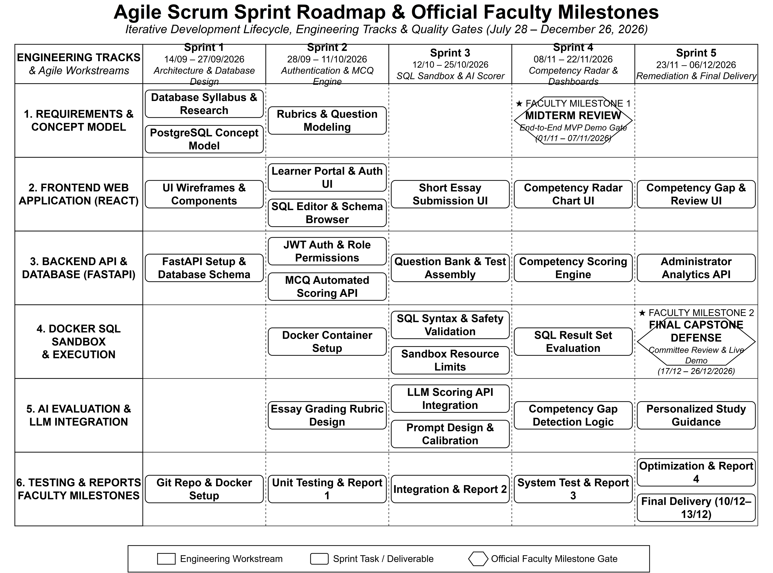
Figure 1: Agile Scrum Sprint Roadmap & Official Faculty Milestones

11.3. Team Role Assignment & RACI Matrix
To maintain clear responsibility, task ownership across team members is mapped using the RACI framework (Responsible, Accountable, Consulted, Informed) in Table 14:
Table 14: RACI Responsibility Assignment Matrix across Major Workstreams
Major Project Deliverable / Task | Thu | Nguyen | Truong | Do | Han
Project Coordination, Scrum Meetings & Backlog | A / R | C | I | I | C
Requirements Gathering & Software Specifications | A | R | C | C | R
Relational Database Architecture & Queries | I | C | A / R | C | I
Frontend UI Development & Visual Dashboards | A / R | I | I | C | R
Docker SQL Execution Sandbox Setup | C | R | I | A / R | I
Rubric Essay Grading & AI Integration | I | R | C | A / R | C
Concept Competency Calculation Logic | C | R | C | A / R | C
Question Banks, Rubrics & Benchmark Data | I | I | A / R | I | R
System Testing, Quality Assurance & User Feedback | C | R | C | C | A / R
Final Report Writing & Presentation Preparation | A / R | R | R | R | R

12. System Architecture Overview

12.1. System Context Diagram
Figure 2 shows DBCAS, its two human actors, and the external systems it depends on: the LLM Provider and the OAuth Identity Provider. Directed flows cover registration and sign-in, assessment responses, curriculum management, analytics, and assistive AI requests and results:
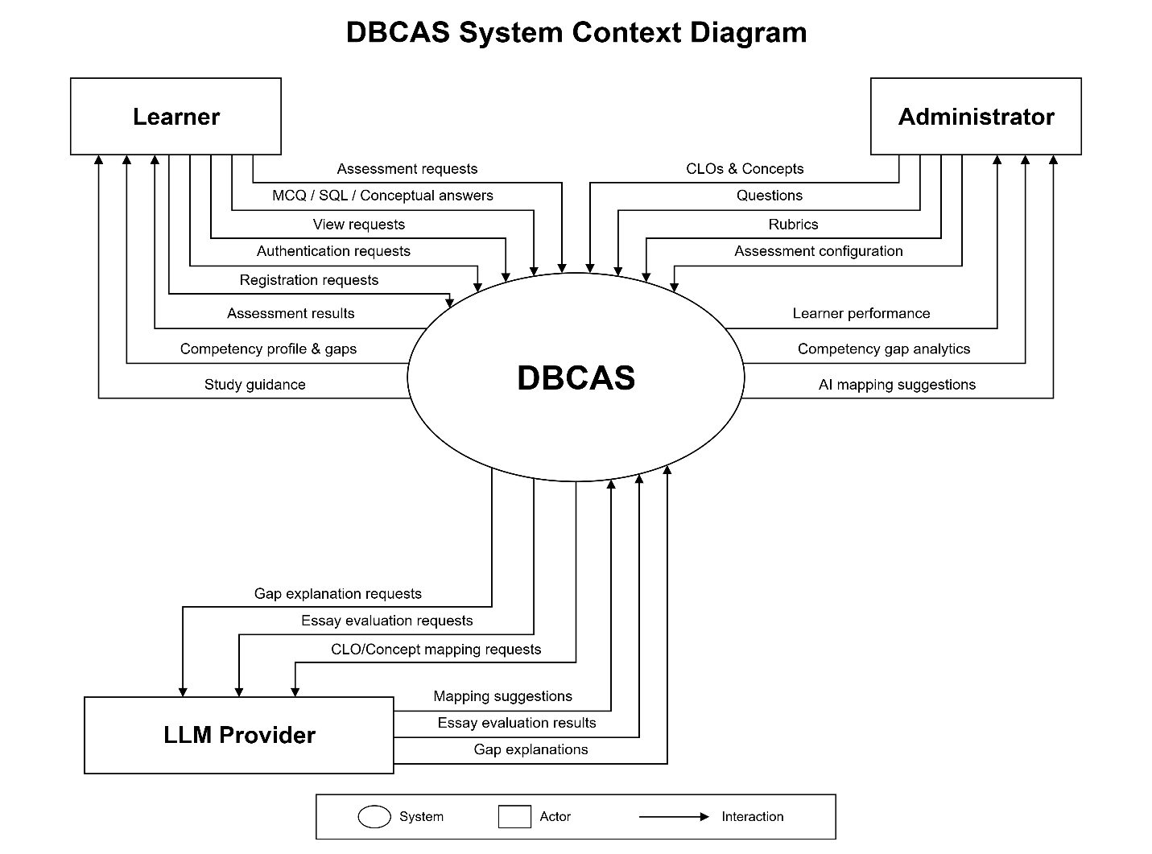
Figure 2: DBCAS System Context Diagram
The System Context Diagram defines the high-level operational boundary of DBCAS and captures its interactions with exactly two human actors and two external software systems: the LLM Provider and the OAuth Identity Provider.
• Learner (Primary Human Actor): An undergraduate student taking database assessments. Learners sign in with email/password or Google/GitHub OAuth, recover a forgotten password through a single-use emailed link when mail delivery is configured, choose their skills and difficulty for formal or practice sessions, and submit multiple-choice responses, read-only SQL queries, and written conceptual answers to DBCAS. In return, they receive visual competency profiles across core PostgreSQL concepts (including cumulative published results), evidence-linked competency-gap explanations, a prioritized list of topics to study, and results released immediately or after administrator review.
• Administrator (System Content Manager): An authorized DBCAS Administrator responsible for academic content and system configuration. Administrators define Course Learning Outcomes (CLOs), configure the PostgreSQL concept model and prerequisites, set difficulty levels, approve AI-generated questions after automated checks, curate the validated question bank and scoring rubrics, configure adaptive assessment and result-release policies, manage roles (Administrator accounts never take assessments: learner assessment routes reject them even on a legacy dual-role account), and review SQL and essay grades when human-verified release is required; an Administrator can never review or publish a result for a session they own. In return, they receive cohort-wide competency gap analytics, individual learner performance records, and system-proposed CLO-to-concept mappings for review.
• LLM Provider (External Software System): An external software service (a provider-agnostic REST API; any compliant LLM vendor may be used) connected via secure API calls. The LLM Provider is utilized strictly for assistive AI analysis: recommending connections between CLOs/questions and PostgreSQL concepts, evaluating short technical essays against administrator rubrics, and generating plain-language explanations of detected skill gaps.
Role mapping and separation: DBCAS defines exactly two application roles. The User role is implemented as Learner, and the Admin role is implemented as Administrator. There is no third role. Self-registration and OAuth create Learner accounts only; Administrator accounts are provisioned by an existing role manager and start disabled. Administrator accounts cannot start, serve or submit an assessment, and an Administrator cannot review or publish a result for a session they own. A Learner may request promotion to Administrator through the course team; an existing Administrator with role-management capability reviews the request and grants or denies it through the audited role-management function. DBCAS does not expose a self-service promotion endpoint, and promotion never happens automatically.
• OAuth Identity Provider (External Software System): Google and GitHub OAuth 2.0 authorization servers used only for sign-in. DBCAS validates a signed state value, applies PKCE for Google, exchanges the authorization code server-side, requires a verified email, and never stores provider access tokens. New OAuth identities become Learners and never receive an Administrator role automatically.
• DBCAS (System Under Study): The central educational software platform that coordinates personalized assessment sessions, freezes the session scope, policy and practice plan before serving and selects formal questions from accumulated evidence, executes read-only SQL queries in a sandboxed environment, stores standardized evaluation evidence, computes competency scores deterministically, supports immediate or human-verified result release, pools published evidence into a cumulative profile, and visualizes competency profiles.
Architectural Boundary & Technology Encapsulation: In strict alignment with system context modeling standards, Figure 2 maintains a high-level view and does not include internal software modules, database engines, application frameworks, or development toolchains as external actors. The OAuth Identity Provider is specified in this section and is not drawn in the baseline figure. Implementation technologies (such as React, Vite, Tailwind CSS, Chart.js, FastAPI, PostgreSQL, Docker, and Git) and internal processing modules (Personalized Plan Assembly, Scoring Engine, Evidence Store, Competency Engine, Competency Gap Analyzer, and Review/Publish workflow) operate wholly within the logical architecture of DBCAS and are detailed in Section 12.2.
AI Ethics & Administrator-Configured Evaluation Principle: In strict compliance with academic ethics, fairness, and transparency, the external LLM Provider functions solely as an assistive component and never autonomously determines a learner's final competency. Administrators configure essay rubrics, competency benchmarks, and the result-release policy. LLM-assisted essay scores are recorded as answer evidence, and DBCAS applies predefined rules to aggregate that evidence into final concept competency scores and rank below-benchmark concepts by shortfall. When human-verified release is configured, an administrator reviews and approves SQL and essay scores before publication, and every review and release transition is auditable. LLM-generated gap explanations link to answer evidence and do not change scores or recommendation order. AI-generated question delivery is an opt-in formal source mode: it requires a configured provider and session-scoped question storage, and it fails closed with an explicit unavailable response rather than serving an unvalidated item.

12.2. Multi-Tier Logical System Architecture
DBCAS is organized into four main layers to keep components clean, easy to test, and simple to maintain, as illustrated in Figure 3:
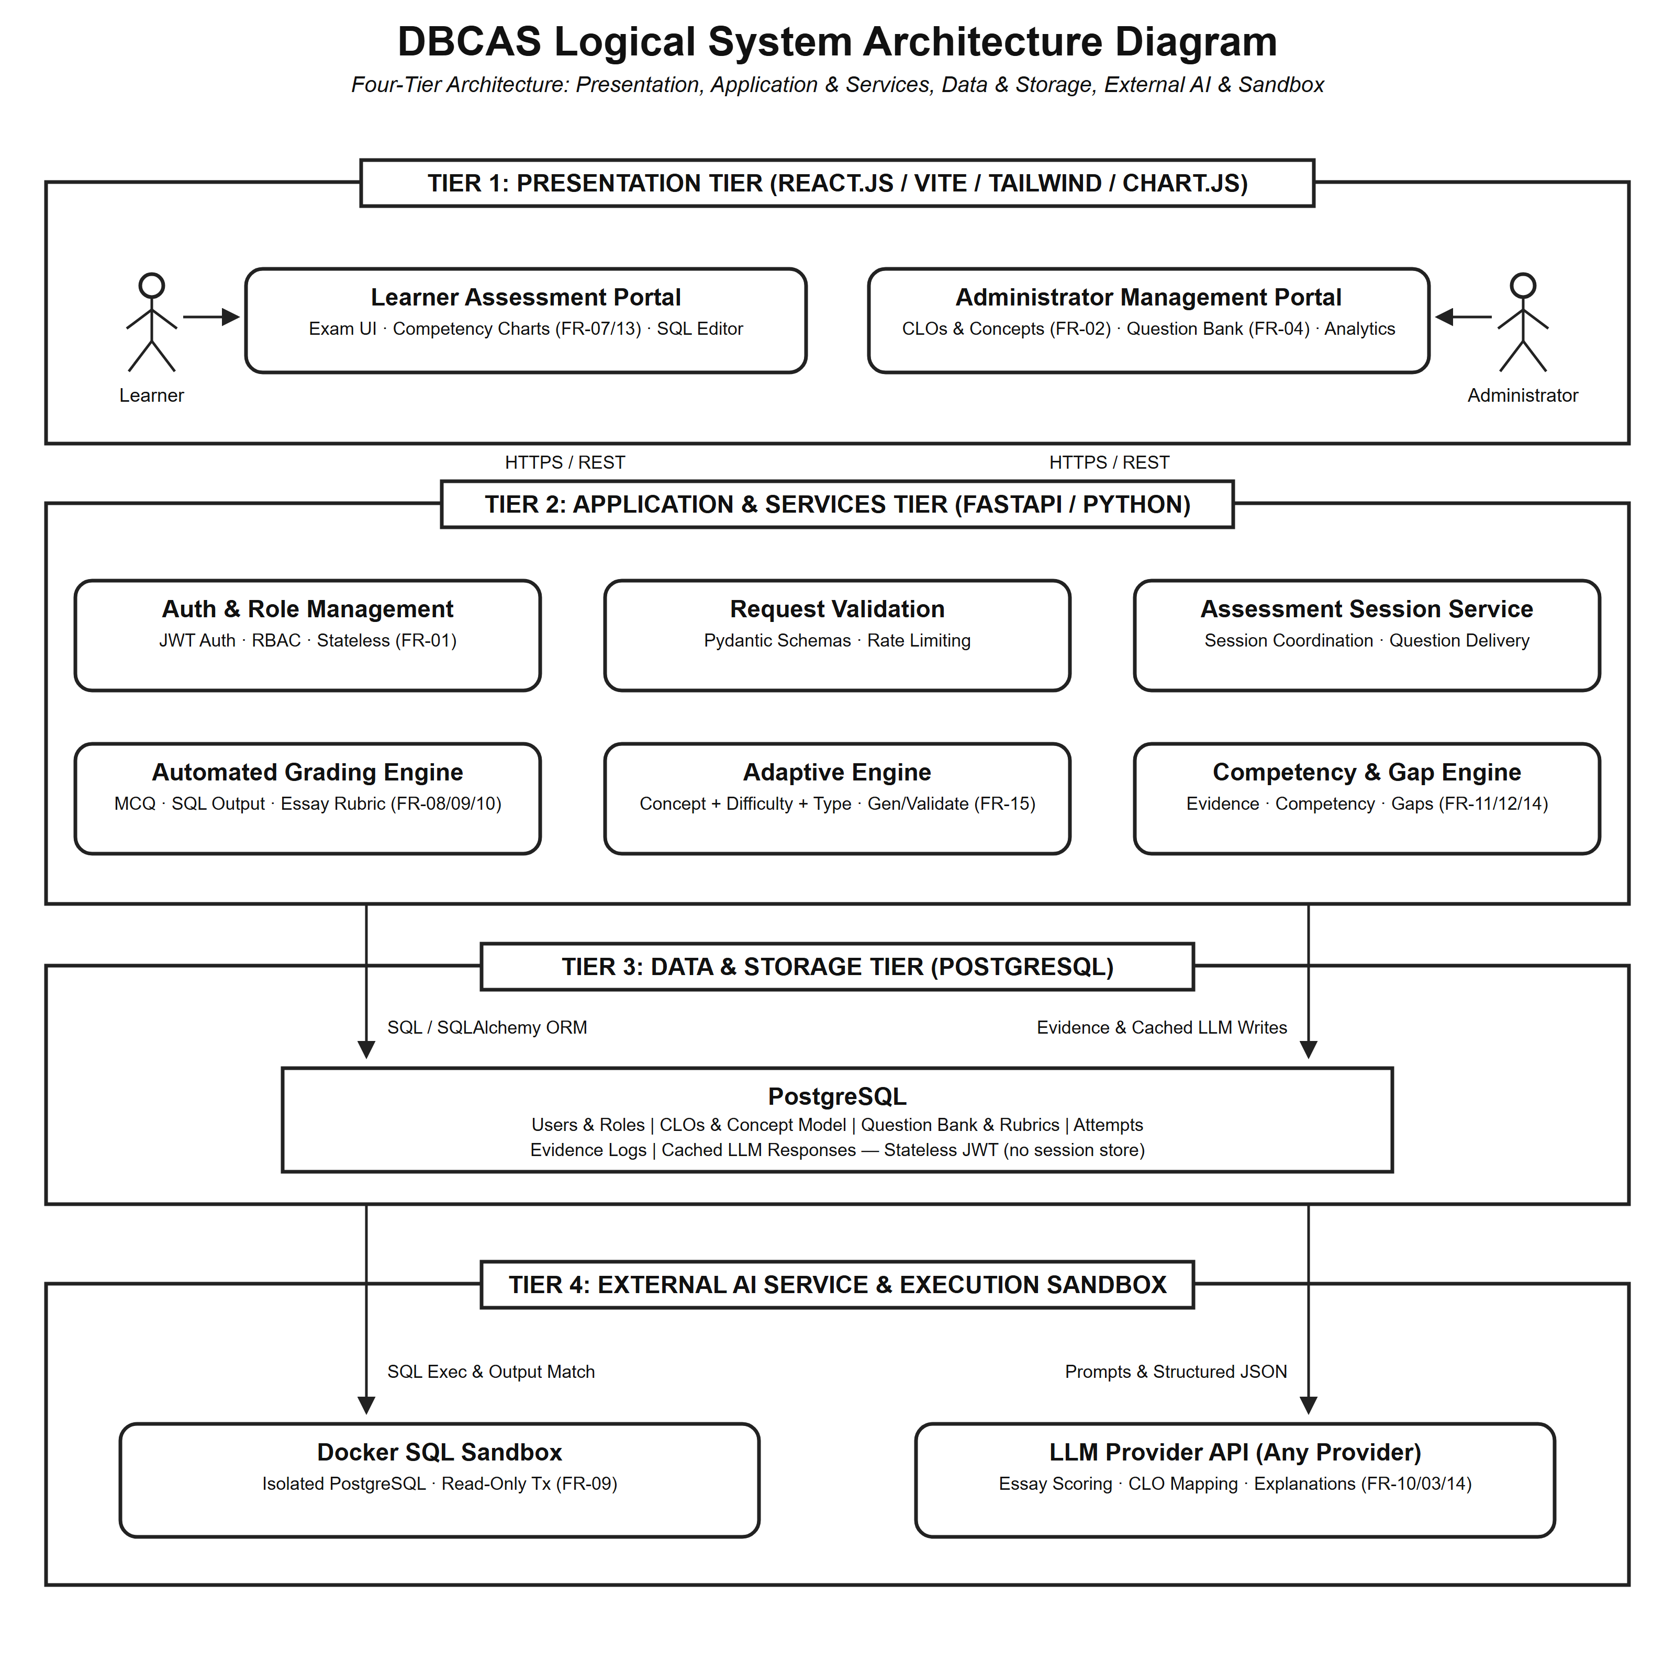
Figure 3: DBCAS Logical System Architecture Diagram
Note: Figure 3 shows the baseline four-tier layout. OAuth sign-in, personalized plan assembly, formal adaptive selection, durable asynchronous grading, and the administrator review/publish workflow operate within the Application & Services and Data & Storage tiers.
The four architectural tiers operate as follows:
• Presentation Tier (Web Frontend): A single-page web app built with React.js and Vite using JavaScript (ES6+ / JSX), styled with Tailwind CSS, and using Chart.js for data visualization. Includes learner portals for formal and practice assessments, results, and radar charts; administrator portals for managing CLOs, questions, rubrics, and human-verified result release; the code editor for SQL queries; and English/Vietnamese and theme preferences.
• Application & Services Tier (FastAPI): A Python backend handling application logic through dedicated services: JWT authentication, OAuth sign-in and role management with immutable audit, personalized plan assembly and formal adaptive selection, session coordination with autosaved drafts, validated question bank management, grading engines with durable retry jobs, configurable result release and administrator review, competency scoring and cumulative aggregation, gap detection, and study-topic ranking.
• Data & Storage Tier: A PostgreSQL 17 database (36 tables) storing users and roles, course outcomes, questions and translations, test attempts, immutable evidence, review and release audit records, competency results, and cached LLM responses. Stateless JWT authentication removes the need for a separate session store.
• External AI & Execution Sandbox: A dedicated Docker container hosting an isolated PostgreSQL instance for read-only learner SQL, with strict memory and runtime limits; every query executes inside a read-only transaction that is rolled back after evaluation. External language model APIs (provider-agnostic) evaluate written conceptual answers using structured administrator rubrics, and OAuth 2.0 authorization servers handle sign-in without exposing provider tokens to the application.

12.3. Evidence-Based Competency & Gap Evaluation Pipeline
The central data flow in DBCAS turns learner answers into deterministic competency evidence through a personalized assessment pipeline, as shown in Figure 4:
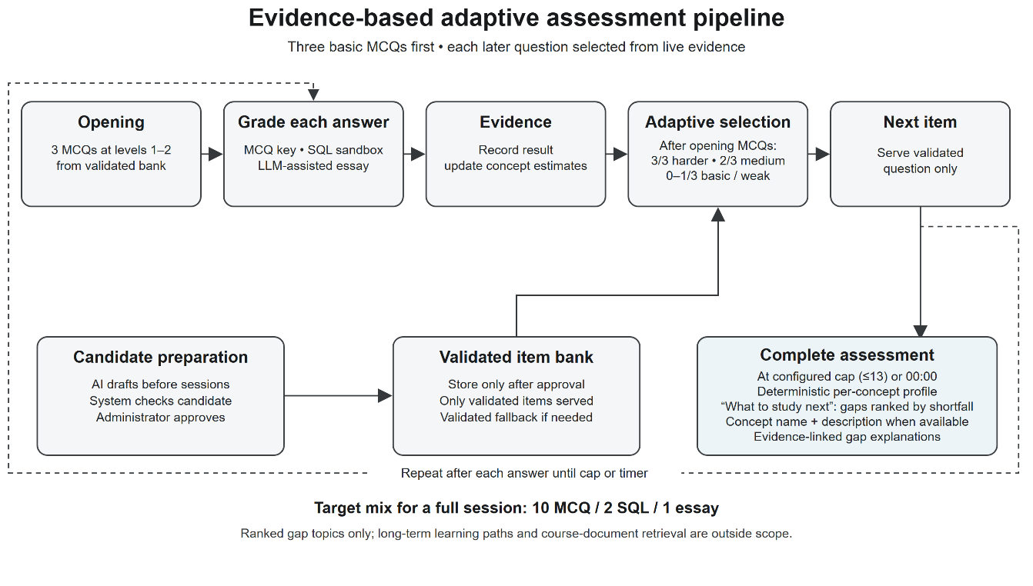
Figure 4: Evidence-based Competency & Gap Evaluation Pipeline
Note: Figure 4 shows the baseline evaluation pipeline. In the implemented system a practice plan is frozen before the first question is served while a formal session selects each later question from accumulated evidence inside the allowed difficulty range and serves the configured mix in strict MCQ → SQL → essay order, learner SQL is read-only, and results are published immediately or after administrator review depending on the assessment policy.
How the Evaluation Pipeline Operates: Before a session, the learner selects the skills to be assessed and a difficulty band. The system fixes the skills, band, question source and length before question one and draws only validated questions with confirmed concept tags, covering every selected skill and never repeating a version family. A practice session freezes its complete plan at that point, meeting the exact length with the formats the bank allows. A new formal assessment keeps the standard 10 MCQ / 2 SQL / 1 essay mix and the 60-minute duration (historical definitions keep their captured mix and duration) but selects each later question as it is needed: three basic MCQs open the session, the band moves at most one step per decision inside the allowed range, formats follow strict MCQ → SQL → essay order, and every decision is audited. When the approved bank cannot supply that sequence, the start stops with an explicit shortage explanation instead of reducing the count or relaxing validation. Answers are scored on submission by format. MCQs use verified keys; read-only SELECT statements run in the Docker sandbox against expected rows and columns; essays use LLM assistance and the four-level administrator rubric. Scores become concept-linked evidence, with drafts autosaved and navigation moving forward only. AI-generated candidates are prepared before sessions; the system checks answer completeness and duplicates, and for SQL items it runs the task and reference answer against test datasets. An Administrator reviews the question, answer, concept tags and difficulty; only approved items enter the validated bank, which is the default source for sessions. Where the deployment provides an AI provider and session-question storage, a formal session may instead choose AI-generated delivery, which keeps the three bank openers and validates every generated question before it is shown. The current development schema does not yet satisfy that storage requirement, so AI mode returns HTTP 503 with the code ai_session_storage_unavailable and directs the learner to BANK mode. When the session ends at the configured length or at the configured deadline, final competency is computed deterministically. Concepts below administrator targets are ranked by shortfall and shown as the “What to study next” list. Depending on the assessment policy, results are published immediately or after an administrator reviews the SQL and essay scores. The learner's cumulative profile pools evidence from published sessions only. The LLM may add evidence-linked explanations but does not affect scores or topic order.

12.4. Multi-Format Assessment & How Scores Are Calculated
To ensure fair, understandable grading, DBCAS avoids mysterious black-box calculations. Instead, each question has an assigned point value and is linked to the specific PostgreSQL concepts it tests. When an assessment is submitted:
• Multiple-Choice Questions: Scored automatically based on the verified correct answer chosen by the administrator.
• Practical SQL Queries: Read-only SELECT statements are executed inside the isolated PostgreSQL 17 Docker sandbox and graded semantically, never by exact string matching. Points are awarded deterministically for syntax validity, correct results across multiple test datasets including edge cases, and required-concept compliance when the question mandates a technique — equivalent SQL formulations receive full credit. DML/DDL are never executed; that knowledge is assessed through MCQ and essay items.
• Short Conceptual Essays: Evaluated against a clear rubric with LLM assistance, checking whether the learner correctly explained key concepts, noted trade-offs, and cited proper technical terminology.
Deterministic Scoring & Human-Governed Competency: To calculate a learner's standing on any given PostgreSQL concept (such as JOINs or Window Functions), the system computes scores deterministically by comparing points earned on items testing that concept against total possible points available for it. The cumulative profile pools point totals across every published session instead of averaging session percentages. If a learner's competency on a concept is lower than the administrator-set passing expectation, the system flags it as a competency gap. After showing the profile, DBCAS ranks those concepts by their shortfall from the target and presents them as study topics, using the concept name and its description when available to clarify what to review. The LLM Provider only generates evidence-linked, plain-language explanations; it does not determine the score or the topic order. When an assessment uses human-verified release, an administrator reviews the SQL and essay scores and approves the result before it is published; every review and release transition is recorded in an immutable audit trail.

12.5. AI Integration & Prompt Engineering
To keep AI evaluation dependable and fair, DBCAS enforces four core prompt design rules and architectural safeguards, detailed in Table 15:
Table 15: AI Evaluation Guardrails and Prompt Design Rules
No. | Prompt Design Principle | Technical Implementation in DBCAS | Quality & Fairness Safeguard
1 | Deterministic Scoring Controls | API temperature is set to a low value (temperature = 0.1) with fixed seeds across repeated calls. | Prevents random score variations and ensures identical learner answers receive consistent grades.
2 | Strict JSON Output Schema | Language model output is constrained to a predefined JSON schema containing numeric scores, rubric levels, and cited text. | Enables reliable automated parsing by the FastAPI backend and prevents free-form text hallucinations.
3 | Rubric-Guided Few-Shot Prompts | Prompts include explicit rubric level definitions (Complete, Mostly Complete, Partial, Incomplete) with concrete grading examples. | Ensures the AI acts strictly as an objective rubric evaluator rather than an unconstrained chatbot.
4 | Administrator-Configured Evaluation Rules | Administrators configure essay rubrics and competency benchmarks and approve AI-generated question candidates before bank entry. The LLM provides rubric-assisted essay scores and evidence-linked gap explanations. DBCAS applies fixed rules to recorded answer evidence to compute concept competency and rank gaps by shortfall; gap explanations do not change scores or order. Assessments configured for human-verified release require an administrator to approve SQL and essay scores before publication. | Keeps evaluation rules and validated question content under Administrator control, with defined system rules for scores and rankings and human sign-off where required.

13. Potential Risks and Mitigation Strategies
To anticipate potential engineering hurdles and keep the project on track, our team analyzed six key risk areas, summarized in Table 16:
Table 16: Project Risk Assessment Matrix and Mitigation Strategies
Risk ID & Category | Specific Risk Description | Likelihood & Impact | Mitigation Strategy
RSK-01  Technical / Security | Learners writing harmful SQL queries or infinite loops that could overload the server. | Likelihood: Low  Impact: High | • Enforce a strict 3-second statement timeout and a 256 MB memory limit on the sandbox container.  • Run queries in an isolated, unprivileged container under a read-only role and accept SELECT statements only; DML/DDL are assessed through MCQ and essay.  • Roll back every learner transaction and reset the sandbox schema between assessment sessions.
RSK-02  AI Consistency | Language model giving slightly different scores or inaccurate feedback on written essay answers. | Likelihood: Medium  Impact: Medium | • Use low temperature settings and require structured JSON output.  • Grade using detailed rubrics that require citing specific sentences from learner answers.  • Route assessments configured for human-verified release through an administrator review queue before publishing.
RSK-03  API Cost & Latency | External LLM Provider fees or slow network responses during busy assessment sessions. | Likelihood: Medium  Impact: Medium | • Use a fast, cost-effective model from the chosen LLM provider.  • Cache identical evaluation queries in a PostgreSQL table and process grading as durable asynchronous jobs.
RSK-04  Dataset Access | Limited access to real university learner exam archives due to school privacy policies. | Likelihood: High  Impact: Medium | • Build a self-contained benchmark dataset of realistic, difficulty-tagged sample questions, schemas, and answers large enough to support personalized plan assembly.  • Include common learner mistakes to test the evaluation pipeline thoroughly.
RSK-05  Schedule Delays | Sprint tasks running behind schedule, risking university review deadlines. | Likelihood: Medium  Impact: High | • Follow strict two-week sprints with velocity tracking at every retrospective.  • Focus on completing core features first for a solid Midterm demonstration.
RSK-06  Personalized Plan Quality | A personalized selection repeatedly over-samples narrow or poorly matched questions, producing an inaccurate ability estimate. | Likelihood: Low  Impact: Medium | • Cover every selected skill and enforce the format mix: freeze the complete practice plan before serving and confine formal selection to the allowed difficulty range and current question phase.  • Log every selection decision and use validated fallback items so no session waits for AI generation.

14. Expected Outcomes / Deliverables
By the conclusion of Capstone Project 1 (Final Submission: December 10–13, 2026; Defense: December 17–26, 2026), our team will deliver a complete package of software artifacts, benchmark data, and technical documentation (with all written reports provided in both PDF and Word .docx formats), detailed in Table 17:
Table 17: Capstone Project Deliverables and Expected Outcomes
No. | Deliverable Item | Detailed Description of Artifact | Delivery Format
1 | Working DBCAS Web Application | A deployed web platform featuring OAuth and email/password sign-in, role management, personalized formal and practice assessments, a read-only SQL sandbox, radar competency charts, cumulative gap reports with a ranked “What to study next” list, and administrator portals for curriculum, question bank, human-verified result release, and cohort performance. | Deployed online application with live demonstration URL and setup guide.
2 | Complete Source Code Repository | Clean, modular source code for the React frontend (JavaScript / JSX), FastAPI backend, Docker sandbox scripts, and evaluation modules, following standard coding guidelines. | GitHub repository containing documentation, Docker Compose setup, and build scripts.
3 | Benchmark Datasets & Rubrics | • Standard database course learning outcomes and PostgreSQL concept taxonomy.  • Question bank with multiple-choice, SQL query, and short essay items tagged by concept and difficulty level.  • Clear grading rubrics and sample learner answers for testing. | Structured JSON, CSV, and SQL seed files stored in the project repository.
4 | Technical Documentation Suite | • Software Requirements Specification (SRS) following standard IEEE guidelines.  • Software Design Document (SDD) with architecture diagrams and database schemas.  • Test plan and test execution report with automated test results.  • Learner user guide and administrator management manual. | Standardized PDF and Word (.docx) documents included in the project release.
5 | Capstone 1 Academic Report | Comprehensive academic thesis document formatted according to Duy Tan University guidelines, explaining the problem, architecture, evaluation methods, and testing results. | Official PDF and Word (.docx) documents submitted to the review committee.
6 | Presentation Slides & Defense Materials | • Comprehensive slide deck prepared for the capstone defense before the faculty academic committee.  • Live demonstration environment showcasing core learner assessment and administrator management workflows. | Presentation slides in PowerPoint and PDF formats, accompanied by demo walkthrough notes.

15. References
Academic literature, curriculum guidelines, software tools, and online references with accurate source details and direct web addresses:
[1] A. Silberschatz, H. F. Korth, and S. Sudarshan, Database System Concepts, 7th ed. New York, NY, USA: McGraw-Hill Education, 2019. Official Companion Website: https://www.db-book.com/
[2] R. Ramakrishnan and J. Gehrke, Database Management Systems, 3rd ed. New York, NY, USA: McGraw-Hill, 2003. Course Archive: http://pages.cs.wisc.edu/~dbbook/
[3] ACM and IEEE Computer Society, "Computer Science Curricula 2013: Curriculum Guidelines for Undergraduate Degree Programs in Computer Science," ACM/IEEE Joint Task Force on Computing Curricula, Tech. Rep., 2013. Available: https://www.acm.org/education/curricula-recommendations
[4] W. Spady, Outcome-Based Education: Critical Issues and Answers. Arlington, VA, USA: American Association of School Administrators, 1994. ERIC Document Reproduction Service No. ED380910: https://files.eric.ed.gov/fulltext/ED380910.pdf
[5] J. Biggs and C. Tang, Teaching for Quality Learning at University: What the Student Does, 4th ed. Maidenhead, UK: Open University Press, McGraw-Hill Education, 2011. Publisher Catalog: https://openlibrary.org/isbn/9780335242757
[6] P. Denny, J. Prather, B. A. Becker, et al., "Computing Education in the Era of Generative AI," Communications of the ACM, vol. 67, no. 2, pp. 56–67, 2024. ACM Digital Library: https://doi.org/10.1145/3624720
[7] J. Leinonen, P. Denny, S. MacNeil, et al., "Comparing Code Explanations Created by Students and Large Language Models," in Proceedings of the 2023 Conference on Innovation and Technology in Computer Science Education (ITiCSE '23), 2023, pp. 124–130. ACM Digital Library: https://doi.org/10.1145/3587102.3588785
[8] H. Keuning, J. Jeuring, and B. Heeren, "A Systematic Literature Review of Automated Feedback Generation for Programming Exercises," ACM Transactions on Computing Education, vol. 19, no. 1, pp. 1–43, 2018. ACM Digital Library: https://doi.org/10.1145/3231711
[9] Google, "Gemini: A Family of Highly Capable Multimodal Models," arXiv preprint arXiv:2312.11805, 2023. Available: https://arxiv.org/abs/2312.11805
[10] PostgreSQL Global Development Group, "PostgreSQL 17 Documentation: SQL Language and Server Administration," 2024. Official Documentation: https://www.postgresql.org/docs/17/
[11] Docker Inc., "Docker Documentation: Resource Constraints and Container Security," 2024. Official Documentation: https://docs.docker.com/engine/security/
[12] Meta Open Source, "React Documentation: Building Modern User Interfaces," 2024. Official Website: https://react.dev/
[13] S. Ramírez, "FastAPI Documentation: High Performance Web Framework with Python," 2024. Official Website: https://fastapi.tiangolo.com/
[14] LeetCode LLC, "LeetCode Database Problem Set and Automated Query Evaluation Engine," 2024. Available: https://leetcode.com/problemset/database/

