
International School
Capstone Project 1
CMU-SE 450_C1SE.70
Architecture Design Document
Version 1.1
Date: October 30th, 2026
DBCAS – AI-Assisted Database Competency Assessment and Skill Gap Analysis
Submitted by C1SE.70
Thu, Nguyen Ngoc Anh - 29209245799
Nguyen, Nguyen Nhat - 26211227029
Truong, Nguyen Quang - 29212730635
Do, Nguyen Quoc - 29211156881
Han, Nguyen Ngoc - 29204423268

Review Panel Representative:

Name Signature Date
Capstone Project 1 - Mentor:

Name MSc Viet, Huynh Duc Signature Date

PROJECT INFORMATION
Project acronym | DBCAS
Project Title | DBCAS – AI-Assisted Database Competency Assessment and Skill Gap Analysis
Start Date | 14/09/2026 | End Date | 26/12/2026
Lead Institution | International School, Duy Tan University
Project Mentor | MSc Viet, Huynh Duc
Scrum master / Project Leader & contact details | Thu, Nguyen Ngoc Anh  Email: 01258319907anhthu@gmail.com  Tel: 0919334040
Partner Organization | Duy Tan University
Project Web URL
Team members | Name | Email | Tel
 | Thu, Nguyen Ngoc Anh | 01258319907anhthu@gmail.com | 0919334040
 | Nguyen, Nguyen Nhat | nhnguyen240602@gmail.com | 0355772330
 | Truong, Nguyen Quang | quangtruongtt8@gmail.com | 0349039023
 | Do, Nguyen Quoc | nguyenquocdodary@gmail.com | 0388496885
 | Han, Nguyen Ngoc | Hannguyenngoc0506@gmail.com | 0899455605

DOCUMENT INFORMATION
Document Title | Architecture Design Document
Author(s) | C1SE.70 Team
Role | Team Members
Date | 30/10/2026 | File name | DBCAS-System-Architecture-v1.1.docx
URL
Access | Project and CMU Program

DOCUMENT APPROVALS
The following signatures are required for approval of this document.
Thu, Nguyen Ngoc Anh  Student ID: 29209245799  Project Manager / Scrum Master / Frontend Developer | Signature | Date
Nguyen, Nguyen Nhat  Student ID: 26211227029  Backend Developer / QA Tester | Signature | Date
Truong, Nguyen Quang  Student ID: 29212730635  Database Developer | Signature | Date
Do, Nguyen Quoc  Student ID: 29211156881  Backend Developer | Signature | Date
Han, Nguyen Ngoc  Student ID: 29204423268  Frontend Developer / QA Tester | Signature | Date
REVISION HISTORY
Version | Date | Comments | Author
1.0 | 18/09/2026 | Init | C1SE.70 Team
1.1 (historical) | 24/09/2026 | Update | C1SE.70 Team
1.2 | 02/10/2026 | Update | C1SE.70 Team
1.3 | 22/10/2026 | Align with the implemented schema and supervisor extensions: personalized assessment, verified result release, OAuth, role management, cumulative competency, translations and 32-table data model. | C1SE.70 Team
1.4 | 29/10/2026 | Assessment views aligned with adaptive formal delivery, frozen practice plans, explicit shortage, opt-in AI generation and learner-only assessment routes. | C1SE.70 Team
1.1 | 30/10/2026 | Unified published baseline: implementation-aligned content, adaptive formal delivery, BANK/AI source modes, 36-table schema, password recovery, role separation and release/privacy guarantees. | C1SE.70 Team
Versioning note: this table preserves the document's real working history. Revisions 1.2–1.4 were successive working drafts prepared after the original 1.1. For publication, the Proposal, User Story, System Architecture and Database Design are released together as the single v1.1 baseline; the original 1.1 row is retained as historical, and the new 1.1 row records this unified publication. No historical date, author or approval has been changed.

Table of Contents
1. Actor, Use Case and UC Diagram 1
1.1. Actors 1
1.2. Use Cases 1
1.3. Use Case Diagram 5
2. System Context Diagram 6
3. Architectural Drivers 7
3.1. Use Case Entities 7
3.2. Operational Use Cases 10
3.3. Quality Attribute Scenarios 27
3.4. Technical Constraints 34
3.5. Business Constraints 35
4. C4 Model 37
4.1. Container Diagram 37
4.2. Component Diagram 40
5. Module View 44
6. Allocation View 47
7. Entity Relationship Diagram 50

List of Tables
Table 1. Actors of the DBCAS system 1
Table 2. Use cases of Learner before sign-in 1
Table 3. Use cases of Administrator 2
Table 4. Use cases of Learner 3
Table 5. Elements of the System Context Diagram 6
Table 6. Use Case Entities: Administrator 7
Table 7. Use Case Entities: Learner 8
Table 8. Use Case Entities: Learner before sign-in 8
Table 9. Use Case Entities: LLM Provider (external system) 9
Table 10. Use Case Entities: OAuth Identity Provider (external system) 9
Table 11. Operational Use Cases: Register Learner Account 10
Table 12. Operational Use Cases: Login 11
Table 13. Operational Use Cases: Logout 12
Table 14. Operational Use Cases: Provision Administrator Accounts and Manage Roles 12
Table 15. Operational Use Cases: Define CLOs and Concept Model 13
Table 16. Operational Use Cases: Review AI-Suggested CLO-to-Concept Mappings 14
Table 17. Operational Use Cases: Curate Validated Question Bank 15
Table 18. Operational Use Cases: Review AI-Recommended Question Tags 16
Table 19. Operational Use Cases: Configure Adaptive Assessment Sessions 16
Table 20. Operational Use Cases: Oversee AI-Generated Question Candidates 17
Table 21. Operational Use Cases: View Learner Competency Profiles and Cohort Analytics 18
Table 22. Operational Use Cases: Take a Personalized Adaptive Assessment Session 19
Table 23. Operational Use Cases: Write and Run SQL in the Embedded Editor 20
Table 24. Operational Use Cases: Answer Multiple-Choice and Essay Questions 21
Table 25. Operational Use Cases: Receive Grading Results and Feedback 22
Table 26. Operational Use Cases: View Visual Competency Profile 23
Table 27. Operational Use Cases: View Competency Gap Explanations 23
Table 28. Operational Use Cases: Review Assessment History and Evidence Records 24
Table 29. Operational Use Cases: Manage Interface Preferences 25
Table 30. Operational Use Cases: Review and Publish Human-Verified Results 26
Table 31. Quality Attribute Scenarios: Page and API Response Time 27
Table 32. Quality Attribute Scenarios: SQL Sandbox Execution Time 27
Table 33. Quality Attribute Scenarios: Sandbox Isolation 28
Table 34. Quality Attribute Scenarios: Unauthorized Access Attempt 29
Table 35. Quality Attribute Scenarios: Learner Data Privacy 29
Table 36. Quality Attribute Scenarios: Scoring Consistency 30
Table 37. Quality Attribute Scenarios: Question Generation Never Blocks a Session 31
Table 38. Quality Attribute Scenarios: Concurrent Learners 31
Table 39. Quality Attribute Scenarios: Replacing the LLM Provider 32
Table 40. Quality Attribute Scenarios: Code Quality and Bug Fixing 33
Table 41. Quality Attribute Scenarios: Exam Interface Usability 33
Table 42. Technical Constraints: Technology Stack Limitation 34
Table 43. Technical Constraints: SQL Sandbox Resource Limits 34
Table 44. Technical Constraints: External LLM Provider Limits and Latency 35
Table 45. Technical Constraints: Modern Web Browser Compatibility 35
Table 46. Business Constraints: Timeline and Deliverables 35
Table 47. Business Constraints: Independent Benchmark Data 35
Table 48. Business Constraints: Human-Governed AI Evaluation 36
Table 49. Business Constraints: Learner Data Privacy 36
Table 50. Responsibilities of Container Diagram 38
Table 51. Responsibilities of Component Diagram 42
Table 52. Responsibilities of Module View 45
Table 53. Responsibilities of Allocation View 48
Table 54. Details about ERD tables 53

List of Figures
Figure 1. Use Case Diagram 5
Figure 2. System Context Diagram 6
Figure 3. Container Diagram 37
Figure 4. Component Diagram 40
Figure 5. Module View 44
Figure 6. Allocation View 47
Figure 7. Entity Relationship Diagram 50
Figure 8. Table Relationship Diagram 51

1. Actor, Use Case and UC Diagram

1.1. Actors
Table 1. Actors of the DBCAS system
Actor | Description
Learner | The User role, implemented as Learner: an undergraduate student who takes adaptive assessments and reviews published competency results. A Learner may request promotion to Administrator; an authorized role manager reviews the request through UC04, and promotion never happens automatically.
Administrator | The Admin role, implemented as Administrator: an authorized DBCAS administrator who manages course outcomes, the question bank, and assessment configuration. Administrators cannot take assessments and cannot review or publish a result for a session they own.
LLM Provider (external system) | A provider-agnostic external REST service used only for assistive AI tasks; it never determines the final competency score.
OAuth Identity Provider (external system) | Google and GitHub OAuth 2.0 authorization servers. DBCAS redirects the browser with a signed state cookie and PKCE where supported, exchanges the authorization code server-side, and receives only a verified profile (provider user id, email, verification flag). Provider access tokens are never stored or exposed to the browser.

1.2. Use Cases
Learner before sign-in:
Table 2. Use cases of Learner before sign-in
No. | Use case | Description
1 | Register Learner Account | A learner creates a Learner account with a name, email, and password; Administrator accounts can never be created by self-registration.
2 | Access Login Page | Unauthenticated visitors are directed to the login page; assessment content and personal data are not accessible without logging in (handled within UC02 Login).
3 | Sign in with Google or GitHub | A visitor authenticates through a configured OAuth provider (UC02); a new verified identity becomes a Learner account, and OAuth never grants a role.
Administrator:
Table 3. Use cases of Administrator
No. | Use case | Description
1 | Login / Logout | Authenticate with email and password to receive a secure JWT and access administrative functions; log out to end the session.
2 | Provision Accounts and Manage Roles | An existing administrator creates new administrator accounts, which stay disabled until manually verified and activated.
3 | Define CLOs and Concept Model | Create and maintain course learning outcomes, the Core PostgreSQL concept model, difficulty levels, and passing benchmarks.
4 | Review AI-Suggested CLO-to-Concept Mappings | Accept, edit, or reject the connections proposed by the assistive AI; nothing is applied without confirmation.
5 | Curate Validated Question Bank | Manage the approved pool of multiple-choice, SQL, and short essay items with answer keys, test datasets, and rubrics.
6 | Review AI-Recommended Question Tags | Confirm or edit the concept tags and evaluation criteria suggested for each question.
7 | Configure Adaptive Assessment Sessions | Choose target concepts and difficulty ranges; new formal definitions use the standard 13-question / 60-minute contract (10 MCQ / 2 SQL / 1 essay), while historical published definitions keep their frozen duration and mix.
8 | Oversee AI-Generated Question Candidates | Review candidates that passed automated checks and approve them into the validated bank or reject them.
9 | View Learner Competency Profiles and Cohort Analytics | See per-learner radar and bar charts, cohort-wide gap analytics, and individual assessment history.
10 | Manage Interface Preferences | Switch the interface language (English / Vietnamese) and light or dark theme; preferences persist in the browser and never change an in-progress session's frozen locale.
11 | Review and Publish Human-Verified Results | Review automated SQL and essay evidence, approve scores with comments, and publish session results when the assessment policy is HUMAN_VERIFIED.
Learner:
Table 4. Use cases of Learner
No. | Use case | Description
1 | Login / Logout | Authenticate to access the assessment platform; log out to securely end the session.
2 | Take a Personalized Adaptive Assessment Session | Complete a personalized assessment session after choosing skills and difficulty: a formal session follows its frozen contract (new definitions use 13 questions in 60 minutes; historical definitions keep their captured duration and mix), or a practice session of 1, 2, 3, 5, 10, or 13 questions; a practice plan is frozen before question one, while a formal session selects each later question from accumulated evidence.
3 | Write and Run SQL in the Embedded Editor | Solve SQL tasks in an editor with syntax highlighting and a schema viewer; queries execute in the isolated PostgreSQL 17 Docker sandbox.
4 | Answer Multiple-Choice and Essay Questions | Select one MCQ option or write a short conceptual essay; answers are saved before submission or when the timer expires.
5 | Receive Grading Results and Feedback | Every answer is scored on submission: MCQ by answer key, SQL semantically in the sandbox, essay by rubric with LLM assistance.
6 | View Visual Competency Profile | See radar and bar charts of PostgreSQL mastery, followed by a ranked list of below-benchmark topics to study.
7 | View Competency Gap Explanations | See below-benchmark concepts, evidence-linked explanations, and a “What to study next” list ordered by shortfall from target.
8 | Review Assessment History and Evidence Records | List completed sessions and open the evidence record of every answer.
9 | Manage Interface Preferences | Switch the interface language (English / Vietnamese) and light or dark theme; preferences persist in the browser and never change an in-progress session's frozen locale.

1.3. Use Case Diagram
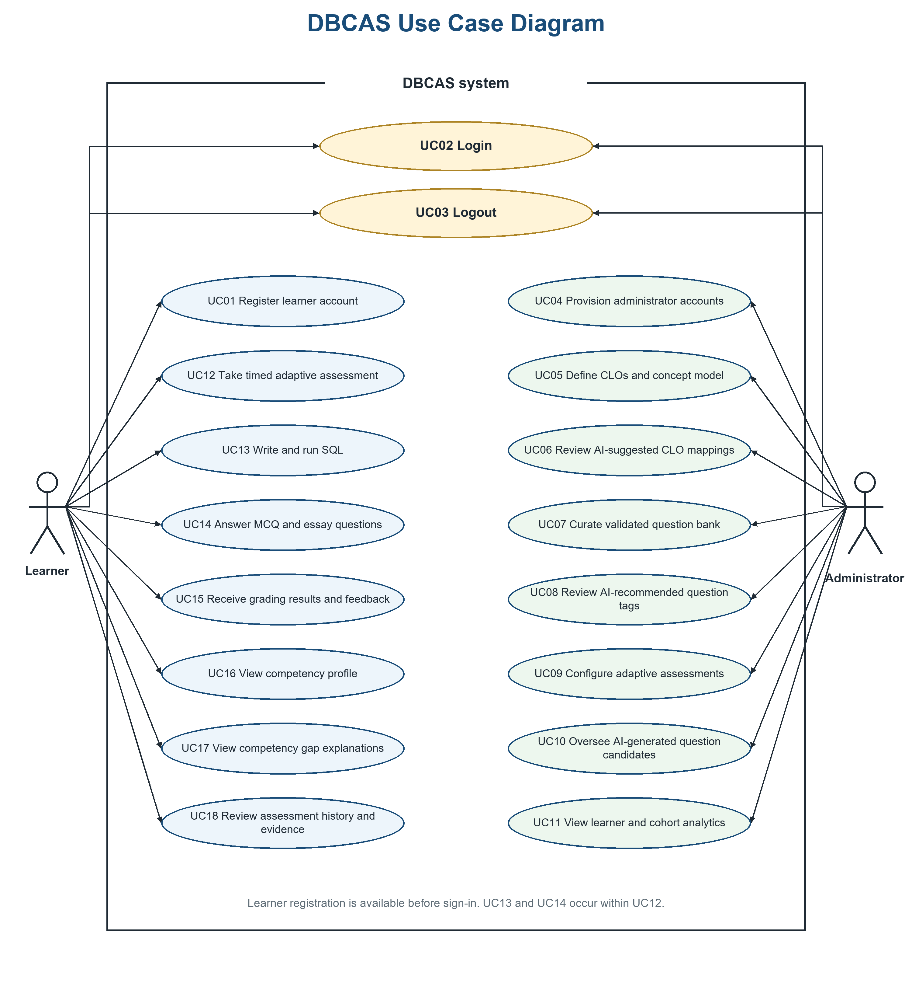
Figure 1. Use Case Diagram
Figure 1 shows the baseline use-case view. UC19 (Manage Interface Preferences) and UC20 (Review and Publish Human-Verified Results), together with the personalized assessment and verified-release extensions, are specified in Section 3.2.

2. System Context Diagram
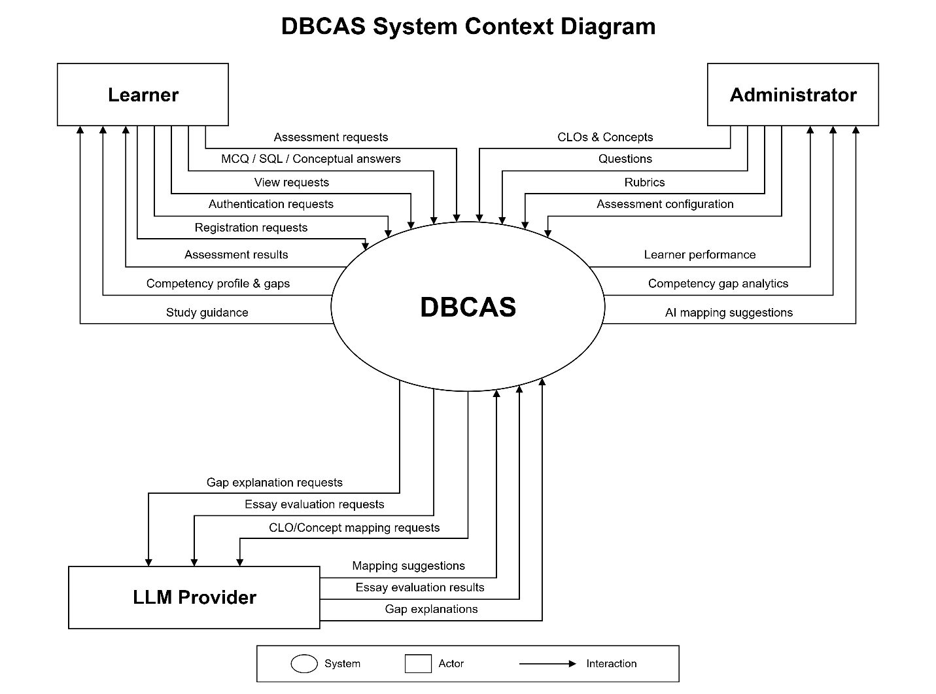
Figure 2. System Context Diagram
The System Context Diagram defines the operational boundary of DBCAS and its interactions with two human actors and three external software systems: the OAuth identity providers and the LLM Provider (Table 5). The baseline figure shows the original boundary; the OAuth providers are listed in the table.
Table 5. Elements of the System Context Diagram
Element | Interactions with DBCAS
Learner | Selects skills, difficulty and practice/formal mode; submits registration and login requests (including Google/GitHub), MCQ responses, live SELECT queries and written answers; receives published per-session and cumulative competency profiles, diagnostic gap reports and ranked study topics.
Administrator | Defines CLOs, concepts and prerequisites, difficulty levels, the validated question bank, translations, rubrics and adaptive assessment rules; manages accounts and roles, approves AI-generated question candidates, and reviews and publishes human-verified results; receives cohort analytics and learner performance records.
LLM Provider (external system) | A provider-agnostic REST service that receives sanitized prompts and candidate requests and returns suggestions and essay feedback. Used strictly for assistive analysis; it never determines the final competency score.
DBCAS (system under study) | Coordinates personalized assessment sessions, freezing the session scope, policy and practice plan and selecting formal questions adaptively, runs SELECT queries in a sandbox, stores standardized evidence, enforces the assessment release policy, computes per-session and cumulative competency deterministically, visualizes profiles, and ranks below-benchmark concepts as study topics.
OAuth Identity Provider (external system) | Google and GitHub authorization servers authenticate the user and return a provider identity. DBCAS verifies state and PKCE, resolves or creates a Learner account from a verified email, and never imports role grants from the provider.

3. Architectural Drivers

3.1. Use Case Entities
Table 6. Use Case Entities: Administrator
ID | E01
Title | Administrator
Description | An authorized DBCAS Administrator responsible for academic content and system configuration.
Provides Assumptions | Has elevated privileges to manage course learning outcomes, the concept model and prerequisites, the validated Question Bank, translations, assessment configuration and result-release policy; can provision accounts and, when granted can_manage_roles, grant or revoke roles; can review and publish human-verified results.
Requires Assumptions | Authenticated with the Administrator role (JWT) and Account.status = active. The platform must provide administrator portals and management tools.
Identified Use Cases | UC02, UC03, UC04, UC05, UC06, UC07, UC08, UC09, UC10, UC11, UC19, UC20
Table 7. Use Case Entities: Learner
ID | E02
Title | Learner
Description | An undergraduate Computer Science or Software Engineering student taking Database Systems coursework who wants a concept-level picture of database competency.
Provides Assumptions | Has a personal Learner account and uses the platform to select skills and difficulty, take formal or practice adaptive assessments, and review published per-session and cumulative competency profiles and gap explanations.
Requires Assumptions | Must be registered and logged in to use assessment functions. A modern web browser and an internet connection are required.
Identified Use Cases | UC02, UC03, UC12, UC13, UC14, UC15, UC16, UC17, UC18, UC19
Table 8. Use Case Entities: Learner before sign-in
ID | E03
Title | Learner before sign-in
Description | An unauthenticated visitor who has not yet logged in to DBCAS.
Provides Assumptions | Can view only the login page and the learner registration form; no assessment content or personal data is accessible.
Requires Assumptions | Must provide a valid email address that has not been registered before to create a Learner account, or sign in with a provider-verified Google/GitHub identity.
Identified Use Cases | UC01, UC02
Table 9. Use Case Entities: LLM Provider (external system)
ID | E04
Title | LLM Provider (external system)
Description | A provider-agnostic external REST service (any compliant LLM vendor) used strictly for assistive AI analysis.
Provides Assumptions | Suggests CLO-to-concept mappings and question tags, drafts question candidates, scores essays against administrator rubrics, and writes plain-language gap explanations.
Requires Assumptions | Receives only sanitized requests (learner names and identifying numbers removed). Its output is supplementary evidence under administrator oversight and never alters the deterministic competency score.
Identified Use Cases | UC06, UC08, UC10, UC15, UC17
Table 10. Use Case Entities: OAuth Identity Provider (external system)
ID | E05
Title | OAuth Identity Provider (external system)
Description | Google and GitHub OAuth 2.0 authorization servers used for social sign-in.
Provides Assumptions | Authenticates the user and returns a provider user id, email, and email_verified flag.
Requires Assumptions | Receives an authorization request with state and PKCE where supported; redirect URIs are registered. DBCAS never stores provider access tokens.
Identified Use Cases | UC02

3.2. Operational Use Cases
Table 11. Operational Use Cases: Register Learner Account
ID | UC01
Title | Register Learner Account
Description | Enables a learner before sign-in to create a Learner account with a name, email, and password.
Entities Involved | E03: Learner before sign-in
Preconditions | The learner must have a valid email address that has not been registered before.
Primary Flow | 1. Learner opens the registration form from the login page.  2. Learner enters name, email, password, and password confirmation.  3. System validates the inputs and password rules and checks that the email is unique.  4. System creates the Account and UserProfile and assigns the Learner role through AccountRole.
Postconditions | A Learner account is created and ready for login; the new account always has the Learner role.
Alternate Flows | A1: Email already registered -- Notify the learner to log in instead.  A2: Password fails validation or confirmation does not match -- Display a validation error.  A3: Learner prefers Google or GitHub -- Use UC02; social sign-in never grants Administrator.
Table 12. Operational Use Cases: Login
ID | UC02
Title | Login
Description | Allows learners and administrators to authenticate securely with email/password or Google/GitHub, recover a forgotten password by email, and access role-specific functionality.
Entities Involved | E01: Administrator, E02: Learner, E03: Learner before sign-in, E05: OAuth Identity Provider
Preconditions | The user must have a registered account with Account.status = active, or a provider-verified email that can be linked to one; login throttling must not be active.
Primary Flow | 1. User opens the login page.  2. For email/password, the system verifies the credentials and active status; repeated failures are throttled server-side. If the password is forgotten, the login page offers a recovery flow: the API returns the same acknowledgement for every address, emails a single-use 15-minute token only for an active account when mail delivery is configured, and stores only its SHA-256 digest. The reset form applies the same password policy and invalidates earlier login sessions.  3. For Google/GitHub, the backend redirects with a signed state cookie (and PKCE for Google), verifies the callback, and exchanges the code server-side.  4. The account is resolved by an existing identity link, then a verified email, otherwise a new active Learner is created; OAuth never grants or changes roles.  5. The SPA exchanges a one-time handoff for the normal Bearer JWT; provider access tokens are never persisted or placed in URLs.  6. System loads current database roles and redirects to the learner or administrator dashboard.
Postconditions | The user is authenticated and redirected to the dashboard of their role; OAuth identities start as Learners and disabled accounts are refused.
Alternate Flows | A1: Invalid credentials -- Display an error message and apply throttling.  A2: Account disabled (for example, a newly provisioned administrator not yet activated) -- Login is refused.  A3: OAuth state or PKCE mismatch, expired handoff, or unverified provider email -- The flow is rejected and no account is linked.  A4: Unauthenticated visit to a protected page -- Redirect to the login page. / A5: Password-reset token is expired, used, revoked or unknown -- The reset is refused with a generic invalid-link message. / A6: Reset mail delivery is not configured -- The request fails closed with password_reset_unavailable while the response still does not reveal whether the address exists.
Table 13. Operational Use Cases: Logout
ID | UC03
Title | Logout
Description | Allows users to securely end their session.
Entities Involved | E01: Administrator, E02: Learner
Preconditions | The user must be logged in.
Primary Flow | 1. User clicks "Logout".  2. The web application removes the JWT and the client-side authenticated state.  3. User is redirected to the login page.
Postconditions | The browser no longer sends the JWT and the user is signed out on the client.
Alternate Flows | A1: Because authentication is stateless, the issued JWT is not revoked server-side and remains valid until its expiration.
Table 14. Operational Use Cases: Provision Administrator Accounts and Manage Roles
ID | UC04
Title | Provision Accounts and Manage Roles
Description | Allows authorized role managers to provision accounts and grant or revoke Learner/Administrator roles under controlled activation and immutable audit. A Learner may request promotion to Administrator; an authorized role manager handles the request through this use case, and DBCAS exposes no self-service promotion endpoint.
Entities Involved | E01: Administrator
Preconditions | Signed in as an Administrator with Account.status = active and can_manage_roles = true.
Primary Flow | 1. Role manager opens the Accounts page.  2. Role manager creates an account with an initial role; new Administrator accounts start disabled.  3. An existing administrator verifies the intended person and activates the account.  4. Grant or revoke role submits the expected current role; the server serializes the change and re-checks the capability.  5. Every change is written to AccountRoleAudit; the one-time role-manager bootstrap is recorded separately.
Postconditions | Role changes take effect immediately, are auditable and immutable; the last active Administrator and the last role manager cannot be removed.
Alternate Flows | A1: Caller lacks can_manage_roles -- Access denied.  A2: Expected role is stale -- The change is rejected with a conflict.  A3: Change would remove the last administrator or role manager -- Rejected.  A4: Self-registration can never grant the Administrator role.  A5: Learner requests promotion -- An authorized role manager verifies that the account is active, grants the Administrator role through this audited flow, and role-management capability is not granted automatically.
Table 15. Operational Use Cases: Define CLOs and Concept Model
ID | UC05
Title | Define CLOs and Concept Model
Description | Allows administrators to define course learning outcomes and the Core PostgreSQL concept model with SQL technique metadata, keywords, objectives, prerequisites, difficulty levels and passing benchmarks.
Entities Involved | E01: Administrator
Preconditions | Must be logged in as an Administrator.
Primary Flow | 1. Administrator opens the Course Outcomes & Concepts page.  2. Administrator creates, edits, or deletes course learning outcomes (CLOs).  3. Administrator defines and maintains concepts by subject area with a difficulty level (1–5), optional sql_feature, keywords and learning objectives.  4. Administrator links concepts through acyclic prerequisite edges.  5. Administrator sets the passing benchmark used to flag competency gaps per concept.  6. System validates and persists the changes before assessments use them.
Postconditions | CLOs, concepts, metadata and prerequisites are stored and available for mappings and assessments.
Alternate Flows | A1: Validation error or prerequisite cycle -- Display the error and keep the previous values.  A2: Persistence failure -- The change is not saved and the administrator is notified.
Table 16. Operational Use Cases: Review AI-Suggested CLO-to-Concept Mappings
ID | UC06
Title | Review AI-Suggested CLO-to-Concept Mappings
Description | Allows administrators to confirm mappings proposed by the assistive AI before they are used.
Entities Involved | E01: Administrator, E04: LLM Provider
Preconditions | CLOs and concepts must already be defined.
Primary Flow | 1. Administrator requests mapping suggestions.  2. System sends a sanitized request to the LLM Provider (reusing cached responses when available).  3. System stores each suggestion as a CLOConcept row with mapping_source = ai and status = pending.  4. Administrator accepts, edits, or rejects each suggestion.  5. Accepted mappings are stored with status = confirmed.
Postconditions | Only administrator-confirmed mappings are applied.
Alternate Flows | A1: LLM Provider unavailable -- The administrator maps CLOs to concepts manually.
Table 17. Operational Use Cases: Curate Validated Question Bank
ID | UC07
Title | Curate Validated Question Bank
Description | Allows administrators to manage the approved pool of assessment items with provenance, translations and version lineage.
Entities Involved | E01: Administrator
Preconditions | Must be logged in as an Administrator.
Primary Flow | 1. Administrator opens the Question Bank.  2. Administrator creates or edits multiple-choice, SQL, and short essay items with prompt, reference answer, explanation, tags, official source references, difficulty level, and points.  3. Administrator attaches MCQ options with the verified answer key, SQL test datasets (setup SQL, expected results, edge cases), and essay rubrics.  4. Administrator provides Vietnamese translations of the prompt, explanation, options and rubric criteria when needed; English remains canonical.  5. Administrator tags each item with PostgreSQL concepts and searches or filters by concept, format, and difficulty.  6. Administrators edit a new version in the question family instead of rewriting evidence already served; the administrator sets the item status to validated so it can be served in live sessions.
Postconditions | Validated, translated and versioned items are available to the adaptive and personalized selection engines.
Alternate Flows | A1: Incomplete item (missing answer key, test dataset, or rubric) -- It cannot be validated.  A2: Translation fails validation or targets English -- It is rejected; English remains canonical.  A3: Version conflict in the same family -- The edit is rejected and the current version is kept.
Table 18. Operational Use Cases: Review AI-Recommended Question Tags
ID | UC08
Title | Review AI-Recommended Question Tags
Description | Allows administrators to keep concept tagging consistent and accurate.
Entities Involved | E01: Administrator, E04: LLM Provider
Preconditions | A question exists in the Question Bank.
Primary Flow | 1. Administrator opens a question for tagging.  2. System analyzes the prompt with the LLM Provider and suggests PostgreSQL concept tags and evaluation criteria.  3. Suggested tags are stored with tag_source = ai, review_status = pending, and confirmed = false.  4. Administrator confirms, edits, or rejects each suggestion before it is saved.
Postconditions | Confirmed tags are attached to the question (review_status = confirmed and confirmed = true); rejected tags remain unconfirmed.
Alternate Flows | A1: LLM Provider unavailable -- The administrator tags the question manually.
Table 19. Operational Use Cases: Configure Adaptive Assessment Sessions
ID | UC09
Title | Configure Adaptive Assessment Sessions
Description | Allows administrators to configure shared adaptive assessment rules, including the formal question contract and result-release policy, without assembling fixed question sets.
Entities Involved | E01: Administrator
Preconditions | Concepts and validated questions must exist.
Primary Flow | 1. Administrator opens the Assessment Builder and enters a title and description.  2. Administrator chooses target concepts, difficulty ranges, and passing benchmarks.  3. For a new formal assessment the system applies the standard contract: 13 questions, a 60-minute countdown, and 10 MCQ / 2 SQL / 1 essay; historical published definitions keep their captured duration and mix.  4. Administrator chooses the result-release policy: IMMEDIATE or HUMAN_VERIFIED.  5. Saving an edit creates a new version in the assessment family; published sessions keep their frozen configuration snapshot.  6. Administrator publishes or closes the assessment.
Postconditions | The configuration is stored and learners can take it once it is published; existing sessions are unaffected by later edits.
Alternate Flows | A1: Invalid configuration (for example, no target concept, more than 13 questions, or total targets above the cap) -- Display a validation error.
Table 20. Operational Use Cases: Oversee AI-Generated Question Candidates
ID | UC10
Title | Oversee AI-Generated Question Candidates
Description | Allows administrators to approve or reject AI-drafted candidates so that only validated items are served.
Entities Involved | E01: Administrator, E04: LLM Provider
Preconditions | Candidates have been drafted ahead of time and stored outside the Question Bank.
Primary Flow | 1. System drafts question candidates with the LLM Provider ahead of live sessions and stores them as QuestionCandidate rows.  2. System runs automated checks: answer completeness, duplicate detection, and, for SQL items, executing the task and reference answer on test datasets.  3. Administrator reviews the question, answer, concept tags, difficulty, and validation results.  4. Administrator approves the candidate (promoted to a validated Question with source = ai_generated) or rejects it.
Postconditions | Only approved candidates enter the validated Question Bank.
Alternate Flows | A1: Candidate fails automated checks -- It is not eligible for approval.  A2: Generation unavailable -- Previously validated items are served as fallback, so no session is blocked.
Table 21. Operational Use Cases: View Learner Competency Profiles and Cohort Analytics
ID | UC11
Title | View Learner Competency Profiles and Cohort Analytics
Description | Allows administrators to see strengths and weaknesses of each learner and of the whole class, including cumulative published evidence.
Entities Involved | E01: Administrator
Preconditions | Must be logged in as an Administrator; at least one completed session exists.
Primary Flow | 1. Administrator opens the analytics dashboard.  2. Administrator selects a learner or a cohort and a published assessment.  3. System aggregates cohort trends, per-session ConceptCompetency records, and the learner's cumulative profile from published sessions only.  4. System displays radar and bar charts, cohort-wide gap analytics, and individual assessment history.
Postconditions | The administrator reviews learner performance and concepts where many learners fall below the passing expectation.
Alternate Flows | A1: No completed sessions -- Display an empty state.
Table 22. Operational Use Cases: Take a Personalized Adaptive Assessment Session
ID | UC12
Title | Take a Personalized Adaptive Assessment Session
Description | Allows learners to select skills and difficulty, then complete a formal or practice adaptive session whose scope, band, source and length are frozen before question one.
Entities Involved | E02: Learner
Preconditions | The learner is logged in and a published assessment is available.
Primary Flow | 1. Learner selects a published assessment, a subset (or all) of its concepts, and a difficulty band: EASY 1–2, MEDIUM 3, or HARD 4–5.  2. Learner chooses FORMAL (the assessment's frozen contract; new definitions use 13 questions in 60 minutes with 10 MCQ / 2 SQL / 1 essay) or PRACTICE with an exact length of 1, 2, 3, 5, 10, or 13 questions. Formal source mode is BANK by default; AI is selectable only where the deployment provides a provider and session-scoped question storage.  3. The SPA sends an idempotency key; for AI mode the server first verifies provider configuration and schema support, then checks that the approved bank can supply the mandatory sequence (BANK) or the three bank openers (AI), freezes the configuration snapshot and, for practice, the full ordered question plan, then creates the session with expires_at = started_at + the assessment duration.  4. Formal sessions open with three basic MCQs, then select each later question from accumulated evidence: the band moves at most one step inside the allowed difficulty range and the configured mix is served in strict MCQ → SQL → essay order; practice sessions cover every selected skill with the formats available.  5. The interface shows a persistent countdown with warnings at 10 and 5 minutes and a progress indicator; navigation is forward-only.  6. The session ends after the configured questions or at 00:00; answers enter the grading and release pipeline.
Postconditions | The session, its snapshots, selection audit and standardized evidence are stored; the result appears according to the assessment release policy.
Alternate Flows | A1: Duplicate start request -- The existing session is returned.  A2: The approved bank cannot supply the mandatory sequence at the requested skills, band and length -- The start is rejected with a clear insufficient-pool error.  A3: Timer reaches 00:00 -- Answers are submitted automatically and the session status becomes timed_out.  A4: Grading fails -- The attempt enters the durable retry queue and the session reports grading_failed until resolved. / A5: AI mode is requested without a provider or session-scoped storage -- The start is refused with HTTP 503 (ai_generation_unavailable or ai_session_storage_unavailable) and the learner is directed to BANK mode. / A6: A generated question fails validation mid-session -- Delivery stops with a durable adaptive_event notice instead of serving unvalidated content.
Table 23. Operational Use Cases: Write and Run SQL in the Embedded Editor
ID | UC13
Title | Write and Run SQL in the Embedded Editor
Description | Allows learners to solve SELECT query tasks in a safe environment.
Entities Involved | E02: Learner
Preconditions | A session is in progress and the current question is a SQL task.
Primary Flow | 1. Learner views the schema viewer for the test tables.  2. Learner writes a query in the editor with syntax highlighting and runs or submits it.  3. The API validates that the statement is a single SELECT; DML/DDL and other statements are rejected before execution.  4. The query runs in the isolated PostgreSQL 17 Docker sandbox under a read-only role, a 3-second statement timeout, and a 256 MB memory limit, inside a read-only transaction that is rolled back.  5. The result or a clear error message is shown to the learner.
Postconditions | The query result is recorded as the learner's SQL answer for grading.
Alternate Flows | A1: DML/DDL or a non-SELECT statement -- Rejected with a message that these topics are assessed only through MCQ/essay.  A2: Statement timeout -- Display a clear timeout message.  A3: SQL error -- Display the error and a helpful hint.
Table 24. Operational Use Cases: Answer Multiple-Choice and Essay Questions
ID | UC14
Title | Answer Multiple-Choice and Essay Questions
Description | Allows learners to demonstrate conceptual knowledge of database design.
Entities Involved | E02: Learner
Preconditions | A session is in progress.
Primary Flow | 1. For an MCQ, the learner selects one option and submits.  2. For an essay, the learner writes a conceptual or design explanation in the text area.  3. Drafts are autosaved with a revision number and restored after a reload.  4. Each submitted answer is final; the learner cannot navigate backward to change it.  5. On timeout, the saved answer is submitted automatically.
Postconditions | The answer is stored in Attempt and sent to grading.
Alternate Flows | A1: Timer expires -- The saved draft is submitted automatically.  A2: Draft revision conflict -- The latest saved revision wins and the learner is prompted to review it.
Table 25. Operational Use Cases: Receive Grading Results and Feedback
ID | UC15
Title | Receive Grading Results and Feedback
Description | Scores every answer on submission and releases results according to the assessment policy.
Entities Involved | E02: Learner, E04: LLM Provider
Preconditions | The learner has submitted an answer.
Primary Flow | 1. MCQ answers are compared instantly with the verified answer key.  2. SQL answers are executed in the sandbox against multiple test datasets, including edge cases, and graded by semantic and result correctness (and required-concept usage when a technique is mandated), never by exact string matching.  3. For essays, the system removes learner names and identifying numbers, then calls the LLM Provider with the four-level rubric, a low temperature, and a strict JSON schema.  4. System stores the score and standardized grading evidence; failed grading jobs are retried with durable leases.  5. Under IMMEDIATE policy, results become visible once every submitted answer is graded.  6. Under HUMAN_VERIFIED policy, the session waits in pending_review; an administrator reviews every SQL/essay score and publishes, after which feedback is shown.
Postconditions | Each answer has a score and an evidence record used for competency calculation; official results are visible only after release.
Alternate Flows | A1: Identical request already cached -- The cached LLM response is reused.  A2: LLM Provider unavailable -- The job is retried; no score is fabricated and the session reports auto_grading or grading_failed.  A3: Reviewer corrects an automated score -- The approved score and comments are stored immutably in GradeReview.
Table 26. Operational Use Cases: View Visual Competency Profile
ID | UC16
Title | View Visual Competency Profile
Description | Allows learners to understand strengths and weaknesses per session and across all published evidence.
Entities Involved | E02: Learner
Preconditions | The learner has at least one completed assessment.
Primary Flow | 1. Learner opens the competency profile page.  2. Learner selects a published session or the cumulative view.  3. System computes competency = points earned / points possible × 100 for each concept; the cumulative view pools points across published sessions only.  4. System renders interactive radar and bar charts aggregated into competency categories.  5. After the charts, system displays a “What to study next” list of below-benchmark concepts ordered by shortfall, with the concept name and description when available.
Postconditions | The learner views the updated per-session and cumulative competency profile and a ranked list of below-benchmark topics.
Alternate Flows | A1: No published assessment -- Display an empty chart and a clear explanation.
Table 27. Operational Use Cases: View Competency Gap Explanations
ID | UC17
Title | View Competency Gap Explanations
Description | Shows below-benchmark concepts with evidence-linked explanations and a ranked “What to study next” list based on published evidence.
Entities Involved | E02: Learner, E04: LLM Provider
Preconditions | The learner has at least one completed assessment.
Primary Flow | 1. Learner opens the competency gap report.  2. System flags concepts whose competency is below the administrator-set passing expectation, weighted by the amount of benchmarked evidence in cumulative view.  3. For each gap, the LLM Provider generates a plain-language diagnostic explanation linked to the related evidence (cached when possible).  4. System displays the explanations and a “What to study next” list ordered by each concept's shortfall from target, showing each concept name and description when available.
Postconditions | The learner knows which topics to study first and why; AI explanations do not alter the deterministic score or topic order.
Alternate Flows | A1: LLM Provider unavailable -- The flagged concepts and ranked study list remain visible; explanations appear when the provider is available.
Table 28. Operational Use Cases: Review Assessment History and Evidence Records
ID | UC18
Title | Review Assessment History and Evidence Records
Description | Allows learners to track their progress over time.
Entities Involved | E02: Learner
Preconditions | The learner is logged in.
Primary Flow | 1. Learner opens the assessment history page.  2. System lists all sessions with dates, release status, and per-concept results for published sessions.  3. Learner can resume an in-progress session.  4. Learner opens a published session to see the evidence record of each answer: question, question type, PostgreSQL concept, difficulty, submitted answer, grading result, and timestamp.
Postconditions | The learner reviews past sessions and evidence; pending results show their release status instead of an early score.
Alternate Flows | A1: No sessions -- Display an empty list.  A2: Results are still grading or awaiting review -- Show the status and hide scores.
Table 29. Operational Use Cases: Manage Interface Preferences
ID | UC19
Title | Manage Interface Preferences
Description | Allows learners and administrators to switch interface language and theme; preferences persist locally in the browser.
Entities Involved | E01: Administrator, E02: Learner
Preconditions | The user is signed in and opens the Settings page.
Primary Flow | 1. User opens Settings.  2. User selects English or Vietnamese and a light or dark theme.  3. The SPA applies the choice immediately and stores it in the browser.  4. A new assessment session records the chosen question locale; an in-progress session keeps its frozen locale.
Postconditions | Preferences persist across visits on the same browser; session evidence is not altered by later preference changes.
Alternate Flows | A1: No stored preference -- English and the default theme are used.  A2: Language changed during a session -- The interface updates but the session's frozen question locale does not.
Table 30. Operational Use Cases: Review and Publish Human-Verified Results
ID | UC20
Title | Review and Publish Human-Verified Results
Description | Allows an administrator to review automated grades for submitted SQL and essay answers and publish session results when the assessment policy requires human verification. Unpublished scores, provisional profiles and gap results stay hidden from the learner until publication.
Entities Involved | E01: Administrator
Preconditions | The session is submitted (completed or timed_out); its assessment policy is HUMAN_VERIFIED; automatic grading has finished or failed; the reviewing administrator is not the session owner.
Primary Flow | 1. Administrator opens the grading review queue.  2. System lists sessions that are pending review, reviewed, or grading_failed.  3. Administrator reviews automated evidence for every submitted SQL and essay attempt; MCQ review is optional.  4. Administrator approves a score with comments; a GradeReview record is written.  5. When all required attempts are reviewed, the administrator publishes the session; the status moves from reviewed to published and an immutable ResultReleaseEvent is recorded.  6. Official scores and feedback become visible to the learner.
Postconditions | The session is published with every required review recorded; audit records cannot be modified or deleted.
Alternate Flows | A1: Grading failed -- The administrator retries the grading job; no score is fabricated.  A2: Another reviewer changed the session -- The stale publish attempt is rejected by the revision check.  A3: Policy is IMMEDIATE -- Results publish automatically without this review. / A4: Reviewer owns the session -- Review and publication are refused with self_review_forbidden. / A5: Required reviews are incomplete -- Publication is refused with review_incomplete.

3.3. Quality Attribute Scenarios
Table 31. Quality Attribute Scenarios: Page and API Response Time
ID | QA01
Title | Page and API Response Time
Quality Attribute | Performance
Stakeholder Role | Learner, Administrator, Developer
Source(s) of Stimulus | Learner or administrator interacts with a page or feature
Stimulus | User opens a page or triggers a standard API request
Relevant Environment Conditions | Normal load during a learning or assessment session
Architectural Elements | Single Page Application, API Application (FastAPI async routes), Database
System Response | System loads the requested data and updates the interface without noticeable delay
Response Measure(s) | Web pages load within 1.5 seconds; standard API endpoints respond within 500 milliseconds
Associated Risks | Unindexed queries or unoptimized frontend bundles may degrade the experience
Table 32. Quality Attribute Scenarios: SQL Sandbox Execution Time
ID | QA02
Title | SQL Sandbox Execution Time
Quality Attribute | Performance
Stakeholder Role | Learner
Source(s) of Stimulus | Learner runs or submits a SQL query
Stimulus | Query is sent to the SQL sandbox for execution
Relevant Environment Conditions | Docker sandbox container running with its configured limits
Architectural Elements | API Application, Sandbox Runner, SQL Sandbox (PostgreSQL 17)
System Response | Query runs in the sandbox and the result or error is returned to the editor
Response Measure(s) | Query execution completes under 2 seconds, with a strict 3-second statement timeout
Associated Risks | Slow or runaway queries can delay feedback and hold sandbox resources
Table 33. Quality Attribute Scenarios: Sandbox Isolation
ID | QA03
Title | Sandbox Isolation
Quality Attribute | Security
Stakeholder Role | Administrator, Developer
Source(s) of Stimulus | Learner submits harmful SQL or an infinite loop
Stimulus | Learner submits harmful SQL, a DML/DDL statement, or an infinite loop
Relevant Environment Conditions | Live assessment session with many learners
Architectural Elements | Sandbox Runner, SQL Sandbox container
System Response | The statement is rejected or stopped and rolled back; production data remains unreachable
Response Measure(s) | Learner execution accepts SELECT only; read-only role, read-only transaction rolled back after evaluation, 3-second statement timeout, 256 MB memory limit, network access disabled, no access to production data
Associated Risks | A misconfigured sandbox could expose the server or the application database
Table 34. Quality Attribute Scenarios: Unauthorized Access Attempt
ID | QA04
Title | Unauthorized Access Attempt
Quality Attribute | Security
Stakeholder Role | Administrator, Developer
Source(s) of Stimulus | Unauthenticated user or a learner attempts a restricted operation
Stimulus | Request without a valid JWT, with the wrong role, from a disabled account, or an OAuth callback with a mismatched state/PKCE value
Relevant Environment Conditions | System exposed to internet traffic
Architectural Elements | API Application (JWT and role-based access control), Database
System Response | System rejects the request and grants no access to administrator functions or other users' data
Response Measure(s) | Every protected request verifies the JWT and current database roles; OAuth requires signed state and PKCE where supported; only can_manage_roles accounts change roles; role changes are audited; Administrator accounts are provisioned and start disabled
Associated Risks | Weak role checks could expose administrative features or learner data
Table 35. Quality Attribute Scenarios: Learner Data Privacy
ID | QA05
Title | Learner Data Privacy
Quality Attribute | Security
Stakeholder Role | Learner, Administrator
Source(s) of Stimulus | System prepares an essay or prompt for the external LLM Provider
Stimulus | Request is about to leave the system boundary
Relevant Environment Conditions | External LLM Provider API used for assistive tasks
Architectural Elements | LLM Gateway (sanitization), API Application, LLM Provider
System Response | Personal details are stripped before any external call
Response Measure(s) | Learner names and identifying numbers are removed from all text sent to the LLM Provider (NFR-07); OAuth provider access tokens are never persisted or exposed to the browser
Associated Risks | Leaking identifying data to an external provider would breach learner privacy
Table 36. Quality Attribute Scenarios: Scoring Consistency
ID | QA06
Title | Scoring Consistency
Quality Attribute | Reliability
Stakeholder Role | Learner, Administrator
Source(s) of Stimulus | Identical answers are graded more than once
Stimulus | Essay answer is evaluated by the LLM Provider
Relevant Environment Conditions | Rubric-guided essay grading with versioned prompts and rubrics
Architectural Elements | Grading Service, LLM Gateway, LLMCache, Rubric
System Response | The same answer receives the same rubric result; final competency is computed deterministically by DBCAS
Response Measure(s) | Low temperature (0.1) with fixed seeds, strict JSON output schema, four-level rubric, cached responses for identical requests, immutable question/session snapshots, and explicit human-verified release review
Associated Risks | Unstable LLM output could make scores inconsistent across repeated runs
Table 37. Quality Attribute Scenarios: Question Generation Never Blocks a Session
ID | QA07
Title | Question Generation Never Blocks a Session
Quality Attribute | Availability
Stakeholder Role | Learner, Administrator
Source(s) of Stimulus | AI question generation is unavailable or still in progress
Stimulus | A session starts while no new AI-generated candidate is available
Relevant Environment Conditions | Assessment start using a personalized scope, policy and practice plan
Architectural Elements | Personalized Assessment Service, Adaptive Engine Service, Question Repository, QuestionCandidate, SelectionLog
System Response | The plan is assembled only from validated bank items, so the session starts and proceeds normally; AI candidates enter the bank only after automated checks and administrator approval
Response Measure(s) | No BANK-mode assessment session fails or waits because of AI generation (NFR-09); practice plans are frozen at start, formal selection stays inside the allowed difficulty range and current question phase, and every decision and fallback is logged in SelectionLog. In opt-in AI mode, a failed generation stops delivery with an audited AdaptiveEvent notice rather than serving unvalidated content.
Associated Risks | A small validated bank could reduce concept coverage and selection quality
Table 38. Quality Attribute Scenarios: Concurrent Learners
ID | QA08
Title | Concurrent Learners
Quality Attribute | Scalability
Stakeholder Role | Learner, Developer
Source(s) of Stimulus | A full class section starts an assessment together
Stimulus | Many learners submit answers at the same time
Relevant Environment Conditions | Peak load during a scheduled assessment
Architectural Elements | API Application (stateless), Database (connection pooling), SQL Sandbox
System Response | The system serves all learners without failure
Response Measure(s) | Supports 100 learners taking an assessment simultaneously; idempotent start-request bindings return the same session for duplicate submissions
Associated Risks | Database connection exhaustion or sandbox saturation under peak load
Table 39. Quality Attribute Scenarios: Replacing the LLM Provider
ID | QA09
Title | Replacing the LLM Provider
Quality Attribute | Modifiability
Stakeholder Role | Developer
Source(s) of Stimulus | Team decides to change the LLM vendor or model
Stimulus | Request to integrate a different provider
Relevant Environment Conditions | Provider-agnostic REST integration behind the LLM Gateway
Architectural Elements | LLM Gateway, API Application, LLMCache
System Response | New provider is configured without changing scoring rules, controllers, or the database schema
Response Measure(s) | Change is limited to the LLM Gateway client configuration; final competency logic remains unchanged
Associated Risks | Provider-specific output formats could break JSON parsing
Table 40. Quality Attribute Scenarios: Code Quality and Bug Fixing
ID | QA10
Title | Code Quality and Bug Fixing
Quality Attribute | Maintainability
Stakeholder Role | Developer, QA Tester
Source(s) of Stimulus | Tester or developer finds a defect
Stimulus | Bug is reported and a fix is prepared
Relevant Environment Conditions | Controller-Service-Repository layering with documented code
Architectural Elements | API Application, Database, automated test suite
System Response | Developer isolates the fault in one layer, fixes it, and verifies it before merging
Response Measure(s) | Automated pytest unit tests for core backend services run before every merge (NFR-08)
Associated Risks | Tight coupling between layers could spread a defect to other modules
Table 41. Quality Attribute Scenarios: Exam Interface Usability
ID | QA11
Title | Exam Interface Usability
Quality Attribute | Usability
Stakeholder Role | Learner
Source(s) of Stimulus | Learner opens the assessment portal on a standard laptop or desktop
Stimulus | Learner starts and answers questions
Relevant Environment Conditions | Modern browser (Chrome, Edge, Firefox, Safari)
Architectural Elements | Single Page Application (Tailwind CSS layouts), API Application
System Response | Interface is clear, with a persistent countdown, warnings at 10 and 5 minutes, progress indicator, draft autosave, forward-only navigation, an embedded SQL editor, and English/Vietnamese plus theme preferences
Response Measure(s) | Timer, progress indicator, and 10/5-minute warnings are always visible; drafts survive reloads; auto-submit occurs at 00:00
Associated Risks | A cluttered exam interface could distract learners and hide time warnings

3.4. Technical Constraints
Table 42. Technical Constraints: Technology Stack Limitation
ID | TC01
Title | Technology Stack Limitation
Description | The system must be built with the selected stack: React 19.3 with Vite 8.3.1 (JavaScript / JSX), Tailwind CSS 4.3, and Chart.js 4.5.1 for the frontend; FastAPI 0.141.1 on Python 3.13 for the backend; PostgreSQL 17 for the database; and Docker Engine CE 29 for the execution sandbox.
Table 43. Technical Constraints: SQL Sandbox Resource Limits
ID | TC02
Title | SQL Sandbox Resource Limits
Description | Learner SQL queries must run in a dedicated Docker sandbox container with memory capped at 256 MB and execution capped at 3 seconds via statement_timeout, under a read-only role, with network access disabled. Learner execution accepts SELECT only; DML and DDL are assessed only through MCQ and essay content.
Table 44. Technical Constraints: External LLM Provider Limits and Latency
ID | TC03
Title | External LLM Provider Limits and Latency
Description | External LLM API calls must be provider-agnostic REST calls, managed with PostgreSQL-backed response caching, asynchronous essay grading, and PostgreSQL-backed durable grading jobs with leases and bounded retries to avoid delays.
Table 45. Technical Constraints: Modern Web Browser Compatibility
ID | TC04
Title | Modern Web Browser Compatibility
Description | The web interface must run on standard modern browsers (Chrome, Edge, Firefox, Safari) using standard HTML5/CSS without custom browser plugins.

3.5. Business Constraints
Table 46. Business Constraints: Timeline and Deliverables
ID | BC01
Title | Timeline and Deliverables
Description | All design, implementation, testing, and documentation must finish within the 15-week Capstone 1 schedule (14 September 2026 -- 26 December 2026), ending with the capstone defense. Written reports are delivered in both PDF and Word (.docx) formats.
Table 47. Business Constraints: Independent Benchmark Data
ID | BC02
Title | Independent Benchmark Data
Description | Real university learner records are not available, so the team uses a self-contained benchmark dataset of sample questions, schemas, and answers.
Table 48. Business Constraints: Human-Governed AI Evaluation
ID | BC03
Title | Human-Governed AI Evaluation
Description | The external LLM Provider is assistive only. Final competency scores are computed deterministically by DBCAS from predefined scoring rules, isolated SQL test suites, and evidence logs, under administrator oversight. Assessments can require HUMAN_VERIFIED release, in which an administrator reviews every SQL and essay score before publication.
Table 49. Business Constraints: Learner Data Privacy
ID | BC04
Title | Learner Data Privacy
Description | Learner names and identifying numbers must be removed before any text is sent to an external LLM Provider, OAuth provider access tokens are never stored, and the platform operates as a standalone setup with learner data anonymization.

4. C4 Model

4.1. Container Diagram
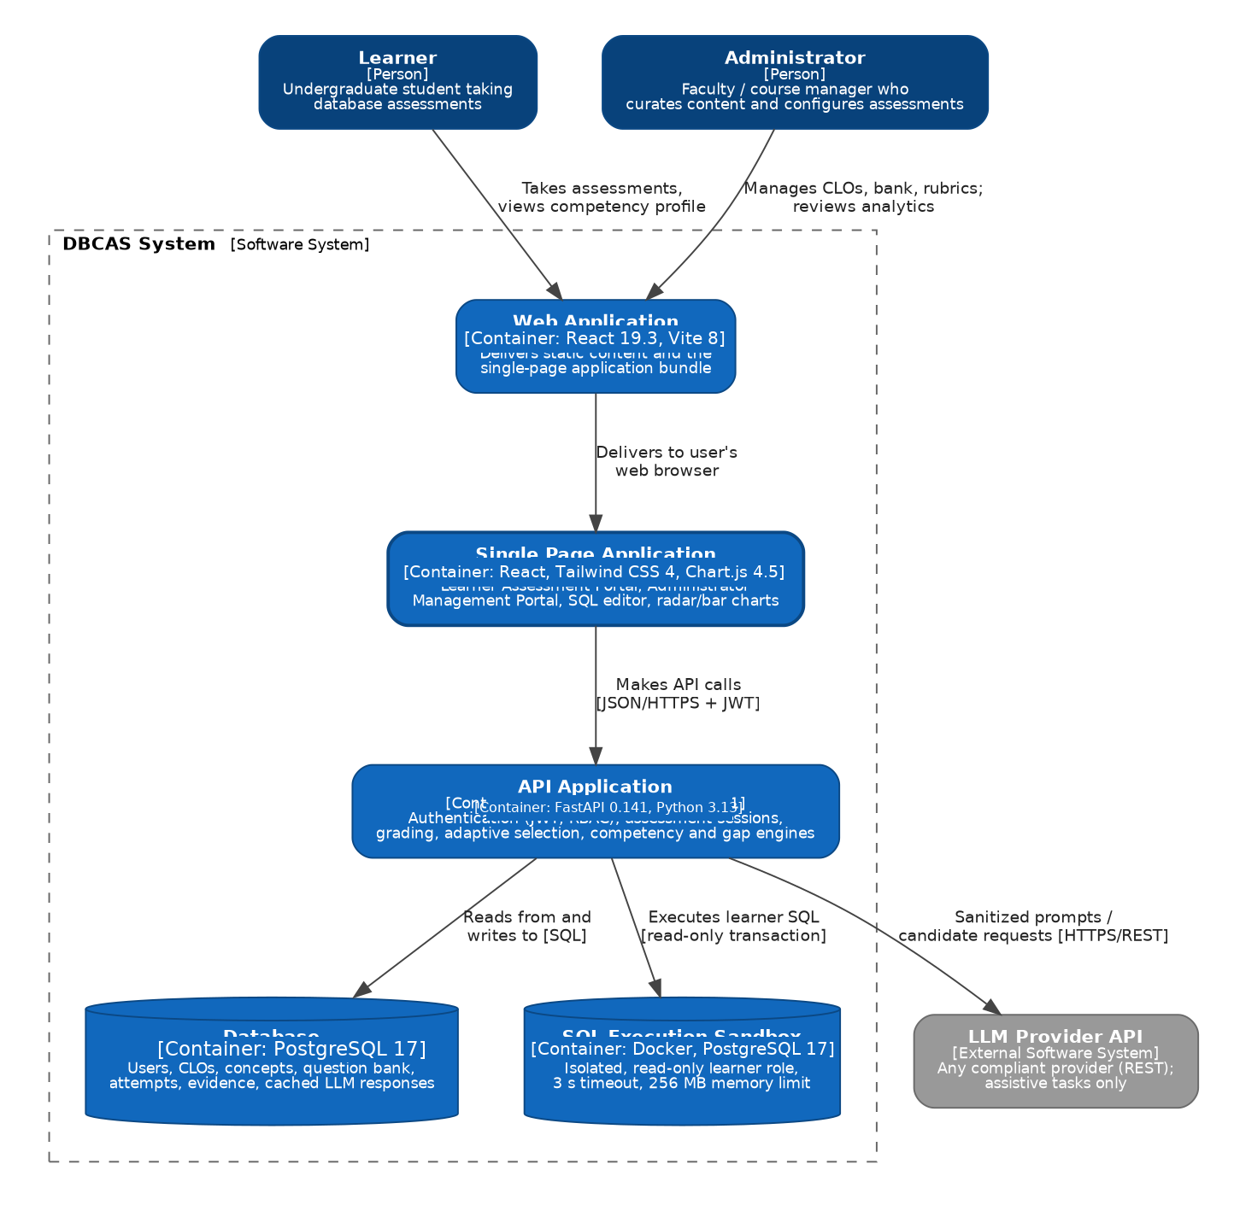
Figure 3. Container Diagram
Prose:
The container diagram above illustrates the high-level architecture of the DBCAS system, designed to give learners and administrators a concept-level view of database competency. The system has two human roles: the Learner, who selects skills and difficulty, takes adaptive assessments and reads published competency results, and the Administrator, who curates course outcomes, questions, translations and rubrics, manages accounts and roles, and reviews human-verified results. Only Learner accounts take assessments: learner assessment routes reject an Administrator, even on a legacy dual-role account. Both interact with the platform through a Single Page Application (SPA) built with React and Vite, delivered by the Web Application container, while core functionality is handled by the API Application built with FastAPI (Python 3.13) and reached through JSON/HTTPS APIs. The API also integrates Google and GitHub OAuth providers and runs an in-process background maintenance worker for session expiry and durable grading jobs; Table 50 lists these containers alongside the baseline diagram.
All persistent data is stored in a PostgreSQL 17 database (36 tables) that the API accesses via SQL, including immutable assessment and question snapshots, assessment blueprints, adaptive decision notices, password-reset tokens and audit, result-release audit and cached LLM responses. Learner SQL is never run against this database: it is executed in a separate, isolated SQL Execution Sandbox (a Docker container running PostgreSQL 17) under a read-only role, SELECT-only validation, a 3-second statement timeout, and a 256 MB memory limit. The API Application also calls an external LLM Provider API for assistive tasks such as essay scoring against rubrics, mapping and tag suggestions, and gap explanations; final competency scores are always computed deterministically by DBCAS. OAuth sign-in is brokered through Google or GitHub; provider access tokens are never stored.
Responsibilities:
Table 50. Responsibilities of Container Diagram
Role | Responsibilities
Learner | - Selects assessment skills, difficulty and practice/formal mode; takes adaptive sessions. / Views published per-session and cumulative competency profiles and gap explanations.
Administrator | - Manages CLOs, concepts, prerequisites, the validated Question Bank, translations and rubrics. / Configures assessments and result-release policy, manages accounts and roles, reviews and publishes human-verified results, and reviews cohort analytics.
Web Application | - Delivers static content and the Single Page Application bundle to the user's web browser.
Single Page Application (SPA) | - Provides the Learner Assessment Portal and the Administrator Management Portal. / Includes the SQL editor, Chart.js radar and bar charts, draft autosave, grading review queue, and English/Vietnamese plus theme preferences.
API Application | - Handles core business logic: password and OAuth authentication, self-service password recovery, role management, personalized session coordination, grading jobs, release review, personalized plan assembly and formal adaptive selection, and competency calculation. / Communicates with the SPA via JSON/HTTPS APIs. / Reads from and writes to the database, runs SELECT queries in the sandbox, and calls the LLM Provider.
Database (PostgreSQL 17) | - Stores users, roles and audit records, CLOs and concepts, the question bank and translations, sessions with immutable snapshots, attempts, evidence, grading jobs, password-reset tokens and audit, release events, competency results, and cached LLM responses (36 tables).
SQL Execution Sandbox | - Executes learner SELECT queries in an isolated PostgreSQL 17 Docker container with a read-only role, 3-second timeout, and 256 MB memory limit.
LLM Provider API | - Provides assistive AI: mapping and tag suggestions, question candidate drafts, rubric-guided essay scoring, and gap explanations.
Background Worker | - In-process maintenance thread that expires timed-out sessions and processes bounded SQL/essay grading jobs with database leases and retries.
OAuth Identity Providers (external) | - Google and GitHub OAuth 2.0 servers used for social sign-in; DBCAS stores only the provider user id, email and verification flag.

4.2. Component Diagram
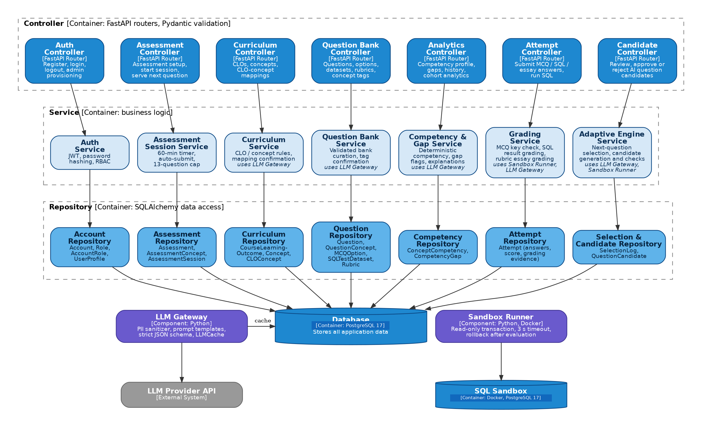
Figure 4. Component Diagram

Prose:
The Component Diagram of the DBCAS system illustrates the structure of the backend implemented with FastAPI in Python. It follows a three-layer architecture of Controller, Service, and Repository layers, giving a clean separation of concerns and easier maintenance. The Controller layer receives requests from the web interface and validates them with Pydantic schemas, covering authentication and OAuth, role management, curriculum (CLOs, concepts and prerequisites), the question bank and translations, personalized assessment starts, answer attempts, grading review and analytics. Each controller delegates to a dedicated Service that encapsulates the business rules.
The Service layer is the core of the system logic: it includes the Identity & Access Service (password and OAuth sign-in, self-service password recovery, login throttling, role management), the Personalized Assessment Service (session scope, practice plan freeze and idempotent starts), the Adaptive Engine (planned and adaptively selected question serving with selection logging), the Grading Service (MCQ by answer key, SQL by sandbox execution, essays by rubric), the Assessment Lifecycle & Release Service (grading jobs, human review and publication), and the Competency & Guidance Service (deterministic per-session and cumulative competency, gaps and study ranking). Two infrastructure components support these services: the LLM Gateway, which removes personal details, builds versioned prompts, enforces a strict JSON schema, and caches responses, and the Sandbox Runner, which executes learner SELECT queries in the isolated Docker sandbox. A background maintenance worker sweeps expired sessions and processes queued grading jobs with database leases. The Repository layer abstracts PostgreSQL 17 access through SQLAlchemy and performs all CRUD operations for the 36 tables. This modular design lets the team replace the LLM provider or add new question types without changing the scoring rules.
Responsibilities:
Table 51. Responsibilities of Component Diagram
Role | Responsibilities
Controller | - FastAPI routers that receive client requests and validate them with Pydantic schemas. / Delegate processing to the corresponding Service.
Service | - Contain business logic: authentication and OAuth, role management, curriculum rules, question bank curation, personalized session control, grading, release review, personalized plan assembly, competency calculation, gap detection, and study-topic ranking. / Call Repository components for data access.
Repository | - Interact with PostgreSQL through SQLAlchemy and perform CRUD operations for the 36 tables.
Adaptive Engine Service | - Serves the next question from the frozen practice plan or, for a formal session, from the decision taken on accumulated evidence inside the allowed difficulty range and the current MCQ → SQL → essay phase.  - Drafts and validates AI question candidates ahead of time.
Grading Service | - Grades MCQ by answer key, SQL semantically in the sandbox, and essays by rubric with LLM assistance. / Enqueues bounded retries and exposes automated evidence for human review.
LLM Gateway | - Removes personal details, builds versioned prompts, enforces the strict JSON schema, calls the provider, and caches responses in LLMCache.
Sandbox Runner | - Runs learner SELECT queries inside the Docker sandbox in a read-only transaction with a timeout and rolls back after evaluation.
Database (PostgreSQL 17) | - Stores all system data.
Identity & Access Service | - Registers and authenticates accounts, completes Google/GitHub OAuth with state and PKCE, applies login throttling, issues and redeems single-use password-reset tokens, and records reset audit events, and enforces capability-gated, audited role changes.
Personalized Assessment Service | - Validates learner-selected concepts, band and question source, freezes the session policy, start request and practice plan, preflights the formal sequence, and supports both delivery modes.
Release & Review Service | - Owns the release lifecycle (auto_grading, pending_review, reviewed, published, grading_failed), records GradeReview decisions, publishes results and writes immutable release events.
Competency & Guidance Service | - Computes deterministic per-session and cumulative published-evidence competency, detects gaps and ranks study topics.
Maintenance Worker | - Sweeps session expiry and claims, leases and retries grading jobs; runs in the API process without an external queue.
Database (PostgreSQL 17) | - Stores all system data (36 tables).

5. Module View
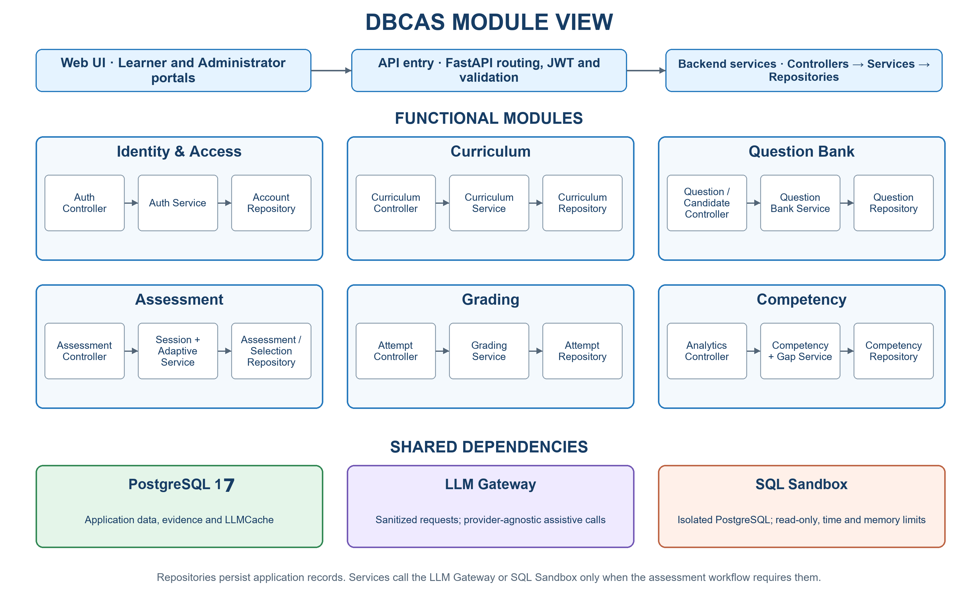
Figure 5. Module View

Prose:
The module view of DBCAS is organized into functional modules that collaborate to deliver the assessment workflow. The Web UI Module provides the Learner and Administrator portals as a single-page application, and the API Gateway Module routes and secures every request. The Identity & Access Module handles registration, email/password and OAuth login, self-service password recovery, login throttling, role-based access control, and audited role management. The Curriculum Module manages CLOs, concepts, prerequisites and confirmed mappings, while the Question Bank Module manages validated questions, provenance, translations, version families, tags, and AI question candidates awaiting administrator approval. The Assessment Module configures shared assessment rules, freezes personalized question plans, runs timed sessions, binds each formal session to an approved assessment blueprint, and serves the next question from the frozen practice plan or from the adaptive decision; the Grading Module scores MCQ, SQL, and essay answers, stores standardized evidence and retries failed jobs; the Result Release & Human Review Module withholds unpublished scores and provisional profiles from learners, enforces IMMEDIATE or HUMAN_VERIFIED publication and records immutable audit events; and the Competency Module computes per-session and cumulative published-evidence competency, detects gaps, ranks below-benchmark concepts for study guidance, and serves learner and cohort analytics. The AI Integration Module (LLM Gateway) and the Sandbox Module (Sandbox Runner and isolated PostgreSQL) encapsulate the two external execution paths. The Localization & Preferences Module provides English/Vietnamese content, translations, theme settings and the frozen session locale. Controllers route requests to services; repositories persist application records in PostgreSQL. Services call the LLM Gateway and SQL Sandbox only for workflows that require them.
Responsibilities
Table 52. Responsibilities of Module View
Role | Responsibilities
Web UI Module | - Provides the Learner and Administrator portals (SPA).  - Accessed via the Web Application.
API Gateway Module | - Acts as the gateway between the Web UI and backend modules.  - Routes requests, validates input, and secures API access with JWT and role checks.
Identity & Access Module | - Handles registration, email/password and OAuth login, password recovery, throttling, logout, role-based access, and audited role management (FR-01, FR-16). / Provisions accounts and administrator roles.
Curriculum Module | - Manages CLOs, the concept model, and confirmed CLO-to-concept mappings (FR-02, FR-03).
Question Bank Module | - Manages the validated Question Bank, provenance, translations, version families, concept tags, and AI question candidates (FR-04, FR-05).
Assessment Module | - Configures shared assessment rules, freezes session policy, practice plans and idempotent starts, runs timed sessions (FR-06, FR-07), serves each planned or adaptively selected question (FR-15) and logs decisions.
Grading Module | - Grades MCQ, SQL, and essay answers, stores standardized evidence, and retries failed jobs (FR-08, FR-09, FR-10, FR-11).
Competency Module | - Calculates per-session and cumulative published-evidence competency, detects gaps, ranks below-benchmark concepts, and provides learner and cohort analytics (FR-12, FR-13, FR-14).
AI Integration Module | - LLM Gateway that sanitizes requests, calls the provider, and caches results.
Sandbox Module | - Sandbox Runner and the isolated Docker PostgreSQL instance for learner SQL.
Database Module (PostgreSQL 17) | - Stores all application data (36 tables).
Result Release & Human Review Module | - Enforces IMMEDIATE or HUMAN_VERIFIED release, manages the review queue and retries, publishes results, and records immutable grade/release audit events (FR-11).
Localization & Preferences Module | - Provides English/Vietnamese UI and question translations, theme preferences, and the frozen session locale.

6. Allocation View
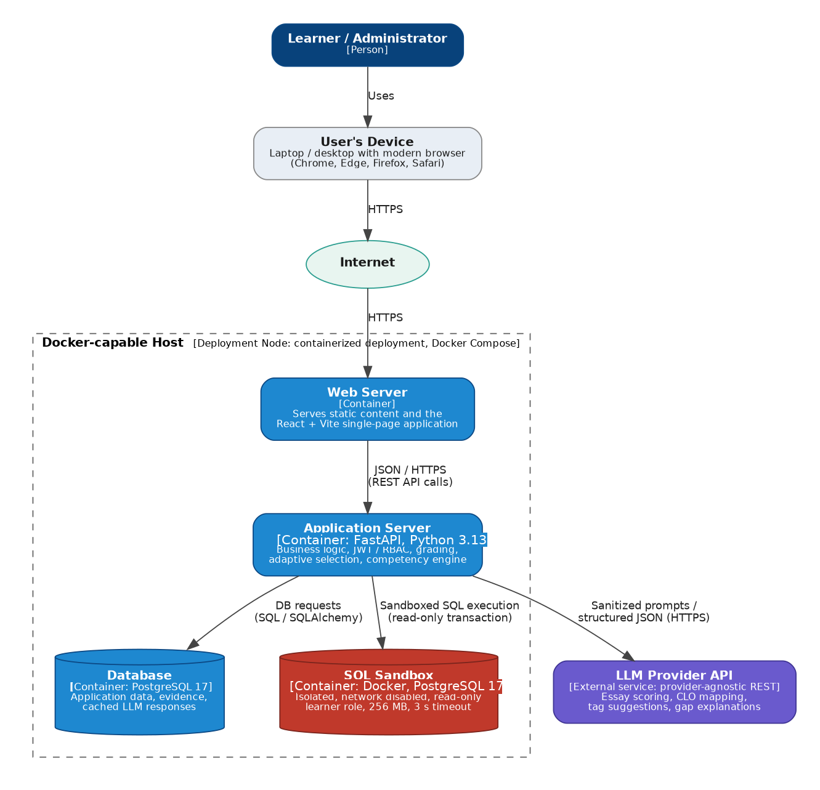
Figure 6. Allocation View
Prose:
The Allocation View for DBCAS shows how the software components are mapped onto the deployment environment. The architecture follows a multi-tier, containerized deployment pattern. The Learner or Administrator uses a laptop or desktop browser, and all traffic flows through the Internet over HTTPS to the Web Server, which serves static content and the React + Vite single-page application. Dynamic requests, such as API calls, are forwarded as JSON/HTTPS to the Application Server (FastAPI, Python 3.13), which holds the core business logic: JWT and OAuth authentication, role checks, personalized session coordination, grading, personalized plan assembly, release review, and competency calculation. The same Application Server runs a background maintenance worker that expires sessions and processes durable grading jobs.
For persistence, the Application Server sends DB requests to the Database (PostgreSQL 17), which stores users, roles and audit records, the question bank, translations, sessions, attempts, immutable snapshots, evidence, release events and cached LLM responses. Learner SQL is sent to a separate SQL Sandbox container (PostgreSQL 17) that runs with a read-only role, SELECT-only validation, no network access, a 256 MB memory limit, and a 3-second statement timeout, so it can never reach application data. Finally, the Application Server calls the external LLM Provider API with sanitized, structured requests for essay scoring, mapping, tagging, and gap explanations, and redirects browsers to Google or GitHub for OAuth sign-in. Separating the sandbox and the AI service from the main application logic protects the system, keeps scoring deterministic, and improves scalability and maintainability.
Responsibilities:
Table 53. Responsibilities of Allocation View
Role | Responsibilities
Learner / Administrator | - Uses the system through a web browser over HTTPS.  - Learners take assessments and view results; administrators manage content and review analytics.
User's Device | - Laptop or desktop with a modern web browser (Chrome, Edge, Firefox, Safari).
Web Server | - Receives HTTPS requests from users.  - Serves static content and the React + Vite single-page application.
Application Server | - Runs the FastAPI backend (Python 3.13): business logic, password/OAuth authentication and password recovery, RBAC and role audit, personalized sessions, grading, release review, and competency calculation. / Sends DB requests to PostgreSQL, SELECT queries to the SQL Sandbox, and sanitized prompts to the LLM Provider; runs the background maintenance worker.
Database (PostgreSQL 17) | - Stores user and role audit data, question bank and translations, sessions and snapshots, attempts, evidence, grading jobs, password-reset tokens and audit, release events, competency results, and cached LLM responses (36 tables). / Provides data to the Application Server upon request.
SQL Sandbox | - Isolated PostgreSQL 17 Docker container for learner SELECT queries: read-only role, no network, 256 MB memory, 3-second statement timeout.
LLM Provider API | - External assistive AI service (provider-agnostic REST) used for essay scoring, mapping, tagging, and explanations.
Background Worker | - Runs inside the Application Server: expires timed-out sessions and processes leased grading jobs with bounded retries.
OAuth Identity Providers | - External Google and GitHub authorization servers used for social sign-in; no provider tokens are stored.

7. Entity Relationship Diagram
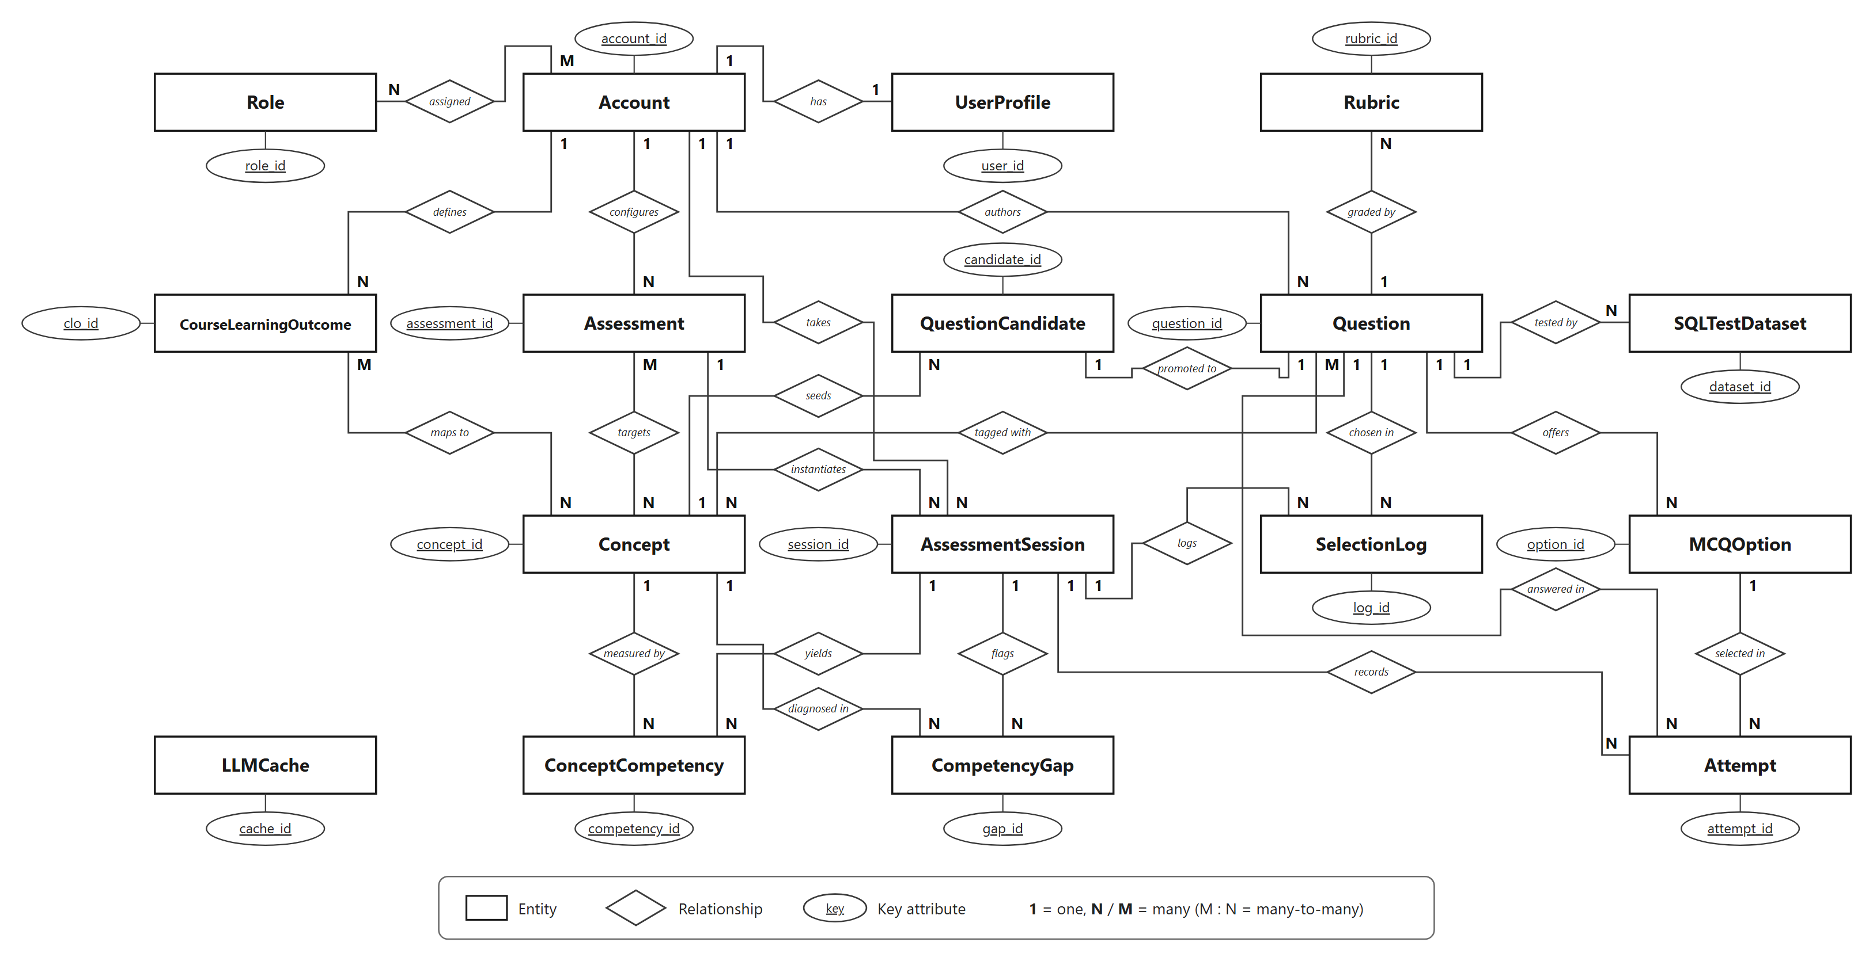
Figure 7. Entity Relationship Diagram
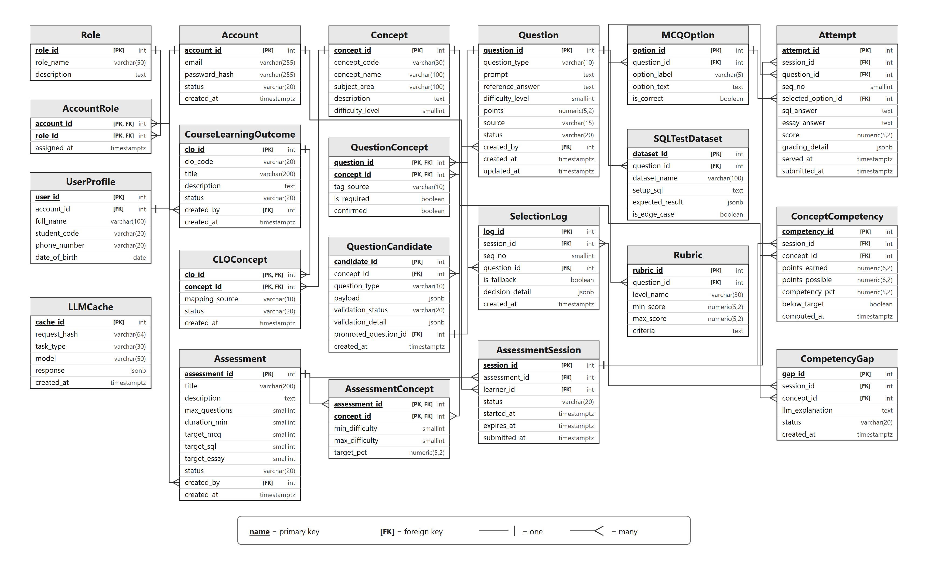
Figure 8. Table Relationship Diagram

Prose:
The Entity Relationship Diagram (ERD) illustrates the structure of the DBCAS PostgreSQL 17 database (36 tables) and the relationships among its entities. Account is the access point for authentication, linked one-to-one to UserProfile, optionally to AccountIdentity for OAuth, and through the AccountRole junction to Role; role changes are recorded in AccountRoleAudit. Administrators define CourseLearningOutcome and Concept records (with prerequisites in ConceptDependency), map them through CLOConcept, and curate the Question bank together with QuestionConcept, MCQOption, QuestionTranslation, SQLTestDataset, and Rubric. QuestionCandidate holds AI-generated drafts outside the bank until an administrator approves them. An Assessment targets concepts through AssessmentConcept and is instantiated as AssessmentSession with a frozen config snapshot, a SessionQuestionPlan, and start-request bindings; it binds an approved AssessmentBlueprint version, records one Attempt per served question, one SelectionLog entry per adaptive decision, and durable AdaptiveEvent notices for any stop decision. Results flow through GradingJob, GradeReview, ResultReleaseEvent, ConceptCompetency and CompetencyGap. AssessmentBlueprint versions the evidence mix that a formal session binds at start. AdaptiveEvent stores durable batch, decision and shortage notices. PasswordResetToken and PasswordResetAudit support single-use password recovery. LLMCache, OAuthHandoff and LoginThrottle are stand-alone technical tables.
The conceptual model in Figure 7 is implemented physically by the core tables shown in Figure 8, which predates the later security, release and evidence extensions. The four many-to-many relationships (assigned, maps to, tagged with, targets) are realized by the junction tables AccountRole, CLOConcept, QuestionConcept, and AssessmentConcept; all 36 tables are described in Table 54.
Details about ERD:
Table 54. Details about ERD tables
Table | Description
Account | Stores login credentials and account status, password-set/change timestamps, and the can_manage_roles capability flag.
Role | Defines the two roles used for role-based access control: Learner and Administrator.
AccountRole | Junction table resolving the many-to-many relationship between Account and Role, recording role assignment timestamps.
UserProfile | Holds personal details linked one-to-one to an Account (full name, student code, phone, date of birth); identifying fields are stripped before any external LLM call.
CourseLearningOutcome | Course learning outcomes (CLOs) defined by administrators and aligned to the database course curriculum.
Concept | The Core PostgreSQL concept model, organized by subject area with a base difficulty level (1–5), sql_feature, keywords and learning objectives; prerequisites live in ConceptDependency.
CLOConcept | Junction table mapping CLOs to concepts; records whether the mapping was set by an administrator or suggested by AI, and its confirmation status.
Question | The validated question bank: MCQ, SQL, and essay items with provenance, explanation, tags, source references, lifecycle status, and family/version lineage.
QuestionConcept | Junction table tagging questions with concepts, including whether a technique is mandatory; AI-recommended tags remain unconfirmed until reviewed.
MCQOption | Answer options for multiple-choice questions, including the verified correct-answer flag used for instant grading.
SQLTestDataset | Test datasets for SQL questions: setup SQL executed in the sandbox and expected result sets, including edge cases.
Rubric | Grading rubric levels (Complete, Mostly Complete, Partial, Incomplete) with score ranges and criteria for essay evaluation.
Assessment | Shared adaptive assessment rules: question cap and type mix, duration, result-release policy, and family/version lineage.
AssessmentBlueprint | Immutable, versioned evidence mix for one assessment competency band: subject area, band, question counts, scoring weights, evidence types, approval basis and approver; new policy is a new version.
AssessmentConcept | Junction table holding the target concepts of an assessment, their allowed difficulty range, and the passing benchmark used for gap detection.
AssessmentSession | One learner's run: status, frozen configuration snapshot, bound AssessmentBlueprint, locale, expiry, submission, start-request id, and result-release status.
AdaptiveEvent | Immutable audit of each adaptive batch or decision, including explicit mid-session shortage notices that stop delivery without substitution.
Attempt | One row per served question: the answer, immutable question snapshot, draft state, grading status, score, and standardized evidence.
SelectionLog | Audit log of every question-plan selection decision (chosen concept, difficulty, question type, and whether a fallback item was used), used to monitor selection quality (FR-15, RSK-06).
ConceptCompetency | Per-concept competency result of a session: points earned vs. points possible, the computed percentage, and the below-target flag.
CompetencyGap | Concepts flagged as gaps with the LLM explanation and a sanitized-input context hash reused for caching.
LLMCache | Cached external LLM responses keyed by a hash of the sanitized request, used to reduce API cost and latency.
QuestionCandidate | AI-generated drafts held outside the Question bank; automated checks run first, then an administrator approves the candidate before it becomes a validated Question.
AccountIdentity | Linked OAuth 2.0 identity (Google / GitHub) with provider user id, email and verification flag.
AccountRoleAudit | Immutable audit of role grants, revocations and the role-manager bootstrap.
PasswordResetToken | Single-use, short-lived password-reset tokens stored only as SHA-256 digests, with expiry, use and revocation timestamps.
PasswordResetAudit | Immutable audit trail of password-reset requests and completions.
OAuthHandoff | Hashed, one-time, short-lived handoff records for exchanging an OAuth identity for a DBCAS JWT.
LoginThrottle | Hashed login keys with recent failures and an expiry window for brute-force protection.
ConceptDependency | Directed prerequisite edges between concepts; cycles are checked by the service layer.
QuestionTranslation | Locale-specific prompt, explanation, option texts and rubric criteria; English remains canonical.
SessionQuestionPlan | Frozen ordered questions reserved for a practice session, including items not yet served; formal adaptive sessions reserve no future rows and record each served decision in selection_log.
SessionStartRequest | Idempotency ledger binding a learner's start/resume request id to a session.
GradingJob | Durable grading queue with leases, retry counters and failure codes.
GradeReview | Human review decision with automated evidence, approved score and comments.
ResultReleaseEvent | Immutable history of every release-status transition.

