

International School

Capstone Project 1

CMU-SE 450_C1SE.70

Database Design Document

Version 1.2

Date: November 8th, 2026

DBCAS – AI-Assisted Database Competency Assessment and Skill Gap Analysis

Submitted by C1SE.70

Thu, Nguyen Ngoc Anh - 29209245799
Nguyen, Nguyen Nhat - 26211227029
Truong, Nguyen Quang - 29212730635
Do, Nguyen Quoc - 29211156881
Han, Nguyen Ngoc - 29204423268

Approved by

MSc. Huynh Duc Viet

Review Panel Representative:

Name

Signature

Date

Capstone Project 1
- Mentor:

Name MSc Viet, Huynh Duc

Signature

Date

PROJECT INFORMATION
Project acronym | DBCAS
Project Title | DBCAS – AI-Assisted Database Competency Assessment and Skill Gap Analysis
Start Date | 14/09/2026 | End Date | 26/12/2026
Lead Institution | International School, Duy Tan University
Project Mentor | MSc Viet, Huynh Duc
Scrum master / Project Leader & contact details | Thu, Nguyen Ngoc Anh  Email: 01258319907anhthu@gmail.com  Tel: 0919334040
Partner Organization | Duy Tan University
Project Web URL
Team members | Name | Email | Tel
 | Thu, Nguyen Ngoc Anh | 01258319907anhthu@gmail.com | 0919334040
 | Nguyen, Nguyen Nhat | nhnguyen240602@gmail.com | 0355772330
 | Truong, Nguyen Quang | quangtruongtt8@gmail.com | 0349039023
 | Do, Nguyen Quoc | nguyenquocdodary@gmail.com | 0388496885
 | Han, Nguyen Ngoc | Hannguyenngoc0506@gmail.com | 0899455605
DOCUMENT INFORMATION
Document Title | Database Design Document
Author(s) | Truong, Nguyen Quang & C1SE.70 Team
Role | Database Developer
Date | 08/11/2026 | File name | DBCAS-Database-Design-v1.2.docx
URL
Access | Project and CMU Program

REVISION HISTORY
Version | Person(s) | Date | Description
1.0 | C1SE.70 Team | 18/09/2026 | Initial release
1.1 | C1SE.70 Team | 30/10/2026 | Update
1.2 | 08/11/2026 | Correct project facts and diagrams | C1SE.70 Team

TABLE OF CONTENTS
1. Introduction 1
1.1. Purpose 1
1.2. Scope 1
1.3. Introduction about PostgreSQL 1
2. Database Diagram 2
2.1. Table Overview 2
2.2. Entity Relationship Diagram 5
3. Database Design for Sprint 12
3.1 Account 12
3.2 Role 12
3.3 AccountRole 13
3.4 UserProfile 13
3.5 CourseLearningOutcome 13
3.6 Concept 14
3.7 CLOConcept 14
3.8 Question 15
3.9 QuestionConcept 16
3.10 MCQOption 16
3.11 SQLTestDataset 17
3.12 Rubric 17
3.13 Assessment 18
3.14 AssessmentConcept 18
3.15 AssessmentSession 19
3.16 Attempt 20
3.17 SelectionLog 21
3.18 ConceptCompetency 21
3.19 CompetencyGap 22
3.20 LLMCache 22
3.21 QuestionCandidate 23
3.22 AccountIdentity 24
3.23 AccountRoleAudit 24
3.24 OAuthHandoff 24
3.25 LoginThrottle 25
3.26 ConceptDependency 25
3.27 QuestionTranslation 25
3.28 SessionQuestionPlan 27
3.29 SessionStartRequest 27
3.30 GradingJob 27
3.31 GradeReview 28
3.32 ResultReleaseEvent 28
3.1. AssessmentBlueprint 28
3.2. AdaptiveEvent 29
3.3. PasswordResetToken 30
3.4. PasswordResetAudit 30
3.5. AssessmentQuestion 31
3.6. EvaluationRecord 31
3.7. GradeEditAudit 31
3.8. RefreshSession 32
3.9. SystemSetting 32
4. Hardware and Software Requirements 33

LIST OF FIGURES

Figure 1: Entity Relationship Diagram 5
Figure 2: Table Relationship Diagram (1/5) 7
Figure 2: Table Relationship Diagram (2/5) 8
Figure 2: Table Relationship Diagram (3/5) 9
Figure 2: Table Relationship Diagram (4/5) 10
Figure 2: Table Relationship Diagram (5/5) 11

LIST OF TABLES
Table 1: Table Overview 2
Table 2: Database Design (Account) 12
Table 3: Database Design (Role) 12
Table 4: Database Design (AccountRole) 13
Table 5: Database Design (UserProfile) 13
Table 6: Database Design (CourseLearningOutcome) 13
Table 7: Database Design (Concept) 14
Table 8: Database Design (CLOConcept) 14
Table 9: Database Design (Question) 15
Table 10: Database Design (QuestionConcept) 16
Table 11: Database Design (MCQOption) 16
Table 12: Database Design (SQLTestDataset) 17
Table 13: Database Design (Rubric) 17
Table 14: Database Design (Assessment) 18
Table 15: Database Design (AssessmentConcept) 18
Table 16: Database Design (AssessmentSession) 19
Table 17: Database Design (Attempt) 20
Table 18: Database Design (SelectionLog) 21
Table 19: Database Design (ConceptCompetency) 21
Table 20: Database Design (CompetencyGap) 22
Table 21: Database Design (LLMCache) 22
Table 22: Database Design (QuestionCandidate) 23
Table 23: Database Design (AccountIdentity) 24
Table 24: Database Design (AccountRoleAudit) 24
Table 25: Database Design (OAuthHandoff) 24
Table 26: Database Design (LoginThrottle) 25
Table 27: Database Design (ConceptDependency) 25
Table 28: Database Design (QuestionTranslation) 25
Table 29: Database Design (SessionQuestionPlan) 27
Table 30: Database Design (SessionStartRequest) 27
Table 31: Database Design (GradingJob) 27
Table 32: Database Design (GradeReview) 28
Table 33: Database Design (ResultReleaseEvent) 28
Table 34: Database Design (AssessmentBlueprint) 29
Table 35: Database Design (AdaptiveEvent) 30
Table 36: Database Design (PasswordResetToken) 30
Table 37: Database Design (PasswordResetAudit) 31
Table 38: Database Design (AssessmentQuestion) 31
Table 39: Database Design (EvaluationRecord) 31
Table 40: Database Design (GradeEditAudit) 32
Table 41: Database Design (RefreshSession) 32
Table 42: Database Design (SystemSetting) 32
Table 43: Hardware and Software Requirements 33

Introduction
The Database Design maps the logical data model to the target database management system, considering the system’s performance requirements. It converts logical or conceptual data constructs to physical data constructs (e.g., tables, etc.) of the target Database Management System.

Purpose
The Database Design aims to ensure that every database transaction of the DBCAS platform — learner accounts, account recovery, the concept taxonomy, the question bank, learner-defined practice sessions, attempts, and competency results — is processed and stored reliably. It describes the PostgreSQL 17 schema that persists all application data for the AI-assisted database competency assessment and skill gap analysis system.

Scope
The Database Design Document has the following objectives:
- To describe the design of a database, that is, a collection of related data stored in the PostgreSQL DBMS, which supports the DBCAS practice workflow (CLO mapping, question banking, SQL sandbox evaluation, rubric grading, and competency gap reporting).
- To serve as a basis for implementing the database and related software, including the FastAPI backend, the Docker-isolated PostgreSQL sandbox, and the LLM-assisted grading pipeline.

Introduction about PostgreSQL
PostgreSQL is a powerful open-source relational database management system (RDBMS) known for standards compliance, reliability, and extensibility. It supports advanced data types such as JSONB, full ACID transactions, and rich indexing, which makes it well suited as the system of record for DBCAS.
PostgreSQL provides high performance and scalability through features such as MVCC, cost-based query optimization, and parallel query execution. For DBCAS, it stores the concept taxonomy, the question bank, practice session state, attempts, and per-concept competency results.
In PostgreSQL, data is organized into tables with well-defined schemas. Constraints such as primary keys, foreign keys, unique constraints, and default values enforce data integrity across the 41 tables of the DBCAS schema, while JSONB columns keep flexible evidence payloads — grading detail, selection decisions, immutable snapshots, and cached LLM responses — queryable.

Database Diagram

Table Overview
Table 1: Table Overview
Table Name | Short Description
Account | Stores login credentials for learners and administrators, including email, password hash, account status, password-set/change flags, the role-management capability flag, and creation date.
Role | Defines the two system roles used for role-based access control: Learner and Administrator. The User role is implemented as Learner and the Admin role as Administrator.
AccountRole | Junction table resolving the many-to-many relationship between Account and Role, recording role assignment timestamps.
UserProfile | Holds personal details of users linked one-to-one to their Account (full name, student code, phone, date of birth); identifying fields are stripped before any external LLM call (NFR-07).
CourseLearningOutcome | Course learning outcomes (CLOs) defined by administrators and aligned to the university database course curriculum (FR-02).
Concept | The Core PostgreSQL concept model, organized by subject area with a base difficulty level and sql_feature, keywords and learning objectives used for practice selection and recommendations (FR-02, FR-14).
CLOConcept | Junction table mapping course learning outcomes to PostgreSQL concepts; records whether each mapping was set by an administrator or suggested by assistive AI, and its confirmation status (FR-03).
Question | The Administrator-approved, validated question bank: multiple-choice, SQL, and short essay items with prompt, reference answer, explanation, difficulty, points, provenance tags and source references, source (bank or AI-generated), lifecycle status, and family/version lineage (FR-04).
QuestionConcept | Junction table tagging questions with PostgreSQL concepts, including whether a technique is mandatory and the review status of AI-recommended tags, which remain unconfirmed until reviewed by an administrator (FR-05, FR-09).
MCQOption | Answer options for multiple-choice questions, including the verified correct-answer flag used for instant grading (FR-08).
SQLTestDataset | Test datasets for practical SQL questions: setup SQL executed inside the Docker sandbox and expected result sets, including edge cases (FR-09).
Rubric | Grading rubric levels (Complete, Mostly Complete, Partial, Incomplete) with score ranges and criteria for rubric-guided essay evaluation (FR-10).
Assessment | Legacy prebuilt assessment definition retained for historical rows only: question count and duration, target type mix, historical release policy and family/version lineage. Migration 019 closes published definitions; no current API creates one.
AssessmentConcept | Legacy junction table holding the target concepts of a retired assessment, their allowed difficulty range, and its passing benchmark; current learner-defined practice snapshots a 70% target in the session configuration.
AssessmentSession | One learner's practice run: status, frozen configuration snapshot (including bank/AI source), optional legacy assessment id (nullable since migration 018), question locale, start and expiry times, submission time, start-request id, and review/release status, including automatic submission when the timer reaches 00:00 (FR-07).
Attempt | One row per served question: the learner's answer (selected option, SQL text, or essay text), an immutable question snapshot, draft state, grading status, the graded score, and standardized grading evidence (FR-11).
SelectionLog | Audit log of every question-selection decision (chosen concept, difficulty, question type and whether a fallback item was used), used to monitor selection quality (FR-15, RSK-06).
ConceptCompetency | Per-concept competency result of a session: points earned vs. points possible on a widened two-decimal scale, the computed percentage, and the below-target flag (FR-12, FR-13).
CompetencyGap | Concepts flagged as gaps and their LLM-generated explanations, with a context hash so identical sanitized explanations are reused. The ranked study list is derived from ConceptCompetency and the session's frozen concept targets (70% for learner-defined practice), ordered by target_pct minus competency_pct; it is not stored separately (FR-14).
LLMCache | Cached external LLM responses keyed by a hash of the sanitized request, used to reduce API cost and latency (RSK-03).
QuestionCandidate | AI-generated drafts held outside the Question bank; automated checks cover answer completeness, duplicates, and SQL task/reference-answer execution on test datasets. An Administrator then approves the candidate before it is stored as a validated Question and becomes servable (FR-15, NFR-09).
AccountIdentity | Google/GitHub identity for sign-in and sign-up, with provider user id and verified-email flag. Matching verified emails link one account; new accounts receive Learner.
AccountRoleAudit | Immutable audit trail of role grants, revocations and the one-time role-manager bootstrap, including actor, target, and previous/new role.
OAuthHandoff | Single-use, short-lived hashed handoffs exchange a verified Google/GitHub identity for rotating access/refresh sessions without tokens in URLs.
LoginThrottle | Server-side brute-force protection: hashed login keys with recent failure timestamps and an expiry window.
ConceptDependency | Directed prerequisite edges between concepts (prerequisite to dependent concept); duplicate edges are blocked by the primary key and cycles are checked by the service layer.
QuestionTranslation | Locale-specific (for example Vietnamese) prompt, explanation, option texts and rubric criteria for a question; English remains canonical on Question, MCQOption and Rubric.
SessionQuestionPlan | Frozen ordered list of questions reserved for a practice session, including items not yet served, so later bank edits cannot alter an in-progress session; the complete plan is stored before question one (FR-15).
SessionStartRequest | Idempotency ledger binding each learner's start or resume request id to a session, replayable after the session has completed.
GradingJob | Durable work queue and lease for SQL and essay grading, with retry counters, availability time and failure classification.
GradeReview | Human review decision for the mandatory administrator approval: automated evidence, reviewer, approved score and comments.
ResultReleaseEvent | Immutable history of every session release-status transition (auto grading, pending review, reviewed, published, grading failed).
AssessmentBlueprint | Legacy, versioned evidence mix of a retired formal definition: subject area, band, question counts, scoring weights, evidence types and approval basis. Kept for historical sessions only.
AdaptiveEvent | Historical audit of adaptive batch or decision events, including mid-session shortage notices; retained for sessions created before learner-defined practice.
PasswordResetToken | Single-use, short-lived password-reset tokens stored only as SHA-256 digests, with expiry, use and revocation timestamps.
PasswordResetAudit | Immutable audit trail of password-reset requests and completions.
AssessmentQuestion | Legacy junction table listing the curated exam question pool of a retired assessment (migration 017); unused by learner-defined practice.
EvaluationRecord | Standardized grading evidence for one answer or scope: question snapshot, rubric result, points, evaluator source, hashes and validation flags.
GradeEditAudit | Immutable audit of every manual grade change: attempt, reviewer, old and new score, reason and timestamp.
RefreshSession | Hashed refresh-token families for email and OAuth sign-in, with credential version, expiry, use and revocation timestamps.
SystemSetting | Runtime settings row retained for historical/operational values; result release is no longer selectable.

Entity Relationship Diagram
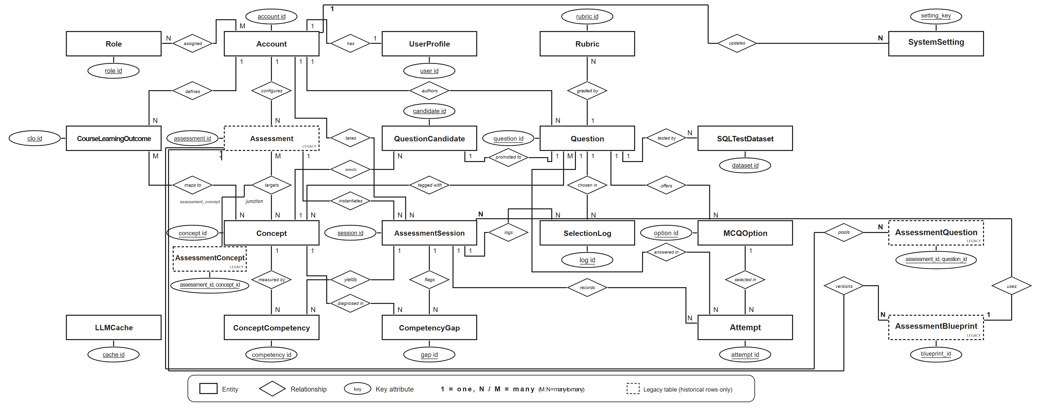
Figure 1: Entity Relationship Diagram
Figure 1 is the conceptual model: the many-to-many relationships (assigned, maps to, tagged with, targets) are implemented by the junction tables AccountRole, CLOConcept, QuestionConcept and the legacy AssessmentConcept shown in Figure 2. SystemSetting stores historical/operational platform values; result release is no longer selectable. The four legacy tables (Assessment, AssessmentConcept, AssessmentQuestion and AssessmentBlueprint) are marked as historical rows only. Tables added by later migrations (account identity, role audit, OAuth handoff, login throttling, concept prerequisites, question translations, the frozen session question plan, session start-request bindings, evaluation records, grading jobs, grade reviews, grade-edit audit, result-release events, refresh sessions, system settings, password-reset tokens and password-reset audit) are documented in the sections below, and all 41 tables appear in Figure 2.
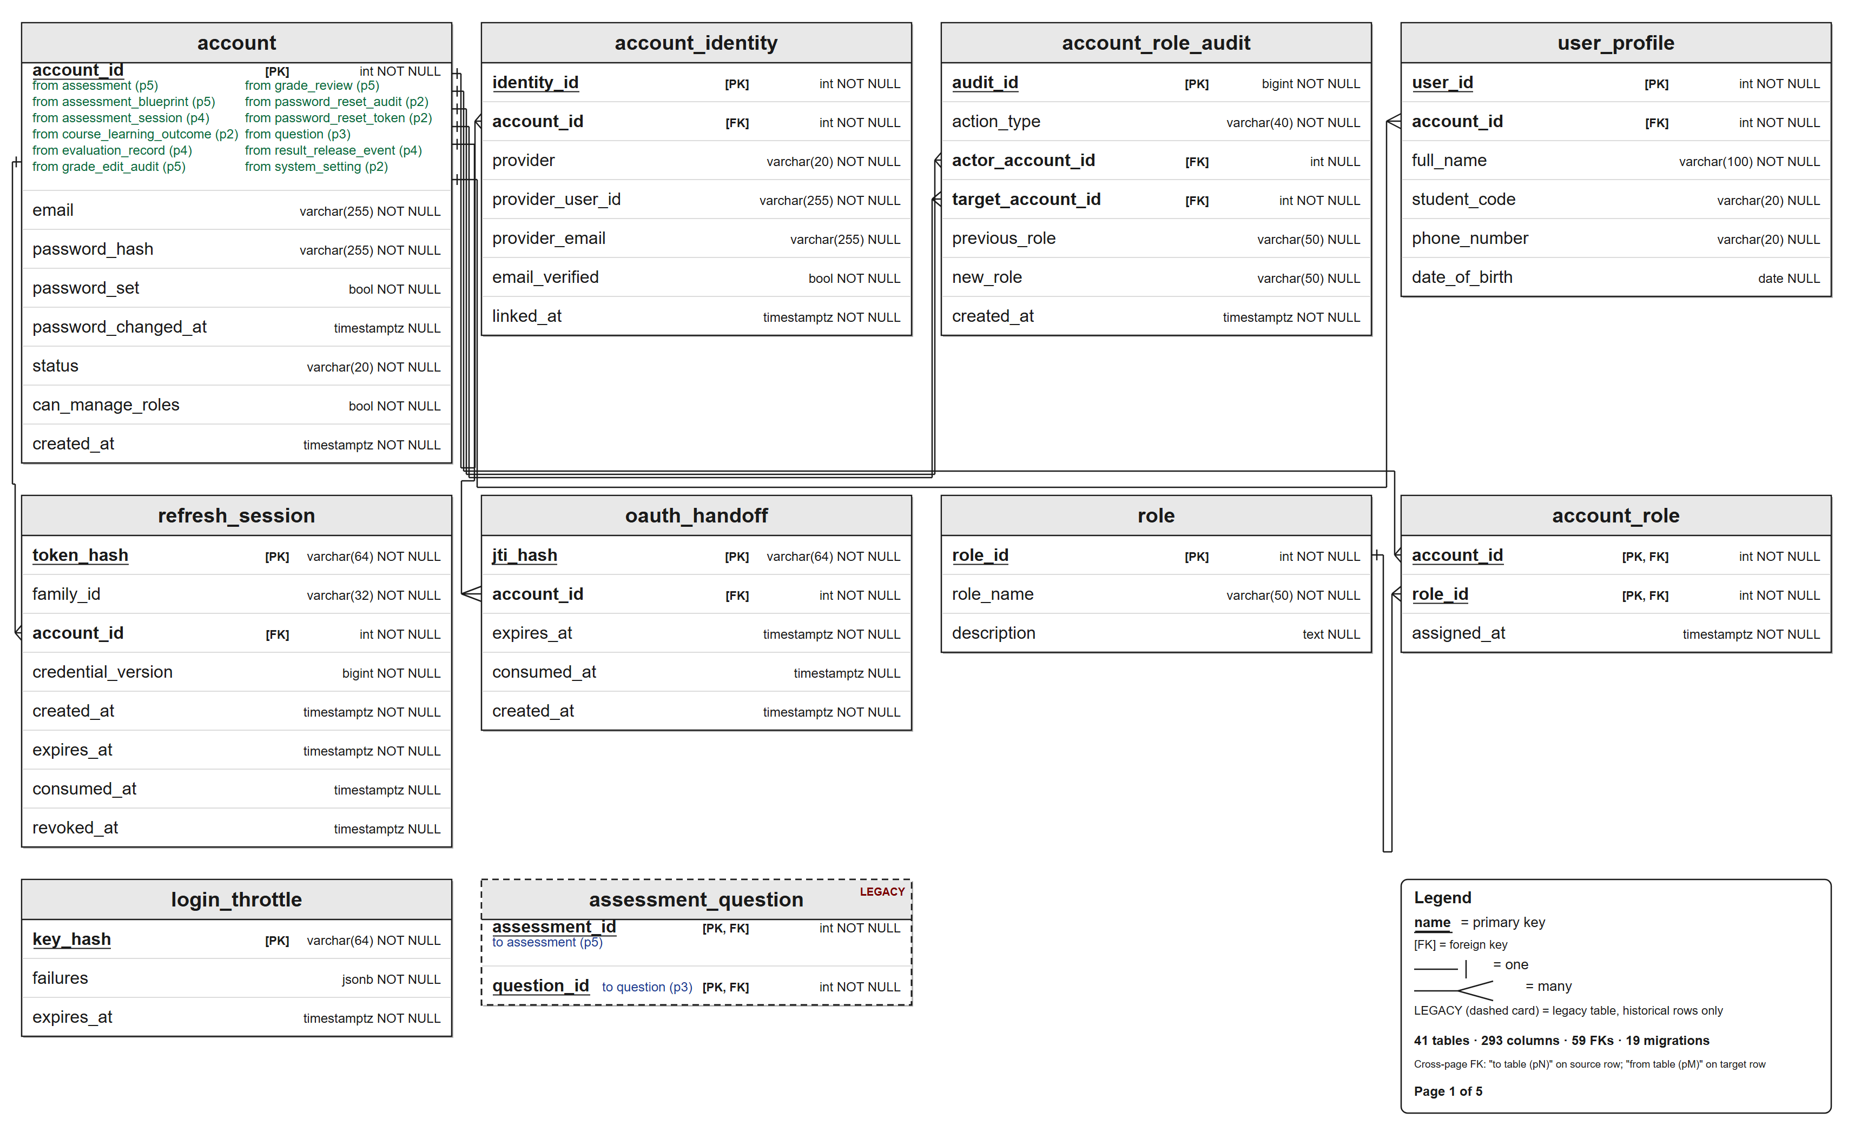
Figure 2: Table Relationship Diagram (1/5)
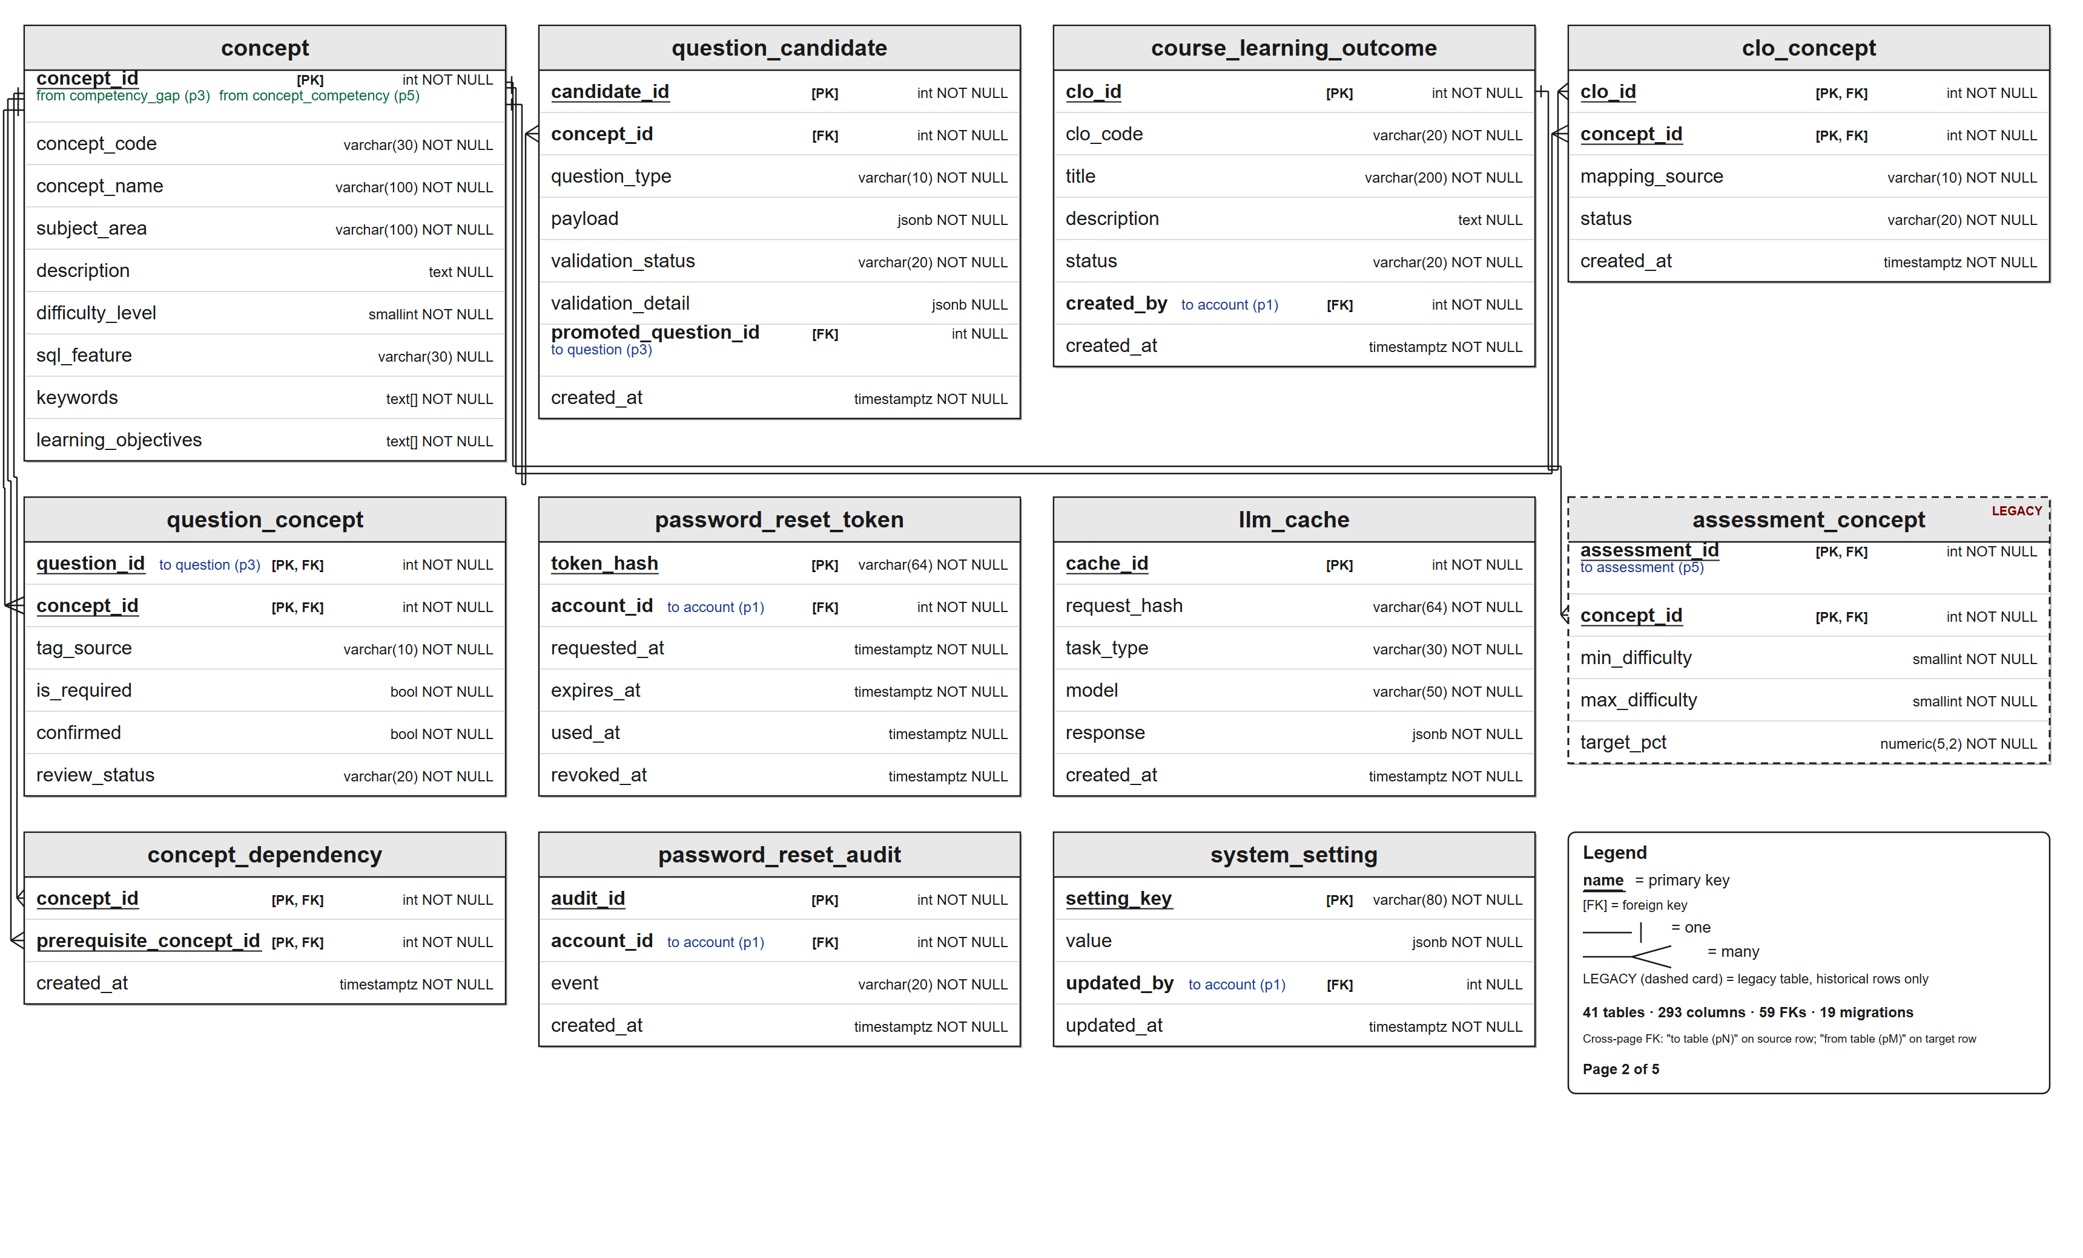
Figure 2: Table Relationship Diagram (2/5)
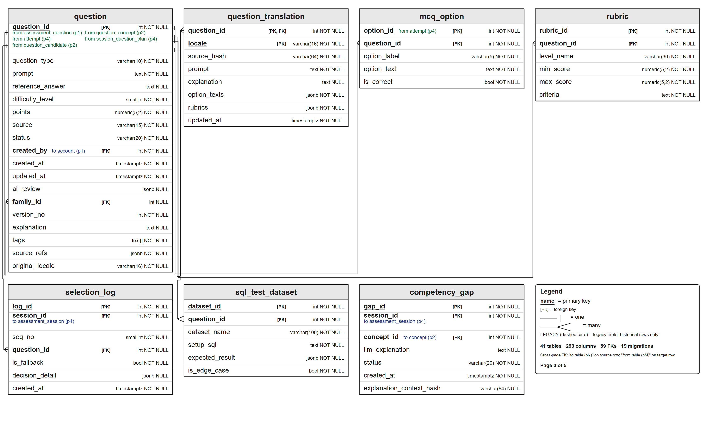
Figure 2: Table Relationship Diagram (3/5)
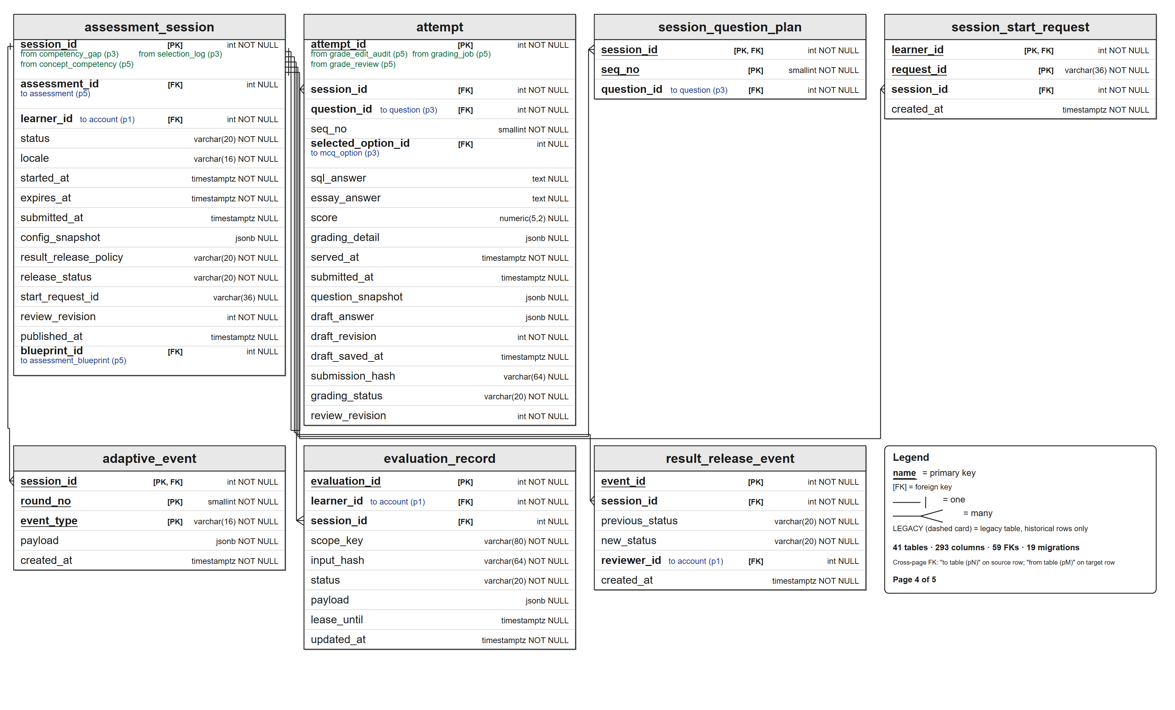
Figure 2: Table Relationship Diagram (4/5)
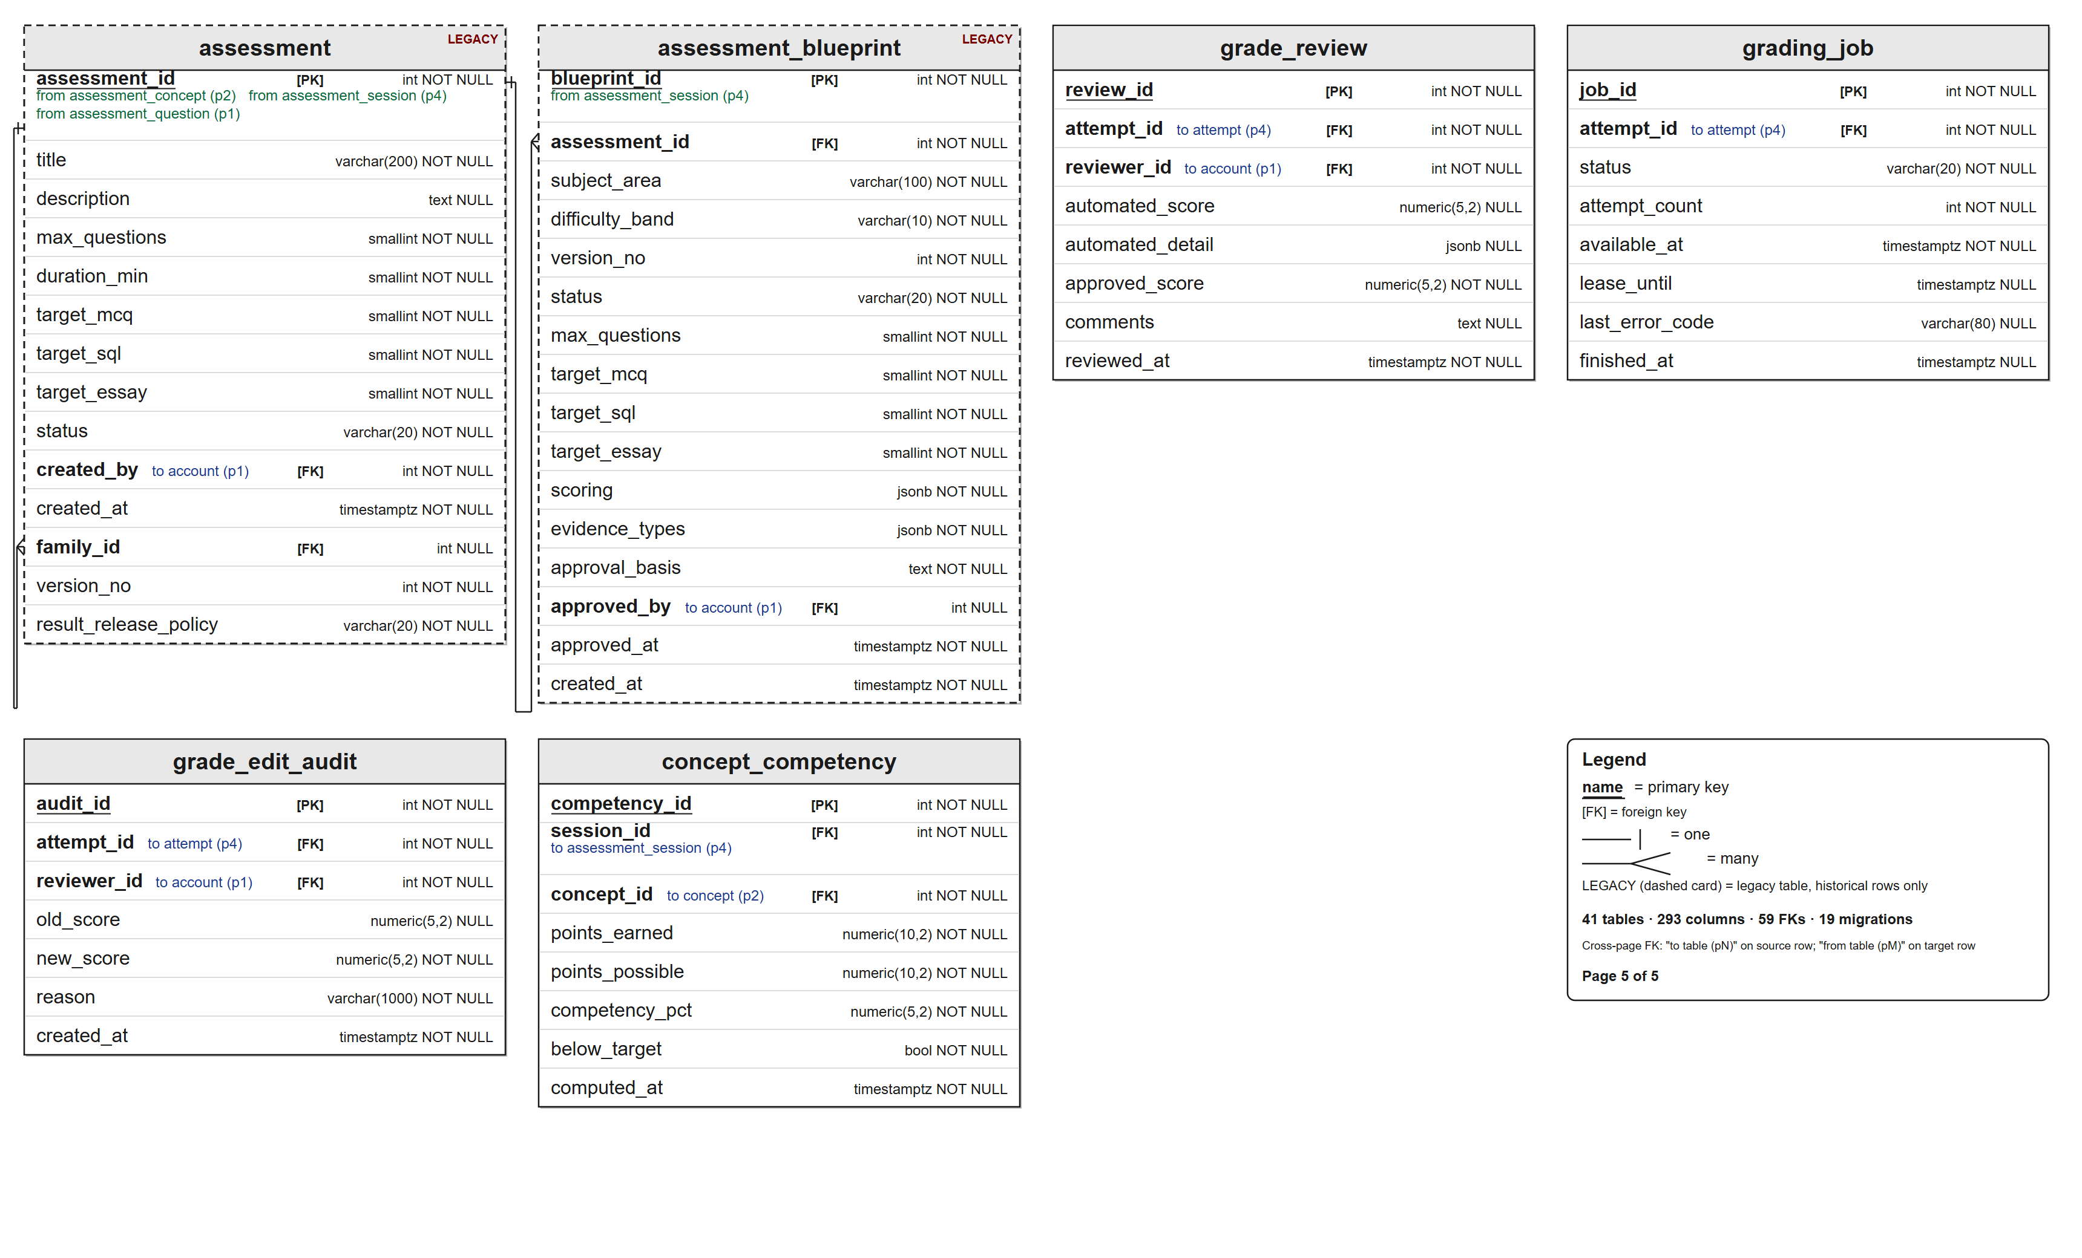
Figure 2: Table Relationship Diagram (5/5)

Database Design for Sprint

Account
This includes the attribute:
Table 2: Database Design (Account)
Attributes | Datatype | Null | Key | Default | Extra
account_id | INT | Not | PK |  | IDENTITY
email | VARCHAR(255) | Not |  |  | Unique
password_hash | VARCHAR(255) | Not
status | VARCHAR(20) | Not |  | 'active' | active / disabled
can_manage_roles | BOOLEAN | Not |  | FALSE | capability to provision accounts and manage roles
created_at | TIMESTAMPTZ | Not |  | NOW()
password_set | BOOLEAN | Not |  | TRUE | FALSE for OAuth-only accounts without a local password
password_changed_at | TIMESTAMPTZ | Yes |  |  | set on reset; invalidates older sessions through the pwd_at claim

Role
This includes the attribute:
Table 3: Database Design (Role)
Attributes | Datatype | Null | Key | Default | Extra
role_id | INT | Not | PK |  | IDENTITY
role_name | VARCHAR(50) | Not |  |  | Unique (Learner / Administrator)
description | TEXT | Yes

AccountRole
This includes the attribute:
Table 4: Database Design (AccountRole)
Attributes | Datatype | Null | Key | Default | Extra
account_id | INT | Not | PK,FK |  | FK → Account
role_id | INT | Not | PK,FK |  | FK → Role
assigned_at | TIMESTAMPTZ | Not |  | NOW()

UserProfile
This includes the attribute:
Table 5: Database Design (UserProfile)
Attributes | Datatype | Null | Key | Default | Extra
user_id | INT | Not | PK |  | IDENTITY
account_id | INT | Not | FK |  | FK → Account, Unique (1-1)
full_name | VARCHAR(100) | Not |  |  | PII — stripped before LLM calls
student_code | VARCHAR(20) | Yes
phone_number | VARCHAR(20) | Yes
date_of_birth | DATE | Yes

CourseLearningOutcome
This includes the attribute:
Table 6: Database Design (CourseLearningOutcome)
Attributes | Datatype | Null | Key | Default | Extra
clo_id | INT | Not | PK |  | IDENTITY
clo_code | VARCHAR(20) | Not |  |  | Unique (e.g. CLO-01)
title | VARCHAR(200) | Not
description | TEXT | Yes
status | VARCHAR(20) | Not |  | 'active'
created_by | INT | Not | FK |  | FK → Account (administrator)
created_at | TIMESTAMPTZ | Not |  | NOW()

Concept
This includes the attribute:
Table 7: Database Design (Concept)
Attributes | Datatype | Null | Key | Default | Extra
concept_id | INT | Not | PK |  | IDENTITY
concept_code | VARCHAR(30) | Not |  |  | Unique (e.g. SQL-JOIN)
concept_name | VARCHAR(100) | Not
subject_area | VARCHAR(100) | Not |  |  | SQL Querying / Data Manipulation & Definition / Constraints & Design Fundamentals
description | TEXT | Yes
difficulty_level | SMALLINT | Not |  | 1 | 1–5 scale
sql_feature | VARCHAR(30) | Yes |  |  | select / where / join / group_by / having / subquery / null_handling
keywords | TEXT[] | Not |  | '{}' | free-text matching keywords
learning_objectives | TEXT[] | Not |  | '{}' | learner-facing objectives

CLOConcept
This includes the attribute:
Table 8: Database Design (CLOConcept)
Attributes | Datatype | Null | Key | Default | Extra
clo_id | INT | Not | PK,FK |  | FK → CourseLearningOutcome
concept_id | INT | Not | PK,FK |  | FK → Concept
mapping_source | VARCHAR(10) | Not |  | 'admin' | admin / ai
status | VARCHAR(20) | Not |  | 'pending' | pending / confirmed / rejected
created_at | TIMESTAMPTZ | Not |  | NOW()

Question
This includes the attribute:
Table 9: Database Design (Question)
Attributes | Datatype | Null | Key | Default | Extra
question_id | INT | Not | PK |  | IDENTITY
question_type | VARCHAR(10) | Not |  |  | mcq / sql / essay
prompt | TEXT | Not
original_locale | VARCHAR(16) | Not |  | 'en' | canonical locale of the prompt (en / vi)
reference_answer | TEXT | Yes |  |  | reference SQL / model answer
explanation | TEXT | Yes |  |  | official explanation shown after release
difficulty_level | SMALLINT | Not |  | 1 | 1–5 scale
points | NUMERIC(5,2) | Not |  | 1.0
source | VARCHAR(15) | Not |  | 'bank' | bank / ai_generated
status | VARCHAR(20) | Not |  | 'draft' | draft / validated / retired
tags | TEXT[] | Not |  | '{}' | searchable topic tags
source_refs | JSONB | Not |  | '[]' | official source citations
family_id | INT | Yes | FK |  | FK → Question (version family root)
version_no | INT | Not |  | 1 | unique per family; lineage version
ai_review | JSONB | Yes |  |  | assistive AI review evidence
created_by | INT | Not | FK |  | FK → Account (administrator)
created_at | TIMESTAMPTZ | Not |  | NOW()
updated_at | TIMESTAMPTZ | Not |  | NOW()
The shipped schema allows Question.source values 'bank' and 'ai_generated' and Question.status values 'draft', 'validated' and 'retired'. Learner-defined practice supports both sources: AI generates MCQ and essay items, SQL items always come from the validated bank, and every generated item is validated before it enters the frozen plan; if AI cannot fill the plan, validated bank items complete it with a single bank_mixed notice.

QuestionConcept
This includes the attribute:
Table 10: Database Design (QuestionConcept)
Attributes | Datatype | Null | Key | Default | Extra
question_id | INT | Not | PK,FK |  | FK → Question
concept_id | INT | Not | PK,FK |  | FK → Concept
tag_source | VARCHAR(10) | Not |  | 'admin' | admin / ai
is_required | BOOLEAN | Not |  | FALSE | technique must be used (FR-09)
confirmed | BOOLEAN | Not |  | FALSE | equals review_status = 'confirmed'
review_status | VARCHAR(20) | Not |  | 'pending' | pending / confirmed / rejected

MCQOption
This includes the attribute:
Table 11: Database Design (MCQOption)
Attributes | Datatype | Null | Key | Default | Extra
option_id | INT | Not | PK |  | IDENTITY
question_id | INT | Not | FK |  | FK → Question
option_label | VARCHAR(5) | Not |  |  | A / B / C / D
option_text | TEXT | Not
is_correct | BOOLEAN | Not |  | FALSE | verified answer key

SQLTestDataset
This includes the attribute:
Table 12: Database Design (SQLTestDataset)
Attributes | Datatype | Null | Key | Default | Extra
dataset_id | INT | Not | PK |  | IDENTITY
question_id | INT | Not | FK |  | FK → Question (sql type)
dataset_name | VARCHAR(100) | Not
setup_sql | TEXT | Not |  |  | DDL + seed data for sandbox
expected_result | JSONB | Not |  |  | expected columns & rows
is_edge_case | BOOLEAN | Not |  | FALSE

Rubric
This includes the attribute:
Table 13: Database Design (Rubric)
Attributes | Datatype | Null | Key | Default | Extra
rubric_id | INT | Not | PK |  | IDENTITY
question_id | INT | Not | FK |  | FK → Question (essay type)
level_name | VARCHAR(30) | Not |  |  | Complete / Mostly Complete / Partial / Incomplete
min_score | NUMERIC(5,2) | Not
max_score | NUMERIC(5,2) | Not
criteria | TEXT | Not

Assessment
This includes the attribute:
Table 14: Database Design (Assessment)
Attributes | Datatype | Null | Key | Default | Extra
assessment_id | INT | Not | PK |  | IDENTITY
title | VARCHAR(200) | Not
description | TEXT | Yes
max_questions | SMALLINT | Not |  | 13 | legacy cap (≤ 13)
duration_min | SMALLINT | Not |  | 60 | countdown length
target_mcq | SMALLINT | Not |  | 10 | target MCQ items
target_sql | SMALLINT | Not |  | 2 | target SQL items
target_essay | SMALLINT | Not |  | 1 | target essay items
status | VARCHAR(20) | Not |  | 'draft' | draft / published / closed
result_release_policy | VARCHAR(20) | Not |  | 'HUMAN_VERIFIED' | HUMAN_VERIFIED (IMMEDIATE only historical)
family_id | INT | Yes | FK |  | FK → Assessment (version family root)
version_no | INT | Not |  | 1 | unique per family; lineage version
created_by | INT | Not | FK |  | FK → Account (administrator)
created_at | TIMESTAMPTZ | Not |  | NOW()

AssessmentConcept
This includes the attribute:
Table 15: Database Design (AssessmentConcept)
Attributes | Datatype | Null | Key | Default | Extra
assessment_id | INT | Not | PK,FK |  | FK → Assessment
concept_id | INT | Not | PK,FK |  | FK → Concept
min_difficulty | SMALLINT | Not |  | 1 | 1–5 scale
max_difficulty | SMALLINT | Not |  | 5 | 1–5 scale
target_pct | NUMERIC(5,2) | Not |  |  | legacy passing benchmark (%)

AssessmentSession
This includes the attribute:
Table 16: Database Design (AssessmentSession)
Attributes | Datatype | Null | Key | Default | Extra
session_id | INT | Not | PK |  | IDENTITY
assessment_id | INT | Yes | FK |  | FK → Assessment (nullable legacy link)
blueprint_id | INT | Yes | FK |  | FK → AssessmentBlueprint (version bound at start; NULL for legacy sessions)
learner_id | INT | Not | FK |  | FK → Account (learner)
status | VARCHAR(20) | Not |  | 'in_progress' | in_progress / completed / timed_out
locale | VARCHAR(16) | Not |  | 'en' | question locale (immutable)
started_at | TIMESTAMPTZ | Not |  | NOW()
expires_at | TIMESTAMPTZ | Not |  |  | started_at + duration_min
submitted_at | TIMESTAMPTZ | Yes |  |  | auto-submit at 00:00
config_snapshot | JSONB | Yes |  |  | frozen practice configuration and concept targets
result_release_policy | VARCHAR(20) | Not |  | 'HUMAN_VERIFIED' | HUMAN_VERIFIED (IMMEDIATE only historical; immutable)
release_status | VARCHAR(20) | Not |  | 'unsubmitted' | unsubmitted / auto_grading / pending_review / reviewed / published / grading_failed
start_request_id | VARCHAR(36) | Yes |  |  | idempotency key of the accepted start request
review_revision | INT | Not |  | 0 | monotonic review counter
published_at | TIMESTAMPTZ | Yes |  |  | result publication timestamp

Attempt
This includes the attribute:
Table 17: Database Design (Attempt)
Attributes | Datatype | Null | Key | Default | Extra
attempt_id | INT | Not | PK |  | IDENTITY
session_id | INT | Not | FK |  | FK → AssessmentSession
question_id | INT | Not | FK |  | FK → Question
seq_no | SMALLINT | Not |  |  | serve order; unique per session
selected_option_id | INT | Yes | FK |  | FK → MCQOption (mcq)
sql_answer | TEXT | Yes |  |  | learner SQL (sql)
essay_answer | TEXT | Yes |  |  | learner essay (essay)
draft_answer | JSONB | Yes |  |  | autosaved in-progress answer
draft_revision | INT | Not |  | 0 | optimistic concurrency for autosave
draft_saved_at | TIMESTAMPTZ | Yes
submission_hash | VARCHAR(64) | Yes |  |  | idempotency hash of the submitted answer
grading_status | VARCHAR(20) | Not |  | 'unsubmitted' | unsubmitted / pending / graded / failed
score | NUMERIC(5,2) | Yes |  |  | graded result (essay LLM-assisted)
grading_detail | JSONB | Yes |  |  | standardized evidence (FR-11)
review_revision | INT | Not |  | 0 | review counter inherited from the session
question_snapshot | JSONB | Yes |  |  | immutable served-question content
served_at | TIMESTAMPTZ | Not |  | NOW()
submitted_at | TIMESTAMPTZ | Yes

SelectionLog
This includes the attribute:
Table 18: Database Design (SelectionLog)
Attributes | Datatype | Null | Key | Default | Extra
log_id | INT | Not | PK |  | IDENTITY
session_id | INT | Not | FK |  | FK → AssessmentSession
seq_no | SMALLINT | Not
question_id | INT | Not | FK |  | FK → Question (validated item served)
is_fallback | BOOLEAN | Not |  | FALSE | validated-item fallback (NFR-09)
decision_detail | JSONB | Yes |  |  | concept / difficulty / type decision
created_at | TIMESTAMPTZ | Not |  | NOW()

ConceptCompetency
This includes the attribute:
Table 19: Database Design (ConceptCompetency)
Attributes | Datatype | Null | Key | Default | Extra
competency_id | INT | Not | PK |  | IDENTITY
session_id | INT | Not | FK |  | FK → AssessmentSession
concept_id | INT | Not | FK |  | FK → Concept; unique per session
points_earned | NUMERIC(10,2) | Not |  | 0
points_possible | NUMERIC(10,2) | Not |  | 0
competency_pct | NUMERIC(5,2) | Not |  | 0 | earned / possible × 100
below_target | BOOLEAN | Not |  | FALSE | competency_pct < target_pct
computed_at | TIMESTAMPTZ | Not |  | NOW()

CompetencyGap
This includes the attribute:
Table 20: Database Design (CompetencyGap)
Attributes | Datatype | Null | Key | Default | Extra
gap_id | INT | Not | PK |  | IDENTITY
session_id | INT | Not | FK |  | FK → AssessmentSession
concept_id | INT | Not | FK |  | FK → Concept
llm_explanation | TEXT | Yes |  |  | assistive AI explanation (FR-14)
explanation_context_hash | VARCHAR(64) | Yes |  |  | cache key for the sanitized explanation input
status | VARCHAR(20) | Not |  | 'open' | open / reviewed
created_at | TIMESTAMPTZ | Not |  | NOW()

LLMCache
This includes the attribute:
Table 21: Database Design (LLMCache)
Attributes | Datatype | Null | Key | Default | Extra
cache_id | INT | Not | PK |  | IDENTITY
request_hash | VARCHAR(64) | Not |  |  | Unique (SHA-256 of sanitized prompt)
task_type | VARCHAR(30) | Not |  |  | essay_score / clo_map / tag / gap_explain
model | VARCHAR(50) | Not |  |  | configured provider model name
response | JSONB | Not |  |  | cached structured JSON output
created_at | TIMESTAMPTZ | Not |  | NOW()

QuestionCandidate
This includes the attribute:
Table 22: Database Design (QuestionCandidate)
Attributes | Datatype | Null | Key | Default | Extra
candidate_id | INT | Not | PK |  | IDENTITY
concept_id | INT | Not | FK |  | FK → Concept
question_type | VARCHAR(10) | Not |  |  | mcq / sql / essay
payload | JSONB | Not |  |  | AI-generated question content
validation_status | VARCHAR(20) | Not |  | 'pending' | pending / validated / rejected
validation_detail | JSONB | Yes |  |  | automated validation results
promoted_question_id | INT | Yes | FK |  | FK → Question, Unique (1-1)
created_at | TIMESTAMPTZ | Not |  | NOW()

AccountIdentity
This includes the attribute:
Table 23: Database Design (AccountIdentity)
Attributes | Datatype | Null | Key | Default | Extra
identity_id | INT | Not | PK |  | IDENTITY
account_id | INT | Not | FK |  | FK → Account
provider | VARCHAR(20) | Not |  |  | google / github
provider_user_id | VARCHAR(255) | Not |  |  | unique together with provider
provider_email | VARCHAR(255) | Yes |  |  | verified provider email
email_verified | BOOLEAN | Not |  | FALSE | provider verification flag
linked_at | TIMESTAMPTZ | Not |  | NOW()

AccountRoleAudit
This includes the attribute:
Table 24: Database Design (AccountRoleAudit)
Attributes | Datatype | Null | Key | Default | Extra
audit_id | BIGINT | Not | PK |  | IDENTITY
action_type | VARCHAR(40) | Not |  |  | ROLE_GRANTED / ROLE_REVOKED / ROLE_MANAGER_BOOTSTRAPPED
actor_account_id | INT | Yes | FK |  | FK → Account (NULL only for bootstrap)
target_account_id | INT | Not | FK |  | FK → Account
previous_role | VARCHAR(50) | Yes |  |  | Learner / Administrator
new_role | VARCHAR(50) | Yes |  |  | Learner / Administrator
created_at | TIMESTAMPTZ | Not |  | NOW() | immutable (trigger)

OAuthHandoff
This includes the attribute:
Table 25: Database Design (OAuthHandoff)
Attributes | Datatype | Null | Key | Default | Extra
jti_hash | VARCHAR(64) | Not | PK |  | SHA-256 of the one-time handoff token
account_id | INT | Not | FK |  | FK → Account
expires_at | TIMESTAMPTZ | Not |  |  | short-lived
consumed_at | TIMESTAMPTZ | Yes |  |  | set once on exchange
created_at | TIMESTAMPTZ | Not |  | NOW()

LoginThrottle
This includes the attribute:
Table 26: Database Design (LoginThrottle)
Attributes | Datatype | Null | Key | Default | Extra
key_hash | VARCHAR(64) | Not | PK |  | SHA-256 of the normalized login key
failures | JSONB | Not |  | '[]' | recent failure timestamps
expires_at | TIMESTAMPTZ | Not |  |  | throttle window end

ConceptDependency
This includes the attribute:
Table 27: Database Design (ConceptDependency)
Attributes | Datatype | Null | Key | Default | Extra
concept_id | INT | Not | PK,FK |  | FK → Concept (dependent concept)
prerequisite_concept_id | INT | Not | PK,FK |  | FK → Concept (prerequisite)
created_at | TIMESTAMPTZ | Not |  | NOW()

QuestionTranslation
This includes the attribute:
Table 28: Database Design (QuestionTranslation)
Attributes | Datatype | Null | Key | Default | Extra
question_id | INT | Not | PK,FK |  | FK → Question; ON DELETE CASCADE
locale | VARCHAR(16) | Not | PK |  | e.g. vi; English remains canonical on Question
source_hash | VARCHAR(64) | Not |  |  | hash of the English source version
prompt | TEXT | Not |  |  | translated prompt
explanation | TEXT | Yes |  |  | translated explanation
option_texts | JSONB | Not |  | '{}' | option_id → translated option text
rubrics | JSONB | Not |  | '{}' | rubric level → translated criteria
updated_at | TIMESTAMPTZ | Not |  | NOW()

SessionQuestionPlan
This includes the attribute:
Table 29: Database Design (SessionQuestionPlan)
Attributes | Datatype | Null | Key | Default | Extra
session_id | INT | Not | PK,FK |  | FK → AssessmentSession
seq_no | SMALLINT | Not | PK |  | reserved order 1..N
question_id | INT | Not | FK |  | FK → Question; unique per session

SessionStartRequest
This includes the attribute:
Table 30: Database Design (SessionStartRequest)
Attributes | Datatype | Null | Key | Default | Extra
learner_id | INT | Not | PK,FK |  | composite FK → AssessmentSession
request_id | VARCHAR(36) | Not | PK |  | client idempotency key
session_id | INT | Not | FK |  | FK → AssessmentSession
created_at | TIMESTAMPTZ | Not |  | NOW() | immutable (trigger)

GradingJob
This includes the attribute:
Table 31: Database Design (GradingJob)
Attributes | Datatype | Null | Key | Default | Extra
job_id | INT | Not | PK |  | IDENTITY
attempt_id | INT | Not | FK |  | FK → Attempt, Unique (one job per attempt)
status | VARCHAR(20) | Not |  | 'pending' | pending / processing / completed / failed
attempt_count | INT | Not |  | 0 | retry counter
available_at | TIMESTAMPTZ | Not |  | NOW() | next eligible attempt
lease_until | TIMESTAMPTZ | Yes |  |  | worker lease deadline
last_error_code | VARCHAR(80) | Yes |  |  | failure classification
finished_at | TIMESTAMPTZ | Yes |  |  | terminal timestamp

GradeReview
This includes the attribute:
Table 32: Database Design (GradeReview)
Attributes | Datatype | Null | Key | Default | Extra
review_id | INT | Not | PK |  | IDENTITY
attempt_id | INT | Not | FK |  | FK → Attempt, Unique
reviewer_id | INT | Not | FK |  | FK → Account (administrator)
automated_score | NUMERIC(5,2) | Yes |  |  | score before human review
automated_detail | JSONB | Yes |  |  | grading evidence snapshot
approved_score | NUMERIC(5,2) | Not |  |  | human-approved score ≥ 0
comments | TEXT | Yes |  |  | reviewer notes
reviewed_at | TIMESTAMPTZ | Not |  | NOW() | immutable (trigger)

ResultReleaseEvent
This includes the attribute:
Table 33: Database Design (ResultReleaseEvent)
Attributes | Datatype | Null | Key | Default | Extra
event_id | INT | Not | PK |  | IDENTITY
session_id | INT | Not | FK |  | FK → AssessmentSession
previous_status | VARCHAR(20) | Not |  |  | release status before the change
new_status | VARCHAR(20) | Not |  |  | release status after the change
reviewer_id | INT | Yes | FK |  | FK → Account (NULL for system events)
created_at | TIMESTAMPTZ | Not |  | NOW() | immutable audit (trigger)

AssessmentBlueprint
This includes the attribute:
Table 34: Database Design (AssessmentBlueprint)
Attributes | Datatype | Null | Key | Default | Extra
blueprint_id | INT | Not | PK |  | IDENTITY
assessment_id | INT | Not | FK |  | FK → Assessment; ON DELETE CASCADE
subject_area | VARCHAR(100) | Not
difficulty_band | VARCHAR(10) | Not |  |  | EASY / MEDIUM / HARD
version_no | INT | Not |  | 1 | unique per assessment, subject area and band
status | VARCHAR(20) | Not |  | 'approved' | approved / retired
max_questions | SMALLINT | Not
target_mcq | SMALLINT | Not |  | 0
target_sql | SMALLINT | Not |  | 0
target_essay | SMALLINT | Not |  | 0
scoring | JSONB | Not |  | '{}' | per-type scoring weights
evidence_types | JSONB | Not |  | '[]' | ordered evidence mix
approval_basis | TEXT | Not |  |  | nonblank approval rationale
approved_by | INT | Yes | FK |  | FK → Account (administrator)
approved_at | TIMESTAMPTZ | Not |  | NOW()
created_at | TIMESTAMPTZ | Not |  | NOW()

AdaptiveEvent
This includes the attribute:
Table 35: Database Design (AdaptiveEvent)
Attributes | Datatype | Null | Key | Default | Extra
session_id | INT | Not | PK,FK |  | FK → AssessmentSession
round_no | SMALLINT | Not | PK |  | 1–13
event_type | VARCHAR(16) | Not | PK |  | batch / decision
payload | JSONB | Not |  |  | decision or shortage notice
created_at | TIMESTAMPTZ | Not |  | NOW() | immutable (trigger)

PasswordResetToken
This includes the attribute:
Table 36: Database Design (PasswordResetToken)
Attributes | Datatype | Null | Key | Default | Extra
token_hash | VARCHAR(64) | Not | PK |  | SHA-256 of the emailed token
account_id | INT | Not | FK |  | FK → Account
requested_at | TIMESTAMPTZ | Not |  | NOW()
expires_at | TIMESTAMPTZ | Not |  |  | requested_at + TTL (15 minutes by default)
used_at | TIMESTAMPTZ | Yes |  |  | set once on redemption
revoked_at | TIMESTAMPTZ | Yes |  |  | set when superseded or after use

PasswordResetAudit
This includes the attribute:
Table 37: Database Design (PasswordResetAudit)
Attributes | Datatype | Null | Key | Default | Extra
audit_id | INT | Not | PK |  | IDENTITY
account_id | INT | Not | FK |  | FK → Account
event | VARCHAR(20) | Not |  |  | requested / completed
created_at | TIMESTAMPTZ | Not |  | NOW() | immutable (trigger)

AssessmentQuestion
This includes the attribute:
Table 38: Database Design (AssessmentQuestion)
Attributes | Datatype | Null | Key | Default | Extra
assessment_id | INT | Not | PK, FK |  | FK → Assessment
question_id | INT | Not | PK, FK |  | FK → Question

EvaluationRecord
This includes the attribute:
Table 39: Database Design (EvaluationRecord)
Attributes | Datatype | Null | Key | Default | Extra
evaluation_id | INT | Not | PK | IDENTITY
learner_id | INT | Not | FK |  | FK → Account
session_id | INT | Yes | FK |  | FK → AssessmentSession
scope_key | VARCHAR(80) | Not
input_hash | VARCHAR(64) | Not
status | VARCHAR(20) | Not |  | 'pending'
payload | JSONB | Yes
lease_until | TIMESTAMPTZ | Yes
updated_at | TIMESTAMPTZ | Not |  | NOW()

GradeEditAudit
This includes the attribute:
Table 40: Database Design (GradeEditAudit)
Attributes | Datatype | Null | Key | Default | Extra
audit_id | INT | Not | PK | IDENTITY
attempt_id | INT | Not | FK |  | FK → Attempt
reviewer_id | INT | Not | FK |  | FK → Account
old_score | NUMERIC(5,2) | Yes
new_score | NUMERIC(5,2) | Not
reason | VARCHAR(1000) | Not
created_at | TIMESTAMPTZ | Not |  | NOW()

RefreshSession
This includes the attribute:
Table 41: Database Design (RefreshSession)
Attributes | Datatype | Null | Key | Default | Extra
token_hash | VARCHAR(64) | Not | PK
family_id | VARCHAR(32) | Not
account_id | INT | Not | FK |  | FK → Account
credential_version | BIGINT | Not |  | 0
created_at | TIMESTAMPTZ | Not |  | NOW()
expires_at | TIMESTAMPTZ | Not
consumed_at | TIMESTAMPTZ | Yes
revoked_at | TIMESTAMPTZ | Yes

SystemSetting
This includes the attribute:
Table 42: Database Design (SystemSetting)
Attributes | Datatype | Null | Key | Default | Extra
setting_key | VARCHAR(80) | Not | PK
value | JSONB | Not
updated_by | INT | Yes | FK |  | FK → Account
updated_at | TIMESTAMPTZ | Not |  | NOW()

Hardware and Software Requirements
This section provides an overview of hardware and software requirements. Below are descriptions of the technological components of the DBCAS.
Table 43: Hardware and Software Requirements
 | Attributes of DBCAS
Attributes | Descriptions
Database | PostgreSQL 17: application database, plus an isolated PostgreSQL 17 instance in the Docker SQL sandbox.
Software | React 19.3 + Vite 8.3.5, Tailwind CSS 4.3, FastAPI 0.141.1 (Python 3.13), Docker Engine CE 29, external LLM provider API, Git 2.54+ & GitHub.
Hardware | Development workstations; a Docker-capable host running the application database and the sandbox container (256 MB memory limit, 3-second statement timeout).
Library | Chart.js 4.5.1, LLM provider API client, Pytest.

