Duc Nguyen
REPORT

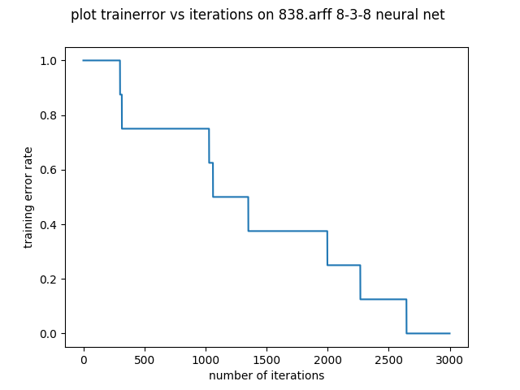
NOTE: I used seed = 0 for all experiments in this report

From this plot, we can see that we achieve a 0 percent error rate on this data set, which is really good. The learning curve is not really a “curve”, it is more “step-like”, and because there are only 8 examples in this data set, whenever there is a sudden drop, it means that we got another example classified correctly. However, it takes us over 2500 iterations to get the error rate to 0, so the network is getting better but very slowly, it takes on average 2600/8 = 325 iterations to get one more example classified correctly.

[[ 0.32896243 0.37541583 0.3808527 ]]
[[ 0.42803458 0.29712826 0.3869328 ]]
[[ 0.0385686 0.67529337 0.97079952]]
[[ 0.95358721 0.92989476 0.03092144]]
[[ 0.43845077 0.78998162 0.26927436]]
[[ 0.64365921 0.04015382 0.97399128]]
[[ 0.09791198 0.97523463 0.35233897]]
[[ 0.97590757 0.09288203 0.36985255]]
The 8 triplets above are the hidden representation of numbers from 1 to 8 after 3000 iterations with w = 3, d = 1 and seed = 0. From these numbers, we can see that the neural network has done pretty well in finding a binary representation for all the numbers (out of 8, there are only 2 that are missing). The problem why we can't find the correct binary representation might be because of initializing. Because I chose the seed to be 0, the initial value of the weight might be far away from the true value of the weight to get the binary representation, so it may need more than 3000 iterations to converge to the true representation.
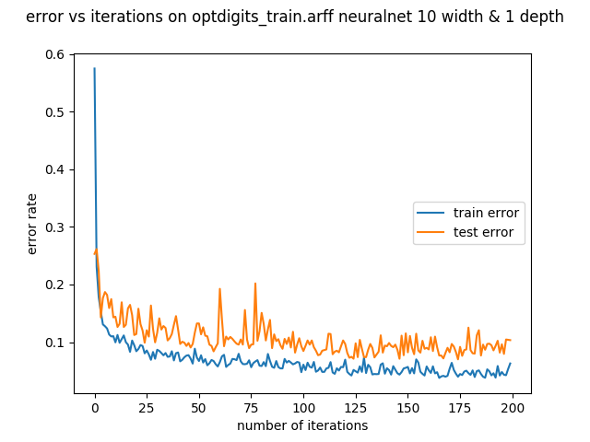
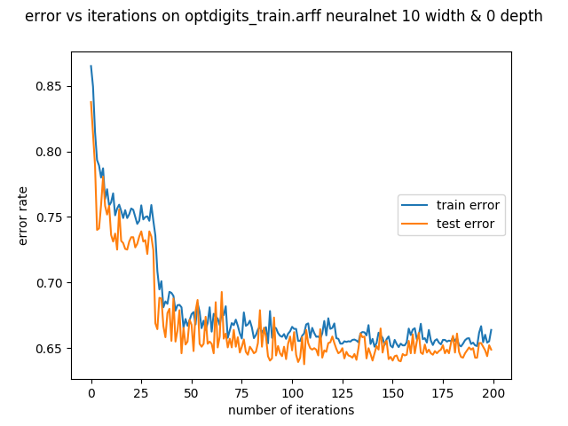

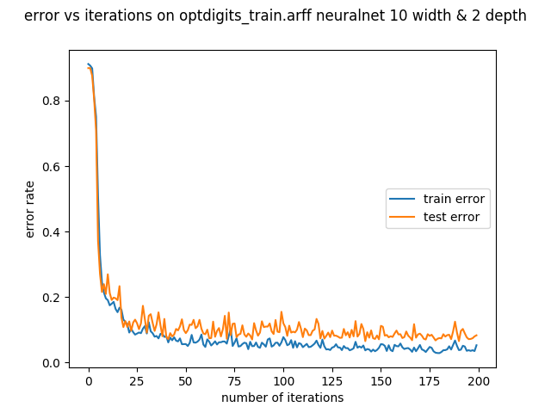

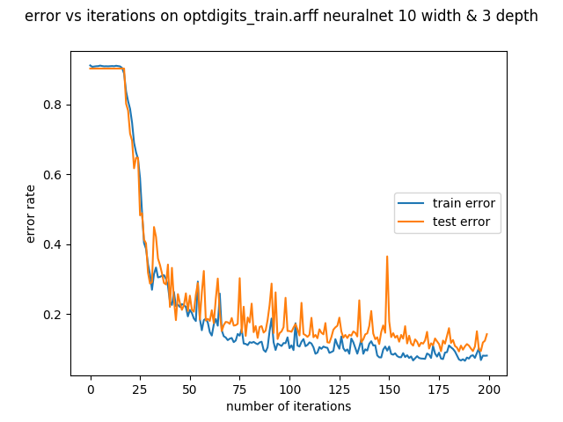
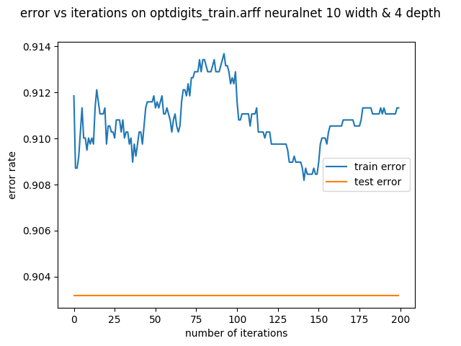
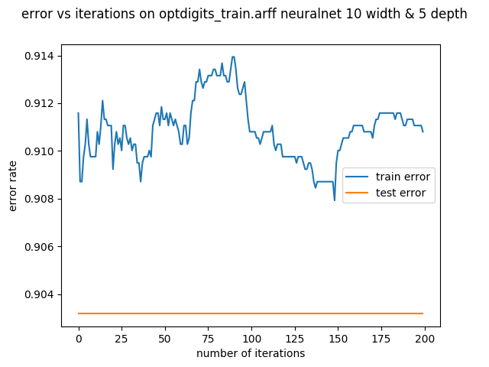
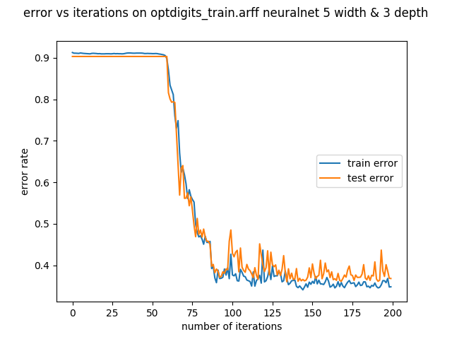

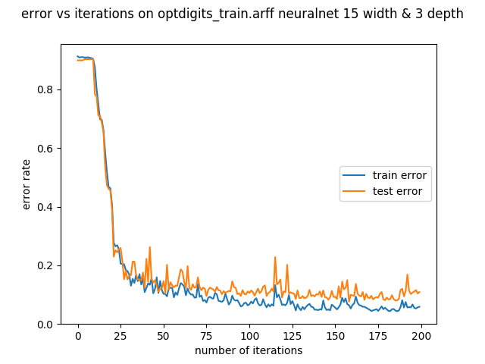
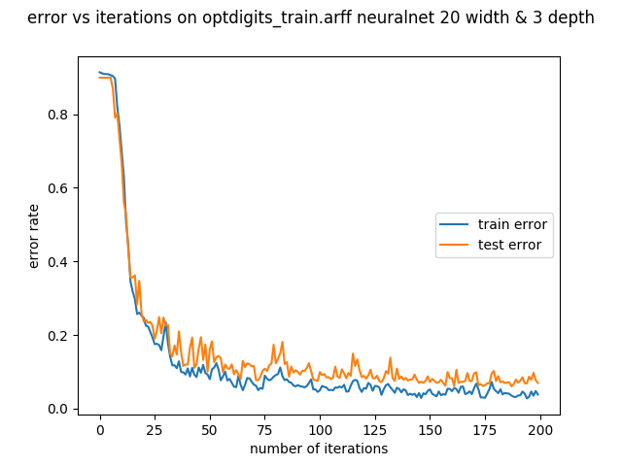

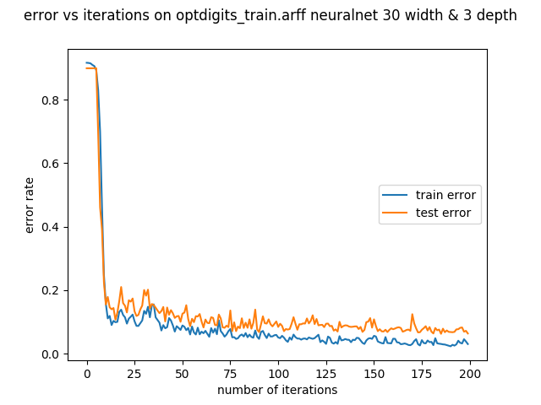
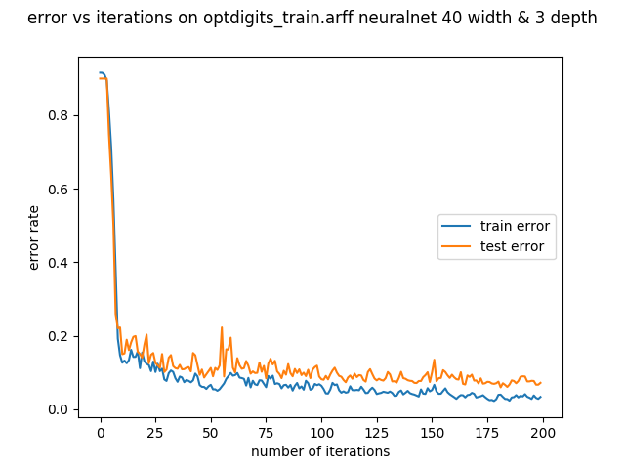
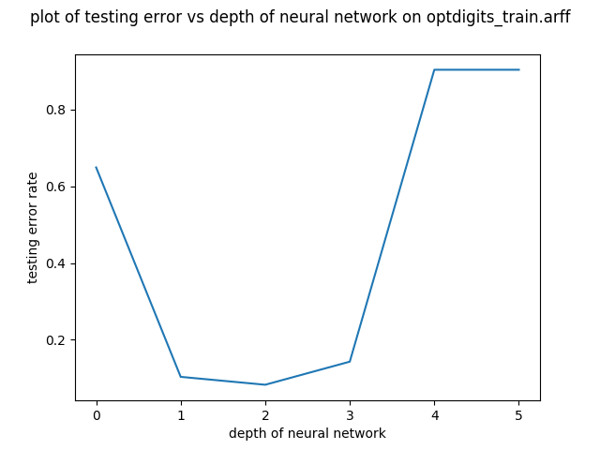
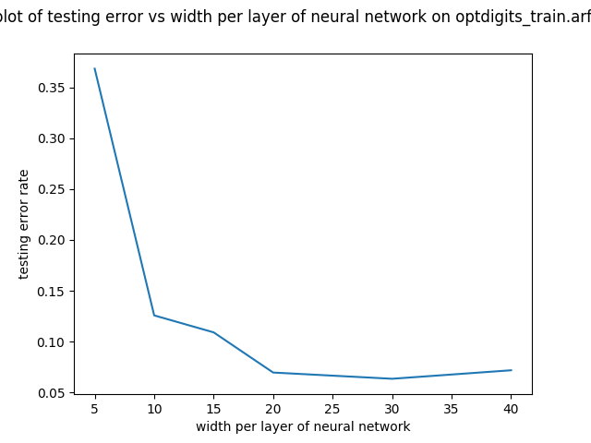

From the plots above, I can see that, for most neural network with different widths and depths, as the number of iterations increases, the error rate decreases. The different networks perform quite well on this data set. In fact, most error rates drop to below 20%, compared to the original error rate of 90%. We can see that for most cases, in the first few iterations, the error rate drops really quickly, but then it flattens out as it goes to 200. This is because at the start, we are quite far from the true label, so every iteration we make a big leap toward the true weight. However, as we get closer and closer to the true weights, the change in delta is less significant, and now we can only make smaller improvement per iterations. Also from the plots, we can see that the train error is usually lower than test error, this is because we are training on the train set, and we are trying to generalize to the test set, so it only makes sense we have better accuracy on the train set. Also, the curve fluctuates a lot, going up and down a lot, but the overall trend is still going down. This is because we are doing stochastic gradient descent, and this updates on every training example, so at a particular iteration it might go up or down depending on the current weight and current example, but overall we are still optimizing to the true value of weights.
There are 2 values of depth 4 and 5 which are outlier to these trends, and the reasoning why is explained in the next paragraph.

From the plot testing vs depth of neural network, keeping the width constant, we can see that with 0 depth, which means the input layer is connected to the output layer, the error rate is quite high (60%). This is because without any layer, this looks a lot like perceptron, which only divides the space into 2, therefore not getting good results for multiple label problem. As depth goes to 1,2 or 3, the error rate decreases by a huge amount, even getting below 10%. This is because at around this depth, we are getting a “deep” enough network to actually approximate the true non-linear function. However, as depth increases to 4 and 5, the error rate gets to around 90%, which is extremely bad. I believe this happens because of the problem of the vanishing gradient, which we can see in the homework as we back propagate to the “front” layers, the amount of change becomes so small that it barely affects the weights at the first few layers. Therefore, because the weight doesn't change much, the output doesn't change much, so the error rate doesn't decrease as well.

From the plot of testing error vs width per layer of neural network, we can see that with width less than 10, the network isn't doing too well. As the width increases, the network gets better and better, reaches maximum at width =20 and performs slight worse after that but still very good. So unlike depth, increase width actually boosts performance by a lot. The reasoning behind this is that as we have more nodes per layer, we have more data to feed in to the next layer, and we retain more information from the original input, so we perform better. If we have too few nodes, we will lose lots of information in the process of feed forward, and we will perform worse.

In my case, the absolute best value for width is 30 while the absolute best value for depth is 2.

