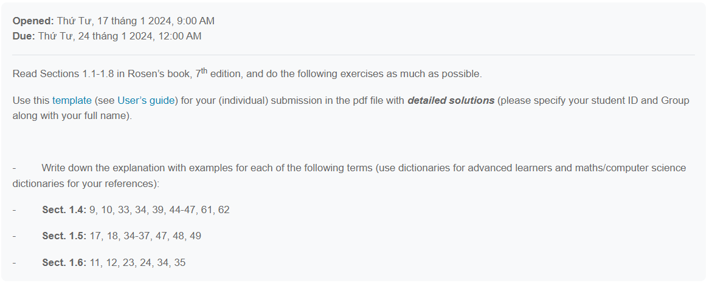

Mẫu

<https://www.overleaf.com/latex/templates/simple-math-homework-template/tbszsswsndrz>