

CAPSTONE PROJECT REPORT
Report 5 – Software Test Documentation
Topic: Customers Management System for NAWACO
Project Code: CMSN
Document Code: CMSN- v1.4

– Hanoi, Jan 2026 –

Table of Contents
I. Record of Changes 3
II. Testing Documentation 4
1. Scope of Testing 4
1.1 Stage of testing 4
1.2 Type of Testing 4
1.3 Range of testing 6
2. Test Strategy 6
2.1 Testing model 6
2.2 Testing Types and Levels 10
2.3 Supporting Tools 11
3. Test Plan 13
3.1 Human Resources 13
3.2 Test Environment 14
3.3 Test Milestones 14
4. Test Cases 15
4.1 Unit test 15
4.2 Integration test 15
4.3 System test 15
4.4 Non-functional test 15
4.5 User Acceptance test 15
5. Test Reports 15
5.1 Unit test 15
5.2 Integration test 17
5.3 System test 17
5.4 User Acceptance Test 18

I. Record of Changes
Date | A*  M, D | In charge | Change Description
10/04/2026 | A | GiangPT | Add Testing document
12/04/2026 | M | GiangPT | Modified Type of testing
12/04/2026 | A, M | GiangPT | Modified testing model.add V-Model structure
20/04/2026 | M | GiangPT | Modified testing document
*A - Added M - Modified D - Deleted

II. Testing Documentation

1. Scope of Testing

1.1 Stage of testing
There are 3 level of testing utilized in our CMSN project, they are Unit testing, Integration testing and System testing
ID | Test Stages | Description
1 | Unit testing | This stage targets the smallest testable parts of the application, such as methods or classes, and verifies their correctness in isolation. It typically employs white-box testing techniques to ensure the internal logic of each component performs accurately as intended by the developer.
2 | Integration testing | Integration testing combines multiple units and tests them as a group. The goal is to identify defects that arise when units or modules interact with each other, ensuring that the integrated components work well together. This testing method helps detect issues with interfaces and interactions between modules
3 | System testing | System testing is the first phase where the entire system is tested as a whole. It aims to validate that the system meets all the outlined requirements and complies with Quality Standards. This type of testing focuses on the overall system functionality rather than individual components.
4 | User Acceptance Test | UAT (User Acceptance Testing) is the phase of software testing performed directly by end users or customers. The purpose of UAT is to verify that the system meets the specified requirements and can be used effectively in real-world scenarios. If the software passes UAT, it means the product is ready for official deployment.
Table 1: Stages of testing

1.2 Type of Testing
Type of Tests | Test Levels
 | Unit | Integration | System | User Acceptance
Functional Testing | X | X | X | X
Non-functional Testing |  | X | X | X
Table 2: Types of testing

1.2.1 Functional testing
Functional testing verifies that individual functions or features of the system operate according to defined requirements. Each test case is designed to validate various logical paths, including different input conditions and boundary scenarios.
- All possible branches of logic within a function or method should be covered using diverse input data.
- The testing process is considered successful if all documented test cases execute and pass without failure.

1.2.2 Non-Functional testing
This testing focuses on the visual and usability aspects of the application to ensure a positive user experience and interface compliance with design specifications.
Performance Testing
- Assesses how the system behaves under expected and peak load conditions. This includes:
- Response Time: How quickly the application responds to user actions or API requests.
- Throughput: Number of transactions processed within a given time frame.
Scalability Testing
- Determines the system's ability to handle increased workloads, such as more users or larger data volumes, without degrading performance.
Reliability Testing
- Ensures the system continues to operate correctly over time and under stress. It includes:
- Stability Over Time: Application can run for extended periods without crashing.
- Error Recovery: The system recovers gracefully from failures or interruptions.
Security Testing
- Assesses the system’s ability to protect data and resist malicious actions. This includes:
- Authentication & Authorization: Ensuring only legitimate users can access resources.
- Data Protection: Validating encryption, secure transmission, and safe data storage.
- Vulnerability Assessment: Detecting and addressing potential security flaws.

1.3 Range of testing
Our team aims to cover all the functionality described in the SRS and optional features that may be added in the future.

2. Test Strategy

2.1 Testing Types

2.1.1 Testing model overview
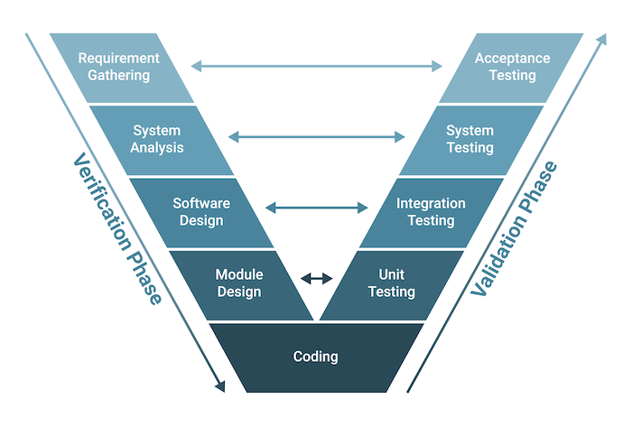
Figure 1: V-Model
The CMSN project adopts the V-Model (Verification and Validation Model) for software development and testing. The V-Model is a structured development methodology that emphasizes a strict relationship between development phases and corresponding testing phases. For every development activity, there is a corresponding testing activity, ensuring that verification and validation are conducted in parallel throughout the lifecycle.
This model enhances traceability, improves quality assurance, and ensures that issues are detected at the earliest possible stage by validating each deliverable against its defined requirements.

2.1.2 V-model structure in CMSN
Verification Phases (Left Side of V):
- Requirements Analysis:
Define and document user requirements. These are validated through acceptance testing later in the cycle.
- System Design:
Specify system architecture and high-level modules. This phase maps to system testing.
- High-Level Design:
Design the structure of sub-systems and their interfaces. It corresponds to integration testing.
- Low-Level Design:
Define detailed design for each module or component. This is linked to unit testing.
- Implementation (Coding):
Actual development of components begins after all design phases are complete.
Validation Phases (Right Side of V):
- Unit Testing:
Conducted to validate individual components against their detailed design specifications.
- Integration Testing:
Ensures that module interactions function correctly according to the high-level design.
- System Testing:
Verifies the complete system behavior against system design and requirements.
- Acceptance Testing:
Validates the software against user requirements, ensuring the system meets business goals.

2.1.3 Key Characteristics
- Clear Mapping Between Phases:
Every development phase has a corresponding testing phase, ensuring alignment between design and validation.
- Early Test Planning:
Testing activities are planned during the early stages of development, improving preparation and efficiency.
- Strict Process Control:
The model follows a sequential flow, minimizing ambiguity and enhancing project tracking.
- High Traceability:
Each requirement is traceable through the entire development and testing process.
- Defect Prevention and Early Detection:
Validation begins from the start, reducing the risk of propagating defects.

2.1.4 Advantages of V-Model
- Improved Quality Assurance:
By validating each development phase through corresponding testing activities, quality is assured at every level.
- Early Identification of Defects:
As testing is planned early, potential issues are identified during the design stages.
- Better Documentation and Control:
Each phase has well-defined deliverables, making it easier to manage and audit.
- Enhanced Stakeholder Confidence:
Clearly structured processes and early visibility into testing provide transparency for stakeholders.
- Minimized Rework:
Early validation reduces the cost and effort of fixing errors discovered late in the process.

2.1.5 How the model is applied
- Requirement Analysis and Acceptance Test Design:
User requirements are defined and simultaneously used to plan acceptance tests.
- System Design and System Testing Preparation:
Architecture and overall system behavior are specified, and system test plans are created accordingly.
- Detailed Design and Integration Test Design:
Each module’s interactions are designed and mapped to integration test cases.
- Coding and Unit Testing:
Individual modules are developed and tested against the low-level design to ensure correct functionality.
- Sequential Testing Execution:
After coding is complete, tests are executed in order: unit => integration => system => acceptance.
- Final Delivery:
Upon passing all levels of testing, the complete system is deployed after formal validation.

2.1.6 Integrating V-Model Testing within the Iterative & Incremental Development Approach
While the CMSN project adopts the Iterative and Incremental Model for software development, it integrates the V-Model as the foundation for test planning and execution within each iteration. This hybrid approach leverages the strengths of both models: the flexibility and adaptability of iterative development, and the structured, phase-aligned testing discipline of the V-Model.
How Integration Works
- Per-Increment V-Model Application:
Each increment in the iterative cycle follows a mini V-Model. Requirements defined for the increment are immediately paired with corresponding test activities:
  - Requirement Analysis => Acceptance Test Planning
  - Design Specification => System & Integration Test Design
  - Module Design => Unit Test Preparation
  - Coding => Unit Test Execution
- Iteration-Based Testing Discipline:
At the end of each iteration, testing is carried out in the order defined by the V-Model:
  - Unit testing for individual components
  - Integration testing for new and existing modules
  - System testing for the full set of implemented features
  - Acceptance testing where applicable
- Feedback-Driven Updates:
Defects found in later testing stages (system or acceptance) inform refinement of earlier phases in the next iteration, maintaining the iterative feedback loop while preserving V-Model rigor.
Regression Testing Integration:
After each increment, regression testing is performed to ensure previously validated features are not broken by new changes — aligning with the V-Model’s emphasis on validation and verification.
Benefits of the Combined Approach
- Balanced Structure and Flexibility:
The V-Model ensures quality through phase-based validation, while iterative cycles allow for continuous improvement and adaptation to evolving requirements.
- Improved Test Planning in Each Iteration:
V-Model discipline allows test cases and test data to be well-prepared and traceable even in small, frequent releases.
- Quality Assurance Across Increments:
Testing is not just reactive but proactively planned from the start of each cycle, leading to better test coverage and early defect discovery.
- Scalable and Manageable Testing Process:
By using the V-Model within iterations, testing remains organized and scalable, even as the project grows in complexity.

2.1.7 Conclusion
This hybrid approach enables the CMSN project to benefit from the agility and feedback loop of the Iterative & Incremental model, while maintaining quality assurance through the structured testing framework of the V-Model. Each iteration becomes a self-contained development and testing cycle with clear traceability, test accountability, and measurable progress — making it a highly effective strategy for delivering robust and reliable systems in dynamic project environments.

2.2 Testing Types and Levels
The testing activities in the project follow a hybrid approach, combining the V-Model with the Iterative & Incremental Development Model. This approach ensures that:
- Verification and validation activities occur in parallel with development.
- Testing is planned and conducted incrementally, aligning with each iteration.
- Each increment undergoes a full testing cycle, enabling early defect detection and continuous quality improvement.

2.2.1 Unit Testing
Purpose: To validate individual units such as functions, methods, or classes.
- Executed by developers during each iteration.
- Verifies that components work in isolation.
- Uses test data to cover multiple logic branches (branch coverage).
- Includes error-handling scenarios (e.g., invalid input or constraint violations).
Testing coverage: The testing cover rate must be at least 90%. (Ex: the Unit has 100 lines of code so the test must execute all 100 lines of code ). If fail the unit will be considered as not working well with business requirements and must be fixed to execute the next level of testing process.

2.2.2 Integration Testing
Purpose: To test interactions between integrated components or services.
- Performed after unit testing within the same iteration.
- Ensures that combined modules interact correctly.
- Common in API-level testing and database interaction.
Testing coverage: The testing cover rate must be at least 100% ( Ex: the project have 10 modules so the testing process must test the connection of all 10 modules ). When this level done, the next level could be executed, if fail the process must be stopped to

2.2.3 System Testing
Purpose: To validate the complete and integrated system.
- Conducted once a functional increment is fully developed.
- Verifies that the system meets functional and non-functional requirements.
- Includes end-to-end test scenarios simulating real-world usage.
Testing coverage: The testing must reach 100% if all features exist in the project or else the project could not be published.
2.2.4 User Acceptance Testing
Purpose: To confirm the system fulfills business requirements and user expectations.
- After system testing, by end users or business representatives.
- That the system supports real-world business workflows and delivers expected outcomes.
- Executing actual business scenarios to ensure readiness for production.
Testing coverage: All critical business processes must be tested and accepted by users; otherwise, the system cannot go live.

2.3 Supporting Tools

2.3.1 Microsoft Excel

Figure 2: Excel
- Description: Microsoft Excel is a spreadsheet program from Microsoft, widely used for data management and analysis, and part of the Office product suite.
- Purpose:
  - Manage and organize test cases systematically.
  - Track test execution status and results.
  - Document test data and prepare summary reports for testing phases.

2.3.2 Postman

Figure 3: Postman
- Description: Postman is an API platform that simplifies building, testing, and managing APIs
- Purpose:
  - Manage and document the list of all APIs in the project.
  - Perform manual testing of API endpoints.
  - Validate API responses against expected results and analyze request-response workflows.

2.3.3 Chrome DevTools

Figure 4: Chrome DevTools
- Description: Chrome DevTools is a set of tools for web developers, built into the Google Chrome browser.
- Purpose:
- View logs and debug web applications directly.
- Inspect and edit HTML, CSS right in the browser.
- Analyze requests, test performance and debug JavaScript.

3. Test Plan

3.1 Human Resources
Worker/Doer | Role | Specific Responsibilities/Comments
GiangPT | Project Manager | - Develops and maintains project schedules to ensure timely completion of tasks, including testing phases.  - Reviews test cases and ensures alignment with project requirements and business goals.  - Examines test reports to monitor progress, identify risks, and maintain quality.  - Communicates testing outcomes and project updates to stakeholders.  - Manages risks during testing and collaborates with the team to mitigate them.
GiangPT  DungND | Tester | - Executes system testing to ensure the system meets functional and non-functional requirements.  - Manages test environments, tools, and resources, and assigns test tasks if applicable.  - Develops a comprehensive Test Plan that defines objectives, strategies, schedules, and deliverables.  - Creates detailed Test Cases covering functionality, business rules, and edge cases.  - Logs defects, tracks progress, and prepares Test Reports summarizing results.  - Ensures compliance with testing standards and validates the system against user requirements.
DungND  HieuDM  HoanTX  DangPH | Developers | - Develops and executes unit tests to validate individual components or modules.  - Writes integration test scripts to ensure proper interactions between system components.  - Resolves bugs reported during testing and collaborates with testers for retesting.  - Refactors and optimizes code to enhance performance, maintainability, and compliance with standards.  - Documents test scripts, resolved issues, and changes for knowledge sharing and transparency.
Table 3: Human resources

3.2 Test Environment
Purpose | Tool | Provider | Version
Database | PostgreSQL |  | V9.8
Browser | Chrome/Edge | Google | 139.0.7258.127/139.0.3405.86
Host | https://capstone-project-chi-rouge.vercel.app/login
Testing Framework | JUnit | JUnit.org | v5.13.4
Static Code Analysis | IntelliJ IDEA | JetBrains | 2024.01.2
Table 4: Table Test Environment

3.3 Test Milestones
Milestone Task | Start Date | End Date
Create test plan | 05/01/2026 | 06/01/2026
Review and update test plan | 05/04/2026 | 20/04/2026
Iteration 1 | 26/01/2026 | 15/02/2026
Create unit test cases | 26/01/2026 | 01/02/2026
Execute unit test | 26/01/2026 | 01/02/2026
Create integration test and system test cases | 26/01/2026 | 01/02/2026
Execute integration test and system test | 26/01/2026 | 01/02/2026
Review and update test plan | 05/02/2026 | 15/02/2026
Iteration 2 | 16/02/2026 | 15/03/2026
Create unit test cases | 16/02/2026 | 01/03/2026
Execute unit test | 17/02/2026 | 01/03/2026
Create integration test and system test cases | 20/02/2026 | 01/03/2026
Execute integration test and system test | 21/02/2026 | 01/03/2026
Review and update test plan | 08/03/2026 | 15/03/2026
Iteration 3 | 16/03/2026 | 05/04/2026
Create unit test cases | 16/03/2026 | 28/03/2026
Execute unit test | 18/03/2026 | 28/03/2026
Create integration test and system test cases | 21/03/2026 | 28/03/2026
Execute integration test and system test | 23/03/2026 | 28/03/2026
Overall Review | 29/03/2026 | 05/04/2026
Table 5: Table Test Milestones

4. Test Cases

4.1 Unit test
Reference: Report5.1_UnitTest_v1.0

4.2 Integration test
Reference: Report5.2_IntegrationTest_v1.0

4.3 System test
Reference: Report5.3_SystemTest_v1.0

4.4 Non-functional test
Reference: Report5.4_NonFunctionalTest_v1.0

4.5 User Acceptance test
Reference: Report5.5_UserAcceptanceTest_v1.0

5. Test Reports

5.1 Unit test
This section outlines the structure of unit tests for each service in the system. The test classes shown above cover core functionalities using isolated test cases. For each service, test reports including test case count, result status, and sample evidence will be provided to demonstrate the effectiveness and correctness of the implemented logic.
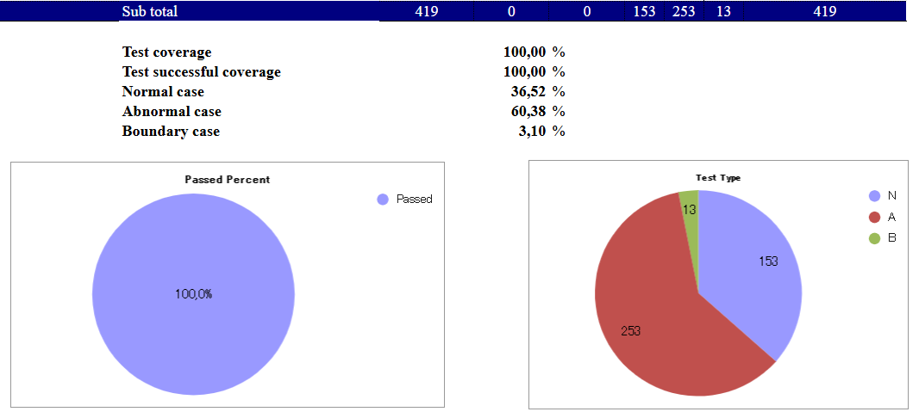
5.1.1.Report of unit testing
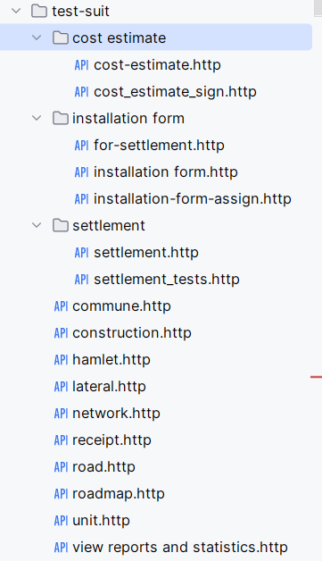
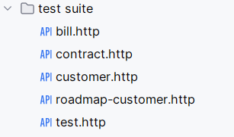

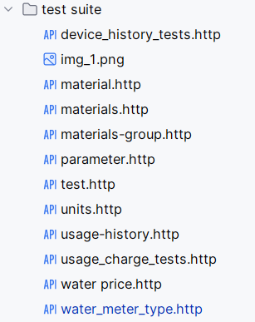
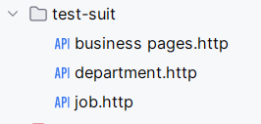

5.2 Integration test
This section presents the results of integration testing, which verifies the interaction between different system modules. The reports below include both white-box testing (via direct API calls using Postman) and black-box testing (based on functional flows from the user’s perspective). Each row in the report reflects a specific integration scenario, with metrics showing the number of test cases executed, passed, or pending. Full coverage and 99,29% pass rate demonstrate that the integrated components work together as intended.
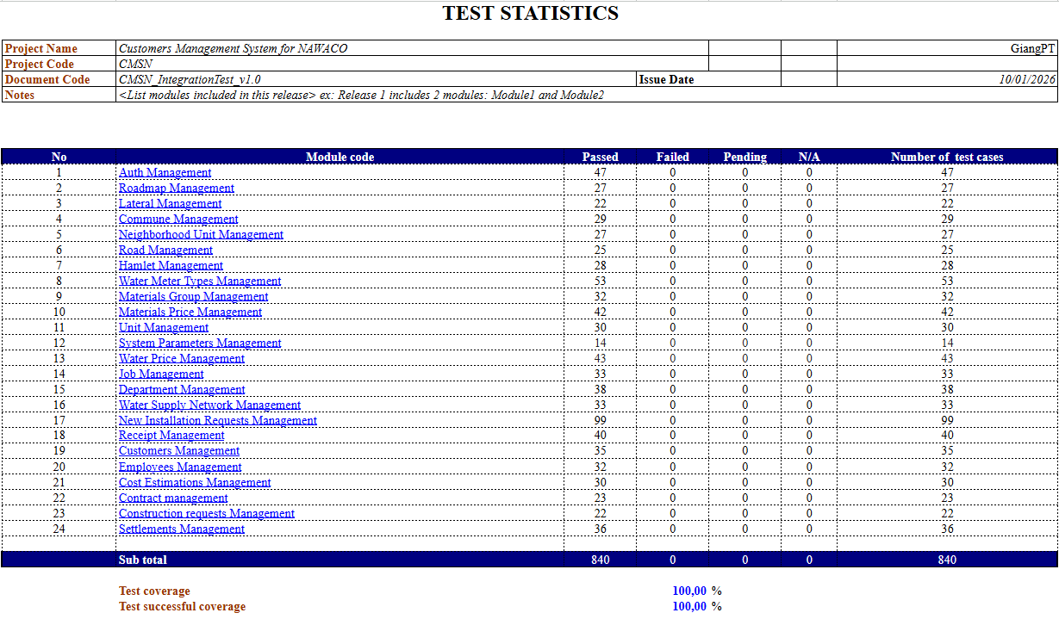
5.2.1:Integration Testing Result

5.3 System test
This section presents the results of integration testing, which verifies the interaction between different system modules. The reports below include both white-box testing (via direct API calls using Postman) and black-box testing (based on functional flows from the user’s perspective). Each row in the report reflects a specific integration scenario, with metrics showing the number of test cases executed, passed, or pending. Full coverage and 100% pass rate demonstrate that the integrated components work together as intended.
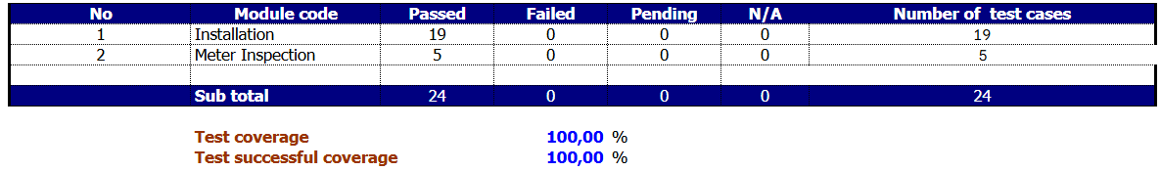
5.3.1: System Testing Result

5.4 User Acceptance Test
This section presents the results of user acceptance testing (UAT), which validates the system against business requirements and usability standards. Each test case corresponds to a specific requirement ID, and covers critical features across project management, schedule views, guest access, and user interface behaviors. All acceptance criteria were met with 100% test coverage, ensuring the product is fully aligned with user expectations and is ready for client sign-off.
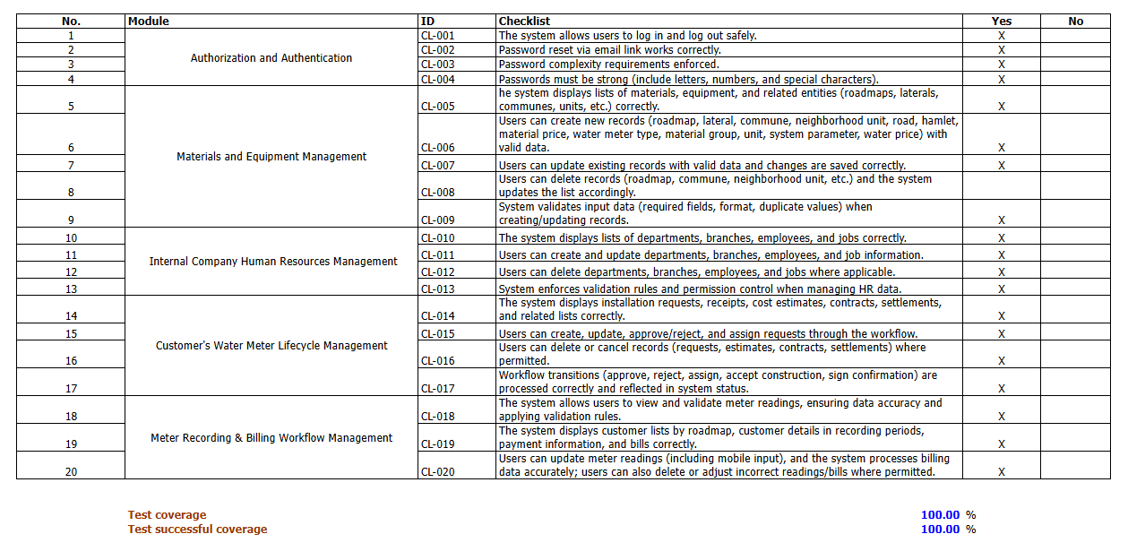
5.4.1: Acceptance Testing Result

