**REPORT**

**MARKET REPORT ANALYSIS**

1. **Analysis Questions Addressed**
   1. **What is the correlation (R2 value) between sales and income?**

R-squared value of 0.76

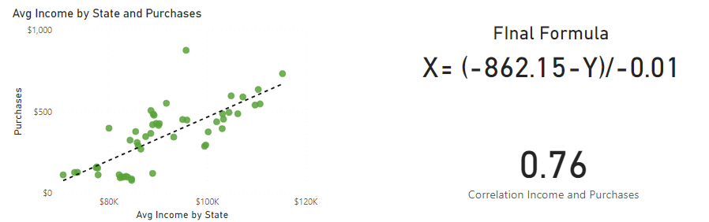

* 1. **What is the correlation (R2 value) between customer ratings and product return rate?**

R-squared value of -0.83

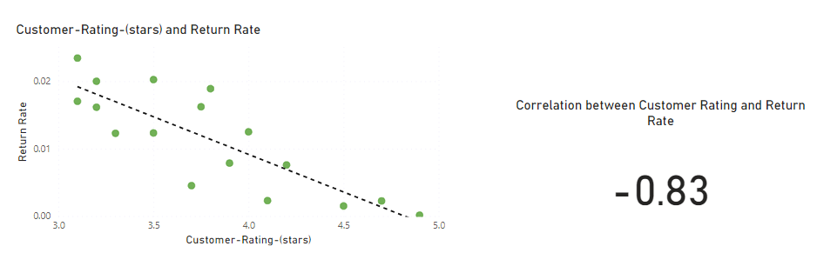

* 1. **What are the linear regression formulas to predict customer income from customer sales?**

The formula for predicting customer incomes based on purchase frequency is:

X = (-862.15- Y)/-0.01



where X represents the customer income and Y represents the purchase frequency.

* 1. **Which customer do you predict has the highest income?**

It is Jon Little with $460.66K

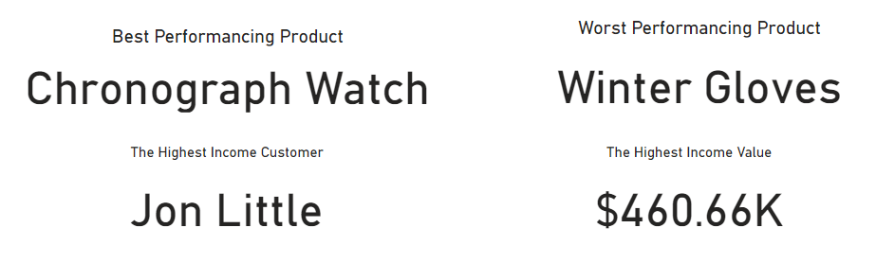

* 1. **Which product will be advertised the most?**

It is Chronograph Watch because it is highest performance product

* 1. **What is the relationship between customer age groups and purchase behavior?**

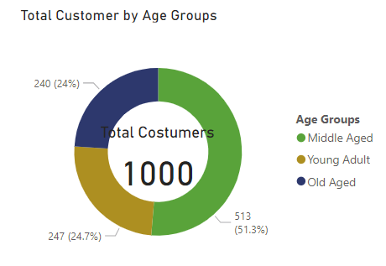

Young adults constitute the largest customer segment (51.3%), followed by middle-aged (24.7%) and old-aged (24%) customers.

* 1. **How does geographic location impact customer purchase power?**

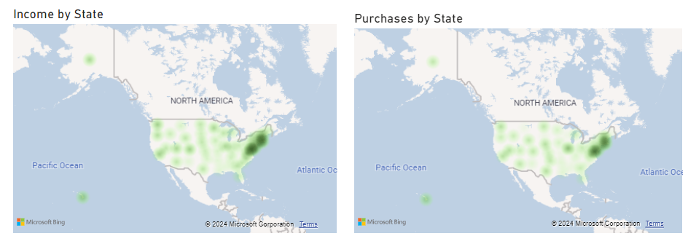

The Northern Eastern region exhibits high purchase power due to higher average incomes among its residents.

* 1. **What role does customer income play in predicting purchase behavior?**

Customer income is a significant predictor of purchase behavior, with a notable linear relationship. The formula for predicting customer incomes based on purchase frequency is:

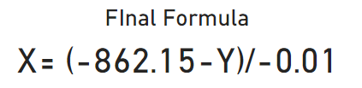

where X represents the customer income and Y represents the purchase frequency.

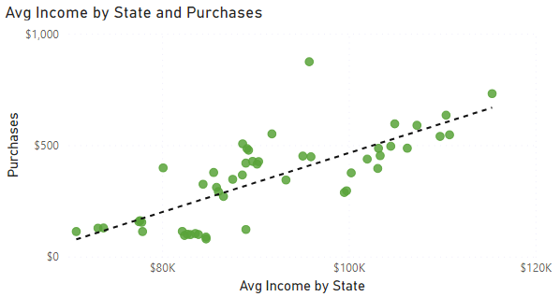

The scatterplot analysis between income levels and purchase frequency shows a strong positive correlation with an R-squared value of 0.76. This indicates that 76% of the variability in purchase frequency can be explained by customer income levels.

* 1. **Which marketing strategies are most effective for different customer segments?**

- Targeted marketing strategies focusing on high-income regions like the Northern Eastern and tailoring promotions for young adults are recommended for maximizing engagement and sales.

1. **Marketing Strategy Recommendations**
   1. **Target High-Income Regions**

- Focus marketing efforts on the Northern Eastern region where high purchase power is prevalent. This can include localized advertising, exclusive promotions, and tailored product offerings to maximize sales.

* 1. **Engage Young Adults**

- Develop marketing campaigns that resonate with young adults, leveraging social media and digital marketing channels. Given their significant representation (51.3%), strategies that appeal to their preferences and lifestyles will likely yield high returns.

* 1. **Segmented Promotions**

- Create segmented promotions for different age groups. For instance, offer tech-savvy products and trendy items for young adults while promoting more practical and lifestyle-enhancing products to middle-aged and old-aged customers.