**FPT ACADEMY INTERNATIONAL**



**FPT – APTECH COMPUTER EDUCATION**

**Music Mp3**

|  |  |  |
| --- | --- | --- |
| **Center Name:** | FPT – Aptech – HCM2 | |
|  | Address:590 Cach Mang Thang Tam,    District 3, Ho Chi Minh City | |
| **Instructor:** | Mr. Hoang Duc Quang | |
| **Class:** | T1.2009.A0 | |
| **Group:** | 0 | |
| **Group members** | Name  Nguyen Duc Dung  Luu Thanh Sang | Student ID  Student1278914 | |
|  | Nguyen Duc Nam | Student1279119 | |
|  | Luu Huy Hoang | Student1279605 | |

**July-2022**

**This is to certify That**

**Mr./Ms.:**

**Nguyen Duc Dung**

**Luu Thanh Sang**

**Nguyen Duc Nam**

**Luu Huy Hoang**

Has successfully designed & developed

Project: Music-MP3

**Submitted by:**

Luu Thanh Sang

**Date of issue:**

**Authorized Signature:**

### TABLE OF CONTENT

REVIEW 1 4

1. ACKNOWLEDGE 5

2. INTRODUCTION 5

3. PROBLEM DEFINITION 6

4. CUSTOMER'S REQUIREMENTS SPECIFICATIONs 6

5. SCOPE OF WORK 8

6. SYSTEM REQUIREMENTS SPECIFICATIONS 9

7. TASK SHEET REVIEW 1 11

## **Review I**

### 1. ACKNOWLEDGE

Our group would like to devote this chapter to express our sincere appreciation to all those who offered us valuable assistance during in carrying out this project.

First,we would like to express our sincere thanks to our dedicated guide Mr.Hoang Duc Quang who gave us advice and supported us to overcome not only technological challenges but also psychological stresses.Without him,our eProject would not have been fully complete and excellent

Thirdly, we would also like to express my gratitude to all the staff members of my center for not only providing me with the opportunity to work with them on this project, but also for their support and encouragement throughout the process.

Finally yet importantly, we wish to say a personal thank you to all our dear classmates and team members who are always willing to support us openly and enthusiastically.

### 2. INTRODUCTION

We are in area where information technology makes listening music and buying music products easier than ever. People can listen everything they want with just one telephone and everything is completed electronically and interactively in real- time. Therefore, we develop a website called Music Mp3 to bring good times and interesting experience to more customers .

Music Mp3 is an online music site where customers can access and listen to the new song , new album,...,buy music products easily without taking too much time.Moreover, It is a place that provide quality songs,products that make users satisfied when listen . And It will provide its users the following features.

For Music Mp3 customer:

* Customer can register account.
* Customer can login and manage their account.
* Customer can search any songs about pop,jazz....
* Customer can search song by name.
* Customer can see songs’ introduction before listen.
* Customer can see MV.
* Customer can see products’ introduction before buying.
* Customer can buy products after adding products to cart.
* Customer can add product to wish list.
* Customer can view cart history.
* Customer can check out with PayPal checkout.
* Customer can view news.

### 3. PROBLEM DEFINITION

After analyzing the project specifications of Music Mp3, to fulfil customers’s requirements properly, we came to conclusion that in order to achieve the best result, we should deal with following queries:

#### From the view point of CUSTOMERS

* A homepage will show the main song, suitable logo, display the logo on all the pages in the site.
* A menu that will include all the functions implemented in the website.
* User can listen songs, view song detail, view MV,buy music products, view cart history and check out after login their account.

#### From the view point of the Administrator

* A login page will grant access Music Mp3 admin.
* Admin can view song.
* Admin can add song.
* Admin can update song.
* Admin can delete song.
* Admin can find song.
* Admin can view products.
* Admin can add products.
* Admin can update products.
* Admin can delete products.
* Admin can find products.
* Admin can view customer account.
* Admin can add customer account.
* Admin can update customer account.
* Admin can delete customer account.
* Admin can find customer account.
* Admin can view news.
* Admin can add news.
* Admin can update news.
* Admin can delete news.
* Admin can find news.

### 4. CUSTOMER'S REQUIREMENTS SPECIFICATIONS

#### CLIENT: MuSIC MP3

#### **BUSINESS/PROJECT OBJECTIVE:**

The project is to design an online website for listening mucic and buying music products

#### **Input to the system:**

**Music Mp3 administrators need to provide:**

* Information required in order creating account to access to the admin system.
* Songs and products music are going to be shown on the website.

**Music Mp3 customers need to provide:**

* Personal information to buy products.

#### **Output from the system:**

**Music Mp3 administrators will be able to:**

* Login/Logout to the admin system.
* Manage view song.
* Manage add song.
* Manage update song.
* Manage delete song.
* Manage find song.
* Manage view products.
* Manage add products.
* Manage update products.
* Manage delete products.
* Manage find customer products.
* Manage view customer account.
* Manage add customer account.
* Manage update customer account.
* Manage delete customer account.
* Manage find customer account.
* Manage view order.
* Manage update order.
* Manage view news.
* Manage add news.
* Manage update news.
* Manage delete news.
* Manage find news.

**Music Mp3 guide will be able to:**

* Register customer account.
* Buy products after add information.
* View products that they have chosen.

**Music Mp3 customer will be able to:**

* Register account.
* Login/Logout to the account.
* Access account (change profile, email, password…)
* Search song they want to listen by name, album, genre...
* Add product to wish list.
* Add product to cart
* Checkout.
* View purchase history.
* View News

**5. SCOPE OF WORK**

The application should perform the following functions:

Login**:**

There are 2 types of account in the application: administrator, Customers accounts.

* Administrator will login as “admin”.
* Customers will login as “user”.

**Buying products:**

* When customer choose a product and the selected product will be added to the cart.
* Customer can buy products at shopping cart after pressing the “Checkout” button and fill in the information.

**Database:**

* The information about song, customers, news will be stored in the database.
* The information from the contact us page.

**6. SYSTEM REQUIREMENTS SPECIFICATIONS**

#### HARDWARE/ SOFTWARE REQUIREMENTS:

##### **Hardware**

###### **Web Server**

|  |  |
| --- | --- |
| **Processor** | Intel Core I5 or higher. |
| **Memory** | 4 GB RAM or greater. |
| **Modem/ADSL** | Internet access is required. |

###### **Client**

|  |  |
| --- | --- |
| **Processor** | Intel Core I3 or higher. |
| **Memory** | 2 GB RAM or greater. |
| **Monitor** | Super VGA (1024x768) or higher resolution. |
| **Modem/ADSL** | Internet access is required. |

##### **Software**

###### **Web Server**

|  |  |
| --- | --- |
| **Operation System** | Window 7 or higher |
| **Browser** | Google Chrome version 35 or Microsoft Edge |
| **Database** | MySQL. |
| **Software** | Internet Information Service |
| Java – Spring Boot framework |

###### **Client**

|  |  |
| --- | --- |
| **Operation System** | Window 7 or higher. |
| **Browser** | Google Chrome version or Microsoft Edge |

##### **Development software**

* Microsoft Windows 10.
* SQl Server.
* Netbeans.
* Google Chrome.

##### **Technology**

* Java - Spring Boot framework.
* JQuery.
* Bootstrap.
* Thymeleaf

HTML/CSS/JS

VERSION CONTROL SYSTEMS: GIT

### 7. TASK SHEET REVIEW 1

|  |  |  |  |  |  |  |  |  |  |
| --- | --- | --- | --- | --- | --- | --- | --- | --- | --- |
| Project Ref. No.: Laptop Computer | |  | Project Name | Activity Plan Prepared By | Date of Preparation of Activity Plan: | | | | |
| Sr./No. | Task |  | Actual Start Date | Actual Days | Team member name | Status |
| 1 | Acknowledgment |  | Music Mp3 | All Team |  |  |  | Finished |
| 2 | Introduction |  |  |  |  |
| 3 | Problem Definition |  |  |  |  |
| 4 | Customer Requirement Specification |  |  |  |  |
| 5 | Scope of Work |  |  |  |  |
| 6 | System Requirement Specification |  |  |  |  |
| 7 | Task Sheet |  |  |  |  |

|  |  |
| --- | --- |
| Date: 14 July 2021 | |
| Signature of Instructor:  **Mr. Hoang Duc Quang** | Signature of Team Leader:  **Luu Thanh Sang** |

# **REVIEW II**

### USE CASES

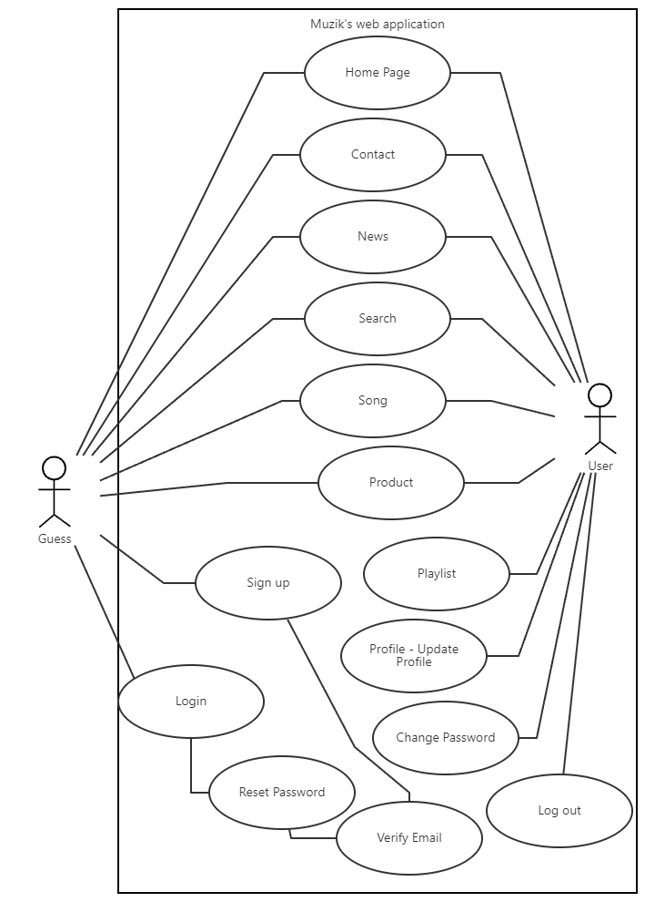

#### HOME PAGE

|  |  |  |
| --- | --- | --- |
| **Use Case ID** | UC-1.1 | |
| **Use Case Name** | Home Page | |
| **Author** | Nam | |
| **Actors** | Guest - User | |
| **Description** | Guest - User view home page | |
| **Trigger** | Guest - User access on homepage | |
| **Pre-conditions** | The guest’s device is already connected to the internet | |
| **Post-conditions** | Success: Show homepage | |
| Fail: No page is shown | |
| **Basic flow** | **Actor’s actions** | **System’s responses** |
| 1. Actor access to homepage | 2. System shows the homepage |

#### SIGN UP

|  |  |  |
| --- | --- | --- |
| **Use Case ID** | UC-1.2 | |
| **Use Case Name** | Sign up | |
| **Author** | Sang | |
| **Actors** | User | |
| **Description** | Guess create an account to login Muzik page | |
| **Trigger** | Guess want to create an account | |
| **Pre-conditions** | The guess’s device is already connected to the internet | |
| **Post-conditions** | Success: A account is created successfully | |
| Fail: Email exist. | |
| **Basic flow** | **Actor’s actions** | **System’s responses** |
| 1. Actor access to Home page and click on Sign up button  3. Actor fill the information and click on “Sign up” button | 2. System shows the create/edit facilities form with following controls:  - “First Name” text field  - “Last Name” text field  - “Email” text field  - “Password” text field  - “Sign up” button  4. System validates the information  5. System save the information to database and show the success message |
| **Exception** | **Actor’s actions** | **System’s responses**  System displays message to actor |
| Actor left “First Name” text field blank | First Name cannot be blank |
| Actor left “Last Name” text field | Last Name cannot be blank |
| Actor left “Email” text field | Email cannot be blank |
| Actor left “Password” text field blank | Password cannot be blank |
| Actor input an existed Email | Email already registered !!! |

#### LOGIN

|  |  |  |
| --- | --- | --- |
| **Use Case ID** | UC-1.3 | |
| **Use Case Name** | Login | |
| **Author** | Sang | |
| **Actors** | Admin - User | |
| **Description** | Admin login to admin system. User login to user system | |
| **Trigger** | Admin want to login to admin system. User login to user system | |
| **Pre-conditions** | The device of admin or user is already connected to the internet | |
| **Post-conditions** | Success: Admin-User login successfully | |
| Fail: Admin- User login fail | |
| **Basic flow** | **Actor’s actions** | **System’s responses** |
| 1. Actor access to admin system  3. Actor fill the information and click on “Login” button | 2. System shows the login form with following controls:  - “Username” text field  - “Password” text field  - “Login” button  -“Sign up” link  -“[Forgot your password?](http://localhost:8080/resetPassword)” link  4. System validates the information  5. System redirect to admin system |
| **Exception** | **Actor’s actions** | **System’s responses**  System displays message to actor |
| Actor left “Username” text field blank | Username cannot be blank |
| Actor left “Password” text field blank | Password cannot be blank |
| Actor input an incorrect login details | Username or Password is incorrect |
| Account is not active | Account is not active |

#### LOG OUT

|  |  |  |
| --- | --- | --- |
| **Use Case ID** | UC-1.4 | |
| **Use Case Name** | Log out | |
| **Author** | Sang | |
| **Actors** | Admin - User | |
| **Description** | Admin log out of admin system. User log out of admin system | |
| **Trigger** | Admin want to log out of admin system. User want to log out of admin system | |
| **Pre-conditions** | The admin or User’s device is already connected to the internet  Admin has already log in to admin system | |
| **Post-conditions** | Success: Log out successfully | |
| Fail: Log out fail | |
| **Basic flow** | **Actor’s actions** | **System’s responses** |
| 1. Actor access to Log out link | 2. System redirect to login page of admin system. |

#### PROFILE - UPDATE PROFILE

|  |  |  |
| --- | --- | --- |
| **Use Case ID** | UC-1.5 | |
| **Use Case Name** | PROFILE - Update Account | |
| **Author** | Sang | |
| **Actors** | User | |
| **Description** | Show User’s profile and update profile | |
| **Trigger** | User want to update profile | |
| **Pre-conditions** | The user’s device is already connected to the internet  User has already log in to user system | |
| **Post-conditions** | Success: User’s account is update successfully | |
| Fail: User’s account is update fail | |
| **Basic flow** | **Actor’s actions** | **System’s responses** |
| 1. Actor access to Muzik’s web app after login and click on User’s image then click My Profile, and click tab Edit Profile  3. Actor fill the information and click on “Submit” button | 2. System shows the create/edit facilities form with following controls:  - “Image” file field  - “First Name” text field  - “Last Name” text field  - “Username” text field read only  - “Submit” button  - “Cancel” button  4. System validates the information  5. System save the information to database and show the success message |
| **Exception** | **Actor’s actions** | **System’s responses**  System displays message to actor |
| Actor left “First Name” text field blank | Full Name cannot be blank |
| Actor left “Last Name” text field | Email cannot be blank |

#### PROFILE - CHANGE PASSWORD

|  |  |  |
| --- | --- | --- |
| **Use Case ID** | UC-1.6 | |
| **Use Case Name** | PROFILE - Update Account | |
| **Author** | Sang | |
| **Actors** | User | |
| **Description** | Show User’s profile and change password | |
| **Trigger** | User want to change password | |
| **Pre-conditions** | The user’s device is already connected to the internet  User has already log in to user system | |
| **Post-conditions** | Success: User’s account is change password successfully | |
| Fail: User’s account is change password fail | |
| **Basic flow** | **Actor’s actions** | **System’s responses** |
| 1. Actor access to Muzik’s web app after login and click on User’s image then click My Profile, and click tab Change Password  3. Actor fill the information and click on “Submit” button | 2. System shows the create/edit facilities form with following controls:  - “Current Password” text field  - “New Password” text field  - “Submit” button  - “Cancel” button  4. System validates the information  5. System save the information to database and show the success message |
| **Exception** | **Actor’s actions** | **System’s responses**  System displays message to actor |
| Actor left “Current Password” text field blank | Current Password cannot be blank |
| Actor left “New Password” text field | New Password cannot be blank |

#### RESET PASSWORD

|  |  |  |
| --- | --- | --- |
| **Use Case ID** | UC-1.7 | |
| **Use Case Name** | PROFILE - Update Account | |
| **Author** | Sang | |
| **Actors** | User | |
| **Description** | User forgot password and reset password | |
| **Trigger** | User forgot password and want to login | |
| **Pre-conditions** | The user’s device is already connected to the internet  User has already log in to user system | |
| **Post-conditions** | Success: User’s account receive an verify email from system | |
| Fail: User’s account is reset password fail | |
| **Basic flow** | **Actor’s actions** | **System’s responses** |
| 1. Actor access to login page and click on “Forgot your password” link  3. Actor fill the information and click on “Reset password” button | 2. System shows the create/edit facilities form with following controls:  - “Email adress” text field  - “Reset password” button  4. System validates the information  5. System save the information to database and show the success message |
| **Exception** | **Actor’s actions** | **System’s responses**  System displays message to actor |
| Actor left “Email adress” text field blank | Email adress cannot be blank |
| Actor input an Email doesn’t Exist | Email address has not been used yet |

#### VERIFY EMAIL

|  |  |  |
| --- | --- | --- |
| **Use Case ID** | UC-1.7 | |
| **Use Case Name** | Verify Email | |
| **Author** | Sang | |
| **Actors** | Guess | |
| **Description** | Guess verify email to create new account or reset password | |
| **Trigger** | Guess go to email verify email to create new account or reset password | |
| **Pre-conditions** | The guess’s device is already connected to the internet | |
| **Post-conditions** | Success: User go to change Password success | |
| Fail: User’s verify email expired | |
| **Basic flow** | **Actor’s actions** | **System’s responses** |
| 1. Actor access to his/her email and click link verify email  3. Actor fill the information and click on “Verify” link | 2. System shows the create/edit facilities form with following controls:  - “Verify” link  4. System validates the information  5. System save the information to database and show the success message |
| **Exception** | **Actor’s actions** | **System’s responses**  System displays message to actor |
| Actor let verify email expired | Go to page message error |