|  |  |
| --- | --- |
|  | **FPT ACADEMY INTERNATIONAL**  **FPT – APTECH COMPUTER EDUCATION** |

**Centre Name: ACE-HCMC-2-FPT.**

**Address: 590 Cach Mang Thang 8, District 3, Ho Chi Minh City, Viet Nam.**

**e-Store**

|  |  |  |
| --- | --- | --- |
| **Supervisor:** | MR. HOANG DUC QUANG | |
| **Semester:** | 4 | |
| **Batch No:** | T1.2009.A0 | |
| **Group No:** | 4 | |
| **Order:** | **Full name** | **Roll No.** |
| 1. | LAY CHAN GIANG | Student1279106 |
| 2. | TRAN LE HUU AN | Student1278916 |
| 3. | HOANG VAN THAO | Student1279126 |
| 4. | VU QUY THIEN ANH | Student1279127 |

JULY 2022

This is to certify that

Mr. Lay Chan Giang

Mr. Tran Le Huu An

Mr. Hoang Van Thao

Mr. Vu Quy Thien Anh



have successfully designed and

developed 

Submitted by:

Date of Issue: ________



**REVIEW I**

**Acknowledgment**

We would like to acknowledge all those who have given support and help us make the project a success.

We wish to express our deep gratitude to all teachers who have been devoting their lives to teach us how to stand-alone and walk ahead.

We are grateful to our families who take care and encourage us even though we are successful or failed, also to our friends who are always care of us. They never leave us alone and always look forward to us when we are on any road of the life.

We are much thankful to the entire staff and chairpersons at the Head Office of Aptech Worldwide, Aptech – Vietnam, and FPT – Aptech Center who have been organizing and looking after our studying course.

There are no words to show our appreciation for teachers of FPT Aptech Centre who have been organizing and looking after us during our studying course to finish this project. Our special thanks Mr Ngo Phuoc Nguyen who works day by day to teach and guide us, e-Project Team at the Head Office who instruct and help us.

Finally, we would like to offer many thanks to all our schoolfellows for their valuable suggestions.

We would like to thank sincerely!

**Problem Definition**

1. **Introduction**

With the great development of technology today, the need to use a computer laptop for work as well as entertainment is gradually becoming necessary. Coming to TDShop, all your technology needs will be solved, we provide all kinds of laptops, computers, components or computer components such as mice, keyboards, hard drives.... Products are guaranteed to be genuine products that have been tested by experts and will not disappoint customers

1. **Project Requirement**
2. **Project Designing**

**HOME PAGE:** This will be the display of TD Shop products, in addition, users can search for products according to personal needs, view promotions as well as other features of the web. There should be separate section for the Admin Login (where the details of website can be modified and updated).

**Product Page:** When the user clicks on his favorite product, it will display detailed information of the product (configuration, price, other models - designs).

**My Cart: H**ere the products that users want to buy will be aggregated and let customers know the total amount and quantity of the order.

**Login Page:** customers log in their own account to access the website

**Register page:** Here customers can register their own account and proceed to purchase products on TD Shop

**ADMIN LOGIN:** where admin login to update website's data**Hardware / Software Requirements**

1. **Server Requirement**

* Hardware

|  |  |
| --- | --- |
| **Component** | **Requirement** |
| **CPU** | Processor type:  Pentium IV-compatible processor or faster  Processor speed:  Recommended: 2.0 GHz or faster |
| **OS** | Microsoft Windows Server 2012 with IIS |
| **Memory (RAM)** | RAM:  Minimum: 512 MB  Recommended: 2 GB or more |
| **Hard Drive** | Free space:  Minimum: 200 MB  Recommended: 50 GB or more  Maximum: Operating system maximum |

* Software

|  |  |
| --- | --- |
| **Component** | **Requirement** |
| **Apache Netbeans IDE 12.4** | JDK 11 or higher |
| **RDBMS** | Microsoft SQL Server 2019 |

1. Client Requirement

* Hardware

|  |  |
| --- | --- |
| **Component** | **Requirement** |
| **CPU** | Processor type:  Pentium III-compatible processor or faster  Processor speed:  Recommended: 1.0 GHz or faster |
| **OS** | All OS (Window, Linux, Android, Mac OS …) |
| **Memory (RAM)** | RAM:  Minimum: 512 MB  Recommended: 1 GB or more  Maximum: Operating system maximum |
| **Hard Drive** | Free space:  Minimum: 10 MB |

* Software

|  |  |
| --- | --- |
| **Component** | **Requirement** |
| **Web Browser** | Chrome, Opera (up to date) |

* Technology

|  |  |
| --- | --- |
| **Frontend** | **String Boot, HTML, CSS** |
| **Backend** | String boot, HTML, CSS, SQL Server |

**Task Sheet Review I**

|  |  |  |  |  |  |
| --- | --- | --- | --- | --- | --- |
| Project Ref. No: 3 | Project Title:  Online Floral Delivery System | Date of Preparation of Activity Plan | | | |
| No. | Task | Actual Start Date | Actual Days | Team Member Names | Status |
| 01 | Acknowledgment | July / 2022 | 1 | All Members | Completed |
| 02 | Problem Definition | All Members | Completed |
| 03 | Customer Requirement | All Members | Completed |
| 04 | Hardware/Software | All Members | Completed |
| 05 | Task sheet | All Members | Completed |

|  |  |  |
| --- | --- | --- |
|  | Prepare By: Group 4 | Approved By: Faculty |
| Date: July , 2022 | Team Leader  Lay Chan Giang | Mr. Hoang Duc Quang |

**REVIEW 2**

1. Use case Diagram
2. Admin

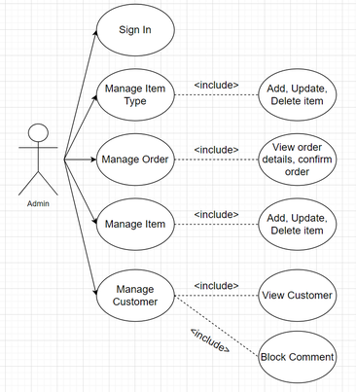

* 1. Login

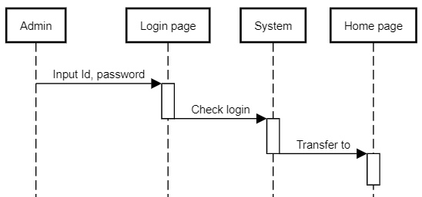

|  |  |  |
| --- | --- | --- |
| **Author** | Lay Chan Giang | |
| **Use Case** | Login | |
| **Actor** | Admin | |
| **Description** | Admin log in after the system checks, it will let you in. | |
|  | **Action** | **System responses** |
| **Basic flow** | 1) Input ID, password | Admin enters ID, password. |
| 2) Check if successful | The system will check whether the ID and password are correct. |
| 3) Transfer to | If everything is correct, the System will transfer to Admin Home Page. |
| **Exception** | Admin ID field blank  Admin ID valid  Password field blank  Password valid  Check correct | Display error message  “ID can not be blank”  “ID must be valid”  “Password can not be blank”  “Password must be valid”  “Incorrcet ID or Password” |

* 1. Manage item

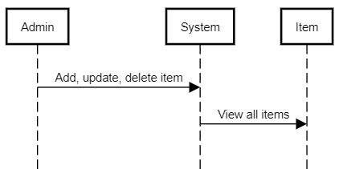

|  |  |  |
| --- | --- | --- |
| **Author** | Lay Chan Giang | |
| **Use Case** | Manage item | |
| **Actor** | Admin | |
| **Description** | Admin manages all items by adding, editing, deleting and viewing | |
|  | **Action** | **System responses** |
| **Basic flow** | 1) Add item | Admin adds items |
| 2) Edit item | Admin edits items |
| 3) Delete item | Admin delete items |
| 4) View all items | The system will show all items to admin |

* 1. Manage order

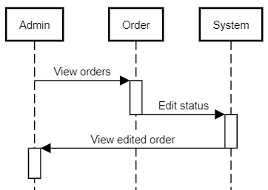

|  |  |  |
| --- | --- | --- |
| **Author** | Lay Chan Giang | |
| **Use Case** | Manage order | |
| **Actor** | Admin | |
| **Description** | Admin edits the status in the order then the system will update the status. | |
|  | **Action** | **System responses** |
| **Basic flow** | 1) View order details | Admin views order details |
| 2) Edit status | The system will update status. |
| 3) View edited order | If the system update is successful, itt will show back to admin. |

* 1. Add, Update, Delete item

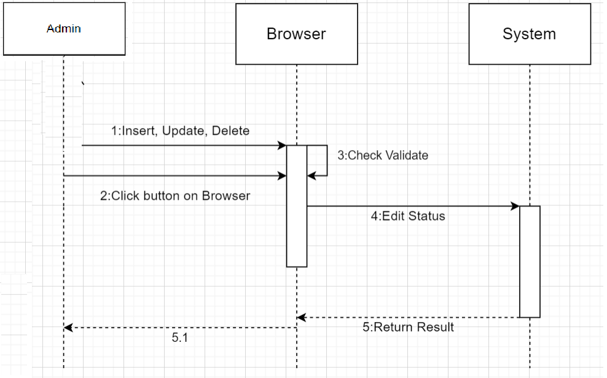

|  |  |  |
| --- | --- | --- |
| **Author** | Lay Chan Giang | |
| **Use Case** | Add, Update, Delete item | |
| **Actor** | Admin | |
| **Description** | Admin add, update, delete product then system will add, update, delete the product list againl . | |
|  | **Action** | **System responses** |
| **Basic flow** | 1)add, update, delete product | Admin create, edit, delete product |
| 2) System perform | The system will perform the specified operations. |
| 3) View edited Product | If the system update is successful, it will show back to admin. |

* 1. Manage Customer

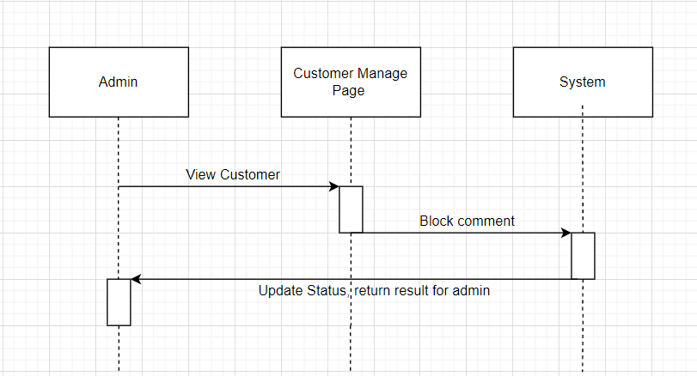

|  |  |  |
| --- | --- | --- |
| **Author** | Lay Chan Giang | |
| **Use Case** | Manage Customer | |
| **Actor** | Admin | |
| **Description** | Admin view the list of customers and block comments from customers who violate the terms | |
|  | **Action** | **System responses** |
| **Basic flow** | 1) View Customer details | Admin views Customer details |
| 2)Block Comment | Admin blocks comments from customers |
| 3) View result | The system will not allow locked customers to comment |

1. Customer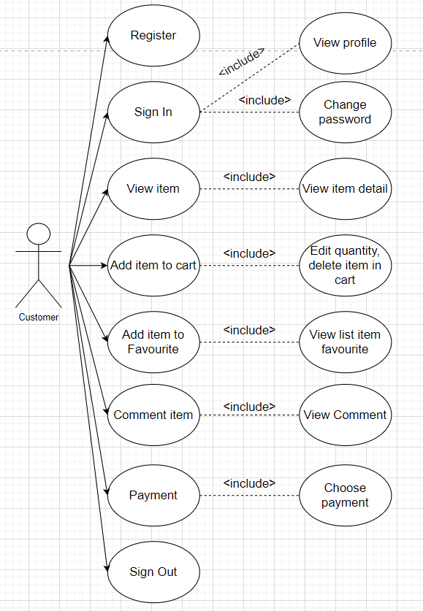
   1. Login

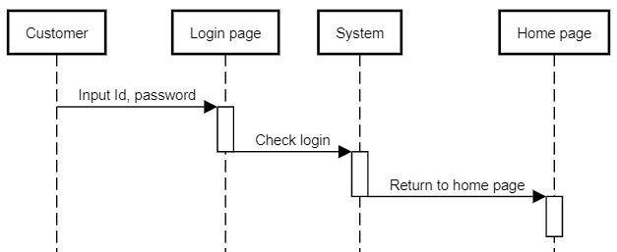

|  |  |  |
| --- | --- | --- |
| **Author** | Lay Chan Giang | |
| **Use Case** | Login | |
| **Actor** | Customer | |
| **Description** | Customer log in after the system checks. | |
|  | **Action** | **System responses** |
| **Basic flow** | 1) Input ID, password | Customer enters ID, password. |
| 2) Check if successful | The system will check whether the ID and password are correct. |
| 3) Return to homepage | Return to Home page if successful |
| **Exception** | Customer ID field blank  Customer ID valid  Password field blank  Password valid  Check correct | Display error message  “ID can not be blank”  “ID must be valid”  “Password can not be blank”  “Password must be valid”  “Incorrect ID or Password” |

* 1. Register

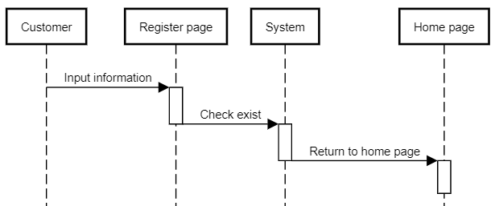

|  |  |  |
| --- | --- | --- |
| **Author** | Lay Chan Giang | |
| **Use Case** | Register | |
| **Actor** | Customer | |
| **Description** | Customer registers a new account by filling in all information. | |
|  | **Action** | **System responses** |
| **Basic flow** | 1) Input information | Customer input all information. |
| 2) Check exist | The system will check whether the account existed |
| 3) Return to login | Return to login if successful |
| **Exception** | Customer ID field blank  Customer ID valid  Password field blank  Password valid  Reenter Password | Display error message  “ID can not be blank”  “ID must be valid”  “Password can not be blank”  “Password must be valid”  Reenter password must be the same as password |

* 1. Add item in a cart

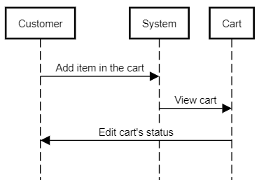

|  |  |  |
| --- | --- | --- |
| **Author** | Lay Chan Giang | |
| **Use Case** | Add item in a cart | |
| **Actor** | Customer | |
| **Description** | Customer chooses products to add in the cart | |
|  | **Action** | **System responses** |
| **Basic flow** | 1) Add item in a cart | Customer adds item in a cart |
| 2) View cart | Customer views all items in a cart |
| 3) Edit cart’s status | Customer edits quantity, removes item in the cart |

* 1. Payment

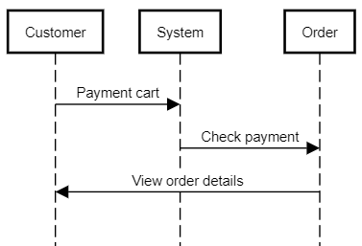

|  |  |  |
| --- | --- | --- |
| **Author** | Lay Chan Giang | |
| **Use Case** | Payment | |
| **Actor** | Customer | |
| **Description** | Customer payment the cart. | |
|  | **Action** | **System responses** |
| **Basic flow** | 1) Payment cart | Customer after placing order will payment a cart |
| 2) Check payment | Customer pays and check payment. |
| 3) View order details | After the customer confirm the payment, customer can view order details |

* 1. View Item

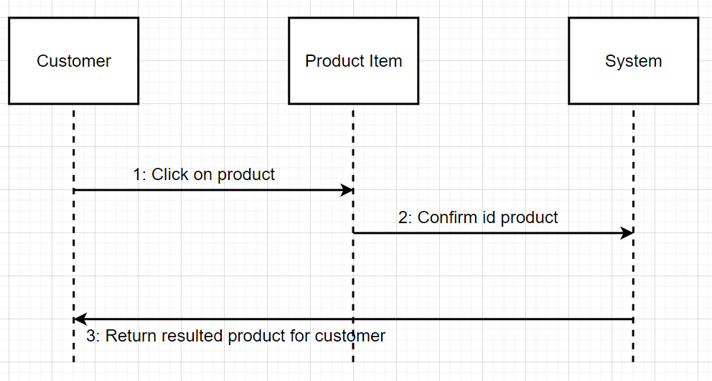

|  |  |  |
| --- | --- | --- |
| **Author** | Lay Chan Giang | |
| **Use Case** | View Item | |
| **Actor** | Customer | |
| **Description** | Customer payment the cart. | |
|  | **Action** | **System responses** |
| **Basic flow** | 1) Click Product | Customers click on the product they want to see. |
| 2) Confirm id product | The system will confirm the id of the product the user needs. |
| 3) Return resulted | The system returns the list of products details that the user needs. |

* 1. Add to cart

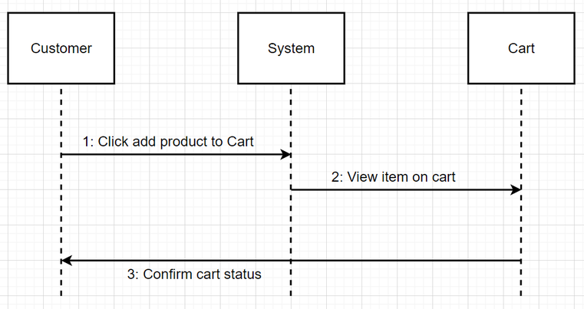

|  |  |  |
| --- | --- | --- |
| **Author** | Lay Chan Giang | |
| **Use Case** | Add to cart | |
| **Actor** | Customer | |
| **Description** | Customer payment the cart. | |
|  | **Action** | **System responses** |
| **Basic flow** | 1) Click add Product to cart | Customer adds the product he wants to buy to the cart. |
| 2) View Cart | Customers see the list of products added to the cart. |
| 3)Confirm cart | . |

1. Data Flow Diagram
2. DFD Level 0

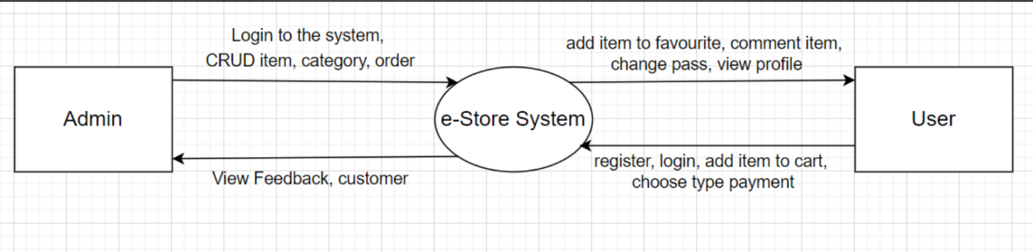

1. DFD Level 1
   1. User

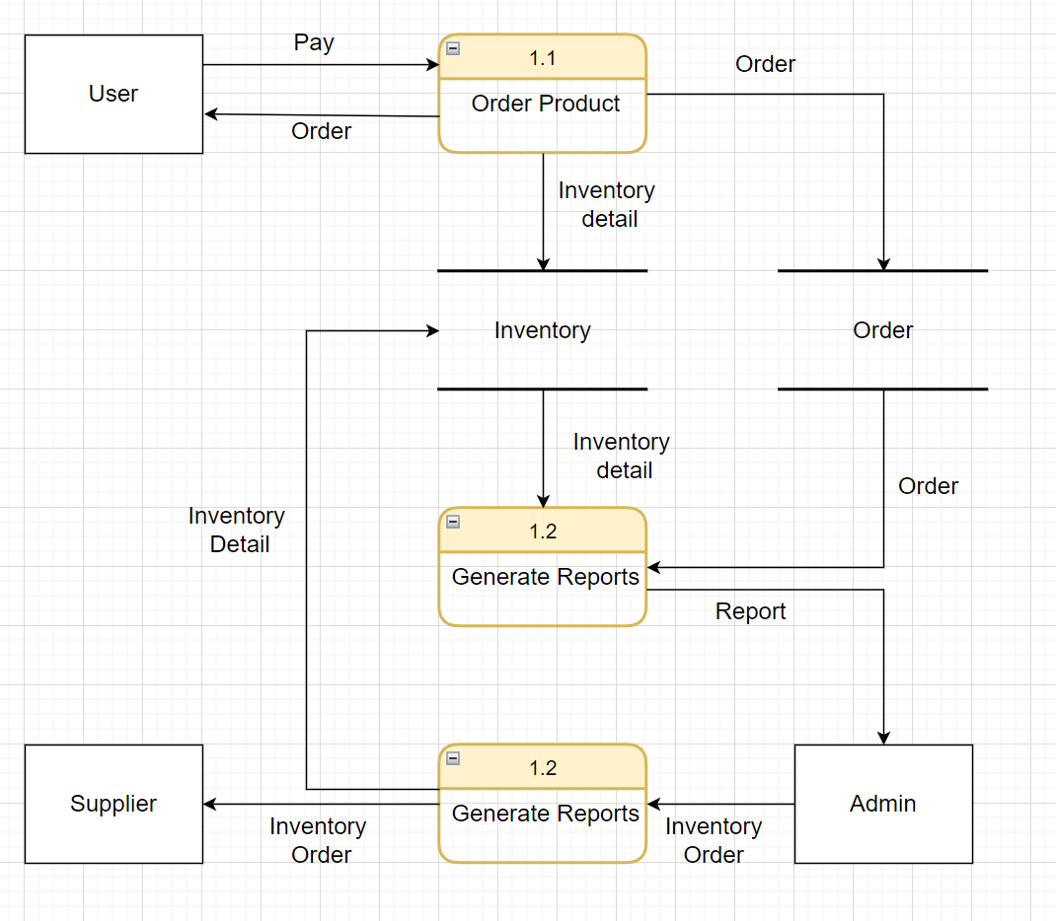

* 1. Admin

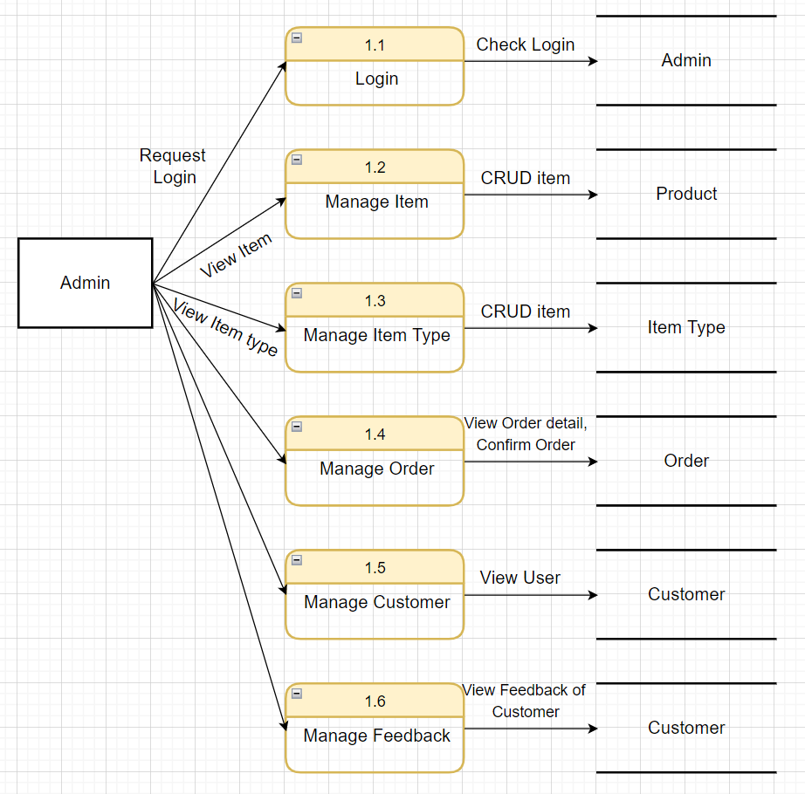

**Task Sheet Review II**

|  |  |  |  |  |  |
| --- | --- | --- | --- | --- | --- |
| Project Ref. No: 3 | Project Title:  Online Floral Delivery System | Date of Preparation of Activity Plan | | | |
| No. | Task | Actual Start Date | Actual Days | Team Member Names | Status |
| 01 | Use case | July / 2022 | 1 | Lay Chan Giang | Completed |
| 02 | Data Flow Diagram | Hoang Van Thao | Completed |
| 03 | Database Diagram | Tran Le Huu An | Completed |
| 04 | Entyti Relationship Diagram | Vu Quy Thien Anh | Completed |
| 05 | Task sheet | All Members | Completed |

|  |  |  |
| --- | --- | --- |
|  | Prepare By: Group 4 | Approved By: Faculty |
| Date: July , 2022 | Team Leader  Lay Chan Giang | Mr. Hoang Duc Quang |