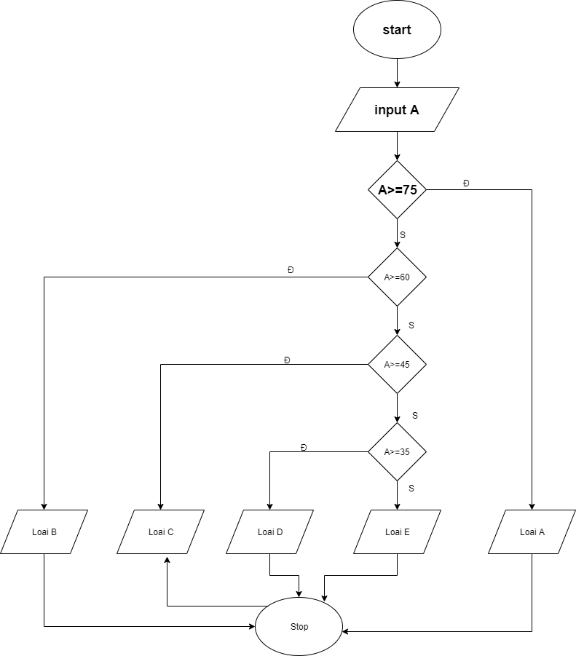

Begin

Input A

If A>=75

Display Loai A

Else If A>=60

Display Loai B

Else If A>=45

Display loai C

Else If A>=35

Else Display Loai D

End if

End