**Practical 1**

1/

2/

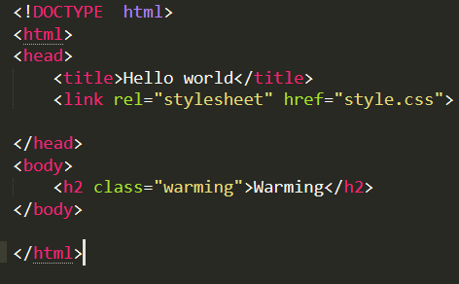

3/

4/

Two empty HTML elements

<br>

<ht>

Two non-empty elements

<p>

<a>

5/

| **Sr. No.** | **Key** | **JPEG** | **GIF** |
| --- | --- | --- | --- |
| 1 | Stands for | JPEG stands for Joint Photographic Experts Group. | GIF stands for Graphical Interchange Format. |
| 2 | Compression Algorithm type | JPEG uses lossy compression algorithm. | GIF uses lossless compression algorithm. |
| 3 | Image Quality | JPEG image may lose some image data causing quality loss. | GIF image is of high quality. |
| 4 | Colors | JPEG image supports 16 million colors. | GIF image supports only 256 colors. |

6/

* Identify the task to be analyzed.
* Break this high-level task down into 4 to 8 subtasks. The subtask should be specified in terms of objectives and, between them, should cover the whole area of interest.
* Draw a layered task diagram of each subtasks ensuring that it is complete
* Produce a written account as well as the decomposition diagram.
* Present the analysis to someone else who has not been involved in the decomposition but who knows the tasks well enough to check for consistency

7/

8/

9/

a/

b/

c/

11/

The most important thing is defining your purpose for the site and the target audience.

**Journal form**

This week, I studied HTML and CSS basic. In addition, I grasp some theories from the teachers’ explanation such as the different between JPEG and GIF image and the difference between the <div> and <span> elements. I tried to code to get familiar with some HTML on the sublime text 3 editor and often get some errors syntax, and then fix it by google research. I repeat so many times until I remember some that syntax I learn.