(Các bạn chỉnh đúng format của trang báo cáo mẫu nhé)



**Table of Contents**

1. Problem Definition 3

1.1 Overview 3

i. Introduction 3

2. Flowchart 5

2.1 Register 5

2.2 Search Products 6

2.3 Purchase Products 7

3. UI\UX 8

3.1 Homepage 9

3.2 Product 10

3.3 Contact 11

3.4 About Us 12

3.5 Blog 13

3.6 Shopping Cart 14

3.7 Checkout 15

3.8 Register 16

# Problem Definition

## Overview

### Introduction

The necessity for a plant nursery Website stems from several factors related  
to the growing interest in gardening, increased demand for plants, and the  
convenience of online shopping. Here are some reasons why such a Website  
would be required:  
1. Increased Interest in Gardening:  
There has been a significant rise in the popularity of gardening and plant  
ownership, driven by various factors such as desire for a green  
environment, stress relief, and aesthetic appeal. As more people engage in  
gardening as a hobby or lifestyle, the necessity for easily accessible and  
diverse plant options becomes crucial.  
2. Wide Variety of Plants:  
Plant nurseries offer a wide variety of plant species, each with unique  
characteristics, care requirements, and purposes. A dedicated Website  
allows the nursery to showcase their extensive collection and provide  
detailed information to potential customers, enabling them to make  
informed decisions based on their specific requirements and preferences.  
3. Convenience and Accessibility:  
An e-commerce as well as informational Website provides convenience by  
allowing customers to browse and purchase plants from the comfort of  
their homes. Users can access the Website at any time, eliminating the  
constraints of physical store hours and geographical limitations. This  
accessibility increases the reach of the nursery, attracting customers from  
different locations.  
4. Plant Information:  
A plant nursery e-commerce Website serves as an informational platform  
for customers. Providing detailed information about each plant species,  
including origin, care requirements, and watering cycle, helps customers  
understand the plants they are interested in.  
This information promotes responsible gardening practices and ensures  
that customers select plants suitable for their environment and abilities.

5. Search, Sorting, and Filtering Capabilities:  
With a wide range of plant options, users may have specific preferences  
such as indoor plants, succulents, or flowering shrubs. The Website's  
search, sorting, and filtering features allow users to find plants that match  
their criteria efficiently. This saves time and enhances the overall user  
experience by narrowing down options based on their preferences.  
6. Customer Engagement and Loyalty:  
A well-designed Website can foster customer engagement and loyalty by  
offering features such as wishlists, personalized recommendations, and  
informative blog content related to gardening and plant care. This  
engagement strengthens the relationship between the nursery and its  
customers, increasing the likelihood of repeat purchases and referrals

### Implementation Environment

* HTML5/ CSS/ JavaScript
* Boostrap / Jquery/ Boostrap Hover
* Google Chrome/ Mozilla FireFox/ Internet Explorer
* Ajax
* Local Storage
* Json

## Flowchart

## Register

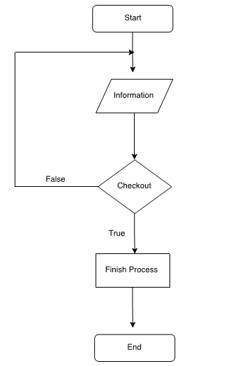

## 

## Search Products

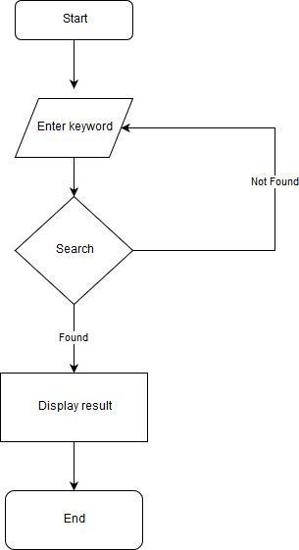

## Purchase Products

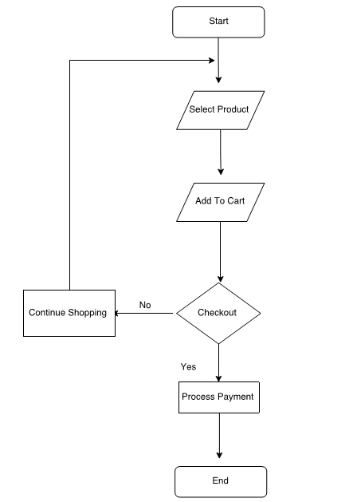

# UI\UX

## HomepageC:\Users\Admin\Downloads\home.png

## Product

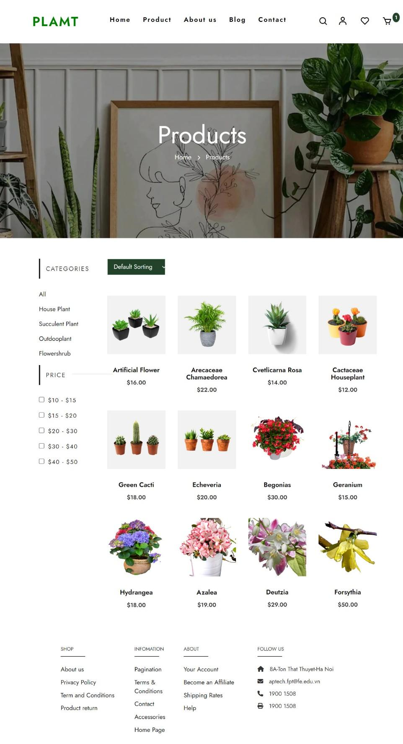

## Contact

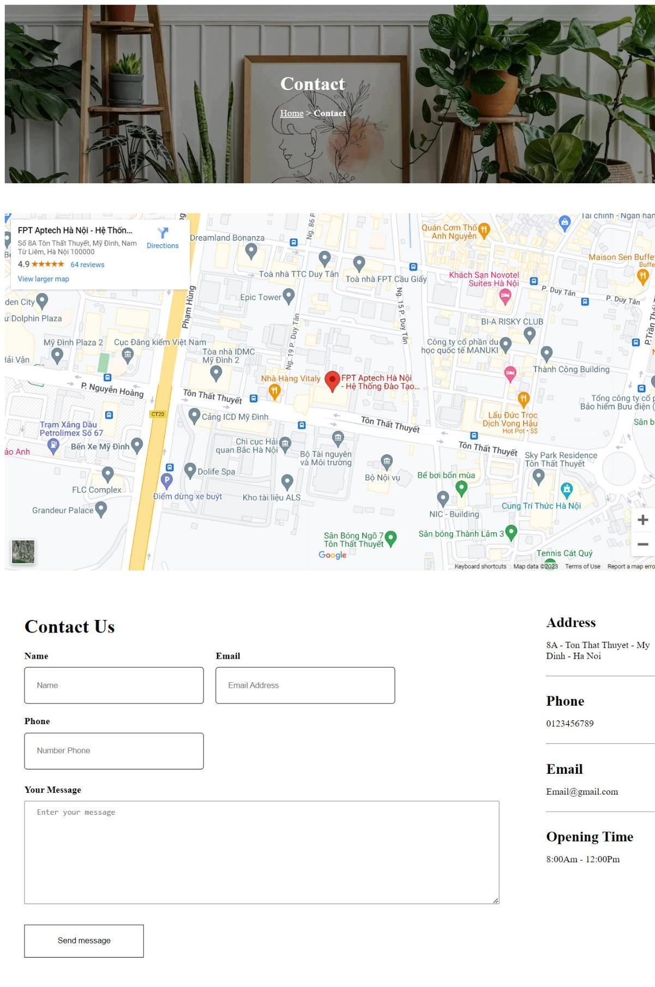

## About Us

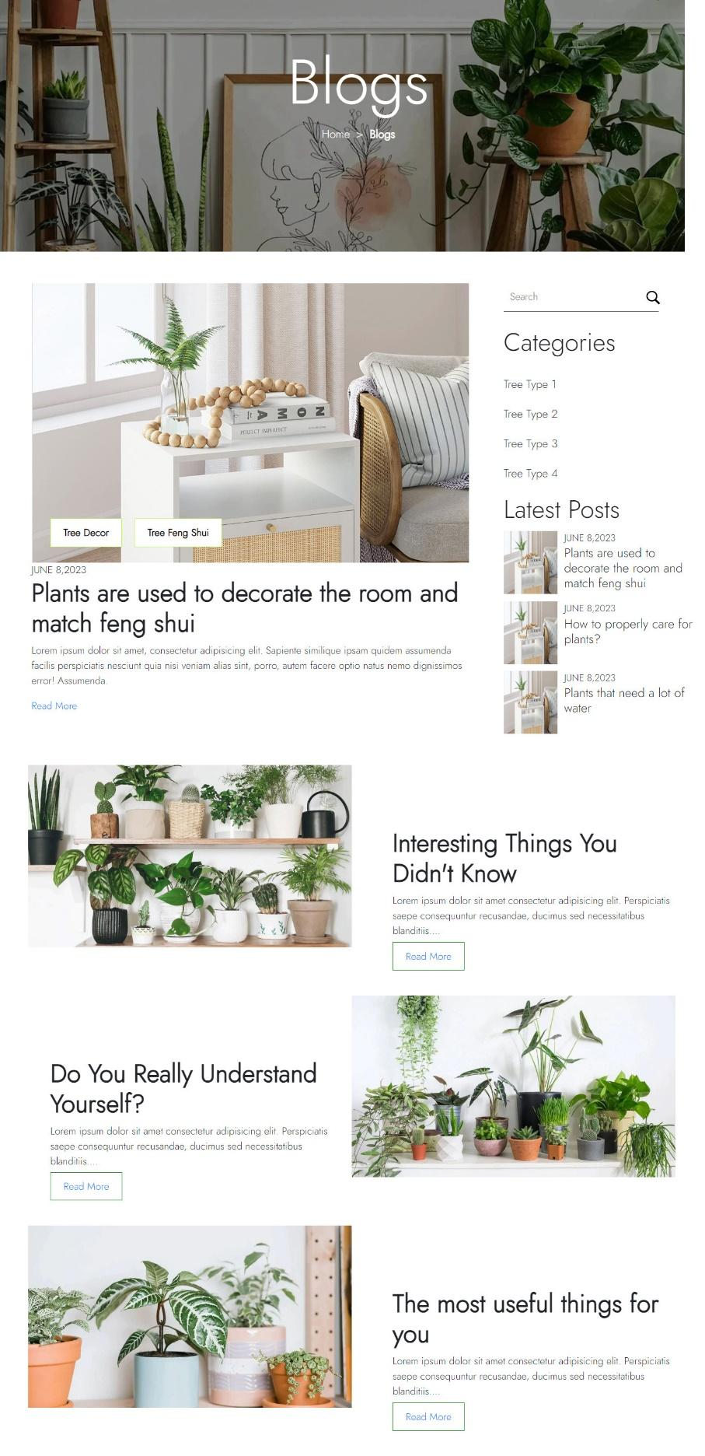

## Blog

## Shopping Cart

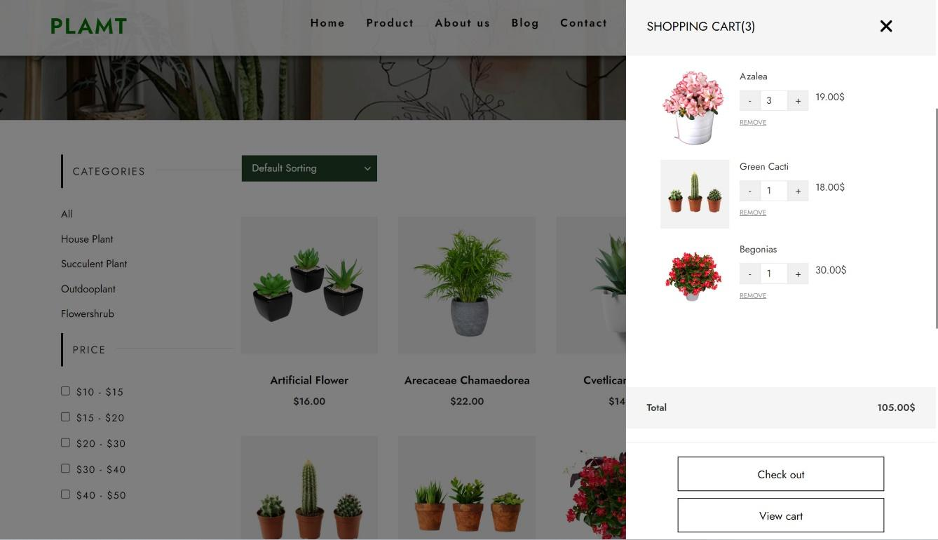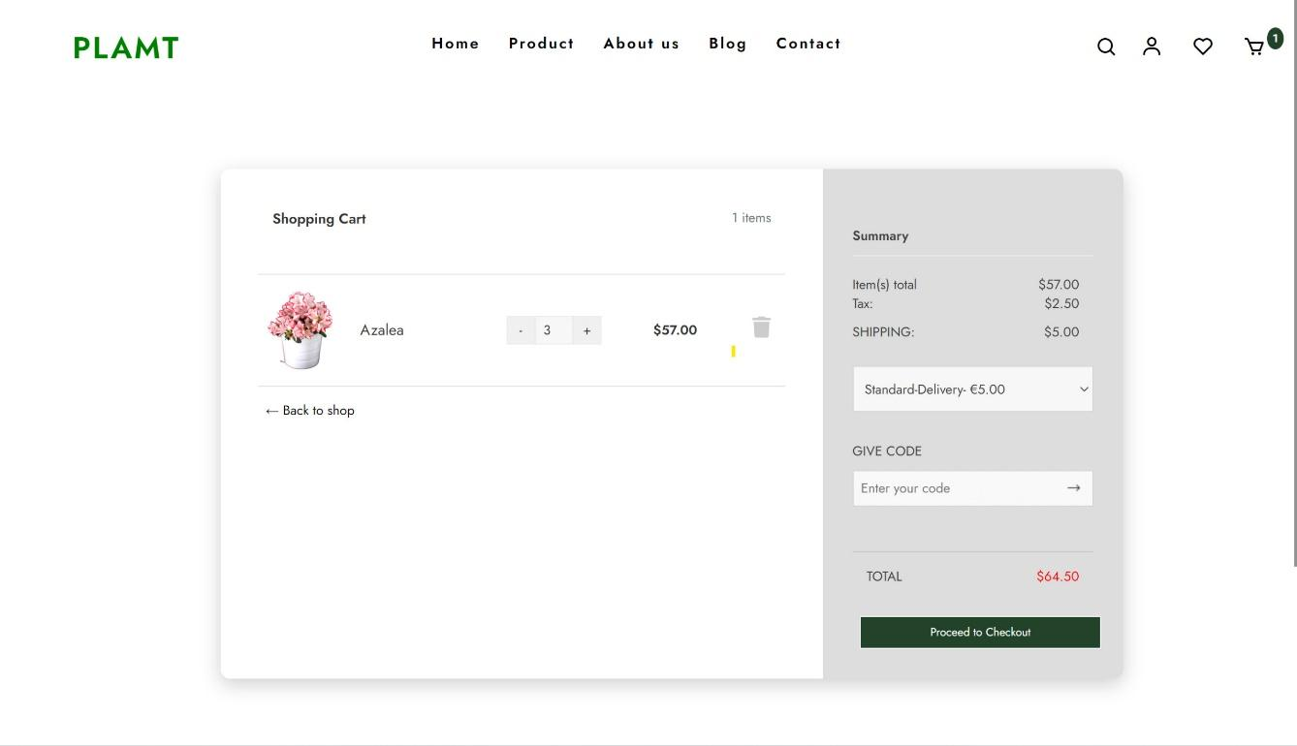

## Checkout

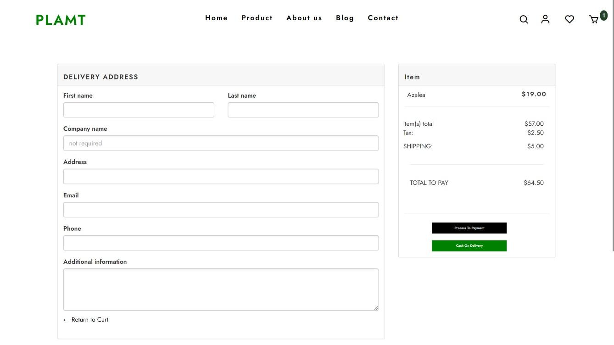

## Register

# https://b-f67-zpg-r.zdn.vn/3154198114807196210/8384751c184cca12935d.jpg