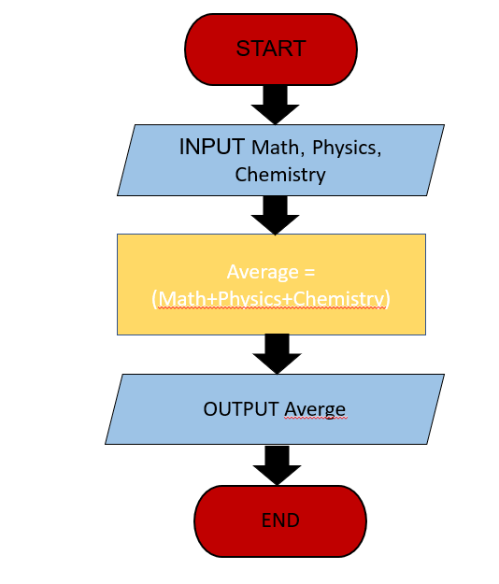Begin   
 INPUT Math,Physics,Chemistry  
 Average=( Math+Physics+Chemistry)/3  
 OUTPUT Averge  
end.