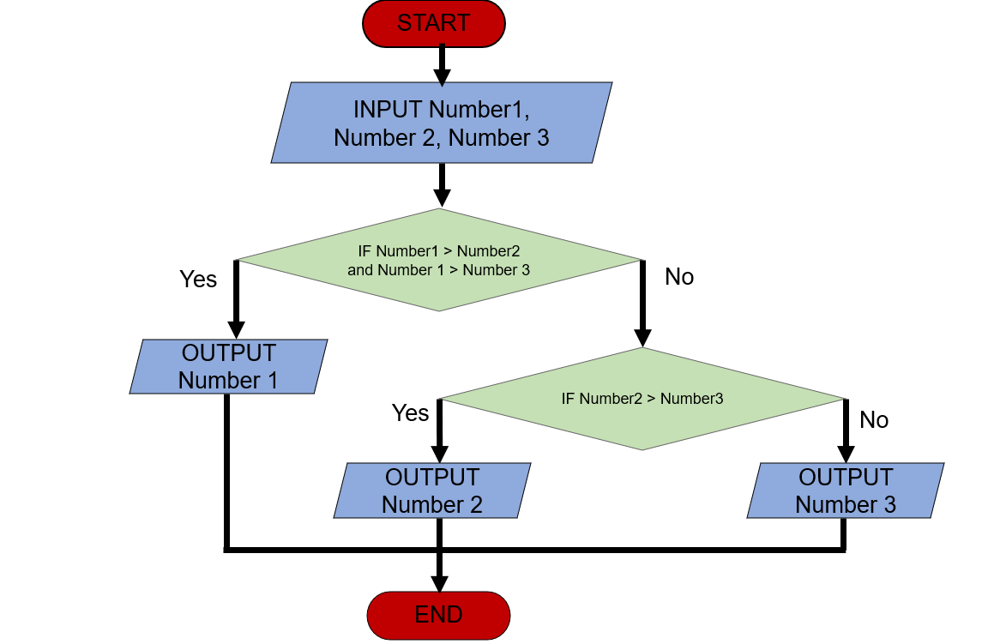Begin  
 INPUT Number a, Number b, Number c  
 IF Number a > number b and number a> number c  
 Display “ Number a biggest “   
 Else  
 IF Number b> Number c  
 Display “ Number b biggest “  
 Else   
 Display “ Number c biggest “  
end.