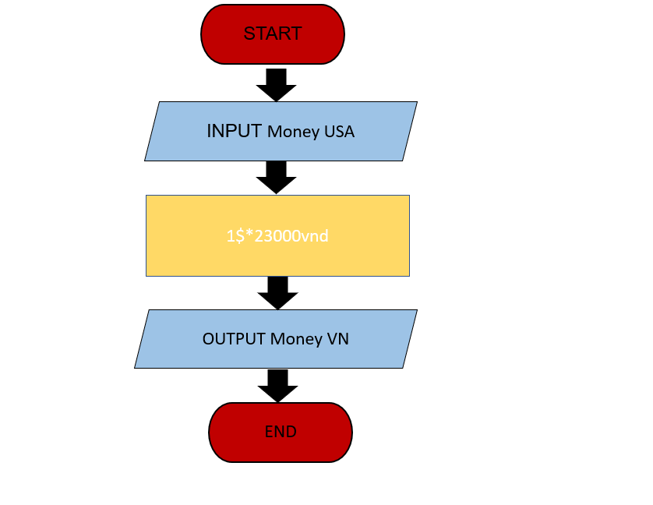Begin   
 INPUT Money USA  
 1$\*23000vnd  
 OUTPUT Money VN  
End.