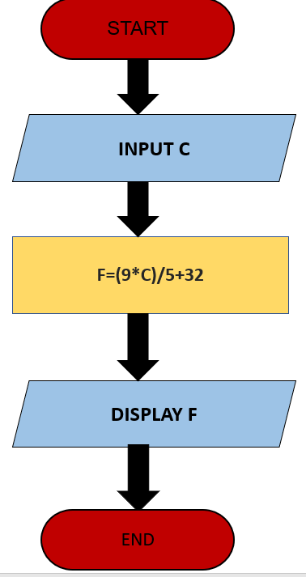NAME: Nguyễn Duy Trung  
CLASS:C0222G1  
  
  
Begin  
 Input C  
 F=(9\*C)/5+32  
 Display F  
End