



**Diamond Shop System**

**Software Requirement Specification**

| **NJS1808 - G6** | |
| --- | --- |
| Group Member | Nguyễn Vũ Thảo Vi - SE183117  Đinh Hữu Lộc - SE182639  Phạm Cao Nguyên - SE182674  Nguyễn Văn Khoa - SE182653  Nguyễn Đức Nguyên - SE182830 |
| Supervisor | Tôn Thất Hoàng Minh |

**<Location, issued date of the Document>**

## Record of change

*A - Added M - Modified D - Deleted

| **Effective Date** | **A* M, D** | **In Charge** | **Change Description** |
| --- | --- | --- | --- |
| 8/5/2024 | A | Nguyễn Vũ Thảo Vi | Add product background |
| 8/5/2024 | A | Đinh Hữu Lộc | Add business opportunity |
| 8/5/2024 | A | Phạm Cao Nguyên | Add Major Features |
| 8/5/2024 | A | Nguyễn Văn Khoa  Nguyễn Đức Nguyên | Add Existing System  Add Software product vision |
|  |  |  |  |
|  |  |  |  |
|  |  |  |  |
|  |  |  |  |
|  |  |  |  |
|  |  |  |  |
|  |  |  |  |
|  |  |  |  |
|  |  |  |  |
|  |  |  |  |
|  |  |  |  |
|  |  |  |  |
|  |  |  |  |
|  |  |  |  |
|  |  |  |  |
|  |  |  |  |
|  |  |  |  |

## TABLE OF CONTENTS

**1** **Introduction** 4

1.1 Product Background 4

1.2 Existing System 4

1.3 Business Opportunity 6

1.4 Software Product Vision 7

1.5 Major Features 7

1.6 Limitations and Exclusions 9

**2** **Overall Description 7**

**3** **FUNCTIONAL Requirements 8**

3.1 <Use Cases Diagram> 8

3.2 < Use Case Name 1> 8

3.3 < Use Case Name 2> 9

**4** **NON-FUNCTIONAL Requirements 10**

4.1 Usability 10

4.2 Reliability 10

4.3 Performance 10

4.4 Supportability 11

4.5 Design Constraints 11

4.6 On-line User Documentation and Help System Requirements 11

4.7 Purchased Components 11

4.8 Interfaces 12

4.9 Licensing Requirements 12

4.10 Legal, Copyright, and Other Notices 12

4.11 Applicable Standards 12

**5** **Supporting Information 13**

# Introduction

## Product Background

The Diamond Shop System emerged from a comprehensive understanding of the evolving diamond retail industry. In the past, diamond shop relied heavily on manual processes, paper-based records, and a patchwork of disconnected software solutions. This traditional approach created a number of inefficiencies that hampered growth and profitability.

For example, manually tracking inventory levels across various locations was not only time-consuming but also prone to errors. Likewise, generating reports on sales trends or customer preferences often required painstaking data collection and aggregation from multiple sources.

These outdated methods made it difficult for diamond shop to keep pace with the changing consumer landscape and optimize their operations for success.

**Challenges of Traditional Diamond Shop Management:**

* Time-consuming manual tasks like inventory management, sales processing, and customer relationship management.
* Difficulty in maintaining accurate and up-to-date data across various systems.
* Limited customer insights and personalization capabilities.
* Inefficient communication and workflows between staff departments.

**The Diamond Shop System Difference:**

* Recognizing these challenges, the Diamond Shop System was envisioned as a comprehensive solution to:
  + Automated Operations: Reduces manual tasks, allowing staff to focus on sales and customer service.
  + Unified Platform: Simplifies management by consolidating all operations into a single, easy-to-use interface.
  + Advanced Analytics: Provides instant insights to help make informed decisions quickly.
  + Enhanced Customer Engagement: Enables personalized marketing and customer interactions.
  + Improved Collaboration: Facilitates better communication and efficient workflows across all departments.

By addressing these challenges and offering a user-friendly, all-in-one solution, the Diamond Shop System aims to empower diamond shop to thrive in the competitive retail landscape.

## Existing System

#### 1.2.1: Blue Nile

* Brief Description: Blue Nile is a leading online retailer specializing in certified diamonds and fine jewelry. They offer a wide selection of GIA-graded natural diamonds and their exclusive Astor by Blue Nile™ diamonds, known for their superior brilliance. Whether you’re searching for the perfect engagement ring, wedding band, or other diamond jewelry, Blue Nile provides high-quality options. Their lab-grown diamonds are also a popular choice for those seeking an eco-friendly alternative. With legendary service, secure deliveries, and a 30-day return policy, Blue Nile ensures a seamless shopping experience for customers worldwide
* Link: [Blue Nile](https://www.bluenile.com/diamonds).
* System actor: Guest, Member, Staff, Admin
* Special Feature:

- Customize own diamond by template

- Education about diamonds

- Classify diamonds based on various shape, size and natural or artificial

* Advantage:

- Wide selection: Blue Nile offers an extensive range of diamonds, engagement rings, and fine jewelry. Customers can explore various shapes, sizes, and styles.

- Online Convenience: Shopping on Blue Nile is convenient, especially for those who prefer browsing and purchasing from the comfort of their homes.

* Disadvantage:
* **Limited Visual Content**: Not all diamonds on the Blue Nile website are accompanied by images or 360-degree videos. This can be a significant drawback for online shoppers who rely heavily on visual details to make a purchase decision. This limitation can hinder a buyer's ability to thoroughly inspect the diamonds, particularly to identify any flaws or inclusions​.
* **Navigation and Interface Issues**: Although Blue Nile's website is generally user-friendly, some users might find certain aspects of the navigation or interface less intuitive. This could include difficulties in filtering products or navigating through the customization options for specific jewelry pieces​.

#### 1.2.2: Jemmia

* Brief description: Jemmia is a leading diamond expert in Vietnam, offering a wide range of diamond products and services. They are committed to providing customers with high-quality diamonds that meet international standards. Jemmia’s diamonds are 100% imported and globally valued.
* Link: <https://jemmia.vn/>
* System actor: Guest, Member, Staff, Admin
* Special Feature:

- Quality Assurance: Jemmia guarantees the correct weight and content of their diamonds. All diamonds and gemstones are 100% imported, internationally certified, and have global value.

- Customer Service: Jemmia’s experienced customer care team is always available to assist and advise customers on choosing the most suitable jewelry.

- Product Variety: Jemmia offers a wide range of products, from diamond rings to wedding jewelry. They aim to preserve wonderful memories with timeless, fashionable jewelry designs.

* Advantage:

-Quality Assurance: Online diamond retailers like Jemmia often provide guarantees on the quality and authenticity of their diamonds.

-Convenience: Customers can browse and purchase products at any time and from anywhere.

-Variety: Online retailers often have a wide range of products, allowing customers to find the perfect diamond that suits their preferences.

* Disadvantage:
* **Language Limitation**: A notable disadvantage of Jemmia is its support only for the Vietnamese language, which limits its accessibility to non-Vietnamese speakers. This restricts its international reach, potentially reducing its user base and impact in the global market.
* **In-Store Pickup Requirement**: Another drawback of Jemmia is that it only allows customers to order items online without the option for home delivery. Customers must visit a physical store to retrieve their purchases. This can be inconvenient for those who prefer the ease of direct delivery, especially if they live far from a store or have limited mobility. This limitation may deter potential customers who seek a more seamless, end-to-end online shopping experience

## Business Opportunity

Market Opportunity:

The luxury jewelry market is increasingly moving online, driven by consumer preferences for convenience, bespoke customization, and transparent sourcing. Although several players have established a presence, there remains significant potential for a platform that offers a highly personalized shopping experience with a strong focus on ethical practices. A dedicated online diamond store can capture this market by providing an exceptional level of customer engagement and unique product offerings not fully available through existing competitors or traditional brick-and-mortar stores.

Strategic Fit and Competitive Advantage:

This venture will cater to affluent customers who not only appreciate the beauty and luxury of diamonds but also deeply value the ethical sourcing of these precious stones. Focusing on transparent sourcing practices and providing comprehensive product information, the platform can distinguish itself from competitors and attract a clientele that prioritizes these aspects in their purchasing decisions.

## Software Product Vision

* Our vision for the software product is to revolutionize the Diamond shopping experience by offering a comprehensive platform that streamlines every aspect of the process for customers .

1. Intuitive and visually appealing interface for seamless navigation and product discovery.
2. Personalization options for tailored shopping experiences, including customization and visualization tools.
3. Community engagement features such as reviews, chat support
4. Convenient ordering and payment options, including secure transactions and voucher management.
5. Efficient management tools for staff and admins, including inventory management and analytics.

## Major Features

**Guests**

FE-01: View by categories

FE-02: View product in 3D models

FE-03: Contacts customer support

FE-04: View product descriptions

FE-05: View Commercial diamond price

FE-06: View Diamond’s Educational content

**Customers**

FE-07: Add to wishlist, cart; view wishlist, cart

FE-08: Order and payment; choose payment method

FE-09: Contact customer support

FE-10: View bill

FE-11: After-sale service

FE-12: Comment and feedback products

**Sales Staff**

FE-13: View request/ send request

FE-14: Customer services

FE-15: Print guarantee - certificate

**Delivery Staff**

FE-16: Update product status

**Manager**

FE-17: Manage Staff

FE-18: View Feedback

FE-19: View/ approve request

FE-20: Manage sales/event

FE-21: Manage comment/feedback

FE-22: Manage product (backup, restore product, account adjustment and web database)

**Admin**

FE-23: Manage payment (input import bill)

FE-24: Manage the account (deleted, changes role)

FE-25: Check customer transaction

## Limitation and Exclusion

* LI-01: Physical Interaction: Given the nature of online shopping, the system may not support physical inspection of diamonds before purchase. While high-quality images and detailed descriptions can mitigate this to some extent, stakeholders should be aware that the platform won't offer in-person inspection options.
* LI-02: Real-Time Inventory Updates: Depending on the complexity of the system and integration with inventory management, real-time updates on diamond availability may not be feasible. There might be a delay in inventory status updates due to synchronization processes.
* LI-03: Physical Security Measures: The online shop system may not directly address physical security measures for diamond shipments, such as armored transport or insurance options. Stakeholders should communicate the standard shipping and security procedures to customers.

# Overall Description

## 2.1 Product Overview

In an era where digital transformation shapes every aspect of commerce, the diamond retail industry stands at a pivotal crossroads. Traditional methods, characterized by manual processes and fragmented systems, have gradually become inadequate to meet the demands of a modern, discerning clientele. The Diamond Shop System emerges as a revolutionary solution, designed to streamline operations, enhance customer engagement, and optimize inventory and sales management through a unified digital platform.

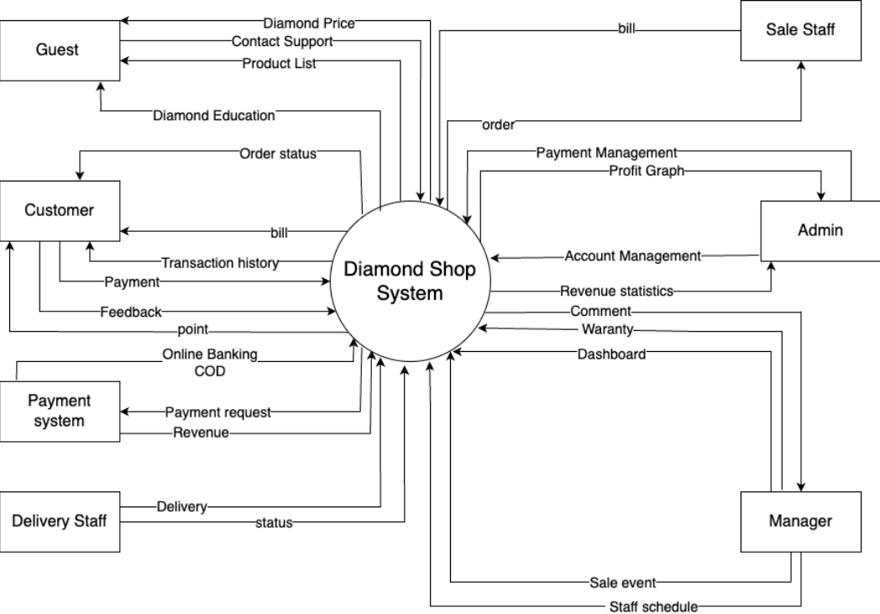

# FUNCTIONAL Requirements

## <Use Cases Diagram>

*[The main Use Case Diagrams of the system]*

## < Use Case Name 1>

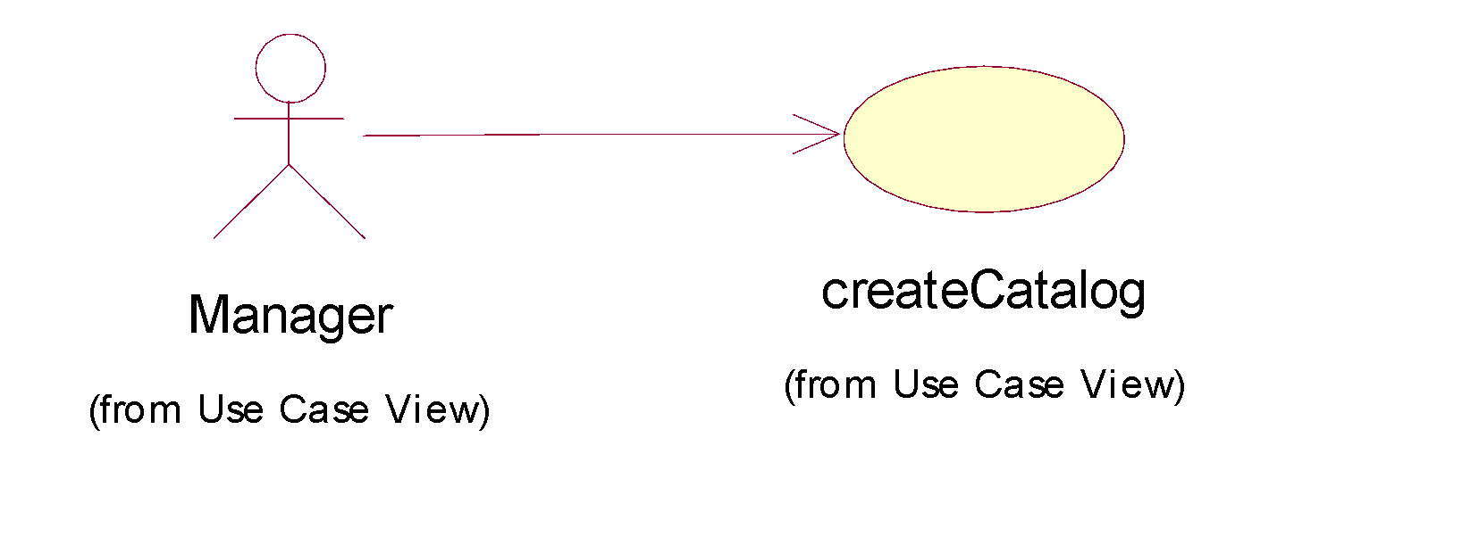

| **USE CASE-n SPECIFICATION** | | | | |
| --- | --- | --- | --- | --- |
| **Use-case No.s** | <UC001> | **Use-case Version** | | <1.0> |
| **Use-case Name** | <Name> | | | |
| **Author** | <Members> | | | |
| **Date** | Dd/mm/yyyy | **Priority** | <High/Normal/Low> | |
| **Actor:**  *<Lit all actors>*  **Summary:**  *<Briefly describe the used case >*  **Goal:**  *<Briefly describe the goal of used case >*  **Triggers**  *<What does lead in using this case?>*  **Preconditions:**  *<List the required pre-conditions for using this case>*  **Post Conditions:**  *<List the required post-conditions for using this case>*  **Main Success Scenario:**  *<List the main steps for using this case to reach the goal successfully >*  **Alternative Scenario:**  *<List other steps for using this case to reach the goal in some alternative conditions >*  **Exceptions:**  *<List exceptions of this use case >*  **Relationships:**  *<List the relationships that use case relates to>*  **Business Rules:**  *<Any concern about the business>* | | | | |

## < Use Case Name 2>

…………………

# NON-FUNCTIONAL Requirements

*[This section describes the non-functional requirements of the system. Some examples are listed as below]*

## Usability

*[This section includes all those requirements that affect usability. For example,*

*specify the required training time for a normal users and a power user to become productive at particular operations*

*specify measurable task times for typical tasks or base the new system’s usability requirements on other systems that the users know and like*

*specify requirement to conform to common usability standards, such as IBM’s CUA standards Microsoft’s GUI standards]*

### <Usability Requirement One>

*[The requirement description goes here.]*

## Reliability

*[Requirements for reliability of the system should be specified here. Some suggestions follow:*

*Availability—specify the percentage of time available ( xx.xx%), hours of use, maintenance access, degraded mode operations, and so on.*

*Mean Time Between Failures (MTBF) — this is usually specified in hours, but it could also be specified in terms of days, months or years.*

*Mean Time To Repair (MTTR)—how long is the system allowed to be out of operation after it has failed?*

*Accuracy—specifies precision (resolution) and accuracy (by some known standard) that is required in the system’s output.*

*Maximum Bugs or Defect Rate—usually expressed in terms of bugs per thousand lines of code (bugs/KLOC) or bugs per function-point( bugs/function-point).*

*Bugs or Defect Rate—categorized in terms of minor, significant, and critical bugs: the requirement(s) must define what is meant by a “critical” bug; for example, complete loss of data or a complete inability to use certain parts of the system’s functionality.]*

### <Reliability Requirement One>

*[The requirement description.]*

## Performance

*[The system’s performance characteristics are outlined in this section. Include specific response times. Where applicable, reference related Use Cases by name.*

*Response time for a transaction (average, maximum)*

*Throughput, for example, transactions per second*

*Capacity, for example, the number of customers or transactions the system can accommodate*

*Degradation modes (what is the acceptable mode of operation when the system has been degraded in some manner)*

*Resource utilization, such as memory, disk, communications, and so forth.*

### <Performance Requirement One>

*[The requirement description goes here.]*

*Interfaces*

## Supportability

*[This section indicates any requirements that will enhance the supportability or maintainability of the system being built, including coding standards, naming conventions, class libraries, maintenance access, and maintenance utilities.]*

### <Supportability Requirement One>

*[The requirement description goes here.]*

## Design Constraints

*[This section indicates any design constraints on the system being built. Design constraints represent design decisions that have been mandated and must be adhered to. Examples include software languages, software process requirements, prescribed use of developmental tools, architectural and design constraints, purchased components, class libraries, and so on.]*

### <Design Constraint One>

*[The requirement description goes here.]*

## On-line User Documentation and Help System Requirements

*[Describes the requirements, if any, for o-line user documentation, help systems, help about notices, and so forth.]*

## Purchased Components

*[This section describes any purchased components to be used with the system, any applicable licensing or usage restrictions, and any associated compatibility and interoperability or interface standards.]*

## Interfaces

*[This section defines the interfaces that must be supported by the application. It should contain adequate specificity, protocols, ports and logical addresses, and the like, so that the software can be developed and verified against the interface requirements.]*

### User Interfaces

*[Describe the user interfaces that are to be implemented by the software.]*

### Hardware Interfaces

*[This section defines any hardware interfaces that are to be supported by the software, including logical structure, physical addresses, expected behavior, and so on.]*

### Software Interfaces

*[This section describes software interfaces to other components of the software system. These may be purchased components, components reused from another application or components being developed for subsystems outside of the scope of this SRS but with which this software application must interact.]*

### Communications Interfaces

[Describe any communications interfaces to other systems or devices such as local area networks, remote serial devices, and so forth.]

## Licensing Requirements

*[Defines any licensing enforcement requirements or other usage restriction requirements that are to be exhibited by the software.]*

## Legal, Copyright, and Other Notices

*[This section describes any necessary legal disclaimers, warranties, copyright notices, patent notices, wordmark, trademark, or logo compliance issues for the software.]*

## Applicable Standards

*[This section describes by reference any applicable standard and the specific sections of any such standards which apply to the system being described. For example, this could include legal, quality and regulatory standards, industry standards for usability, interoperability, internationalization, operating system compliance, and so forth.]*

# Supporting Information

*[The supporting information makes the SRS easier to use. It includes:*

*Table of contents*

*Index*

*Appendices*

*These may include use-case storyboards or user-interface prototypes. When appendices are included, the SRS should explicitly state whether or not the appendices are to be considered part of the requirements.]*