Step 1: Create distribution

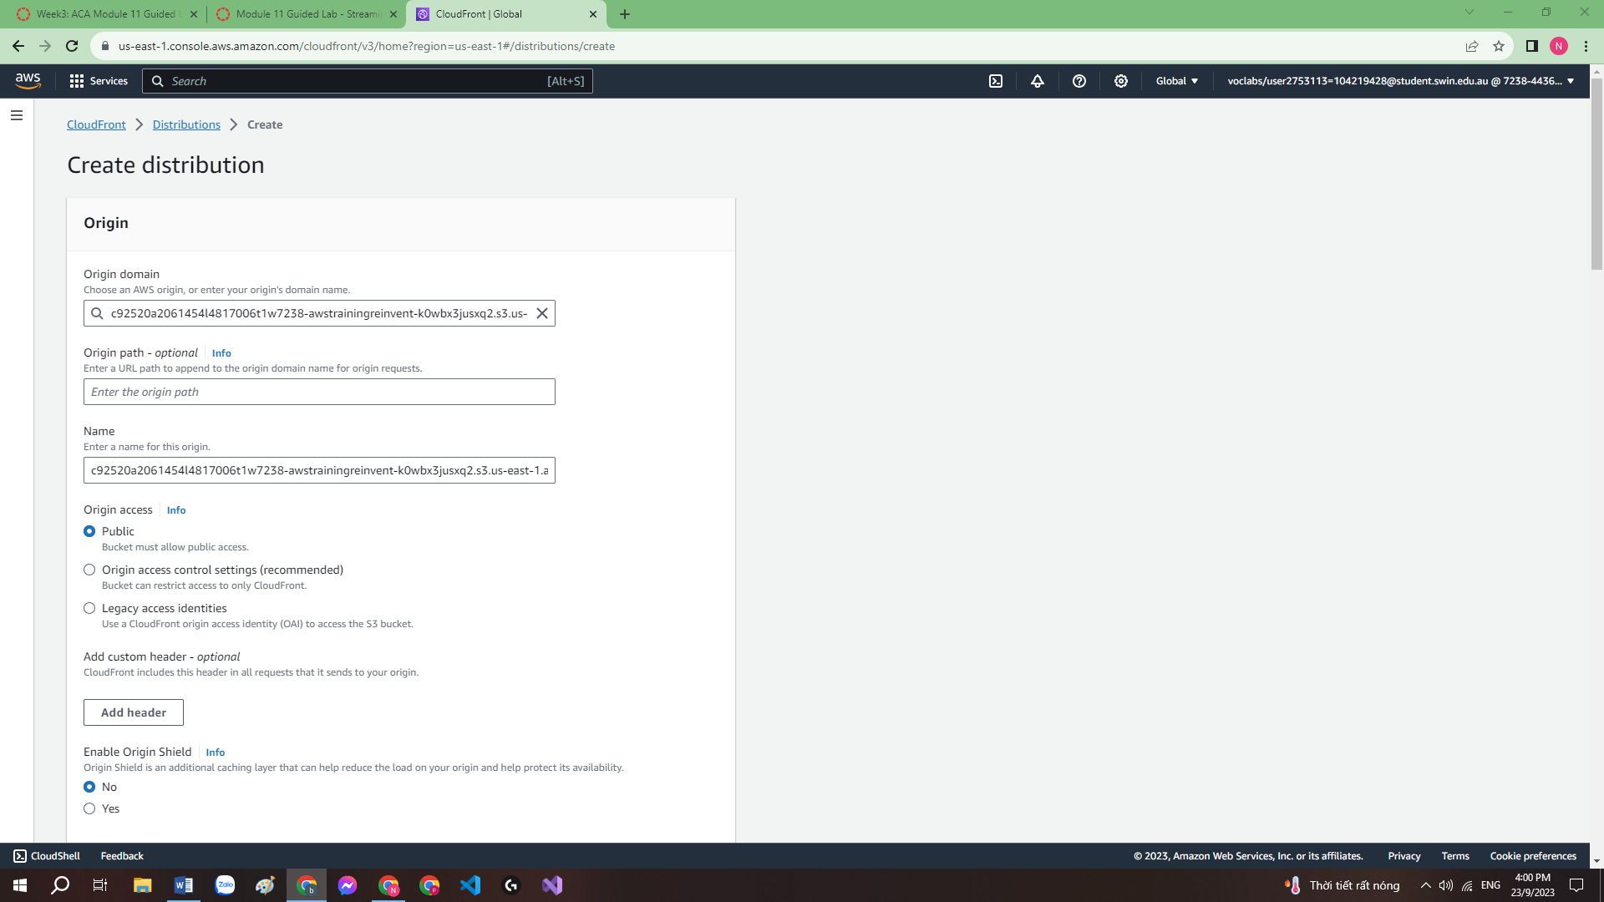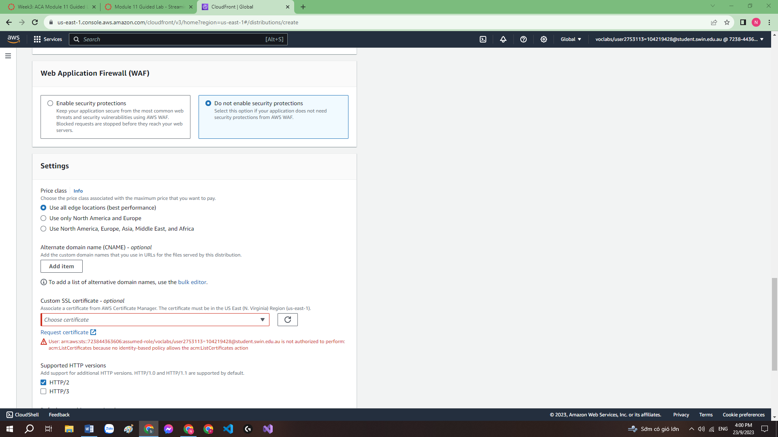

Step 2: Create a pipeline for elastic transcoder

I found one of the instruction(12) not pointing to anything but nothing going south so far

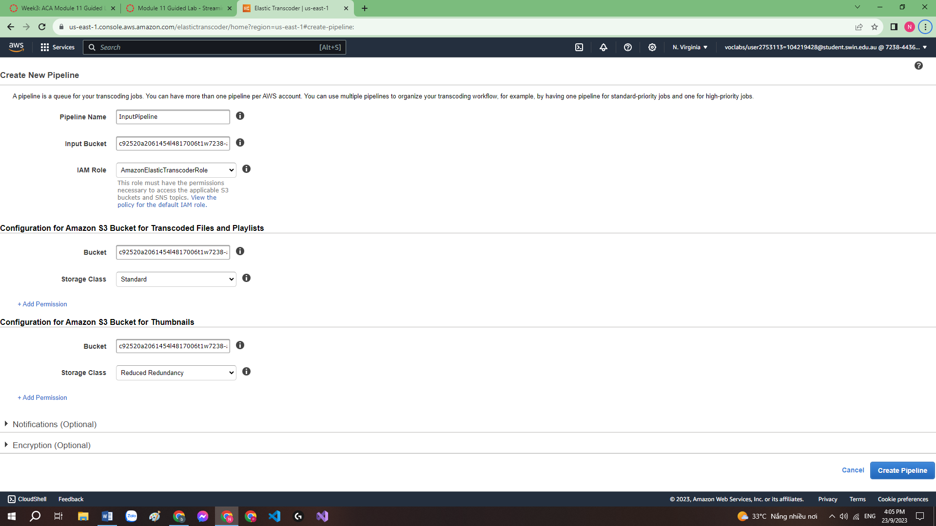

Step 3: create job of the transcoder

3.1: create job

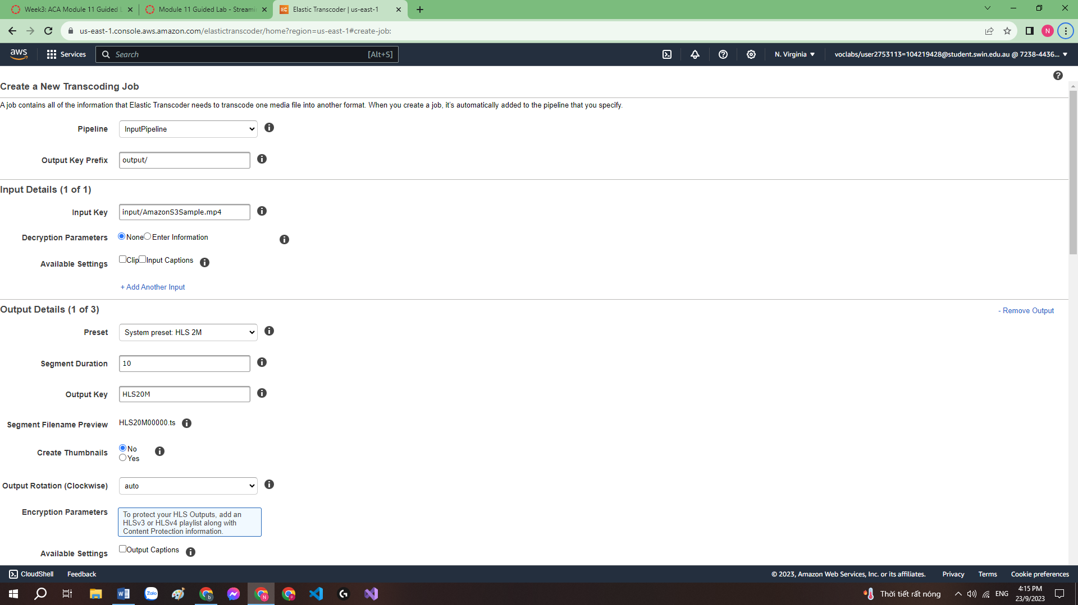

3.2: configure output detail

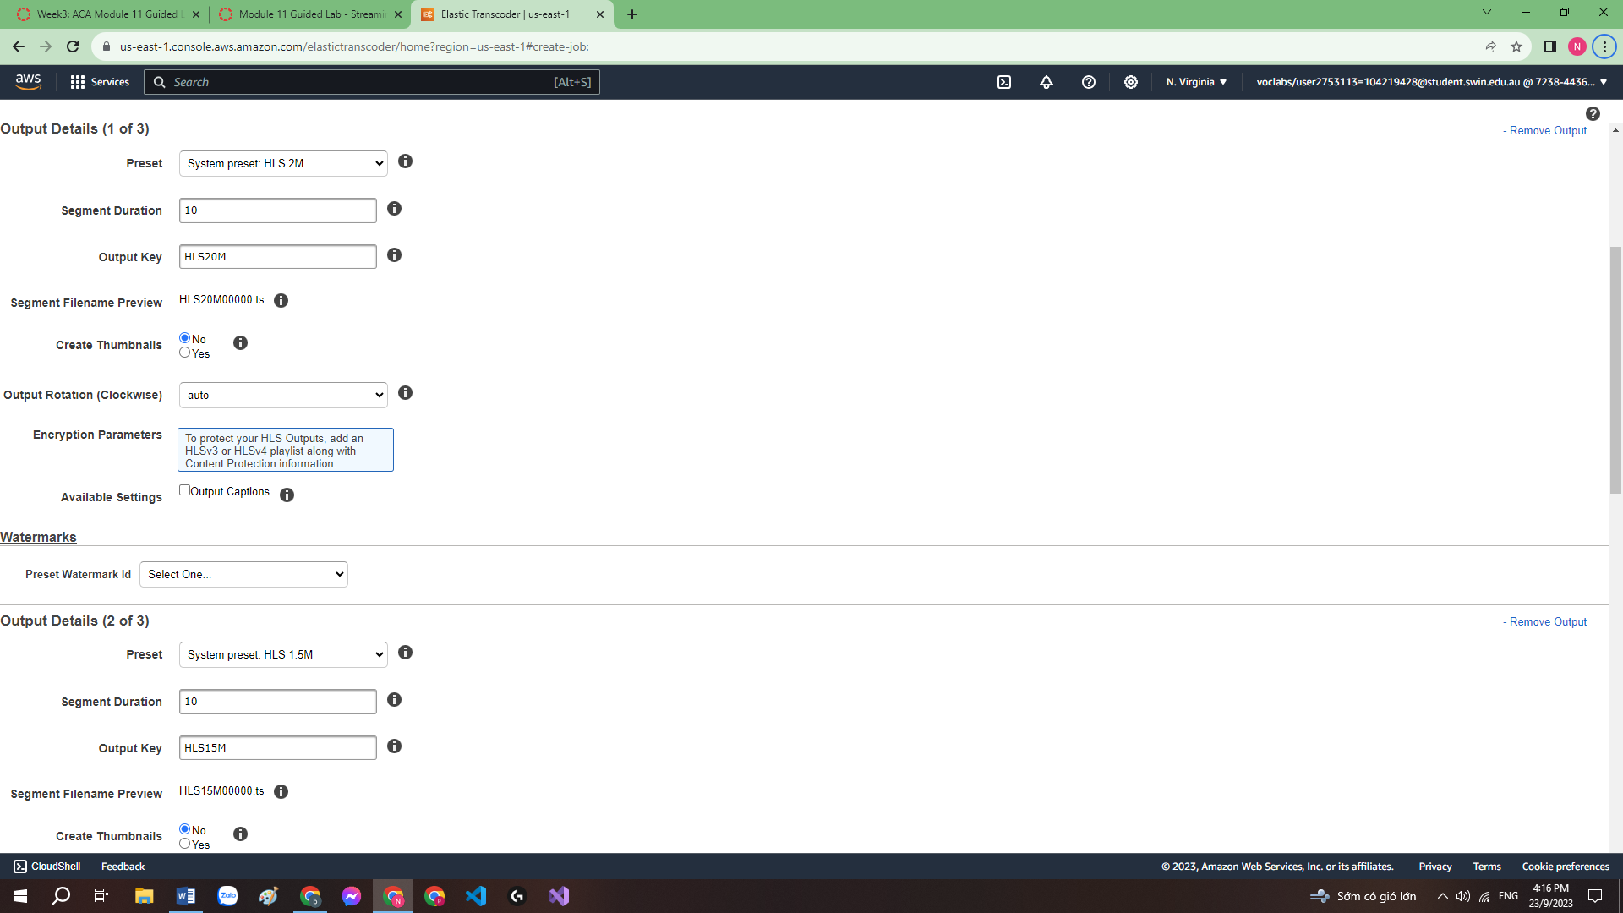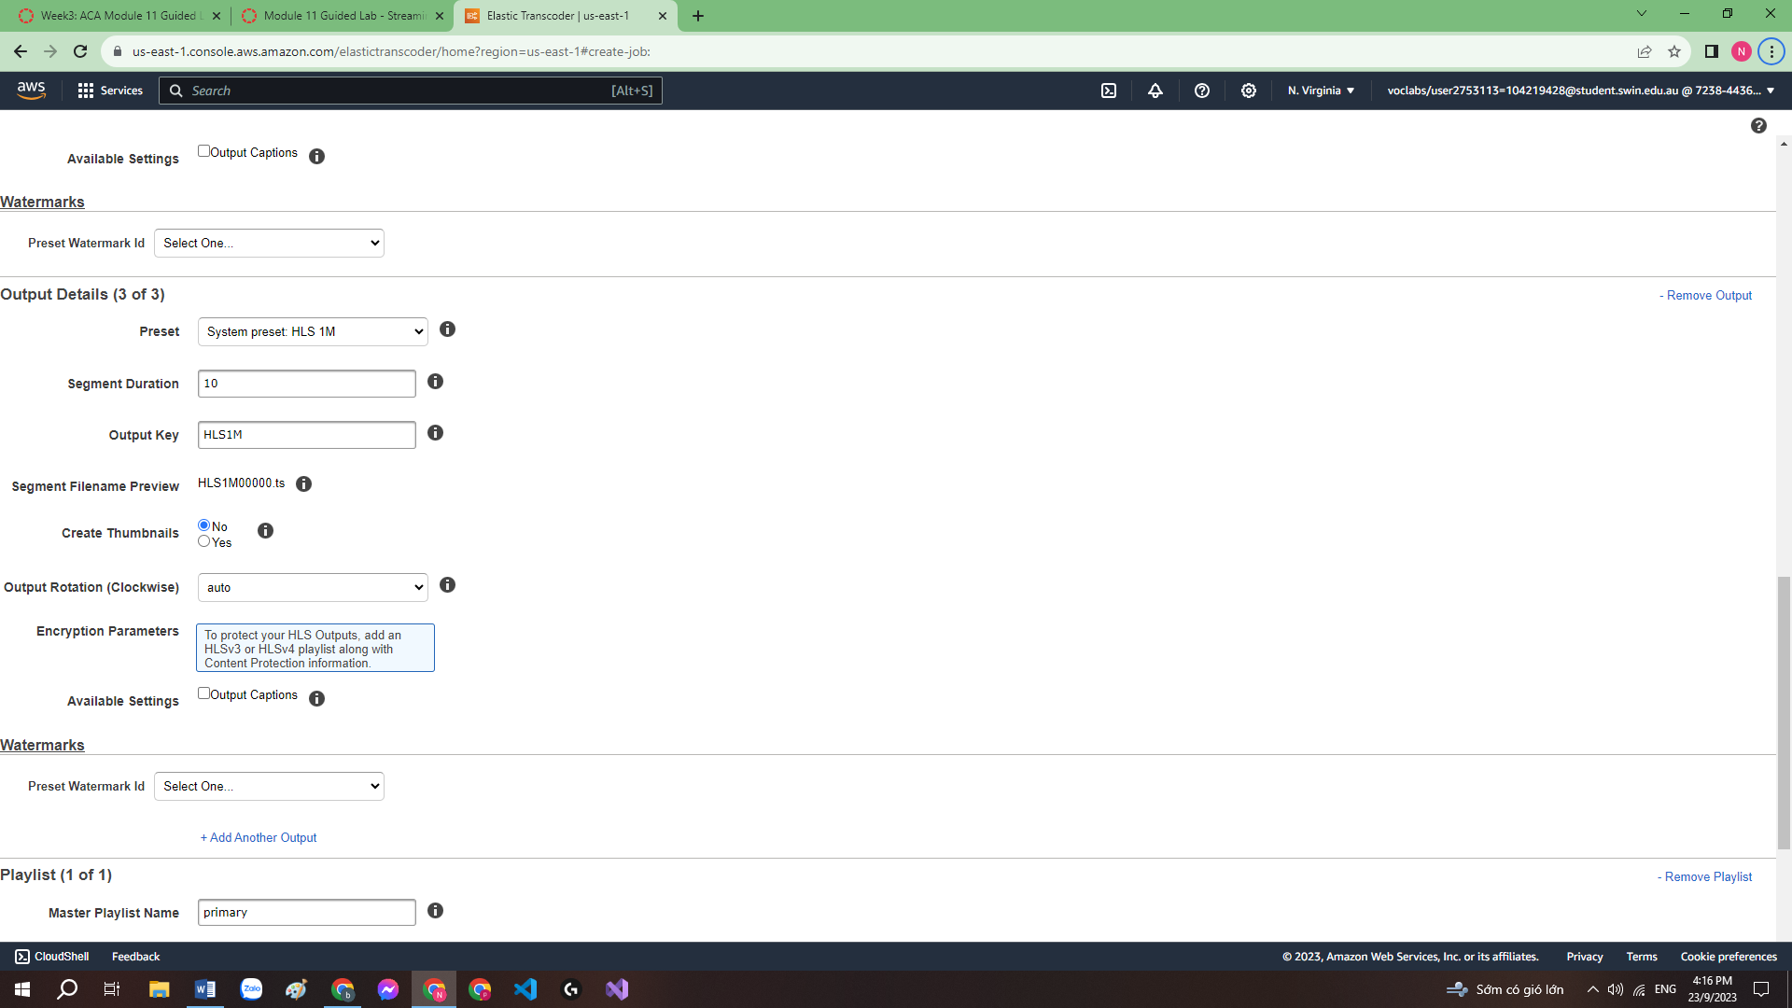

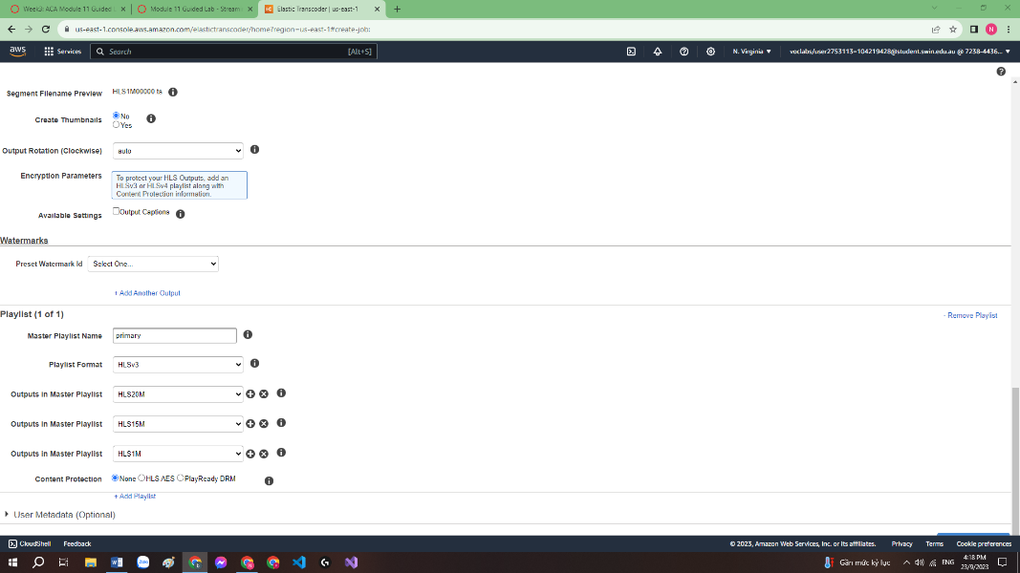 3.3: Configure a playlist

Step 4: obtain the distribution domain name

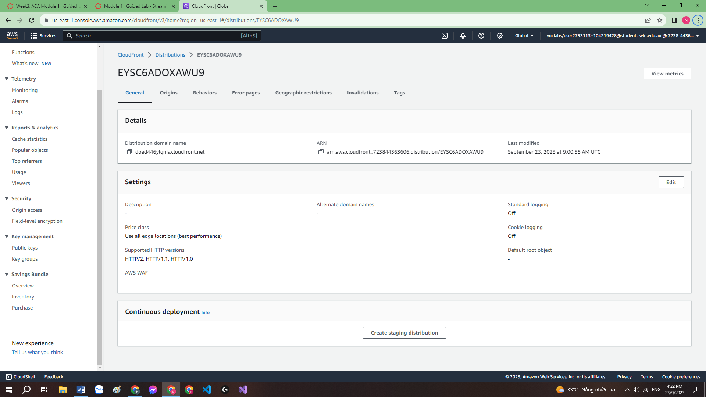

<https://doed446ylqnis.cloudfront.net>

Step 5: Obtain the playlist path

<https://d2jx2qv0n6yl61.cloudfront.net/output/primary.m3u8>

