**SWINBURNE UNIVERSITY OF TECHNOLOGY**

**COS30045**

**Project Reflection**

|  |  |  |
| --- | --- | --- |
| **NAME & STUDENTID** | **:** | **Nguyen Gia Binh (104219428)** |
|  |  |  |
| **CLASS** | **:** | **COS30045** |
| **LECTURER**    **TUTOR** | **:**    **:** | **HOANG XUAN TUNG**  **(**txhoang@swin.edu.au**)**  **HOANG XUAN TUNG**  **(**txhoang@swin.edu.au**)** |

**Hanoi, April 6, 2024**

**TABLE OF CONTENTS**

TABLE OF CONTENTS

**CHAPTER 1: INTRODUCTION**

**CHAPTER 2: REFLECTION**

2.1: Data source

2.2: Data processing

**CHAPTER 1: INTRODUCTION**

Migration is a natural and inevitable aspect of human history. In the current globalized world, international migration has become more common. Understanding these complex forced migration dynamics is crucial for policies and international relations efforts to resolve the core Invasion and address the refugee crisis humanely based on international law. The report will establish an individual perspective on the data visualization project focusing on migration from Ukraine since Russia invasion 24 February 2024. The goal of this project was to create an interactive application that allows users to examine and interpret migration statistics in an accessible and enlightening way. Through the application of data visualization principles and coding skills, the intention was to establish an appealing digital interface that clearly conveys the complex aspects of migratory movements.

Throughout this essay, I’m taking a deep dive into my own academic growth and the contributions I made to our group project. It’s been a journey of significant learning milestones. I’m going to break down how I managed to apply these to our interactive visual tool. This isn’t just about the end result, though—it's also about the process, including the programming techniques I got to grips with. On top of that, I'm reflecting on how we all worked together on this project. I'll get into my role and how I fit into the group, plus how that changed as the semester went on. There were definitely a few roadblocks along the way, and I'll be talking about those too—what went down, how we dealt with it, and how we pulled it all together for a win in the end.

**CHAPTER 2: REFLECTION**

**1.1: Concept**

Throughout this project, I have got a grip on 2 fundamental aspect of data visualization: data preparation to lay the foundation for creating informative and impactful data visualizations and interactivity to help user more engage in the visualization.

Data preparation is like cleaning and organizing your workspace before a project. Raw data is often messy, containing errors, inconsistencies, and inconsistencies. We prepare the data and tackles these issues by collecting the right information, formatting it for analysis, and ensuring its accuracy. This meticulous cleaning process is essential as ensures our visualizations and analysis are built on a solid foundation, leading to trustworthy insights and reliable conclusions.

Interactivity transforms data exploration from a passive experience into an active discovery process. Users can engage with the data on their terms, uncovering hidden patterns, drilling down for deeper understanding, and personalizing their journey through the information. This interactivity fosters curiosity and empowers users to become active participants in the data story, leading to richer insights and a stronger connection with the information.

Together, data preparation provides a solid foundation, and interactivity empowers users to truly engage with the data story. Considering this advantages, I try to embrace them as much as possible during the design process .

**1.2: D3js**

Throughout the duration of our project, I engaged with several coding strategies, prominently the implementation of D3.js—a robust JavaScript framework—to generate interactive visualizations. This tool, also referred to as Data-Driven Documents, granted us the capability to flexibly work with data to produce visuals that respond and adapt to that data.

Focusing on migration flow from Ukraine to European country after the invasion of Russia, we harnessed the power of D3.js to craft graphics that were not only visually striking but also full of insight. Techniques such as data manipulation, data binding, and dynamic rendering were key to converting the crude migration figures into significant graphical depictions.

The manipulation of data was a pivotal aspect of our approach. We meticulously refined the migration statistics to tailor them for visualization purposes, including grouping the data by various factors like time, country of origin, and destination.

We integrated the data with visual components such as bars, lines, and map using data binding methods. This integration formed a link between the data and its graphical display, facilitating real-time updates to the visualization in accordance with data modifications or user input.

Furthermore, our rendering methods were driven by the data, enabling us to spontaneously create and adjust visual elements grounded in the migration statistics. Utilizing scales, we translated quantitative data into corresponding visual attributes, crafting precise histograms, trend lines, and maps that accurately depict migratory trends.

In summary, by utilizing D3.js and its related programming techniques, we were able to produce interactive and enlightening visualizations that successfully delineate migration patterns from Ukraine. Our strategic application of data manipulation, data binding, and dynamic rendering has translated complex datasets into clear and engaging graphical viualization.

**CHAPTER 3: CONTRIBUTION**

To start, I contribute not just the viewable project but also the idea, the planning and almost everything else in this project. Before diving deeper into what I did in details, let me clarify one thing first, the other teammate did contribute something but it is so low effort and quality that I just can not except it, it took him 3 weeks to deliver something so subpar to what I focus on doing in 2 days. That is not to say what I did was very good,complex and high level, it just that his work quality is just that low.

**3.1: Data finding**

**2.2: Data processing**

The datasets obtained from the aforementioned organizations guarantee both high integrity and timeliness. However, it is essential to conduct data cleaning and restructuring on the original datasets to ensure they meet the necessary level of 'conformity' required for visualization in D3.

**Isarael and Gaza(Palestine) conflict**

The original data have a lot of unnessary data respectively with our intended usage. The initial dataset comprises detailed information concerning recent internal displacement incidents, including the type of event, the number of affected populations, the region of occurrence, and corresponding dates, links, etc. Each entry in this dataset represents an event that caused displacement with precise sequential dates, and coordinate, I decide to delete some of the column that have duplicate and most of the time detail that I have yet to figured out how to visualize it. Furthermore the event name column have duplicate date information in it cells which somehow cause d3 to sometimes has bug. My solution to it is to write a simple python code that would delete the date and the “-” in the data.

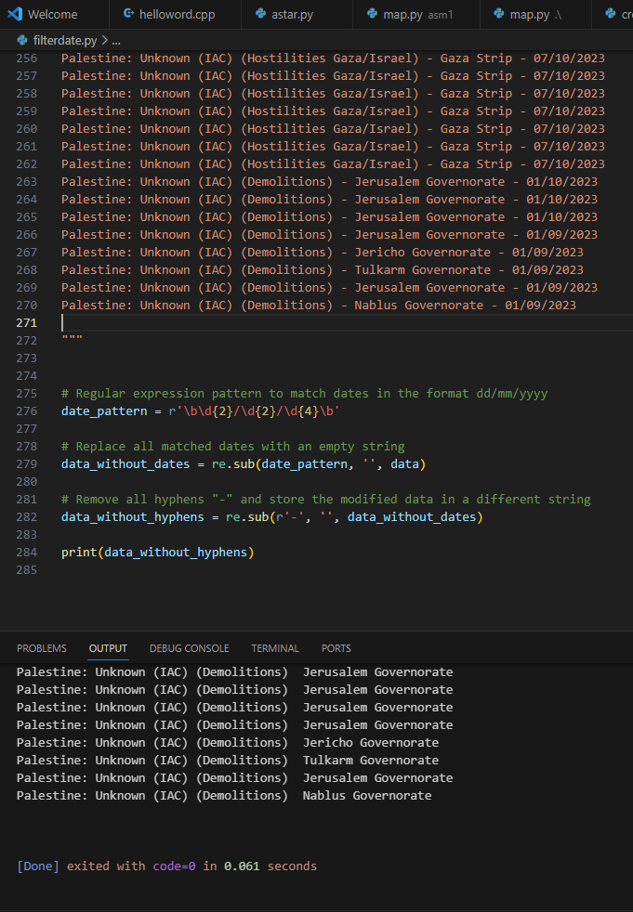

**CHAPTER 3: REQUIREMENT**

**3.1 Must-Have Features**

There are a few features that we consider to be very important to give the reader an easier time understanding of what the chart is for. These features include:

* Interactive visualization:

1. Hover effect: With hover effect, user can see the detail in which a point on the map or a section of a chart represent.
2. Zoom in: This effect allow the user to see the timeline closer especially in line chart or area chart
3. Clickable: Point on the map or sections of the chart may be clickable and would lead to a sub html page with smaller chart or found report representing that point or section

* Additional information:

1. Label: This is a must be to help the reader quickly indentify What the reader is seeing.

* Color: data can be categorize in dozens of type and column, the contrast between color can make some important element to shine through and get to the reader.

**3.2 Optional Features**

1. Tooltip: in the first design, sub pages would be use to give a more detail view on the points or section of the data but if we use tool tip, there would need to be a sub page and therefore maintaining the page integrity would be easier but at the same time tooltip is relatively hard to implement effectively and easily in my experience.
2. Guide: There should be a guide either by a button or render out next to the chart to give the reader an easier time indentify each section.

**CHAPTER 4: VISUALIZATION DESIGN**

**4.1: Concept**

In the early stage, charts and map are coded out simple in order to give an overall design to it and so that later on we can lean our back onto the ready skeleton of the chart.

**Isarael and Gaza(Palestine) conflict**

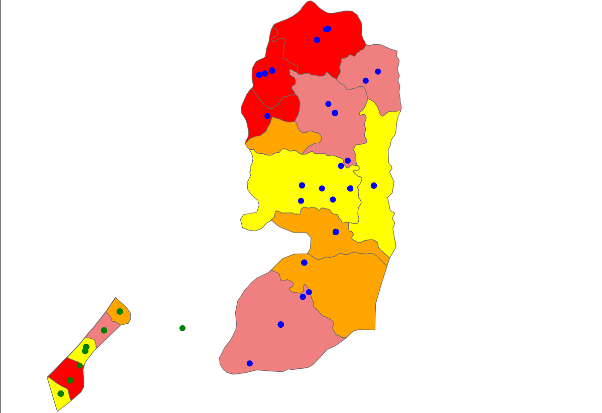

In here green is our focus area in which the main conflict between Isarael and Gaza happen. As of now, the dots are so near each other that it seem only a handful of it happen but in reality it is around 100 dots cluster together since the areas is hit so often. We plan to make a bigger circle with scale color to show the severity of each area and later the hover effect and/or subpage will be added to show more detail information.

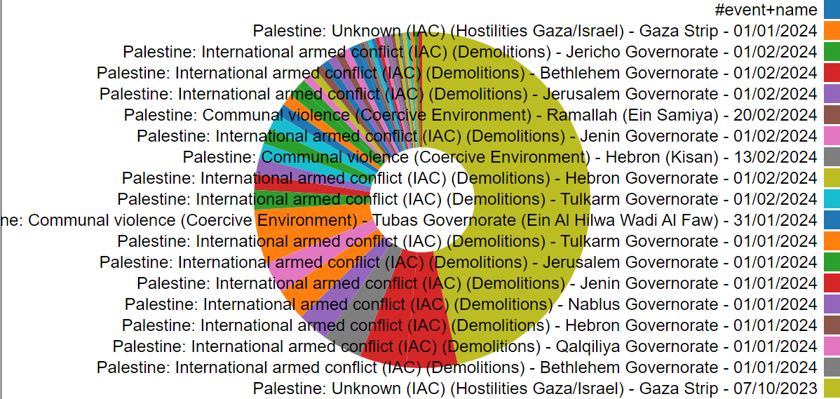

Next is the pie chart to show which event affect the dataset the most, this chart is not yet completed as the code to clean the data for this section is not yet fully working and as a result return the same event but with different date as a slice. The legend for this is as intended just not ready because later on there will be a button to signal the legend to show below the chart or as a hover.

**4.2: Manifestation**

**CHAPTER 5: VALIDATION**

**\*Project stand-up* in progress**

**CHAPTER 6: CONCLUSION**

**REFFERENCE**

International Migrant Stock 2020. (n.d.). https://www.un.org/development/desa/pd/sites/www.un.org.development.desa.pd/files/files/documents/2021/Jan/undesa_pd_2020_international_migrant_stock_documentation.pdf

Canton, H. (2021). United Nations Relief and Works Agency for Palestine Refugees in the Near East—UNRWA. In *The Europa Directory of International Organizations 2021* (pp. 286-289). Routledge.