**STRUCTURE OF THE SPEAKING TEST**

|  |  |  |
| --- | --- | --- |
| **PART** | **DURATION** | **FORMAT** |
| Part 1: Social interaction | 2-3 minutes | Answer 3-6 questions about 2 different familiar topics |
| Part 2: Solution discussion | 3 minutes (1 minute to prepare and 2 minutes to speak) | Choose 1 of 3 given solutions for the problem |
| Part 3: Topic development | 4 minutes (1 minute to prepare and 2 minutes to speak) | Give own opinions on a given topic and answer extended questions |

**USEFUL LANGUAGES FOR SPEAKING TEST**

*1. Common connective words*

|  |  |
| --- | --- |
| Addition | In addition/ and/ similarly/ besides/ furthermore/ also/ moreover/ not only …. But also/ likewise |
| Sequence | Firstly/ initially/ secondly/ to begin with/ then/ next/ following this/ afterwards |
| Consequence | As a result/ so/ therefore/ consequently/ thereby/ in that case |
| Contrast | However/ on the other hand/ despite/ in spite of/ though/ although/ but/ on the contrary/ otherwise/ instead of/ compared with |
| Example | For instance/ for example/ one example/ in particular/ such as/ namely/ to illustrate |
| Reason | Since/ as/ so/ because/ due to/ the reason why/ in other words |
| Time | Before/ since/ as/ when/ until/ meanwhile/ whenever/ as soon as |
| Summary | In conclusion/ in summary/ finally/ to sum up/ to conclude/ in short |

*2. Expressing feelings*

|  |  |
| --- | --- |
| Negative feelings | Positive feelings |
| I’m afraid I can’t stand  I absolutely hate ….…; it’s really horrible.  I really don’t like ….  I’m not very keen on …. | I love/ I adore  I’m quite keen on  I’m fond of  I’m into doing st |

*3. Hesitating linking words or phrases*

- Well, to be honest

- Actually,

- Let me see

- You know

- I’m not really sure, but perhaps…

- Well, it’s a bit difficult for me to say, but I guess….

**CRITERIA OF EVALUATION**

1. Grammar: + Range of structures

+ Accuracy

2. Vocabulary: + Range of vocabulary

+ Control of lexical accuracy

3. Pronunciation: + Individual sounds

+ Stress (word stress/ sentence stress)

+ Intonation

4. Fluency: + Hesitation

+ Extended speech

5. Discourse management:

+ Thematic development

+ Coherence

+ Cohesion

**PART 1: SOCIAL INTERACTION**

In this part, you answer 3-6 questions about 2 different topics.

**Tips:** - Answer at least 2-3 sentences for each question

- Stay on the topic and give extra information (reason for your answer as well)

- Use hesitating words and phrases to make your answer natural

- Use linking words

- Never speak as if you memorize the answer

**Question types**

*1. Like/ Dislike*

- Use expressing feelings expressions

- List ideas by using linking words or phrases

E.g.: What do you like about your hometown?

è The best thing about living here is that everything is at your fingertips. Moreover, I just adore the local cuisine. However, I’m afraid I can’t stand the traffic jams during rush hours.

*2. Yes/ No question*

- Confirm the answer: yes/ no/ it depends

- State the reasons and clarify the reason by using examples (optional)

E.g.: Do you like sport?

è Yes, definitely. I am into it since it helps me to keep fit. Furthermore, I can enjoy meaningful time with my friends.

*3. Wh- question*

- Give the answer and supporting ideas (WHAT/ WHERE)

E.g.: Where does your family live?

è We live in Danang city, the largest city of Central Vietnam. This beautiful place is famous for sandy beaches and annual festivals.

- Give the answer and the reason (WHY/ HOW)

E.g.: How did you come here today?

è I came here by motorbike as it is my only vehicle. Furthermore, it’s quite convenient because it is easy to find a parking lot.

**PART 2: SOLUTION DISCUSSIONS**

In this part of the test, you are given A SITUATION and THREE OPTIONS for you to choose from. You need to decide on THE BEST choice and JUSTIFY your opinion.

Example: You are 18 now, and you have the right to decide on that kind of accommodation you want. There are three options for you to choose from: living with your parents, living with your close friends in a rented house, and living in the dormitory. Which do you think is the best choice?

- SITUATION: You are 18 now, and you have the right to decide on that kind of accommodation you want.

- OPTIONS: living with your parents, living with your close friends in a rented house, and living in the dormitory

- REQUIREMENT: Which do you think is the best choice?

**ANSWERING METHOD**

**Step 1:** Analyze the topic (1 minute)

- Choose the option that you have more ideas (not the one you are interested in)

- List 2 advantages/ reasons of the option you choose and disadvantages of the 2 remain options

**Step 2:** Answer the question (2 minutes)

- Introduction: State the option you choose

- Body: state 2 advantages and compare with the other 2 options

- Conclusion: summarize your choice

***Language features:***

- Comparative and superlative (to show the similarities and differences between the options, try to highlight the most outstanding features of your option)

- Signal words to list the reason and supporting ideas to create coherence within your answer

***Answer sample:***

As for me, living in the dormitory is an ideal choice because of two main reasons. First, it will be more convenient and effective for my study. I don’t have to waste much time travelling to campus. I can also get accessed to study facilities such as library or computer labs much more easily. Second, living in the dormitory will help me to enjoy my student life to the fullest. There are many fun activities on campus for me to participate in. I can also build a larger network of friends because many students live in the dormitory. By contrast, living with my parents or with my friends in a rented house will involve commuting to college, which makes it harder for me to utilize campus facilities or take part in all the activities organized at university.

**STRUCTURE TO CONVEY YOUR IDEAS**

*- State your opinion:*

I suppose I would choose A as the most suitable choice/ method/ means …..

Obviously A would be the ultimate option.

A is the option that suits me the most.

*- Explain your choice by giving two advantages*

This is due to/ because of two main factors.

Clearly, there are two main reasons for my choice.

*- Present 2 other options.*

It is also suggested that in choose B and C…

However, I was recommended that (B & C)

*- Present disadvantages of B and C*

As compared to A, …..

In comparison with A, …

Conversely, B/ C is not suitable …

B and C are not the ultimate options due to ….

**PART 3: TOPIC DEVELOPMENT**

In this part of the test, there will be a STATEMENT and some SUPPORTING DETAILS, which are displayed in a MIND-MAP. You need to CLARIFY the statement by using the supporting details and your OWN IDEAS.

Example: **Reading habit should be encouraged among teenagers.**

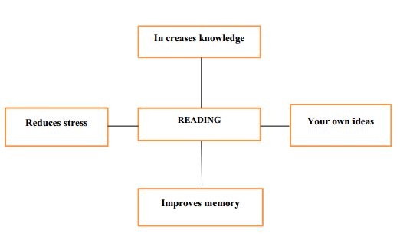

- Statement: Reading habit should be encouraged among teenagers.

- Supporting details: increase knowledge/ reduce stress/ improve memory

**ANSWERING METHOD**

**Step 1:** Analyze the topic (1 minute)

- Find synonym, phrasal verbs, collocation, etc. to change the expressions of the statement topic

- Find example for each supporting detail or clarify it with more information.

- Find your own idea and example or more information for it

**Step 2:** State your answer (2 minutes)

- Introduction: paraphrase the statement

- Body: develop the supporting details which are given as nouns, noun phrases, verb phrases into sentences. For each supporting detail, present examples or further information

- Conclusion: summarize the topic

***Answer sample:***

Reading culture seems to be forgotten because of modern technology. However, teens should engage with reading for following reasons.

First of all, the culture of reading allows young generation to widen their understanding. In fact, everything they achieve from book would fill their head with new information.

Next, reading habit would be method to free your mind. No matter how much stress they have at a school, at home, in their relationships, it all just slips away when they lose themselves in a great story.

Another good point of reading culture is the memory improvement it brings. When you read a book, you have to remember characters, their backgrounds as well as their ambitions, history, etc. It is undeniable that it is a good method to practice memorization skills.

Lastly, teens would improve focus and concentration through reading books. When they read a book, all of their attention is focused on the story. As a result, their ability to concentrate would be increase.

To sum up, the youth should be inspired to read books due to the benefits it brings.

**SPEAKING TOPICS**

**TOPIC 1: YOUR STUDY**

*Some expressions:*

- Name of some majors in university

- Name of subjects in high school

- senior student/ fresh graduate

- major in/ specialize in

- I choose it simply because …./ The reason why I decided on ….. is that …..

- The starting point was that I was born for ….., and my dream is to be a ….. one day.

- I’m not good at …., and the study of …. Is really not my cup of tea.

- ….. is the one that I really cannot get over.

- by watching videos on YouTube/ listening to songs/ practicing speaking English every day with friends/ participating in English clubs/ taking online courses/ reading English books to widen the vocabulary/ using a dictionary to get correct pronunciation

**PART 1:** Common questions

- What is your major at college?

- Why do you choose that major?

- What is the most challenging in you major?

- Do you like your time in high school?/ Do you like going to school when you were a child?

- What was your favorite subject at high school?

- How often do you go to the library?

- How do you learn English?

-

- In what ways do people can improve English?

**PART 2:** You are about to study at university. There are three things to consider: cost of the course, reputation of the university, and distance from home. Which of these is the most important?

**PART 3:** Online courses provide us with a lot of benefits.

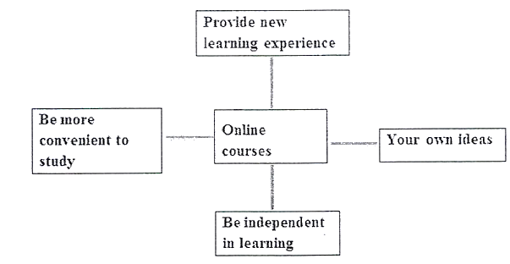

*Follow-up questions:*

- What are disadvantages of online courses?

- Are online courses beneficial to children?

**TOPIC 2: YOUR HOBBIES AND INTERESTS**

*Some expressions:*

- free time = spare time = leisure time

- Catch up on gossip with my best friends/ Watch films my boyfriend or girlfriend/ - Go window-shopping with my bestie/ Go travelling around the country or world/ Play video games/ Go on a picnic with my family members….

- Refresh or relax myself/ Ease my mind/ Release my pressure/ Ease my stress/ Keep fit/ Be in good shape/ Live a well-balanced life/ Boost family concord/ Maintain bonds with friends and family members

**PART 1:** Common questions

- What do you like to do in your spare time?

- How do you spend your holidays or weekends?

- What is your favorite way of relaxation?

- Who do you enjoy spending your free time with?

+

- Would you prefer to stay home or go out in the weekends?

**PART 2:** You have free time this weekend, and you plan to spend time with your family. There are 3 options for you to choose: going to the cinema, having meal in a restaurant, and going to the beach. Which plan will be your best choice?

**PART 3:** There are many reasons for people to take up a new hobby.

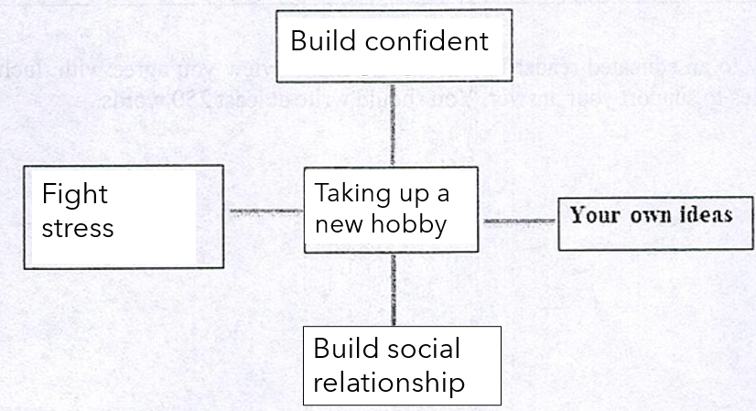

*Follow-up questions:*

- What hobbies are common in your country?

- Can hobbies have any negative effects?

- Has modern life limited the time we spend on hobbies?

**TOPIC 3: TV PROGRAMS**

*Some expressions:*

- the news/ films/ documentary/ cartoon/ game show/ sports program/ drama

- comedy/ action/ romance/ sci-fi/ animation/ ….

- broaden my horizon and enrich my knowledge/ create imagination/ entertain/ reduce stress/ help me keep us with the latest news and information

- have a better atmosphere/ great sound/ amazing visual effects

- Cheer myself up/ relax myself/ release my pressure/ escape from daily life/ boost my imagination/ please my eyes with visual effects/ maintain my childhood interest

**PART 1**: Common questions

- What is the most popular TV program in your country?

- Why do people like watching TV?

- How often do you watch TV? What is your favorite TV program?

- Do you prefer reading books or watching TV?

- Do you like watching films?

- How often do you go to the cinema?

**PART 2:** Your group of friends decide to go see a movie tonight. There are 3 options: a comedy, a horror movie, and a romantic movie. Which one is your best choice for the group?

**PART 3:** There are a lot of benefits of watching TV.

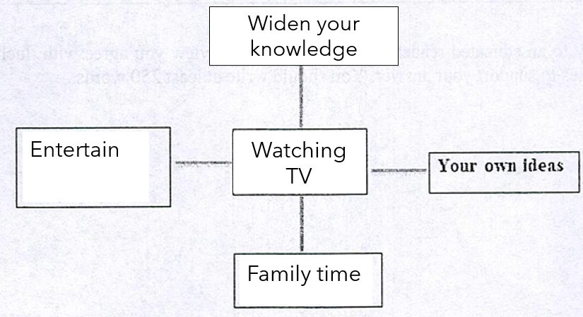

*Follow-up questions:*

- How popular is watching television in your country?

- What effects can watching television have on children?

- How the TV programs differ now than that of 10 years ago?

**TOPIC 4: TRAVEL**

*Some expressions:*

- beach/ mountain/ wildlife safari/ hiking/ countryside/ historical site/ coastal city

- go sightseeing/ take photos/ buy souvenirs/ eat local food/ enjoy specialties/ visit traditional trade villages

- cheap – expensive/ tour guide/ flight ticket/ accommodation/ transportation

- broaden my horizon/ meet different people from different places/ try different food/ learn different languages and cultures

- get away from daily routines/ release pressure/ revitalize my life/ boost family or friend bonding/ experience new customs/ visit new sceneries/

- Ha Long Bay/ Golden Bridge/ Ho Chi Minh Mausoleum/ Ba Dinh Square/ Hoan Kiem Lake/ Water Puppet theatre/ Phu Quoc Island/ Phong Nha-Ke Bang National Park/ Mekong Delta….

**PART 1:** Common questions

- Do you like travelling?

- Do you prefer to travel alone or with others?

- How often do you travel?

- What kind of travel do you like?

- What do you like to do when you travel?

- Do you like to travel abroad?

- What are some famous places in your country?

**PART 2:** Your family is going to travel abroad. There are 3 options: Thailand, Singapore and the US. Which would be the most interesting travel destination for your family?

**PART 3:** Traveling provides us with a lot of benefits.

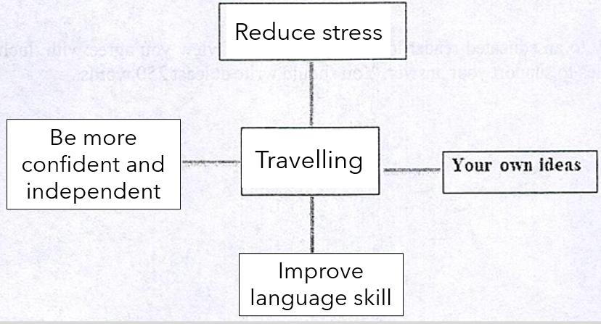

*Follow-up questions:*

- Why do some people prefer to travel abroad rather than in their own country?

- Do you think it is important to prepare before taking a trip to another country?

- Do you think it is safer to travel now than in the past?

**TOPIC 5: TECHNOLOGY**

**PART 1:** Common questions

- Do you often use the computer?

- Do you prefer desktops or laptops?

- Do you think it is important to learn how to use a computer?

- Has the Internet made your job / studies easier?

- How much time do you spend using a computer at work or at home?

- Have you ever bought anything online?

- What are the advantages of smart phones?

- How much time do you usually spend online?

- What’s your favorite website?

- Do you read online newspaper?

**PART 2:** Your younger brother is about to graduate from high school. You are thinking of buying him a present. Three options have come to your mind: a laptop, a smartphone, a smart watch. Which option will be the best?

**PART 3:** The Internet plays an important role in modern society.

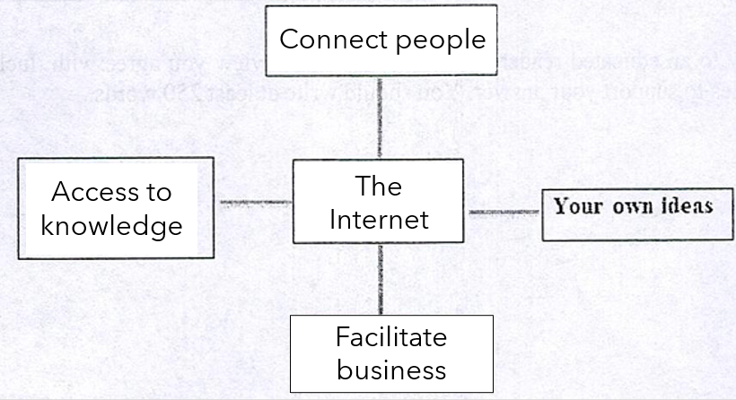

*Follow-up questions:*

- Which websites are popular among your generation?

- Do you think all information on the internet is true?

- How can people find reliable information on the internet?