**TEAM 09 AMPAGES**

**DATABASE ANALYSIS AND DESIGN**

**HISTORICAL**

|  |  |  |  |
| --- | --- | --- | --- |
| Version | Date | Author | Content |
| 0.1 | 22/10/2022 | Trinh Ngoc Phu | Create Document |
| 0.2 | 01/11/2022 | Nguyen Ha | Draw ERD |
| 0.3 | 06/11/2022 | Nguyen Ha | Update content |
| 1.0 | 06/11/2022 | Trinh Ngoc Phu | Check document |

**CONTENT**

**I. Introduction:** 3

**1. Goal:** 3

**2. Execute team:** 3

**3. Reader:** 3

**II. ERD:** 4

**III. Database schema:** 4

**IV. Logic Data Diagram:** 5

# **I. Introduction:**

## **1. Goal:**

This document is used to describe the database of the Academic Advisor Management website.

## **2. Execute team:**

|  |  |
| --- | --- |
| Full name | Role |
| Trinh Ngoc Phu | **Leader** |
| Ma Khon Tuyen | Member |
| Nguyen Ha | Member |
| Tran Thanh Hoai | Member |
| Nguyen Trong Thang | Member |
| Do Trong Quang | Member |

## **3. Reader:**

|  |  |
| --- | --- |
| Reader | Content |
| Trinh Ngoc Phu | II, III, IV |
| Ma Khon Tuyen | II, III, IV |
| Nguyen Ha | II, III, IV |
| Tran Thanh Hoai | II, III, IV |
| Nguyen Trong Thang | II, III, IV |
| Do Trong Quang | II, III, IV |

# **II. ERD:**

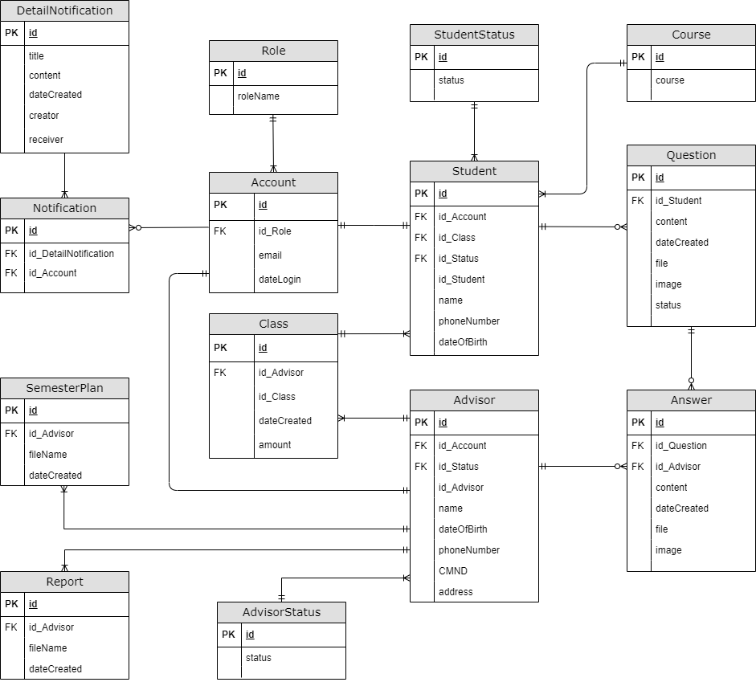

# **III. Database schema:**

1. ROLE (**ID**, ROLENAME)
2. ACCOUNT (**ID,** EMAIL, ID_ROLE)
3. STUDENT (**ID,** ID_ACCOUNT, ID_CLASS, ID_STATUS, ID_STUDENT, NAME, PHONENUMBER, DATEOFBIRTH).
4. ADVISOR (**ID,** ID_ACCOUNT, ID_ADVISOR, NAME, PHONENUMBER, DATEOFBIRTH).
5. CLASS (**ID**,ID_ADVISOR, ID_CLASS, DATECREATED, AMOUNT).
6. QUESTION (**ID**, ID_STUDENT,CONTENT, DATECREATED, FILE, IMAGE, STATUS ).
7. ANSWER (**ID,** ID_QUESTION, ID_ADVISOR, CONTENT, DATECREATED, FILE, IMAGE).
8. STUDENTSTATUS (**ID,** STATUS).
9. COURSE (**ID,** COURSE).
10. DETAILNOTIFICATION **(ID,** TITLE, CONTENT, DATECREATED, CREATOR, RECEIVER).
11. NOTIFICATION (**ID**, ID_DETAILNOTIFICATION, ID_ACCOUNT).
12. ADVISORTSTATUS (**ID,** STATUS).
13. SEMESTERPLAN(**ID**, ID_ADVISOR, FILENAME, DATACREATED)
14. REPORT(**ID**, ID_ADVISOR, FILENAME, DATACREATED)

# **IV. Logic Data Diagram:**

1. **ROLE TABLE**

|  |  |  |  |  |
| --- | --- | --- | --- | --- |
| No. | Column Name | Description | Data Type | Allow Nulls |
|  | **id** | Role id | Int | Not Null |
|  | roleName | Role of user. | Nvarchar (50) | Not Null |

1. **ACCOUNT TABLE**

|  |  |  |  |  |
| --- | --- | --- | --- | --- |
| No. | Column Name | Description | Data Type | Allow Nulls |
|  | **id** | Account id | Int | Not Null |
|  | id_Role | Role id | Int | Not null |
|  | email | User email, used for login | Varchar (100) | Not null |

1. **STUDENT TABLE**

|  |  |  |  |  |
| --- | --- | --- | --- | --- |
| No. | Column Name | Description | Data Type | Allow Nulls |
|  | **id** | Student id | Int | Not null |
|  | id_Account | Account id | Int | Not null |
|  | id_Class | Class id | Int | Not null |
|  | id_Status | Status id | Int | Not null |
|  | id_Student | Student code | Varchar(10) | Not null |
|  | name | Student name | Nvarchar (100) | Not null |
|  | phoneNumber | Student personal phone number | Varchar(10) | Null |
|  | dateOfBirth | Student date of birth | Date | Null |

1. **ADVISOR TABLE**

|  |  |  |  |  |
| --- | --- | --- | --- | --- |
| No. | Column Name | Description | Data Type | Allow Nulls |
|  | **id** | Advisor id | Int | Not null |
|  | id_Account | Account id | Int | Not null |
|  | id_Advisor | Advisor code | Varchar(20) | Not null |
|  | name | Advisor name | Nvarchar(100) | Not null |
|  | dateOfBirth | Advisor date of birth | Date | Null |
|  | phoneNumber | Advisor personal phone number | Varchar(10) | Null |

1. **CLASS TABLE**

|  |  |  |  |  |
| --- | --- | --- | --- | --- |
| No. | Column Name | Description | Data Type | Allow Nulls |
|  | **id** | Class id | Int | Not null |
|  | id_Advisor | Advisor id | Int | Not null |
|  | id_Class | Class code | Varchar(50) | Not null |
|  | dateCreated | Date class was created | Datetime | Null |
|  | amount | Total number of student in class | Int | Null |

1. **QUESTION TABLE**

|  |  |  |  |  |
| --- | --- | --- | --- | --- |
| No. | Column Name | Description | Data Type | Allow Nulls |
|  | **id** | Question id | Int | Not null |
|  | id_Student | Student id | Int | Not null |
|  | content | Content of the question | Nvarchar (256) | Not null |
|  | dateCreated | Date question was created | Datetime | Null |
|  | file | File name attached to the question | Varchar (100) | Null |
|  | image | Picture attached to the question | Varchar (100) | Null |
|  | status | Status of the question | Nvarchar (50) | Null |

1. **ANSWER TABLE**

|  |  |  |  |  |
| --- | --- | --- | --- | --- |
| No. | Column Name | Description | Data Type | Allow Nulls |
|  | **id** | Answer id | Int | Not null |
|  | id_Question | Question id | Int | Not null |
|  | id_Advisor | Advisor id | Int | Not null |
|  | content | Content of the answer | Nvarchar (256) | Not null |
|  | dateCreated | Date answer was created | Datetime | Null |
|  | file | File name attached to the answer | Varchar (100) | Null |
|  | image | Picture attached to the answer | Varchar (100) | Null |

1. **STUDENTSTATUS TABLE**

|  |  |  |  |  |
| --- | --- | --- | --- | --- |
| No. | Column Name | Description | Data Type | Allow Nulls |
|  | **id** | Status id | Int | Not null |
|  | status | Learning status of student | Nvarchar(100) | Not null |

1. **COURSE TABLE**

|  |  |  |  |  |
| --- | --- | --- | --- | --- |
| No. | Column Name | Description | Data Type | Allow Nulls |
|  | **id** | Course id | Int | Not null |
|  | course | Course student | Int | Not null |

|  |  |  |  |  |
| --- | --- | --- | --- | --- |
| No. | Column Name | Description | Data Type | Allow Nulls |
|  | **id** | Detail notification id | Int | Not null |
|  | title | The title of the notification | Nvarchar (100) | Not null |
|  | content | The content of the notification | Nvachar (256) | Not null |
|  | dateCreated | Date notification was created | Datetime | Null |
|  | creator | Notification creator | Nvarchar (100) | Null |
|  | receiver | Notification recipient | Nvarchar (100) | Null |

1. **DETAILNOTIFICATION TABLE**
2. **NOTIFICATION TABLE**

|  |  |  |  |  |
| --- | --- | --- | --- | --- |
| No. | Column Name | Description | Data Type | Allow Nulls |
|  | **Id** | Notification id | Int | Not null |
|  | id_DetailNotification | Detail notification id | Int | Not null |
|  | id_Account | Account id | Int | Not null |

1. **ADVISORSTUDENT TABLE**

|  |  |  |  |  |
| --- | --- | --- | --- | --- |
| No. | Column Name | Description | Data Type | Allow Nulls |
|  | **id** | Status id | Int | Not null |
|  | status | Learning status of student | Nvarchar(100) | Not null |

1. **SEMESTERPLAN TABLE**

|  |  |  |  |  |
| --- | --- | --- | --- | --- |
| No. | Column Name | Description | Data Type | Allow Nulls |
|  | **id** | Semester plan id | Int | Not null |
|  | id_Advisor | Advisor id | Int | Not null |
|  | fileName | File name of semester plan | Varchar (100) | Not null |
|  | dateCreated | Date semester plan was created | Datetime | Null |

1. **REPORT TABLE**

|  |  |  |  |  |
| --- | --- | --- | --- | --- |
| No. | Column Name | Description | Data Type | Allow Nulls |
|  | **id** | Report id | Int | Not null |
|  | id_Advisor | Advisor id | Int | Not null |
|  | fileName | File name of report | Varchar (100) | Not null |
|  | dateCreated | Date report was created | Datetime | Null |