Tổng kết điểm :

Module 1 :

Quiz 1: 100%

Quiz 2: 100%

Quiz 3: 90%

Module 2 :

Quiz 1: 100%

Quiz 2: 100%

Quiz 3: 100%

Module 3 :

Quiz 1: 100%

Quiz 2: 100%

Quiz 3: 100%

Module 4 :

Quiz 1: 100%

Quiz 2: 100%

Quiz 3: 90%

**MODULE 1 (3 QUIZ)**

Practice Quiz: Artificial Intelligence and Machine Learning



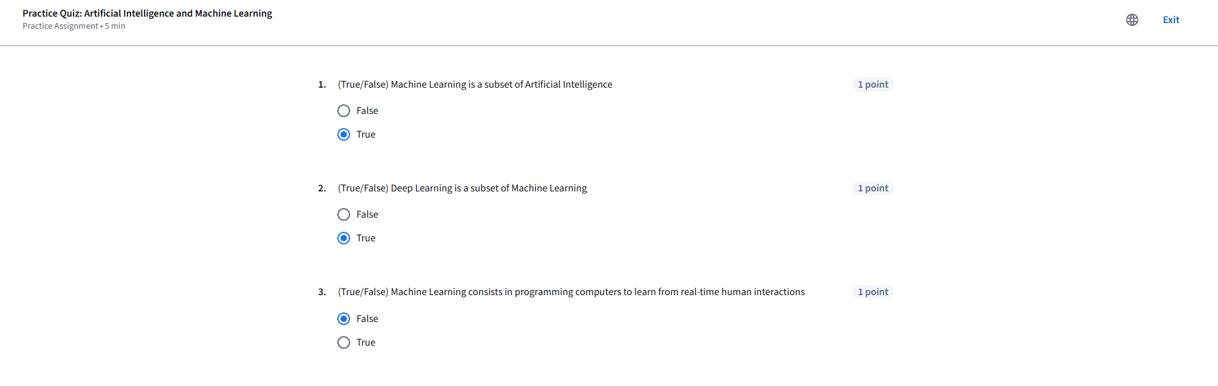

Practice Quiz: Modern AI Applications and Workflows



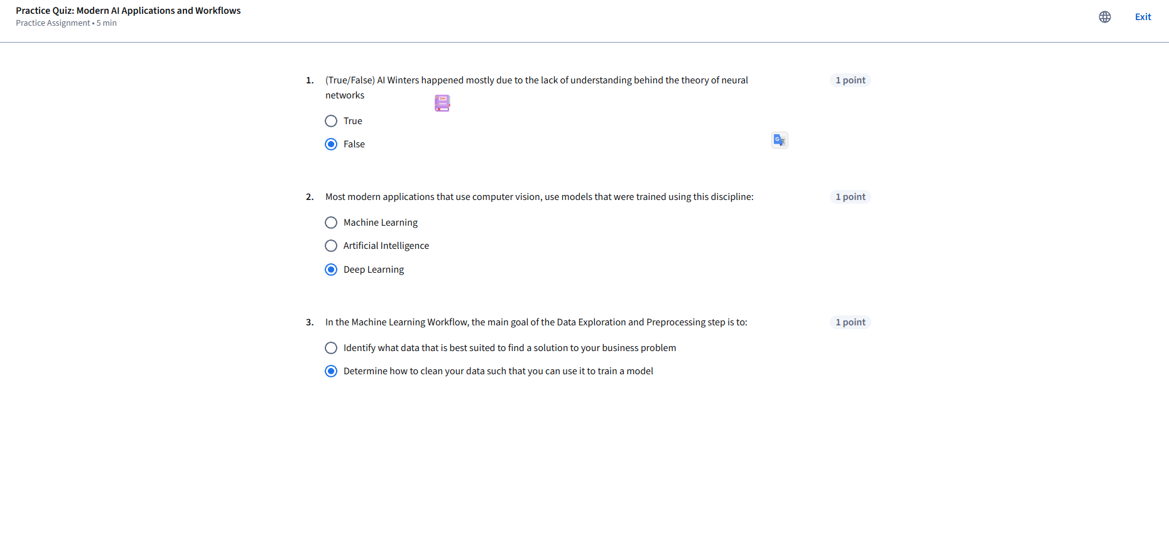

Graded Quiz: Module 1 - Modern AI and its Applications



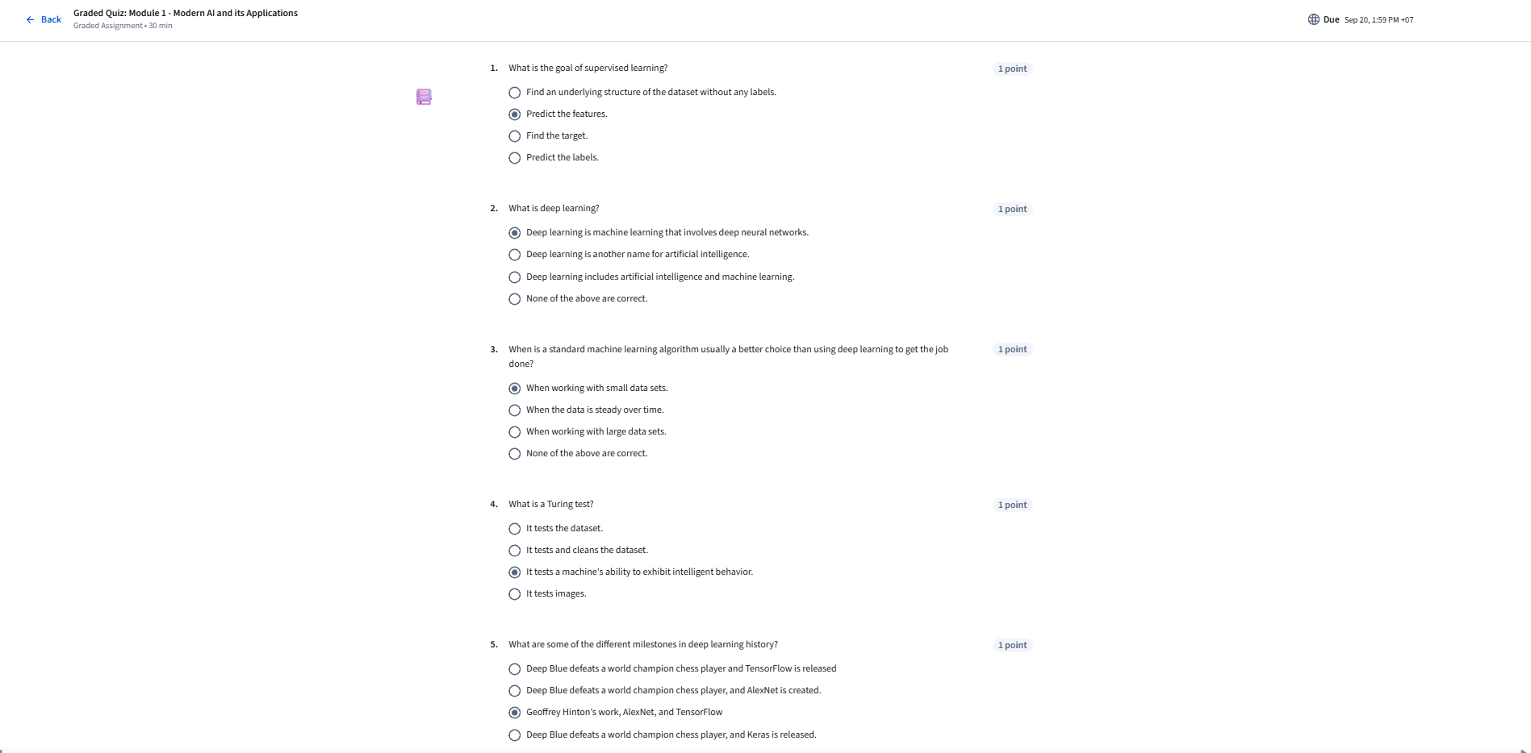

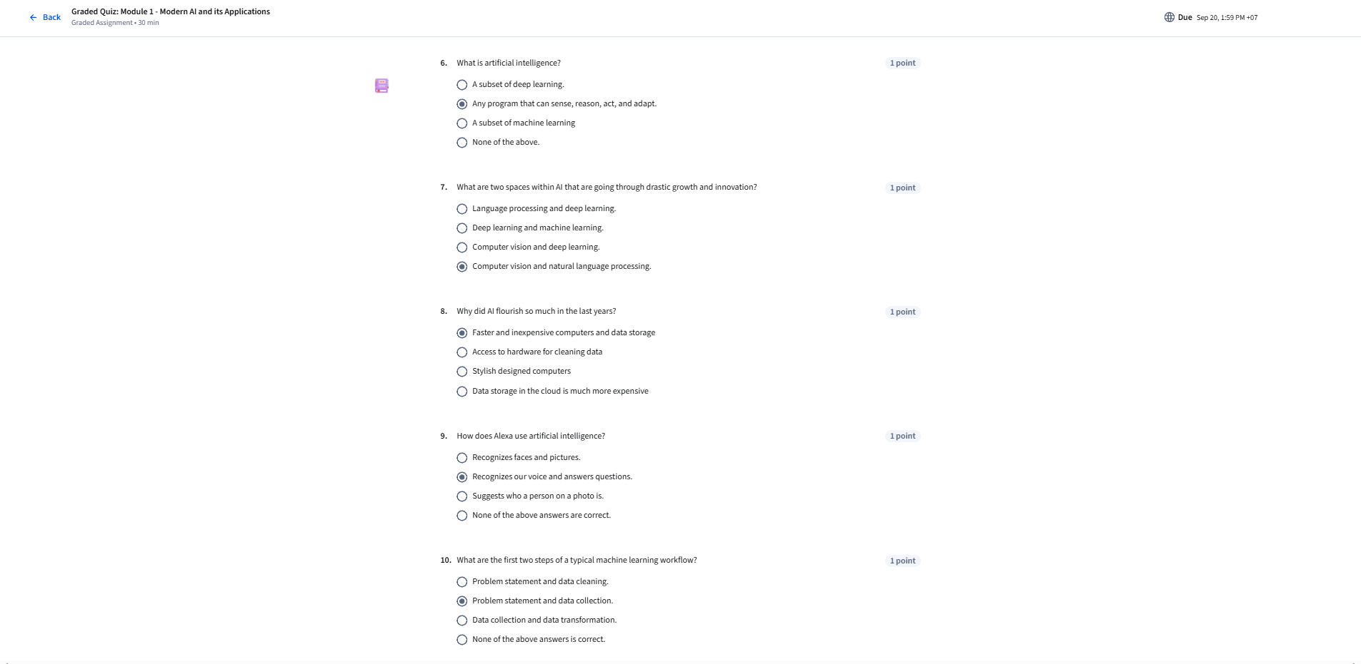

**MODULE 2 ( 3 QUIZ)**

Practice Quiz: Retrieving Data



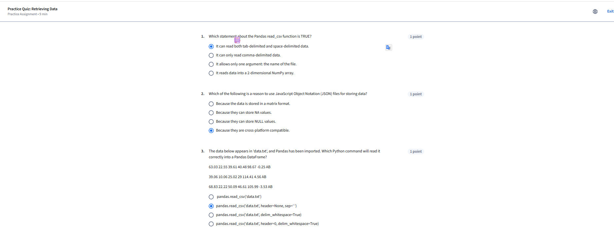

Practice Quiz: Data Cleaning



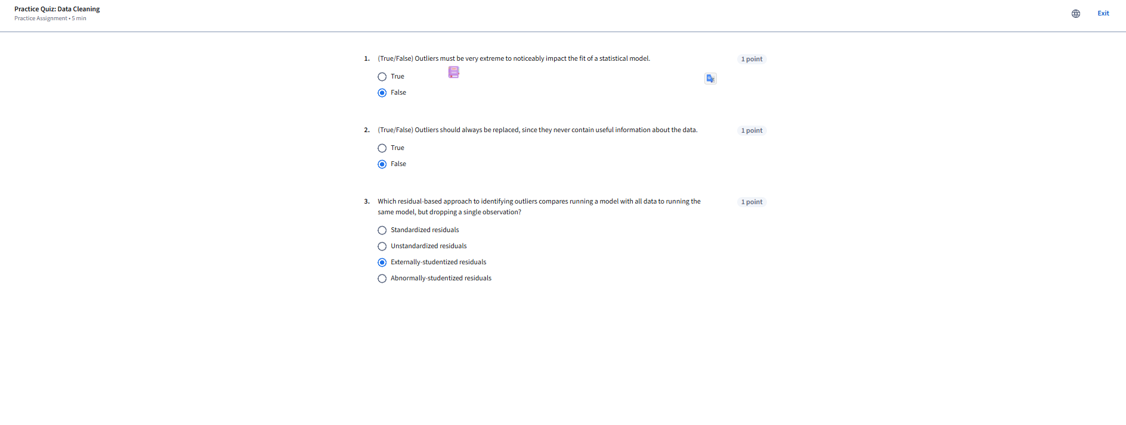

Graded Quiz: Module 2 - Retrieving Data and Cleaning Data



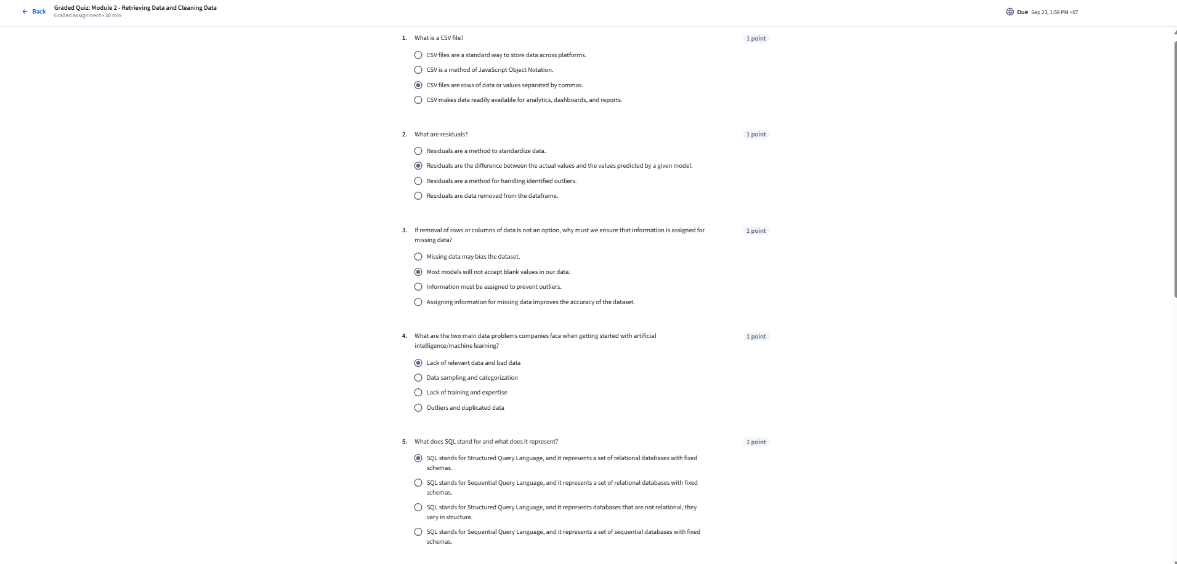

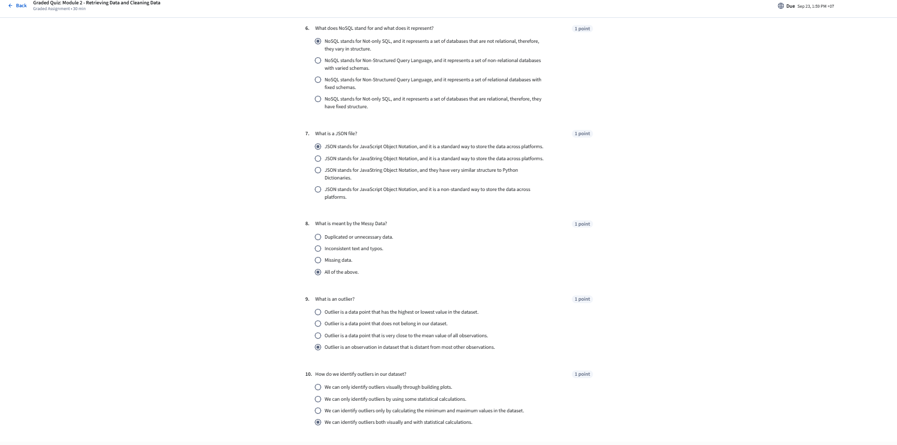

**MODULE 3 (3 QUIZ)**

Practice Quiz: Exploratory Data Analysis





Practice Quiz: Feature Engineering and Variable Transformation



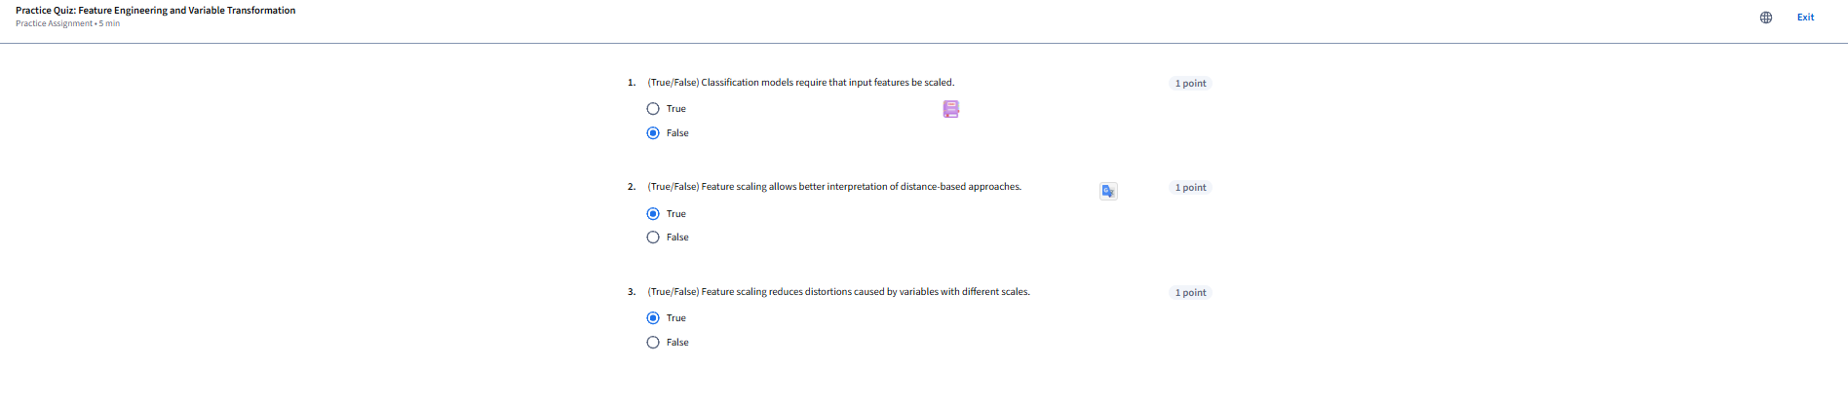

Graded Quiz: Module 3 - Exploratory Data Analysis and Feature Engineering



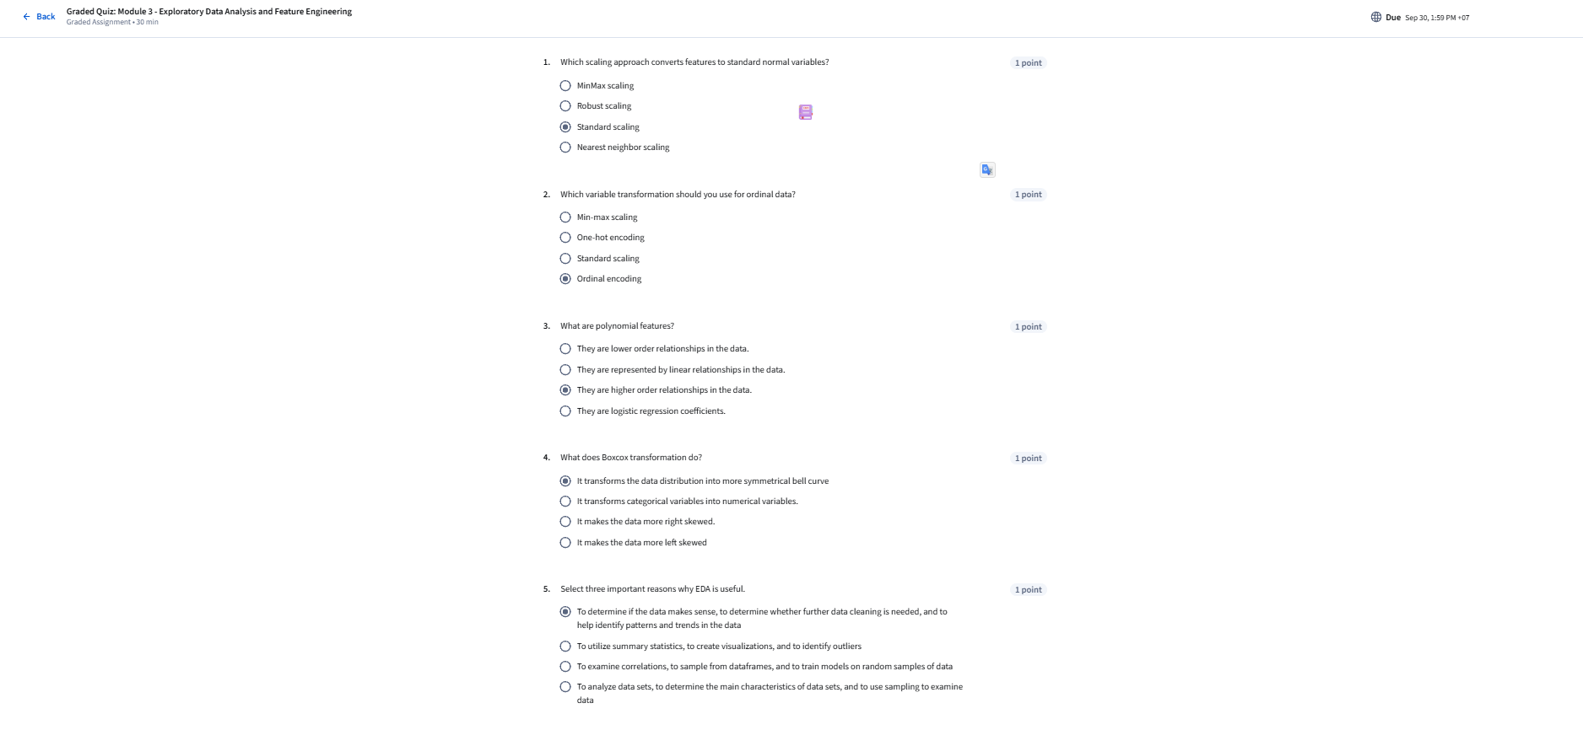

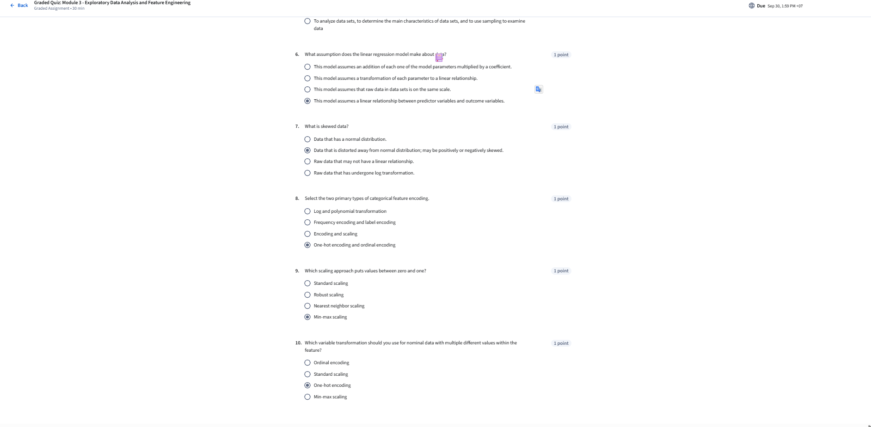

**MODULE 4 (3 QUIZ)**

Practice Quiz: Estimation and Inference, and Hypothesis Testing



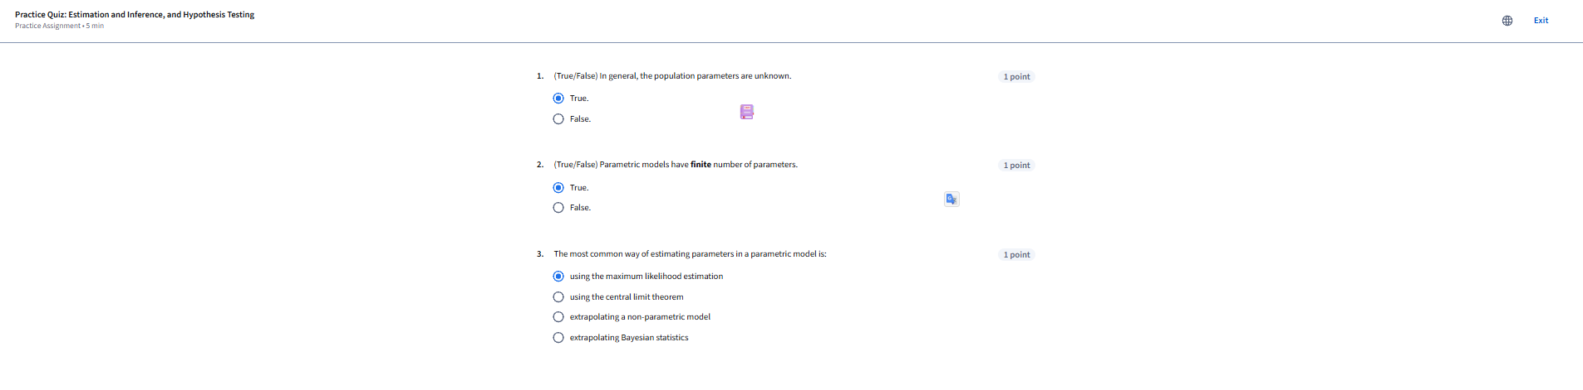

Practice Quiz: Hypothesis Testing



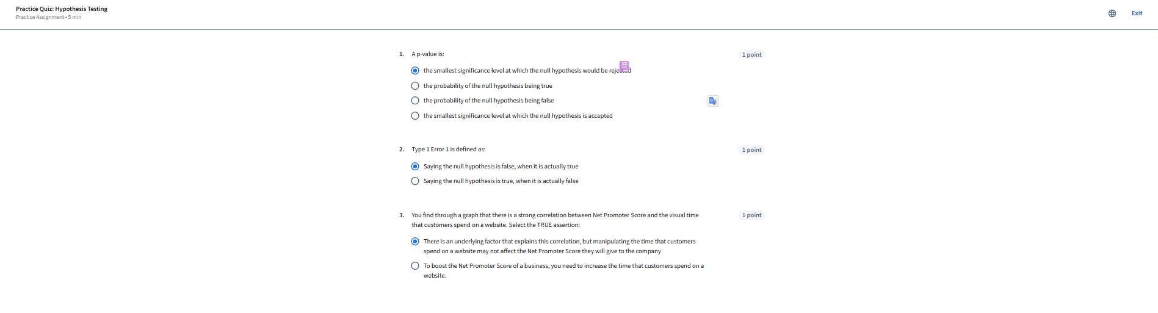

Graded Quiz: Module 4 - Inferential Statistics and Hypothesis Testing



