Tổng kết điểm :

Module 1 :

Quiz 1: 100%

Quiz 2: 100%

Quiz 3: 100%

Module 2 :

Quiz 1: 100%

Quiz 2: 100%

Quiz 3: 100%

Module 3 :

Quiz 1: 66%

Quiz 2: 80%

Module 4 :

Quiz 1: 100%

Quiz 2: 100%

Quiz 3: 90%

Module 5 :

Quiz 1: 100%

Quiz 2: 80%

**MODULE 1 (3 QUIZ)**

Practice Quiz: Introduction to Supervised Machine Learning



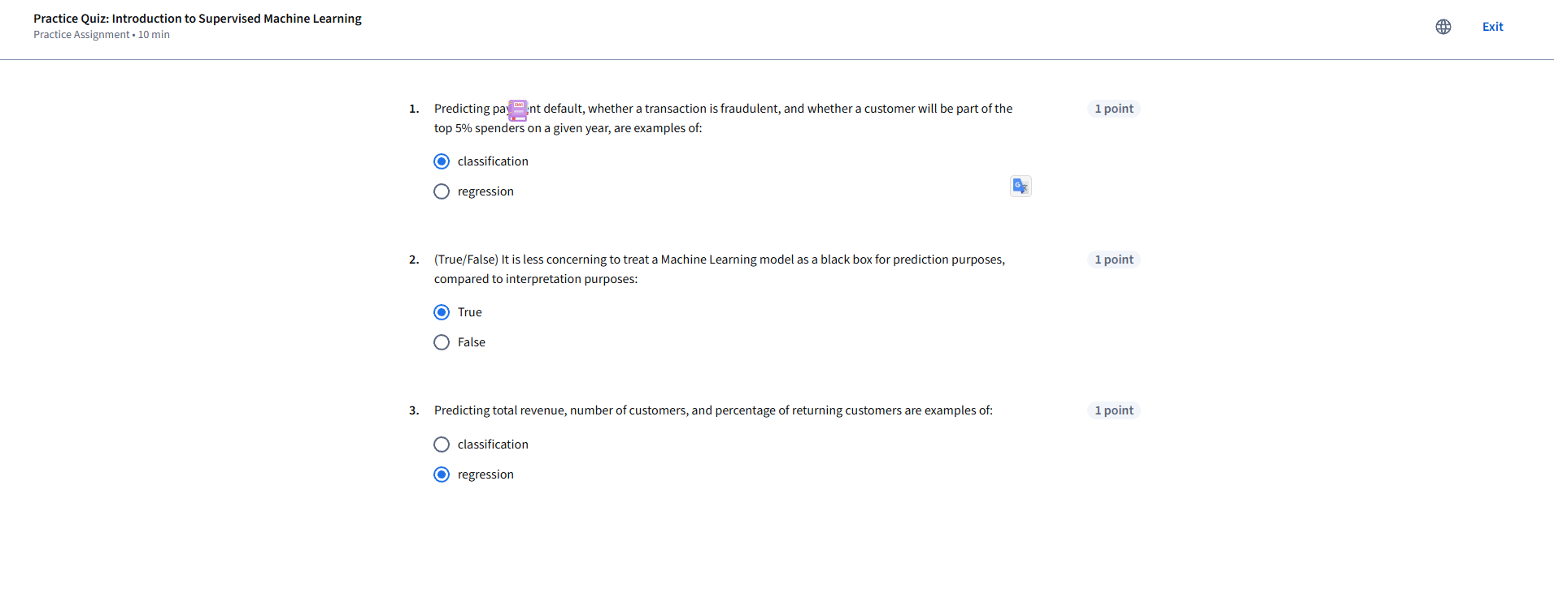

Practice Quiz: Linear Regression



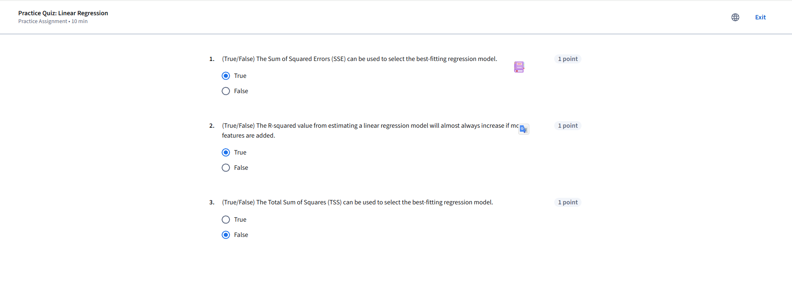

Module 1 Graded Quiz: Introduction to Supervised Machine Learning and Linear Regression



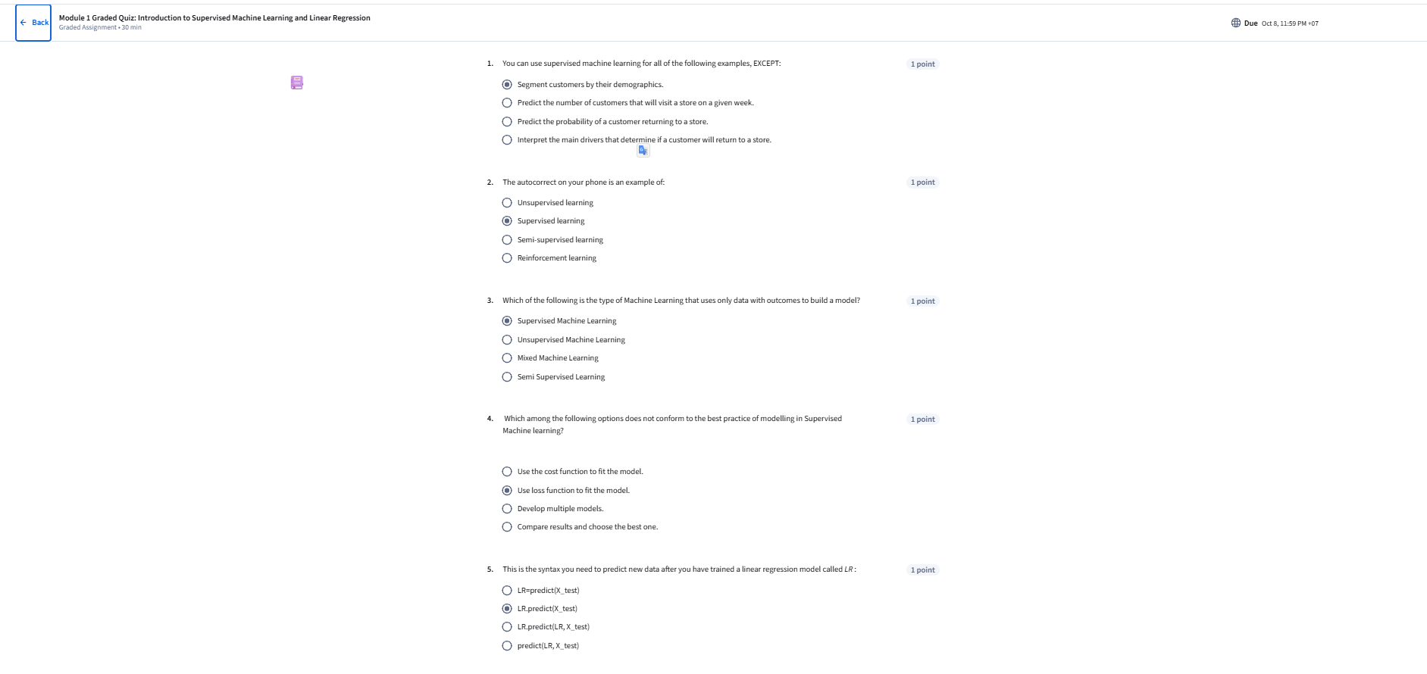

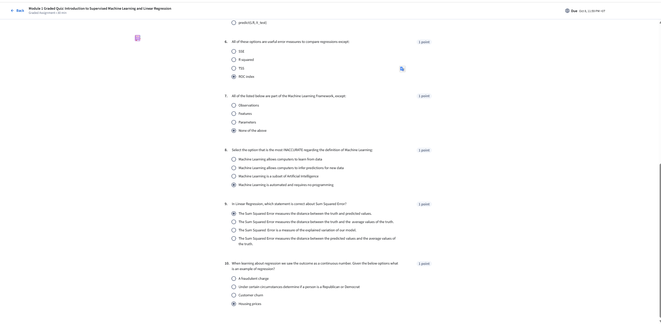

**MODULE 2 ( 3 QUIZ)**

Practice Quiz: Training and Test Splits





Practice Quiz: Polynomial Regression

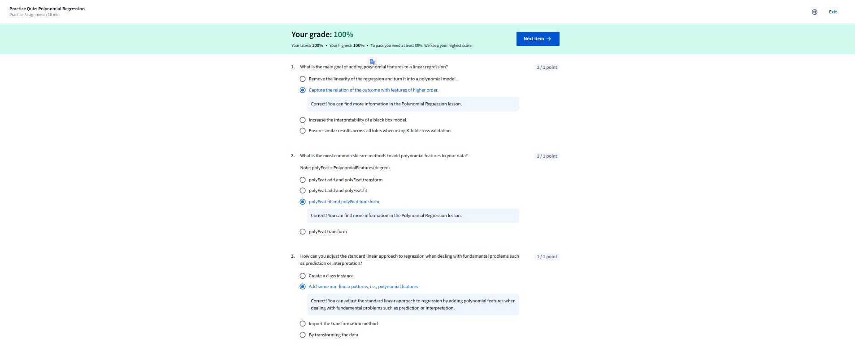

Module 2 Graded Quiz: Data Splits and Polynomial Regression

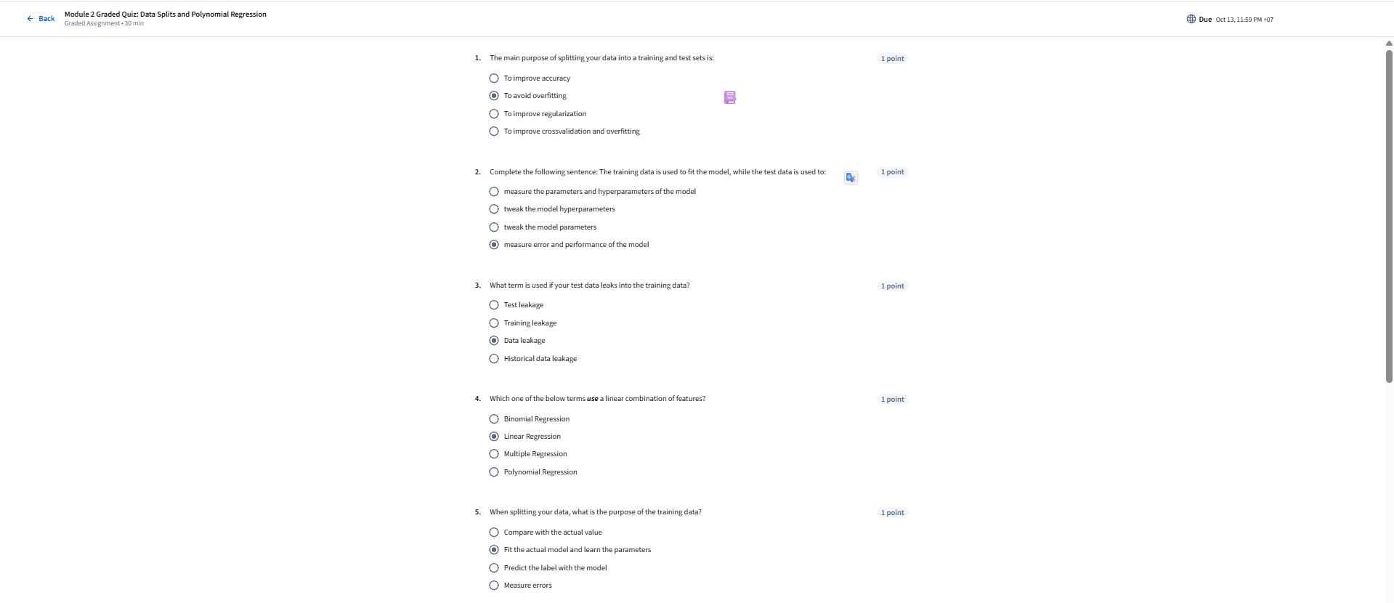

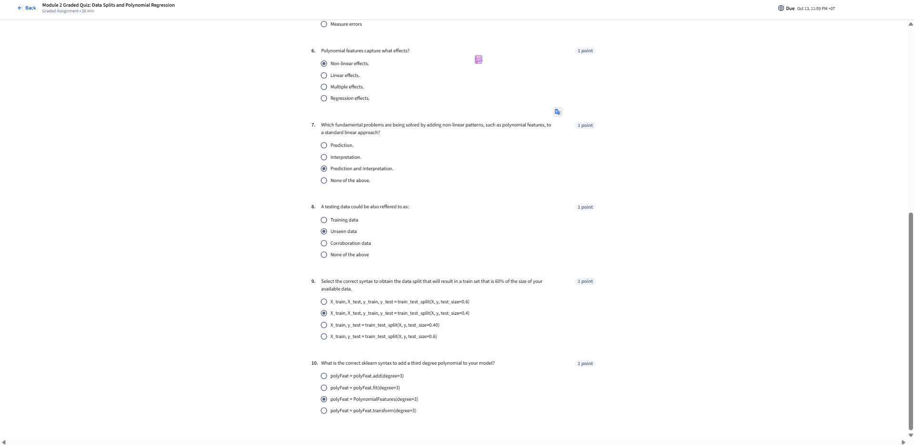

**MODULE 3 (2 QUIZ)**

Practice Quiz: Cross Validation

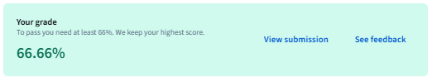



Graded: Module 3 Quiz: Cross Validation



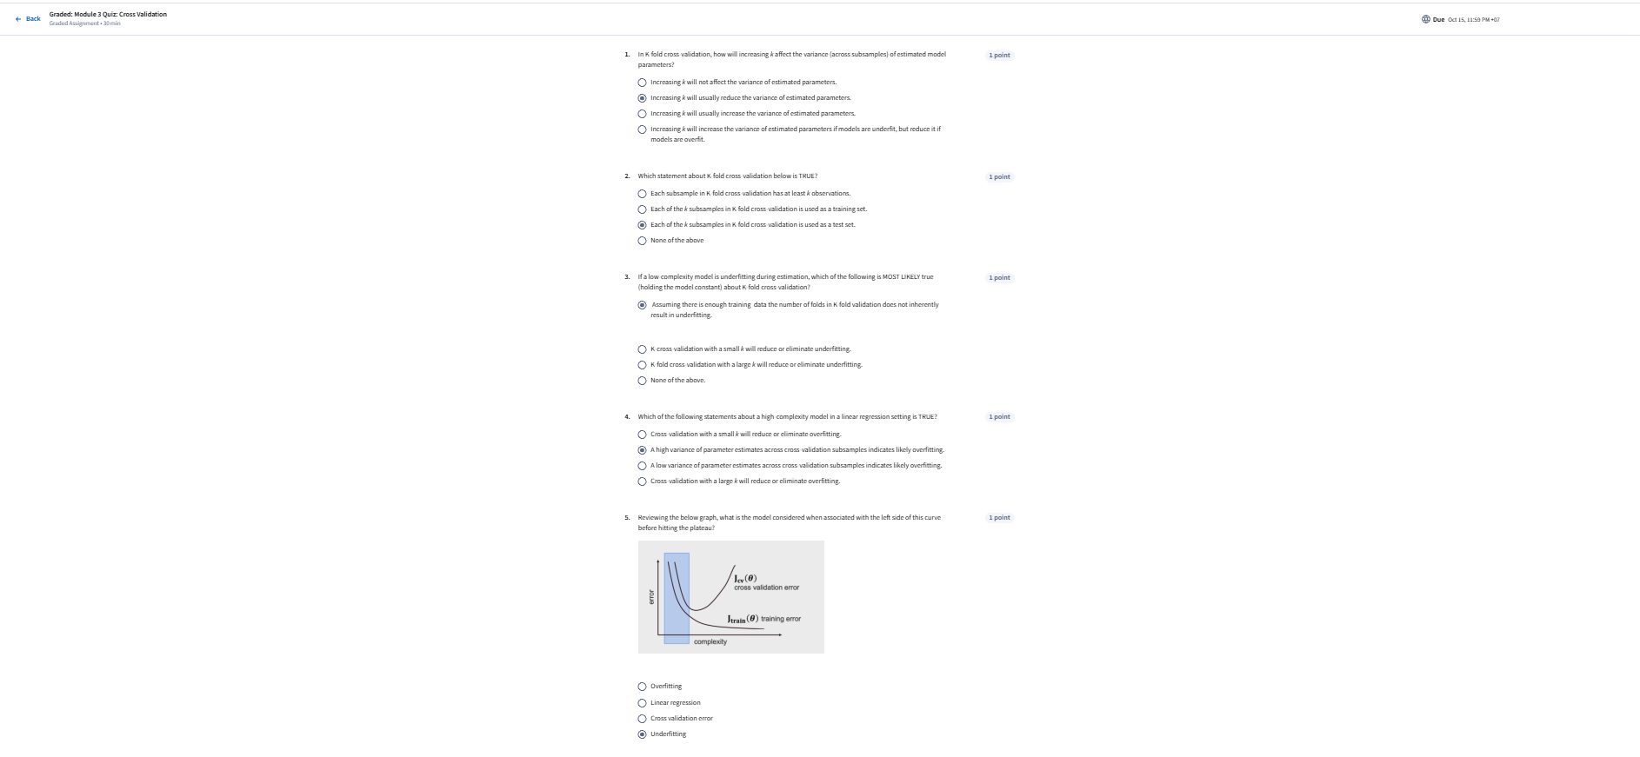

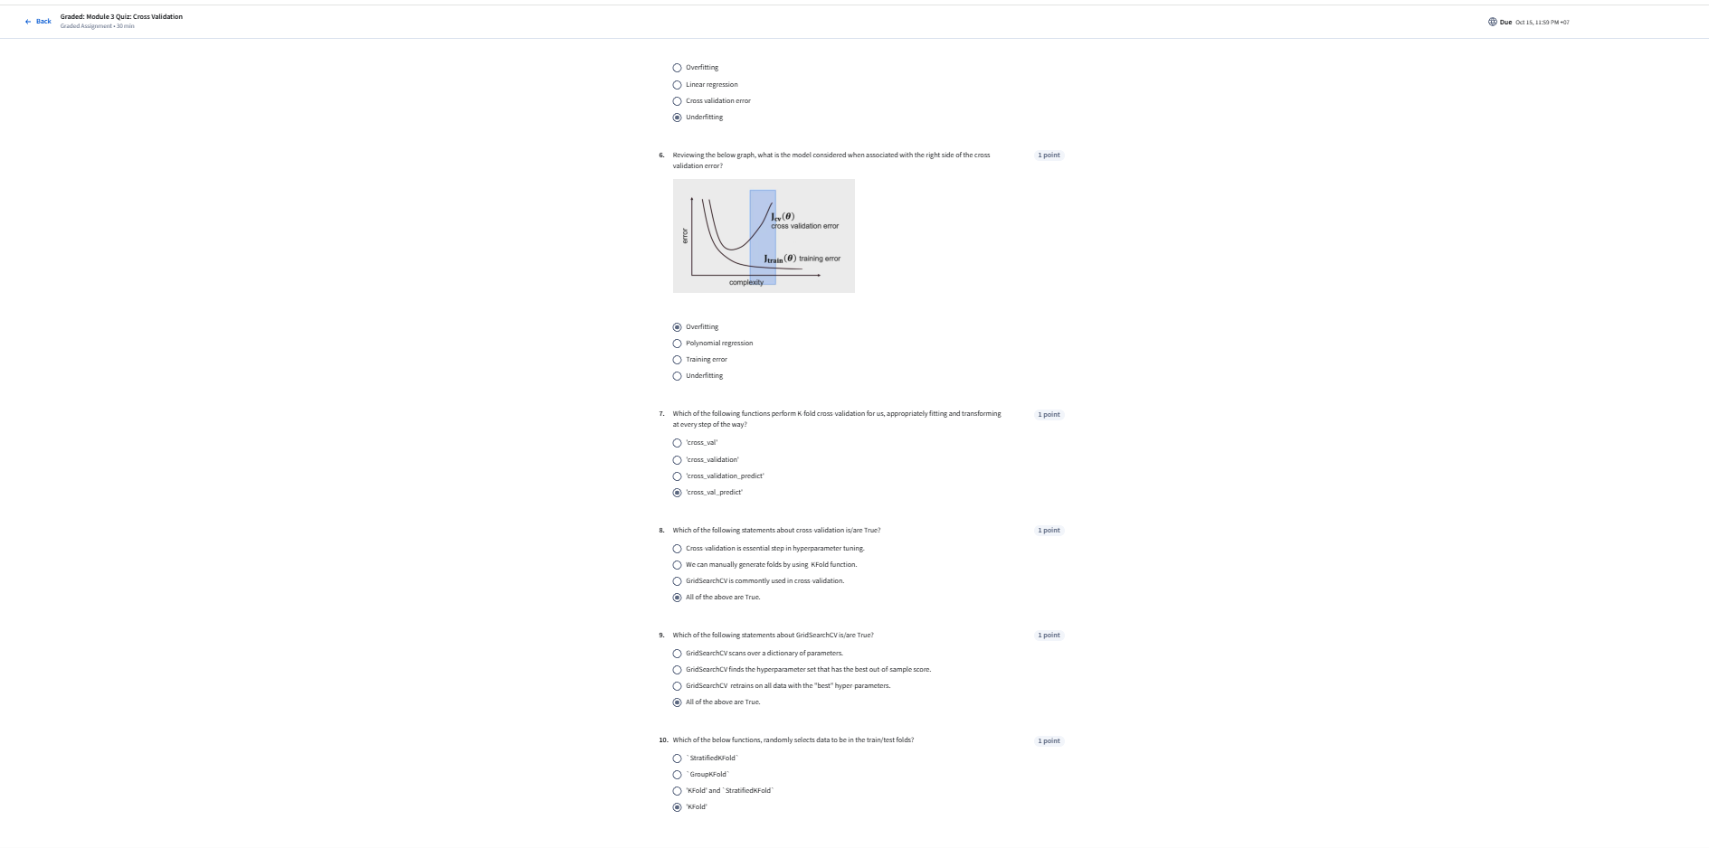

**MODULE 4 (3 QUIZ)**

Practice Quiz: Regularization Techniques



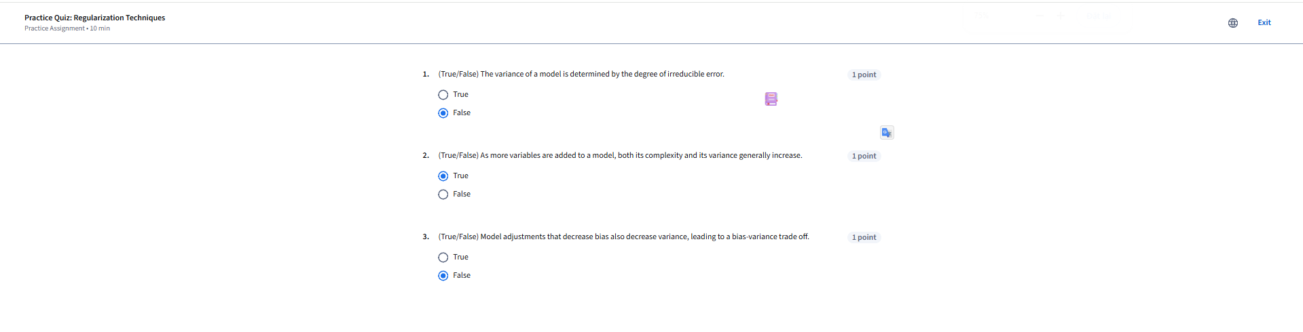

Practice Quiz: Polynomial Features and Regularization



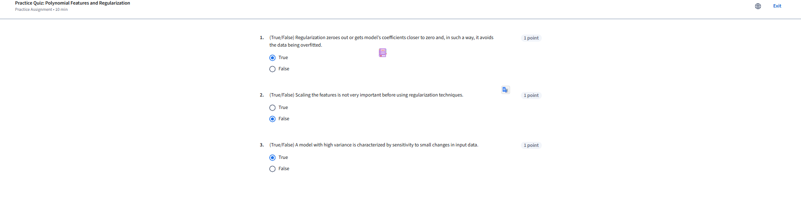

Module 4 Graded Quiz: Bias Variance Trade off and Regularization Techniques: Ridge, LASSO, and Elastic Net



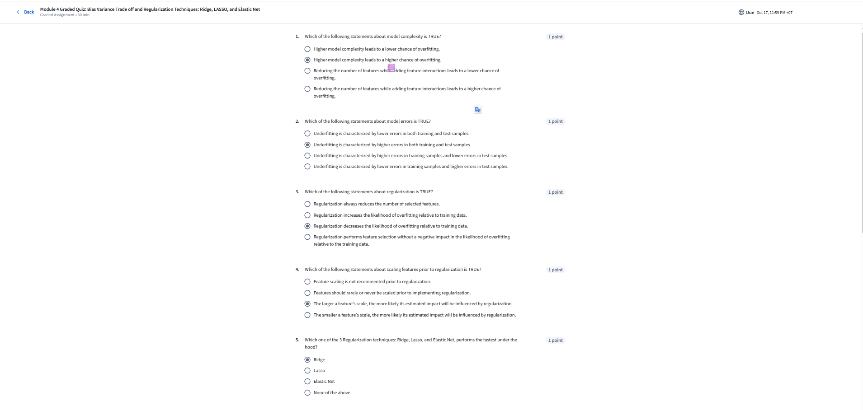

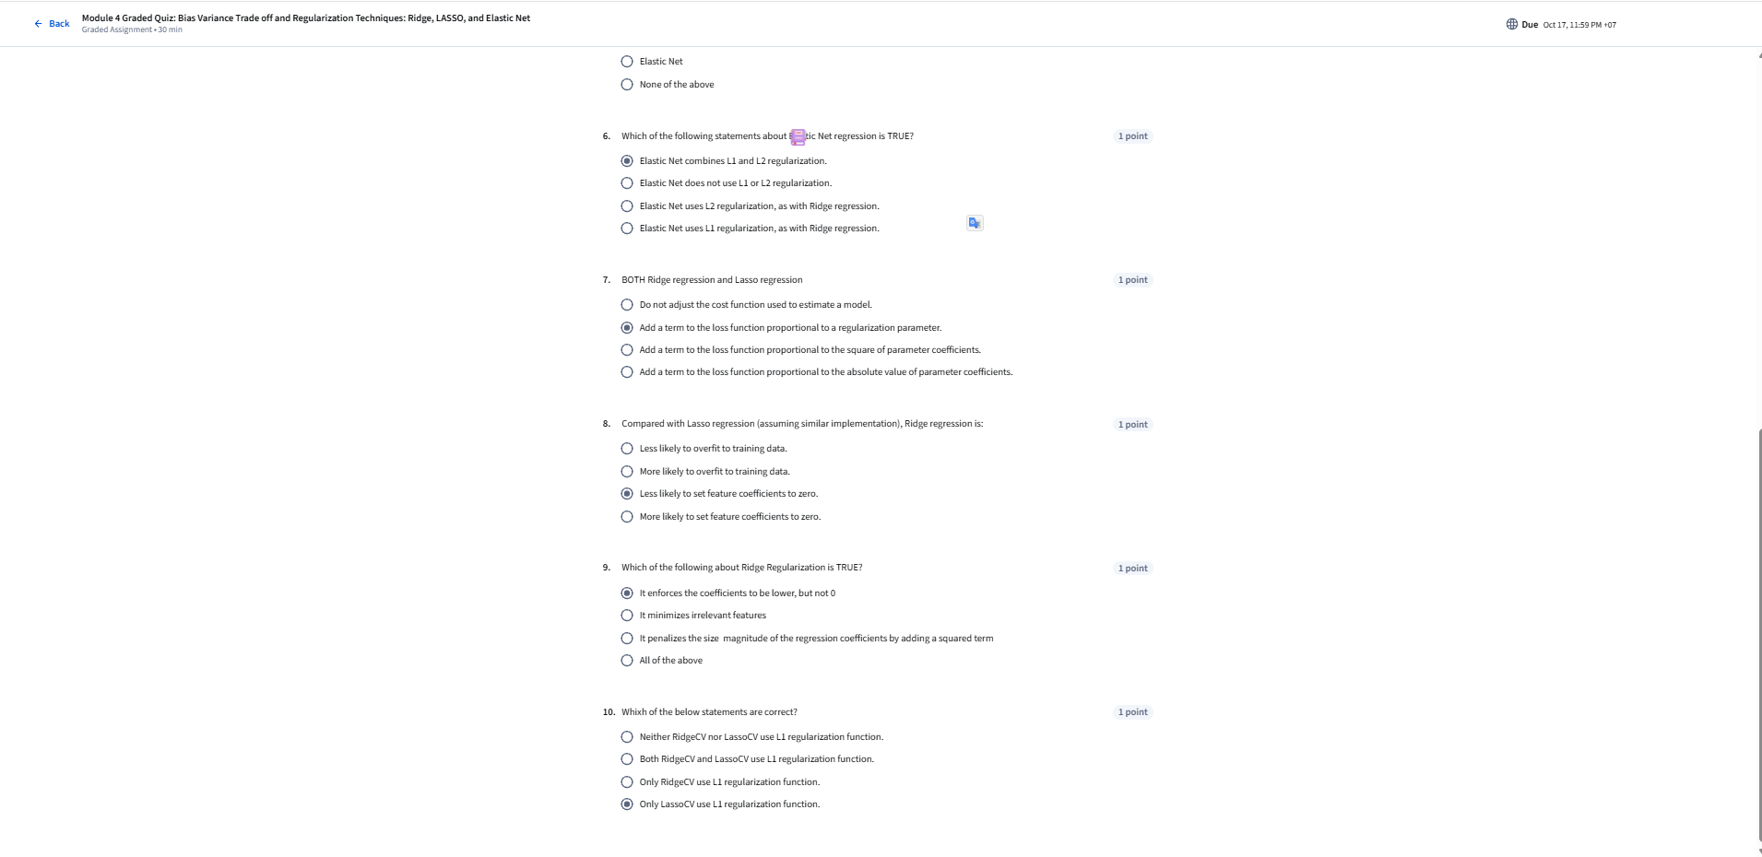

**MODULE 5 (2 QUIZ)**

Practice Quiz: Details of Regularization





Module 5 Graded Quiz: Regularization Details



