Tổng kết điểm :

Module 1 :

Quiz 1: 100%

Quiz 2: 100%

Quiz 3: 100%

Module 2 :

Quiz 1: 100%

Quiz 2: 100%

Quiz 3: 87.50%

Module 3 :

Quiz 1: 100%

Quiz 2: 100%

Quiz 3: 100%

Quiz 4: 67.50%

Module 4 :

Quiz 1: 100%

Quiz 2: 100%

Quiz 3: 90%

Module 5 :

Quiz 1: 100%

Quiz 2: 100%

Quiz 3: 100%

Quiz 4: 100%

Quiz 5: 100%

Quiz 6: 80%

Module 6:

Quiz 1: 100%

Quiz 2: 100%

Quiz 3: 70%

**MODULE 1 (3 QUIZ)**

Logistic Regression



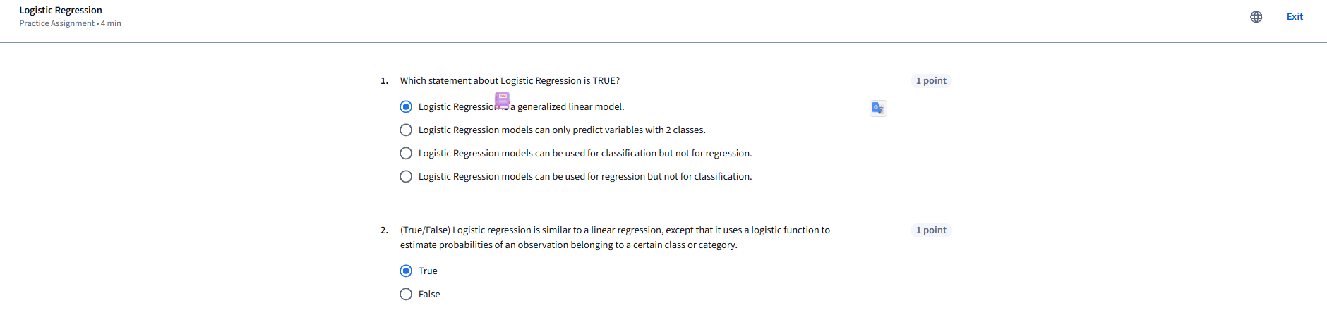

Logistic Regression Labs



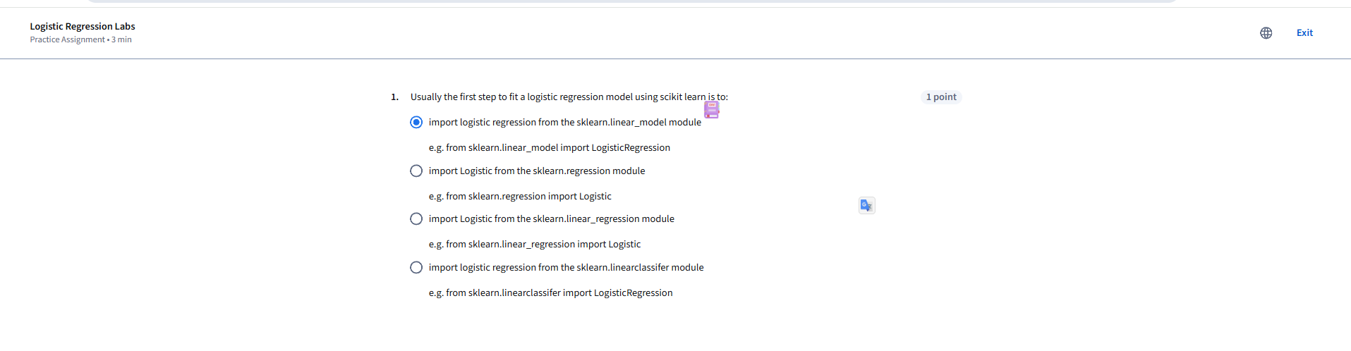

Module 1 Graded Quiz Logisitic Regression



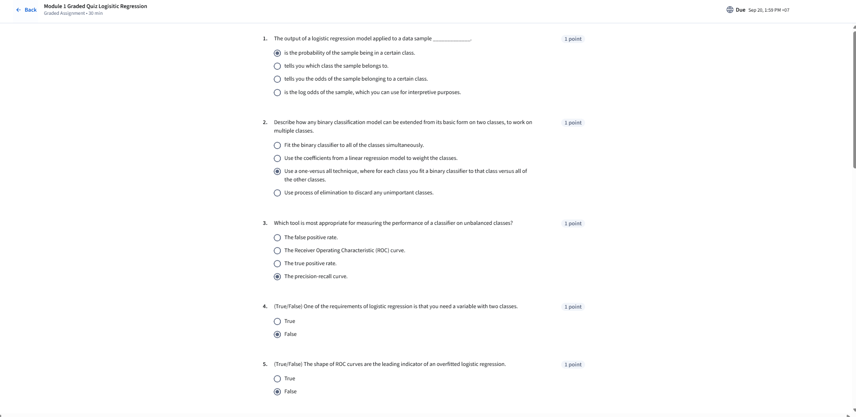

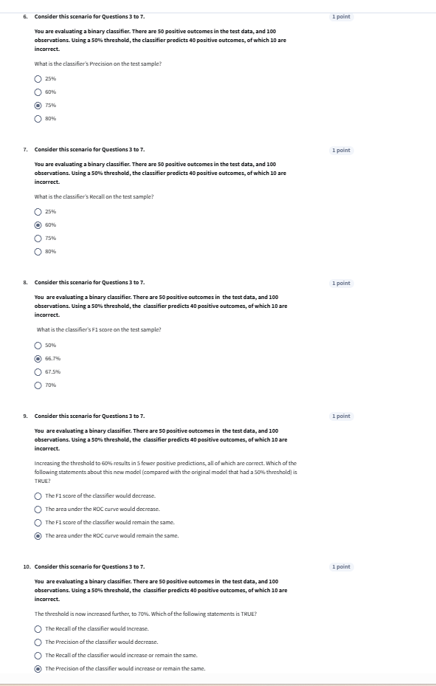

**MODULE 2 ( 3 QUIZ)**

K Nearest Neighbors



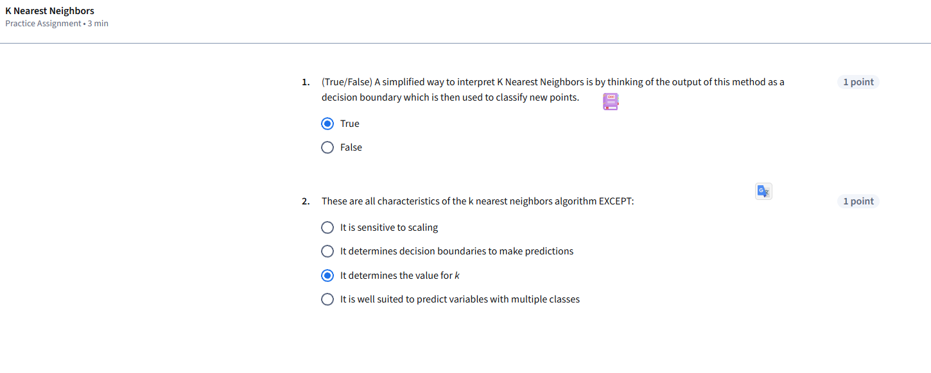

K Nearest Neighbors Labs



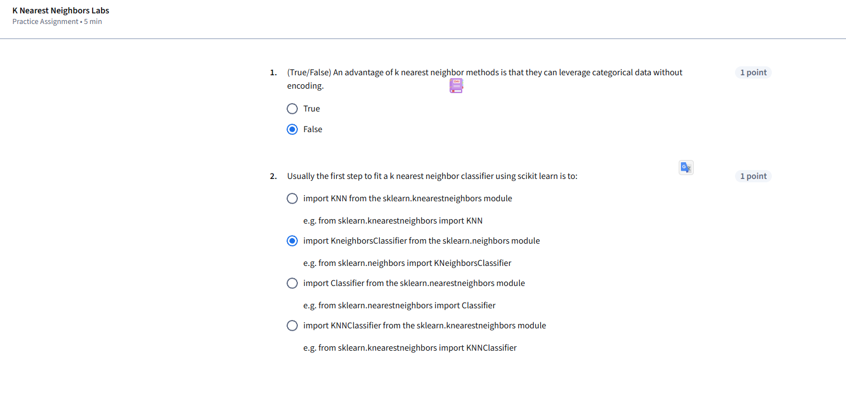

Module 2 Graded Quiz - KNN



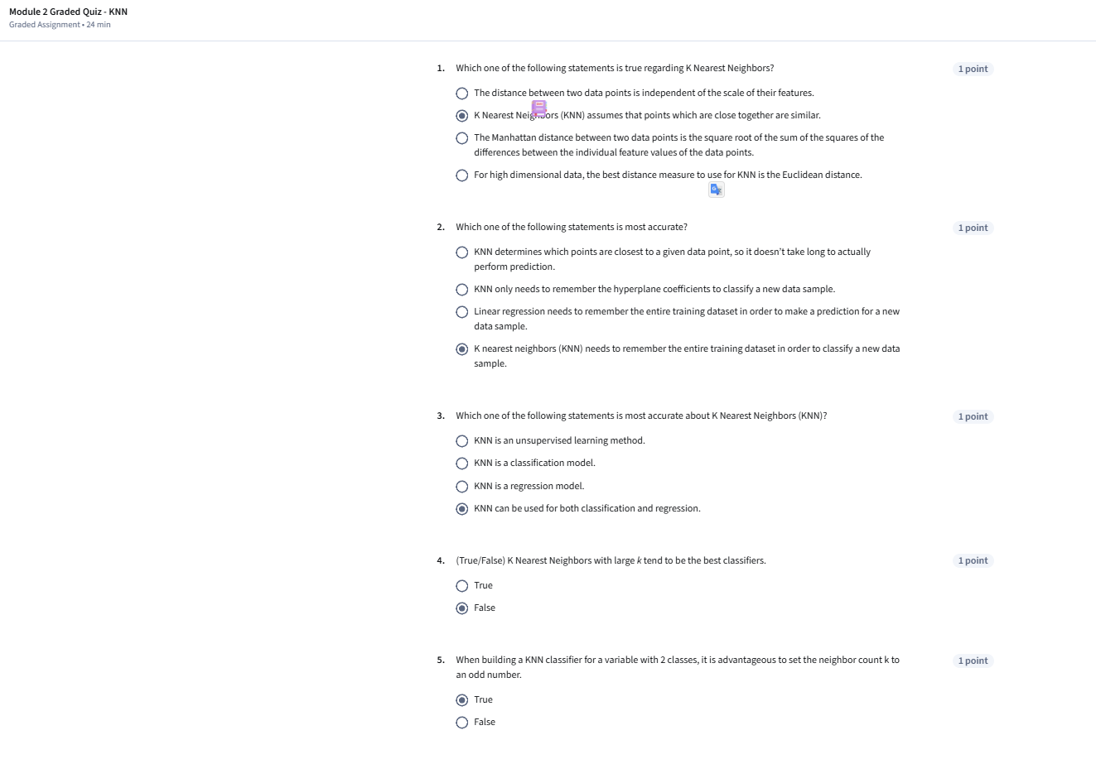

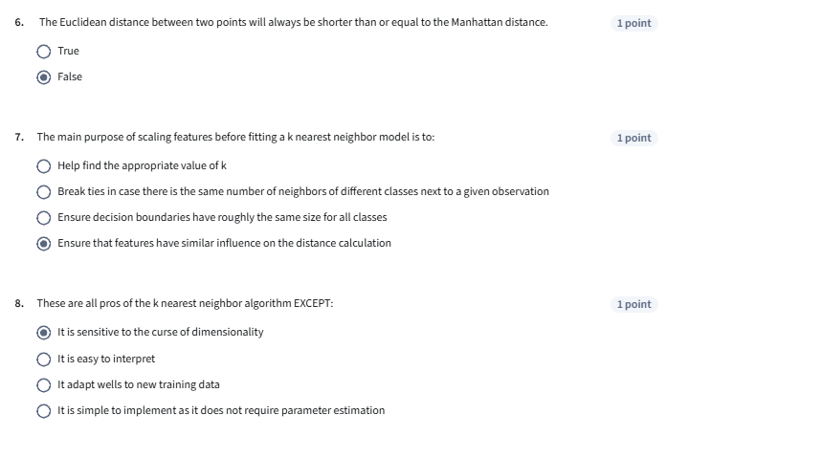

**MODULE 3 (4 QUIZ)**

Support Vector Machines



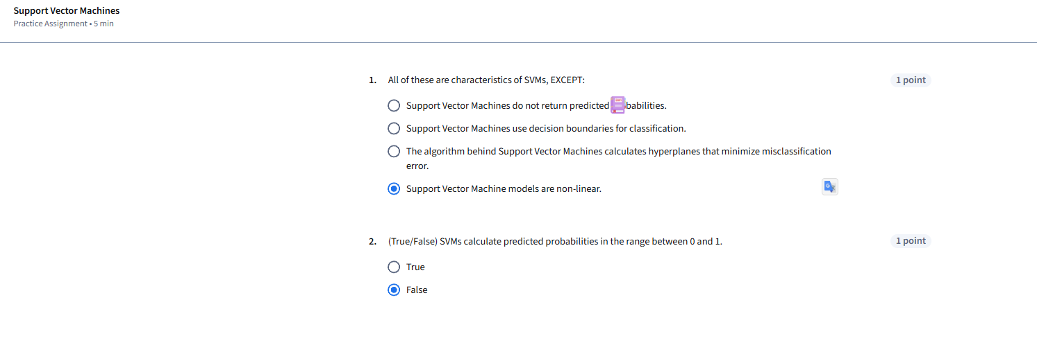

Support Vector Machines Kernels



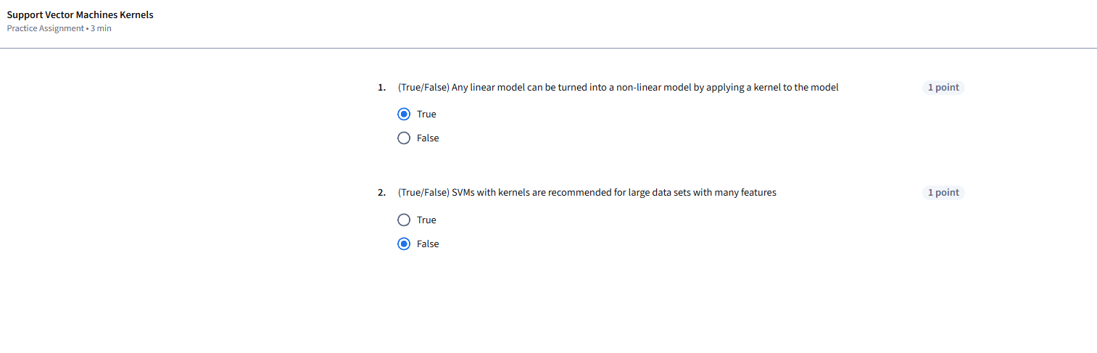

Support Vector Machines Labs



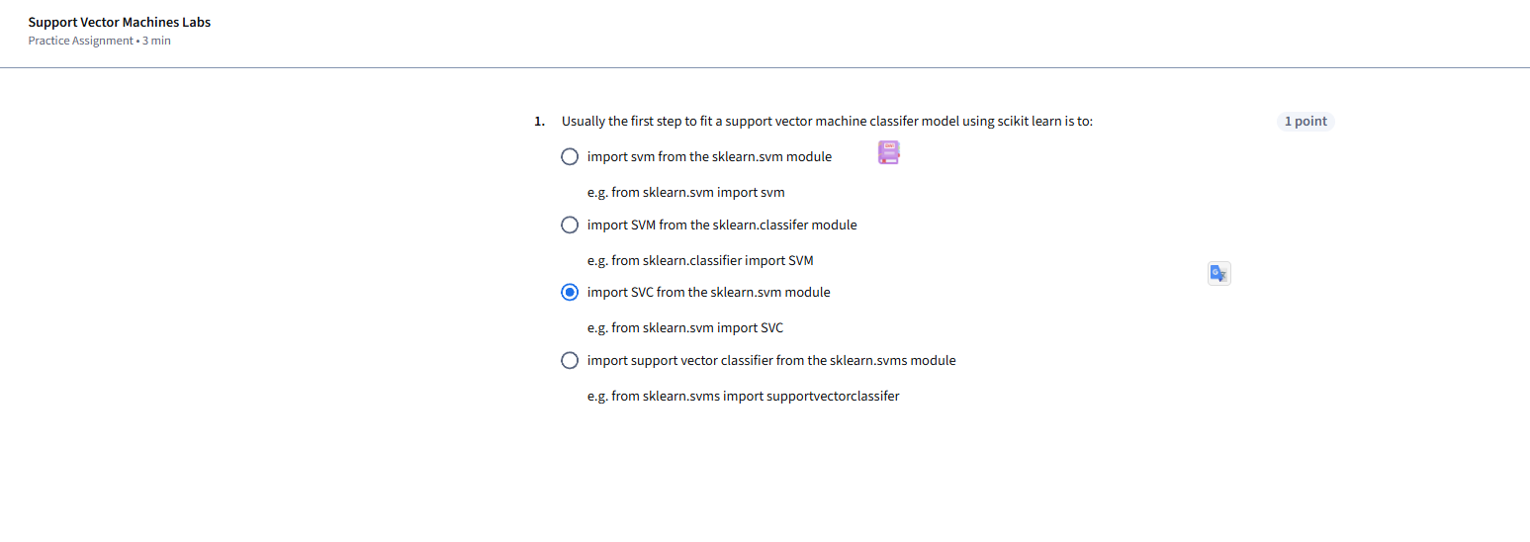

Module 3 Graded Quiz: Support Vector Machines



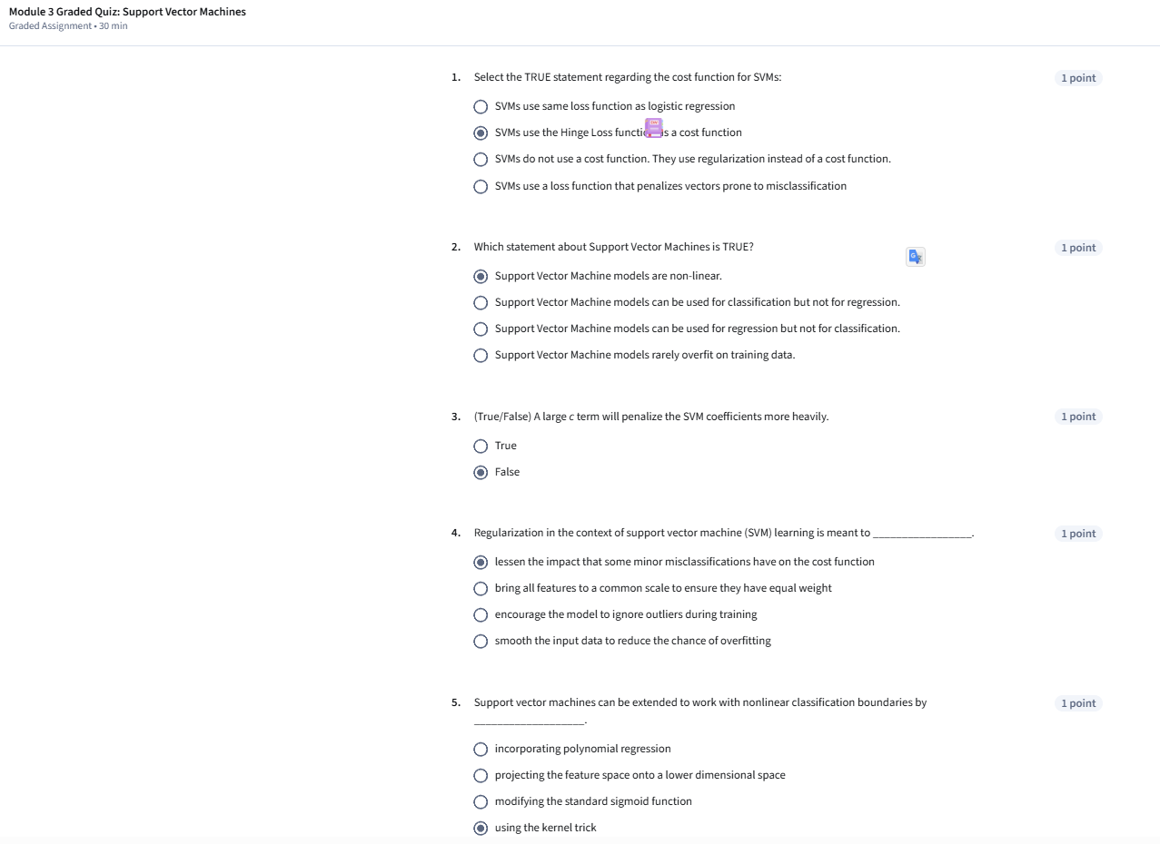

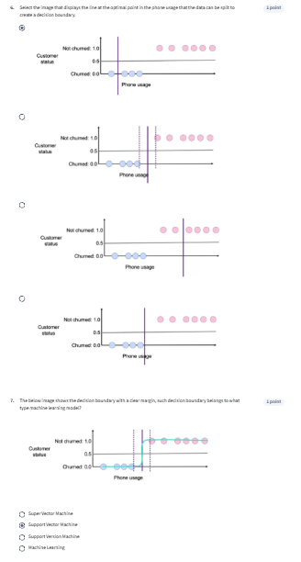

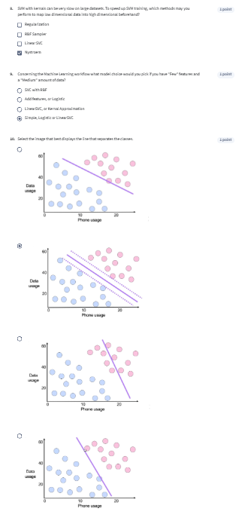

**MODULE 4 (3 QUIZ)**

Decision Trees



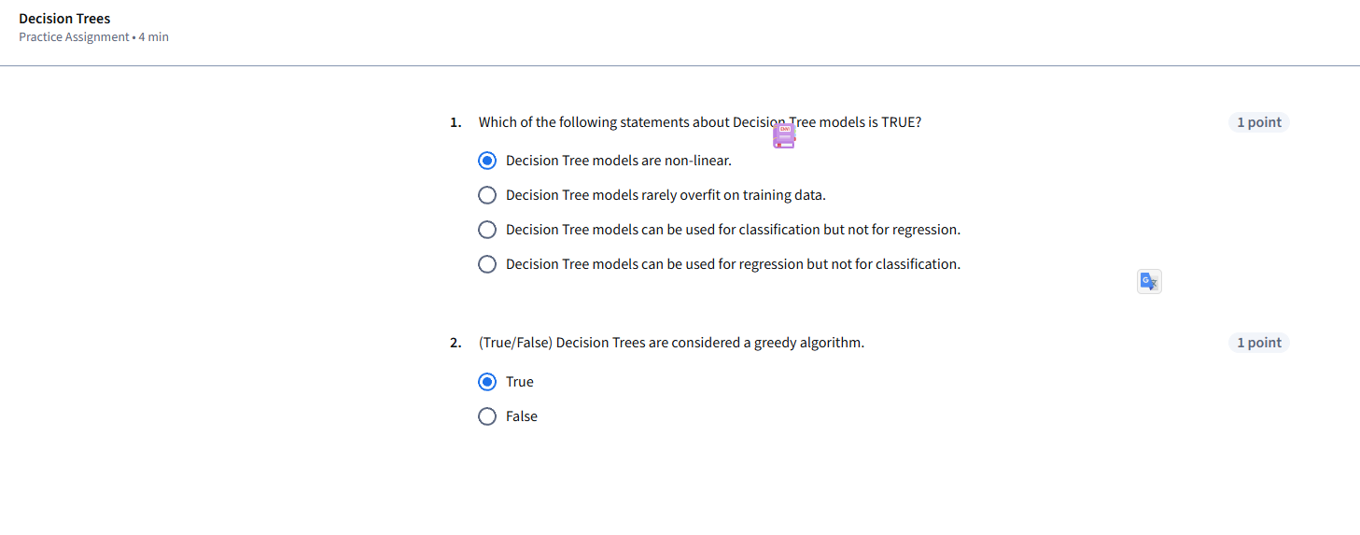

Decision Trees Labs



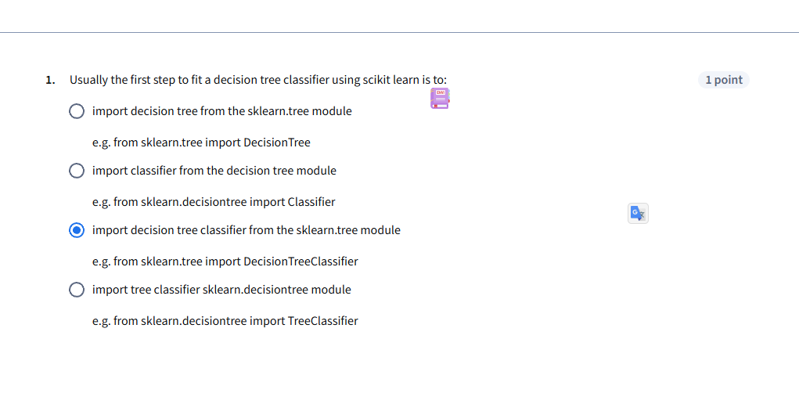

Module 4 Graded Quiz: Decision Trees



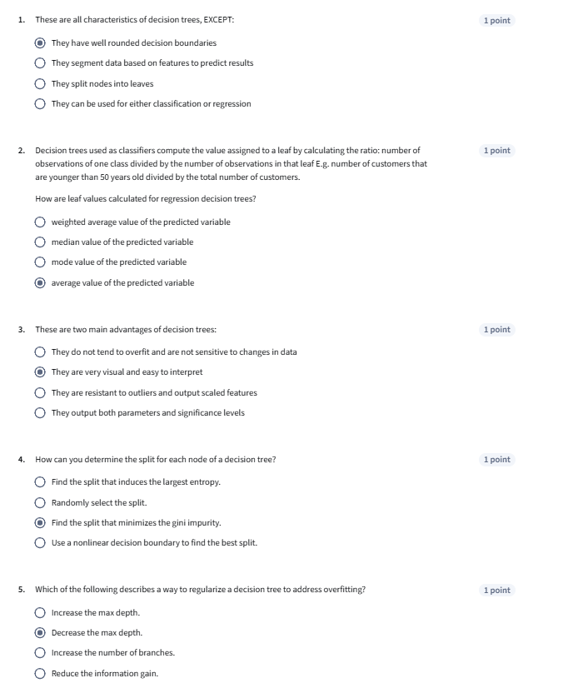

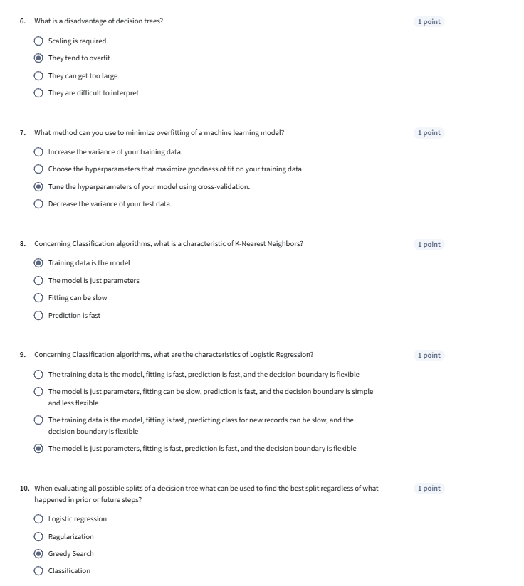

**MODULE 5 (6 QUIZ)**

Bagging



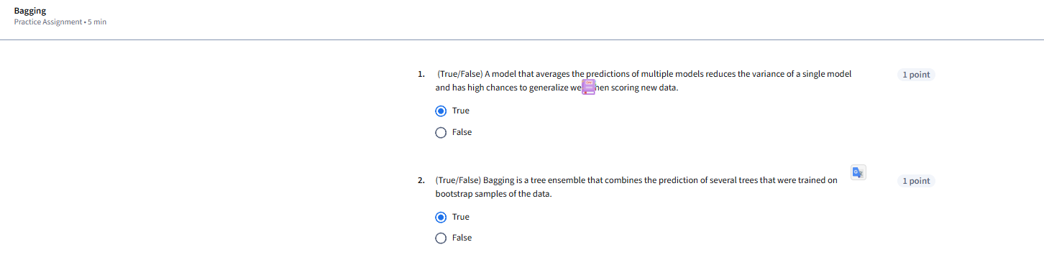

Random Forest



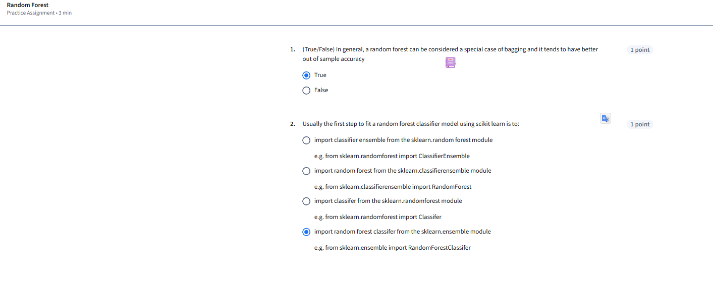

Bagging Labs



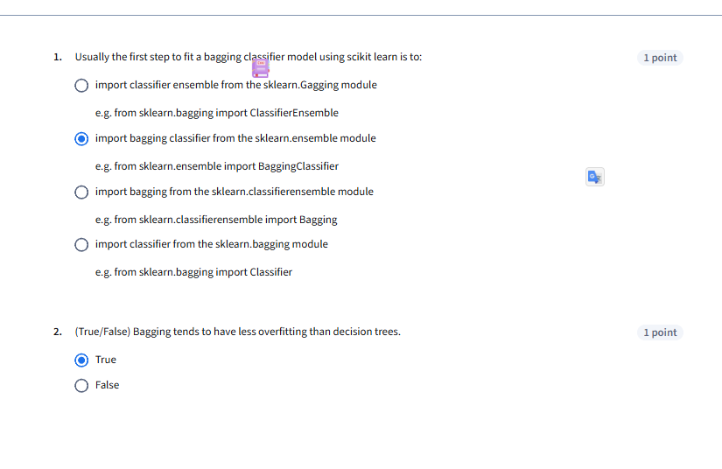

Boosting and Stacking



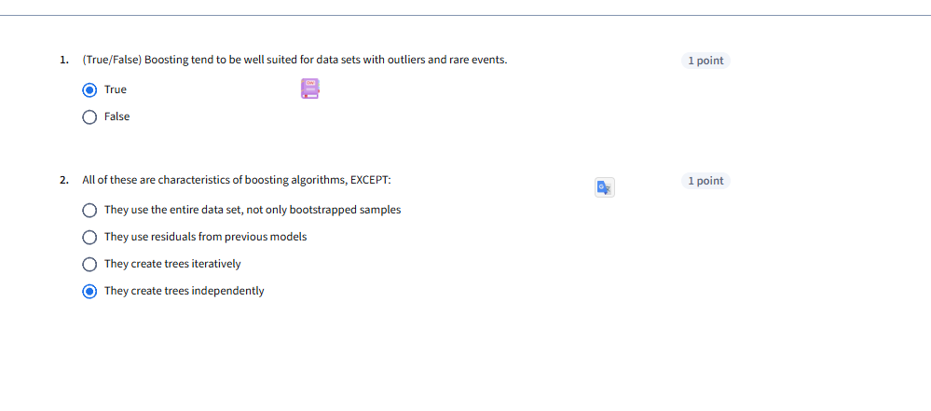

Boosting and Stacking Labs



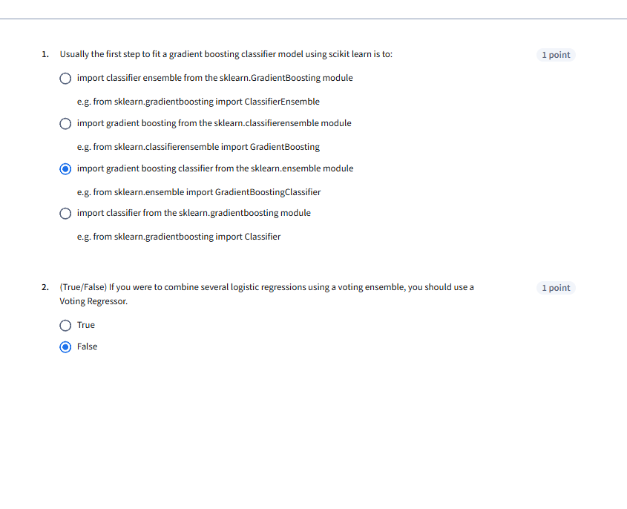

Module 5 Graded Quiz



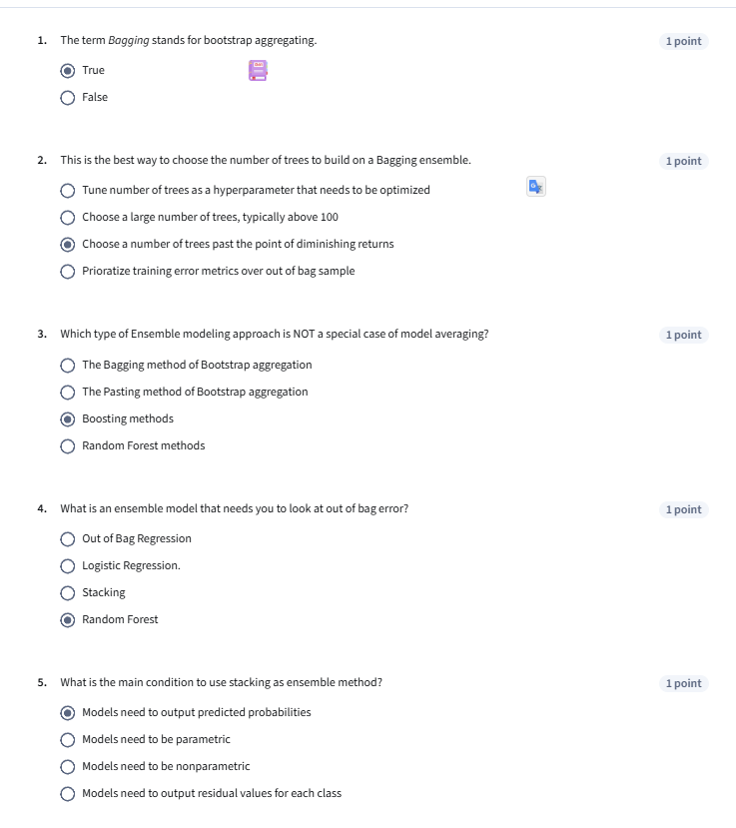

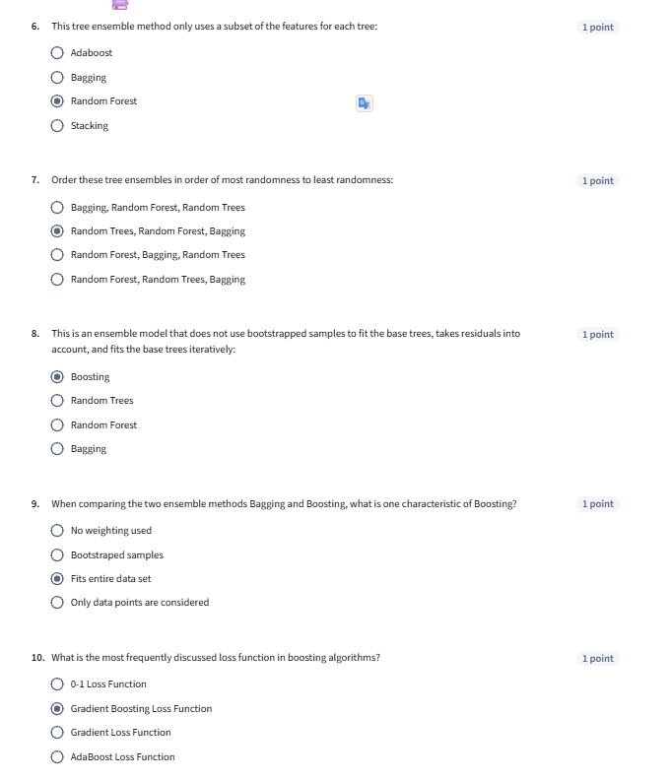

**MODULE 6 ( 3 Quiz)**

Practice: Model interpretability



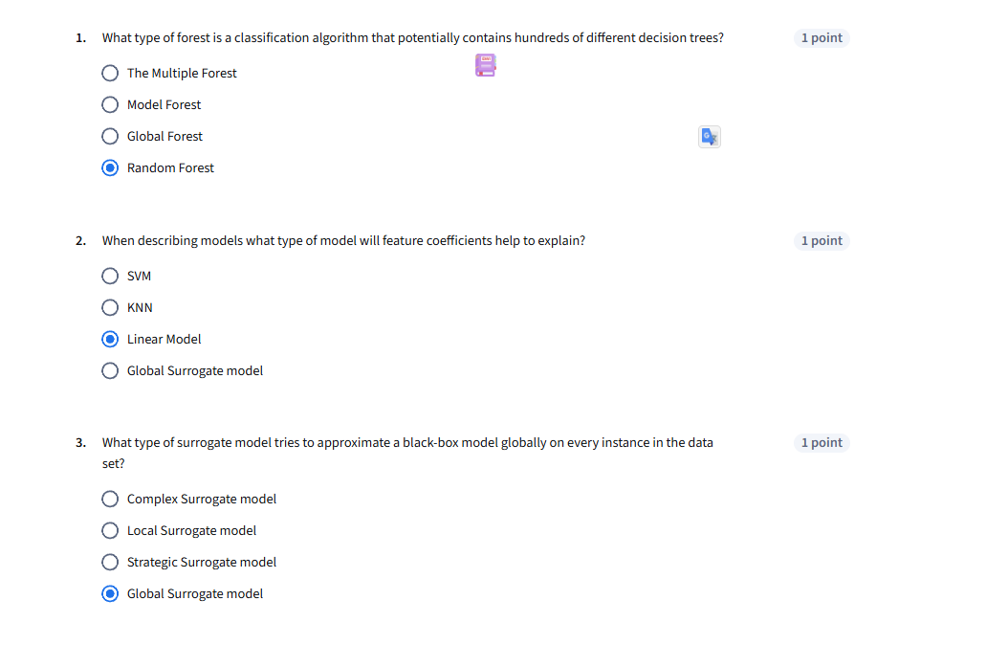

Modeling Unbalanced Classes



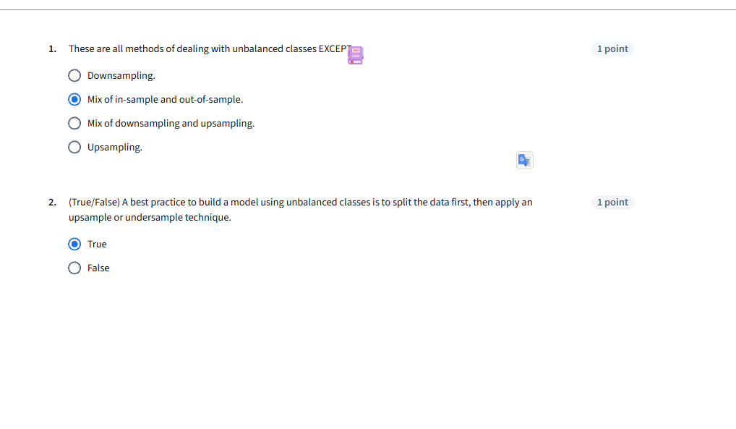

Module 6 Graded Quiz



