Tổng kết điểm :

Module 1 :

Quiz 1: 100%

Quiz 2: 100%

Quiz 3: 100%

Module 2 :

Quiz 1: 100%

Quiz 2: 100%

Module 3 :

Quiz 1: 100%

Quiz 2: 100%

Quiz 3: 100%

Module 4 :

Quiz 1: 100%

Quiz 2: 100%

Module 5 :

Quiz 1: 100%

Quiz 2: 100%

Module 6:

Quiz 1: 100%

Quiz 2: 80%

**MODULE 1 (3 QUIZ)**

Ungraded: Introduction to Unsupervised Learning



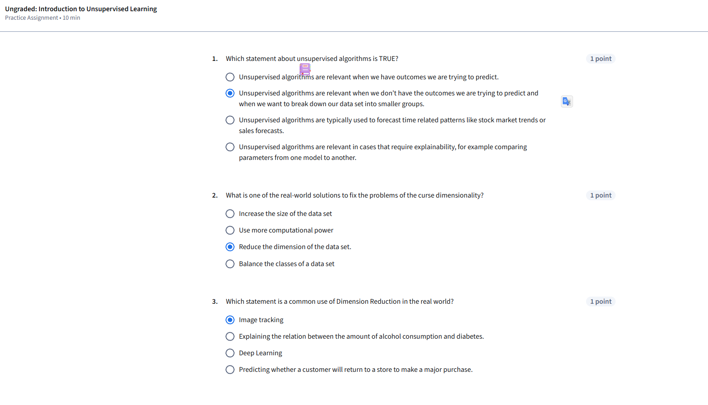

Ungraded: K Means Clustering



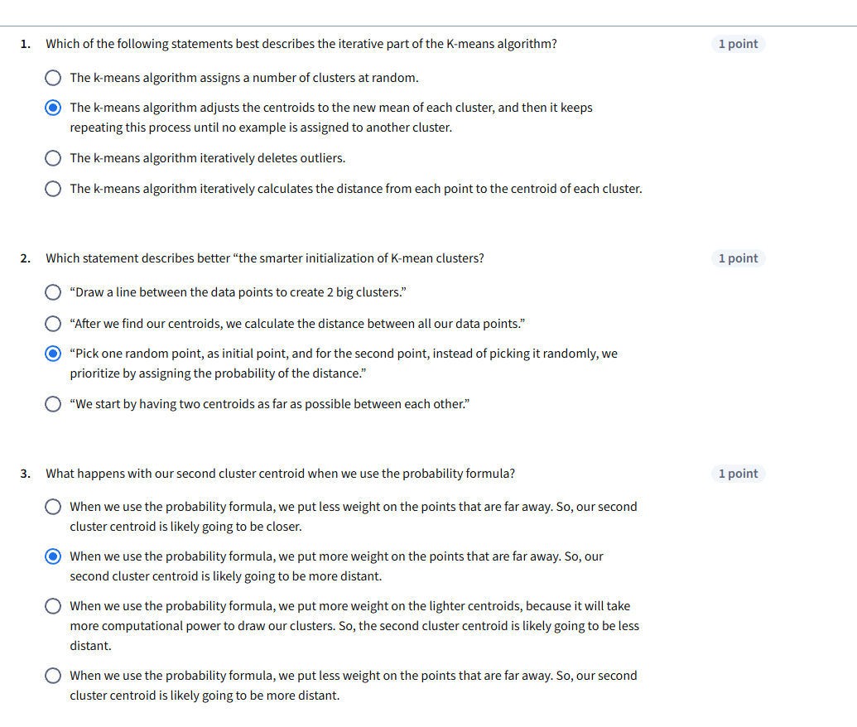

Graded: Module 1 Quiz



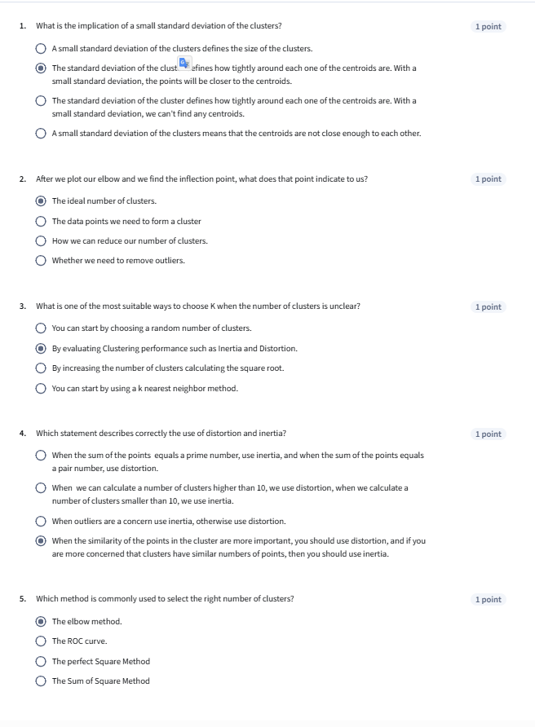

**MODULE 2 ( 2 QUIZ)**

Ungraded: Distance Metrics



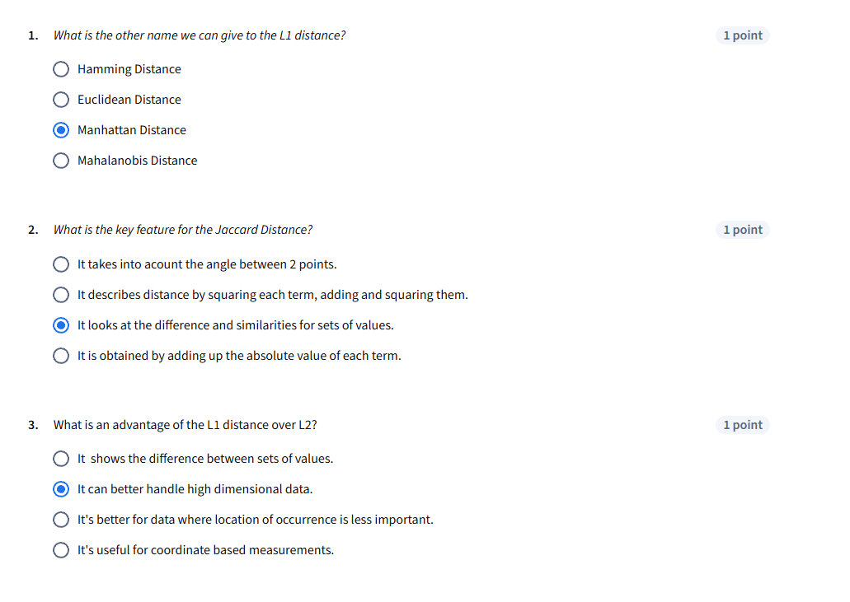

Graded: Module 2 Quiz



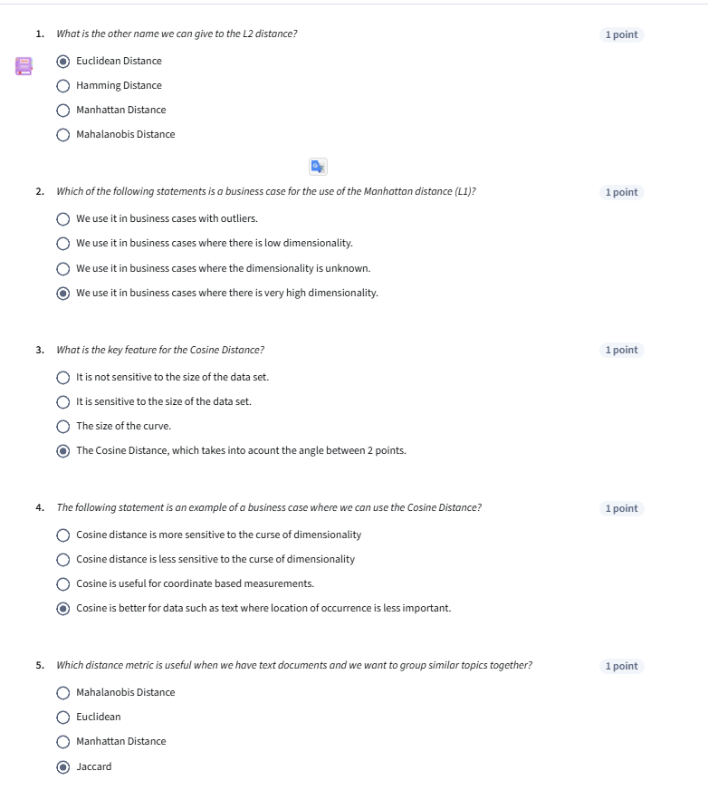

**MODULE 3 (3 QUIZ)**

Ungraded: Clustering Algorithms



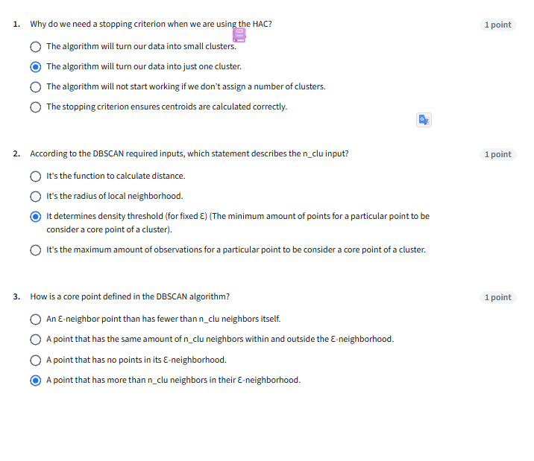

Ungraded: Comparing Clustering Algorithms



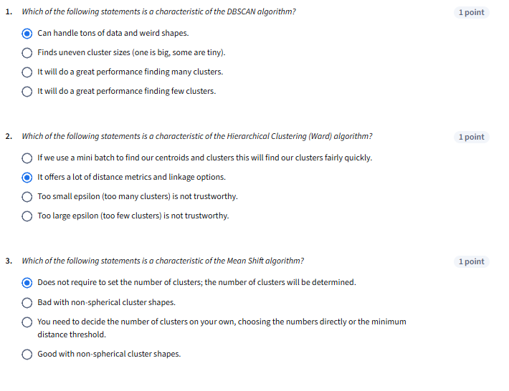

Graded: Module 3 Quiz



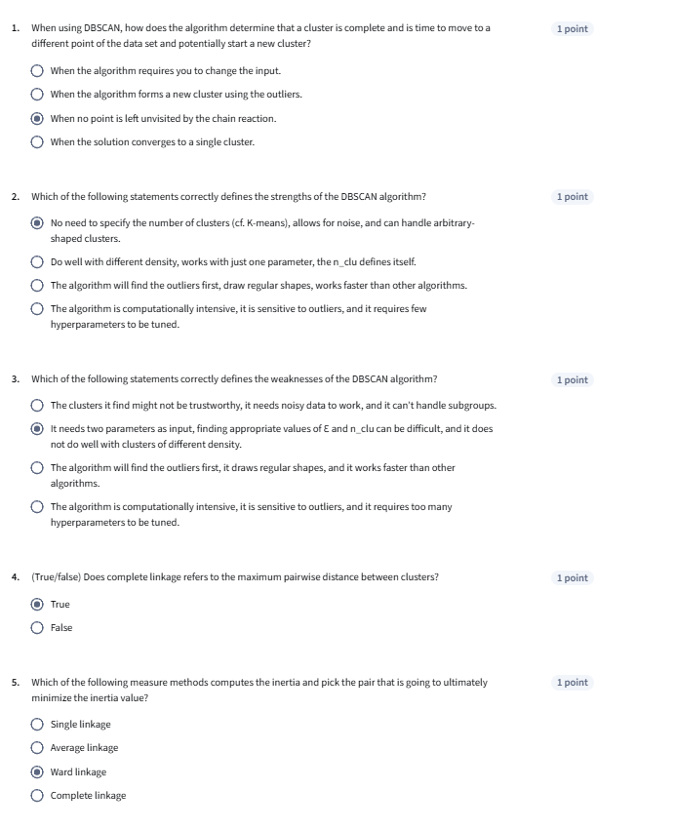

**MODULE 4 (2 QUIZ)**

Ungraded: Dimensionality Reduction



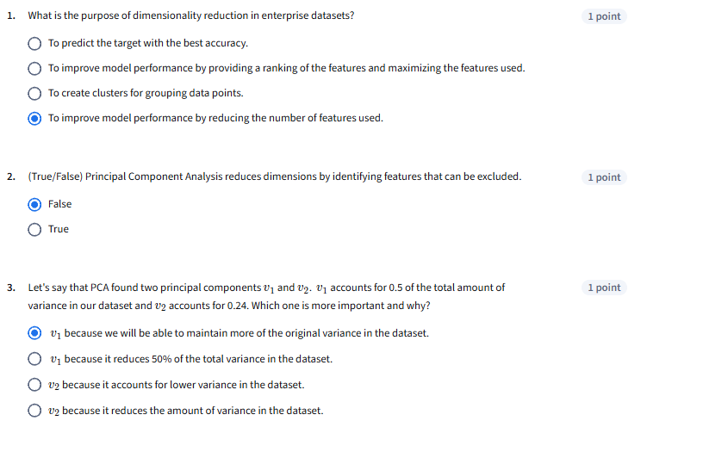

Graded: Module 4 Quiz



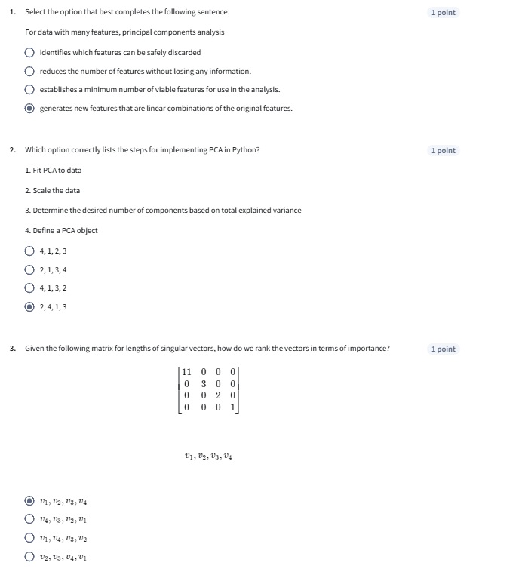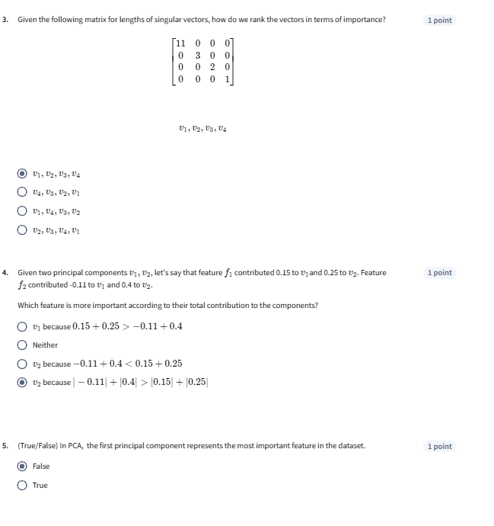

**MODULE 5 (2 QUIZ)**

Ungraded: Kernel PCA and MDS



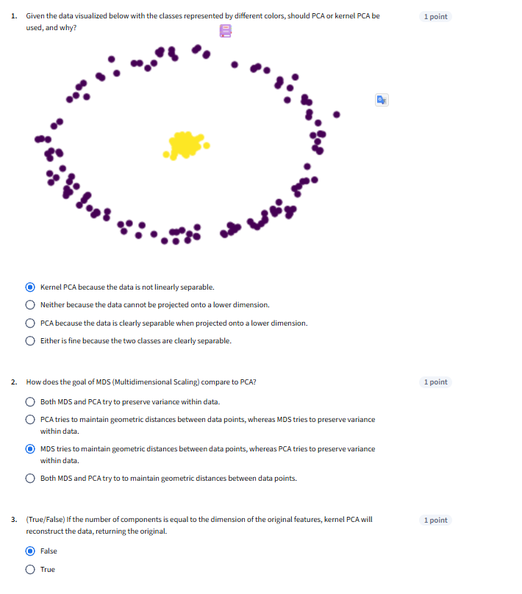

Graded: Module 5 Quiz



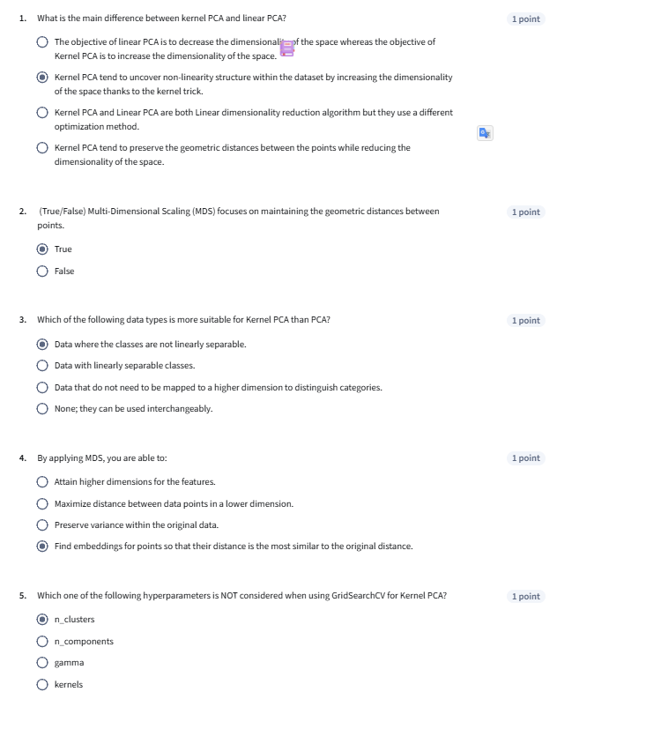

**MODULE 6 ( 2 Quiz)**

Ungraded: Non Negative Matrix Factorization



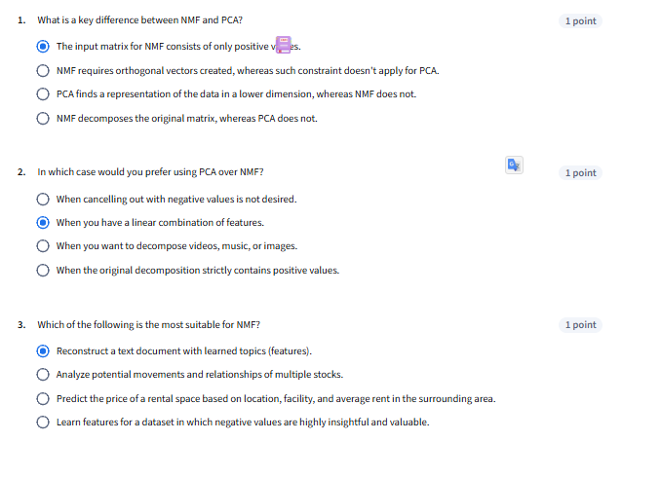

Graded: Module 6 Quiz



