Thuy Linh defeated Malaysian badminton 'prodigy'.

With experience and courage, Vietnam's number one player defeated Karupathevan Letshanaa to enter the quarterfinals of the Indonesia Masters 2025 badminton tournament on the afternoon of January 23.

Indonesia Masters at the super 500 level, taking place in the capital city of Jakarta, gathered many of the world's top players. In the first round, Thuy Linh unexpectedly defeated India's number one player, world number five and silver medalist at the 2016 Rio Olympics, bronze medalist at the 2021 Tokyo Olympics, and champion of the 2018 World Tour Finals, Pusarla Venkata Sindhu 2-0.

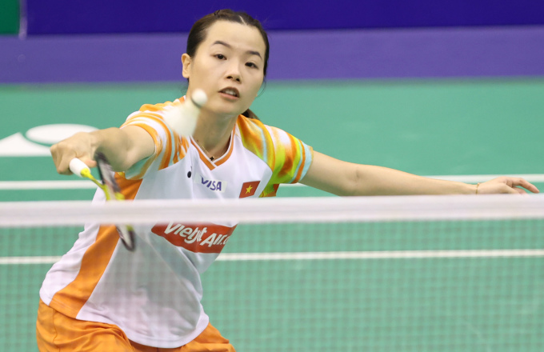

Nguyen Thuy Linh in a net play to score against Letshanaa.

Thuy Linh's opponent in the second round this afternoon is Letshanaa - currently world number 59, a "prodigy" of Malaysian badminton who reached the final of the Indonesia Masters 3 in November 2024. Therefore, she proactively played diversely, continuously forcing Thuy Linh to retreat deep to defend in the first set to lead Thuy Linh 5-1. But when she had guessed her opponent's playing style, Thuy Linh proactively played slowly, with closed-hand strokes. The player from Phu Tho scored seven consecutive points to lead 8-5. But then, with four outbound strokes, Thuy Linh let her opponent lead 10-9. With two tight chops to score points, she reached 11-10 to enter the break.

In this tournament, Thuy Linh is no longer alone but has the company of expert Hariawan Hong. After being discussed by the Indonesian expert, the player from Phu Tho returned to the set to play more diversely. Good net play helped her score a series of six points to lead 17-12.

But with the tug-of-war at the net, Letshanaa also responded, making it difficult for Thuy Linh. The Malaysian player scored six points to tie the score at 18-18. However, with the courage of a player who has participated in the Olympics twice, Thuy Linh quickly broke the opponent's streak of points, hit a long ball at the end of the court, scored three points, and won 21-18.

The scenario of set one was repeated in set two when Letshanaa continued to lead Thuy Linh by 6-1. But by being careful and meticulous in her shots, the Vietnamese player gradually narrowed the score to 4-6, 5-7, tied the score at 9-9 and then took the lead at 11-9 before the break of the set.

A minute of consultation with the expert did not help Thuy Linh perform as well as before. She often made mistakes and ran out of breath in long shots. Meanwhile, the opponent played like a possessed person to narrow the score and then lead 17-15. Thuy Linh continued to make mistakes, giving Letshanaa the opportunity to end the set with a score of 21-17.

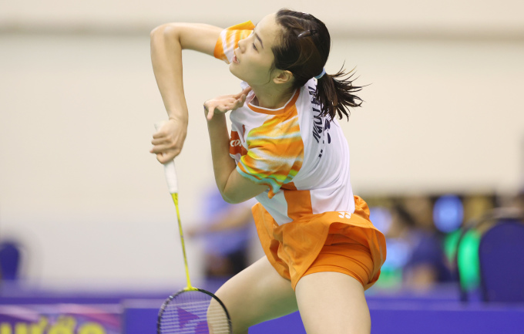

Tennis player Nguyen Thuy Linh surpassed her opponent six years younger to enter the quarterfinals of the Indonesia Masters 2025.
Thuy Linh is 28 years old this year, while Letshanaa is only 22, so badminton fans are worried about the Vietnamese player's physical strength when entering the third set. However, with advice from experts, Thuy Linh chose a durable style of play, sending the shuttlecock out in both directions to wear down her opponent. She therefore always led in the deciding set, but with a close margin of 6-4, 9-7 and 11-10.

The two players continuously fought for each point. Thuy Linh was exhausted many times and had to kneel down to catch her breath. On the other side of the court, Letshanaa also had to fall many times with Thuy Linh's difficult shots. The Malaysian player also played tricks by not returning the shuttlecock to the court after losing points to cause frustration. Letshanaa tried hard to catch up and then equalized 15-15 and led 16-15. But Thuy Linh, encouraged by the Indonesian audience, played calmly, leading 19-18 and then 20-18. However, with two shots out, the 28-year-old player missed two match points, allowing her opponent to tie the score at 20-20.

In a difficult position, Thuy Linh did not lose her composure, she skillfully controlled the ball at the back of the court and waited for the opportunity with two powerful smashes to score two important points to end the match. After scoring 22-20, Thuy Linh received a standing ovation from the home audience. On the contrary, Letshanaa angrily threw her racket, walked slowly and did not come to shake hands with Thuy Linh who was waiting at the net. It was not until the referee reminded her that the 22-year-old girl came forward to do the procedure and walked away, not looking at the winner.

Thuy Linh was born on November 20, 1997 in Phu Tho. She turned professional at the age of 14, and four years later, won the 2015 National Badminton Championships. Since 2018, Thuy Linh has been the number one female badminton player in Vietnam, winning seven consecutive national individual badminton championships. She has also won the Vietnam Open three consecutive times since 2022. Thuy Linh has also competed twice in the 2020 Tokyo Olympics and 2024 Paris Olympics. She is currently ranked 28th in the world.

Thuy Linh's opponent in the quarterfinals is Sung Shuo-yun, the world number 24 from Taiwan.

